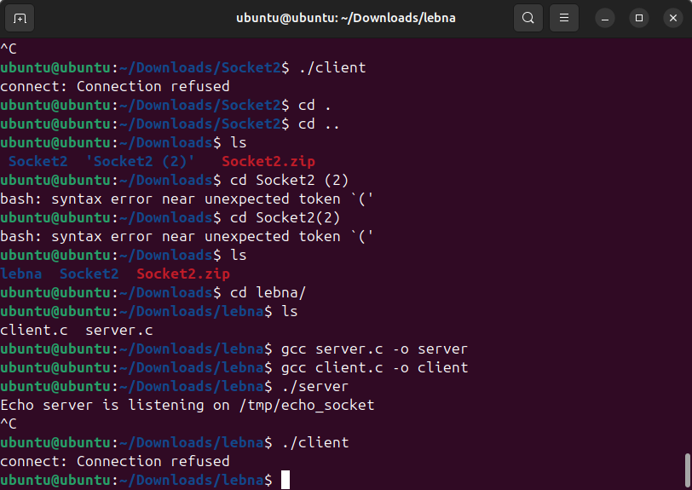
Run the Code and Demonstrate How It Works:
- The server listens on /tmp/echo_socket, as we can see in the output
- The client gets "Connection refused" because the server isn't accepting connections when the client tries.
Socket Type and Creation:
- Socket Type: Unix domain socket (AF_UNIX).
Server:
- Create Socket: The server calls socket(AF_UNIX, SOCK_STREAM, 0) to create a Unix domain socket.
- Bind Socket: The server binds the socket to a specific path (/tmp/echo_socket) using bind().
- Listen: The server then listens for incoming connections using listen().
Client:
- Create Socket: The client also creates a Unix domain socket with socket(AF_UNIX, SOCK_STREAM, 0).
- Connect: The client attempts to connect to the server's socket using connect() and the path /tmp/echo_socket.
The server listens for connections, and the client connects to it through the Unix domain socket, but it refuses in my case.

