1) Try to run the code in Unix environment. Create Makefile. Demo how it works
- I create a Makefile to compile the code.
Makefile:
- 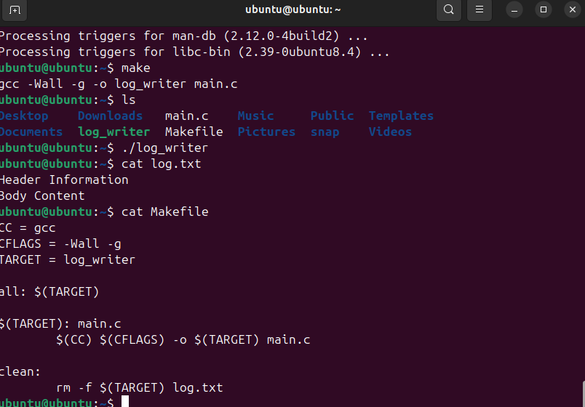
- Then I complie the it with
  - make
  - ./file_writer
  - Cat log.txt
    - Which output the below
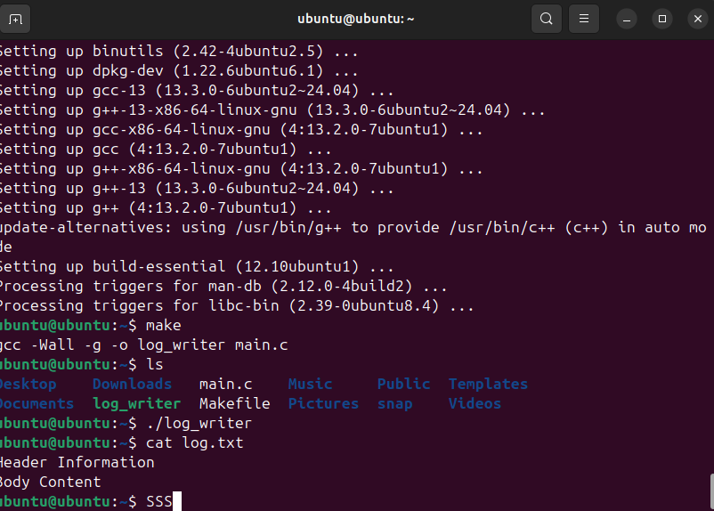
- We see a gap of 20 bytes between the header and body as it mentioned in the code

Q2) Explain each line of code.

- int fd = open("log.txt", O_WRONLY | O_CREAT | O_TRUNC, 0644);
  - Opens or creates the file log.txt in write-only mode.
  - O_CREAT: create if not exists, O_TRUNC: empty it if it exists.
  - 0644: file permissions (owner read/write, others read-only).
- if (fd < 0) { perror("open"); return 1; }
  - Checks for error. If file open fails, prints error and exits.
- char header[] = "Header Information\n";
- write(fd, header, strlen(header));
  - Defines a header string and writes it to the file.
- if (lseek(fd, 20, SEEK_SET) == -1) { perror("lseek"); return 1; }
  - Moves the file pointer 20 bytes ahead from the start.
  - If that goes over data, it creates a gap.
- char body[] = "Body Content\n";
- write(fd, body, strlen(body));
  - Writes the body after the gap.
- close(fd);
  - Closes the file and saves the changes.

