1) Try to run the code in Unix environment. Create Makefile. Demo how it works
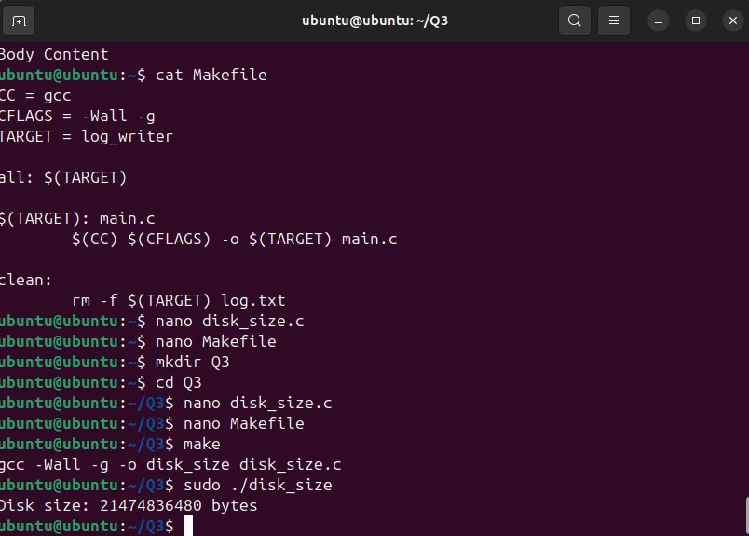
Makefile:
- 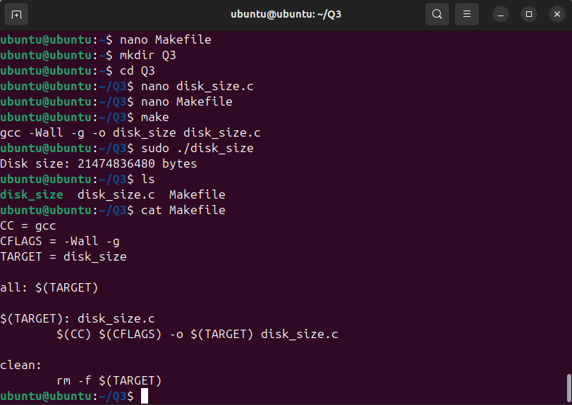

2) Role of ioctl in this code
- ioctl stands for input/output control. It is a system call used for device-specific operations that can’t be handled by regular system calls.
- Here, ioctl(fd, BLKGETSIZE64, &disk_size) sends a command (BLKGETSIZE64) to the block device /dev/sda via the file descriptor fd.
- The command requests the total size of the disk in bytes.The result is stored in the variable disk_size.

3) What if we change open() to fopen()? Would that work? Explain.
- open() is a system call that returns a file descriptor (int) and is used for low-level file operations, including device files.
- fopen() is a standard library function that returns a FILE* stream and is designed for regular files and buffered I/O.
- open() is required because ioctl() works with file descriptors (ints), not FILE*.
- If you replace open() with fopen(), you would get a FILE* pointer, and will not be passed directly to ioctl().
- To use fopen(), you’d need to get the file descriptor by calling fileno() on the
  - FILE* (e.g., int fd = fileno(fp);).

