1) Try to run the code in Unix environment.
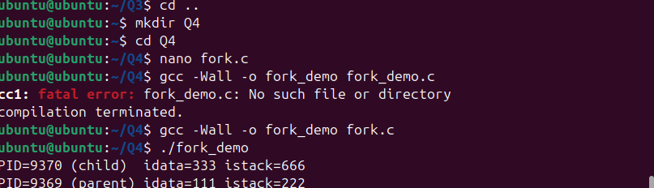
How it works:
- The program starts with two variables:
  - idata (global/static, initial value 111)
  - istack (local, initial value 222)
- It calls fork() to create a child process.
- After fork():
  - Child process (childPid == 9370): multiplies both idata and istack by 3.
  - Parent process: sleeps for 3 seconds (BLOCK A), then continues.
- Both processes then print their own process ID, and the values of idata and istack.
- Because idata is static/global, and istack is local, both processes have their own copy after fork().
2) How many parent/child processes are created?
- Only one child process is created by the single call to fork().
- So we have:
  - 1 parent process (original)
  - 1 child process (new)
3) What happens if we remove BLOCK A (the sleep(3) in the parent)?
- Without the sleep(3), the parent process does not pause.
- Both parent and child will proceed to print immediately after the fork.
- Which makes the output order to become unpredictable. The parent may print before or after the child.
- The values printed would be the same
- Only the timing and the order of output changes.

