AUTOMATED PROFILE
PICTURE UPLOAD
UI and API test automation | Presentation + complete speaker script
Prepared for project review
Presenter: ____________________ Date: ____________________
Suggested duration: 6?8 minutes

Before you present
- Open the GitHub repository and its Actions tab so you can show the workflow and run artifacts.
- Have the latest Cucumber HTML report, API endpoint report, and scenario screenshot available locally or from a GitHub Actions artifact.
- Do not display or share local.credentials.json, account passwords, or repository secret values during the presentation.
- The recorded local run passed with 1 scenario and 0 failures. The API report recorded HTTP 200 for all four listed operations.
- The assignment asks for multiple pushes. Show the repository commit history and confirm it contains more than one push; do not claim this unless it is visible in the history.

Presentation at a glance
- 1. Title and project purpose
- 2. Requirements and success criteria
- 3. Framework, language, and project structure
- 4. Automated UI scenario
- 5. API endpoint and response validation
- 6. Reports and screenshots
- 7. GitHub Actions pipeline and daily SAST schedule
- 8. Demonstration and results
- 9. Conclusion and questions

Slide 1 ? Automated Profile Picture Upload
Suggested timing: About 30 seconds

Slide content
- Title: Automated Profile Picture Upload
- UI and API test automation
- Presenter name and date

What to say
Good day. My project is an automated test solution for uploading and verifying a user profile picture on the Ndosi Automation website. I built it with Java, Selenium WebDriver, Cucumber, TestNG, and Maven. In this presentation, I will explain the user-interface flow, the API checks, and how the pipeline produces reports and screenshots for review.

Presenter cue
Introduce the project and the technologies. Keep this slide brief; the next slides explain the implementation.

Slide 2 ? Objective and Acceptance Criteria
Suggested timing: About 40 seconds

Slide content
- Automate the requested profile update journey
- Verify the changed image in the UI and after a profile API read
- Validate response codes for the related API operations
- Run on GitHub Actions and retain reports/screenshots

What to say
The objective is to automate the complete profile-picture update journey. The test signs in, navigates to My Profile, edits the profile, uploads a new picture, and confirms that the updated picture is displayed and persisted. The API requirement is to identify the endpoints involved in that journey and validate their response codes. The delivery also includes a detailed README, a GitHub Actions workflow, scheduled execution, and clear reports with screenshots.

Presenter cue
Connect these points directly to the task requirements. Avoid suggesting a live deployment or pipeline run unless you are showing one.

Slide 3 ? Framework and Project Structure
Suggested timing: About 45 seconds

Slide content
- Java 21 and Maven
- Selenium WebDriver with Chrome
- Cucumber with TestNG
- frameworkfiles packages: runner, steps, pages, hooks, utils, testdata

What to say
I chose Java because it works well with Selenium and the testing tools used here. Cucumber expresses the scenario in readable Given, When, and Then steps. TestNG runs the Cucumber runner, Maven manages dependencies and test execution, and Selenium drives Chrome. The code is separated into runner, steps, page objects, hooks, utilities, and test data under the frameworkfiles package. The page objects hold browser interactions, while the hooks start and stop the browser and attach a screenshot after the scenario.

Presenter cue
If asked why these tools: say they form a familiar Java UI automation stack and allow readable scenarios plus reusable browser code.

Slide 4 ? UI Automation Scenario
Suggested timing: About 50 seconds

Slide content
- Open site and log in
- Navigate to My Profile
- Edit profile and upload image
- Verify displayed image and persisted profile

What to say
This is the scenario from the feature file. First, the test opens the Ndosi Automation website and uses the menu to open the login page. It signs in with the configured account, opens the menu again, and selects My Profile. It edits the profile, uploads the selected test image, and saves. Finally, it checks the success confirmation and compares the displayed profile image with the image returned by a follow-up profile API read. On this machine, the image is loaded automatically from the configured Downloads path; CI supplies its image through a GitHub Actions secret.

Presenter cue
Show the Gherkin feature file if useful. Do not show any password or secret configuration value.

Slide 5 ? API Endpoint Checks
Suggested timing: About 60 seconds

Slide content
- POST /APIDEV/login ? HTTP 200
- GET /APIDEV/profile ? HTTP 200
- PUT /APIDEV/profile ? HTTP 200
- POST /APIDEV/profile/image ? HTTP 200
- Follow-up profile read verifies persisted image URL

What to say
The test captures browser network responses during the UI flow and checks the required API operations. The login operation is POST slash login. The profile is loaded with GET slash profile. Saving profile details uses PUT slash profile, and uploading the image uses POST slash profile slash image. In the report from the successful local run, each of these operations returned HTTP 200. The test also checks the captured response statuses and makes an authenticated GET profile after the upload, then verifies that the returned image URL matches the image displayed in the application.

Presenter cue
These status codes are from the generated local API report. If presenting a different run, open its own api-endpoints.txt and quote that run?s actual values.

Slide 6 ? Reports and Screenshots
Suggested timing: About 45 seconds

Slide content
- target/cucumber-reports/cucumber.html ? readable report
- target/cucumber-reports/cucumber.json ? structured result
- target/cucumber-reports/api-endpoints.txt ? API status evidence
- target/screenshots/ ? saved scenario screenshot
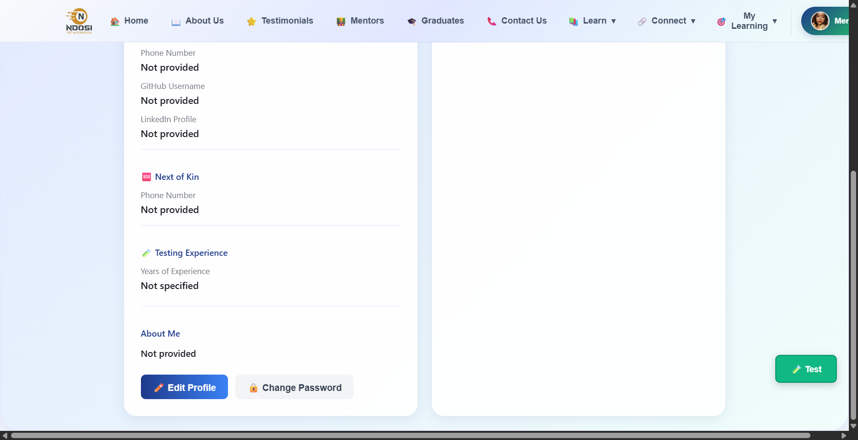
Evidence screenshot captured after the profile workflow.

What to say
For evidence, the test generates a readable Cucumber HTML report and a JSON report. It also writes an API endpoint report containing the methods, paths, and response codes. The TestNG and Maven reports are available under the Surefire reports directory. The Cucumber hook takes a screenshot at the end of the scenario, saves it under target screenshots, and attaches it to the scenario report. The screenshot shown here is from the successful profile workflow run.

Presenter cue
Use the included screenshot as visual evidence. For a live review, open the HTML report and the API report.

Slide 7 ? GitHub Actions and Daily Schedule
Suggested timing: About 55 seconds

Slide content
- Triggers: push, pull request, manual dispatch, daily schedule
- Cron: 0 22 * * * UTC = 00:00 SAST
- Java 21 + Chrome; test runs headlessly
- Secrets supply credentials and image; artifacts preserve evidence

What to say
The GitHub Actions workflow runs when code is pushed, when a pull request is opened or updated, when manually dispatched, and on a daily schedule. The scheduled cron expression is zero minutes past 22:00 UTC. South African Standard Time is UTC plus two, so that corresponds to midnight SAST. The workflow sets up Java 21 and Chrome, obtains the password and image from repository Actions secrets, runs Maven in headless mode, and uploads reports and screenshots as an artifact even when the test run fails.

Presenter cue
Show .github/workflows/cucumber.yml and, if available, a completed Actions run with the artifact. The cron is midnight SAST; do not describe it as 22:00 local time.

Slide 8 ? Demonstration and Results
Suggested timing: About 60 seconds

Slide content
- Latest successful local run: 1 test, 0 failures, 0 errors
- Four reported API operations returned HTTP 200
- Screenshot and reports are generated; CI uploads them as an artifact

What to say
I will now show the evidence from the run. The Cucumber output shows that the profile-picture scenario completed successfully. The result was one test run, with zero failures and zero errors. The API report lists HTTP 200 for login, profile retrieval, profile update, and image upload. This screenshot shows the profile page after the workflow. Together, the scenario result, API response report, and screenshot show that the upload was exercised and that the saved image was verified.

Presenter cue
Show only outputs from the run you are presenting. Avoid overstating the result as proof of every possible image format or every account.

Slide 9 ? Conclusion and Questions
Suggested timing: About 30 seconds

Slide content
- End-to-end UI flow
- API response validation and persistence check
- CI schedule, reports, and screenshots
- Repository history: show multiple pushes if present

What to say
To conclude, I automated the profile-picture upload from login through persistence verification. The solution checks the related API responses, runs locally and in GitHub Actions, and produces reports and screenshots that support review. The workflow is scheduled for midnight SAST. I will finish by showing the repository history to confirm the required multiple pushes, and then I am happy to answer questions.

Presenter cue
Before presenting, verify the commit history contains more than one push. If it does not, do not state that this requirement is complete.

Quick reference for questions

What does the test verify?
It exercises login, profile navigation, image upload, a success confirmation, the displayed image, API response codes, and persistence through a follow-up profile read.

Which API calls are validated?
POST /login, GET /profile, PUT /profile, and POST /profile/image, under the /APIDEV base path. The captured successful local report shows HTTP 200 for each.

How is the picture selected?
Locally the test uses the configured Downloads image path by default; PROFILE_PICTURE_PATH can override it. The CI workflow decodes a private image from the PROFILE_PICTURE_BASE64 Actions secret.

How are secrets handled?
The CI workflow reads SITE_PASSWORD from a GitHub Actions secret. Locally, the password file is ignored by Git; credentials should not be committed or displayed.

When does the scheduled pipeline run?
At 22:00 UTC, which is 00:00 SAST (UTC+2).

Where are artifacts?
Locally under target/cucumber-reports, target/screenshots, and target/surefire-reports. CI uploads them as cucumber-report-and-screenshots.

What should I show for the multiple-push requirement?
Open the GitHub repository commit history and show more than one push/commit. Confirm the evidence before claiming this requirement is satisfied.

Project files to open during review
- src/test/resources/features/profile-picture.feature ? readable scenario
- src/test/java/frameworkfiles/runner/RunCucumberTest.java ? Cucumber/TestNG runner and glue packages
- src/test/java/frameworkfiles/steps/ProfilePictureSteps.java ? scenario step implementations
- src/test/java/frameworkfiles/hooks/TestHooks.java ? browser lifecycle and screenshot attachment
- src/test/java/frameworkfiles/utils/ApiTraffic.java ? captured API checks/reporting
- .github/workflows/cucumber.yml ? CI triggers, nightly schedule, test, and artifact upload
- README.md ? setup, run instructions, pipeline, and outputs

