

**Real estate auction system**

**Software Requirement Specification**

| Project Code | F4Land |
| --- | --- |
| Document Code |  |
| Group Member | SE160226 - Lê Ngọc Bảo Duy  SE171049 - Trương Phước Sang  SE172418 - Lê Huy Hoàng  SE171131 - Trần Anh Kiệt |
| Supervisor | Lại Đức Hùng - HungLD - HungLD5@fe.edu.vn |

**Ho Chi Minh, Mar 1st 2024**

**Record of change**

*A - Added M - Modified D - Deleted

| **Effective Date** | **Changed Items** | **A* M, D** | **Change Description** | **New Version** |
| --- | --- | --- | --- | --- |
| 20/09/2023 | Introduction | A | Add purpose, scope, definitions, definitions, acronyms, and abbreviations, references, overview. |  |
| 22/09/2023 | Overall description | A | Add product perspective, user characteristics. |  |
| 24/09/2023 | Functional requirement | A | Add Use Cases Diagram and Use Case List. |  |
| 25/09/2023 | Use case detail | A | Add UC-01, UC-02, UC-03, UC-04, UC-05, UC-06. |  |
| 26/09/2023 | Use case detail | A | Add UC-07, UC-08, UC-09, UC-10, UC-11. |  |
| 27/09/2023 | Use case detail | A | Add UC-12, UC-13, UC-14, UC-15, UC-16, UC-17. |  |
| 28/09/2023 | Use case detail | A | Add UC-18, UC-19, UC-20, UC-21, UC-22 |  |
| 30/09/2023 | Use case detail | A | Add UC-23, UC-24, UC-25, UC-26, UC-27, UC-28 |  |
| 02/09/2023 | Use case detail | A | Add UC-29, UC-30, UC-31, UC-32, UC-33 |  |
| 05/10/2023 | Use case detail | A | Add UC-34, UC-35, UC-36, UC-37, UC-38, UC-39 |  |
| 09/10/2023 | Use case detail | A | Add UC-40, UC-41, UC-42, UC-43, UC-44 |  |
| 12/10/2023 | Non-functional requirement | A | Add usability. |  |
| 14/10/2023 | Non-functional requirement | A | Add reliability. |  |
| 15/10/2023 | Non-functional requirement | A | Add performance. |  |

**SIGNATURE PAGE**

**ORIGINATOR:** Nguyen Ngoc Toan

Tran Anh Kiet

Le Huy Hoang

Truong Phuoc Sang

Le Ngoc Bao Duy

**REVIEWERS:** Lai Duc Hung 08/03/2024 Lecturer

**APPROVAL:** Lai Duc Hung 08/03/2024 Lecturer

**TABLE OF CONTENTS**

**1 Introduction 6**

1.1 Purpose 6

1.2 Scope 6

1.3 Definitions, Acronyms, and Abbreviations 6

1.4 References 7

1.5 Overview 7

**2 Overall Description 8**

2.1. Product perspective 8

2.2. User characteristics 8

2.3. Assumptions and dependencies 8

**3 FUNCTIONAL REQUIREMENTS 9**

3.1 Use Cases Diagram 9

3.2 Use Case List 9

3.3 Use Case Detail 13

3.3.1 UC-01: Sign In 13

3.3.2 UC-02: Change Password

### 3.3.3 UC-03: Reset Password

3.3.4 UC-04: Sign Up

3.3.5 UC-05: View Profile

3.3.6 UC-06: Edit Profile

3.3.7 UC-07: Auction List

3.3.8 UC-08: Auction Details

3.3.9 UC-09: Create Auction

3.3.10 UC-10: Update Auction

3.3.11 UC-11: Approve Auction

3.3.12 UC-12: Join Auction

3.3.13 UC-13: Bidding

3.3.14 UC-14: Send Ticket

3.3.15 UC-15: Ticket History

3.3.16 UC-16: List Ticket

3.3.17 UC-17: Notification  
3.3.18 UC-18: List Payment

3.3.19 UC-19: Payment Details  
3.3.20 UC-20: Update Payment

3.3.21 UC-21: Recharge Money

3.3.22 UC-22: Withdraw Money

3.3.23 UC-23: Ticket Details

3.3.24 UC-24: Reply Ticket

3.3.25 UC-25: Close Ticket

3.3.26 UC-26: Dashboard

3.3.27 UC-27: Manage User

3.3.28 UC-28: Manage Staff

3.3.29 UC-29: Create Staff

3.3.30 UC-30: Setting Auction

3.3.31 UC-31: Chatting

3.3.32 UC-32: Customer Service Department

15

**4 NON-FUNCTIONAL Requirements 133**

4.1 Usability 133

4.2 Reliability 133

4.3 Performance

133

# INTRODUCTION

## Purpose

F4Land is the website where great opportunities in real estate await! As the leading destination for real estate auctions, we specialize in connecting savvy buyers with a wide range of top properties. The platform helps users post news and participate in auctions in a transparent and secure way for buyers and sellers.

## Scope

## 

| **Acronym** | **Definition** | **Vietnamese** |
| --- | --- | --- |
| Guest | A person using the  application without signing  in. | Khách |
| Member | A person who authenticate to the system | Thành viên hệ thống |
| Staff | A person who manage about the auction and the request of member | Nhân viên hệ thống |
| Admin | A person who own the system and manage setting of the system | Quản trị hệ thống |

## Definitions, Acronyms, and Abbreviations

## References

## Overview

The second chapter, the Overall Description, of this document provides an overview of the product's functionality. It describes the informal requirements and is used to establish the context for the specification in the next chapter.

The third chapter, the Functional Requirements section, of this document is written to describe the functionality of the product in technical terms including its use-cases and details.

The fourth chapter, the Non-functional Requirements section, of this document is written to describe in detail the non-functionality of the product, defining how a system should look like. The fifth chapter, the Database section, of this document is written to describe in detail the database (specifically, ERD and Relation Schema) of the product, defining how data are stored and organized.

# OVERALL DESCRIPTION

## 2.1. Product perspective

RealEstateAuction is an automated or manual auction system for properties related to land, houses or kiosks. This is a new project that approaches users using the auction method to choose the winner of that asset. The system is designed to evolve over multiple versions, incorporating additional features to enrich the auctioneer and auctioneer experience.

## 2.2. User characteristics

| Guest | A person using the  application without signing  in. |
| --- | --- |
| Member | A person who authenticate to the system |
| Staff | A person who manage about the auction and the request of member |
| Admin | A person who own the system and manage setting of the system |

## 

## 2.3. Assumptions and dependencies

AS-1: Since the application is a web based application there is a need for the internet browser. It will be assumed that the users will possess decent internet connectivity.

AS-2: Staff members at RealAuctionEstate are assumed to work full-time.

# FUNCTIONAL REQUIREMENTS

## Use Cases Diagram

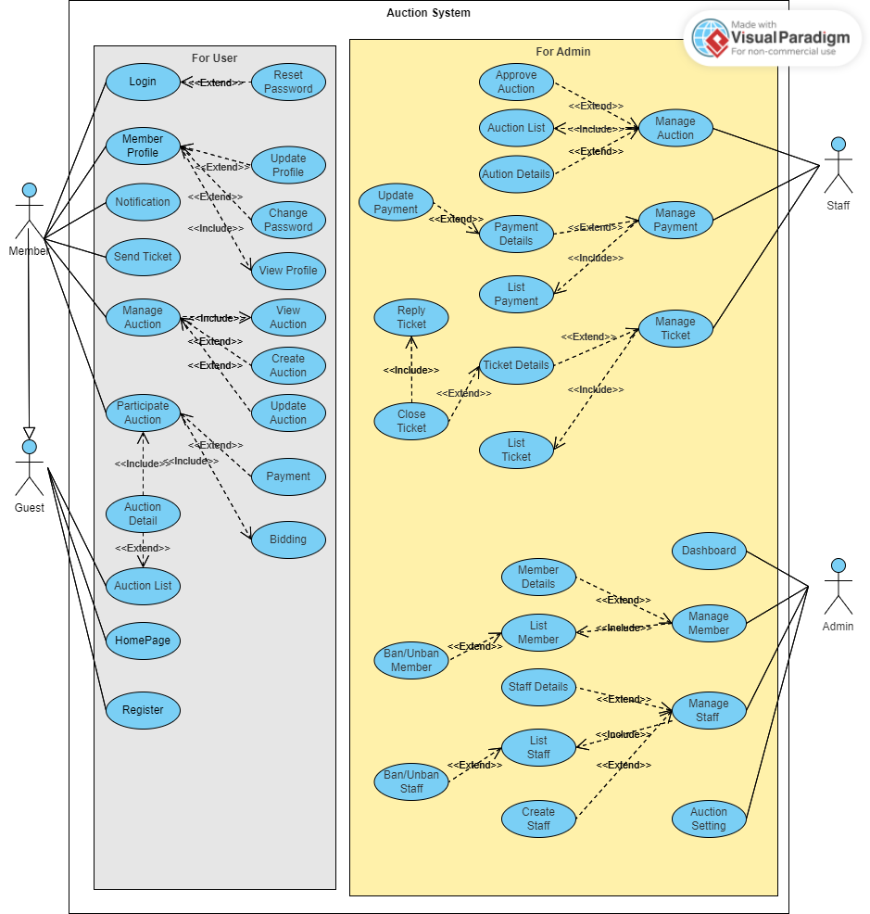

## Use Case Detail

#### 3.3.1 UC-01: Login

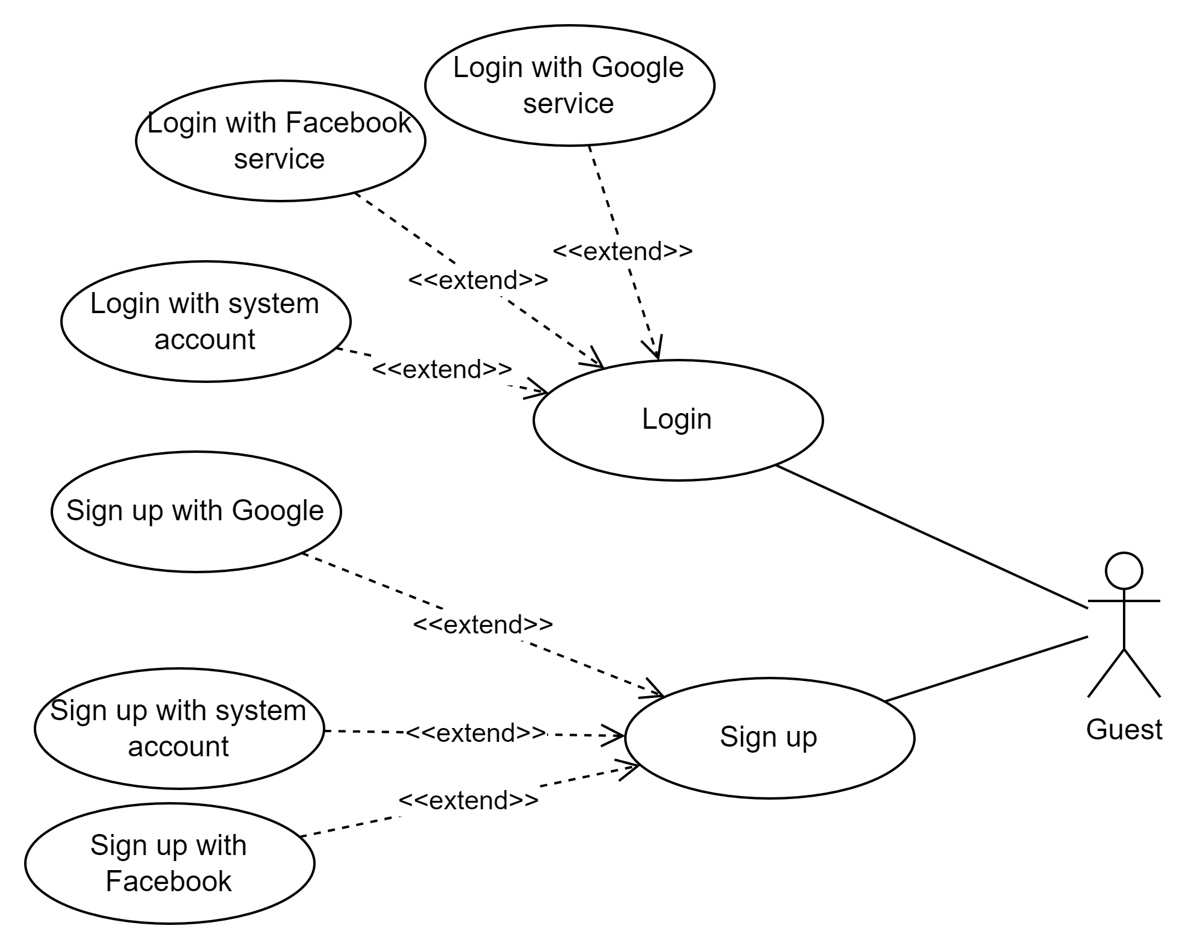

| **USE CASE-01 SPECIFICATION** | | | | |
| --- | --- | --- | --- | --- |
| **Use-case No.** | UC-01 | **Use-case Version** | | 1.0 |
| **Use-case Name** | Login | | | |
| **Author** | Nguyen Ngoc Toan - SE171130 | | | |
| **Date** |  | **Priority** | High | |
| **Actors:**   * Member,Staff,Admin   **Summary:**   * This feature allows user to login to the system   **Goal:**   * Login to the website successfully.   **Triggers :**   * Users want to login in the system   **Preconditions:**   * Users have an account in the system. * *The actor has a Facebook Account, Google Account or an account registered before.* * *The account used to log in must be authorized to access the system.* * *The account must not be banned by admin*   **Post Conditions :**   * User login successfully to the system.   **Main Success Scenario:**     | Step | Actor Action | System Response | | --- | --- | --- | | 1 | User click on “Đăng nhập” button | A pop-up screen display for user  ***Email****: text input, required, check email format.*  ***Password****: password input, not empty, and at least 8 characters.*  *Below the form is a button used to log in with Facebook.* | | 2 | User enter account information |  | | 3 | User click “Đăng nhập” button in the pop-up screen | System validate account of the user | | 4 |  | System redirect to the current page and display successful message |   **Alternative Scenario:**   * AS-1:  1. Users enter wrong account information or accounts that do not exist in the system. 2. System display failed message for user 3. User back to Step 1 in **Main Success Scenario**   **Exceptions:**     | No | Cause | System Response | | --- | --- | --- | | 1 | The system is not available | The error page 500 display for user |   **Relationships:**   * N/A   **Business Rules :**   * N/A | | | | |

#### 3.3.2 UC-02: Change password

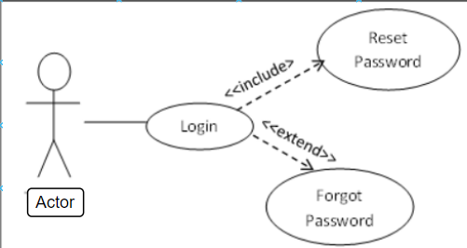

| **USE CASE-02 SPECIFICATION** | | | | |
| --- | --- | --- | --- | --- |
| **Use-case No.** | UC-02 | **Use-case Version** | | 1.0 |
| **Use-case Name** | Change password | | | |
| **Author** | Nguyen Ngoc Toan - SE171130 | | | |
| **Date** |  | **Priority** | Medium | |
| **Actor:**   * Member   **Summary:**   * This feature allows members to change a new password when they did not like the old password.   **Goal:**   * Members can recreate the new password of an account registered before.   **Triggers:**   * Members want to change their password.   **Preconditions:**   * Users have an account in the system.   **Post Conditions:**   * Users change passwords successfully.   **Main Success Scenario:**     | Step | Actor Action | System Response | | --- | --- | --- | | 1 | Member click on “Đổi mật khẩu” in the pop-up “Thông tin cá nhân” screen. | System displays a screen for members to enter the old password of the member's account and new password | | 2 | Members enter and confirm new password and clicks “Lưu lại” | System validates the old password and whether the new password is correct or not. |   **Alternative Scenario:**   * AS-1: Old password is not correct  1. Display error message ”Mật khẩu cũ không đúng”. 2. Back to Step 1 in **Main Success Scenario**.  * AS-2: The new password is not correct  1. Display error message ”Mật khẩu mới không hợp lệ”. 2. Back to step 3 in **Main Success Scenario**.  * AS-3: Confirm password does not match with new password.  1. Display error message “Mật khẩu nhập lại không khớp!”. 2. Stay in Step 4 in the Main **Success Scenario**.   **Exceptions:**     | No | Cause | System Response | | --- | --- | --- | | 1 | The system is not available | The error page 500 display for user | | 2 | Confirm password does not match with new password | Display error message “Mật khẩu nhập lại không khớp!” |   **Relationships:**   * N/A   **Business Rules:**   * Password is not empty and contains at least 8 characters. | | | | |

#### 3.3.3 UC-03: Reset Password

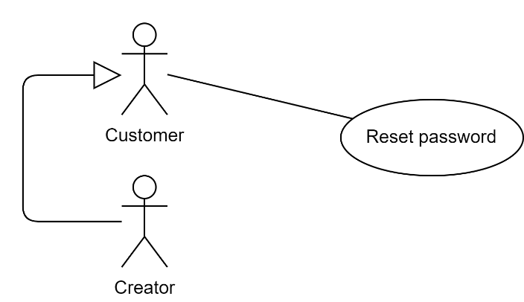

| USE CASE-03 SPECIFICATION | | | | |
| --- | --- | --- | --- | --- |
| **Use-case No.** | UC-03 | **Use-case Version** | | 1.0 |
| **Use-case Name** | Reset Password | | | |
| **Author** | Nguyen Ngoc Toan - SE171130 | | | |
| **Date** |  | **Priority** | Medium | |
| **Actor:**   * Member, Staff, Admin   **Summary:**   * This feature allows members to reset passwords when they forget the old password.   **Goal:**   * Members can recreate the new password of an account registered before.   **Triggers:**   * Members want to reset their password.   **Preconditions:**   * Users have an account in the system.   **Post Conditions:**   * Users reset passwords successfully.   **Main Success Scenario:**     | Step | Actor Action | System Response | | --- | --- | --- | | 1 | Member click on “Quên mật khẩu” in the pop-up login screen. | System displays a screen for members to enter the email of the member's account. | | 2 | Members input the email and click “Tiếp tục”. | System validate the email existing in the system or not | | 3 | Member enter OTP send to email and click “Xác nhận” | System validate the OTP sent to email and redirect to create a new password page. | | 4 | User enter new password and confirm password | System recreate new password with email account of member |   **Alternative Scenario:**   * AS-1: Email not exist in the system  1. Display error message ”Email không tồn tại”. 2. Back to Step 1 in **Main Success Scenario**.  * AS-2: Wrong OTP  1. Display error message ”Sai OTP!”. 2. Back to step 3 in **Main Success Scenario**.  * AS-3: Confirm password does not match with new password.  1. Display error message “Mật khẩu nhập lại không khớp!”. 2. Stay in Step 4 in the Main **Success Scenario**.   **Exceptions:**     | No | Cause | System Response | | --- | --- | --- | | 1 | The system is not available | The error page 500 display for user | | 2 | Confirm password does not match with new password | Display error message “Mật khẩu nhập lại không khớp!” |   **Relationships:**   * N/A   **Business Rules:**   * The email must be valid. * Username is not empty, not contain space and contains at least 5 characters. * Password is not empty and contains at least 8 characters. | | | | |

#### 3.3.4 UC-04: Sign Up

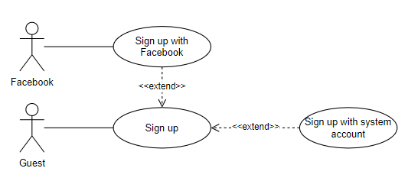

| USE CASE-04 SPECIFICATION | | | | |
| --- | --- | --- | --- | --- |
| **Use-case No.** | UC-03 | **Use-case Version** | | 1.0 |
| **Use-case Name** | Sign Up | | | |
| **Author** | Nguyen Ngoc Toan - SE171130 | | | |
| **Date** |  | **Priority** | Medium | |
| **Actor:**   * Member   **Summary:**   * This feature allows guests to create new accounts to become RealEstateAuction member   **Goal:**   * Guests can create a new account successfully and become RealEstateAuction member   **Triggers:**   * Guests want to register an account in the RealEstateAuction   **Preconditions:**   * Users have an account in the system.   **Post Conditions:**   * The system creates a new account and redirects to the home page.   **Main Success Scenario:**     | Step | Actor Action | System Response | | --- | --- | --- | | 1 | On the home page, guests click on “Đăng ký”. | The system displays a form for guests to enter information: - Họ và Tên: a string input is not empty.  -Mật khẩu/Xác nhận mật khẩu: two strings must be identical, not empty and at least 8 characters.  - Ngày sinh: a datetime data  - Email: a string input must follow the email regex (XXX@YYY.ZZ).  - Số điện thoại: a string of numbers  has 10 characters.  - Địa chỉ: a string is not empty. | | 3 | Guests input password, full name, birthday, email, phone number, address. |  | | 4 | Guests click on “Đăng ký”. | System checks all input. If all are valid, the system will create a new account, inform ”Đăng ký thành công” and redirect to the home page. |   **Alternative Scenario:**   * AS-1: Email not exist in the system  1. Display error message ”Email không tồn tại”. 2. Back to Step 1 in **Main Success Scenario**.  * AS-2: Wrong phone number  1. Display error message ”Số điện thoại không hợp lệ”. 2. Back to step 3 in **Main Success Scenario**.   **Exceptions:**     | No | Cause | System Response | | --- | --- | --- | | 1 | The system is not available | The error page 500 display for user |   **Relationships:**   * N/A   **Business Rules:**   * The email must be valid. | | | | |

#### 3.3.5 UC-05: View Profile

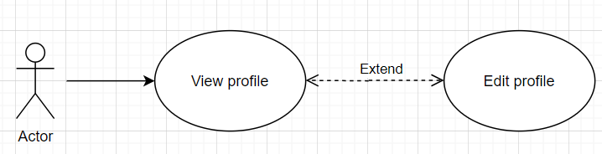

| USE CASE-05 SPECIFICATION | | | | |
| --- | --- | --- | --- | --- |
| **Use-case No.** | UC-03 | **Use-case Version** | | 1.0 |
| **Use-case Name** | View Profile | | | |
| **Author** | Nguyen Ngoc Toan - SE171130 | | | |
| **Date** |  | **Priority** | Medium | |
| **Actor:**   * Member, Staff, Admin   **Summary:**   * This feature allows actor to view a detailed profile   **Goal:**   * Actor can see basic information on their profile   **Triggers:**   * Actor wants to view their profile   **Preconditions:**   * Actor must login to their account   **Post Conditions:**   * System shows the profile page.   **Main Success Scenario:**     | Step | Actor Action | System Response | | --- | --- | --- | | 1 | In the header of each page, actor clicks on the “Thông tin cá nhân” | System redirects to the “Thông tin cá nhân” page and shows information about these fields:   * Họ và tên: Full name * Ngày sinh: Birthday * Địa chỉ: District * Email * Số điện thoại: Phone number |   **Alternative Scenario:**  -N/A  **Exceptions:**  *-* N/A  **Relationships:**  -N/A  **Business Rules:**   * Password is not displayed. | | | | |

#### 3.3.6 UC-06: Edit Profile



| USE CASE-06 SPECIFICATION | | | | |
| --- | --- | --- | --- | --- |
| **Use-case No.** | UC-06 | **Use-case Version** | | 1.0 |
| **Use-case Name** | Edit Profile | | | |
| **Author** | Nguyen Ngoc Toan - SE171130 | | | |
| **Date** |  | **Priority** | Medium | |
| **Actor:**   * Member, Staff, Admin   **Summary:**   * This feature allows actor to change their information such as full name, birthday, address, Email, Phone, Gender   **Goal:**   * Actor can change their information such as full name, birthday, address, Email, Phone, Gender   **Triggers:**   * Actor wants to edit their profile.   **Preconditions:**   * Actor must login to their account   **Post Conditions:**   * System redirect to view profile page and shows the changed information..   **Main Success Scenario:**     | Step | Actor Action | System Response | | --- | --- | --- | | 1 | In the header of each page, actor clicks on the avatar icon | The system will display a small navigator below the avatar icon, including the following buttons:   * Thông tin cá nhân * Đổi mật khẩu * Đăng xuất | | 2 | Actor clicks on “Thông tin cá nhân” | System redirects to the “chỉnh sửa hồ sơ” page and shows fields:   * Họ và tên (Full name) * Ngày sinh (Birthday) * Địa chỉ (Address) * Email: a string input must follow the email regex (XXX@YYY.ZZ). * Số điện thoại (Phone number): a string of numbers has 10 | | 3 | Actor clicks on “Lưu lại” | The system saves and redirects to the view profile page then shows the changed information. |   **Alternative Scenario:**   * N/A   **Exceptions:**     | No | Cause | System Response | | --- | --- | --- | | 1 | Actor inputs the data of the birthday which doesn’t match the constraint. | System shows an error message ”Ngày sinh không hợp lệ”. | | 2 | Actor inputs a phone number which doesn’t match the constraint. | System shows an error message ”Số điện thoại không hợp lệ”. |   **Relationships:**   * This use case extends from view profile   **Business Rules:**   * Date of birth can not exceed current date. * Email must follow the email regex ([XXX@YYY.ZZ](mailto:XXX@YYY.ZZ)). * The phone number must have 10 characters. * The password must be correct when editing profile | | | | |
|  | | | | |

#### 3.3.7 UC-07: Auction List

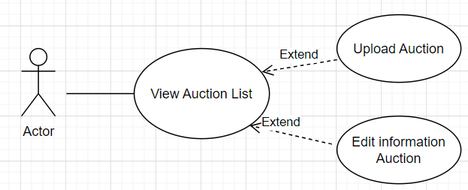

| USE CASE-07 SPECIFICATION | | | | |
| --- | --- | --- | --- | --- |
| **Use-case No.** | UC-07 | **Use-case Version** | | 1.0 |
| **Use-case Name** | Auction List | | | |
| **Author** | Le Huy Hoang - SE172418 | | | |
| **Date** |  | **Priority** | Medium | |
| **Actor:**   * Guest, Member, Staff, Admin   **Summary:**   * This feature allows members to view and participate in the auction.   **Goal:**   * Members can visit and bid on the auction.   **Triggers:**   * Members click on "Tham gia đấu giá" on the home page in the auction list section.   **Preconditions:**   * Users have an account in the system.   **Post Conditions:**   * Users can see the auction list at the home page and they can join the auction successfully.   **Main Success Scenario:**     | Step | Actor Action | System Response | | --- | --- | --- | | 1 | Members click on “Tham gia đấu giá” on the home page in the auction list section. | System displays a screen will notify “Bạn có muốn tham gia đấu giá” | | 2 | Members click “Đồng ý” | Members will have access to the auction page |   **Alternative Scenario:**  N/A  **Exceptions:**     | No | Cause | System Response | | --- | --- | --- | | 1 | The system is not available | The error page 500 display for user |   **Relationships:**   * N/A.   **Business Rules:**   * The email must be valid. | | | | |
|  | | | | |

#### 3.3.8 UC-08: Auction Details

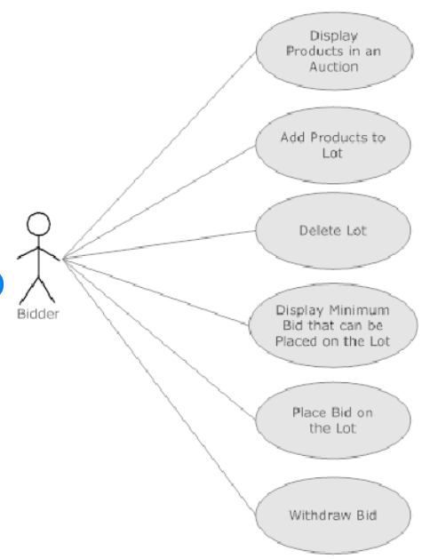

| USE CASE-08 SPECIFICATION | | | | |
| --- | --- | --- | --- | --- |
| **Use-case No.** | UC-08 | **Use-case Version** | | 1.0 |
| **Use-case Name** | Auction Details | | | |
| **Author** | Le Huy Hoang - SE172418 | | | |
| **Date** |  | **Priority** | Medium | |
| **Actor:**   * Member, Staff, Admin   **Summary:**   * This function allows members to view details and information of the auction such as title, time, location, images,...   **Goal:**   * Members can participate and view the details of the auction   **Triggers:**   * Members click on “Chi tiết buổi đấu giá” from the auction list.   **Preconditions:**   * Users have an account in the system.   **Post Conditions:**   * Users click on the view details button and see full information of the auction..   **Main Success Scenario:**     | Step | Actor Action | System Response | | --- | --- | --- | | 1 | Member click on “Chi tiết buổi đấu giá” in the auction list screen. | The system displays the details of the auction | | 2 | Members click “Mô tả”. | Members will see complete information such as:   * Area: Khu vực * Location: Tọa Lạc * Address: Địa chỉ * Price: Giá tiền |   **Alternative Scenario:**  N/A  **Exceptions:**     | No | Cause | System Response | | --- | --- | --- | | 1 | The system is not available | The error page 500 display for user |   **Relationships:**   * This use case extends from uc-07.   **Business Rules:**   * The email must be valid. | | | | |

#### 3.3.9 UC-09: Create Auction

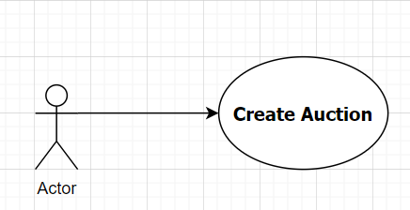

| USE CASE-09 SPECIFICATION | | | | |
| --- | --- | --- | --- | --- |
| **Use-case No.** | UC-09 | **Use-case Version** | | 1.0 |
| **Use-case Name** | Create Auction | | | |
| **Author** | Le Huy Hoang - SE172418 | | | |
| **Date** |  | **Priority** | Medium | |
| **Actor:**   * Member   **Summary:**   * This feature allows members to create auctions.   **Goal:**   * Members can create the auctions.   **Triggers:**   * Members click on “Quản lý đấu giá” from the home page view.   **Preconditions:**   * Users have an account in the system.   **Post Conditions:**   * Users can create the auctions successfully.   **Main Success Scenario:**     | Step | Actor Action | System Response | | --- | --- | --- | | 1 | Member click on “Quản lý đấu giá” in the home page screen. | System displays a screen for members to create the auctions. | | 2 | Members click “Tạo đấu giá”. | The system displays a screen allowing members to fill in auction information | | 3 | Members must fill in all of the details of the auction including image,address,amount,... | If the member skips this field, the error message "this field cannot be skipped" will appear. | | 4 | Users enter and confirm the auction. | System displays a screen for members if the auction was created successfully. |   **Alternative Scenario:**  N/A  **Exceptions:**     | No | Cause | System Response | | --- | --- | --- | | 1 | The system is not available | The error page 500 display for user |   **Relationships:**   * This use case extends from uc-01.   **Business Rules:**   * The email must be valid. | | | | |

#### 3.3.10 UC-10: Update Auction

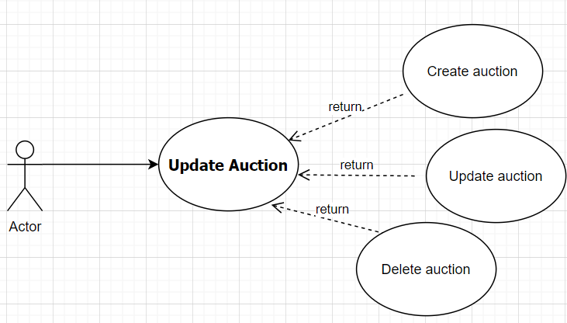

| USE CASE-10 SPECIFICATION | | | | |
| --- | --- | --- | --- | --- |
| **Use-case No.** | UC-010 | **Use-case Version** | | 1.0 |
| **Use-case Name** | Update Auction | | | |
| **Author** | Le Huy Hoang - SE172418 | | | |
| **Date** |  | **Priority** | Medium | |
| **Actor:**   * Member, Staff, Admin   **Summary:**   * This feature allows members to update auctions when they want to change details of auctions.   **Goal:**   * Members can change details of their auctions..   **Triggers:**   * Members click on “Cập nhật đấu giá” from the “Quản lý đấu giá” screen.   **Preconditions:**   * Users can update auctions in the system.   **Post Conditions:**   * Users update auctions successfully.   **Main Success Scenario:**     | Step | Actor Action | System Response | | --- | --- | --- | | 1 | Member click on “Cập nhật đấu giá” from the manage auction screen. | System displays a screen for members to update auction | | 2 | Members input new details and click “Cập nhật”. | System displays a screen to notify update auctions successfully   * Area (Diện tích) * Location (Vị trí) * Price (Giá) * Contact (Thông tin liên lạc) * Date time (Ngày giờ) |   **Alternative Scenario:**  N/A  **Exceptions:**     | No | Cause | System Response | | --- | --- | --- | | 1 | The system is not available | The error page 500 display for user |   **Relationships:**   * This use case extends from uc-09.   **Business Rules:**   * The email must be valid. | | | | |

#### 3.3.11 UC-11: Approve Auction

| USE CASE-11 SPECIFICATION | | | | |
| --- | --- | --- | --- | --- |
| **Use-case No.** | UC-011 | **Use-case Version** | | 1.0 |
| **Use-case Name** | Approve Auction | | | |
| **Author** | Le Huy Hoang - SE172418 | | | |
| **Date** |  | **Priority** | Medium | |
| **Actor:**   * Staff, Admin   **Summary:**   * This feature allows managers to approve member's auction post   **Goal:**   * Managers can approve member's auction post to displayed to everyone entering the auction   **Triggers:**   * Managers want to approve member's auction post   **Preconditions:**   * Managers have an account in the system.   **Post Conditions:**   * Manager successfully approve member's auction post   **Main Success Scenario:**     | Step | Actor Action | System Response | | --- | --- | --- | | 1 | Managers login into “Quản lý đấu giá” page | System displays a screen for managers to view many member's auction post | | 2 | Managers check and Click “Duyệt bài” | The system notifies that the user has successfully participated in the auction and has become one of the auction players |   **Alternative Scenario:**  N/A  **Exceptions:**     | No | Cause | System Response | | --- | --- | --- | | 1 | The system is not available | The error page 500 display for user |   **Relationships:**   * N/A   **Business Rules:**   * User must login with staff or admin account | | | | |

#### 3.3.12 UC-12: Join Auction

| USE CASE-12 SPECIFICATION | | | | |
| --- | --- | --- | --- | --- |
| **Use-case No.** | UC-11 | **Use-case Version** | | 1.0 |
| **Use-case Name** | Join Auction | | | |
| **Author** | Le Huy Hoang - SE172418 | | | |
| **Date** |  | **Priority** | Medium | |
| **Actor:**   * Member   **Summary:**   * This feature allows members to join auctions and play bids.   **Goal:**   * Members can join auctions and play bids.   **Triggers:**   * Members want to join auctions and play bids.   **Preconditions:**   * Users have an account in the system.   **Post Conditions:**   * Members successfully join into actions.   **Main Success Scenario:**     | Step | Actor Action | System Response | | --- | --- | --- | | 1 | Member click on “Chi tiết bài đấu giá” in one of the auctions post. | System displays a screen of auctions post include information, time, price | | 2 | Member click on “Tham gia đấu giá” | The system notifies that the user has successfully participated in the auction and has become one of the auction players |   **Alternative Scenario:**  N/A  **Exceptions:**     | No | Cause | System Response | | --- | --- | --- | | 1 | The system is not available | The error page 500 display for user | | 2 | Members don't have enough money to join auctions | Display error message “Tài khoản không đủ để tham gia đấu giá!” |   **Relationships:**   * N/A   **Business Rules:**   * Must have enough money to join auction | | | | |

#### 3.3.13 UC-13: Bidding

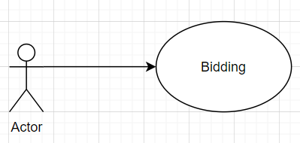

| USE CASE-13 SPECIFICATION | | | | |
| --- | --- | --- | --- | --- |
| **Use-case No.** | UC-13 | **Use-case Version** | | 1.0 |
| **Use-case Name** | Bidding | | | |
| **Author** | Tran Anh Kiet - SE171131 | | | |
| **Date** |  | **Priority** | Medium | |
| **Actor:**   * Member   **Summary:**   * This feature allows members choose the price you want to bid on   **Goal:**   * Members can choose the price you want to bid on   **Triggers:**   * Members want to choose the price you want to bid on   **Preconditions:**   * Users have an account in the system. * User have enough money to bid * User joined to the auction they want to bid   **Post Conditions:**   * Users successfully bid on.   **Main Success Scenario:**     | Step | Actor Action | System Response | | --- | --- | --- | | 1 | Member click on “Chi tiết bài đấu giá” in one of the auctions post. | System displays a screen of auctions post include information:   * Time:(Thời gian đấu giá) * Price:(Giá tiền) * UserName:(Tên người dùng) | | 2 | Member click on “Tham gia đấu giá” | The system notifies that the user has successfully participated in the auction and has become one of the auction players | | 3 | Member enter the price you want to bid on and click "Đấu giá" | The system displays the message “bạn đã đấu giá thành công” |   **Alternative Scenario:**   * AS-1: Members run out of money to bid  1. Display error message ”Tài khoản không đủ tiền để đấu”. 2. Back to Step 3 in **Main Success Scenario**.   **Exceptions:**     | No | Cause | System Response | | --- | --- | --- | | 1 | The system is not available | The error page 500 display for user | | 2 | Members run out of money to bid | Display error message ”Tài khoản không đủ tiền để đấu”. |   **Relationships:**  N/A  **Business Rules:**   * Members must have enough money to bid | | | | |

#### 3.3.14 UC-14: Send Ticket

| USE CASE-14 SPECIFICATION | | | | |
| --- | --- | --- | --- | --- |
| **Use-case No.** | UC-14 | **Use-case Version** | | 1.0 |
| **Use-case Name** | Send ticket | | | |
| **Author** | Tran Anh Kiet - SE171131 | | | |
| **Date** |  | **Priority** | Medium | |
| **Actor:**   * Member   **Summary:**   * This feature allows members to send ticket to managers   **Goal:**   * Members can send ticket to managers   **Triggers:**   * Members want to send ticket to managers   **Preconditions:**   * Members have an account in the system.   **Post Conditions:**   * Members successfully send ticket to managers   **Main Success Scenario:**     | Step | Actor Action | System Response | | --- | --- | --- | | 1 | In the “Quản lý yêu cầu hỗ trợ ” Screen, member click on “Tạo yêu cầu” | System displays a form for members to enter the information like:   * Title: Tiêu đề * Content: Chủ đề * Image: Hình ảnh (cần được yêu cầu) | | 2 | Members fill in the form and click on “Tạo” | System validate the ticket and send to managers |   **Alternative Scenario:**  N/A  **Exceptions:**     | No | Cause | System Response | | --- | --- | --- | | 1 | The system is not available | The error page 500 display for user |   **Relationships:**  N/A  **Business Rules:**  N/A | | | | |

#### 3.3.15 UC-15: Ticket History

| USE CASE-15 SPECIFICATION | | | | |
| --- | --- | --- | --- | --- |
| **Use-case No.** | UC-15 | **Use-case Version** | | 1.0 |
| **Use-case Name** | Ticket History | | | |
| **Author** | Tran Anh Kiet - SE171131 | | | |
| **Date** |  | **Priority** | Medium | |
| **Actors:**   * Member, Staff   **Summary:**   * This feature allows members to see the ticket which they sent .   **Goal:**   * Members can see the list ticket .   **Triggers:**   * Members click on “Quên mật khẩu” from the login screen.   **Preconditions:**   * Users have an account in the system.   **Post Conditions:**   * Users recreate passwords successfully.   **Main Success Scenario:**     | Step | Actor Action | System Response | | --- | --- | --- | | 1 | Member click on “Quên mật khẩu” in the pop-up login screen. | System displays a screen for members to enter the email of the member's account. | | 2 | Members input the email and click “Tiếp tục”. | System validate the email existing in the system or not | | 3 | Member enter OTP send to email and click “Xác nhận” | System validate the OTP sent to email and redirect to create a new password page. | | 4 | User enter new password and confirm password | System recreate new password with email account of member |   **Alternative Scenario:**   * AS-1: Email not exist in the system  1. Display error message ”Email không tồn tại”. 2. Back to Step 1 in **Main Success Scenario**.  * AS-2: Wrong OTP  1. Display error message ”Sai OTP!”. 2. Back to step 3 in **Main Success Scenario**.  * AS-3: Confirm password does not match with new password.  1. Display error message “Mật khẩu nhập lại không khớp!”. 2. Stay in Step 4 in the Main **Success Scenario**.   **Exceptions:**     | No | Cause | System Response | | --- | --- | --- | | 1 | The system is not available | The error page 500 display for user | | 2 | Confirm password does not match with new password | Display error message “Mật khẩu nhập lại không khớp!” |   **Relationships:**   * This use case extends from uc-01.   **Business Rules:**   * The email must be valid. | | | | |

#### 3.3.16 UC-16: List Ticket

| USE CASE-16 SPECIFICATION | | | | |
| --- | --- | --- | --- | --- |
| **Use-case No.** | UC-16 | **Use-case Version** | | 1.0 |
| **Use-case Name** | List Ticket | | | |
| **Author** | Tran Anh Kiet - SE171131 | | | |
| **Date** |  | **Priority** | Medium | |
| **Actor:**   * Member,Staff   **Summary:**   * This function allows members to submit support requests.   **Goal:**   * Members can create a support ticket and send it to staff.   **Triggers:**   * Members want to create a ticket.   **Preconditions:**   * Users have an account in the system.   **Post Conditions:**   * Users create support tickets successfully.   **Main Success Scenario:**     | Step | Actor Action | System Response | | --- | --- | --- | | 1 | Members click on “Tạo yêu cầu” in the managed support requests login screen. | System displays a screen for members to enter the title, content and image of the support ticket. | | 2 | Members input the title, content, image and click “Tạo”. | System validate the ticket existing in the system or not and send it to staff.. |   **Alternative Scenario:**   * N/A   **Exceptions:**     | No | Cause | System Response | | --- | --- | --- | | 1 | The system is not available | The error page 500 display for user |   **Relationships:**   * N/A   **Business Rules:**   * N/A | | | | |

#### 3.3.17 UC-17: Notification

| USE CASE-17 SPECIFICATION | | | | |
| --- | --- | --- | --- | --- |
| **Use-case No.** | UC-17 | **Use-case Version** | | 1.0 |
| **Use-case Name** | View Notification | | | |
| **Author** | Tran Anh Kiet - SE171131 | | | |
| **Date** |  | **Priority** | Medium | |
| **Actor:**   * Member,Staff   **Summary:**   * This feature helps members to receive the notification from the system.   **Goal:**   * Members can see the notifications.   **Triggers:**   * Members want to view the notifications.   **Preconditions:**   * Users have an account in the system.   **Post Conditions:**   * The system displays the notification for the user to see   **Main Success Scenario:**     | Step | Actor Action | System Response | | --- | --- | --- | | 1 | Members click on “Thông báo” in the pop-up homepage screen. | System displays a list of all the notifications. |   **Alternative Scenario:**  -N/A  **Exceptions:**     | No | Cause | System Response | | --- | --- | --- | | 1 | The system is not available | The error page 500 display for user |   **Relationships:**   * N/A   **Business Rules:**   * N/A | | | | |

#### 3.3.18 UC-18: List Payment

| USE CASE-18 SPECIFICATION | | | | |
| --- | --- | --- | --- | --- |
| **Use-case No.** | UC-18 | **Use-case Version** | | 1.0 |
| **Use-case Name** | View List Payment | | | |
| **Author** | Tran Anh Kiet - SE171131 | | | |
| **Date** |  | **Priority** | Medium | |
| **Actor:**   * Staff   **Summary:**   * This feature allows staff to view the user's payment, deposit, and withdrawal lists.   **Goal:**   * Staff can view the user's payment, deposit, and withdrawal lists.   **Triggers:**   * Staff want to view the user's payment, deposit, and withdrawal lists.   **Preconditions:**   * Staff has an account in the system.   **Post Conditions:**   * Staff accesses the payment management page successfully.   **Main Success Scenario:**     | Step | Actor Action | System Response | | --- | --- | --- | | 1 | Staffs click on “Phê duyệt thanh toán” on the screen. | System displays a list of the user's payment, deposit, and withdrawal |   **Alternative Scenario:**   * AS-1: Email not exist in the system  1. Display error message ”Email không tồn tại”. 2. Back to Step 1 in **Main Success Scenario**.  * AS-2: Wrong OTP  1. Display error message ”Sai OTP!”. 2. Back to step 3 in **Main Success Scenario**.  * AS-3: Confirm password does not match with new password.  1. Display error message “Mật khẩu nhập lại không khớp!”. 2. Stay in Step 4 in the Main **Success Scenario**.   **Exceptions:**     | No | Cause | System Response | | --- | --- | --- | | 1 | The system is not available | The error page 500 display for user | | 2 | Confirm password does not match with new password | Display error message “Mật khẩu nhập lại không khớp!” |   **Relationships:**   * This use case extends from uc-01.   **Business Rules:**   * The email must be valid. | | | | |

#### 3.3.19 UC-19: Payment Details

| USE CASE-19 SPECIFICATION | | | | |
| --- | --- | --- | --- | --- |
| **Use-case No.** | UC-19 | **Use-case Version** | | 1.0 |
| **Use-case Name** | View Payment Details | | | |
| **Author** | Truong Phuoc Sang-SE171049 | | | |
| **Date** |  | **Priority** | Medium | |
| **Actor:**   * Staffs, Members   **Summary:**   * This feature allows members and staff to view the details of the payment.   **Goal:**   * Members and staff can view the details of the payment.   **Triggers:**   * Members and staff want to view the details of the payment.   **Preconditions:**   * Users have an account in the system.   **Post Conditions:**   * Members and staff view the details of the payment successfully.   **Main Success Scenario:**     | Step | Actor Action | System Response | | --- | --- | --- | | 1 | Members and staff click on “Chi tiết” in the payment management page. | System displays a screen which is full of details of payment for members and staff:   * Tên khách hàng: * Nội dung: * Trạng thái: * Ngày giờ: * Số tiền: |   **Alternative Scenario:**  N/A  **Exceptions:**     | No | Cause | System Response | | --- | --- | --- | | 1 | The system is not available | The error page 500 display for user |   **Relationships:**   * N/A   **Business Rules:**   * N/A | | | | |

#### 3.3.20 UC-20: Update Payment

| USE CASE-20 SPECIFICATION | | | | |
| --- | --- | --- | --- | --- |
| **Use-case No.** | UC-20 | **Use-case Version** | | 1.0 |
| **Use-case Name** | Update Payment | | | |
| **Author** | Truong Phuoc Sang-SE171049 | | | |
| **Date** |  | **Priority** | Medium | |
| **Actor:**   * Member, Staff, Admin   **Summary:**   * This feature allows members to update the payment method or information.   **Goal:**   * Members can update the payment method or information.   **Triggers:**   * Members click on “Cập nhật” from the payment page.   **Preconditions:**   * Users have an account in the system.   **Post Conditions:**   * Users can update the payment successfully.   **Main Success Scenario:**     | Step | Actor Action | System Response | | --- | --- | --- | | 1 | Members click on “Cập nhật” in the payment page. | System displays a screen for members to update payment. | | 2 | Members input new details and click “Cập nhật”. | System displays a screen to notify update payment   * payment method (Phương thức thanh toán) * Address (Địa chỉ):no more than 500 words * Contact number (SDT liên hệ):accept number only | | 3 | Members click on “Xác nhận” in the update payment display screen. | System displays a screen to notify update payment successfully.:   * Cập nhật thành công | |   **Alternative Scenario:**   * N/A   **Exceptions:**     | No | Cause | System Response | | --- | --- | --- | | 1 | The system is not available | The error page 500 display for user | | 2 | Confirm password does not match with new password | Display error message “Mật khẩu nhập lại không khớp!” |   **Relationships:**   * This use case extends from uc-19.   **Business Rules:**   * Members can only transfer money through Vietnam bank. | | | | |

#### 3.3.21 UC-21: Recharge Money

| USE CASE-21 SPECIFICATION | | | | |
| --- | --- | --- | --- | --- |
| **Use-case No.** | UC-21 | **Use-case Version** | | 1.0 |
| **Use-case Name** | Recharge Money | | | |
| **Author** | Truong Phuoc Sang-SE171049 | | | |
| **Date** |  | **Priority** | Medium | |
| **Actor:**   * Member, Staff, Admin   **Summary:**   * This feature allows members to recharge money to account.   **Goal:**   * Members can recharege moeny to their account.   **Triggers:**   * Members click on “Nạp tiền” from the view profile screen.   **Preconditions:**   * Users have an account in the system.   **Post Conditions:**   * Users recharge money successfully.   **Main Success Scenario:**     | Step | Actor Action | System Response | | --- | --- | --- | | 1 | Members click on “Quản lý thanh toán” in the pop-up view profile screen. | System displays a screen for members to view the payment list:   * User name:Tên người dùng * Money added:Tiền cần nạp * Bank account:tài khoản ngân hàng | | 2 | Members click “Nạp tiền”. | System displays a screen for members to enter the amount of price to their wallet:   * PaymentID:Mã đơn hàng | | 3 | Members must fill in the information like price,account bank,money transfer content,... | System displays a screen to allow for members to fill all the information. | | 4 | Members click “Xác nhận” | System displays a screen for members to notify about the payment ticket that created success. |   **Alternative Scenario:**  N/A  **Exceptions:**     | No | Cause | System Response | | --- | --- | --- | | 1 | The system is not available | The error page 500 display for user | | 2 | Incorrectly entered the confirmation code during the deposit process | Display error message “Hãy điền thông tin xác định một cách chính xác.” |   **Relationships:**   * This use case extends from uc-20.   **Business Rules:** | | | | |

#### 3.3.22 UC-22: Withdraw Money

| USE CASE-03 SPECIFICATION | | | | |
| --- | --- | --- | --- | --- |
| **Use-case No.** | UC-22 | **Use-case Version** | | 1.0 |
| **Use-case Name** | Withdraw Money | | | |
| **Author** | Truong Phuoc Sang-SE171049 | | | |
| **Date** |  | **Priority** | Medium | |
| **Actor:**   * Member, Staff   **Summary:**   * This feature allows members to withdraw money from their wallet to their bank account.   **Goal:**   * Members can withdraw money from their wallet to their bank account.   **Triggers:**   * Members click on “Rút tiền” from the home page view screen.   **Preconditions:**   * Users have an account in the system.   **Post Conditions:**   * Users withdraw money successfully.   **Main Success Scenario:**     | Step | Actor Action | System Response | | --- | --- | --- | | 1 | Members click on “Rút tiền” in the pop-up home page view screen. | System displays a screen for members to notify them about withdrawing money tickets. | | 2 | Members must fill in the information like price,account bank,withdraw money content,... | System displays a screen to allow for members to fill all the information. | | 3 | Member enter OTP send to email and click “Xác nhận” | System validate the OTP sent to email and redirect to create a new password page. | | 4 | User enter new password and confirm password | System recreate new password with email account of member |   **Alternative Scenario:**   * AS-1: Email not exist in the system  1. Display error message ”Email không tồn tại”. 2. Back to Step 1 in **Main Success Scenario**.  * AS-2: Wrong OTP  1. Display error message ”Sai OTP!”. 2. Back to step 3 in **Main Success Scenario**.  * AS-3: Confirm password does not match with new password.  1. Display error message “Mật khẩu nhập lại không khớp!”. 2. Stay in Step 4 in the Main **Success Scenario**.   **Exceptions:**     | No | Cause | System Response | | --- | --- | --- | | 1 | The system is not available | The error page 500 display for user | | 2 | Confirm password does not match with new password | Display error message “Mật khẩu nhập lại không khớp!” |   **Relationships:**   * This use case extends from uc-01.   **Business Rules:**   * The email must be valid. | | | | |

#### 3.3.23 UC-23: Ticket Details

| USE CASE-03 SPECIFICATION | | | | |
| --- | --- | --- | --- | --- |
| **Use-case No.** | UC-23 | **Use-case Version** | | 1.0 |
| **Use-case Name** | Ticket Details | | | |
| **Author** | Truong Phuoc Sang-SE171049 | | | |
| **Date** |  | **Priority** | Medium | |
| **Actor:**   * Member, Staff   **Summary:**   * This feature allows members and staff to view details of the ticket.   **Goal:**   * Members and staff can view details of the ticket.   **Triggers:**   * Members want to view details of the ticket.   **Preconditions:**   * Users have an account in the system.   **Post Conditions:**   * Users view details of the ticket successfully.   **Main Success Scenario:**     | Step | Actor Action | System Response | | --- | --- | --- | | 1 | Members click on “Detail” on the ticket screen. | System displays a screen for members and staff to view all of the information on the ticket,include:   * Tiêu đề * Nội dung * Hình ảnh |   **Alternative Scenario:**  -N/A  **Exceptions:**     | No | Cause | System Response | | --- | --- | --- | | 1 | The system is not available | The error page 500 display for user |   **Relationships:**   * N/A   **Business Rules:**   * N/A | | | | |

| USE CASE-03 SPECIFICATION | | | | |
| --- | --- | --- | --- | --- |
| **Use-case No.** | UC-03 | **Use-case Version** | | 1.0 |
| **Use-case Name** | Reset Password | | | |
| **Author** | Truong Phuoc Sang-SE171049 | | | |
| **Date** |  | **Priority** | Medium | |
| **Actor:**   * Member, Staff, Admin   **Summary:**   * This feature allows members to reset passwords when they forget the old password.   **Goal:**   * Members can recreate the new password of an account registered before.   **Triggers:**   * Members click on “Quên mật khẩu” from the login screen.   **Preconditions:**   * Users have an account in the system.   **Post Conditions:**   * Users recreate passwords successfully.   **Main Success Scenario:**     | Step | Actor Action | System Response | | --- | --- | --- | | 1 | Member click on “Quên mật khẩu” in the pop-up login screen. | System displays a screen for members to enter the email of the member's account. | | 2 | Members input the email and click “Tiếp tục”. | System validate the email existing in the system or not | | 3 | Member enter OTP send to email and click “Xác nhận” | System validate the OTP sent to email and redirect to create a new password page. | | 4 | User enter new password and confirm password | System recreate new password with email account of member |   **Alternative Scenario:**   * AS-1: Email not exist in the system  1. Display error message ”Email không tồn tại”. 2. Back to Step 1 in **Main Success Scenario**.  * AS-2: Wrong OTP  1. Display error message ”Sai OTP!”. 2. Back to step 3 in **Main Success Scenario**.  * AS-3: Confirm password does not match with new password.  1. Display error message “Mật khẩu nhập lại không khớp!”. 2. Stay in Step 4 in the Main **Success Scenario**.   **Exceptions:**     | No | Cause | System Response | | --- | --- | --- | | 1 | The system is not available | The error page 500 display for user | | 2 | Confirm password does not match with new password | Display error message “Mật khẩu nhập lại không khớp!” |   **Relationships:**   * This use case extends from uc-01.   **Business Rules:**   * The email must be valid. | | | | |

#### 3.3.24 UC-24: Reply Ticket

| USE CASE-03 SPECIFICATION | | | | |
| --- | --- | --- | --- | --- |
| **Use-case No.** | UC-24 | **Use-case Version** | | 1.0 |
| **Use-case Name** | Reply Ticket | | | |
| **Author** | Truong Phuoc Sang-SE171049 | | | |
| **Date** |  | **Priority** | Medium | |
| **Actor:**   * Member, Staff   **Summary:**   * This feature allows members and staff to reply to a ticket.   **Goal:**   * Members can ask staff and staff can answer all questions.   **Triggers:**   * Members want answers when they have problems.   **Preconditions:**   * Users have an account in the system.   **Post Conditions:**   * Users reply successfully.   **Main Success Scenario:**     | Step | Actor Action | System Response | | --- | --- | --- | | 1 | Members and staff click on “Phản Hồi” on the ticket screen. | System displays a screen for members and staff to enter the contents and images to send to each other. | | 2 | Members and staff input the contents and click “Gửi”. | System displays a screen “Gửi Thành Công”. |   **Alternative Scenario:**  -N/A  **Exceptions:**     | No | Cause | System Response | | --- | --- | --- | | 1 | The system is not available | The error page 500 display for user |   **Relationships:**  -N/A  **Business Rules:**   * N/A | | | | |

#### 

#### 

#### 

#### 

#### 3.3.25 UC-25: Close Ticket

| USE CASE-03 SPECIFICATION | | | | |
| --- | --- | --- | --- | --- |
| **Use-case No.** | UC-25 | **Use-case Version** | | 1.0 |
| **Use-case Name** | Close Ticket | | | |
| **Author** |  | | | |
| **Date** |  | **Priority** | Medium | |
| **Actor:**   * Member, Staff   **Summary:**   * This feature allows members and staff to close the ticket.   **Goal:**   * Members and staff can close the ticket.   **Triggers:**   * Members and staff want to close the ticket..   **Preconditions:**   * Users have an account in the system.   **Post Conditions:**   * Users close the ticket successfully.   **Main Success Scenario:**     | Step | Actor Action | System Response | | --- | --- | --- | | 1 | Members click on “Đóng” on the ticket screen. | System displays a screen “Vé đã đóng”. |   **Alternative Scenario:**  -N/A  **Exceptions:**     | No | Cause | System Response | | --- | --- | --- | | 1 | The system is not available | The error page 500 display for user |   **Relationships:**  -N/A  **Business Rules:**   * N/A | | | | |

#### 3.3.26 UC-26: Dashboard

| USE CASE-03 SPECIFICATION | | | | |
| --- | --- | --- | --- | --- |
| **Use-case No.** | UC-26 | **Use-case Version** | | 1.0 |
| **Use-case Name** | Dashboard | | | |
| **Author** |  | | | |
| **Date** |  | **Priority** | Medium | |
| **Actor:**   * Staff,Admin   **Summary:**   * This feature allows staff and admin to view the user payment and user posts.   **Goal:**   * Admin,staff can view and manage user post and transaction statistics for the website.   **Triggers:**   * Actors click on “Xem thống kê” from the managed screen by staff and admin.   **Preconditions:**   * Actors have an account in the system.   **Post Conditions:**   * Actors can view the dashboard successfully.   **Main Success Scenario:**     | Step | Actor Action | System Response | | --- | --- | --- | | 1 | Staff and Admin click on “Xem thống kê” in the manage screen. | System displays a screen for staff, admin a statistical table includes details:   * Name user: Tên người dùng * Post: Bài đăng * Date time: ngày giờ * Total payment: Tổng doanh thu * Post ID: Mã bài đăng | | 2 | Actors click “Xuất hóa đơn” to print the revenue report table. | The screen will display a dialog box to print a copy of the document |   **Alternative Scenario:**  **Exceptions:**     | No | Cause | System Response | | --- | --- | --- | | 1 | The system is not available | The error page 500 display for user |   **Relationships:**   * N/A.   **Business Rules:**   * N/A. | | | | |
|  | | | | |

#### 3.3.27 UC-27: Manage User

| USE CASE-03 SPECIFICATION | | | | |
| --- | --- | --- | --- | --- |
| **Use-case No.** | UC-27 | **Use-case Version** | | 1.0 |
| **Use-case Name** | Manage User | | | |
| **Author** |  | | | |
| **Date** |  | **Priority** | Medium | |
| **Actor:**   * Staff,Admin   **Summary:**   * This feature allows staff and admin to manage all of the users.   **Goal:**   * Staff and admin can manage all of the users.   **Triggers:**   * Staff and admin want to manage all of the users.   **Preconditions:**   * The administrator has appropriate permissions to manage user accounts.   **Post Conditions:**   * Staff and admin manage all of the users successfully.   **Main Success Scenario:**     | Step | Actor Action | System Response | | --- | --- | --- | | 1 | Staff and admin click on “Quản lý người dùng” in the home page screen | System displays a screen for admin and staff to manage members information include:   * Danh sách người dùng * Tìm kiếm và lọc người dùng * Sửa đổi thông tin người dùng * Kích hoạt hoặc vô hiệu hóa người dùng | | 2 | Staff and admin click on “Tìm kiếm” | System displays the information:   * Name: Họ và tên * Dob: Ngày tháng năm sinh * Address: Địa chỉ * Phone Number:Số điện thoại * Sex: Giới tính | | 3 | Admin and staff click on “Xác nhận”. | System displays a user who is looking for it. |   **Alternative Scenario:**  -N/A  **Exceptions:**     | No | Cause | System Response | | --- | --- | --- | | 1 | The system is not available | The error page 500 display for user |   **Relationships:**   * N/A   **Business Rules:**   * N/A | | | | |

#### 3.3.28 UC-28: Manage Staff

| USE CASE-03 SPECIFICATION | | | | |
| --- | --- | --- | --- | --- |
| **Use-case No.** | UC-03 | **Use-case Version** | | 1.0 |
| **Use-case Name** | Manage Staff | | | |
| **Author** |  | | | |
| **Date** |  | **Priority** | Medium | |
| **Actor:**   * Admin   **Summary:**   * This feature allows admin to manage staff.   **Goal:**   * Admin can manage staff.   **Triggers:**   * Admin wants to manage staff.   **Preconditions:**   * Admin have an account in the system.   **Post Conditions:**   * Admin manages staff successfully.   **Main Success Scenario:**     | Step | Actor Action | System Response | | --- | --- | --- | | 1 | Admin click on “Quản lý nhân viên” in the home page screen. | System displays a screen for admin to manage staff information include:   * Create Staff: Tạo mới tài khoản nhân viên * Delete Staff: Xóa tài khoản nhân viên * Edit profile: Chỉnh sửa thông tin | | 2 | Admin click “Sửa thông tin”. | The screen will display the information that needs to be edited:   * Name: Họ và tên * Dob: Ngày tháng năm sinh * Address: Địa chỉ * Phone Number:Số điện thoại * Sex: Giới tính | | 3 | Admin click on “Xác nhận”. | The screen will notify "Bạn có muốn thay đổi không?" | | 4 | Admin click on “Đồng ý” | The screen will display the changed information |   **Alternative Scenario:**   * N/A   **Exceptions:**     | No | Cause | System Response | | --- | --- | --- | | 1 | The system is not available | The error page 500 display for user |   **Relationships:**   * N/A   **Business Rules:**   * N/A | | | | |

#### 3.3.29 UC-29: Create Staff

| USE CASE-03 SPECIFICATION | | | | |
| --- | --- | --- | --- | --- |
| **Use-case No.** | UC-29 | **Use-case Version** | | 1.0 |
| **Use-case Name** | Create Staff | | | |
| **Author** |  | | | |
| **Date** |  | **Priority** | Medium | |
| **Actor:**   * Admin   **Summary:**   * This feature allows the admin to create an account for staff.   **Goal:**   * Admin can create an account for staff   **Triggers:**   * Admin click on “Tạo tài khoản nhân viên” from the login screen.   **Preconditions:**   * Admin have an account in the system.   **Post Conditions:**   * Admin created account staff successfully.   **Main Success Scenario:**     | Step | Actor Action | System Response | | --- | --- | --- | | 1 | Admin click on “Tạo tài khoản nhân viên” . | System displays a screen for admin create staff form:   * Name: Họ và tên * Dob: Ngày tháng năm sinh * Address: Địa chỉ * Phone number: Số điện thoại * Email: | | 2 | Admin click on “Xác nhận” | The screen will notify "Bạn có muốn thêm tài khoản không?" | | 3 | Admin click on “Đồng ý” | The screen will return to the home page |   **Alternative Scenario:**  -N/A  **Exceptions:**     | No | Cause | System Response | | --- | --- | --- | | 1 | The system is not available | The error page 500 display for user |   **Relationships:**   * N/a   **Business Rules:**   * N/A | | | | |

#### 3.3.30 UC-30: Setting Auction

| USE CASE-03 SPECIFICATION | | | | |
| --- | --- | --- | --- | --- |
| **Use-case No.** | UC-30 | **Use-case Version** | | 1.0 |
| **Use-case Name** | Setting Auction | | | |
| **Author** |  | | | |
| **Date** |  | **Priority** | Medium | |
| **Actor:**   * Member, Staff, Admin   **Summary:**   * This feature allows members, staff, admin to set the auction.   **Goal:**   * Members, staff, admin can set the auction.   **Triggers:**   * Members, staff, admin want to set the auction.   **Preconditions:**   * Users have an account in the system.   **Post Conditions:**   * Members, staff, admin set the auction successfully.   **Main Success Scenario:**     | Step | Actor Action | System Response | | --- | --- | --- | | 1 | Members, staff, admin click on “Cài Đặt” on the manage auction. | System displays a screen having information need to edit:   * Started Date/Time :ngày và giờ bắt đầu. * Ended Date/Time: ngày và giờ kết thúc. * Starting price: giá khởi điểm. * Final price: giá chót. * Area: Khu vực * Location: Tọa Lạc * Address: Địa chỉ | | 2 | Members, staff, admin input all of the information and click “Xác nhận”. | System displays “Sửa đổi hoàn tất”. |   **Alternative Scenario:**  -N/A  **Exceptions:**     | No | Cause | System Response | | --- | --- | --- | | 1 | The system is not available | The error page 500 display for user |   **Relationships:**   * N/A   **Business Rules:**   * N/A | | | | |

# NON-FUNCTIONAL REQUIREMENT

## Usability

- The user doesn’t need specialized skills to use the app.

- The user can understand all the functions within 1 hour of self-experiencing.

- All texts and messages should be written in Vietnamese to be suitable for most Vietnamese people.

- The interface of the web should follow the Figma prototypes’ design.

## Reliability

- The availability of the system is over 88%.

- Mean Time Between Failures (MTBF) should be more than 110 hours.

- Mean Time To Repair (MTTR) should be less than 18 hours .

- Precision in the system’s output must be 98%.

- Maximum Bugs must be less than 5

## Performance

- Response time for a transaction must be less than 7 seconds.

- Processing time is from 0.5 to 0.7 seconds for each frame

- Capacity for the number of users the system can accommodate is at

at least 400 users.

- Resource utilization, such as memory, disk, communications, and so

forth must be smoothie and with minimal error.