



**Table of Contents**

1. Introduction
2. Functional requirements
3. Overall Description
4. Public Feature
5. Common Feature
6. Customer Feature
7. Staff Feature
8. Admin Feature
9. Other requirements
10. Configuring information
11. User Input data formats
12. **Introduction**

Real estate auctions have emerged as a preferred method for buying and selling properties, offering efficiency and transparency to both buyers and sellers. A Real Estate Auction System serves as a centralized platform, streaming the entire auction process from listing to closing. With features like property marketing, bidding management, transaction facilitation, and analytics, these systems enhance the auction experience and adapt to emerging trends such as block chain and virtual reality. In essence, they represent a vital tool in the modern real estate industry, driving innovation and efficiency in property transactions.

1. **Functional requirements**
2. Overall Description

The Real Estate Auction System is a comprehensive platform designed to facilitate the buying and selling of properties through auctions. It streamlines the entire auction process, from property listing and marketing to bidding, transaction management, and closing. With features such as centralized property databases, real-time bidding, secure transaction management, and robust analytics, the system enhances transparency, efficiency, and convenience for buyers, sellers, and auctioneers alike. It adapts to emerging technologies and market trends, ensuring a seamless and competitive auction experience in the dynamic real estate industry.

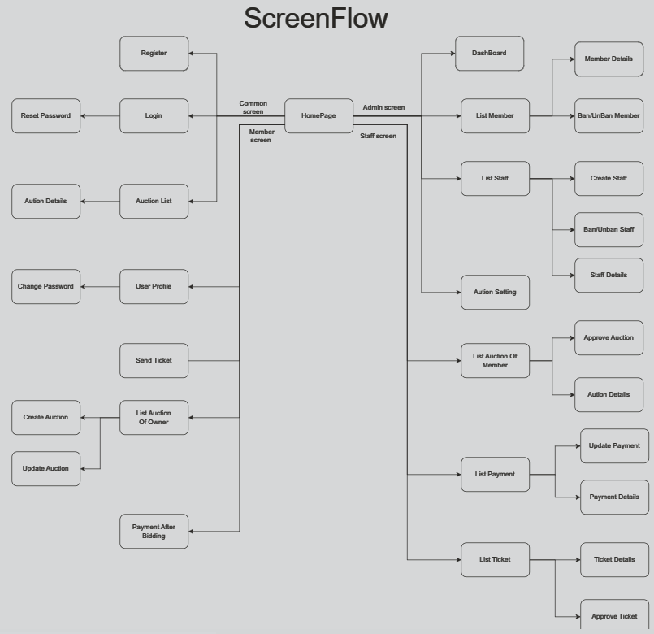

1. Public Feature

This feature includes the screens used for the Guest, as listed below

- Home Page: the starting page of the system

- Auction List: list of the auction post is approved for members to participate

- Auction Details: the page of auction for member

1. Common Feature

The common functions/screens used for all types of users, as listed below

* User Login: authenticate the user to give him/her to access authorized features later on
* User Register: register new user into the system, verified by the registered email
* Reset Password: use in case the user forgot his/her password
* Change Password: change user’s login password
* User Profile: view & edit/update user profile
* User Authorization: authorize user into the system functions based on his/her role

1. Member Feature

This includes the screens used for system customers, as listed below:

- Home Page: the starting page of the system

- Auction List: list of the auction post is approved for members to participate

- Auction Details: the page of auction for member

- My Auction List: list of member bidding auction

- Payment list: list of deposit and withdraw, refund money of member

- Ticket list: List of member support tickets sent to system management

- User Profile: view & edit/update user profile

1. Staff Feature

This includes the screens used for Staff, as listed below

- Home Page: the starting page of the system

- Manage payment: the page for manage list of deposit and withdraw, refund money of member

- Manage ticket: the page for manage list ticket of member

- User Profile: view & edit/update user profile

1. Admin Feature

This includes the screens used for Admin, as listed below

- Home Page: the starting page of the system

- Manage payment: the page for manage list of deposit and withdraw, refund money of member

- Manage ticket: the page for manage list ticket of member

- User Profile: view & edit/update user profile

-Manage staff: the page for admin to manage staff

1. **Other requirements**
2. Configuring information

-In the Real Estate Auction System, configuration plays a crucial role in tailoring the platform to meet specific needs and preferences. Here's a comprehensive guide on configuring various aspects of the system:

+User-Configured Data Management(Post Categories,Product Categories,User Roles,Admin Menu,Other Settings)

+Once-Configured Data Management(System Configuration Files)

1. User Input data formats   
   -Ensure all data inputs adhere to agreed formats, lengths, and validation rules as approved by the supervisor before implementation. Data validation should be implemented at both frontend and backend to maintain consistency and security.