Black: ZHANG Hai Tao  (China), 4 Dan | White: BACIU Radu  (Bucureşti), 4 Dan | Komi: 5,5 points  Time Limit: 1.5 hours  Cluj-Napoca Tournament, (May 1987).
Moves 1 – 16  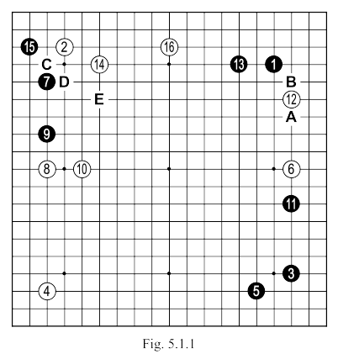 | White 8: A very wide pincer, a little uncommon, but it seemed to be effective in this case: because black will not attack in the left corner, with HOSHI (see Fig. 5.1.2).  White 12: Playing at "A", we should expect "B" and then ... (see Fig. 5.1.4).  White 14: I could have played at 1 in Fig. 5.1.5 (with the sequence that follows), but I would face the possibility that, later, the marked stone could be attacked, my intention was to keep black 7 and 9 as two weak stones on the left side, so as to protect my MOYO on the bottom side.  If 14 was played at "C", there would follow black "D", white "14", black "E", giving a stable position to my opponent, at a moment when it was not clear what action to take in this area.
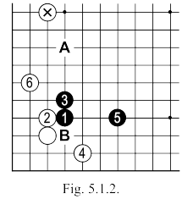 | Fig. 5.1.2. The sequence up to 6 here is JOSEKI and it should be followed by black "A".  Such a move would be unthinkable given the presence of the marked stone, and so black will be forced to find another attack on SAN-SAN.  But be careful: white 2 should not be played at "b", because it would allow black to chose the variation in Fig. 5.1.3.  Fig. 5.1.3. After white 4 here, black will ignore "A" in favour of OSAE at 5.  Compare the two versions and you will easily realize that the position of black in the second is much better than the first, because, of course, his SHIMARI in the right corner.
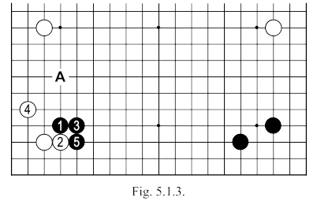
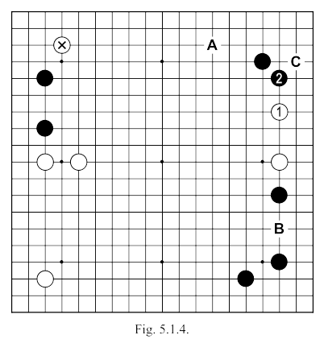 | FIG. 5.1.4. White 1 here is a possible variation, which black could chose to answer at 2. In this case, White can create a magnificent point of attack with "A" (it is in a good relationship with the marked stones on the left). If black does not want to give this move to white, then he will himself play at "A" after 1 - but in this case white, with the extension of "C" will get a good shape, and black will be left with a quite bothersome AJI at "B". This AJI is present in the first variation, but it was not strong enough because of the scattered position of the two white stones on the right side.
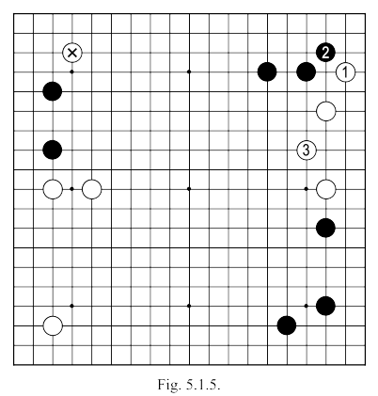 | ( White 14: I could have played at 1 in Fig. 5.1.5 (with the sequence that follows), but I would face the possibility that, later, the marked stone could be attacked, my intention was to keep the two black stones on the left side weak, so as to protect my MOYO on the bottom side. )
.

Moves 17 – 34  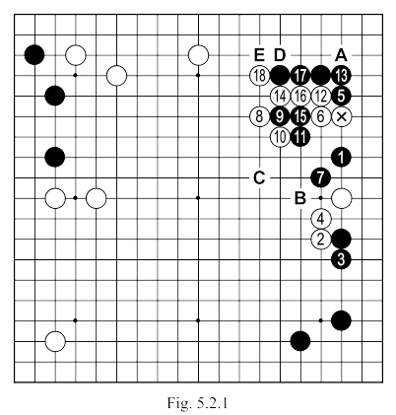 |  | White 2: After the attack of Black 1, the position is very delicate, and white must be careful (see Fig. 5.2.2)  White 8: In such a situation, a simple IKKEN at 9 is too close.  Black 9: A premature attempt to cut; better was "C" (or something similar).  Black 11: Doesn’t solve anything, even if it was played at 15 (see Fig. 5.2.6).  Black 17: Better at "D" or "E".
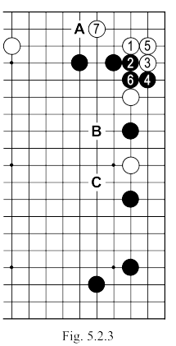 | 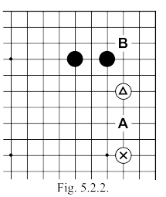 | Fig. 5.2.2. In a normal situation, a distance of three spaces between the two white stones allows black an UCHIKOMI at “A”. In this case, the marked stone can be used to invade at “B” (making an exchange), leaving the triangled stone to fend for itself. If I had played I would probably have chosen the sequence shown in Fig. 5.2.3...
 | Fig. 5.2.3. After white 7 here, black holds in reserve a move at “A”, he can begin with “B” or “C” with the aim of taking profit on the side.  Fig. 5.2.4. White 1 here (in the sequence that follows black 8 can also be played at “A”) is a usually playable approach, but it would strengthen black too much on top. In addition, it was very hard to see how I could use further the groups in an area well controlled by my opponent. |  | 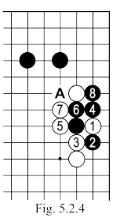
.

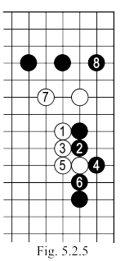 | 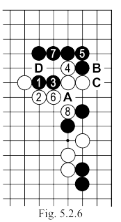 | Fig. 5.2.5. White 1 here is another possible move, but after the sequence to 8, which would have followed, I was left feeling that it was too easily giving a large enough profit.  Returning, to Fig. 5.2.1 I decided to strengthen my lower of the two stones with the moves 2 and 4, waiting to see how he will attack my marked stone (which anyway left an AJI at "A", for the exchange). White 4 can be played at "B".  Fig. 5.2.6. Moves 1 and 3 here do not separate the white stones, as seen in this sequence to 8.  If black 5 is played at 6, white 5 would immediately solve things. If black 5 is played at "A", then white 5, black "B", white "C" and will make life or connection and ATE at 7, followed by “D”.
Moves 35 – 54  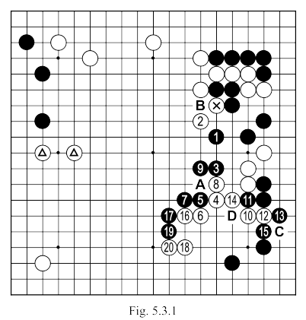 |  | White 2: It was better if I went to the center (possibly with "A"). Simply capturing the marked stone with "B" gains little for black. It is true that in this way his group will "settled" for the moment, but that will not mean that it becomes a strong group. White "A" would fix, in addition, the state of his stones on the right side, and create an interesting position with the marked stones on the left side - a basis for an immense MOYO.  Black 5: Trying to cut the connection with the white stones at 14 is not a feasible plan (see Fig. 5.3.2).  Black 13: Had it been played at 14, we would follow the sequence in Fig. 5.3.4.
.

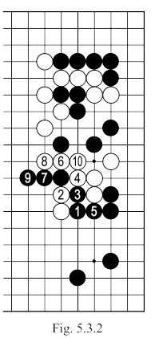 | 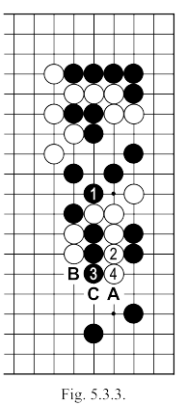 | Fig. 5.3.2. After black 1 here, played with the idea of stopping white advancing into the center, the sequence to 10 is strong. If black 5 is played at 10, white will continue with the variation in Fig. 5.3.3.  Fig. 5.3.3. After 4 here white, black should play "A" or "B", or white "C" will rescue the group.
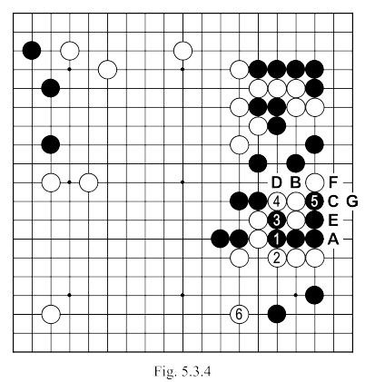 |  | Fig. 5.3.4. After black 1 here, white forces the sequence to 5, so as to play (possibly) at 6. The white group is "settled", and isolating black's SHIMARI in the bottom corner may even seem quite spectacular. Later, white can always, play the sequence white "A", black "B", white "C", black "D", white "E" to reduce severely black's profit on the side. If after white "A" black answers "C", there follows white "F", black "B", white "G", black "D", white "E". This would be, then, the result of a direct action (brutal), but probably we can get even bigger profit from combining the AJI sites with an attack on black's SHIMARI at the bottom.  White 16: Could be played at “C”, followed by black “D”. White would have lived on the edge, but on the bottom of the situation would become quite confusing (which I didn’t want, given the proximity of my MOYO on the left side). Additionally, perhaps more importantly, the black group in the center cannot be captured, probably, these few stones can become very powerful, something I absolutely didn’t want.
.

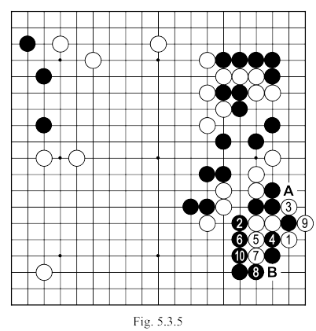 | There is no contradiction between these: in Fig. 5.3.4 I gave black a few stones in the center - strengthening him, there - but the corner remains weak, while in the latter variant black has strong positions both in the center and in the corner, which is not the same thing. In the first version, because of the weakness of his group in the corner, I could decide myself how to expand on the bottom to augment the MOYO on the left, while in the latter, black has only strong groups, and it is easy for him to take the initiative. Compare with Fig. 5.3.5, which shows the likely outcome if white 14 in the game (Fig. 5.3.1) had been played at "C".  Fig. 5.3.5. Following the sequence to 12 here, it's possible to live with "A" or "B", but the wall black obtains plus the fact that the white stones in the middle are hopelessly alone will have a strong influence on the entire area of the bottom of the board including on white's MOYO on the left.
Moves 55 – 76  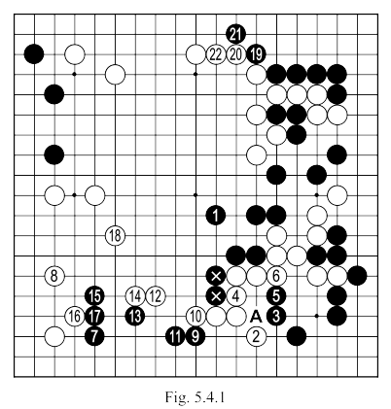 | Black 1: If this move was played at 4 ... (see Fig. 5.4.2).  White 4: Played so and not at "A" since it is important to take liberties from the two marked black stones.  White 12: The outcome of this sequence is that the escape of the white group. Due to move 4, the last stone is connected with the rest of the group (see Fig. 5.4.5).

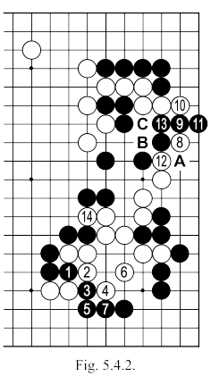 | Fig. 5.4.2. After black 1 here, white will continue in the sequence up to 7, after which he'll play 8. If black attempted to still keep him separated by 9, 11 and 13 (if 13 is played at "A", white "B") white will cut at 14 and trigger the further sequence of Fig. 5.4.3. After white 16 of the latter figure, black can not be under any illusion about winning the SEMEAI.  If black 11 of Fig. 5.4.2 would be played at 12 (or "A"), black 16 of Fig. 5.3.3 will be played directly at "C".  If black 9 of Fig. 5.4.2 would be played at "A", the sequence of Fig. 5.4.4 may still be possible. |  | 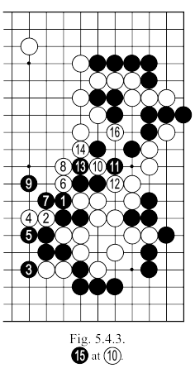
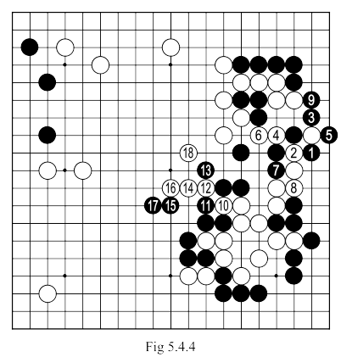 |  | Fig. 5.4.4. After black 1 and white 2 here, the continuation is obligatory for black, it ends with white 18 which separates (and later captures) six black stones.  We must notice especially this last option: the position taken by white in the middle (closing well one side of this territory above) is better than that obtained in Fig. 5.4.3. At the same time, black gets much stronger on the bottom, in Fig. 5.4.3, than in Fig. 5.4.4. We can draw from this the conclusion that the correct attitude is for white to cut at 12 in Fig. 5.4.4 (direct) and not to play first 2 and 4 in Fig. 5.4.3.

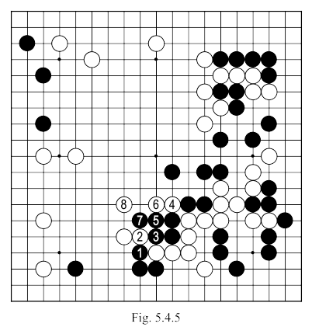 | Fig. 5.4.5. Black can not cut with 1 and 3 here because after the sequence to 7, white 8 captures with GETA the cutting stones.  After the move 22 in Fig. 5.4.1 (move 74 in the game), we can make a first count of territories. Black has about 6-8 points in the upper left corner, about 10 points on the bottom, about 15 in the lower right corner and another 15-20 in the top right; so all in all about 50 points. White has about 20 points on the left side, for another 20 on the side and can count on about 10-20 points in the center. If we add 5.5 points for KOMI, we reach around 60 points for white, which gives them a minimum of 10 points advantage over black.
Moves 77 – 99  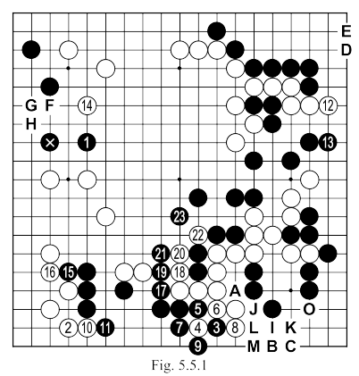 | White 2: Knowing Haitao played YOSE better than me, I tried to solidify the advantage that I had so far.  White 4: A sacrifice that allows move 8 and is not even made in GOTE (if it was played directly at 8, there would follow black 6, white, "A"). The descent of 8 is very important as it will allow later white "B" or "C" and, thus, a reduction of 15 points for Black here.  Black 13: An absolutely unnecessary move (white 12 threatens to reduce the upper-right territory with "D" or "E"), allowing white to keep SENTE at an absolutely critical time for black. After the match, Haitao explained that he simply had not seen the sequence of Fig. 5.4.5, and, therefore, considering my group still under attack, ruled out a contact move such as white 13.  White 14: After this move, the advantage of white is significantly increased on the board. After moves 8 and 12 (with their possible YOSE) reduce respectively the black territory by 10 and 22 points each, white 14 largely focused on my prospective territory

on the top (and center). In addition, this move was made in SENTE (if black does not respond, white "F" black "G" white "H") and, therefore, taking further initiative. With an advantage - now - of about 25 points, I began to expecting possible resignation from my opponent.

Black 17: A futile attempt, yet…

White 18: Of course I should have played 19, but I was so sure of my victory and my opponent felt in such disarray that I thought I could afford a fantasy: the idea was that all chasing me on the right side , he had left a rather weak group in the center, and now he himself pushed me over this group …

White 22: The fatal mistake. It had to be played at 23. It was my turn this time to not see a move as simple as black 23 which locks me in perfectly. With no chance to make a second eye. An elementary mistake of course, but the scent of victory, and this feeling that you are invulnerable, also leaves room for mistakes. After black 23 (move 97 of the game) I had only 15 minutes remaining of my initial thinking time and I spent it thinking about the enormity of my mistake (which really started with move 20) and trying to see if I can save the group (in the bottom corner are some AJI points, but they're insufficient to give an eye - if white "I", black plays "J" and if white tries "K" black "1", white "M", black "N").
The game continued (but 120-140 moves were not recorded because Haitao entered BYO-YOMI), I managed to achieve a huge territory covering center, top and left side of the board (isolating the marked stone and 1), and he took only 4-5 points in the corner. The huge loss incurred in the right corner exacted its price at the end when I realized that I was over 10 points behind, and it could not be recovered.

