Black: BACIU Radu  (Bucharest), 4 DAN | White: SUMIYA Haruia  (Japan), 4 DAN | Komi 5.5 points  Time Limits: 1.5 hours  Cluj-Napoca Tournament, May 1987
Moves 1 – 15  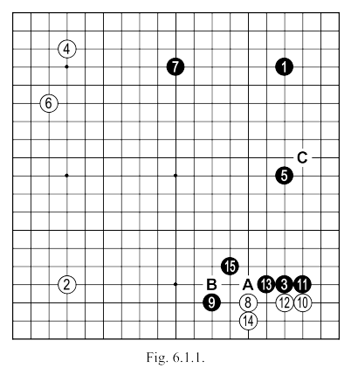 |  | Black 9: After the white KAKARI of 8, in the presence of black stone at 5, this HASAMI is the most efficient response. The following sequence up to black 15 is JOSEKI.  Black 11: Should be played here and not at 12. After invasion at SAN-SAN, you should always block on the side with the largest extension (if it exists, of course). If HOSHI has two equidistant extensions, block on the side of the higher one. This is the correct way to use a wall in a JOSEKI sequence, i.e. to orientate it so as to maximise your influence. If the stone at 5 hadn't existed, the problem is different: in that case if we still play the same sequence in the lower right corner, after black 15, white "C" would be greatly reduce the efficiency of the black wall.
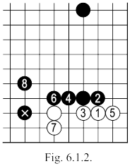 | 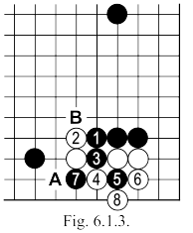 | Fig. 6.1.2. An alternative idea. The sequence up to 8 here is all JOSEKI, white keeps an entry point to the side territory while black strengthens his position in the center ( the relationship between 8 and the marked stone). In the game's line, the black shape has some sensitive points "A" and "B".  White 14: This is the correct JOSEKI move. If instead we play "A"... (see Fig. 6.1.3)  Fig. 6.1.3. If after black 1 here white continues with 2, the sequence continues up to 8, after which Black can play "A" or "B". Black "A" is possible if he has some strong positions nearby, when the two white stones have poor prospects. Black 'B' leads to Fig. 6.1.4 whose final result is clearly better for black than the variation played in Fig. 6.1.1.
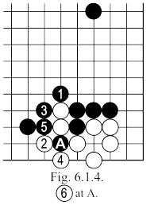

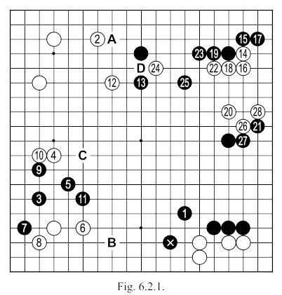  Moves 15 - 42 | White 2: Should have been "A" which is a more efficient point for white later in the game on the top side.  Black 5: Normally, we play the variation in Fig. 6.2.2. In the game I played thus, continuing with the exchange of moves 9 and 10 (a poor exchange as it strengthens White) in order to make move 11. I really liked this move and the almost symmetrical shape it made with the HOSHI points. In addition, the group which I obtained in this way was very safe (and I needed just such a group here, in order to play the upcoming complications, because the MOYO was too big). Playing move 11 I thought about my marked stone, which if cut, could need help and I thought about an attack at "B" to strengthen the central influence that I already had. Another reason I played so, was that the position of stones 5 and 11 allowed me a beautiful extension to "C" or an invasion.
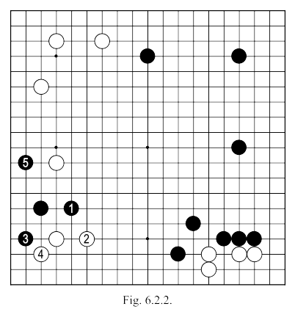 | Another reason I played so, was that the position of stones 5 and 11 allowed me a beautiful extension to "C" or an invasion of white's MOYO on the top side - so, the exchange of black 9 with white 10 wasn't so important. Lastly, I managed to slightly increase the pressure against the 3 white stones in the bottom corner as seen by comparison with Fig. 6.2.2.  Black 15: Could be played at 16 (see Fig. 6.2.3).  Black 25: If I simply connected at "D", white's group on the right side would have escaped any danger, while on the top side would be created new and unpleasant problems.

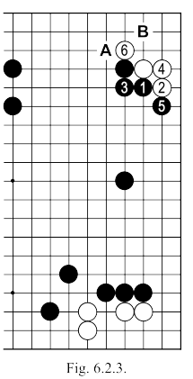 | 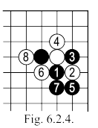 | Fig. 6.2.3: After black 1 here, the sequence up to 6 is possible (if black continues with "A", white "B"). The situation on the whole board, then , means that to play this way is to bet everything on a single, giant MOYO. If black 3 of this sequence would be played at 4 (see Fig. 6.2.4.) the sequence up to 8 there is far too easy on white.  In general, for the NOBI of white 4 it is possible to play "A". After black 1, white can play directly at 4, envisaging the sequence in Fig. 6.2.6 (such an approach may be adopted where white doesn’t care too much about the right side).  In the game, then, I preferred to play 15, 17 and 19, taking profit on the side and pushing my opponent into an area I controlled, and 21, to gain profit on the right side (all these moves were made in SENTE).
 | 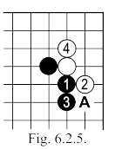
 | 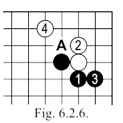
Moves 43 – 54  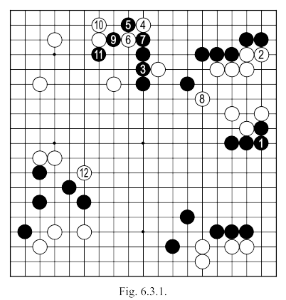 |  | White 2: A hard move to take because white wants to play 3 but ... (see Fig. 6.3.2).  White 8: A necessary move, but it allows black to play moves 9 and 11. After the latter move, black gets a better position on the board. White was afraid of the attack shown in Fig. 6.3.6.  Black 11: Allows white 4 and 10 to link, but this is a minor point compared to the AJI created in white's MOYO in the left.

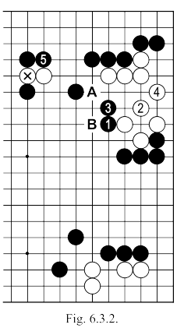 | Fig. 6.3.2: Once white has cut the marked stone, black could have continued with 1, then the white group has to make life with the sequence up to 4 (if white 2 is played at 3, black can break the white shape with 2 and "A" or simply play "B": white doesn't have a move to make life) After white 4, black 5 keeps enough points on the top side, and can imagine that in the centre of the board plus the right side he will have a considerable territory. But this would be the least of white's problems. More dangerous is the attack for black in Fig. 6.3.3.
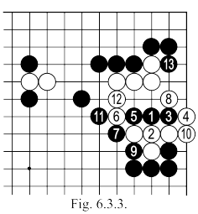 | Fig. 6.3.3: After 1 here, white can not simply connect at 2, this only creates trouble, leading to the capture of the entire group as the sequence shows. So after the attack of 1, white will have to adopt one of the variations in Fig. 6.3.4 or Fig. 6.3.5, then run out to the center. In the center, however, black is already powerful, and even if white would manage to escape (which in itself is quite difficult), it can not be done without endangering his own MOYO on the left, while black will get a big profit and possibly eventually secure the center and the right side.  A defensive move is therefore necessary, but white 2 of Fig. 6.3.1 leaves black a possible attack. Do you see it?
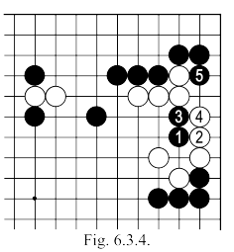

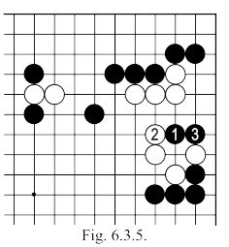 | Fig. 6.3.6: Black HASAMI-TSUKE (move 1 here) could have very unpleasant consequences. If white answers with 2 and 4, black 5 opens a very serious KO for white, without any risk to black (if then white "A", black "B").
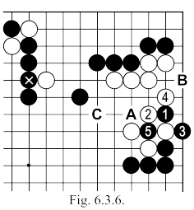
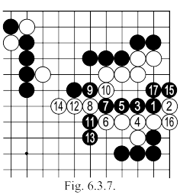 | Fig. 6.3.7: White 2 here, and the continuation shown, turns out to not be a solution because after black 17, the latter will win the SEMEAI.  Fig. 6.3.8: Nor does resisting with 2 and 4, as here, lead to something better for White, as shown in the sequence, black 13 will capture with SHICHO. If white tries 8 at 12, black will answer with "A".  Returning, then, to Fig. 6.3.6, after the exchange of black 1, white 2, black 3, white will be forced to run out to the center (possibly "C"), but now the task is even more difficult as black has a chance to strengthen the top side, by connecting with the marked stone.
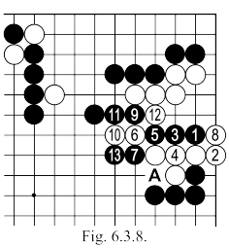

Moves 55 – 88  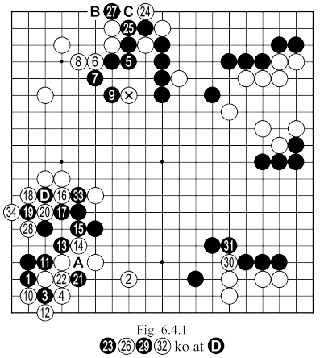 | Black 5, 7 and 9: Reduce white's corner territory, and at the same time threatening (with the attack on the marked stone) greater control of the center. In addition, these moves create the possibility, later, to be able to make a severe reduction of white's territory on the left side. This tactic is enough for black to win the match: he has at least 60 points in hand on the board, so, approximately 10 points more than could be made, in the best case, by his opponent.  White 16, 18 and 20: Starting a KO in which white has not much to win. If after this fight black's position would be more or less threatened, white would create many AJI points in the center of the board, but here the black group is very safe.  White 22: Better at "A".  Black 27: Not a big enough KODATE ... Remember though that the KO fight taking place is not very important for black, so, basically he can welcome any points gain. Secondly, "B" would be the next KODATE of white (threatening "C"), which would have meant that white would connect these stones in SENTE. Thirdly, if we calculate exactly what black 27 makes ... (see Fig. 6.4.2)  Fig. 6.4.2: The sequence here would be the natural continuation if white does not answer black's marked move (of course it will not happen immediately, but later, in YOSE)  Comparing this result with that of Fig. 6.4.3, white gets to make connect with 1, 3 and 5, we will reach a perhaps unexpected conclusion: black's marked move is worth no more and no less than 19 points (the sum of the triangled points in both variations plus two white prisoners).
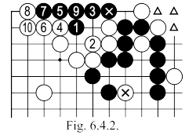
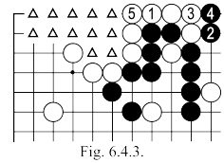

Moves 89 – 111  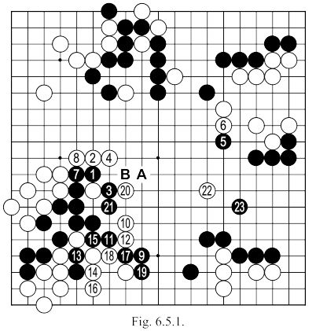 | White 6: Useless: white's side group is not in danger.  White 20: Ineffective because the sequence up to 17 will separate the two white stones (meanwhile the black group on the left will make life).  Black's last move in this figure may seem a bit passive, but my reasoning was: I have 40 points on the top side, more than 20 on the right side and on the bottom (with the group on the left) I will get about 10 points, for a total of 70 points. White can not make more than 30 points on the left side, plus about 6 on left lower side, and about 8 more in the upper right; if you add 10 points on the right side and KOMI, we have a total of 60 points. Black, therefore, has an advantage of about 10 points, which I was determined to keep.
Moves 111 – 142  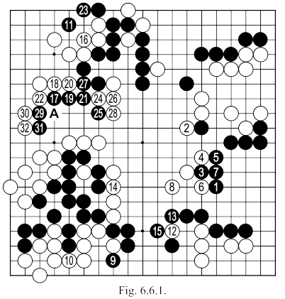 | White 8: Trying to catch up by making points in the centre.  White 10: Absolutely necessary because of the attack in Fig. 6.6.2.  White 12: Trying to separate the black stones on the bottom, but ...  Black 13: After this TESUJI white's plan fails (see Fig. 6.6.3).  White 16: Too small. Much bigger was 19 or 30.  Black 25: Must be played now and not later, when white could ignore it, so as to take in SENTE 29 and 31, whilst protecting the cut at “A”.

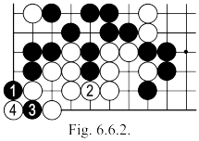 | Fig. 6.6.2: If white does not defend here, black 1 and 3 mean that the group's survival depends on winning a KO. If white 2 is played at 3, black 2 kills unconditionally.  Fig. 6.6.3: If white continues with 1, as shown here, the sequence up to 10 captures four stones.
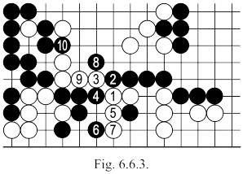
Moves 143 – 180  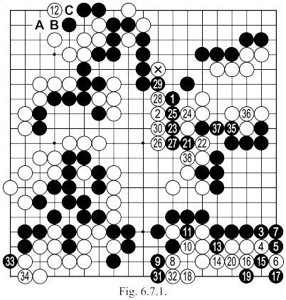 | After the last move of Fig. 6.6.1 (move 142 in the game), black territories remained intact, and they still numbered around 70 points, while white was reduced to about 45 points on the board (without KOMI and without counting yet the center). My task still was, therefore, to not let my opponent make 20 points in the center.  Black 1: Means that the marked stone is absolutely lost (see Fig. 6.7.2).  White 8 and 10: played so as to no longer need the connection at 15 and, therefore, to take SENTE there.  White 12: Better at "A". As played, if black "B”, white can not block with "A" because of black "C".  White 22: Playing according to Fig. 6.7.3 should keep more points in the center.

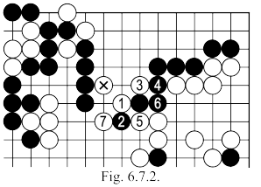 | Fig. 6.7.2: If black does not answer here, white has the sequence up to 7, rescuing the marked stone, while making points.  Fig. 6.7.3: White's profit in this variation is much higher. If black 4 is played at 5, we could continue as in Fig. 6.7.4.
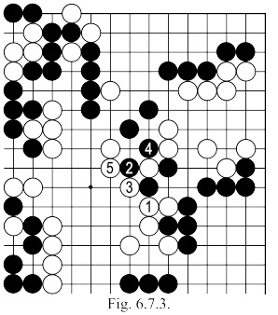
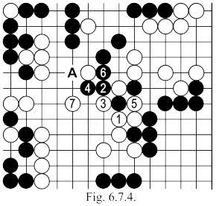 | Fig. 6.7.4: After this variation white stands better than in the game (by at least 3 points).

Moves 181 – 213  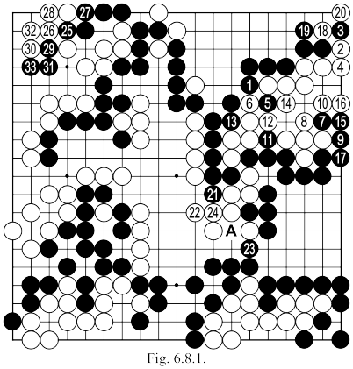 | White 8: Can not be played at 11 (or 15), since it would bring the sequence of Fig. 6.8.2., after which the whole white group dies.  White 24: Can not connect at "A" (see Fig. 6.8.3.).  Black 27: Should be played directly at 29.  White 28: Had to be played at 30, but for a few moves now, nothing matters: black has an advantage of about 20 points on the board and there is nowhere for this advantage to be recovered. White seeks only a more elegant way to fail. In such a situation, black 29 is forced, and after the sequence to 33, white resigns.
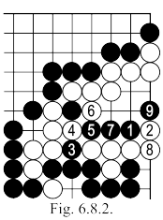 | Fig. 6.8.3: If after 1 here, white connects at 2, black can push with 3 and white as not to lose everything here will have to answer with 4. Now black 5 forces white 6, and then 7 (and possibly further to 11) to capture eight white stones.
