Game 4
 | Komi: 5.5 points  Time Limits: 1 hour for each player  Braşov Tournament (November 1986)
  Black: CALOTĂ Lucreţiu  (Braşov), 1 Dan | White: ZHANG Hai Tao  (China), 4 Dan
Moves 1 – 18  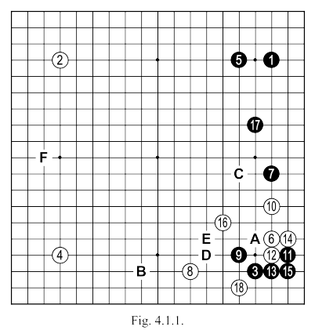 | White 6: Allows black the possibility of playing move 7, which is in perfect relation with the IKKEN-SHIMARI above. More appropriate would have been IKKEN-TAKAGAKARI at “A”. Another possibility is to play as in Fig. 4.1.2.
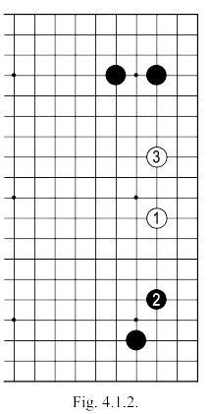 | Fig. 4.1.2. White plays WARIUCHI with 1 here; black 2 followed by white 3 comprise a rare technique, but one applicable in this case. The fact that black obtains a SHIMARI in this variation guarantees profit, but one which is not as big as it seems on first sight: its influence over the board is reduced by white 1 and 3, which have a very solid position. Later, white might attack either corner given favourable conditions.

 | White 8: After black 7, white is faced with a delicate problem in how to continue. In general we adopt the variation in Fig. 4.1.3, when after black 6 the position is stabilised. White must take care not to play 3 directly in this sequence.  Fig. 4.1.4. After white 1, black responds with 2 and HANE KAESHI at 4. The sequence continues to 9 here, black obtains a solid group in the corner with the option of following up with NOZOKI at “A” or “B”, to neutralise the influence of white’s group. In Fig. 4.1.5 we see one of the many possibilities for black to use the AJI there.
  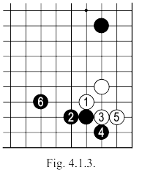
  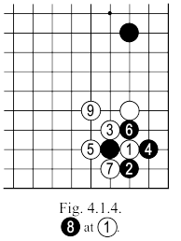
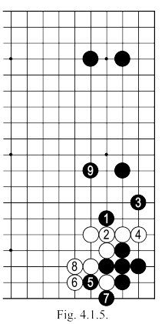
  (Fig. 4.1.5 we see one of the many possibilities for black to use the AJI there.)
  Fig. 4.1.6. If after white 1, black resists with SAGARI at 2, white can continue with OSAE at 3. Now black KIRI at 4 is obligatory, because black 5 followed by white “A” would lead to a far too low position (see Fig. 4.1.7)
  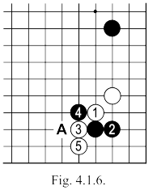

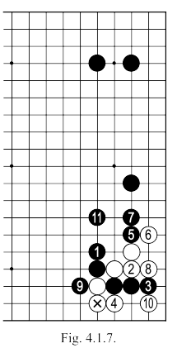
  Fig 4.1.7. Here is one variation which may arise from the previous position, it is very interesting for black with regards to the whole board position (to sacrifice the three stones in the corner in exchange for a powerful outside influence).
  Fig 4.1.8. White 1 here, followed by black 2, is another way to play, white has the possibility of obtaining life (perhaps) with TSUKE at “A”.
  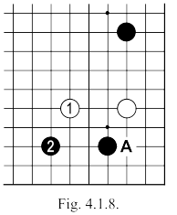
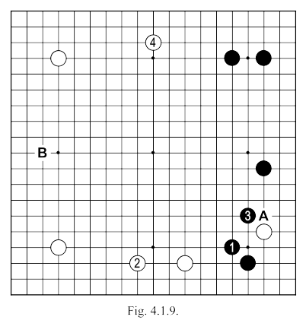 | As played, White 8 in the game intends to also play a move at "B", but after Black 9 …  Fig. 4.1.9. If after black 1 here, white would play at 2, black 3 and probably white 4 are a natural continuation. White 4 played at "A" would bring life on the right side, but a very small territorial profit in exchange for too strong a black wall facing the center of the board. In the position of this variation, black could continue with "B" because, later, after a white answer on the left side (or possibly even an exchange of 2-3 moves), he himself could occupy "A": move 5 of black could be played directly at "A", in which case white would play "b" and, therefore, an a relatively balanced exchange (immediate profit versus MOYO).  White 10: Had to try the variation of Fig. 4.1.9. In trying to resist prematurely here, white only plays into the hands of his opponent (it would be like after black 3 of Fig. 4.1.9, white would continue directly with "A").

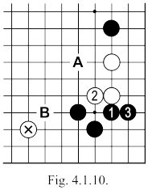 | Black 11: Much more correct for black would be 1 in Fig 4.1.10  Fig. 4.1.10. In order to continue attacking effectively, black must first obtain a strong position for himself in the corner without settling the neighboring white groups. After black 3 here, white can try to extend to "A", black "B" will put pressure on the marked stone whilst the situation of the fleeing white group remains unresolved. Of course Black can try to force the game a little, as shown in the variation of Fig. 4.1.11.  Fig. 4.1.11. In this variation, white 4 can be played at "A", in which case black continues with "B". For Black, the advantage is that you gain a move at "C" (which is very important for the MOYO above), without it being too passive. But there is also an advantage for white: he can always make life with a move at "D".
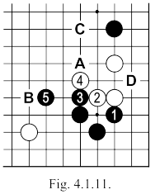
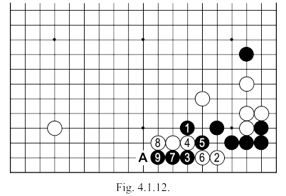 | Black 17: Given white's attack of 18, this move should have been played at "D", moving out to the center and keeping the two white groups separated. White 18 would then be useless because, as shown in Fig. 4.1.12 ...  Fig. 4.1.12. After the sequence up to 9 here, white can not play OSAE at "A", and he will lose the two stones 2 and 6.  White 18: The attack is premature, it is out of the question to capture the black group. A simple move at "E" should be played in SENTE (black will now have to live in the corner), because then by occupying "F" would bring white a remarkable positional advantage.

Moves 19 – 37  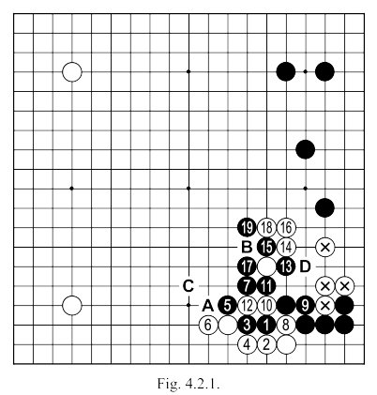 | Black 1: Better directly at 12.  Black 3: Better directly at 7.  White 6: Much too passive: should double HANE at “A” or cut at 8.  Black 7: Mistake! This move doesn’t connect the black stones.  White 8: This captures two black stones, and strengthens white's position on the side, but black still escapes too easily and manages to attack the marked stones. If white had simply played at "B", black would probably continue with 11 and white "C" would occupy a nice position. Notice that in this way, white's profit on the bottom promises to be much greater, the black group continues to be under attack (its life is not assured), while the white group on the right side has left its problems behind.  Black 15: Should be played at “D” (see Fig. 4.2.2).
 | Fig. 4.2.2. If after black 1 here, white connects with 2, then black 3, white 4 and black 5 continues the attack (if white "A" black "B"). If after black 1, white plays the "C" ... (continuation in Fig. 4.2.3).  Fig. 4.2.3. Following the exchange of 1 and 2 here, black will continue with 3 strengthening his MOYO at the top. Now White will have to play "A" or "B" and black "C" (perhaps "D").
  <The diagram for Fig.4.2.2.
  is missing in the original text>
  <The diagram for Fig.4.2.3.
  is missing in the original text>
.

Moves 37 – 59  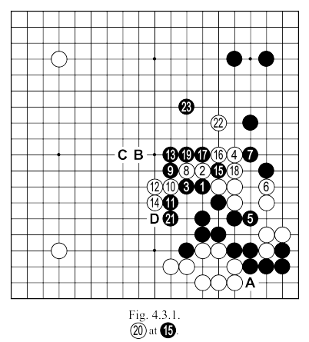 | Black 3: Should play at 8.  Black 11: Unnecessary. Playing 13 first was better. Forcing White 12, thus reducing the sphere of influence of the stones 9 and 13. If after black 13 (in place of 11), white himself plays 11, black "A" is enough. The "Shape" developing from stones 9 and 13 is particularly important now, and can influence the outcome of the game.
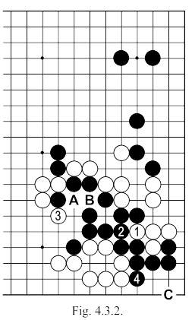 | After white 14, black's situation is quite complicated. The group on the lower side will live, but it is completely enclosed (see Fig. 4.3.2 and Fig. 4.3.3).  Fig. 4.3.2. All white could do here would be to attack with 1 and, then, with 3. After black 4, however, the group's life is assured. If white 3 is played at "A", black will connect at "B" and if white continues with "C", black 3 (also) obtains life.
.

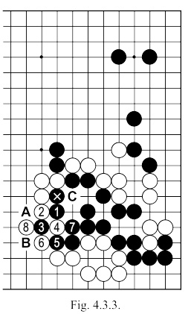 | Fig. 4.3.3. If black descends with 1 here, with the aim of 3 to separate the white stones in the center, the sequence up to 8 shows this will not work, white closes him in with a perfect wall. The cuts from "A" and "B" have no significance whatsoever as long as, recapturing at 4, White has a threat at "C".  In this area at least, the situation is very bad for Black. If he does not recover enough elsewhere, the game can be considered as lost. Having said that, of course we turn our attention to the black MOYO top right and the white group on the right side.
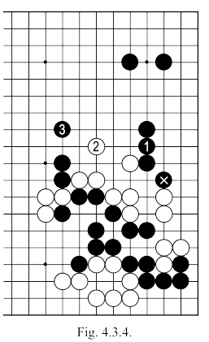 | Fig. 4.3.4. Given that white playing at "A" will give life, black can reinforce with 1 here, and after exchanging moves up to 3, obtain a profit on the right side, leaving the white group's life undecided: white will have to play at least once, here, in the future.
.

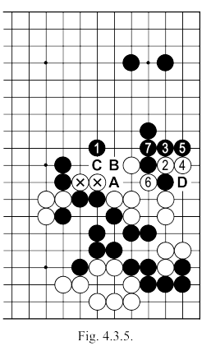 | Fig. 4.3.5. If Black will play 1, white could make life with the sequence up to 6, and then the black MOYO on the top would look more promising (the more so, since after black 7, if white does not play there, a black attack at "A" would require abandoning the two marked stones; if after black "A" white would continue with "B", then black "C" and white will still need to defend at "D"). Black 5 and 6 can be played, but this will not prevent the white group from living, whilst leaving some AJI points for black above the wall. If after one black, white adopts the line in Fig. 4.3.6 …
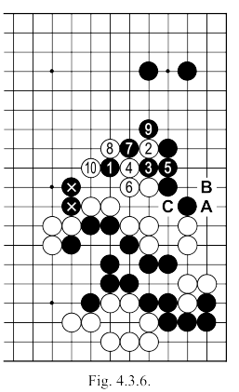 | Fig. 4.3.6. After the continuation of white 2, we expect the sequence up to 10. The result is that black can hope for a fairly large profit on the right side (top); but that will have to abandon for now the two marked stones, leaving it until later to see what can be done with them (an attempt to rescue them now would only lead to strengthening white's position on the left side). To keep the pressure on the white group, black could consider playing move 7 as a KIKASHI for 8, but this approach is futile since there exists on the board the sequence white "A", black "B", white "C", to make life.  But be careful: these latest versions are not balanced on the whole board, but only assure black a minimum as a basis on which to continue the game.  Black 15,17 and 19: Only pushes white into the middle of the black MOYO, the only place on the board where the latter could hope to make a profit as compensation. In addition, the black group that formed in the center of the board becomes very "solid", without being efficient, now present an increasingly difficult problem

..

as how not to lose them (as with the two marked stones in Fig. 4.3.6)
If the previous analysis let us conclude that the white group on the right side can neither be killed (yet) nor enclosed (yet), then correct attitude for black would be to no longer play here. He should develop his position in the center of the board with a move like "B" or "C", but before this is good for him to first play "D". This point is very important in itself because if white takes it he would make a strong wall on the eighth line (along to 12). Playing at "D" prevents this wall, and limits whites prospects of making a huge territory at the bottom. On the other hand, separating the stones 10, 12 and 14 will directly strengthen the neighbouring group of four black stones. At this moment it is necessary for black to take the fight elsewhere: later, after more stones are on the board (especially on the top side), returning to the white group on the right side will be possible, and perhaps, even more effective
Moves 59-88  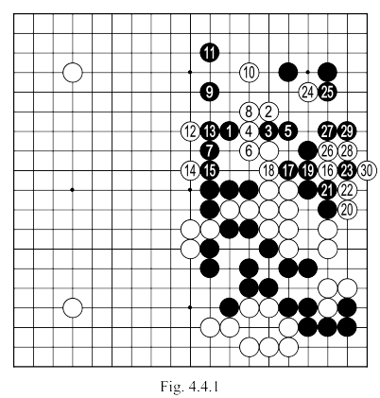 | Black 3: Strengthens white, without covering the problems in his own group.  Black 21: Had to be played at 26 and if white 23, then black 28.  After White 30, Black's position on the board is particularly bad. The profit in the top corner is small, the centre group is inefficient, the left side is open but (because of white's influence) can not bring much hope.

.

Moves 89 – 129  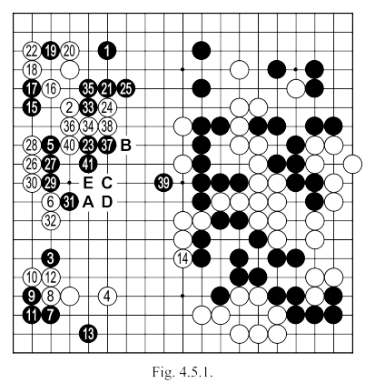 | Black 1 and 3: A better idea might have been 29 directly to have as many threats on the board as possible.  Black 7: Normally a solution, but in this case black must take control of the game (possibly BOSHI at "A"? ...)  Black 15: First play 23 and after a probable white response, on top, black "A". This 15 can be played at any time. However, in such situations black 16 is normally more efficient.  Black 21: Better 22 to connect the stones and weaken the white group. One of the variations shown in Fig. 4.5.2 and Fig. 4.5.3 should also to be considered.  Black 23: Better at 29, to make life there. Black should instead try to resolve the position of his group, whilst disturbing as little as possible the other areas of the board.  Black 27: Should block at 28 or extend to "B".  Black 33 and 35: Better at "B". In the game, after 38 white, the fugitive black group will find the wall to be a big problem.
 | Black 39: Should defend against the cut at 40 (with "C", "D" or "E") given that the white lead around 20 points, any "gift" of this kind is out of the question.  ( Black 21: Better 22 to connect the stones and weaken the white group. One of the variations shown in Fig. 4.5.2 and Fig. 4.5.3 should also to be considered. )
  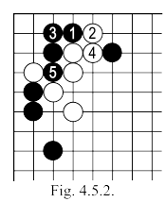
  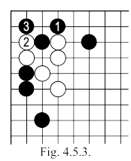

Moves 129 – 150  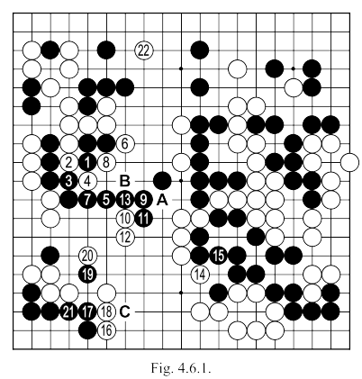 | Black 1: Should be played at 4 (see Fig. 4.6.2).  Black 13: Played thus, leaves an AJI with the cut at "A". Should have been at "B".  White 14: Too low. The life of the black group is not threatened, he can play TENUKI (for example at "C"), white could try instead Fig. 4.6.3.
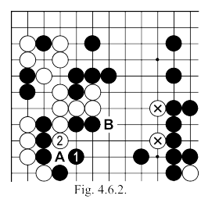 | Fig. 4.6.2. If Black 1 here white continues with 2, black may extend to 3. Now if white "A", black "B" isolates the two marked stones, taking a nice profit in the center. The difference between this variation and the game is around more than 10 points in black's favour.
.

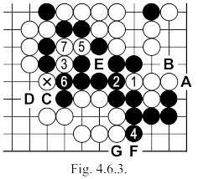 | Fig. 4.6.3. After the sequence up to 8, black lives in the corner, and white captures four stones. Next, the final moves of YOSE are hard to predict: black "A" white "B", black "C", white "D", then there remains a possible KO at "E" (for 1/2 point) and occupying point "F" (or "G" respectively ), another half a point. If, however, black would respond to the move of white's marked stone ... (see Fig. 4.6.4).  Fig. 4.6.4. Following the exchange of moves to 3, from here, it can be assumed that white will get to play (later on) at "A", and black gets the connection in SENTE of "B", and the white response "C". Considering these two variations, we conclude that for black, ignoring move 14 of Fig. 4.6.1 won't lose here more than about 5 points, while the move at "C" is far more valuable.
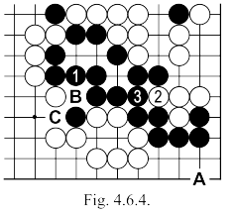
Moves 151 – 163  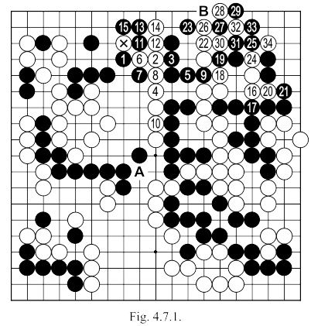 | Black 1: Played 6, it would have neutralize the attack of the marked white stone  Black 5: Should be played at 8 (see Fig. 4.7.2).  Black 7: Should be played at 1 in Fig. 4.7.3.

.

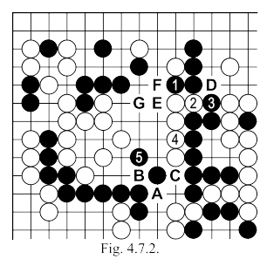 | Fig. 4.7.2. After black 3 here, white could connect at 4, threatening a move at "A" (which would inevitably separate "B" or "C"), but then black will connect at 5. If white continues with the cut at "D" black "E" captures five stones (if white "F" black can respond with "G").  Black 19: Played at 22, it could have saved something on the top side.  White 28: Should be played at "B" (see Fig. 4.7.4).
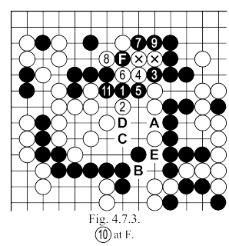 | Fig. 4.7.3. Black 1 here robs any chance of escape for the two marked white stones.  The illustrated sequence in the continuation is one of the possible ways for white to try, but it fails to black 11. If white 2 is played at "A", black will continue at 3, and if white will cut at "B", black can defend with "C" (at which point "D" and "E" are MIAI. This manoeuvre is no longer possible after exchange of black 7 and white 8 in the game (Fig. 4.7.1).  After the connection of white 10 (securing the cut of "A"), the game is permanently lost for black: with all the complications there are, especially on the top side, you can have no illusions.  Fig. 4.7.4. After White 1 here, black has to answer at two, then white three becomes a move without any reply (see continuation to 7). In the game, after move 184 of white (move 34 of Fig. 4.7.1), Black can take the KO, which he could win in the end, but only at the cost of his group in the upper left side, which would entail losing the game.
