Black: CANTACUZINO Şerban  (Bucureşti), 4 Kyu | White: BUTNARIU Alexandru  (Bucureşti), 2 Kyu |  | Komi: 5,.5 points  Time Limits: 1 hour per player  Timişoara (20-22 March 1987), Tournament, final of group B.
Moves 1 – 38  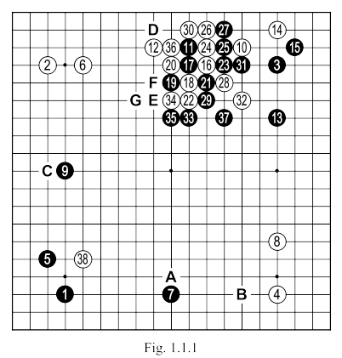 |  | White 6: Perhaps better at “A”. Black should not be left to take this point, which forms a good relationship with his SHIMARI in the left corner. Further, black “A” threatens to take “B” (another excellent move), when his position on the bottom side would become too good.  Black 7: We cannot call it a “mistake” but this move would have been preferable at “A”. As an extension, this 7 in the game would have better with an IKKEN SHIMARI on the left side, besides which, now, occupying the point “B” would be less efficient, having all the stones on the third line would be too low.  White 8: The double wing extension of black 9 is a move too big to be allowed; not to mention that, a white stone at “C” (or maybe 9) would be in a good relationship with his stones 2 and 6.
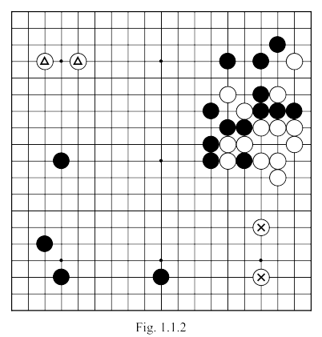 |  | White 10: This direction of attack is a mistake. Had to play on the right side. Possibly it seems strange that in a nearly symmetric position on the board, that the direction of attack can have much importance, and yet…  One of the basic principles in GO is do not attack strong groups. In this case, before move 10, white has 2 groups and we can consider that the NIKKEN SHIMARI in the right corner has more weak points than the IKKEN SHIMARI in the opposite corner, so it is weaker. Let us suppose that white has attacked on the right side and that things unfold identically to what happened in the game, but with a mirror image centered on the diagonal with move 37. The resulting situation is shown in Fig. 1.1.2, the two marked white stones are strengthened, and the triangled stones become weaker, wheras in the sequence in the game, the latter where the more solid. Moreover, we can demonstrate that the weaknesses of the stones at 4 and 8 (of Fig. 1.1.1) can be manipulated with more success than those of the two triangled stones in Fig. 1.1.2.
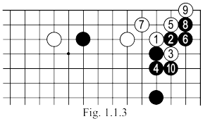 | Black 13: Too far from HOSHI. Better was IKKEN TOBI. Another possibility for this move could be 18.  White 14: Had to move toward the centre with IKKEN from white 10, especially since black 13 left behind AJI, which can be exploited by white.  White 16 and 18: Exaggerated. White cannot expect anything good in starting this fight, especially since the black group on the right was strengthened by the exchange 14 - 15. If he wanted to play this way, then white should have prepared his attack with 14 at 1 in Fig. 1.1.3. In the following sequence up to 10, white is sure to have at least one eye on the top side, and thus a more solid position. If black 4 of Fig. 1.1.3 is played directly at 10, white can continue the sequence as shown in Fig. 1.1.4, obtaining profit in the corner and on the top side (where now if black "A", white can block at "B").  Black 21: should be played directly at “D” (see Fig. 1.1.5). In the sequence in the game, black sacrifices two stones in a useless fashion, and his profit is smaller.
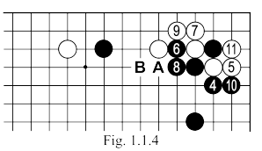
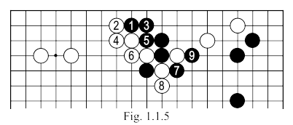
Moves 1 – 38 | White 28: Should be at 29 or directly at 30. ATE at 29 would give white a position looking towards the center and, therefore, to the black MOYO on the bottom; MAGARI at 30 left an unfinished situation in the center where points 28 and 29 are AJI's in the black shape to be used: later. If now or later, black will defend here, this will mean a GOTE move for him, and white will benefit from a SENTE move, in a different part of the board.  White 33: Mistake. Firstly, black gains a good position with moves 33, 35 and 37; secondly, white could have made the same maneuver sacrificing the stone at 28 and reducing black's territory; thirdly, used thus, the AJI has almost no meaning.  White 36: Useless; must be played at "E", then white will have a considerably bigger territory. The two stones 11 and 17 are already captured, there is no need to actually take them from the board. Further, Black can play anytime the simple sequence like black "E", white "F", black "G" ... with which to further reduce white's territory, while making his own points in the center.

Moves 39 – 55  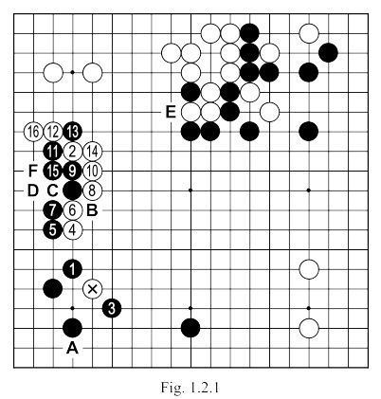 |  | Black 1: This is one possible answer, in general, following white's attack with the marked stone and because we are dealing with a position that we could meet quite often in our games (meaning a natural attack on the KEIMA SHIMARI shape), it can be worth looking in more detail at what can happen here. Let us first see another possible response of black (Fig. 1.2.2).
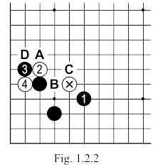 |  | Fig. 1.2.2: So, in response to white's attack with the marked stone, black can play 1, and white continues with TSUKE at 2. After black 3, white will be forced to play 4, for if he would play "A", then black "B", white "C", black "D ", and the resulting shape would be ugly.  Fig. 1.2.3: Continuing on from the previous position, black captures with 1 and 5 and white makes a nice extension at 6 intending SABAKI. White should not be afraid to cut at "A" (Fig. 1.2.4 shows what would happen in such a situation, the white shape is strengthened by this attack). If however white connects with 6 (in Fig. 1.2.3) at "A", then black "B", makes it difficult for the white stones. Neither is KAKETSUGI at "C" a good idea for white as black has "D" and again white's group is under attack. This does not mean, of course, that the white will die here, he always has the possibility of running towards the center, but this solution would inevitably lead to strengthening black on both sides (with a big profit), merely saving his group does not promise white too many points: however, this was not the intention of the attack with the marked stone.
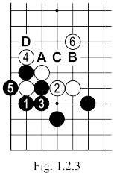 | 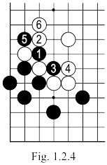

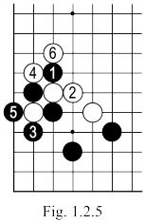 | 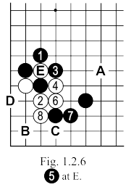 | FIG. 1.2.5: In Fig.1.2.3 black played ATE at 1, but it may be better to chose this variation, depending on the result of the SHICHO after white 6. In the game (Fig. 1.2.1) this sequence is favourable for black, so, instead of 1, 3 would show a much more severe attitude.  In such a situation, all white can do is to play the sequence in Fig. 1.2.6, after which if black tries "A" to enclose, white "B", black "C", white "D" makes life.  Turning now to Fig. 1.2.3 where, after white 2, black plays TSUGI at 3. What would happen if Black directly captures 5?  Fig. 1.2.7: So black captures with the marked stone, and white continues at 1; black connects at 2 now because he can not afford a KO as every white extension will be a KODATE (and generally a KO at the beginning of the game is almost impossible to win) . The sequence continues up to white 5 fixing his shape, and achieving a satisfying result.
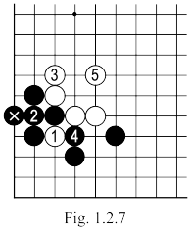
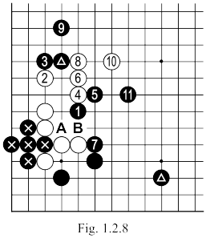  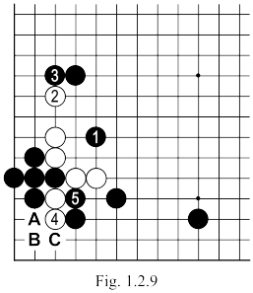 |  | In the game we saw that black got to extend on both sides of his KEIMA SHIMARI, in that case he can play in Fig. 1.2.7 directly at 5. In this case, it would complicate things a little …  Fig. 1.2.8: Given, therefore, the double extension (marked stones) black can attack with 1. Now a simple connection at "a" or "b" would leave white's shape heavy, and white may struggle to live in an area controlled by his opponent. If White tries to get to the center with the sequence here, the price will be too high given the profit black makes the sides (especially on the bottom). White's only chance then is to make use of the weakness is the triangled black group.  Fig. 1.2.9. So after black 1, white can exchange 2 and 3 and continue with 4 which obliges 5. Now white has a choice between "A", "B" and "C”
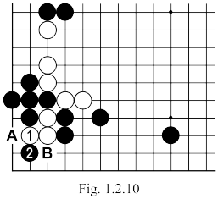 | Fig. 1.2.10: OSAE at 1 will prove catastrophic for white after black's excellent TESUJI of 2: points "A" and "B" are MIAI to capture the white group.  Fig. 1.2.11: The KOSUMI if white 1 here is also not a solution, as shown by the sequence up to black 4 which robs white of any hope.
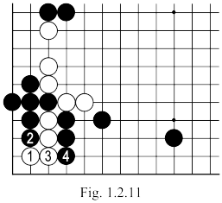
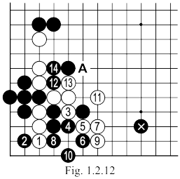 | Fig. 1.2.12: SAGARI of 1 is the only correct move for white. The natural continuation is shown here, white 15 can be played at "A" or an attack close to the marked black stone (now isolated in white's area of influence). Don't forget that black made territory on the left side: at the beginning there were four black stones in that quarter, controlling the area, so white can not dream of destroying the entire MOYO of black.  Fig. 1.2.13: If after white 1 in the previous sequence, black plays OSAE at 2 here, then white will continue with 3, 5 and 7, and later 11, 13 and 15, and eventually 17, black's capture is inevitable. If instead of 8 black plays directly at 9, white will open a KO which is too big for black. After the exchange of 8 and 9 black will play at "A", then white will continue with "B", black 15 and white 10, leading to a won SEMEAI (ME-ARI ME-NASHI).
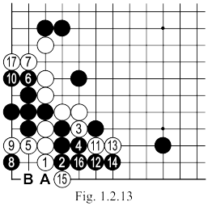

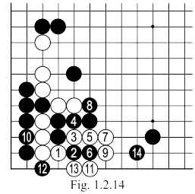 |  | Fig. 1.2.14: It's dangerous for white to play this MAGARI (in place of move 3 in Fig. 1.2.12) because the sequence up to 14 here will leave him with two weak groups, the situation is a bad.  In Fig 1.2.15 white's group on the bottom can make life in the sequence up to 11, but black's position towards the center of the board remains solid..
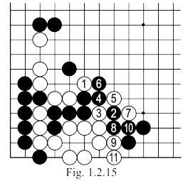
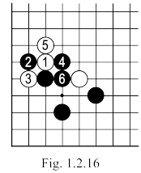 | 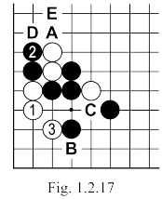 | Fig. 1.2.16: Let's see a possible sequence if after white 1, black 2, white 3, which I studied until now, black continues with ATE at 4 and then TSUGI at 6.  Fig. 1.2.17: After the last figure, white plays NOBI at 1, and after black 2, KOSUMI-TSUKE. Now black can play "A" and white would be satisfied with "B" taking the corner. If instead of "A" black plays "C" then there will follow white "A", black "D", white "E" etc … If this parallel advance (black on the second and white on the third line) is favorable, white can continue with any sequence, even if his corner stones will be later captured (they become of secondary importance). But notice that white is (if desired) has a sequence to live in the corner (Fig. 1.2.18), it is possible to at once exchange 1 and 2, in the latter figure, or later.  Fig. 1.2.19: After Fig. 1.2.17, black must not think that the attack with 1 would bring a better result, because after the sequence to 6, he is left with a very unpleasant situation.
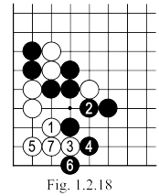 | 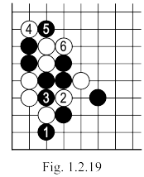

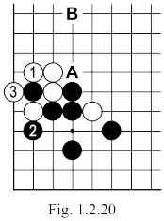 | 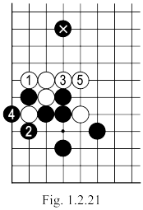 | Fig. 1.2.20: White can capture, of course, with 1 and 3 as in this variation (from Fig. 1.2.16), but in this case his profit will be quite small (without prospects) compared with what black takes on the lower side. In addition, black has the opportunity to push at "A", especially if he already has a stone at "B".
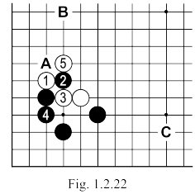 | Fig. 1.2.21: If after exchanging 1 with 2 white tries to isolate the marked black stone, continuing with 3 and 5 (reducing his opponent's profit in the previous diagram), then he finds himself with a not so strong group (without a real base), which doesn't fit with his plans (indeed, it could become the next target of attack).  Fig. 1.2.22: In Fig. 1.2.2 black played 3 in response to the white TSUKE at 2, but he could try this HANE-DASHI (move 2 here), when the SHICHO after the sequence up to 5 is good for him. So white must be very careful when he starts the attack, about the SHICHO; otherwise he would have to play 5 at "A" and enter into a bad fight for him, especially in the presence of black extensions at "B" and "C".
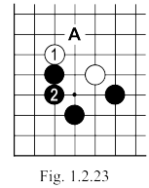 | 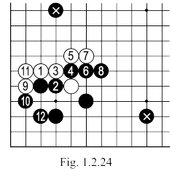 | Fig. 1.2.23: After, a black HIKI at 2 here is another possible answer, but it can be considered "a little too soft", enabling white to continue with "A" or "B" depending on his plans ("A" intending to make territory on the left side, "B" for SABAKI).
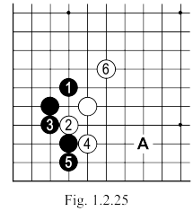 | Fig. 1.2.24: The result of this variant (after black answers at 2 to white 1) is generally not considered to be great for black, but with the two marked stones, it can be considered satisfactory because black gets a considerable profit on the bottom, while the resulting white wall, is troubled by the opponent's HOSHI.  Fig. 1.2.25: Following the attack of marked white stone, another answer might be this KOSUMI at 1, and the sequence from here to 6 is a possible continuation, where 6 can be played at "A" (depending on the whole board).

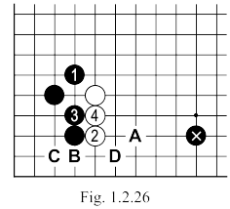  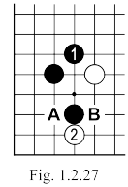 | Fig. 1.2.26: White 2 here would actually be the correct answer to black 1; given the marked stone (as a possible extension at "A" would be very ugly), white 4 should be played at "B" followed by black "C" and white "D".  Fig. 1.2.27: White (TSUKE) is a special move, which resolves the local situation: if now black "A", white HANE at "B" gives a good feeling.  Fig. 1.2.28: Starting from the position in Fig. 1.2.27, black can play 1 here, then white can cut at 2. If black ATE at 3, white 4 and 6 are KIKASHI, and after 8 he can be satisfied. White 8 can be played at "A", if we attach little importance to KIKASHI stones - actually a proverb says "abandon KIKASHI stones". If after white 2 black plays 3 directly at 6, there follows white 4, black 5, white "B" and black's situation is bad.  Fig. 1.2.29: The SHICHO, which results, is not favorable to white, blacks could play this sequence, triggered by ATE 1 (in place of move 3 in Fig. 1.2.28).
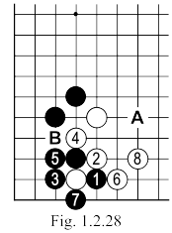
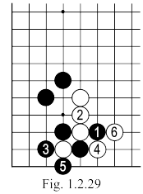
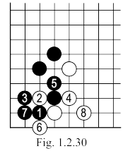  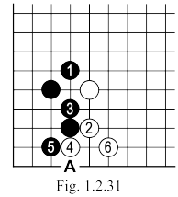 | Fig. 1.2.30: Continuing from Fig. 1.2.27, black can play at 1, and after white 2, black 3 can be an alternative to the game that triggers the sequence up to 8.  Fig. 1.2.31: Let's see the result - in the same vein - the attack with white 2, is the response to the black KOSUMI at 1. In Fig. 1.2.30, white exchanged 6 and 7, securing an eye on the side, while in Fig. 1.2.31 Black can still play at "A", disrupting white's shape.  Fig. 1.2.32: After exchanging 1 and 2, it is not a great idea for black to capture the marked stone marked, because with the sequence up to 8, white too easily makes SABAKI.  If instead of 7 black plays at 8, white can continue as in Fig. 1.2.33 where, before exiting with 4, he creates a possible eye (in GOTE) corner.
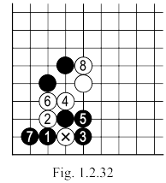
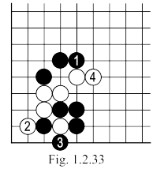

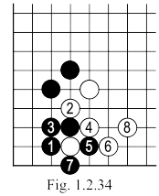 | 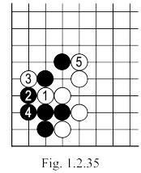 | Fig. 1.2.34: In response to black 1 in Fig. 1.2.30, white could play like this, reaching a similar result as in Fig. 1.2.28.  If black 5 is played as TENUKI, white can continue as in Fig. 1.2.35 and can be very satisfied with this final result.  Fig. 1.2.36: There is a counterattack for black in the variation of Fig. 1.2.34, after the attack of white 2, there is NOBI with 3. After the sequence up to 11 white will not be too happy (especially with the two marked black stones). In such a situation white should adopt the variation played in Fig. 1.2.37.  Fig. 1.2.37: If black starts with this NOBI, the sequence up to 6 gives white unconditional life. If now black "A" white "B"; if black "C" (instead of "A"), white "D" black "E" white "B" black "F" and then white "A" also lives; if black starts with "B", then white "D", black "G", white "A".
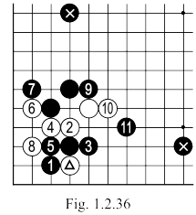 | 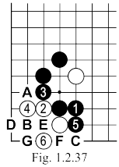
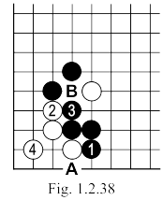 | Fig. 1.2.38: If white 2 in the previous version, black can play the 1, which is a very strong move. The sequence that follows up to 4 allows black to get a KO with "A" but, given the bad AJI of "B", it would probably be better to first fix this defect while leaving open the KO for later. If white then plays "A" himself, then black will be pleased with the strong wall he gained in SENTE.  Fig. 1.2.39: Since the result of Fig. 1.2.38 is poor for him, white can choose this variation, which also gives black strong central influence; but after move 7, white can play TENUKI. If he now tries to kill the black group in the corner ...  But perhaps the reader would like to solve this problem by himself. As this is a position that we can often meet in our own games, closer study certainly wouldn't hurt.
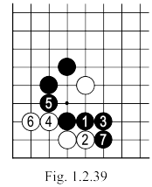

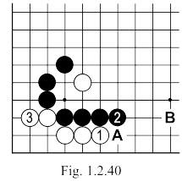 | 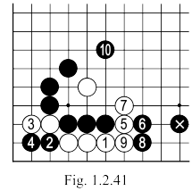 | If White is unconvinced by the result in Fig. 1.2.39, then after black 5 he can play Fig. 1.2.40 …  Fig. 1.2.40: After move 3 here, not only does white living happily in the corner, but he also renders black "A" a move without any real value. Naturally this would not have been the case had black a stone at "B", in which case he could play the variation in Fig. 1.2.41. In this variation, after the sequence up to 10, white will be forced to continue to fight in a very difficult position.  Fig. 1.2.42: If after exchanging 1 and 2, black plays OSAE at 3, white HANE at 4 is the only move, but if black has a stone at "A", he could attack particularly severely with the HASAMI-TSUKI of "B".
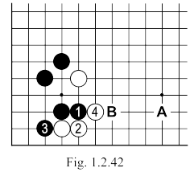
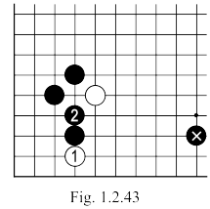 | 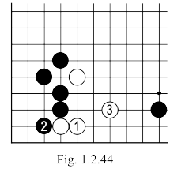 | In the presence of the marked stone, black can play HIKI at 2, in response to white 1. Now white, depending on the overall situation of the board can continue to play locally or play elsewhere, returning later (depending on how the whole board situation changes in the meantime) to decide how to complete the action he started in this corner. If he decides to act immediately here, then there is a choice of the variations shown in Fig. 1.2.44, Fig. 1.2.45 and Fig. 1.2.46.  And to conclude this study we ask: have you solved the problem in Fig. 1.2.39?
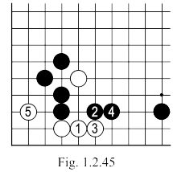 | 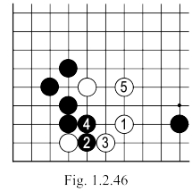

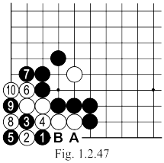 | To check, follow the correct solution in Fig. 1.2.47 and if this doesn't match your own conclusions, check your calculations again: there must be a mistake somewhere.  Fig. 1.2.47: Black 1 here is a TESUJI and the most severe attack on the corner group. After the forced sequence up to 10, black will have to occupy both "A" and "B", while white will calmly play KO with the capture at 8. If white 4 is played directly at 8, it's a mistake, because in this case we have a one step KO (ie vital) when black captures with 5.  Fig. 1.2.48: The HANE of 1 here is an inappropriate attack, because after the sequence up to 9 that would follow, white recaptures with 10 making unconditional life. If 3 is played at 4, there is white 3 black "A" white "B", which again makes life. Turning now to Fig. 1.2.1. From the above analysis we can conclude that black 1 played at 3 would have been a more severe line.
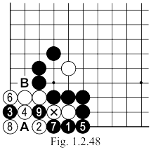
Moves 39 – 55 | White 2: First "A" to test black's reaction. Only according to this reaction can white decide on the correct way that he should play in a different part of the board.  Black 5: Better was "B", forcing White to enter into a disadvantageous fight (black is strong all around). Points "C", "D" or "E" can be other possibilities for this move. The actual move of 5 helps white (via the following sequence) to claim enough territory in the left corner, largely negating the influence of the black center.  Black 9: Double HANE at 10 would have made smaller the loss suffered by black here.  Black 13: If it was played at 14, it could have been used later, eventually with the AJI at “F”, but here it is useless.  Black 15: Better at “G”, because of the huge YOSE at 16.

Moves 55 – 82  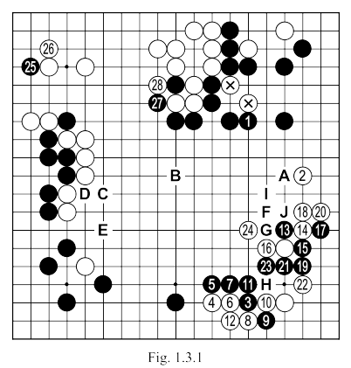 | Black 1: An extension like "A" or "B" would also resolve the AJI that you may have noticed around the marked white stones. Moreover black "A" is in itself a huge move; black "B" is another idea, aiming at a move at "C" - if white answers with "D", then black "E", after which white has every right to panic.  Black 15: This is not the right attitude from black given the situation on the board. Let's first count territories. White has about 60 points on the top left and, if unchecked, can take 30-35 points in the opposite corner, adding KOMI, a total of more than 100 points. Black has at least 40 points in the top right corner and about the same amount in the bottom left, plus side.
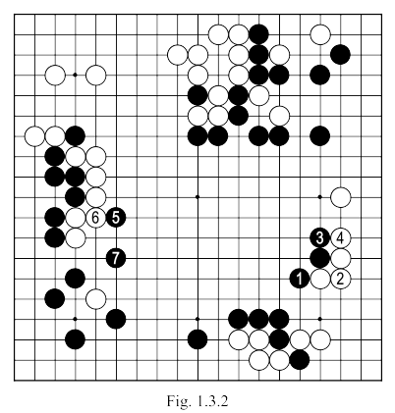 | Now if Black applies the tactics in Fig. 1.3.2, he can easily make in the center the minimum of 20 points needed to win this game (especially since white has no other way to make points on the board. Black 15 in Fig. 1.3.1 lead to unnecessary complications, which are not clearly favorable, and which could even turn against him.  White 20: Given the fact that black can live on the edge (see Fig. 1.3.3), this move would have been better at "F", without worrying about the black moves in Fig 1. 1.3.4 where the marked stone still can not escape.  Black 23: The correct answer for white here is "G", as it avoid any problems … black 23 should be played at "H", which, however, requires white "G", but it also emphasizes the AJI at "I", taking the liberties of the white stones.  White 24: The only answer is "G". If after white "G", black trying to go out with "J" then GETA with "K" is sufficient for white.

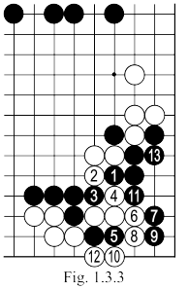 | 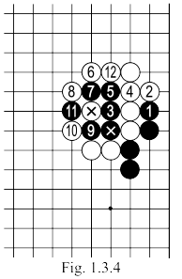 | White 20: Given the fact that black can live on the edge (see Fig. 1.3.3), this move would have been better at "F", without worrying about the black moves in Fig 1. 1.3.4 where the marked stone still can not escape.
Moves 83 – 102  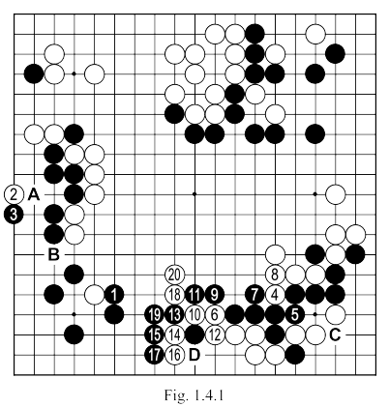 |  | Black 3: Mistake. Should be at "A". In most positions, this block would work (see Fig. 1.4.2). In our case, however, black has a AJI at "B" that his opponent can exploit successfully (see Fig. 1.4.3).

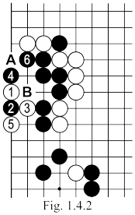 | 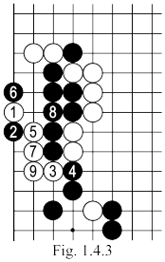 | Fig. 1.4.2: After exchanging 1 and 2 here, white should continue at "A" and if black "B" white connects or plays TENUKI: this sequence is a natural YOSE, where white wins, at least 1 point in SENTE (even if later black captures 1).  Fig. 1.4.3:. After exchanging 1 and 2 here, the white can play 3 and if black cuts with 4, white 5 works very well. Here is an excellent proof that in GO we can never apply "fixed rules", absolutely every situation has its own specific character.  White 4 and 6: A hazardous attack…  Black 7: Should cut at 12 (see Fig. 1.4.4.).  Fig. 1.4.4: After exchanging 1 and 2, white must play 3, with the plan of isolating the black group. Now black has KIKASHI at 4 and 6 which offer an escape route to the center (on the edge he has at least one eye because of the AJI at "A"). The only problem for Black is "how to get out most efficiently." Of course, 6 can be played at "B", "C" or "D", without his stones being separated, but the idea is to but the idea is to put the two opponent's stones 1
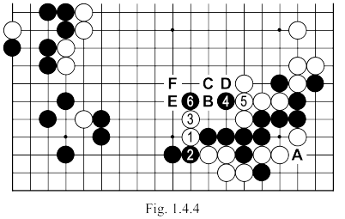
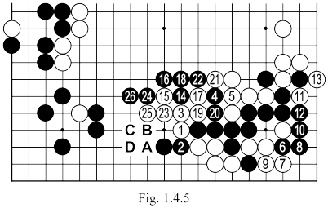 |  | and 3 under the most pressure without endangering his own groups (middle right side and bottom)...  Fig. 1.4.5: So, after the sequence up to 5, black plays 6 trying to make life on the edge. If white resists with the sequence up to 13, then Black can play 14 then the severe HANE of 16. If now white attacks with 17, Black can calmly connect at 18 (obliging white 19) for, after 20 and 21, and black cuts with 22. His group on the side still has 5 liberties. If White continues with KATATSUGI at 23, then black OSAE at 24 and NOBI at 26 all but finish the sequence, there is no way to lose (if white "A" black "B" leads to DAMEZUMARI;  if white "C", then black "d" also works; if white "D", black "B" and then "C"). If instead of 23 white plays KAKETSUGI at 25 ... (see Fig. 1.4.6).  Fig. 1.4.6: After this white 1, black plays ATE at 2, and white continues with HIKI at 3, black blocks at once with 4; white 5 is followed by black 6 starting the sequence up to 14, and white's group is captured in SHICHO.
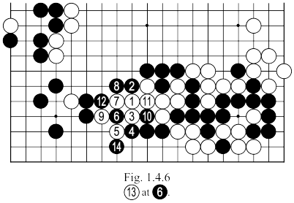
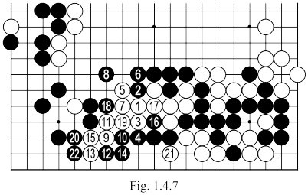 | Fig. 1.4.7: If instead of 5 in the previous variation, white plays 5 here, black must not rush to capture the stone, but simply connect with 6 and then make GETA at 8. Note that all the while, the white group at no time has enough liberties to capture the black stones on the right. After black 8, white can try 9 to increase his number of liberties, the sequence up to 22 shows that this fails. If instead of playing KEIMA with 9 white plays HANE at 20 …  Fig. 1.4.8: After this white 1, black will continue with 2, 4 and 6 because then he can apply the technique of HORI-KOMI with 8 and 10. If now white descends at 11, black has the sequence up to 22 to win. Instead of 11, white can play …
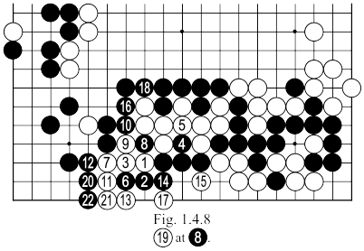
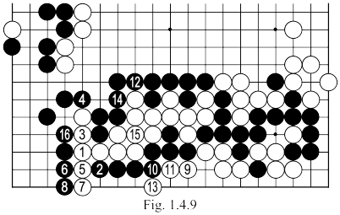 | Fig. 1.4.9: TSUKE-NOBI at 1 by white here is followed by black NOBI at 2, which ensures the SEMEAI is won in the variation in this figure, or in Fig. 1.4.10.  You could say - not without reason - that such a sequence, starting at one side and ending on the opposite side, with all its variations, can not be completely calculated in a game where you have total thinking time of 1 hour …
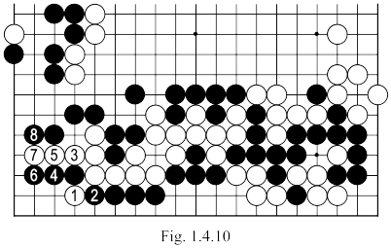

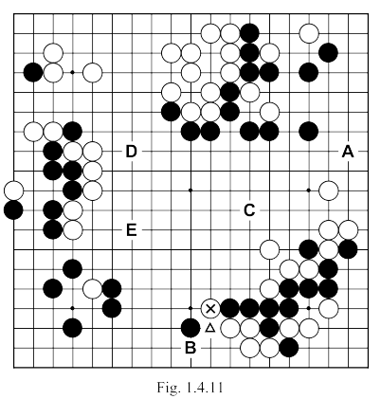 | Let us return to the position in Fig. 1.4.1 (see Fig. 1.4.11).  Fig. 1.4.11: After the marked white stone is played, the situation on the board is as follows: black has two territories each with about 40 points ( a total of about 80 points) and white has 60 points in the (top) left, about 8 to 10 on the bottom and 10-15 on the right side, for a total of 78-85 points. Of course there are still important areas to play at "A", "B", "C", "D" or "E" but, assuming that in the center black can recover the KOMI he gives to white, the situation is very close. A passive approach by one of the players now, is likely to lose the game. In this case, black must now play the cut at "A"and the sequence up to 5 of Fig. 1.4.4 follows naturally.
 | Now black wants to play 6 and after white "E" he can continue with "F", but that grants white the opportunity to cut in the sequence of 17 to 21 in Fig. 1.4.5. and in the SEMEAI there, black's group is isolated and has 3 liberties, which is evidently not enough. So black picks the sequence of 6 up to 13 in Fig. 1.4.5 whereupon, he threatens to make life on the edge, gets five liberties - as played - then 14 and white responds at 15 (white cannot play passively). Now Black can read the critical sequence, starting from the premise that 16 is played, that white cuts and we see moves 17-21, finishing with black 26.

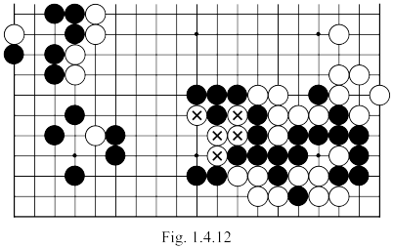 | Ignoring, then, basically the entire right side of the board (we only need to remember that the black group has five liberties) - see Fig. 1.4.12. - we don't need to consider the five white stones, marked in the last figure, unless they can achieve, in SENTE, as many liberties (the condition necessary to win the SEMEAI). You must recognize that the sequences we will examine, starting from this position, are not at all complicated, their only difficulty comes from the length which they have - and this is just a matter of practice. If you begin solving mentally, without putting stones on the board, life and death puzzles (TSUME-GO), or if you try to look ahead before every move during a game to "see" (slowly) progressively further; after a while, you will get the knack of reading such sequences.
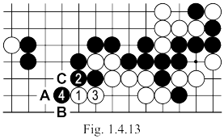 | Black 7: We know now that there is no way out to the center (with or without the cut at 12).  White 12: Should be played directly at 14.  White 14: Better is 1 in Fig. 1.4.13.  Fig. 1.4.13: After the sequence up to 4 here, white keeps a big YOSE point at "A" (after which black can not descend to "b" because of white "C").  White 16: Should capture at once with "D", leaving 17 as white's move in YOSE. If after white "D" black descends at 17, white can be satisfied with keeping SENTE. After 16 and descent of 17, the point "D" can still be taken by either of the two players.  Fig. 1.4.14: After white captures the marked stones, if black plays TENUKI, the sequence beginning with white 1 can be played by both in SENTE, the difference between this variation and the one played in the game is about 20 points.
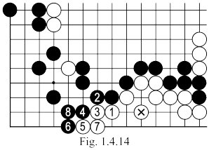

Moves 103 – 148  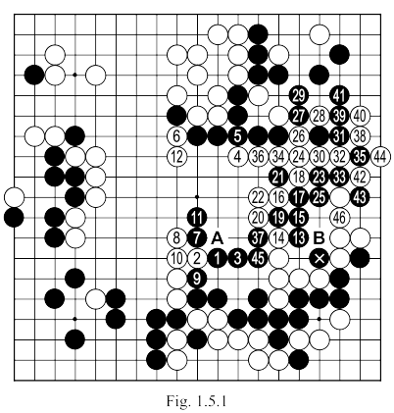 | Black 3: Better at "A", which is more painful for white. Black should not be afraid to make contact, he cannot be separated (as demonstrated in Fig. 1.5.2 and Fig. 1.5.3).  Black 7: A move at 12 is very big and should be played directly (see Fig. 1.5.4).  White 14: Should be 15, given that if black answers at 14, then white "B" makes a SHICHO ending at the stone white 4.  Black 25: Mistake. Should be played at 1 in Fig. 1.5.5.  White 34: Better directly at 38.  Black 37: Bigger was 43,bringing about 30 points on the side. Considering that in this situation white would probably connect his six stones (captured with 37 in the game), we can say that the difference between the two moves is roughly 18 points (SENTE).
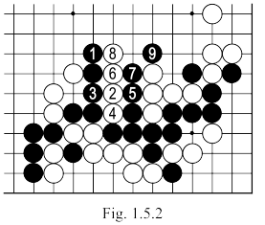 | After move 46 in Fig. 1.5.1 (148 in the game) we can make a new estimate of the score. White has almost 70 points in the (top) left, about 10 in the middle of the right side and about 15 points on the bottom, so a total of 100 points (if we add KOMI).  Black has just over 20 points in the (top) right, about 30 in the (bottom) left, and around a further 20 points of territory in the right - so a total of just over 70 points. With a minimum of 25 points advantage, white has a very comfortable position.  Black 3: Better at "A", which is more painful for white. Black should not be afraid to make contact, he cannot be separated (as demonstrated in Fig. 1.5.2 and Fig. 1.5.3).
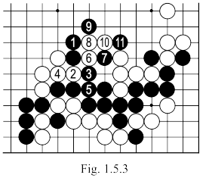

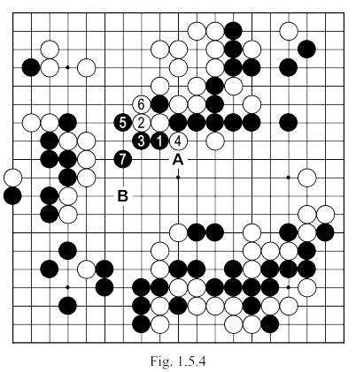 | Black 7: A move at 12 is very big and should be played directly (see Fig. 1.5.4).
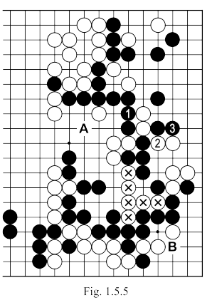 | Fig. 1.5.5: Following the exchange of moves 1 and 3 here, black will get a much bigger profit on the top side than from capturing the 6 marked stones and besides that, now, white will have to make life on the side before it is too late, black has the points "A" and "B" as MIAI to make his own group live.

Moves 149 – 192  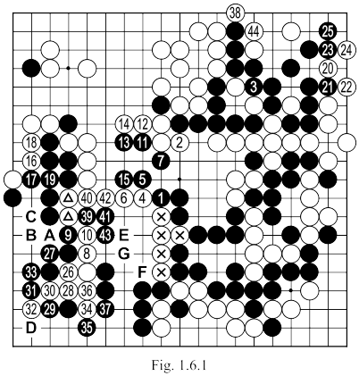 |  | Black 1: Useless. First KIKASHI at 42 and only if White connects at 40, black 1 capturing the 5 marked stones.  White 8: Better white 9, black "A", white 8.  White 16: Should answer black 15.  Black 17: Should play at 42 as it is is much bigger and then white 40, black 41, white 39, black 43.  White 20, Black 21 etc…: All these moves are smaller than 42.  White 26: Useless.  Black 27: Better at 28. If white continues at "A", black 27, white "B" black "C".  Black 29: Should be played at 30.  Black 33: Better "D" to prevent white 34. There is nothing on the left side. (see Fig. 1.6.2).  Black 39: Better at 40 (see Fig. 1.6.3) which captures the two marked white stones, making 20 points instead of 16.  Black 43: Better at "E", preparing to take "F" and blocking a later white "G". White is leading and every point is precious.
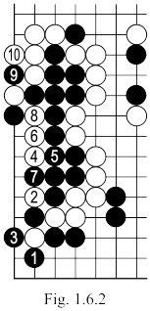 | 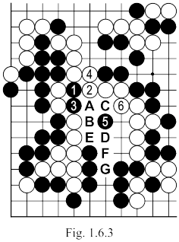 | Black 33: Better "D" to prevent white 34. There is nothing on the left side. (see Fig. 1.6.2).  Black 39: Better at 40 (see Fig. 1.6.3) which captures the two marked white stones, making 20 points instead of 16.  Fig. 1.6.3: If after black 1 here, white connects at 3, black will continue with 2, white 4, black "A", white "B", black "C", white 6 and black 5. Given that after the sequence shown here white keeps a move at "D" (to which black does not have to answer at "E" but with "F" - to also protect a point at "G"), we can say that black's profit was 20 points, unlike the sequence in the game which made only 16 points, and will give white himself two points here, which makes a difference, in fact, of 6 points between the two variations.

Moves 193 – 256  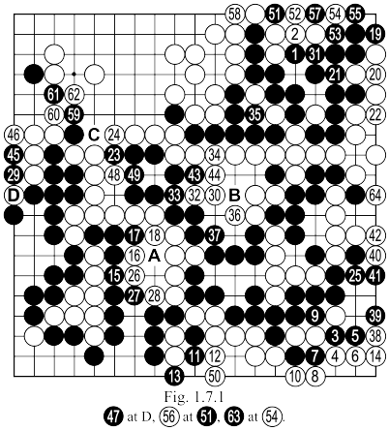 | Before continuing our analysis, let us count the territories again. White's territory in the (top) left can now be counted almost exactly at 63 points, plus 10 on the right side and another 15 on the bottom, so a total of 93 points (with KOMI). Black probably makes 44 points in the (lower) left, only about 20 points on the right and about 8 on top, and thus adrift by about 20 points. It is good to count often during our games, because only then can we know the wisest strategy to continue with. In this case for example, if White had had a stricter attitude to guarding his current territories he could have obtained a comfortable victory ... but in the game, he only just held on.  White 6: Mistake. Should be 7.  Black 15: Absolutely useless. Better is black 16, white "A", black 28. After the last mistake of white (move 6), black now has about 83 points, while the total points for his opponent fell below 90.
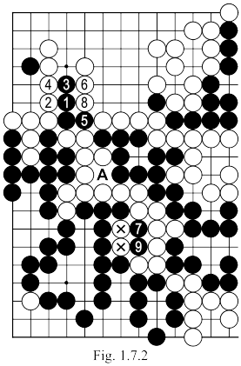 | Black 29: Bigger is black 36, white “B”, black 30.  White 50: A mistake what could prove fatal if …  Black 51: It was necessary to play at 59 (see Fig. 1.7.2).  Fig. 1.7.2: After the forced sequence up to 4 here, black cuts at 5 and white must continue with 6. Black 7 is a HORIKOMI because white cannot capture at 9 as he would lose a liberty and the entire group. The sequences ends with white 10, giving black a profit of 8 points in SENTE: 4 points from capturing the two marked white stones, plus 2 more points as white no longer has an eye at 7 and 9, and so has to play inside his own territory with 8 and 10 (in total 6 stones are played to capture 4 black). If he played elsewhere, black would win the match by 3.5 points.

Returning to 51 in the game ... This sacrifice is useless, giving him one point for free to white. It should be played directly at 54, after which white can not block at 57 because black 51 would put him in DAMEZUMARI.

Black 61: We have seen how to play. After 62, white will not even have to lose (at the end of the game) a point, by defending at "C", which he will now have to eventually do.
Black 63: This connection is worth half a point (since it is a KO), while a move at 64 would be worth 1 point (forcing White to put three stones in his territory to capture only two blacks). Naturally, however, this last move has no influence on the final outcome of the game, when white will win by 6.5 points, a difference of 1 point is more or less totally insignificant.

