Game 2

 | Komi: 5.5  Time Limits: 1.5 hours per player  Timișoara (20-22 March) Tournament, Group A
  SCHMIDT Walter, Timișoara, (3 DAN) | CALOTĂ Lucreţiu (Braşov), 1 DAN
Moves 1-14  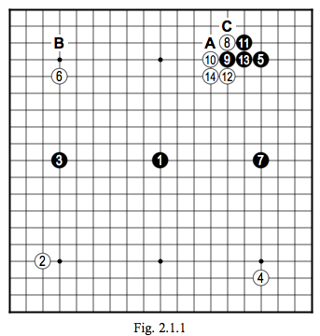 | White 8: Maybe better at 9 (see Fig. 2.1.2).
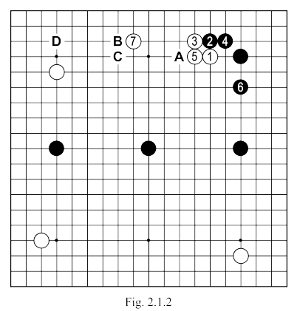 | Fig. 2.1.2. If we imagine the sequence 1 to 7 is played (with the alternative that 5 can be played instead at “A”, followed by white taking one of the points “B” or “C” instead of 7), it can be said that locally we have arrived at a balanced result. Let's see first what might happen next on the board, then go back to the game to consider the flaws of 8.  In Fig. 2.1.2. we can see that “D” became a key point on the board, occupied by white it would create an impressive MOYO; but it is also clearly a good point for a Black invasion. Let us then look first at the possibilities for black’s attack and the consequences it could have.

 | Fig. 2.1.3. Once black has played the marked stone, white can continue with the sequence up to 11, gaining influence on the top side. If black chooses to play 8 instead at 10, the white can gain influence on both sides (see Fig. 2.1.4), which is a better result for him. Of course, white 5 of Fig. 2.1.3 can be played directly at 7 to obtain a similar result to that of Fig. 2.1.4 (see Fig. 2.1.5). Considering the actual game, obtaining the result in Fig. 2.1.3 seems to be preferable for white. Comparing this result with Fig. 2.1.2 it seems we get a satisfactory position.  Fig. 2.1.6. After moves 1 and 2 in Fig. 2.1.3, white can continue as shown in this new figure, and if you compare this result with Fig. 2.1.2 you will notice that the black group on the top side is not comfortable.
  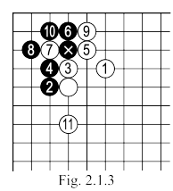 | 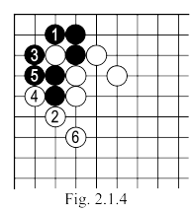
  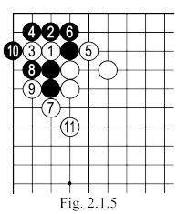 | 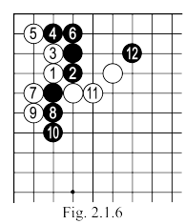
 | A variation which generally results in a very difficult battle is shown in Fig. 2.1.7, but to return to the game, In Fig. 2.1.8, considering the presence of the two marked black HOSHI, white should come out with "A" or "B"(shown in Fig. 2.1.2). We can see that in such a situation, white would be happy to have a stone at "A" (produced from one of the variations of the game from Fig. 2.1.2).  Fig. 2.1.9. After white 1 black can answer with 2 here (with the OSAE of 3 we can see how the presence the marked stone prevents black from playing 4 at "A". The sequence continues until white 7 after which black “B" is necessary, though it feels small. White remains, then, with SENTE and will be able to handle any later play at "C".  Fig. 2.1.10. Do not forget that there are a number of JOSEKI starting from this position, because they result in white influence in an area already under the influence of black’s SAN-REN-SEI, these are uninteresting.
  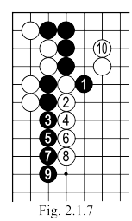
  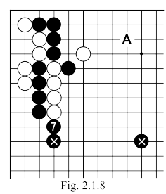
  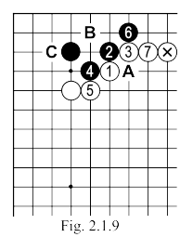
  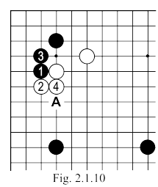

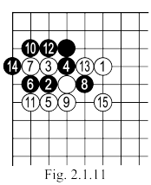  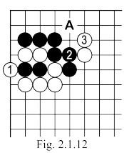 | Fig. 2.1.11. But what happens if, after black 2, white plays HANE at 3 followed by ATE at 5? ... The sequence ending with white 15 would be satisfactory under normal conditions for white, but not here in the situation in the game. After Black 12, White can capture 1with 3 (see Fig. 2.1.12). This should be good for white given the good shape he has now made and that “A” is vital for the survival of the black corner group, and that his central stones are probably not under too serious a threat. Black may play instead of TSUGE at 2 in Fig. 2.1.12, TSUKE at 3 (see Fig. 2.1.13).  Fig. 2.1.13. If after black 2, white plays 3, the sequence to 18 is automatic and a total disaster for white (the black group in the corner can not be killed: white "A", black "B", white "C", black "D", white "E", black "F" or "H" are MIAI to make life for black group).
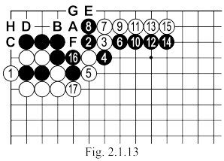
 | Fig. 2.1.14. After 2 & 4 in this figure, black can declare himself to be most pleased.  Fig. 2.1.15. More variations, which may interest us, are possible after 8 in this sequence, but they are inapplicable (for white) in this match, because of black’s SAN REN SEI in the middle. Nevertheless, the curious reader can make a study of this position, starting from the premise that white’s best continuation is “A”.  Fig. 2.1.16. If White would attack with TSUKE, the sequence up to 6 could follow (this last move can also be played at “A” or “B”). In this case the two white groups, whilst not "feeble", cannot be boasted about, nor do they show any great prospects for development
  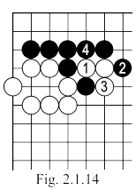 | 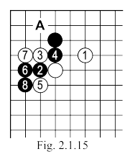
  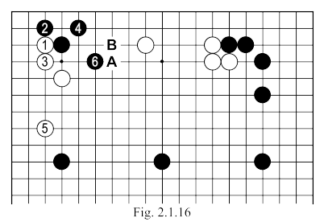

 | Fig. 2.1.17. White can attack the marked black stone after the TSUKE of 1. After the sequence up to 10, which is considered JOSEKI, white can continue with "A" or "B", but given the presence of the marked black stones, white cannot be content with this variation. Moreover, black will have a huge YOSE move at "C", which cannot be answered with SAGARI at "D" as the continuation of Fig. 2.1.18 as simply a disaster for him.  After white plays at 5 in Fig. 2.1.17, black can choose the variation of Fig. 2.1.19 with TSUGI at 1, because the white SHICHO 2, which may follow, would be captured at TENGEN.  Fig: 2.1.20: And to round off the list of possible attacks on the black stone at KOMOKU (but here not too high on the efficiency front) there is the play of OGEIMA; we might expect the sequence to 10 here, after which Black can be satisfied because of his stones in the center of the board.
  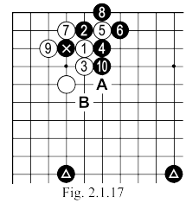 | 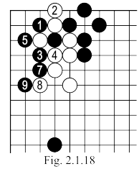
  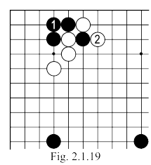 | 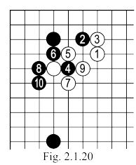
 | Instead of 8 (Fig. 2.1.20), black can play 1 in Fig. 2.1.21, the result for him is then better.  Turn back now to Fig. 2.1.1 and we can see the white KAKARI played in the game at move 8 is faulty, considering our earlier analysis we see the need for a white stone somewhere near HOSHI on the center top edge, if black invades “at B”.  After the sequence up to Black 13, the KATATSUGI 14 should be better played at “A” leading us to the JOSEKI shown in Fig. 2.1.22. In this variation, the two black stones at “A” and “B” would leave white uncomfortable.
  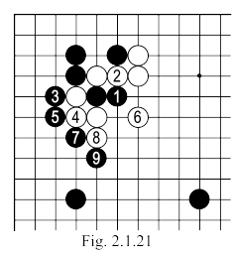
  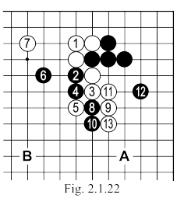

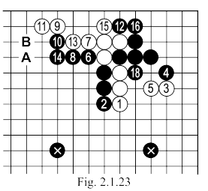 | Neither is the sequence of Fig. 2.1.23 much better because after black 16, white wants very much to play “A”, but the existence of the two marked stones will force him to first manage his group on the right side (for which life is anyway quite difficult and can not be completed without greatly strengthening black there), leaving point “B” as an excellent point of attack for his opponent.  Fig. 2.1.24. This is a common JOSEKI, where white plays SAGARI at 1 instead of KATATSUGI in Fig. 2.1.22; a PONNUKI is obtained, and when black plays 6 (which is itself very great) this will be amplified by the presence of his central REN-SEI's SAN.  So after move 14 in the game, the point “A” (in Fig. 2.1.1) becomes a very important AJI in the white shape, which black can use in different ways.
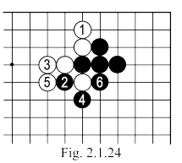
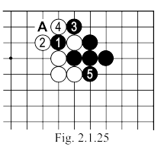 | Fig. 2.1.25. The direct play of 1 is obviously a possibility for black, but in this case, it would leave white the rather elegant continuation of 2 and 4. The importance of the white play of 4 should not be underestimated, for it prevents a possible black HANE at “A” and provides a KO (ultimately) to connect the white stones, reducing a lot of AJI that his opponent would have had here if this move was not played.  Fig. 2.1.26. Black 1 here could be quickly chosen, but this HANE would induce the NOBI of white 2, which would make the latter breathe a sigh of relief.  But what happens if black is plays directly at “A” and makes an invasion on the top side? ... There is nothing good for white anyway.
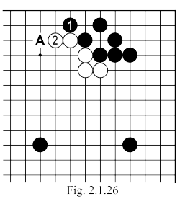

 | Fig. 2.1.27. Here's another method for black to attack (move 1 here is TESUJI), to which White can continue with 2, but black 3 will place him in a delicate situation. If after black 1 white connects at “A”, black can choose between connecting with “B” or attacking with “C” when, depending on white’s response, he might use 1 in a more favourable manner.  Turning back now to Fig. 2.1.1, after the move of black 7, we conclude that there exists a direct link to the white KAKARI in the right corner (top) and point “B”. If White 8 had been played at 9, his task would have been much easier (later) in case of the attack of black “B”. Continuing, after black 13, White 14 is not - despite appearances - an ideal play, he must play at “C” thus inviting the JOSEKI sequence in Fig. 2.1.24 (see Fig. 2.1.28).  Fig. 2.1.28. After the sequence to 7 here, black's center position is very good, but his continuations are not straightforward. An attack at “A” looks necessary, because white’s top MOYO can not be neglected. On the other hand, there is a possibility that at the end white will hold three corners, which again means that this is not a question without importance.
  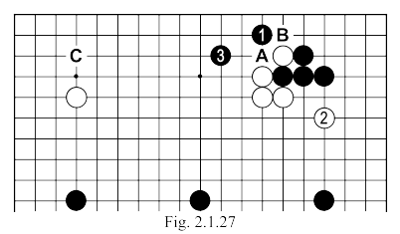
  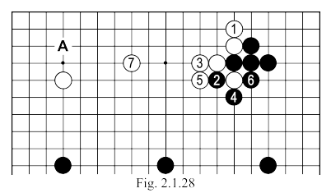
Moves 15-30  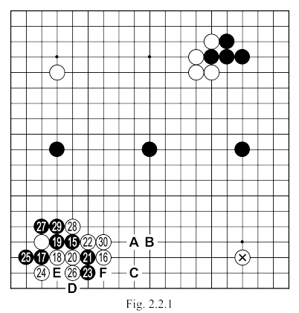 | Black 1: A risky play

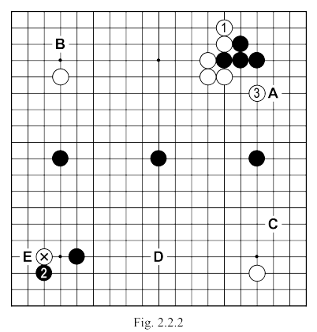 | If white plays TENUKI now, with the SAGARI of 1 in Fig. 2.2.2, Black should in principle continue with “A” (or 1 line to the left), but in this case, white may respond to black’s marked KAKARI resolving in the position SENTE. This would be a great loss for Black, so that he might be tempted to eschew the choice of “A” and continue with 2. In this case though, white 3 would be a very severe move that can not be ignored.
 | Later, White will come back (perhaps) to answer the attack of black 2, but now this would probably mean something like the sequence in Fig. 2.2.3, but rather than just holding the a corner, moves such as “B”, “C” and “D” could be more interesting; The marked stone can still be used even if black would play again in the corner here (say at “E”).  White 2 (in Fig. 2.2.1). This HASAMI would have been more effective at “A” or “B” Another possibility is the direct response of 14.  Fig. 2.2.4. The most common continuation for white after black attacks with IKKEN TAKAGAKARI (the KAKARI stone is marked) are “A”, “B”, “C” and “D”.  Fig. 2.2.5. It would be very naive to hope that, in the whole board situation, after the TSUKE of white 1 that black will play the OSAE of 2, giving rise to the JOSEKI to 6 here (where 6 can also be played at “A”). In this variation black 4 could be pushed to “B” because then 6 could occupy one of the points “C” or “D”.
  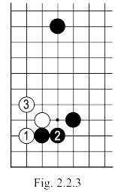
  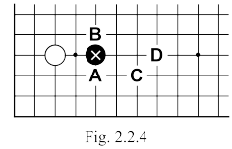
  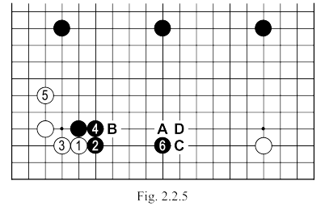

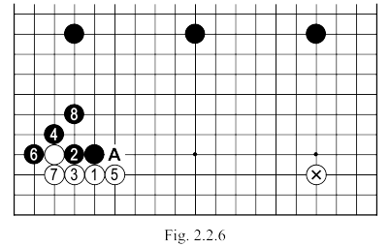 | Fig. 2.2.6. After white 1, black will probably prefer to continue with 2 and 4 in this fashion. White 5 can be played at “A”, but then it will enter the NADARE JOSEKI; played so as to invite the ONADARE JOSEKI, black could not be dissatisfied with the result in this figure after moves 6 to 8. As for NADARE and ONADARE JOSEKI, their study would occupy too much space, so we will confine ourselves to mentioning only that the presence of the central SAN REN SEI destroys what white can get from their complications. With this sequence up to 8 black gets a good position in the center, while the white group on the left and the marked KOMOKU on the right are all on the third line (too low).  Fig. 2.2.7. White 1 here is another possible answer to the marked stone. The sequence up to 7 is JOSEKI, but then white will have to expect a black KAKARI at “A” that will begin a huge and powerful MOYO in the center of the board. Following the exchange 1 to 2, white can also continue with “B” (instead of 3); black should continue “C” and could force the game into some fighting sequences, sequences that will be favourable to him due to his whole board position.
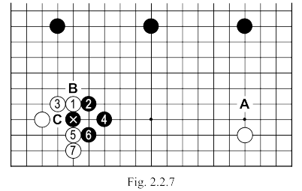
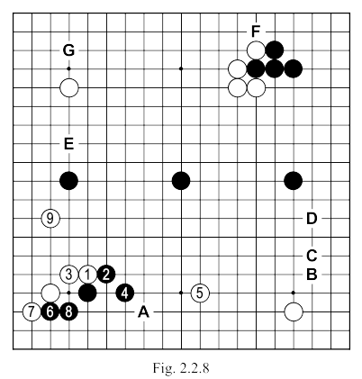 | Fig. 2.2.8. Here's another variation that white could consider trying. Move 5 is a good relationship with the marked stone in the corner, and with the extension of 9, in addition to building the group in the left corner, and approaching the marked black stone, there is also another very hot area, the top side. Following this sequence, white creates many good points in the game for the future (“A”, “B”, “C”, “D” or “E” are only some of them, not to mention the “F” and “G” that we saw before).

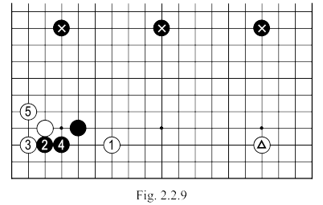 | Fig. 2.2.9. If White plays the HASAMI of 1, black continues with the TSUKE of 2, where 3 and 5 obtain a form with few prospects on the left side, while the stone at 1 will remain in a position too far from the triangled stone in the right corner. The black stones, in contrast, enjoy good support from the central SAN-REN-SEI, which makes the outcome for white far from satisfactory. But it would be far worse if white 3 of this sequence was played at 4 (as in Fig. 2.2.10).  Fig. 2.2.10. The SHICHO here ends favourably for black. Without a stone on TENGEN of course white would come out ahead as a result of this combination, but here this result is disastrous for him. We can therefore draw the conclusion that after black 1, white can not play 2 unless it is there is a favourable SHICHO. White should avoid the SHICHO sequence by playing 6 at 7.
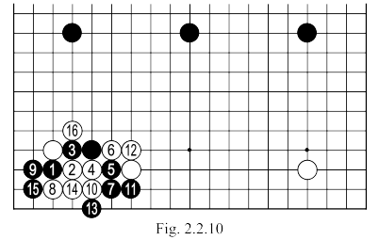
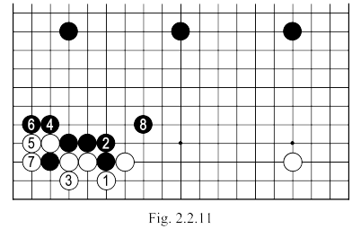 | In the variation of Fig. 2.2.11, with the sequence up to 8, black can get a better result.  Fig. 2.2.12: After black 11 in Fig. 2.2.10, white can play 1 as shown here, and after 2 to 4, black can continue with 5 through to 11, and this result is satisfactory for Black. If white plays 5 at “A” he intends to resist ...
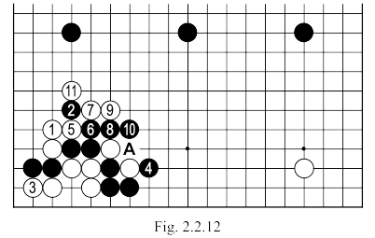

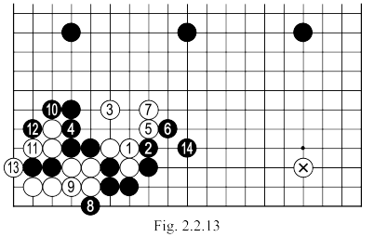 | Fig. 2.2.13. After white 1, black continues with the sequence 2 to 14, then the white group in the centre is in a very delicate position and note his isolated KOMOKU in the right corner.  Fig. 2.2.14. White’s HASAMI of 1 here is another possible response to the attack of black’s marked stone. The situation on the board, after continuing to 12 here does not seem sufficient for white. Additionally black has the possibility of choosing (after white 1) another variation (see Fig. 2.2.15).
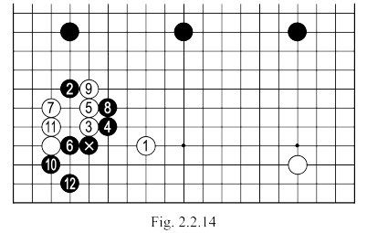
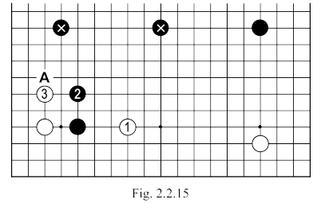 | Fig. 2.2.15. After exchanging black 2 and white 3 here, black can continue with “A” or (given the existence of the marked stones) can start thinking about the best way to attack on the right side.  So we can draw the conclusion, following the reviewed variants, that the only good answer for white to black 1 in Fig. 2.2.1 would be at 14. However if he feels he must play a HASAMI, then to select a wider one (“A” or “B”) because Black would emerge too well from any other (local) continuation, to create a positive relationship between HASAMI and his own marked stone so as to balance the loss that white will suffer on the lower left side. It is a very delicate moment and the continuation will ultimately be made based on the nature and style of each player. I for one would feel pretty bad knowing that if you respond now, here, you will still have to answer almost all attacking moves made by your opponent, so I would seriously consider the possibility of playing TENUKI (possibly playing 1 in Fig. 2.2.2).

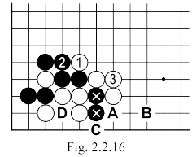 | Black 13 (Fig. 2.2.1): Now we know what should be played (see Fig. 2.2.10 and following figures).  White 14 and 16: Constitutes a bad exchange for white. Compare Fig. 2.2.16 and Fig. 2.2.17 which illustrate the variation played in the match and the correct JOSEKI continuation. In Fig. 2.2.16 white gets a (superficially) better position, through the influence his stones carry to the center (and perhaps especially by not letting black himself occupy this position) but... the black wall that is formed in Fig. 2.2.17 is not particularly efficient, because of the AJI of “A” where white could cut at any time. On the other hand, in Fig. 2.2.16 there remains for white a very bad AJI at “A” (if later Black will be able to take the SENTE point “B” (when white might therefore be forced to respond somewhere else than “A”) there may follow the sequence: black “C”,white “D”, black “A” when the two marked stones are saved, while capturing the white group in the corner).
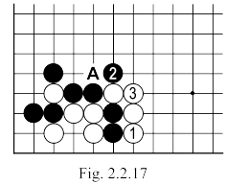
Moves 31-51  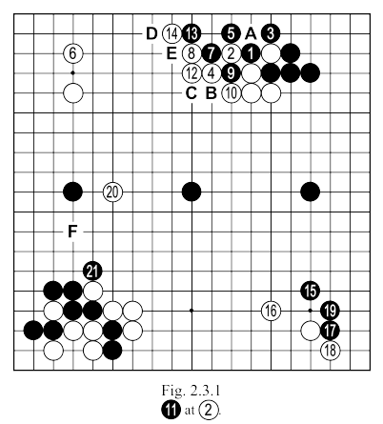 | White 4: Ought to be played at "a" (see Fig. 2.1.25)  White 6: Must be played at 7. However great the SHIMARI he achieves with 6, white can not allow his opponent an attack like the one in Fig. 2.3.2.

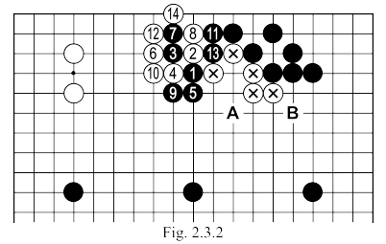 | Fig. 2.3.2. After black 1 here, it is not possible for white to answer at 2 as the sequence up to 14 gives his opponent an enviable position. When Black will attack with a move like “A” or “B”, the chances of survival of the white group will be extremely low. White could play 6 at 7, in which case this will give rise to the sequence in  Fig. 2.3.3.  After exchanging 1 and 2 here, white must play 3, then black will continue with 4 and 6 (speculating that white, lacking KODATE, can not afford to start a KO). At the end of this variation, white’s prospects on the board do not seem bright - especially given that the bottom side is compromised because of the AJI discussed in Fig. 2.2.16.  Fig. 2.3.4. If after the attack of black 1, white answers with 2 as shown here, the sequence up to 7 will be also be favorable for black. 6 can of course be played at 7, but in this case, black “A” is sufficient.
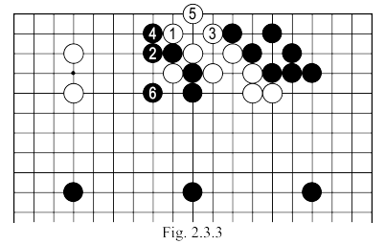
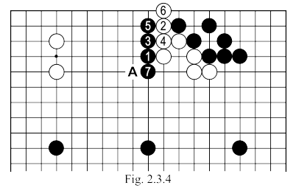 | White 8 and 10 (in Fig. 2.3.1) are not a solution because,  Black 11: better to cut at “B”. White cannot win the KO without losing something big on the left corner (or another area).  White 12: better at “C”. After the move in the game, black is able to cut at “B”, forcing white to capture the stone in SHICHO.  Black 13: Should have cut at “B”.  White 14: With the sequence of 8 to 12, white tried to keep a large territory between these stones and his SHIMARI in the upper left corner, but in doing so he leaves a big AJI that - sooner or later - will be used by black so as to destroy his intention or, worse, forcing him to pay too great a price for what he obtains there. Now, apart from KIRI at “B” which we already saw, white has AJI at “D” and “E”.  Black 21: Maybe it was better to play “F”, ensuring at least 20 points on the left side and in addition - which is even more important - a strong position in this area, allowing for greater freedom in entering the white MOYO above.

Moves 51-78  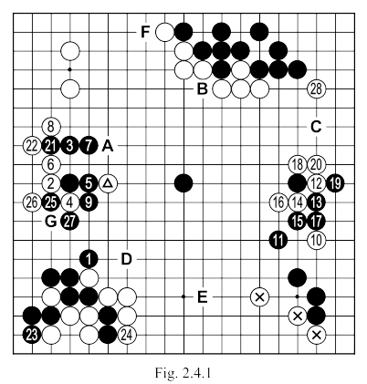 | Black 7: Playing at “A” would have threatened to cut at “B”.  After the sequence to 9, the exchange turns out not to have been particularly advantageous for Black because White has made a profit on the left side (previously an area of influence of black) while consolidating his SHIMARI in the top corner. There is a very effective method in such cases to find out what exactly went wrong within a sequence (see Fig. 2.4.2).
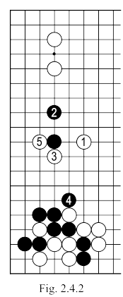 | Fig. 2.4.2: Starting from the initial position in Fig. 2.4.1 where white attacked with move 1, black could answer with 2, and white after 3, black continues with 4, allowing white 5, this turns out to be a mistake. The position obtained is identical to that of Fig. 2.4.1 after white 4, so it can be concluded that in the game, to answer with 1 to the attack of the marked white stone is not good. By thus reversing the order of moves (but starting from the same basic structure) black 4 of Fig. 2.4.2 proves to be inefficient.  White 10: Too brutal, especially now when whites can not afford it. Due to the triangled stone the AJI of “B” is erased (for now) but the three marked white stones remain very weak, making a direct attack on the three neighboring black stones to be ineffective. In fact, the continuation in the game will show that white’s AJI here will be pertinent to the battles that will take place in the area, forcing us to remember another basic principle of GO : make yourself strong before attacking.

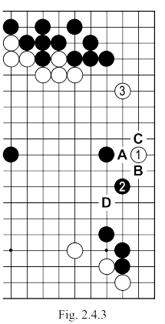 | White 10 (again): In terms of the invasions that this move offers ... Generally in such situations, white 1 in Fig. 2.4.3 is an ideal attack. Black “A” is one of the possible answers, after which white plays “B” or “C”, these points being MIAI (if white “B” " black “C” and vice versa if white “C” black “B”). In this case, after white 1, black “A”, white “B”, black “C”, a move like white “D” would be very severe, so after white 1, black may prefer to respond with 2, after which white could extend (perhaps at 3), obtaining a good result in the top half of the right side and still preserving points with AJI on the lower side that can be used later. The sequence up to 18 in Fig. 2.4.1 leaves black with a strong group, which makes the AJI in the three marked white stones more dangerous (Compare with the AJI discussed in Fig. 2.2.16).
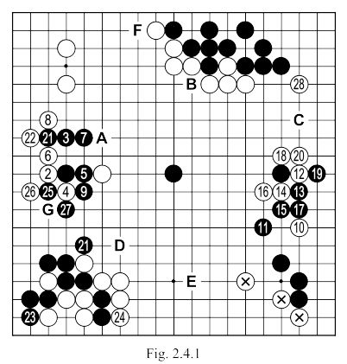 | Black 19: Bigger would have been a move in the top corner (perhaps “C”).  Black 23: A big mistake. In forcing white 24, black eliminates an important AJI without any benefit (his gain on the left side is only 7-8 points, whereas white now potentially has much more on the bottom).  Black 25 and 27 are too low. There are better points on the board to play (“C”, ”D”, ”E” or “F”). Locally on the right side, black should have played 25 at “G” and if white connects at 25, black 27.

Moves 79-108  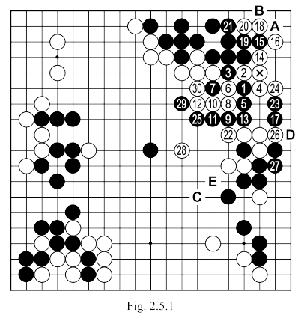 | Black 1: Here is a situation that we encounter very often in the game of GO. The last play by white was the marked stone, and it is a big loss for Black in this area.
 | If Black would respond otherwise (see Fig. 2.5.2), he could keep 8 to 10 points in the corner, but would make white’s reduction SENTE (for the remainder of the game). In Fig. 2.5.3 if after the marked stone is played, imagine black does not respond (in the meantime with “A” or “B”) to white 1, for it possible to play TENUKI (this is the advantage of living groups, to not have to answer any opponent's attack). The difference between the two versions can be 15 points for white, but let's not forget that in the meantime black won two moves in other parts of the board (two TENUKIs) that will fully compensate for the loss in this corner.
  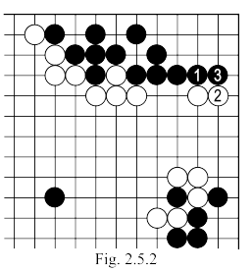
  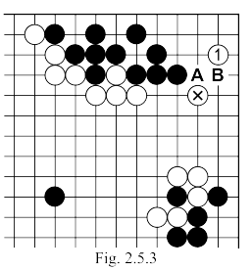

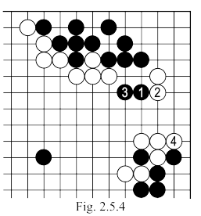 | Here black 1 (move 79 of the game), is a possible option, but the timing is not right. If white had continued quietly at 2 and 4 in Fig. 2.5.4, his group would be stabilized and black 1 can be seen to have been ineffective.  White 2: Should be played as in Fig 2.5.4.  White 6: An aggressive move, but before attacking, ensure you are strong.  Black 7: In the sequence of Fig. 2.5.5 white is divided into two (black has “A” capturing a stone, or the extension at “B” from his own group).
Fig. 2.5.5
< It has not proven possible to recover the original position from the text, nor to make a reliable guess as to its nature >

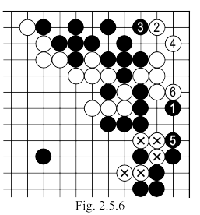 | Black 15: Should be played as in Fig. 2.5.6.  Fig. 2.5.6. After Black 1 here, white will be forced to make life in the corner with 2 and 4, and after Black 5 White 6 is still required. In this way, the black ends in SENTE and will have no problem capturing the five marked white stones (-).  White 16: A mistake. If now the black blocks at “A”, white 18, black 20, white “B”, now white’s corner would be alive in KO (The KO is bad for white because black has nothing to lose here). To live unconditionally, white should have played as in Fig. 2.5.7.

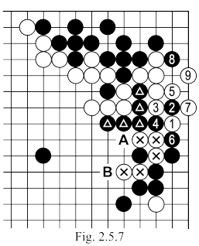 | Fig. 2.5.7. With the sequence up to 9 here, white makes life. Let us compare the result here with the variation of Fig. 2.5.6. Apparently, in Fig. 2.5.6 white gets a better result, if we consider the 8 points you earn in the corner (compared to Fig. 2.5.7). However, there is an important difference between the two positions, namely that in Fig. 2.5.6 all the black stones on the side are connected, whereas in Fig. 2.5.7 the triangled stones are isolated. This does not mean, of course, that he would be in danger, because “A” captures three white stones, but it does mean that he WILL HAVE TO BE PLAY ONCE here (or another move with the same intention - possibly “B”) while in Fig. 2.6.6 locally black can afford a much wider move, with a higher profit - accepting that we are only talking about the local situation. In Fig. 2.5.6 however, black can even afford something much more serious, which is to play TENUKI, ignoring this area. For white trying now to save the marked stones would be tantamount to suicide: the AJI of these stones is absolutely minimal.
Moves 79 – 108 | In Fig. 2.5.7 black is not ABSOLUTELY CONNECTED, as he is having some AJI which white could possibly use later. Overall, however, in either of the two versions, the result is very bad for white. He managed to live in the upper left corner, on the right, but he obtained this only from an attack that directly strengthened black on the right side (and we must not forget that white is very weak on the bottom side and strengthening black around there can only do harm).  Black 19: Anything but this! Better at 20 or just TENUKI. This move just loses SENTE without any benefit.  Black 25: Better at, or around, “C”  Black 27: Can be played at “D”.  White 28: This stone, played at “E”, would allow better chances to make SABAKI.  White 30: If white’s middle group will end up captured, this move will be proved to have been extremely small.

Moves 109 – 158  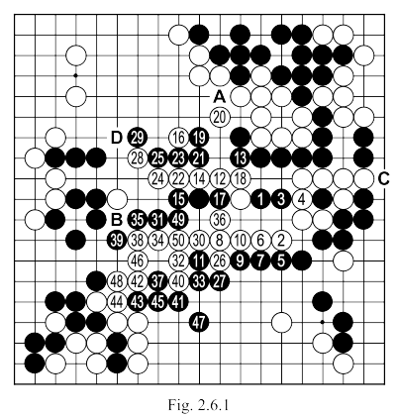 | Black 5: Must be played directly at 7 (see Fig. 2.6.2).
 | Fig. 2.6.2: After Black 1, white can try to escape with 2 and 4, but black responds calmly at 3 and 5. Now it is hard to believe that white can save the group. Notice the difference between this variation and the one played in the game, there white is a step ahead (see the exchange white 6, black 7 for example). Pay attention to black 5, which should not be played as the brutal “A”, leading to the sequence of Fig. 2.6.3 where we end with an exchange: the central white group is captured, but black must give the 3 marked black stones and with them the corner.  Fig. 2.6.3. Following the sequence up to 12, black will have to connect at “A” and white will defend himself against the cut of “B”. If instead of “A” black would play at “B”, the triangled white stone can be sacrificed, allowing black to live in the corner in return for capturing 7 black stones on the side.  White 8: Wrong because it allows black to cut him.  Black 9: Better to cut at 10 (see Fig. 2.6.4).
  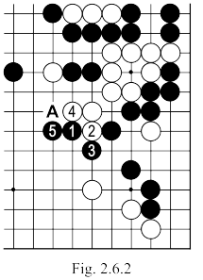 | 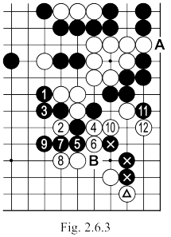

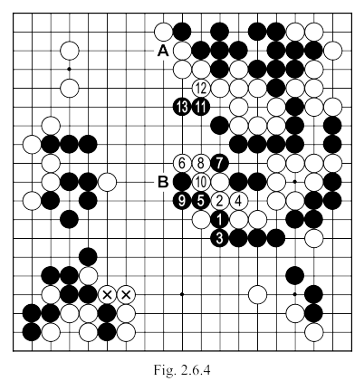 | Fig. 2.6.4. If Black plays 1 here, the sequence up to 13 could follow, after which the white group is again forced to run (and do not forget that there is a very bad AJI for white at “A”). If black 9 is played at 10, then white “B” will create a SHICHO that ends at the 2 marked stones.  Black 11: Too late. It would have been better to play KEIMA at 13. Played thus, it only destroys AJI in the shape.  Black 19: Permitting the defense of 20, and destroying an important AJI: “A”.  Black 39: White can no longer be stopped from connecting these two groups, so this move is better played at “B” to make a secure connection. Do not forget that black is not yet connected to “C” and that, therefore, white can play “D” threatening the black group in the center while a staking out territory in the top left. Actually 39 leaves an additional AJI for black, at “B”.  Black 49: Useless. Later it could have been a possible KODATE; played now, it does nothing, black can be satisfied that his move receives an answer (but unfortunately this counts for nothing at the end of the game).
Moves 159 – 170  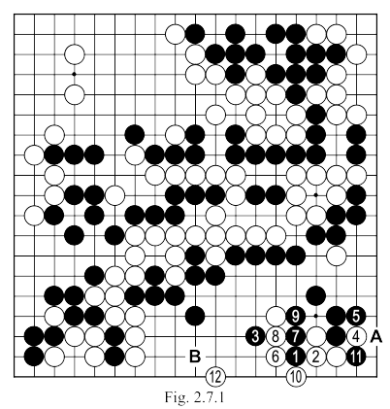 | White 2: Mistake, but in fact white has no good response to the attack of black 1.  Black 3: Played at 7, there is no hope left for the white stones.  White 6: Should be played as in Fig. 2.7.2.

 | Fig. 2.7.2. With the sequence up to 7 here, white makes life. Black has to take care to play 4, if it is not played, then white 4, black “A”, white “B” and the white group lives. If black 2 is played at 3, we can reach the sequence of Fig. 2.7.3, after white 15, white again makes life.  In the latter variation, white should not be tempted to answer black 12 by connecting at 14 (see Fig.2.7.4). There, if white connects with 1, black will continue with the HORIKOMI of 2 and TSUGI at 4. Now white has no better than 5, but black 6 and 8 will leave him in DAMEZUMARI.  There was “A” at the end of the sequence of Fig. 2.7.3. This was white’s last chance to survive here. And since we are talking about of Fig. 2.7.3 it is interesting to note that if black plays 14 at 15, then white’s only correct answer is to play at 14 (see Fig. 2.7.5).
  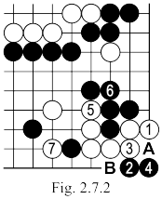 | 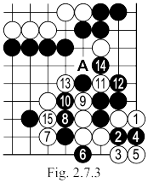
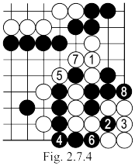
 | Fig. 2.7.5. With the sequence up to 4 here, white captures four black stones making life. If white 2 was the capture of 3, there should follow black “A”, white 4, black “B” and now white can only continue with “C” and accept to fight KO.  Black 10: Now SAGARI at “A” no longer works (see Fig. 2.7.6) so this move does not save anything.  White 12: There is not even the slightest chance for white to make the connection between his two groups, so if black wants to reduce the profit on the right side then a move like “B” would have been more appropriate.
  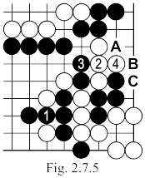
  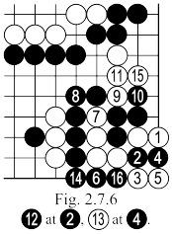

Moves 171-190  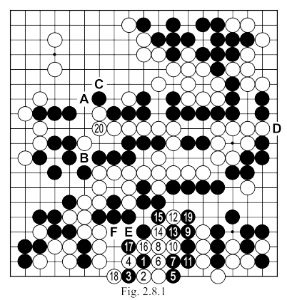 | Black 3: First NOBI at 4 and then HORIKOMI (see Fig. 2.8.2).  Black 5: Better at 7 (see Fig. 2.8.3), white 10: at 13, then black can not directly block at 12, because of white 10; So white 13, black 19, after which white can play elsewhere. Later, when the time is right for this move, white 10 will be in perfect SENTE (black is obliged to respond to 11) and also (possibly later) white 12. Move 16 is GOTE for both players, it can be left until the end, as it only has a value of 3 points (in GOTE).
 | White 10: Another option would be 12, followed by black 13, white 14, black 15 and white 16; black then has to continue with 10 and white will play “E” and if black connects, then “F” in SENTE.  In this case you can gain one point more than in the game. Here, then, is how, paradoxically, after a move that was not played in perfect SENTE (move 10 in Fig. 2.8.1), that white still stands ahead: further proof that in GO it its never clever to waste (not only) SENTE moves, thinking that opponents need to respond. Beware lest his defensive play is not accompanied by a profound "thank you".  White 20: Playing at “A” would also threaten “B” but... if Black will respond with “B”, White can continue with “C” forcing black to respond with “D”.
  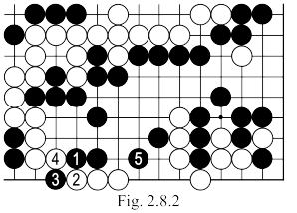
  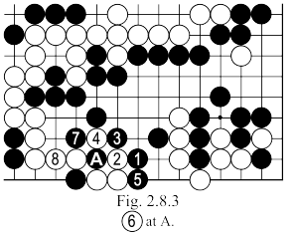

Moves 191-214  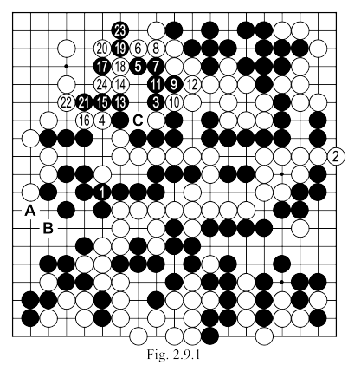 | White 2: Thoughtless. White can not hope to capture the black group. Since black is about 15 points ahead on the board, there is only chance for white to restore the balance, getting a huge territory in the left corner and possibly occupying the point “A” (or “B” to force a KO).  Black 3: Can be played at 4, without worrying about a cut at “C”. In such a case, any attempt to cut by white would fail because of the AJI in that area left over from the beginning of the game.
 | Fig. 2.9.2. Beyond linking his groups, black 1 has the advantage of protecting the two cutting points of “A” and “B”. If white tries to cut at 2, black is able to remove any trouble with the sequence starting at move 3. More elegant is to play 3 directly at 8, then if white continues with 4, then black 5 and then GETA at 7 will be enough; 3 can of course be played at 5, and if white 3, black, 9 and 11.  White 14: Does not kill the black group, so it was better to play at 18 in order to take as many points in the corner as possible.  Black 17: It could be at 18 (see Fig. 2.9.3).  Fig. 2.9.3. After black 1 here, if white tries to flee with 2 and 4, black will capture, after move 5, the whole white group on the middle of the top side.
  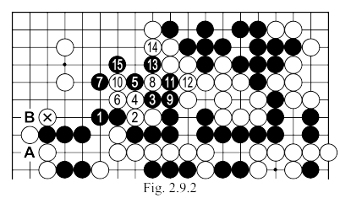
  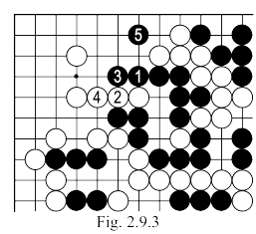

 | Black 19: The fatal mistake, after the sequence that ends with white 24, black is forced to resign. Should play as in Fig. 2.9.4.  Fig. 2.9.4. Following move 1 here and the sequence up to 4, to continue, black must play KIKASHI at 5 and then 7: this TESUJI makes life no matter what white may try…  Fig. 2.9.5. If after black 1 white pushes at 2, the sequence will continue up to 5, and after white 6 he has to make life (if white would try to play at 7; black 12 will start a SEMEAI he cannot lose). In the continuation all the responses of white are forced and black makes life in the corner. If white 4 was played at 6, black would answer at 4 then play 11.
  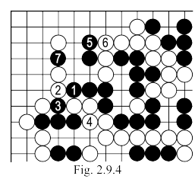
  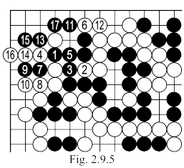
 | Fig. 2.9.6. If white plays at 4, then after the connection of 5 he still has to make life, and a move at 6 is one try to do so. Black should respond now with SAGARI at 7 (threatening. “A”) and then 9 capturing the marked stone. If White 8 is played at 9, for black; “A”, if white insists with “B”, then black 6, white “C”, black “D” after which white will lose the SEMEAI.  Fig. 2.9.7. White 2 here is another possible response, launching the sequence to 6, followed by SAGARI at 7. If white now connects at 8 Black will get life by playing 11. If white 8 is instead played at 9, then black 8 white 10, black “A”.
  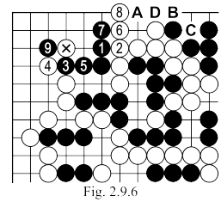
  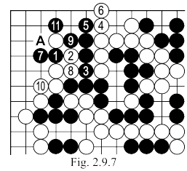

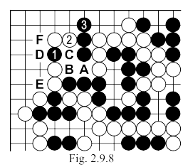 | Fig. 2.9.8. After exchanging 1 with 2 here black will continue with SAGARI at 3 and if white “A”, black “B”, white “C”, black “D”, white “E”, black “F”.

