Game 3
 | Komi: 5.5 points  Time Limits: 1.5 hours  Tournament: Cluj-Napoca, 1–3 May 1987
  SCHMIDT Walter (Timişoara), 3 DAN | BACIU Radu (Bucureşti), 4 DAN
Moves 1 – 23  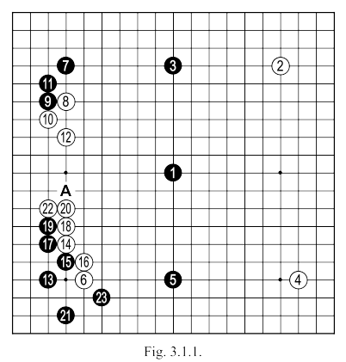 | After White 14, in the lower left corner a position is created which we discussed before (see Fig. 2.1.3 and later). The sequence played in this game is JOSEKI, generally black 15 is played directly at 17,to not give the possibility to white to himself occupy this point. If after 15 white does play 17, black will not be able to push at 16: white has the choice between playing NOBI or IKKEN from the stone at 6, or occupying the point “A” - leaving the stone at 6 to fend for itself, it's still having a lot of points of AJI, even if black will continue with OSAE at the right side of 6 (perhaps white can begin something, starting with a move at 23). In a normal situation, white could consider a variation of this kind, but, in our actual case, the three black stones in the middle of the board would make any possible development more difficult.
 | Fig. 3.1.2. After black 1 here, white could respond with "A" or "B".  Fig. 3.1.3. After white plays the OSAE of 1, black KIRI-CHIGAE at 2 becomes a very strong play, the sequence ending with 12 produces an interesting fight. White 5 could be played at "A", black 5, white "B", but in this case the SHICHO is not favourable for white. If black 6 was played at 7, white can descend with 6, obtaining more profit in the corner.
  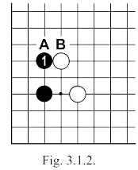
  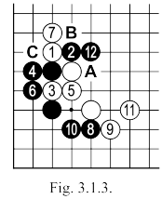

 | Fig. 3.1.4. White can respond quietly to the NOBI of 1, after the marked stone, triggering the JOSEKI up to 7. If black 2 is played at 6, white could choose another variation shown Fig. 3.1.5 or Fig. 3.1.6. The latter could have been played in the game (after black 19), but it would have placed at risk my 3 stones at the top (8,10,12), since the position of the central black SAN-REN-SEI could not be worse. Additionally, in such a situation, the resulting white group in the left (bottom)), will not have good prospects for making territory, since the black HOSHI is present in the middle of the bottom side.  Fig. 3.1.7. After white 3 in Fig. 3.1.4 if black pulls back with 4, white can continue as in this new variation, when it is absolutely necessary for him to play 3.
  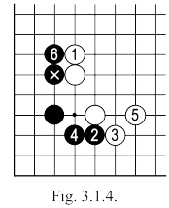 | 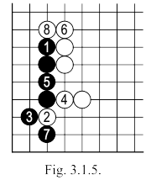
  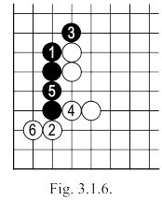 | 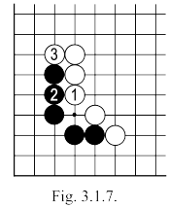
 | White 18: Normally it is possible to play 19, according to the JOSEKI shown in Fig. 3.1.8, but in the game the white stones of 8 10 12 are thick  Fig. 3.1.8. Here, then, we see the correct beginning of the JOSEKI (in the game black 1 and 3 are reversed)  Up to white 8 everything looks normal, but instead of black 9 one could be tempted to play "A" (see Fig. 3.1.9).  Fig. 3.1.9. After black 1 here, white plays 2 then 4 and 6, threatening "A" (which captures 2 black stones) or 8, which starts a SHICHO. If the SHICHO is working, the damage is so great for black, that he can resign the game at once. If the SHICHO is not working for white, he could continue with 13, which will give him a more than satisfactory result.
  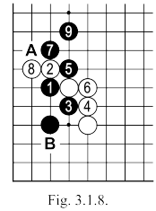
  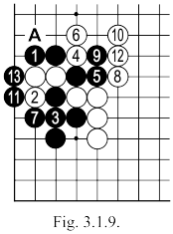

 | Fig. 3.1.10. After black 5 from the previous figure, if the resulting SHICHO is not favorable to black, white can play more severely here with 1 then black 2, white 3. If we continue with black playing 4, exchanging 5 and 6, white can quietly connect with 7, saving his three marked stones (in the case that the SHICHO at "A" does not work). If black 4 is played at 7, the situation will not change very much (see Fig. 3.1.10, 3.1.11).  Fig. 3.1.11. After the sequence up to 4 here, black 5 can not connect with "A" because white "B" will capture in GETA the two marked stones. Turning now to Fig. 3.1.8, white has a very nice move at "B" (see Fig. 3.1.12).
  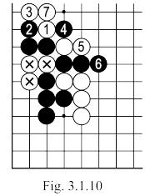
  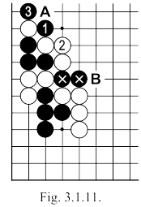
 | Fig. 3.1.12. After this white 1, black is not able to block directly at 2, the followup sequence up to 13 is automatic and leads to a catastrophe for him. Following white's move, black can only chose the variation in Fig. 3.1.13 and rush to capture the two marked stones (which white did not forget to use with his move 3) Black 6 can be TENUKI, but white 7 and 9 bring a nice profit in SENTE.  Fig. 3.1.14. To avoid the difficult complications of the last sequence, black can play HANE(move 1 here), in place of 5 in Fig. 3.1.8. The sequence which follows can be considered JOSEKI and ends with white 10. During the game I considered that this would be one of the possible results if I played 18 (in Fig. 3.1.1.) at 19, resulting in that position
  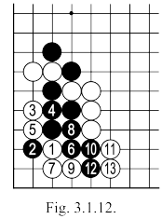
  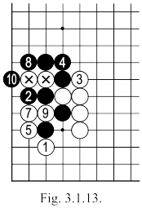 | 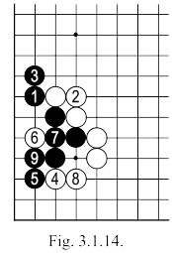
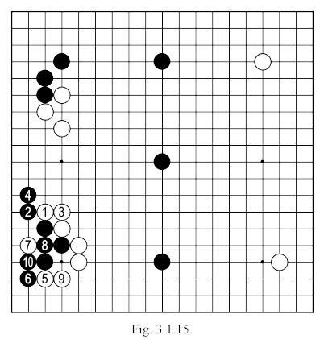 | Fig. 3.1.15. Following the sequence up to black 10 in the previous figure, move 11 becomes a difficult choice for white. For the moment, we have not found a satisfactory move for this position (and I still do not know where it could be best played), so I played NOBI with 18 and 20, followed by MAGARI at 22 to obtain a more secure position.
Moves 23 – 52  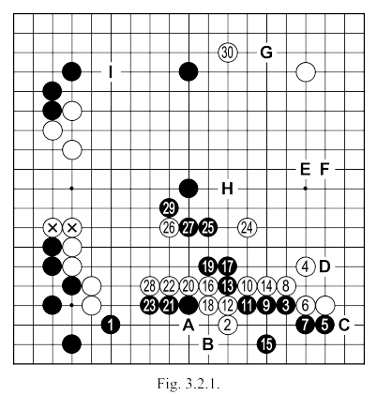 | White 2: For this move, the area of the right corner seemed the most urgent; a simple SHIMARI would be just too slow, even if I made an OGEIMA SHIMARI, so I chose 2 as it was more aggressive. If black responds prudently with "A" (or an equivalent) I have the opportunity to make a SHIMARI or to play IKKEN TOBI at 13, inviting an invasion.  Black 3: A little too brutal. Maybe it was better to play something like "A" or "B" and if white plays 13, black can choose between making an invasion or to reserve for later a reduction of white's MOYO, from his strength.

 | White 6: Another possibility here is "C" (in the sequence shown in Fig. 3.2.2) in the sequence in the game, white focuses more towards the centre, but he leaves a bad AJI at "D".  Fig. 3.2.2. After white 3 here (which could be played at "A"), the marked stones work very well with the aid of point "B", if black tries to attack this side, white "C" is a severe counterplay.  White 10: Could be played at 13.  Black 15: If it was played at 16, it could launch the sequence in Fig. 3.2.3. where white obtains life on the side. If here black 15 was played at 18... (see Fig. 3.2.4).
  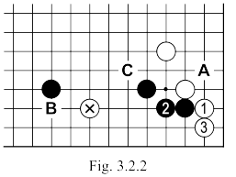
  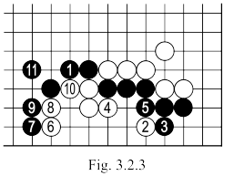
 | Fig. 3.2.4. After black 1 here, white can continue with the sequence up to 10, threatening to live in SEKI (if white 11, black "A", white "B", black "C", white "D", black "E", white "F").  If black counters with 11, white plays 12 and 14, then 16 and 18, threatening "G" and "H" freeing the threatened group.  Black 3 can be played at 4, a move that could bring the response of white SAGARI at 2, as in Fig. 3.2.5.  Fig. 3.2.5. Now black 3 must still be played (if Black would play at 4, for example, white 5, black 3, white "B" and the last move captures because of DAMEZUMARI).  After White 6, the group can come out (or live), black must wait to cut at "A" because of the AJI at "C" (black "A", white "D", black "E", white "F", black "G", white "H", black "I", white "C").  Black 15: It seems better to chose the idea of variation Fig. 3.2.3 (see Fig. 3.2.6).
  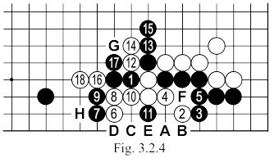
  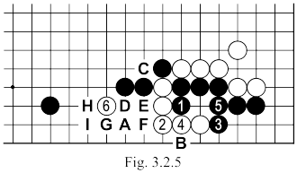

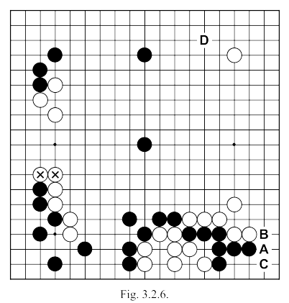 | Fig. 3.2.6. Here we see the board after move 12 of white in Fig. 3.2.3. To continue, Black will have to play "A" followed by white "B" and then black "C" to secure the corner (this sequence creates AJI in the white shape above). Now white probably will feel obliged to play somewhere in the middle right side giving Black time to play "D". In this way, the situation on board would have remained balanced, but in the game, allowing white to play 24 and then 30 (see Fig. 3.2.1), black begins to cede, little by little, the board.  White 28: Another possibility would have been 29, but if Black would answer at "H" then I would be forced to play on the right side, which would have allowed Black to continue at "G" - which is not comfortable for me.  White 30: Could be played at "E" or "F", but I would have left black the chance to occupy the beautiful point "G". Additionally, we should take into account the fact that in the top left corner as shown here, the JOSEKI played is incomplete from the black perspective (white has the two marked stones as an extension, while black does not have a stone at "I" - see Fig. 3.2.1.)
Moves 53 – 74  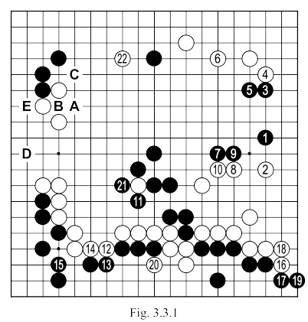 | Black 7 and 9: There are more important areas. One idea to try for example black "A" white "B" black "C".  An invasion at "D" could also bear fruit (see Fig. 3.3.2).  Black 15: This defense is not absolutely necessary.  12 and 14 are not an efficient connection for these groups, with only a possible further reduction of 4 to 5 points of black territory, in the event that move 15 is not played here.  Basically then, black 15 is a 4 to 5 point GOTE move.  White 16: Too small (as are the moves in the following sequence, up to and including black 19).  Black 21: Far too small. Until now there have been many mistakes on both sides, but this is perhaps the greatest one. By allowing white to attack first with 22, black now loses any chance of winning the match.

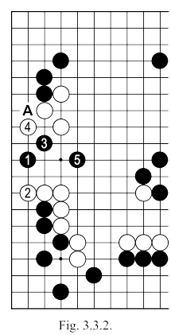 | Fig. 3.3.2. After black 1 here, white 2 blocks the connection, but black 3 gives another threat to link at "A". Finally, with black 5 the white stones are separated into 2 groups which are heavy (without mentioning that the white MOYO is destroyed here).
Moves 75 – 112  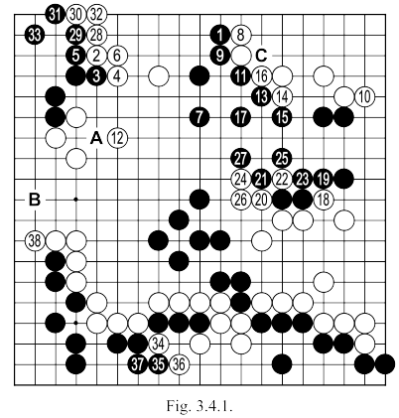 | White 12: Removing the aji of "A", and preventing the invasion of "B" (Fig. 3.3.2). Only now I did I notice that possibility for black and had to pause operations in other areas, in favour of this one. I was asked why I did that, since my partner seemed not to have noticed this attack. The answer is simple: In GO we cannot count on the fact that your opponent will never will see some move. This would be a mistake, in all respects. The strength of a player is not only defined by his good moves, or by the number of mistakes he makes, but by the median of the two. The moves of a 5 Kyu for example, may include moves that might just as well have been played by a 2 Kyu or 1 Kyu, and poor moves, that would not even be played by a 10 Kyu. We can never predict whether the next move of our partner will be good or bad. If it is bad that means that we have escaped; but if it is good?

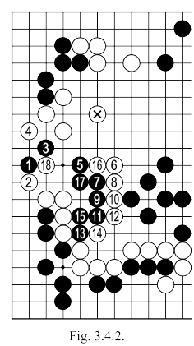 | Fig. 3.4.2. After White 6 here, because of the marked stone, black can not hope to come out on top, all you can try is the sequence to 17, but 18 would take away white's hope. If black 7 is played at 8, the sequence of Fig. 3.4.3 will follow, which also end in failure after white 8.
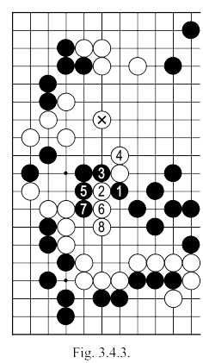 | Black 13: Better at "C", probably triggering the sequence of Fig. 3.4.4, where black captures two white stones in SENTE, with the further possibility to (perhaps) play 11 and to even keep some of his central territory.
 | 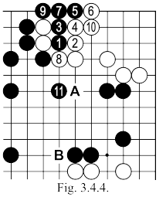 | Black 15: He still could play "C". A Japanese proverb says: There is no territory in the center.  If black 7 is played at 9, White will ignore the connection 10 (inviting an possible KO) to play "A" (or even a space below), which in combination with the AJI of "B" will bring more trouble to black than he could create by playing ATE at 10  Black 35 and 37: Too small, almost useless.

Moves 113-172  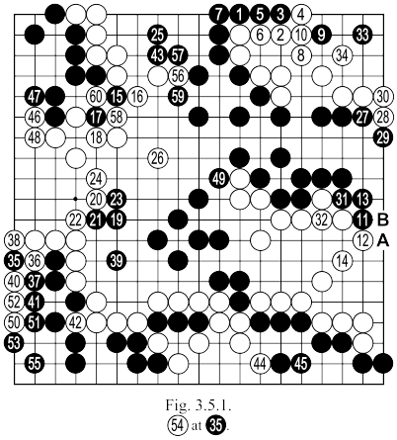
  White 2: It is not possible to block with 5 because the sequence of Fig. 3.5.2, but better was 6 which was saving two points (those occupied by stones 4 and 8).
  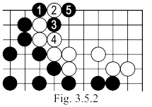
  White 8: Better directly to 10, so as give fewer KODATE.
  White 14: Better was "A" completely closing the territory and allowing later white "B" in SENTE. In the game (Fig. 3.6.1), the exchange white 54, black 55, white 56, will be played in GOTE and the current movement 14 will prove to be absolutely useless on the board.
 | White 28: Too small (three points in GOTE). Better was 52 or 41 (see Fig. 3.5.3 and Fig. 3.5.4). The difference between these two variations is two points. After Black 8 of Fig. 3.5.3 TENUKI could be played, but if White plays 8 (threatening "A"), black must connect at "B".  Black 39: Should connect at 40.  Black 43: Should block at 52. White can now win here 3 to 4 points in SENTE, points that black cannot recover after his move at 43. It was perhaps bigger to play black 48.  Black 45: This answer is absolutely obligatory. If black plays TENUKI, white would immediately attack with 1 in Fig. 3.5.5.
  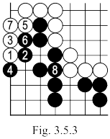 | 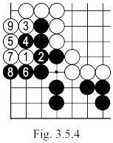
  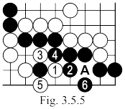

Moves 173 – 233  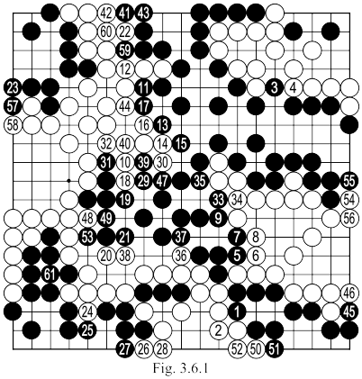 | White 4: Too small.  Black 23: If everything is GOTE, it is better to play directly 57.  Black 53: A 1 point GOTE move. Black 56 is worth 2 points. After 62 white (move 234 in the game) game is completed with an advantage of 7.5 points in favour of white.

