Black: CALOTĂ Lucreţiu  (Braşov), 2 DAN | White: BUTNARIU Alexandru  (Bucureşti), 1 KYU | Komi: 5.5 points  Time Limits: 2 hours main,1 minute Byo-Yomi  Băile Herculane, 1987

Moves 1 – 40  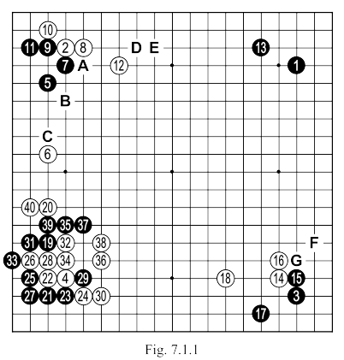 | White 6: The more common response in this situation is "A" (aiming at "B" or directly "C").  White 8: Another possibility is to play as in Fig. 7.1.2.  White 12: It was better at "D", to not allow black a much better attack at "E" (considering the black stone 1 in the right corner).  Black 19: Generally, this JOSEKI is continued with black "F" ( else white "G" would be too strong). Now if black wants to attack the stone at 4, he must play at 30. As played in the game, black 19 allows the ideal response of white 20.  White 22: Instead blocking at 23, we would be likely to play the sequence in Fig. 7.1.3 and the result for white would have been much better.  White 24: Should be played at 29. Given the presence of 19, blocking like this it is not the right attitude.  White 26: It was still not too late to play 29 (see Fig. 7.1.5).
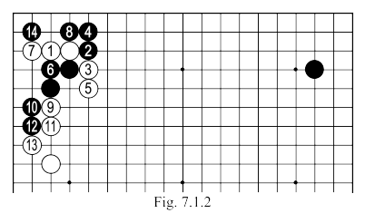 | Fig 7.1.2: The sequence up to 14 is considered JOSEKI, white sacrifices 3 stones in the corner to obtain outside influence.  Fig 7.1.3: The sequence up to 7 here is JOSEKI, and the white wall that is formed is working well with his own triangled stone (and the local white shape). Black takes the left corner, but white gets a strong central influence, while strengthening his two marked stones. For comparison, look at Fig. 7.1.4: the result which should have been obtained after move 22 in the game.
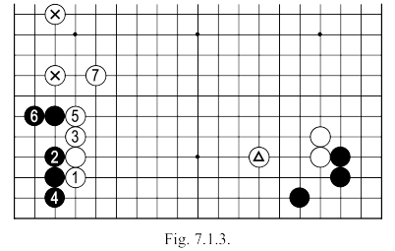
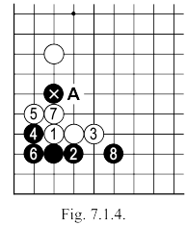 | 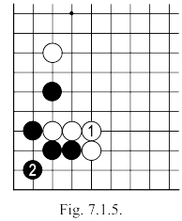 | Fig 7.1.4: In this variation, not only does black obtain a good position on the lower side, but his marked stone (in the absence of a white stone at “A”), could cause further trouble for his opponent. In addition, observe the relationship between the three white stones on the right and the group of the same color on the left side, the relationship is completely worse than in the variation of Fig. 7.1.3.  Fig. 7.1.5: After the exchange of moves up to 3 here, the result is better than in the game.  White 28: Better at 29 (see Fig 7.1.6).  Fig. 7.1.6: If after 1 here, black cuts with 2, then the sequence up to 9 is automatic, and white can be pleased with the strong wall he makes.  Black 29: Better at 30.  After Black 39, White's position is quite bad: he is separated, and his group on the bottom left side is "heavy" (a group of ten stones that captured one stone of the opponent and whose influence is limited).
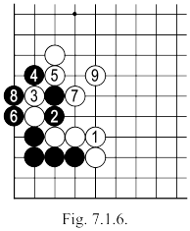
Moves 41 – 81  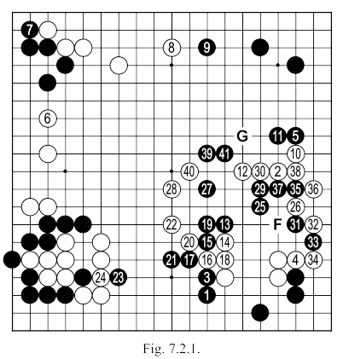  Only the labels F and G could be discovered in this figure. |  | White 6: White shouldn’t have played here, he invites black 7 giving convenient stability for black's group. Closer analysis of the position would, probably, be necessary now (see Fig. 7.2.2).  White 10: As played, it strengthens black; leaving weaknesses in his shape. After 11 and 12, white can now play a move at "A", but this would mean, of course, that black would be strengthened on the top side, obtaining too much profit. It would have been better to play "B" or even 38, strengthening his own shape and preparing for a future invasion (or of a substantial reduction) of the black MOYO.  Black 19: Would have been better at “C” and if white continues with “D”, black can choose between “E” or another point on the board (leaving “E” for later)  Black 25: Start with 27 and, after breaking into the center, you can search for an efficient way to use the weakness in the opponent's group. Played so, this move strengthens white exactly where, later, black could have attacked.

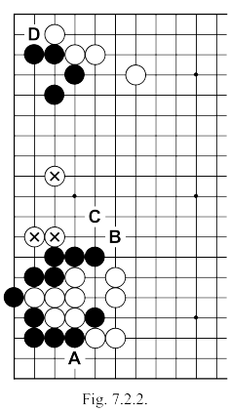 | Fig. 7.2.2: Here is, then, the position of the left side of the board, before white's move 6 in Fig. 7.2.1. (move 46 in the game).  From the perspective of territory this area is neutral, there are groups of both colours which for each, in the game, will bring a number of points. Right now there are no big moves here, to ensure a real profit. It should be noted, however, that if white plays at "A", black has only one eye in the corner, and will therefore have to go out into the middle ... but what would happen if the center would be blocked? To block the center, white doesn't necessarily need to play "B" and "C": other moves (even distant ones) that would hinder black making a second eye would be useful. A similar story can be told of the black group on the top, if white would plays "D". At this moment, any attack would be premature, but later …  Everything discussed so far can make an excellent game plan for white to proceed, but with one condition: not to touch (from a distance) the current position of black on the left side of the board, so as not to make it stronger. Meanwhile, if black plays there first, this will mean that he has to not play a move elsewhere in the board, which would bring a higher profit (because the marked white group is flexible enough to be able to ignore at least one attacking move against him).
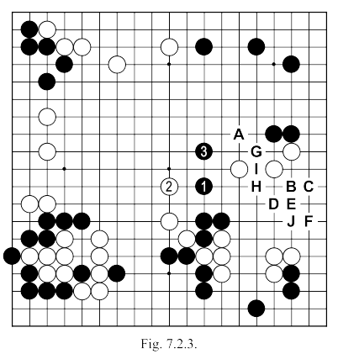 |  | Black 29,31, and 33: Better directly at 39. These moves serve to make white completely connected without bringing the slightest benefit to black. Assuming that black plays (after the exchange of 23 and 24) as shown in Fig. 7.2.3 …  Fig. 7.2.3: If after black 1 here white continues (as in the game) with 2, black will extend to 3. Now "A" becomes very important, if white takes this point then "B", "C" "D", "E" and "F" are all good points for a possible attack (not to mention "G", which threatens a double cut). In the game, black has finally played moves 1 and 3 here, but meanwhile has blocked his access to the right (I refer, of course, to the type of access which allows us to take profit, and not merely the reduction achieved in the game, for instance after black 3, white "A", black "H", white "I" black "J"). If after black 3, white makes a base somewhere on the side, black "A" gives more than satisfactory compensation.  White 34: Mistake. Had to play "F" (see Fig. 7.2.4).

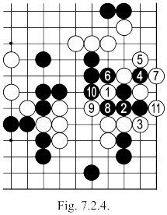 | Fig. 7.2.4: White 1 here and the sequence that follows is the only way to keep white's groups connected.  Black 35: Should be played as in Fig. 7.2.5.  Fig. 7.2.5: After black 1 here, the four marked white stones are separated in the sequence shown: or by the sequence black 1, white 3, black 2. After black 5, white can try "A", black "B", white "C", black "D", white "E" (or "F"), but any result is favorable to black, who can always connect with "G".
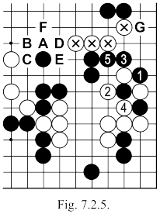
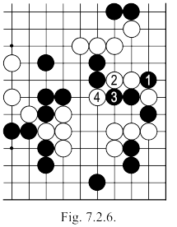 | Fig. 7.2.6: If after black 1 in the last figure, white tries to play 2, black quietly follows with 3, as white 4 can not separate his stones.  White 38: Better at "B", this move allows the YOSE of "A". Even if we are only at the start of the game, the moves at the end must still be provided and prepared for.  White 40: Better at "G", so as to penetrate the opponent's MOYO. If the black group in the center of the board comes back towards the three white stones (20, 22 and 28) then with a movement like "H" white will can remember that on the left side, there is something interesting (see discussion of Fig. 7.2.2).

Moves 81 – 127  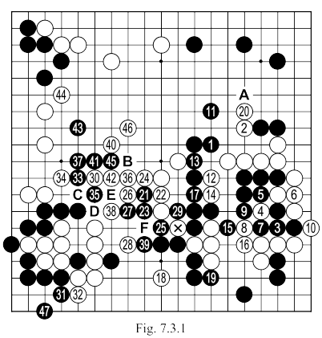 | Black 3, 5, etc ...: useless sequence, because the stones are lost after white 10. Black lost us some good KODATE here.  White 16: Should not capture 4. The four black stones are small compared to what is available with a move on the bottom (see Fig. 7: 3.2).  White 18: Much more important is "A" (see Fig. 7.3.3).  White 20: So as to be able to play at "A" without fear that this stone could be separated (see Fig. 7.3.4).  White 24: Safer is "B".
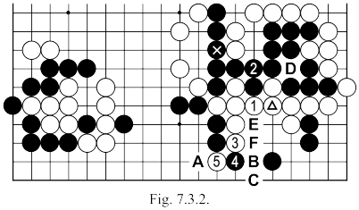 | Fig. 7.3.2: After the exchange of the marked and triangled stones, whites continues with 1 and if black connects at 2, the sequence up to 5 separates the black stones on the bottom. Note that if White now gets to play "A", his two stones will no longer be captured. On the other hand, if black "A", white "B" or "C" separates and captures the group in the corner. As the white triangled stone allows a capture at "D", then black could have continued by himself playing at the triangled point (ignoring white's cut at the marked point, as now he would capture four white stones with "E"). Once black has played at the triangled stone the sequence illustrated here is no longer possible. The sequence would also become impossible if white would start not with 1 here but 3 directly (after exchanging white 3, black 4, white 5, black can play "F" in SENTE and then "A").

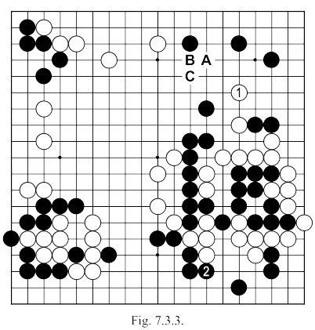 | Fig. 7.3.3: After white 1 here, black will have to play 2, and white (who already has a small territorial advantage) can reduce black's top, while also attacking the large black group in the center of the board (which means that things could turn bad for even the black group in the lower left side. An alternative option for white to continue would be "A" followed by black "B" and white "C" to cut.  Turning now to the white 18 in Fig. 7.3.1 we should note that if white wants to make profit on the bottom, then the variation of Fig. 7.3.2 is simply better.
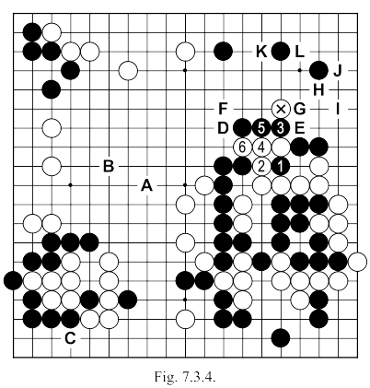 | Fig. 7.3.4: After white has played the marked stone, the only way to punish him is the sequence up to 5 here. After white 6, then, black must realise that his center group no longer has an eye, as it is separated, then, it has to run somewhere. Even if the group manages to escape in the end (which is surely problematic), white can manage the flow of play, so as to obtain two or three points like "A" and "B" (points occupied, then, in SENTE), because then he can launch the deadly attack at "C", and the black corner group will not have anywhere to form a second eye. As a result of following this path (after white 6), the marked stone will not be completely abandoned. If, for example, white got to occupy "D", then he will be able later to cut at "E"; if "D" and "F" are occupied by white, he can then play "G" making black connect with "H" or "I". By consideration of the other key points in black's group on the top right- "J", "K" or "L" - we conclude that here white has many places to try to play. Let's see for example what would happen if …

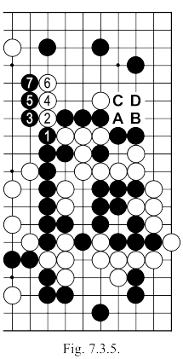 | Fig. 7.3.5: After black plays 1, if white cuts at once with 2, black will continue with 3, 5 and 7, capturing the cutting stones. Given, however, that this sequence can be played anytime, can white first cut with "A"? ... So after black 1, white "A", black "B", white "C", black "D" now, the white sequence from 2 works. So after exchanging black 1 and white "A", black should continue with "C" reducing his territory and giving white some points on the right side. This result may seem insufficient, in which case white must seek a drastic solution ... (see Fig. 7.3.6).
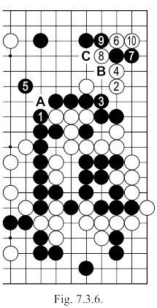 | Fig. 7.3.6: After black 1, relying increasingly on the cut at "A", white can play at 2, forcing the connection at 3, because then 4 requires the other connection at 5 (or something similar). Now, white 6 gives life in the sequence up to 10 where should we see black "B", we can calmly answer with "C". If black 7 is played at 8, then white 7 also makes life.  White 26: Must connect at 29. This cutting stone should not be given up so easily. Capturing the marked stone is problematic for black, he has to make safe his own stones and prevent a later attack at the top and on the right  White 28: Could try 38, see the sequence given in Fig. 7.3.7.

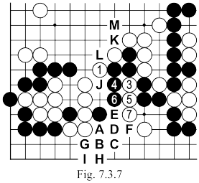 | Fig. 7.3.7: If, after the white 1 here, black doesn't answer (or we play "L" followed by white "K", black "M"), the sequence beginning with white 3 will capture the black stones no matter which line he tries, after white 7. If black now plays "A", white "B", black "C", white "D", black "E", white "F", black "G", white "H", black "I", white "J" ... (white will sacrifice a stone once again with a play at "B"). If the after white 1 January black defends at 7, white can continue with "F" and …  Fig. 7.3.8: Suppose, then, that we exchange moves: white 1, black 2 and white 3. If black now cuts with 4 and 6, in order to separate the marked white stones, then white 7 and 9 will be played SENTE because then 11 places a serious question mark around saving black's two cutting stones. In this way, white connects at "A" in SENTE (as he forces black "B"), and later white will perhaps be able to make a move at "C", simultaneously threatening "D" and "E". In this variation, white 11 can be played at "f", but this leaves more AJI.
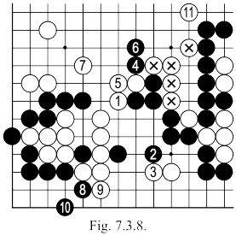
White 34: Better at 42, to avoid a heap of trouble and keep some points in the center.

White 36: Better at 37 if black then cuts at 36, white "B" manages to connect his stones and encloses (on this side) a fairly substantial territory. If after white "B" black continues with 41, then white will play at "C" and if black then tries to cut with 45, white "D", black 47 and white "E" makes 40 and "F" MIAI to save the group in the center. If after white 37, black 42, white "C", black "E", white 45 if black insists with "B" then white "D", black 47 and white 36 (black had to make the connection at 38, as well as that of "F").
White 44: Too small. Much more important just now is the (top) right corner.

Moves 127 – 160  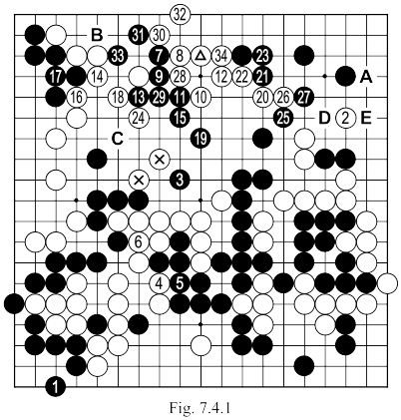 | White 2: It was more effective to directly attack at "A".  Black 7: A little exaggerated. The weakness of the triangled white stone is not enough to give a good development for black on the top side (we must not forget that white "B" is always played in SENTE threatening the life of black's group in the corner).  White 8: Should be played at 28 and if black continues with 9, white 29. Later, if black 11, white 13. Up to now white leads the game by nearly 10 points. But because of his last mistake, black will manage to take the lead.  White 24: Must connect with the group on the right. This move is unnecessary, because after the sequence up to white 32, black will still have the possibility of taking "C" and therefore capturing the two marked white stones.  Black 25: As the invasion destroyed the white territory on top side, black now has an advantage of about 5 points, so his moves from now on should try to solidify this lead. The current move is played in an absolutely neutral zone.
White 26: Had to live on the side, otherwise white can expect trouble to come when he least needs it (especially so since here he enters BYO-YOMI, and so he has only a minute to think about each move).

Black 27: If played at "D", it would maintain a threat against the isolated white group, as well as making a profit on the right side.

Black 33: Correct was "F" making white's connection at "G" into a GOTE move, instead of a SENTE move (as it will be later). It is, of course, a minor issue, only 1-2 points, but why not keep the chance to win points instead of now surely losing them?

Moves 161 – 214  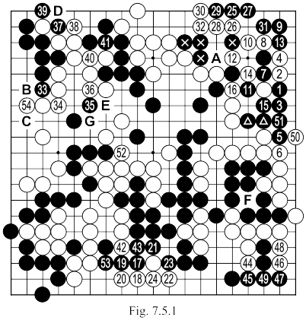 | White 2: Should play at 3: with then, probably, black 11, white 2, black 7, white 15 and so on; both sides connect their stones. Here, white can not hope for more.  White 4: It can't be played at 7 (after black 4 either black will connect or the white stones would be captured in trying to prevent the connection).  Black 5: Should cut first at 7 since …  White 6: This connection is unnecessary. Should connect at 7.  Black 13: Should be played at “A" (see Fig. 7.5.2).  White 54: Small. However if he must play here then "B" is better to stop a later SAGARI at "B" by black (see Fig. 7.5.7).
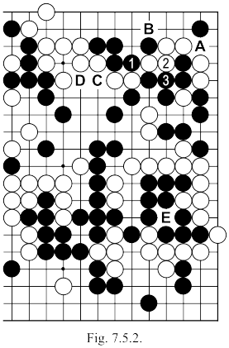 | Fig. 7.5.2: Following the exchange here of black 1, white 2, black 3, white suddenly finds himself with three separate groups, each having weak points: "A" or "B" for the group in the corner, "C" (threatening "D" and, thus, to kill the top group) and finally "E", which is actually the worst threat (continuation in Fig. 7.5.3).

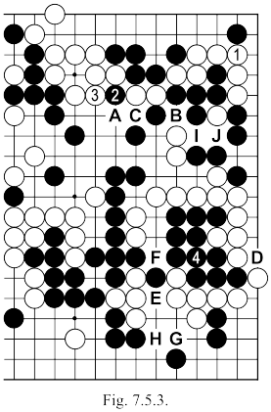 | Fig. 7.5.3: Let's presume that, starting from the position of Fig. 7.5.2, white would connect here with 1. Black will cut at 2 and when white defends at 3, black will be able to connect at 4: the large white group on the right side is no longer alive. The separation is good (if white "A", black "B" or if white "B" black "C"), black has the right to play "D" at any time to make a false eye on the side. If white "E", black "F", white "G", black "H". Pay attention to the order of moves here: if Black would connect at 4 before cutting at 2, after white "I", black "K", white "B" black has to connect at the marked stone and white can play 1.
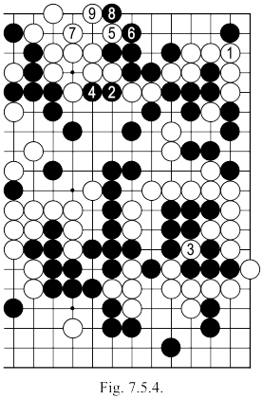 | Fig. 7.5.4: If after exchanging white 1, black 2, white captures 3, black can directly attack at 4 and will get a KO in the sequence up to 9 here. To get an even better result, black will be able to use the weak group in the corner, as in Fig. 7.5.5 where after black 11 white dies unconditionally (if now white "A", black "B" ... or if white "C", black "D", white "A", black "B" white "E", black 11).
 | 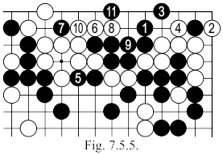

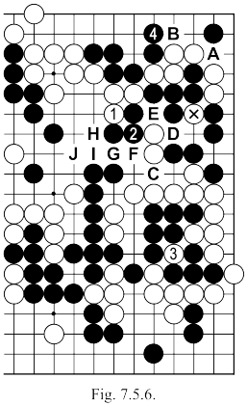 | Fig. 7.5.6: If after the position of Fig. 7.5.2, white plays 1, black can continue with 2, forcing white 3 and, then, he can play 4. Now white can play "A" which would be followed by black "B" Notice that black 2 left an AJI at "C", which does not allow white to cut at "D" (after white "D", black "E" and the marked stone can not be connected), simply cutting at "E" presents no danger (white "E", black "D", white "F", and black can TENUKI because if white continues with "G", black "H", white "I", "black "J").
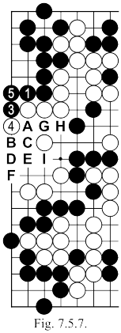 | Fig. 7.5.7: If black plays 1 here, then white will be inclined not to answer, but in this case black 3 and 5 will be played in SENTE (otherwise if white 6 is TENUKI, black "A", white "B", black "C", white "D", black "E", white "F", black "G", white "H", black "I").

Moves 215 – 291  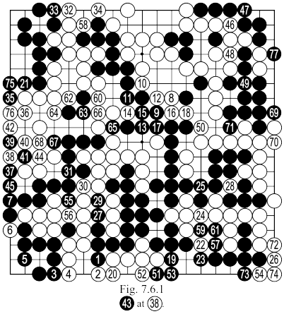 | Since move 16 of white's in Fig. 7.5.1, black lost the advantage he had and he was behind by nearly 15 points. This points difference is hard to recover, since there are nothing but small moves left on the board.  White 40: Should connect at 41 (see Fig. 7.6.2) which would have prevented the loss of 3-4 points.  The game ends after move 291 with a difference of 12 1/2 points in favour of white.  The game took place at the National GO Championship held in November 1987 at Băile Herculane, during the Games Festival "HERCULES".
