**STUDENT-RECONNECTOR: STUDENT AND TEACHER PROFILING WITH EMBEDDED COMMUNICATION SYSTEM AND ALUMNI TRACKING APPLICATION**

A Capstone Proposal

Presented to the Faculty of the

Department of Computer and Information Sciences

University of San Carlos

In Partial Fulfillment

of the Requirements for the Degree

BACHELOR OF SCIENCE IN INFORMATION AND COMMUNICATIONS

TECHNOLOGY

By

FERDINAND BRYLE BAGUIO

MELODY ABIGAIL Y. CUENCO

LECARRE L. GAVINI

JONAS E. PAQUIBOT

ANGIE CENIZA, PhD

Faculty Adviser

June 2018

**ABSTRACT**

At the University of San Carlos (USC), communication overall lacks and compensate that through social media as means to deliver information. Social media’s features are deviated due to the majority of USC users using social media. On the other hand, graduates of the University are not taken to account fully. This application focuses on creating an interactive and productive environment with seamless communication in academic context by imitating social media features and enhancing them to suit specific academic needs. And, track graduates from university by data inputted through communication between graduates and USC. All these features seek to answer the question: “Why the University does tolerate use of social media as ways and means of communication but blocks social media on their networks?” and “How will the University improve without knowing the situation of their graduates?” It is hoped this application will add seamless communication on the web for the users from USC, provide data on their graduates, and will overall improve USC.

**TABLE OF CONTENTS**

**ABSTRACT ………………………i**

**TABLE OF CONTENTS ………………………ii**

**LIST OF FIGURES ………………………iii**

**LIST OF TABLES ………………………iv**

**CHAPTER 1 INTRODUCTION ………………………1**

**1.1 Rationale of the Study ………………………1**

**1.2 Statement of the Problem ………………………3**

**1.2.1 General Objective ………………………3**

**1.2.2 Specific Objectives ………………………3**

**1.3 Significance of the Study ………………………3**

**1.4 Scope and Limitations ………………………4**

**CHAPTER 2 RELATED SYSTEMS ………………………5**

**CHAPTER 3 TECHNICAL BACKGROUND ………………………10**

**CHAPTER 4 DESIGN AND METHODOLOGY ………………………13**

**4.1 Conceptual Framework ………………………13**

**4.2 Analysis and Design ………………………16**

**4.3 Development Model ………………………17**

**4.4 Development Approach ………………………18**

**4.5 Software Development Tools ………………………19**

**4.6 Project Management ………………………20**

**4.6.1 Schedule and Timeline ………………………20**

**4.6.2 Responsibilities ………………………21**

**4.6.3 Budget and Cost Management ………………………22**

**4.7 Verification, Validation, and Testing ………………………22**

**BIBLIOGRAPHY ………………………23-24**

**Appendix A Transmittal Letter**

**Appendix B Interview Guide**

**Appendix C Software Requirements Specifications**

**CURRICULUM VITAE**

**LIST OF FIGURES**

**Figure 1: Conceptual Framework ………………………13**

**Figure 2: Entity- Relationship Diagram ………………………15**

**Figure 3: Use Case Diagram ………………………16**

**Figure 4: Agile Development Model ………………………17**

**Figure 5: Top-Down Approach ………………………18**

**LIST OF TABLES**

**Table 1: Tabulation of Related Systems ………………………9**

**Table 2: Summary of the Software Tools ………………………19**

**Table 3: Gantt Chart of Activities, 3rd semester, SY 2017-2018 ………20**

**Table 4: Gantt Chart of Activities, 1st semester, SY 2018 ………………21**

**Table 5: Roles and Responsibilities ………………………21**

**Table 6: Estimated Budget and Cost ………………………22**

**CHAPTER 1**

**INTRODUCTION**

* 1. **Rationale of the Study**

University of San Carlos is a Catholic educational institution administered since 1935 by Society of the Divine Word (SVD) missionaries. 79 faculty members actively engaged in research (AY 2016–17). 8 CHED Centers of Excellence (COE). 66 research collaboration agreements signed (AY 2016–17). 16 Level III FAAP-accredited programs as evaluated by PAASCU.

The Integrity of the University is unfathomable. Year after year, proud students graduate from this prestigious school knowing that they had overcome their first stepping stone to success. With its teaching methods, discipline, and facilities, the University has more than enough solid foundation to produce highly educated students.

As the world's communications digitalized, things innovated, and processes automated, the University of San Carlos is slowly adapting to this rapid change. For the benefit of the University, Software and Applications were made such as Caloy (Information system that directs users to locations in-campus), ISMIS (Automation of enrollment, student profiling, and other features), and EZproxy (Online book resource). But there are applications that students and teachers use which only the University cannot provide. Applications providing mass communication and getting everyone's attention effortlessly.

Facebook have been at the aid of students and teachers alike. Facebook relays information through Facebook's news feed, groups, and chat system. Online applications such as Facebook falls into a category called social media and Facebook is top #1 among all social media websites in the Philippines. Moreover, Facebook, as a social media website, is derived to satisfy academic purposes which eliminates the academic value. Users from the University relied on other tools mentioned to relay information and provide cloud storage.

A separate application is needed with a profiling feature. The application is able to provide all the needs for students and teachers. Whereas, the academic value and purpose are still present. An application that eliminates the University’s reliance on social media and for users to track their performance easily. Able to present visualized- academic records in order for students to be aware and improve.

As students graduate from the University, they became Alumni of the University. Without complete detail of the former student’s achievement, successes, and milestones accomplished, the University would not improve without their results. According to Johnson, “If a country can’t track its graduates, then there’s no way to know if its education system is having any positive effects.” Alumni tracking is an added feature to monitor the University’s graduates, do information gathering and analysis based on the specifications from the Department of Computer and Information Sciences faculty.

Tracking the students of University of San Carlos after they graduate would provide data that would prove useful to the University as they become adapt and improve based on these. To add with a deeper communication between student-student, teacher-student, and teacher-teacher in the context of academic reasons. Preserving the academic value of communication and awareness without reliance of social media. With all these together, these key features could be an application worth deemed called “USC Application.”

* 1. **Statement of the Problem**

**1.2.1 General Objective**

This research aims to develop a Student-Reconnector: Student and Teacher Profiling with Embedded Communication System and Alumni Tracking Application.

**1.2.2 Specific Objectives**

1. Determine and collect data about the problem and constraints between the student and the teacher.
2. Design and develop the application.
3. Test and evaluate the application.
4. Deploy the application.
   1. **Significance of the Study**

Data analysis, alumni tracking and communication will help the students, faculty and alumni of the Department of Computer and Information Sciences by utilizing the data managed and gathered from the application.

**Students.**  They would keep track on their academic records especially their class-related records and data. These are visualized such as graphs and charts. This would help them achieve new and higher goals.

**Alumni.** They connect with the University. A centralize communication application where the alumni would know the situation of the University, exposed to opportunities provided by the University, and allows them to continue their contribution to school organizations, departments, students and the like.

**Department.** Student and teacher analysis would provide the department insights to improve their craft and the teaching experience for teachers and learning experience for students.

**University**. It would greatly benefit their reach on web potentiality. The University would expand their capabilities which are communication, data analysis, and alumni tracking.

With the communication feature, the University would not place their reliance on social media to convey information on the preponderance. With the data analysis feature such as student and teacher profiling, the University would use such data to improve and enhance the learning and teaching experience and raise academic awareness. On the other hand, the alumni tracking feature would help the University to know the situation of graduates. The University must comprehend whether they produce good or bad results to improve their overall performance.

**Future Researchers**. They would benefit from this application as it can be further polished. They may add more features to this application and expand the capabilities of the University or any kind whatsoever. This application inspires future researchers to contribute to Schools/Universities/Academies.

**1.4 Scope and Limitations**

This application provides communication between students and teachers, profiles students and teachers and, tracks alumni. This focuses on the students, teachers and, graduates of the University of San Carlos. Available on Web interfaces and is mobile responsive. **Communication:** student-student, student-teacher, teacher-student at the Talamban Campus categorized by classes, department, batch, and school. **Profiling:** students and teachers at the Talamban Campus only and provide analysis and statistical data. **Tracking:** alumni of the University for all schools at the Talamban Campus.

This application is able to include students, teachers, schools from all campuses of the University. Internet connectivity is need but the University’s network would suffice.

**CHAPTER 2**

**RELATED SYSTEMS**

‘Communication’ is the core subject of “Electronics & Communication” branch of Engineering. Nowadays, it is very demanding field also… (Yadav, 2008, p.1)

Over the past few decades, we have witnessed a remarkable progress in communication systems; both digital and analog. In keeping with these evolving technological advances of telecommunications. Communication Systems aims to make student get acquainted with these changes in a solid and illustrative manner. Although the book covers both analog and digital communication systems, greater emphasis has been placed on the latter by incorporating the most commonly known wireless digital technologies. (Ramakrishna, 2013)

According to the book, Methods for Analyzing Social Media (2013), social media are becoming increasingly attractive for users. It is a fast way to communicate ideas and can be a key source of information about how people interact. Today it is among the most influential communication channels. For this reason, social media are important for audience research as well as for technologies that can be used in human services. Social media can be generally understood as web-based services “that build on the ideological and technological foundation of Web 2.0 and that allow the creation and exchange of User Generated Content” (Kaplan, 2010).

Social media are playing an increasingly important role as information sources for travelers. The goal of this study is to investigate the extent to which social media appear in search engine results in the context of travel-related searches. The study employed a research design that simulates a traveler's use of a search engine for travel planning by using a set of pre-defined keywords in combination with nine U.S. tourist destination names. The analysis of the search results showed that social media constitute a substantial part of the search results, indicating that search engines likely direct travelers to social media sites.

This study confirms the growing importance of social media in the online tourism domain. It also provides evidence for challenges faced by traditional providers of travel-related information. Implications for tourism marketers in terms of online marketing strategies are discussed. (Xiang, 2009)

The importance of social media as platforms of social interaction, communication and marketing is growing. Increasing numbers of businesses in various industries have already integrated or plan to integrate social media applications into their marketing programs. Higher education institutions show increased interest in the potential of social media as a marketing tool. Particularly important is the potential of these tools to reach and attract future students. An important issue for research is to understand how potential students use social media and what their role is in the decision-making process of choosing a program of study, a University, or College. This paper identifies market segments among future students based on the use of the social media and examines the impact of the social media on the choice of a higher education program and institution.

While penetration of social media is extremely high among future students, the impact of these in the choice of study and institution is relatively low compared to more traditional forms of university marketing. This paper provides university marketers with a useful insight into the developments in the market and discusses various options and opportunities for engaging social media as effective marketing tools. (Sanko, 2011)

According to Lui’s article, Social Media Tools as a Learning Resource,” Journal of Education Technology Development and Exchange (JETDE), “Social media tools have become ubiquitous. You can see our students use them all the time. Among them most popular tools are Facebook, Wiki, YouTube, bulletin board, LinkedIn, blogging, and twittering. The advancement of modern technologies tries its best to accommodate the needs from people, especially the younger generation. As educators, how can we take advantage of this momentum?”. (Lui, 2010)

Her paper, as well, conducted in fall 2009 at the Central Campus of the University of Houston. The study investigated student’s use of different social media tools, their perceptions and attitudes towards these tools, and their preference of social networking groups.

The results show that the three top-used social media tools are Facebook, Wikipedia and YouTube; the top four reasons for using social media tools are for social engagement, direction communication, speed of feedback, and relationship building.

Regarding social networking group, they preferred a group of civically engaged and no membership required as well as a group based on contemporary topic that may not last long. Based on their input, the author suggested some educational implications of some of these tools as a valuable resource for teaching and learning.

In addition, SMS will certainly represent one of the major milestones in the history of mobile telephony. With SMS, users have forged their own dialect to cope with service limitations, compose their own communication groups or communities, and are enjoying new channels of interactions.

When an organization grows, it needs to evolve in order to effectively manage the increased amount of information required to effectively run. Today, this means making the leap from analog to digital. For the local chapter of Campus Crusade for Christ on the University of Wisconsin - La Crosse campus, increased growth within the ministry and with the scope of their target area has begun to cause logistical problems with managing student leaders and alumni. To solve this problem, a software engineer project named LARA (Leadership and Alumni Records Archive) has been developed to provide support with managing the internal structure of the organization including the management of applications for leadership, the management of the internal structure of student leaders, and the management of contact information for alumni.

This paper describes the software process involved in creating this rich internet application, the issues faced during its creation, justifications for decisions made in the development process, and the current status of the project. (Wienkes, 2010)

The proposed system for tracking information about alumni at University of East Sarajevo is called ALTRIS (Alumni Tracking Information System). University of East Sarajevo (UoES) is a public higher education institution comprised of 17 organizational units geographically distributed over the eastern part of BiH. Since the UoES is geographically distributed, many functions of the university are also distributed. Information systems on organizational units of the UoES are still running independently, without some kind of integration at the university level. ALTRIS is designed to track information about alumni from all organizational units of the university. For that purpose, the integration of relevant data from individual information systems will be required. Basic features for tracking alumni information, such as alumni list, alumni search, alumni profiles, alumni employment rates and listing of alumni job positions. (Kocarev, 2011)

A system of profiling was introduced in Australia in 1994 to identify adult jobseekers most at risk of becoming long-term unemployed. The profiling system uses the following predictors of long-term unemployment: age; educational attainment; Aboriginal and Torres Strait Islander status; birth in a non-English speaking country; English speaking ability; disability; and geographical location. In Australia the formal profiling system is complemented by assessments of public employment service officials, who can select jobseekers in the first 12 months of unemployment registration for further assessment on the basis of a set of supplementary factors. These additional factors include poor-motivation, low self-esteem, poor numeracy and literacy skills and substantial time out of the workforce. In 1995, the formal profiling system identified about 5 percent of screen applicants and a further 10 percent were identified on the basis of the supplementary assessments. As such, the Australian system should be regarded as predominantly a characteristic screening rather than a profiling system. (Layte, 2005)

With all technological benefits from different aspects combined, would be a great advancement to the education system’s automation. Dealing with student-learning and promoting growth and awareness for students and teachers alike.

Table 1

*Tabulation of related systems*

|  |  |  |  |
| --- | --- | --- | --- |
| Proponents | Systems | Category | Year |
| Bredl, Klaus | The Open Laboratory | Communication | 2013 |
| Kocarev, Ljupco | Tracking System for Alumni | Tracking | 2012 |
| Layte, Richard., O'Connell, Philip J. | Profiling System | Profiling | 2005 |
| Le Bodic, Gwanael | Mobile Messaging Technologies | Communication | 2003 |
| Liu, Youmei | Social Media Tools | Profiling | 2010 |
| Ramakrishna, Rao P. | Communication System | Communication | 2013 |
| Wienkes, Kirk Thomas | Leadership and Alumni Tracking System | Tracking | 2010 |
| Yadav, Abhishek. | Analog Communication System | Communication | 2008 |
| Xiang, Zheng | Social Media | Profiling | 2009 |

**CHAPTER 3**

**TECHNICAL BACKGROUND**

This chapter discusses the fundamental definitions that are relevant to this study.

**Social Media**

Social refers to the way people interact with others through sharing information and at the same time receiving the pass information. On the other hand, media is the instrument of communication, just like the commonly used today the internet. Social media platform is built to be user-friendly for everyone’s efficiency in sharing the information immediately. It is a quicker way to communicate one person to another although no matter what location the user might be.

Social Media are web-based communication tools that will allow people to interact through sharing and receiving Information. Social Media continues to evolve and provide better updates to achieve such way of communication. It provides a real impact on society because communication is one important thing.

**File Sharing**

File Sharing is really helpful whether if an individual is a student or a teacher. With file sharing, you would be able to allow your friends to see the documents in which you want to contribute.

**Geographic Information System Technology (GIS)**

To know where that person is, Geographic Information Systems is a computer system whereas the data being stored would be displayed related to the position of the Earth. Simply means it is a tracker where the person is currently staying and views the profile of that person and updates from that person as well. One way to easily communicate indirectly on each other is through a communication system in which they will keep in touch through a geographical system, just like the tracking of the Individual.

**Generate Tracking Reports**

Maintaining the records of the graduates from the University of San Carlos is a must. In order to keep in touch with where the alumni have been lately, they would provide their details from time to time. Important details that would be helpful in locating them after they have graduated from the University of San Carlos. Details include Job Title, Zip Code, Country, and Address.

It is indeed beneficial for the University for this will allow them to track the graduates constantly. Through Generating Tracking Reports, indeed it would make the alumni tracking easier and very efficient to see the individual&#39;s detailed reports as months and years passes by.

**Mobile Responsive**

In using the application, it is best to have the same representation of the system whether what device is being used. The design of the website will adjust to the exact size of the device you are using. And that is how mobile responsive works.

As technology passes by rapidly, the evolution of the gadgets as well follows and probably many individuals are comfortable using their mobile phones for the convenience as well as for it is handy. In a mobile responsive system, it will serve the same web pages from the smartphones, tablets, PC or a laptop.

The advantage is that first, it would be easier to load web pages once a system is basically created for mobiles according to Google. Second is that it is more understandable to look at flexible images and text aside from having a good content.

**Markup Languages**

There is actually numerous list of different Markup Languages. And how does markup language and code really differ? Markup Language is the building blocks used to create web pages or all shapes and sizes. (Kyrin).

Through annotations did it is actually understandable by both human and the computer. It interprets and distinguish how it is written and also from the text itself. Hypertext Markup Language is actually one of the Markup Language to be used, for it defines the way how multimedia is to be shown in a web browser. Languages in which it will make one’s system connect interactively to the document.

**Framework**

In creating a system, Framework is to support the structure and turn it into something useful. It will allow the developers to identify what kind of programs should be built.

**Client-server**

Since we are focusing on a client-server network this is to access different resources such as the list of names, schedules or other services. The aim of this type of network is to serve the clients by giving them what they need. Just like how it will request from the server.

A network is actually the way in connecting and communicating to the server. On the other hand, the server would make sure the request is valid and take the request to serve the client.

**Mobile Computing**

Multiple devices that will let people access the information and data no matter where they are staying. It can be connected by Local Area Network (LAN) or they could use the Wi-Fi by connecting via wireless local area network (WLAN).

**CHAPTER 4**

**DESIGN AND METHODOLOGY**

This chapter explains how the system works and mentions important information needed in developing the system. It will serve as the basis for the development of the system as well as the different stages undergone in developing the project.

**4.1 Conceptual Framework**

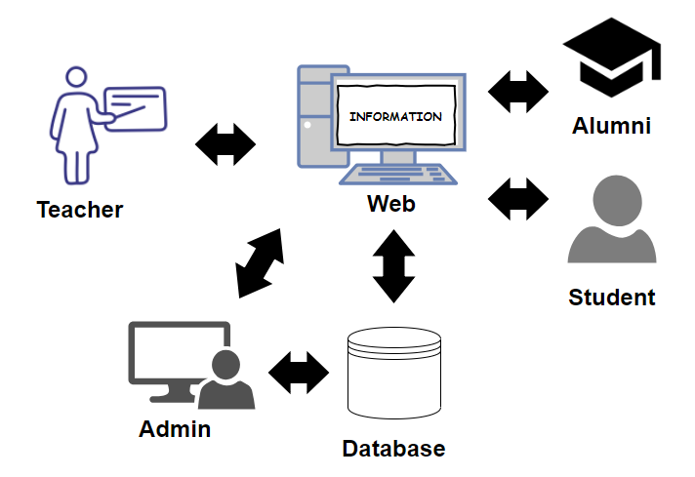A Web-based and Mobile Responsive System will be beneficial exclusively for the students and teachers of the Department of Computer and Information Science since it will save time and effort from checking one's performance and school's information, track alumni, and communicate seamlessly. it is also convenient for it is a web-based. Alumni tracking is also added to look into their employment status. Figure 1 shows the conceptual framework of the Student- Reconnector.

*Figure 1. Conceptual Framework*

The teacher, student, alumni and admin are the users of the proposed system. The teacher will manage the student performance in class in terms of grades. The student can view his/her class performance, and school updates.

Both student and teacher can see their class schedules for the semester. In addition, the teacher and the student can communicate through the chat feature for concerns or any other agreements. The alumni are the ones filling up a form for the alumni tracking. Alumni students will be monitored of their employment status.

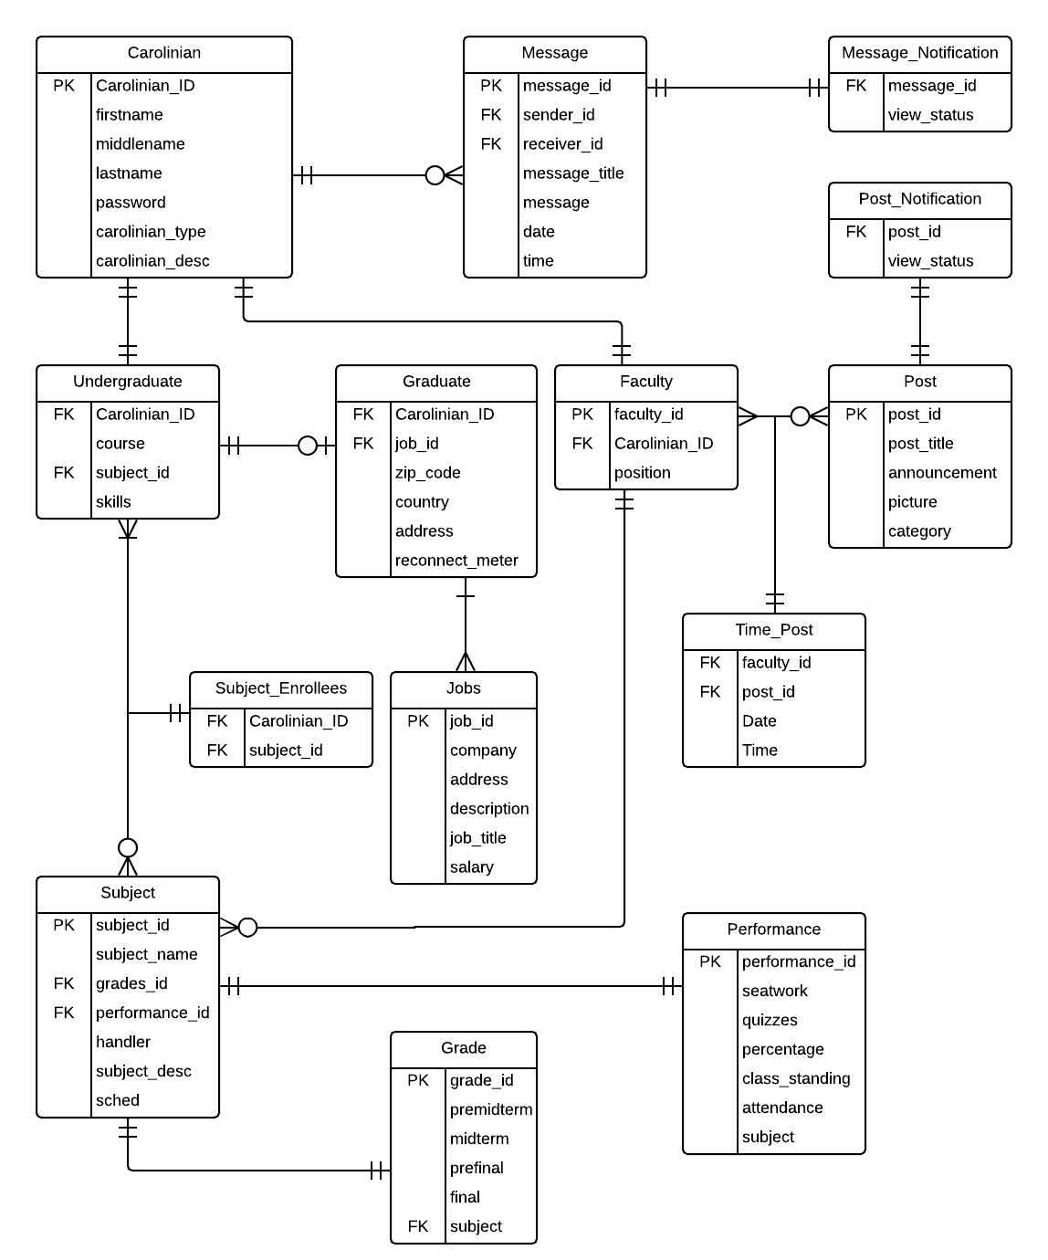

Figure 2. Entity- Relationship Diagram

**4.2 Analysis and Design**

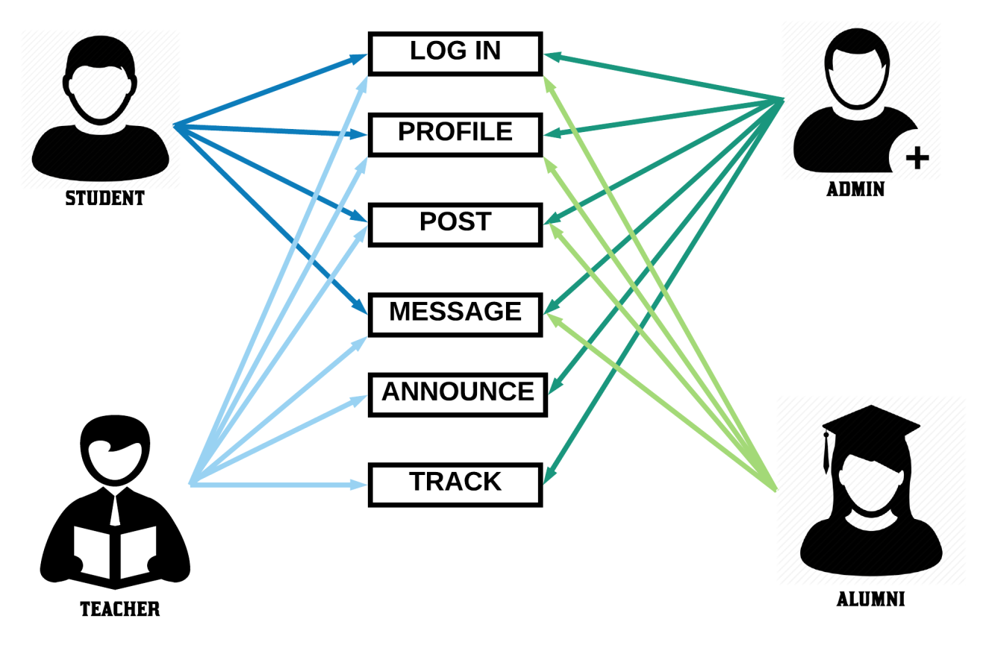

*Figure 3*. Use Case Diagram

**4.3 Development Model**

The Agile Development Model is used by the developers as their system development model because the system will be developed in incremental, rapid cycles and will result to releasing small incremental changes in the system with each and every release building on preceding functionality.

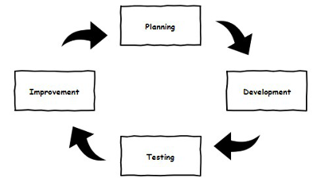

*Figure 4. Agile Development Model*

**Planning**. It is where the developers brainstormed their ideas of a system, determining different mechanisms to be used during the development of the system, and how the system will be designed and gathering needed resources.

**Development**. It is where the developers start programming the system’s modules, functionalities and the user interface.

**Testing**. It is where different system developers will test and evaluate the system for feedbacks and to uncover bugs and errors to be identified and be changed immediately.

**Improvement**. It is where the developers will make sure that the satisfaction of the end-users will be met through progressive implementation of minor or major changes. This will be repeated until it will become a well-developed system.

**4.4 Development Approach**

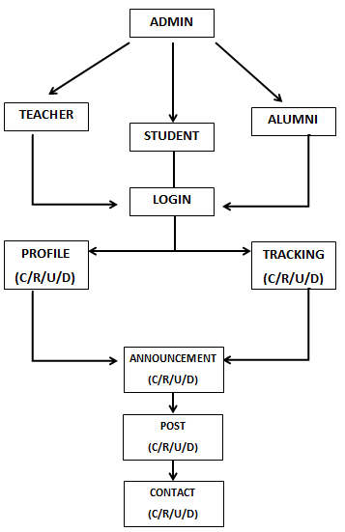

Figure 5. Top-Down Approach

Top-down approach is used in developing the system where the developers visualized and planned thoroughly about the system to be develop and gathered information through an online survey then analyze the gathered data and was developed and tested.

**4.5 Software Development Tools**

The table below shows the different software development tools used to develop the system.

Table 2

*Summary of the Software Tools*

|  |  |  |  |
| --- | --- | --- | --- |
| **Name** | **Version** | **Source** | **Usage** |
| HTML5 | 5.2 | https://www.w3.org/TR/2017/REChtml52-20171214/ | structuring and presenting the content  of the website |
| CSS | 3.0 | https://www.w3.org/TR/2017/NOTE-css-2017-20170131/ | designing or styling the user interface |
| PHP | 7.1.3 | php.net/archive/2017.php | programming the back-end and frontend of the system |
| jQuery | 3.3.1 | https://code.jquery.com/jquery-3.3.1.min.js | Framework |
| JavaScript | 1.8.5 | None | programming the back-end of the system |
| Laravel | 5.6 | https://laravel.com/docs/5.6/installation | Back-end Framework |
| Sublime Text | 3.0 | https://www.sublimetext.com/3 | Browser for Simulation |
| Google Chrome | 6.3.3 | https://google.com/ | Software for coding |
| XAMPP | 7.2.5 | https://www.apachefriends.org/ | Database Connectivity |
| PhpMyAdmin | 4.8.0.1 | https://www.phpmyad | Database |

**4.6 Project Management**

This section shows the modules done and spent on certain time frames.

**4.6.1 Schedule and Timeline**

Table 3

*Gantt Chart of Activities, 3rd Semester, SY 2017-2018*

|  |  |  |  |  |  |  |  |  |  |  |  |  |  |  |  |  |
| --- | --- | --- | --- | --- | --- | --- | --- | --- | --- | --- | --- | --- | --- | --- | --- | --- |
| **Month** | May | | | | June | | | | July | | | | August | | | |
| **Week** | 1 | 2 | 3 | 4 | 1 | 2 | 3 | 4 | 1 | 2 | 3 | 4 | 1 | 2 | 3 | 4 |
| **Activities** |  |  |  |  |  |  |  |  |  |  |  |  |  |  |  |  |
| **Planning**  Sub-activities: |  |  |  |  |  |  |  |  |  |  |  |  |  |  |  |  |
| Requirements |  |  |  |  |  |  |  |  |  |  |  |  |  |  |  |  |
| Brainstorming |  |  |  |  |  |  |  |  |  |  |  |  |  |  |  |  |
| **Information Gathering**  Sub-activities: |  |  |  |  |  |  |  |  |  |  |  |  |  |  |  |  |
| Data Gathering |  |  |  |  |  |  |  |  |  |  |  |  |  |  |  |  |
| **Analysis**  Sub-activities: |  |  |  |  |  |  |  |  |  |  |  |  |  |  |  |  |
| Title Page, Chapter 1  (Rationale, Significance of the  Study, Scope and Limitations) &  Abstract |  |  |  |  |  |  |  |  |  |  |  |  |  |  |  |  |
| Chapter 2 (Related Systems) |  |  |  |  |  |  |  |  |  |  |  |  |  |  |  |  |
| Chapter 3 (Technical  Background  and initial Reference List |  |  |  |  |  |  |  |  |  |  |  |  |  |  |  |  |
| Chapter 4 (Design and  Methodology) |  |  |  |  |  |  |  |  |  |  |  |  |  |  |  |  |
| **Revision of Documents** |  |  |  |  |  |  |  |  |  |  |  |  |  |  |  |  |
| **Capstone Proposal Defense** |  |  |  |  |  |  |  |  |  |  |  |  |  |  |  |  |
| **Final Revision of Capstone**  **Documents** |  |  |  |  |  |  |  |  |  |  |  |  |  |  |  |  |
| **Development**  Sub-activities: |  |  |  |  |  |  |  |  |  |  |  |  |  |  |  |  |
| Design |  |  |  |  |  |  |  |  |  |  |  |  |  |  |  |  |
| Making the UI Design |  |  |  |  |  |  |  |  |  |  |  |  |  |  |  |  |

Table 4

*Gantt Chart of Activities, 1st Semester, SY 2018 - 2019*

|  |  |  |  |  |  |  |  |  |  |  |  |  |  |  |  |
| --- | --- | --- | --- | --- | --- | --- | --- | --- | --- | --- | --- | --- | --- | --- | --- |
| **Month** | September | | | | October | | | | November | | | | December | | |
| **Week** | 1 | 2 | 3 | 4 | 1 | 2 | 3 | 4 | 1 | 2 | 3 | 4 | 1 | 2 | 3 |
| **Activities** |  |  |  |  |  |  |  |  |  |  |  |  |  |  |  |
| **Development**  Sub-activities: |  |  |  |  |  |  |  |  |  |  |  |  |  |  |  |
| Front-end Coding |  |  |  |  |  |  |  |  |  |  |  |  |  |  |  |
| Back-end Coding |  |  |  |  |  |  |  |  |  |  |  |  |  |  |  |
| **Testing**  Sub-activities: |  |  |  |  |  |  |  |  |  |  |  |  |  |  |  |
| Testing and Evaluation |  |  |  |  |  |  |  |  |  |  |  |  |  |  |  |
| Debugging and Correcting  Errors |  |  |  |  |  |  |  |  |  |  |  |  |  |  |  |
| Validation, Verification  & Testing |  |  |  |  |  |  |  |  |  |  |  |  |  |  |  |
| **Revision** |  |  |  |  |  |  |  |  |  |  |  |  |  |  |  |
| **Final Revision of Capstone**  **Documents** |  |  |  |  |  |  |  |  |  |  |  |  |  |  |  |

* + 1. **Responsibilities**

Table 5

*Roles and Responsibilities*

|  |  |  |
| --- | --- | --- |
| Member | Role | Assignment |
| Ferdinand Bryle Baguio | Back-end Programmer | Tracking Module |
| Melody Abigail Cuenco | Front-end Programmer | Communications Module |
| Leccare Gavini | Back-end Programmer  Front-end Programmer | GIS, Communications, and Profiling Modules Management |
| Jonas Paquibot Jr. | Front-end Programmer | Alumni Module |

* + 1. **Budget and Cost Management**

Table 6

*Estimated Budget and Cost*

|  |  |
| --- | --- |
| Expense | Cost |
| Printing | ₱ 1000.00 |
| Transportation | ₱ 500.00 |
| Miscellaneous | ₱ 2000.00 |
| Laptop | ₱ 140,000.00 |
| Web Hosting | ₱ 700.00 |
| **Total** | ₱ **144,200.00** |

**4.7 Verification, Validation and Testing**

A black-box testing will be conducted after the system is developed by the developers to test for the functionalities and the system's overall performance and be validated among the researchers/ developers and 3 – 5 testers that has a knowledge of programming to conduct the back-box testing. After verification of the system, the researchers will conduct a validation (user-acceptance testing) where teachers and students of University of San Carlos Talamban Campus under the Department of Computer and Information Sciences to rate the system’s non-functional requirements such as functionality, reliability, usability, efficiency and maintainability.

The number of students that will conduct the validation is 60-80. This calculation was done with the Yamane Formula and decided by the Capstone Proponents.

**BIBLIOGRAPHY**

**Journal Article**

A Lenhard, K Purcell, A Smith, K Zickuhr. (2010). “Social Media & Mobile Internet Use among Teens and Young Adults”. Electronic article. Retrieved from <https://eric.ed.gov>

Bredl, Klaus, Hunniger, Julia, Jensen, Jakob Linaa. (2013, July 19). “Methods for Analyzing Social Media”. Electronic book. Retrieved from https://books.google.com

Gwenael Le Bodic. (2003). “Mobile Messaging Technologies and Services: SMS, EMS and MMS”. Electronic book. Retrieved from https://books.google.com

Kocarev, Ljupco. (2012). “ICT Innovations”. Electronic Book. Retrieved from

https://www.springer.com

Layte, Richard., O’Connell, Phillip J. (2005). “Profiling the Unemployed: An

Analysis of the Galway and Waterford Live-Register Surveys”. Electronic Book. Retrieved from https://books.google.com

Lui, Youmai. (2010). “Social Media Tools as a Learning Resource”. Electronic article. Retrieved from doi: 10.18785/jetde.0301.08

Ramakrishna, Rao P. (2013). “Communication System”. Electronic book. Retrieved from https://books.google.com

Wienkes, Kirk Thomas. (2010). “Leadership and Alumni Tracking System”.

Electronic book. Retrieved from https://books.google.com

Xiang, Zheng. (2009). “Role of social media in online travel information search”. Electronic article. Retrieved from https://doi.org/10.1016/j.tourman.2009.02.016

Yadav, Abhishek. (2008). “Analog Communication System”. Electronic book. Retrieved from https://books.google.com

Zinck Sanko, Marc C. (2011, March 16). “Potential of the social media as instruments of higher education marketing: a segmentation study”. Electronic article. Retrieved from <https://doi.org/10.1080/08841241.2011.573593>

**Web Article**

Alfaro, Rojan. (2014). “RTNHS Alumni Tracking System“. Retrieved from: <https://prezi.com/_t07ge_e1lrb/rtnhs-alumni-tracking-system/>

Bucki, James (2018). “Learn about the Benefits of Mobile Computing”. Retrieved

from:[https://www.thebalancesmb.com/definition-of-mobile-computing 2533640](https://www.thebalancesmb.com/definition-of-mobile-computing%202533640)

Byers, Josh. (2012)."A Beginner’s Guide to Mobile Responsive Design”.

Retrieved from: <https://www.studiopress.com/beginners-guide-responsive-design/>

Kyrin, Jennifer. (2018). “What are Markup Languages?”. Retrieved from:

<https://www.lifewire.com/what-are-markup-languages-3468655>

Moreau, Elise. (2018). “The Top Social Networking Sites People Are Using”.

Retrieved from: [https://www.lifewire.com/top-social-networking-sites- people-are-using-3486554](https://www.lifewire.com/top-social-networking-sites-%20%20%20%20%20people-are-using-3486554)

Nations, Daniel (2018). “What is Social Media?”. Retrieved from:

<https://www.lifewire.com/what-is-social-media-explaining-the-big-trend-> 3486616

Rouse, Margaret. (2008).”Client Server Model”. Retrieved from:

<https://searchnetworking.techtarget.com/definition/client-server>

University of San Carlos Website. Retrieved from:

<http://www.usc.edu.ph/about/index>

W3C Working Group Note. (2017). “CSS Snapshot 2017”. Retrieved from:

<https://www.w3.org/TR/2017/NOTE-css-2017-20170131/>

**APPENDICES**

**Appendix A**

**Transmittal Letter**

May 28, 2018

Mary Jane Sabellano, MSIT

Chair, Department of Computer and Information Sciences

University of San Carlos

Dear Ms. Sabellano,

Greetings!

May we request from you the permission to gather information from you and the Department of Computer and Information Sciences faculty for our research entitled “Student-Reconnector: Student and Teacher Profiling with Embedded Communication System and Alumni Tracking Application”.

The above research study is a requirement for the completion of the degree in Bachelor in Science in Information and Communication Technology in the University of San Carlos. We are confident that the result of the study would be useful and helpful in the betterment of the community.

Thank you very much. We are looking for your positive response.

Respectfully yours,

Baguio, Ferdinand Bryle

Cuenco, Melody Abigail

Gavini, Lecarre

Paquibot, Jonas

BSICT Students, University of San Carlos

Endorsed by:

Angie Ceniza

Capstone Adviser

Approved by:

Mary Jane Sabellano, MSIT

Chair, Department of Computer and Information Sciences

**Appendix B**

**Interview Guide**

1. What social media platforms/ tools do you use?
2. How often do you rely on social media?
3. How does social media benefit you academically?
4. Does it help student know more and learn more?
5. If so, site some scenarios where they perform better?
6. Do students still fail to comply with thought online capabilities are extended?
7. Why or why not?
8. Does a better system suit the students’ needs?
9. What are your concerns on student performance with the current technological advancements?
10. Why does the University tolerate information posts, important academic files being stored, and mass-communication occurring on social media in the context of academics but block use of social media on campus networks?

**Appendix C**

**Software Requirement Specifications**

Department of Computer and Information

Sciences School of Arts and Sciences

University of San Carlos

**STUDENT-RECONNECTOR: STUDENT AND TEACHER PROFILING WITH EMBEDDED COMMUNICATION SYSTEM AND ALUMNI TRACKING APPLICATION**

A complete Software Requirements Specifications

Version 1.0

Client:

University of San Carlos

Proponent:

Ferdinand Bryle Baguio

Melody Abigail Cuenco

Lecarre Gavini

Jonas Paquibot

**Introduction/ Rationale of the Study**

Facebook relays information through Facebook's news feed, groups, and chat system. Online applications such as Facebook falls into a category called social media and Facebook is Top #1 among all social media websites. Moreover, Facebook, as a social media website, is derived to satisfy academic purposes which eliminate academic value and also alienate academic purposes. Users from the University relied on other tools mentioned to relay information and provide cloud storage.

A separate application is needed with a profiling feature. Able to provide all the needs for students and teachers. Whereas, the academic value and purpose are still present. An application that the University of San Carlos which eliminates reliance to social media and for users to track their performance easily with the application. Able to compare statistical data in order for self-awareness and self-improvement to take place.

As students graduate from the University, they became Alumni of San Carlos. Without complete detail of former student’s achievement, successes, and milestones accomplished, the University would not improve more without their results. And for the application to suffice as deemed called “USC Application.” Alumni tracking was added to monitor the University’s graduates and do information gathering and analysis based on the specifications from the Department of Computer and Information Sciences faculty.

Tracking the students of San Carlos after they graduate would provide data that would prove useful to the University as they become adapt and improve based on these. To add with a more deep communication between student-student, teacher-student, and teacher-teacher in the context of academic reasons. Preserving the academic value of communication and awareness without reliance of social media. With all these together, these key features could be an application worth deemed called “USC Application.”

**System Description**

The Student-Reconnector: Student and Teacher Profiling with Embedded Communication System and Alumni Tracking Application is an application that will save time and effort from checking one's performance and school's information, it is also convenient for it is a web-based. Alumni tracking is also added to look into their employment status. Profiles and do deep analysis for self-improvement and self-awareness on academic performance. Also with the embedded communication system, there will be academic communication connectivity where the application allows users to communication in certain groups and specific places.

**Types of User:**

**Faculty** – Access to communication, tracking, and profiling features.

**Students** – Access to communication. profiling features.

**Alumni** – Access to communication, tracking and profiling features.

**Design Model**

A Web-based and Mobile Responsive System will be beneficial exclusively for the students and teachers of the Department of Computer and Information Science since it will save time and effort from checking one's performance and school's information, it is also convenient for it is a web-based. Alumni tracking is also added to look into their employment status.

The teacher, student, alumni and admin are the users of the proposed system. The teacher will manage the student performance in class in term of grades. The student can view his/her class performance, and school updates. Both student and teacher can see their class schedules for the semester. In addition, the teacher and the student can communicate through the chat feature for concerns or any other agreements.

The alumni are the ones filling up a form for the alumni tracking. Alumni students will be monitored of their employment status.

**System Flow/ Development Process**

There are (3) components that are to be develop in developing the Student-Reconnector: Student and Teacher Profiling with Embedded Communication System and Alumni Tracking Application. First, is the development of the profiling module that includes class, student, teacher, and performance. Second, is the tracking module which is provides a graphical interface for teacher. This module tracks and monitor alumni through geographic information system which is a system designed to manage and analyze alumni location and situation to present geographical data. Third, is the communication module, it completes the cycle on the flow of information as it connects students, teachers, and modules to inform and raise awareness. Communication module includes, contact, SMS, and post.

**STUDENT-RECONNECTOR: STUDENT AND TEACHER PROFILING WITH EMBEDDED COMMUNICATION SYSTEM AND ALUMNI TRACKING APPLICATION**

Tracking

Profiling

Communication

rw

1. **Profiling Module** – It enables the user to check progress, performance and academic data through statistical interfaces and prediction algorithms.

Profiling

Data

Performance

Progress

1. **Tracking Module** – It allows teachers find alumni through geographical interfaces.

Tracking

Geographical

Alumni

1. **Communication Module** – It allows users to interact and receive information through posts and announcements.

Communication

rw

Profiling

Tracking

Post

Announcement

**Use Case Diagram**

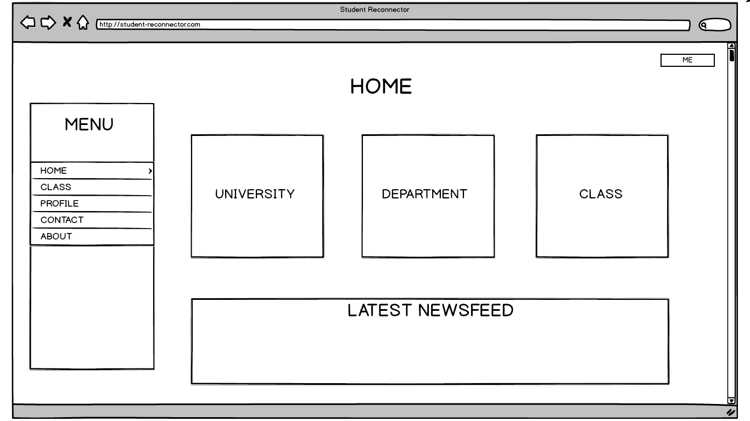**Wireframe of the Student-Reconnector: Student and Teacher Profiling with Embedded Communication System and Alumni Tracking Application**

**STUDENT HOME PAGE**

The first page of the Student Reconnector System to get started, view the different posts and filter only the ones you want to see first to be organized.

1. **Menu Bar-** consist of the Home, Class, Profile, Contact and About.
2. **Buttons-** display University’s, Department and Class different post and updates.
3. **View-** see what is posted lately by the instructors regarding the specific subject, latest announcements and even reminders by the instructors.
4. **Dropdown-** contains the user image, name and the position whether the user is a Student or Teacher.

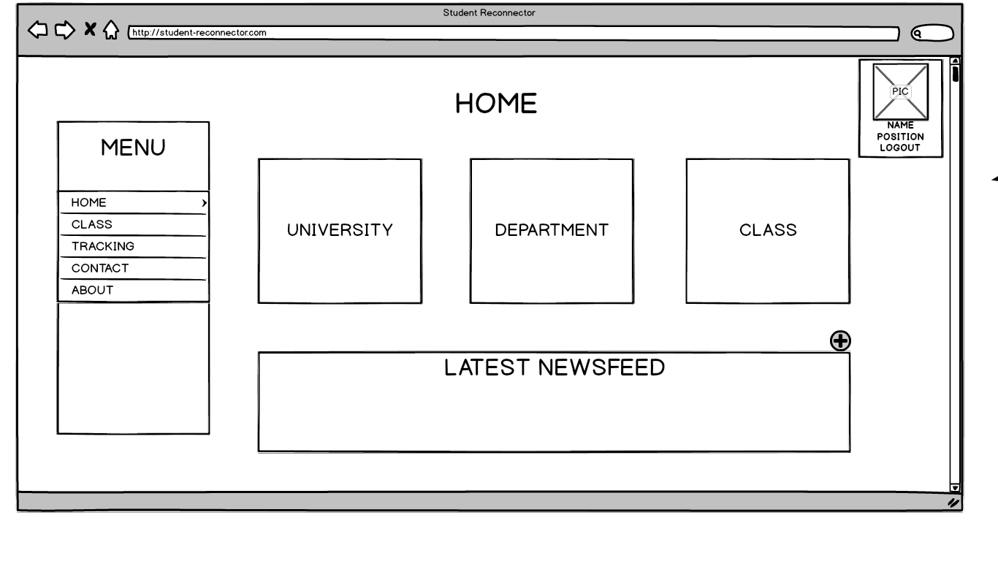

**TEACHER HOME PAGE**

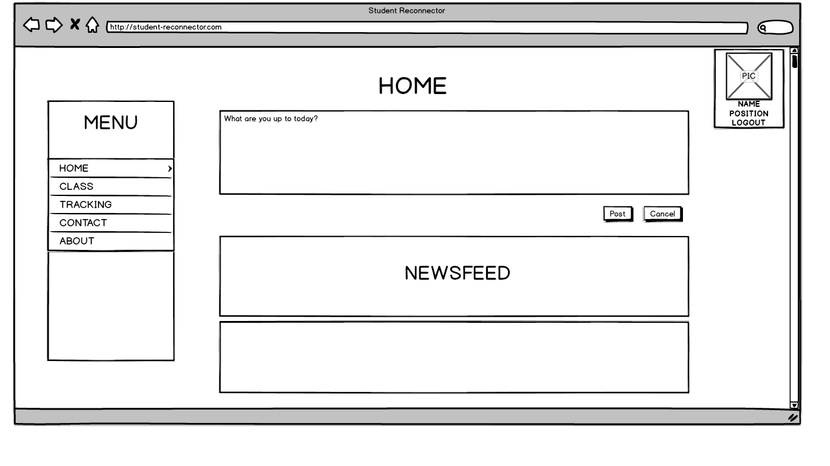**Add-** along with the newsfeed, the teacher can create posts regarding his/her lessons, announcements and many more.

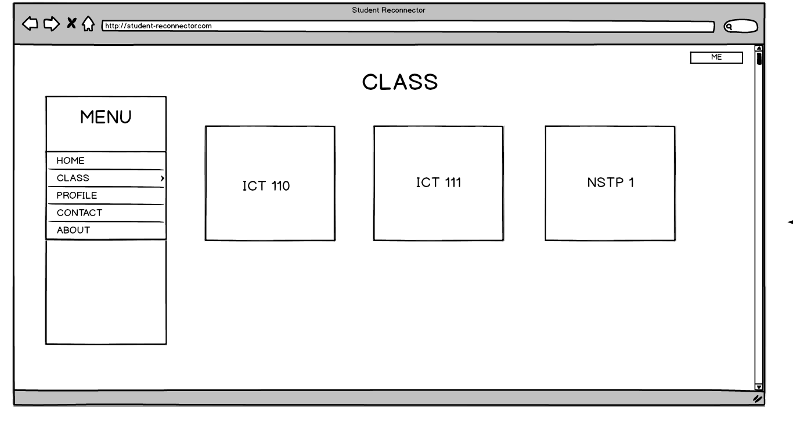

**STUDENT CLASS PAGE**

The classes that the student enrolled for the semester will be shown here also to know more about the subject

**1. Buttons-** A list of schedules the student can view from to know more about the subject, in which he/ she enrolled to.

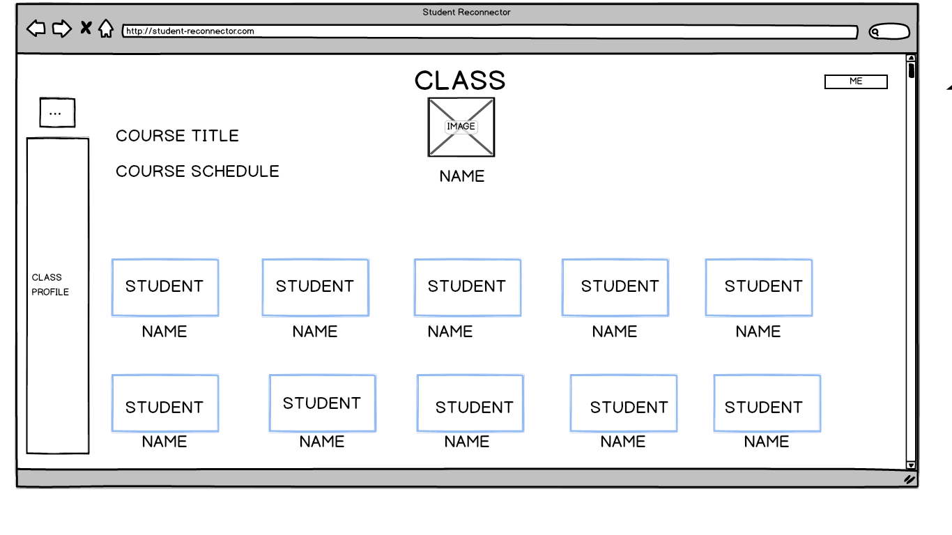

**STUDENT CLASS PAGE**

1.**Display-** class list classroom seating arrangement.

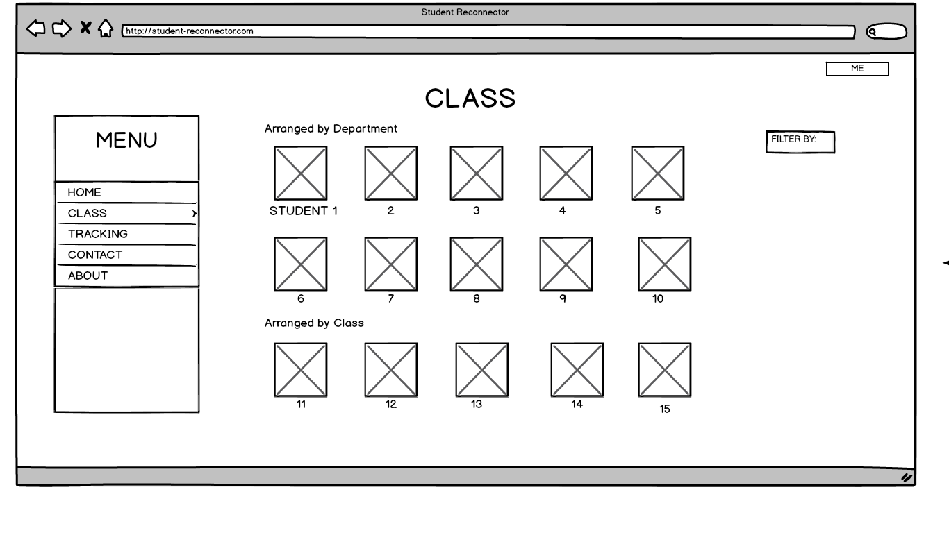

**TEACHER CLASS PAGE**

An organized way to show the student’s where their seat actually is.

1. **Filter By-** the class list of students in the particular subject could be viewed according to its filter. Filter by Department and Class.
2. **Clickable Boxes-** Student’s Arrangement according to instructors seating plan.

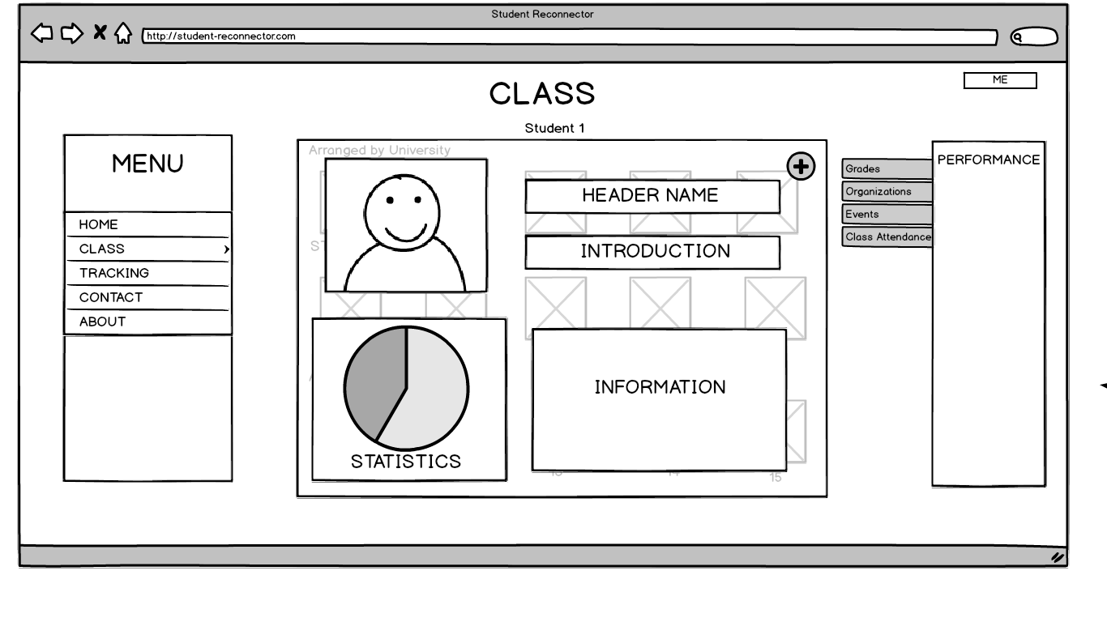

**TEACHER CLASS PAGE**

Mianly focuses on the student’s pofile

**1.Clickable Boxes-**Profile of the student will be shown depending on who the instructor chose. Header Name, Introduction, Information of the student.

**2.Graph-** to show the statistics of the student’s performances.

**3.Submenu-** Performance Menu consist of Grades, Organizations, Events and Class Attendance

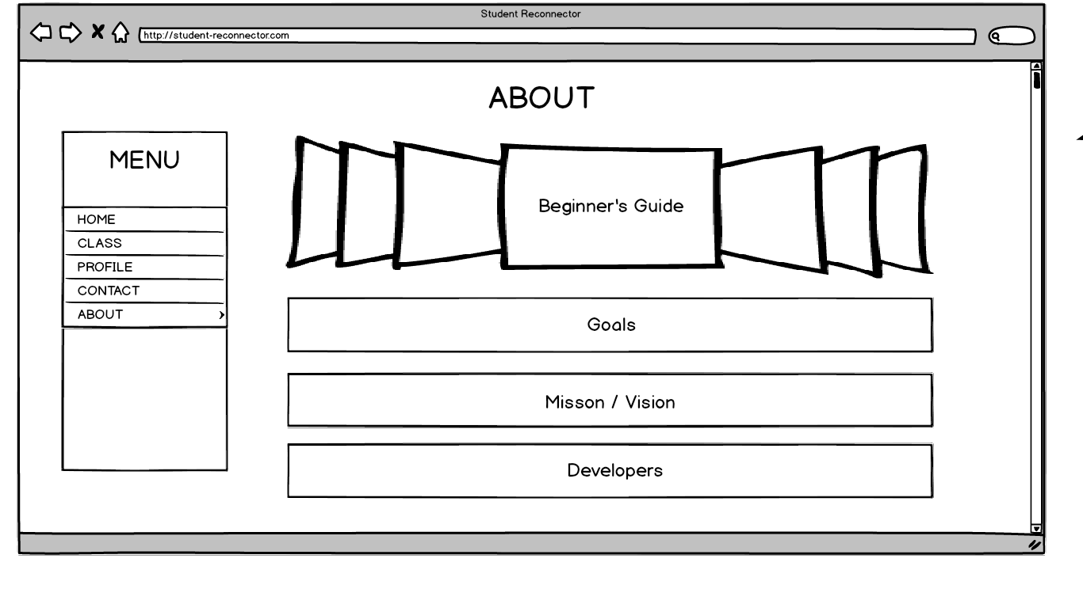

**STUDENT AND TEACHER ABOUT PAGE**

To know more about the system and the development process as well as the creators.

**1. Carousel**- a slideshow of a manual or guide to know how to use this system.

**2. Buttons-** Goals, Mission/Vision, Developers previews about the system and about the developers.

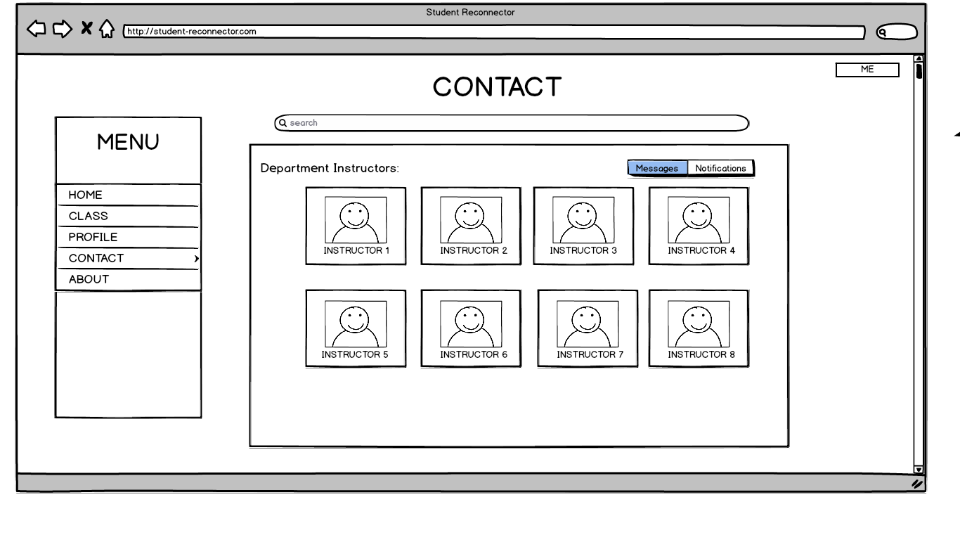

**STUDENT AND TEACHER CONTACT PAGE**

**To easily contact one another as a student-teacher relationship for all the concerns**

**1.Options-** to choose an instructor to contact by messaging privately

**2.Messages-** where the student and teacher can message each other for concerns.

**3.Notifications-** to get notify once someone posted

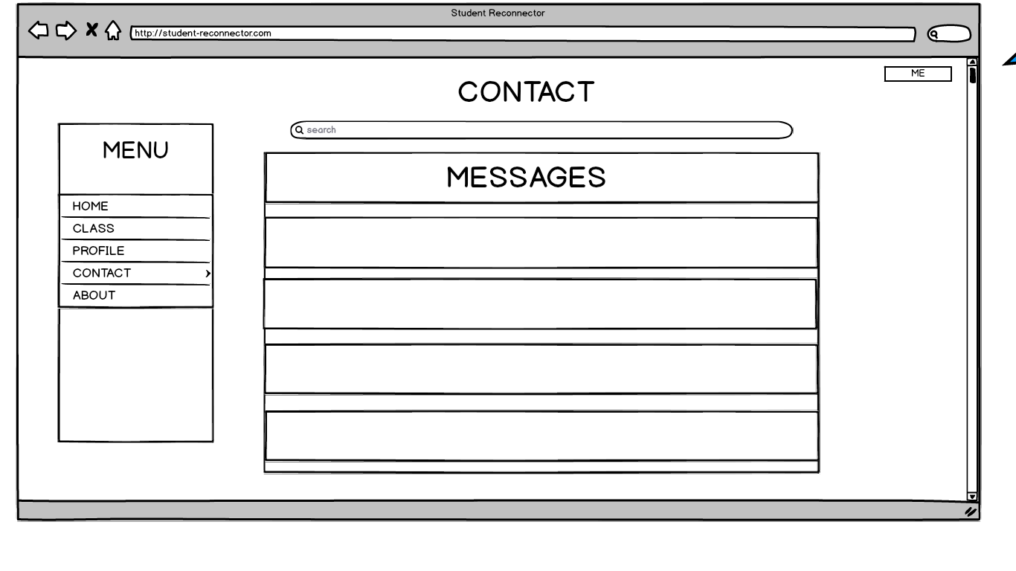

**STUDENT AND TEACHER CONTACT**

View messages from the highest to the lowest

**1.View-** all messages

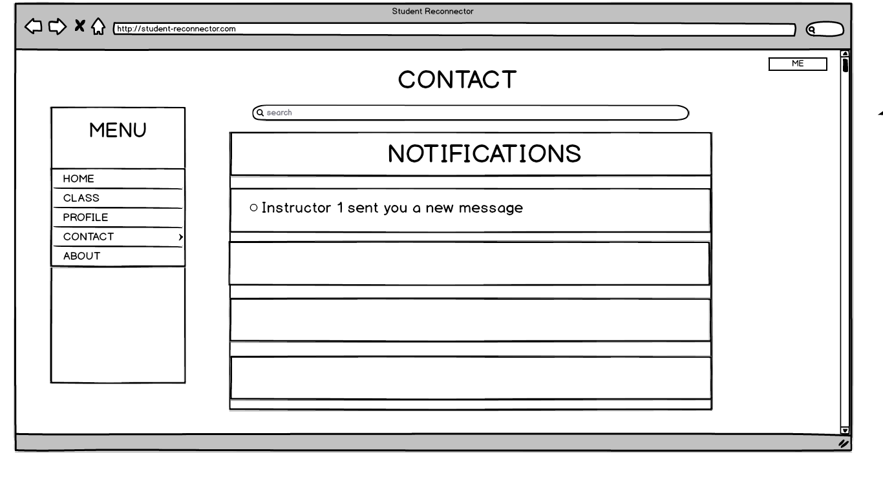

**STUDENT AND TEACHER CONTACT**

**1.View-** all notifications

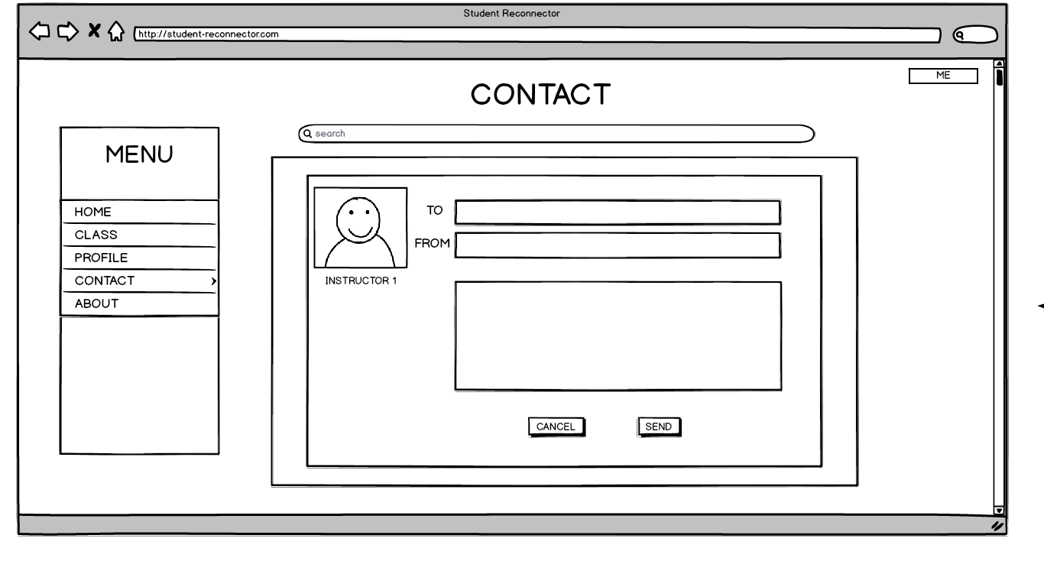

**STUDENT AND TEACHER CONTACT**

**1.Add-** to create a message fill up the form

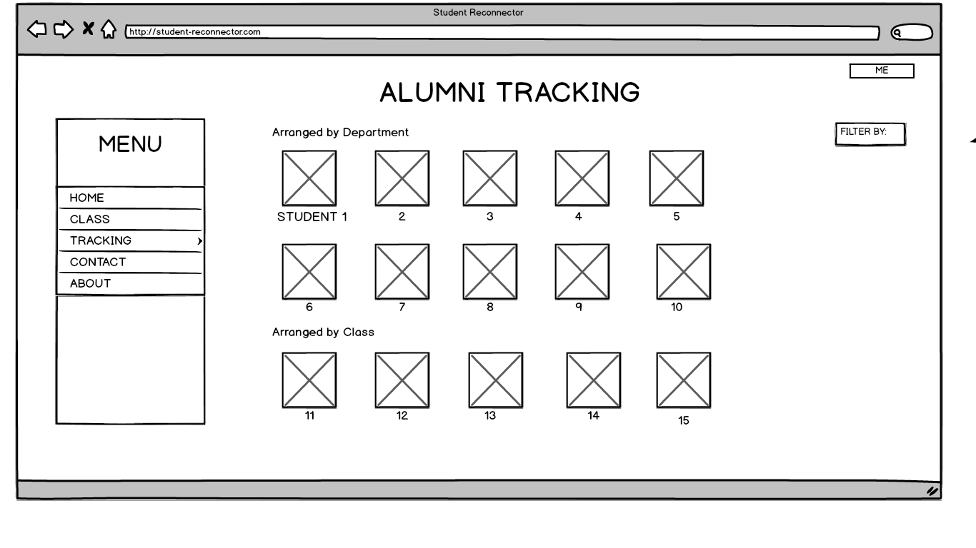

**TEACHER ALUMNI TRACKING**

**1. View-**List of alumni’s

**2. Filter By-** categorized by the year the alumni graduated

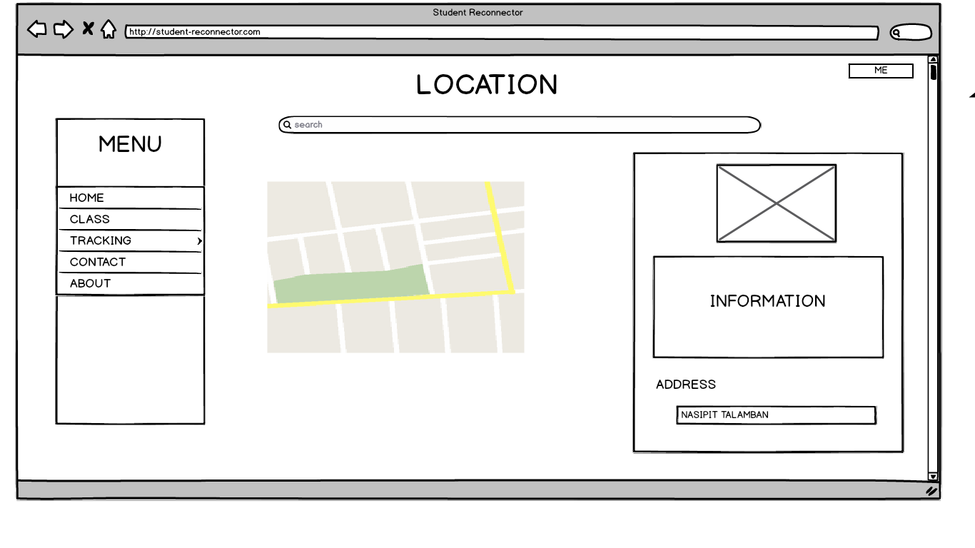

**TEACHER ALUMNI TRACKING**

**1.Display-**chosen student’s Image, Information address and other basic information

**CURRICULUM VITAE**

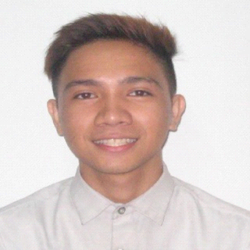**CONTACT INFORMATION**

**Name:** Baguio, Ferdinand Bryle

**Address:** B# 13 H. Abellana Street Talamban, Cebu City

**Cell Phone:** 09255219878

**Email:** baguioferdinand@gmail.com

**PERSONAL INFORMATION**

**Birthday:** December 19, 1996

**Religion:** Roman Catholic

**Civil Status:** Single

**EDUCATION**

University of San Carlos

Bachelor of Science in Information and Communication Technology

Tertiary Level (2015 – Present)

Maria Montessori International School

Secondary Level (*2009-2013)*

Maria Montessori Children's House

*Primary Level (2004-2009)*

**TECHNICAL SKILLS**

*Knowledgeable in Computer Software:*

* *Microsoft Applications (Word, Excel, PowerPoint)*

*C Programming language*

* *PHP,JAVASCRIPT,SQL,HTML,CSS*
* *Laravel Framework*

*Adobe Photoshop, Indesign, Director*

* *Sony Vegas, Windows movie maker*

**WORK EXPERIENCE**

*Lite Technology Intern*

**TRAININGS/ SEMINARS:**

DCIT Cyber Security Carava

OJT Orientation

PSITE 7 ICT Congress

5th Research Forum

Governance and Cyber Security Talk

**CURRICULUM VITAE**

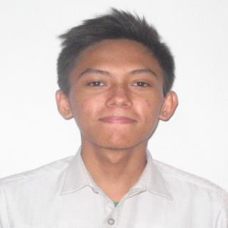**CONTACT INFORMATION**

**Name:**Jonas E. Paquibot Jr.

**Address:**#16 PNCO Apartment PC Hills Apas, Cebu City

**Telephone:**417-2541

**Cell Phone:**09228268653 / 09953115983

**Email:**paquibotjonas24@gmail.com

**PERSONAL INFORMATION**

**Birthday:** August 24, 1998

**Religion:** Roman Catholic

**Civil Status:** Single

**EDUCATION**

University of San Carlos

Bachelor of Science in Information and Communication Technology

Tertiary Level (2015 – present)

Matilda L. Bradford Christian School

Secondary Level (2011 – 2015)

Mabolo Christian Academy and Matilda L. Bradford Christian School

Primary Level (2005 – 2011)

**TECHNICAL SKILLS**

* Basic Networking
* Keyboarding
* Programming

**WORK EXPERIENCE**

* Department of Labor and Employment (DOLE) Intern / OJT

**TRAININGS/SEMINARS**

Governance and Cyber Security Talk

DCIT Cyber Security Carava

OJT Orientation

PSITE 7 ICT Congress

5th Research Forum

**CURRICULUM VITAE**



**CONTACT INFORMATION**

**Name:**Melody Abigail Yu Cuenco

**Address:**1821 M.J. Cuenco Ave., Mabolo Cebu City

**Cell Phone:**09335156232

**Email:**mcuenco11@gmail.com

**PERSONAL INFORMATION**

**Birthday:** November 06,1998

**Religion:** Roman Catholic

**Civil Status:** Single

**EDUCATION**

University of San Carlos

Bachelor of Science in Information and Communication Technology

Tertiary Level (2015 – Present)

Philippine Christian Gospel School

Secondary Level (*2011-2015)*

Philippine ChristianGospel School

*Primary Level (2005-2011)*

**TECHNICAL SKILLS**

Skillful in using Microsoft Softwares: (Word, Excel, Publisher, PowerPoint)

Capable of using Adobe Softwares: (Photoshop, Premiere, InDesign, Illustrator)

Basic Programming Languages such as: (HTML, JAVA, CSS, PHP)

Experienced in: (Database, Networking, Wordpress)

**WORK EXPERIENCE:** Convert Better Intern - SEO

**TRAININGS/SEMINARS**

Governance and Cyber Security Talk

DCIT Cyber Security Carava

OJT Orientation

PSITE 7 ICT Congress

5th Research Forum

**CURRICULUM VITAE**

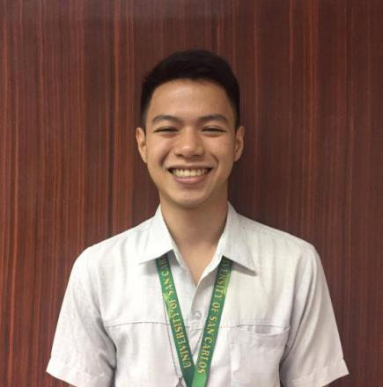**CONTACT INFORMATION**

**Name:** Lecarre L. Gavini

**Address:** San Vicente Vill. Sta Lucia#19, Mandaue City. Wireless

**Telephone:** 236-1591

**Cell Phone:** 09334534847

**Email:** lecarregavini@gmail.com

**PERSONAL INFORMATION**

**Birthday:** October 21,1998

Religion: Roman Catholic

Civil Status: Single

**EDUCATION**

University of San Carlos

Bachelor of Science in Information and Communication Technology

Tertiary Level (2015 – Present)

Colegio de la Inmaculada Concepcion

Mandaue City, Tipolo

Secondary Level (2012- 2015)

Mandaue Technical Institute - Holy Child Learning Center Foundation

Mandaue City, Wireless

Primary Level (2005- 2010)

**TECHNICAL SKILLS**

Web-Application: HTML, CSS, JavaScript, Bootstrap, PHP, AngularJS, and jQuery

Database: SQL

Design: Photoshop, Illustrator, Premiere Pro, and After Effects and Audacity

Microsoft: Excel, Word

and PowerPoint

Programming Languages: JAVA, OOP, and C++

File Sharing: GitHub

**WORK EXPERIENCE:** Convert Better Intern – SEO

**TRAININGS/SEMINARS**

Governance and Cyber Security Talk

DCIT Cyber Security Caravan

OJT Orientation

PSITE 7 ICT Congress

5th Research

Establishing Work Ethic