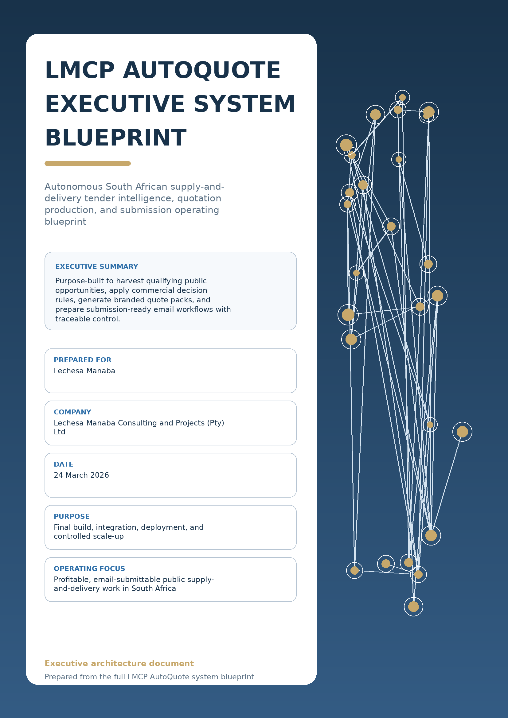

1. Executive brief
Operating mandate, commercial intent, and scope boundaries for the canonical production path.

LMCP AutoQuote is envisioned as a focused tender operations engine for profitable public supply-and-delivery work in South Africa. The platform should continuously harvest opportunities, apply explicit qualification rules, estimate commercial viability, generate branded quotation packs, and prepare submission-ready email workflows inside one controlled operating model.
This is not a generic tender scraper. It is a production system for finding the right opportunities, rejecting the wrong ones early, and moving only qualified work into pricing, pack generation, and dispatch with full auditability.
OPERATING MANDATE
One canonical workflow should serve manual run-once execution, scheduled autonomous harvesting, and supervised auto-submission. All three operating modes should use the same services, data objects, and decision rules.

Business goal  • Continuously discover qualifying RFQs and tender notices from approved public-sector procurement sources.  • Advance only opportunities that match LMCP target categories and email-submittable operating constraints.  • Turn approved opportunities into branded PDF quote packs with traceable submission preparation. | Success criteria  • Clear rule-based qualification with explainable exclusion reasons.  • Reliable commercial scoring and quote-readiness promotion.  • Controlled pack assembly, attachment manifesting, and email dispatch logging.

2. System at a glance
End-to-end operating chain and scope guardrails.

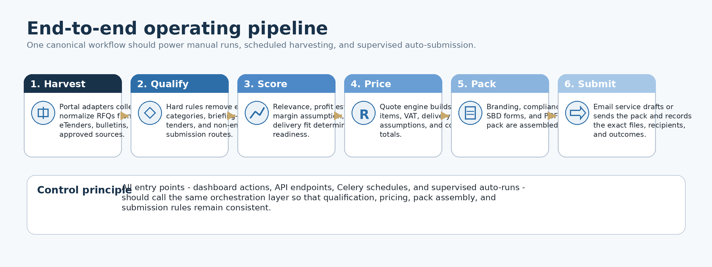

In scope  • Supply and delivery RFQs and tenders across national, provincial, municipal, SOE, and other approved public-sector sources.  • Harvesting, normalization, qualification, relevance and profitability screening, quote drafting, PDF generation, compliance assembly, and submission readiness.  • Reusable company branding, compliance document storage, and approved supplier or product pricing logic. | Out of scope for current production track  • Medical consumables, IT equipment, petrol, diesel, and other excluded categories.  • Any opportunity with a compulsory briefing session or site visit requirement.  • Portal-native workflows that cannot be translated into a controlled email submission path.

3. Target architecture
Single-stack design to prevent duplication, preserve consistency, and support controlled autonomy.

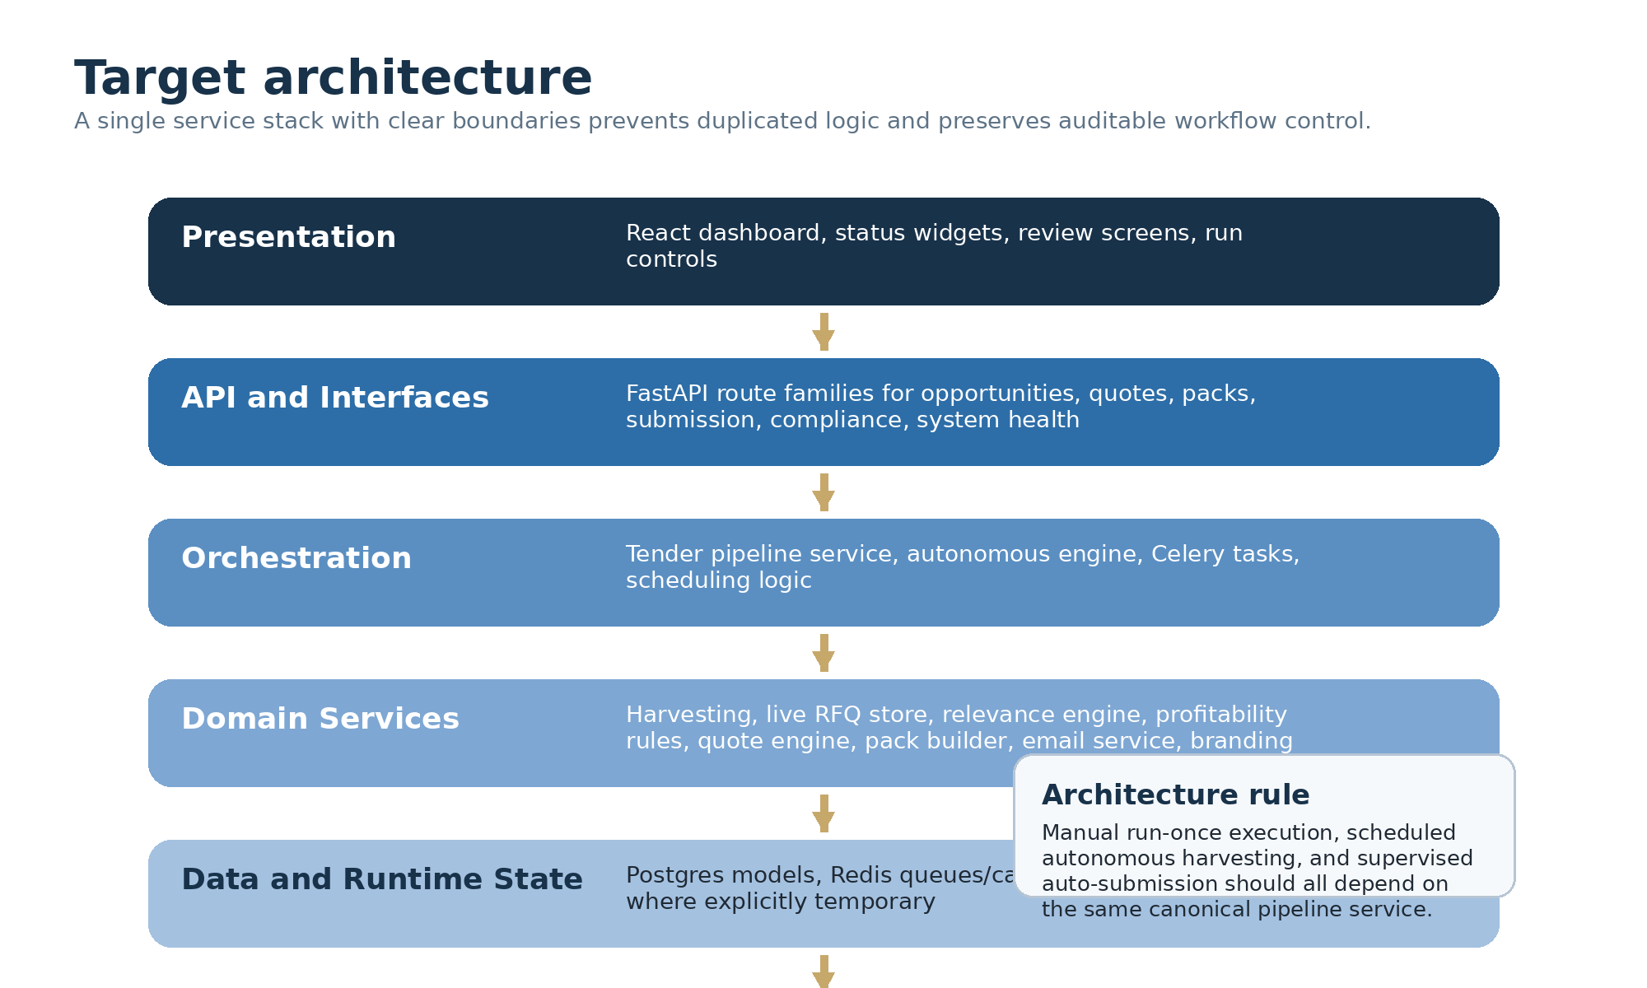
Core layer map
Layer | Purpose | Primary components
Presentation | Human control and visibility | React dashboard, status widgets, review screens, run controls
API and interfaces | Secure business entry points | FastAPI route families for dashboard, opportunities, quotes, packs, submission, compliance, system health
Orchestration | Cross-module workflow execution | Tender pipeline service, autonomous engine, Celery tasks, scheduling logic
Domain services | Business logic and transformations | Harvester, live RFQ store, relevance engine, profitability rules, quote engine, pack builder, email service, branding
Data and runtime state | Persistence and caching | Postgres models, Redis queues and cache, tightly controlled temporary runtime JSON
External integrations | Connectivity to sources and delivery channels | eTenders adapters, other approved portal adapters, SMTP provider, document generation libraries

4. Commercial decisioning
Qualification, exclusion, and quote-readiness promotion should be rule-based and explainable.

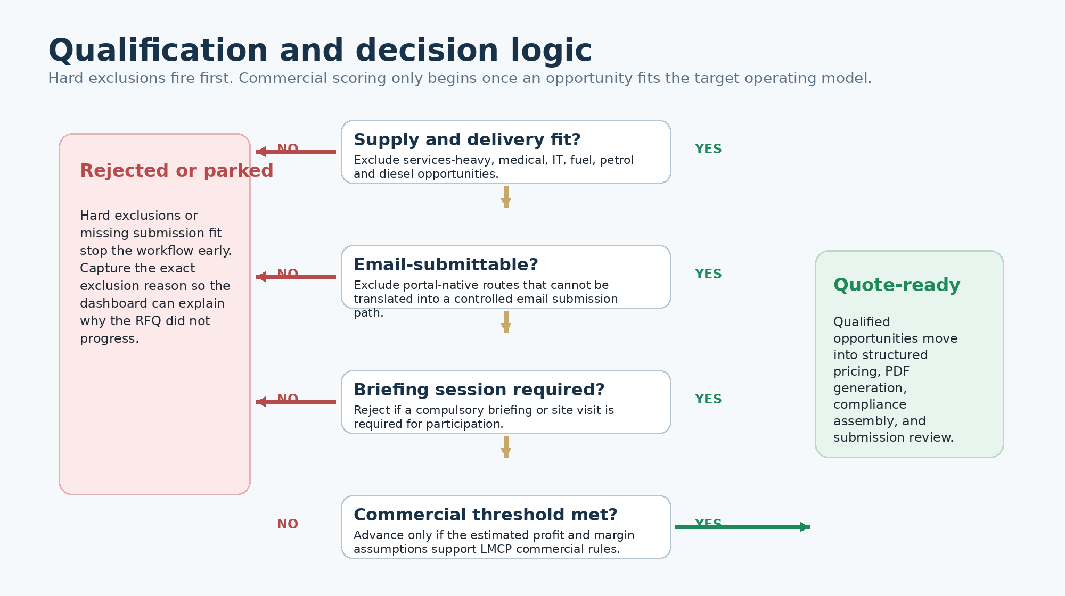
Decision framework
Control area | Rule intent | Operational consequence
Hard exclusions | Reject services-heavy work, excluded categories, briefing-session tenders, and non-email-compatible routes. | Stops wasted effort before scoring and stores the exact exclusion reason.
Positive signals | Prefer goods-based procurement, repeatable delivery scope, supplier-aligned categories, and submission routes that can be handled reliably. | Raises relevance and reduces manual interpretation burden.
Commercial threshold | Advance only when estimated profit and margin assumptions meet LMCP commercial rules. | Promotes work into quote-ready state and avoids low-value churn.
Explainability | Every decision outcome must be traceable in both machine-readable and human-readable form. | Supports dashboard review, audits, debugging, and operating trust.

5. Quote generation and submission pack
The quote factory must be data-driven, brand-safe, and compliance-aware.

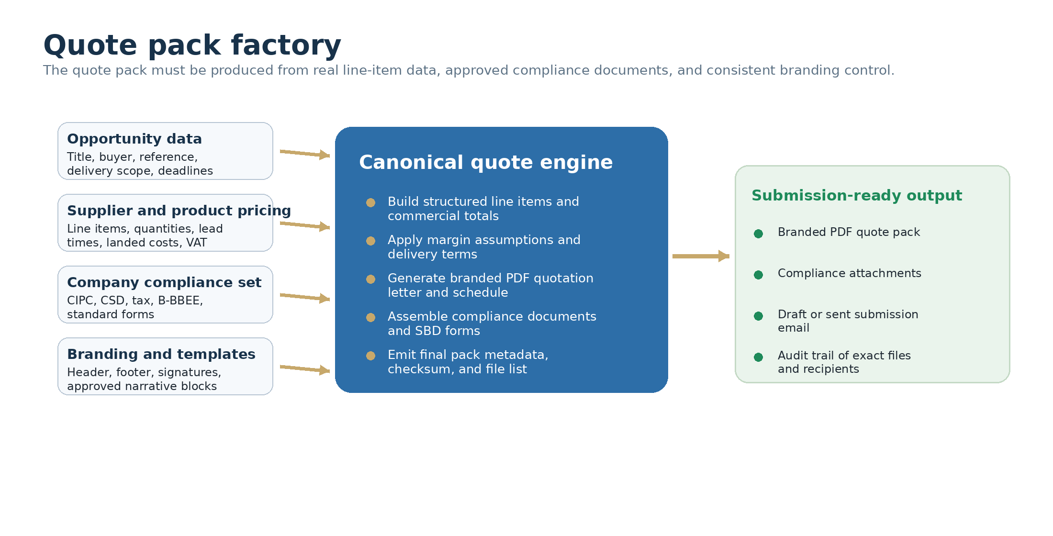
Quote PDF standard  • LMCP-branded header and identity pulled from a central branding module.  • Opportunity reference, issuing entity, RFQ number, and closing information.  • Structured line items, unit pricing, delivery assumptions, VAT, totals, and validity period.  • Authorised signature block and approved narrative language. | Submission pack standard  • Primary quotation PDF plus the commercial offer.  • Required compliance attachments and completed standard forms where applicable.  • Exact attachment manifest with final filenames, checksum, and storage path.  • Email draft or sent record linked to the same bundle metadata.

6. Core data objects and audit trail
Objects should progress through a controlled lifecycle with persistent references to files and outcomes.

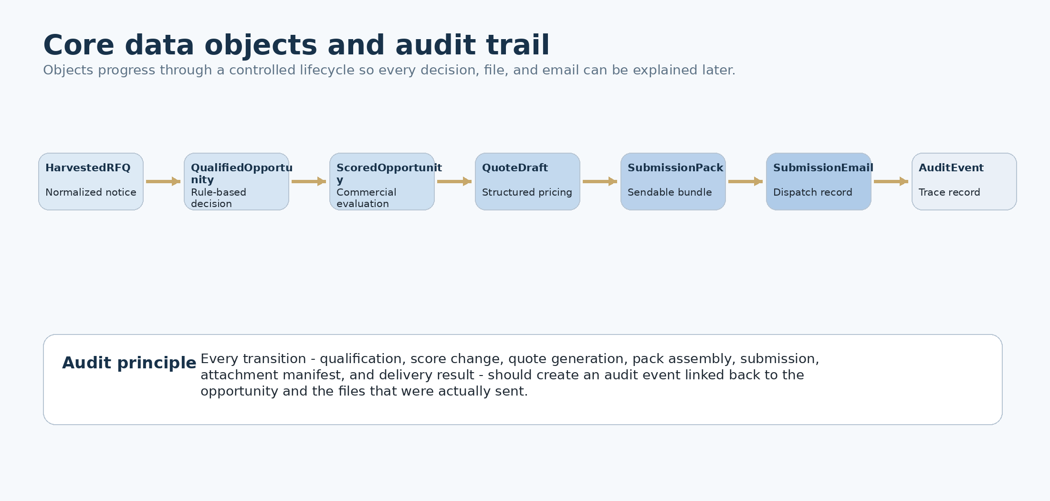
Canonical data objects
Object | Purpose | Key fields | Lifecycle notes
HarvestedRFQ | Normalized notice record | external_id, source, title, issuing_entity, province, dates, submission_method | Created by the harvester; raw source reference retained.
QualifiedOpportunity | RFQ after rule-based qualification | qualification_status, exclusion_reason, commodity_tags, email_submission_ok | Transitions from harvested state after rule evaluation.
ScoredOpportunity | Commercially evaluated opportunity | relevance_score, profit_estimate, margin_assumption, quote_ready | Drives queue promotion into the quote stage.
QuoteDraft | Structured quotation dataset | items, quantities, unit prices, totals, VAT, delivery assumptions, validity | Can be regenerated after pricing changes.
SubmissionPack | Final sendable bundle metadata | quote_pdf_path, compliance_files, sbd_forms, checksum, status | Must track the exact files sent.
SubmissionEmail | Email dispatch record | recipient, cc, subject, attachment_paths, sent_at, result | Should support both draft and sent states.
AuditEvent | Trace log | event_type, entity_type, entity_id, timestamp, actor, metadata | Generated at each significant stage.

7. Canonical modules and route families
Responsibilities should stay singular and interfaces should stay predictable.

Module responsibility map
Module or area | Canonical responsibility
app/main.py | Single application entry point with approved routers and startup hooks.
app/tasks.py | Celery task registration and task-level orchestration entry points.
app/services/tender_pipeline.py | Canonical orchestrator from harvested items to qualified, quote-ready output.
app/services/tender_harvester.py | Harvests and normalizes notices from source adapters.
app/services/live_rfq_store.py | Temporary live RFQ runtime store and filtered retrieval helpers.
app/autonomous_engine.py | Scheduling control and supervised autonomous pipeline execution.
app/quote_pack_service.py | Document assembly, pack generation, and final output handling.
app/email service or email_api.py | Submission drafting, sending, and message logging.
app/branding/company_branding.py | Central identity and template configuration used by all outgoing documents.

API route blueprint
Route family | Purpose | Control note
dashboard | Summary, health, counts, latest events | Read-only operational visibility.
autonomous | Status, run-once, schedule control | Must call the canonical pipeline service.
opportunities | Harvest results, review, promotion | Supports browsing and triage without bypassing rules.
quotes | Quote draft generation and retrieval | Should not skip qualification data.
quote pack | Build and retrieve PDF packs | Uses real quote data, branding, and manifests.
submission | Draft or send emails; track results | Must create audit events and retain file references.
compliance | Manage compliance documents and requirement mapping | Central source for attachment assembly.
system | Readiness and diagnostics | Used for environment and service checks.

8. Governance, security, and control tower
Production-safe autonomy depends on explicit safeguards, auditability, and human review points.

Security and governance controls  • Protect email credentials, database secrets, and external keys with environment-bound secret handling.  • Validate outbound recipient addresses against approved instructions before sending.  • Preserve source provenance and file lineage so every attachment in a pack can be traced to a stored reference.  • Never allow silent replacement of quote tools, recipients, or attachments without an audit event. | Control tower requirements  • System health tiles for API, database, Redis, worker, and scheduler readiness.  • Batch counters for harvested, excluded, qualified, quote-ready, quoted, packed, emailed, and failed states.  • Latest error stream with drill-down to entity and stage.  • Review queue for high-risk steps, retries, and approval gates before auto-submission.

DESIGN PRINCIPLES
Single source of truth. No duplicate systems. Deterministic pipeline behavior. Traceability first. Production-safe autonomy. Brand and compliance integrity.

9. Recommended build sequence and acceptance
Finish the canonical chain first, then add scale and autonomy on top of a stable operating path.

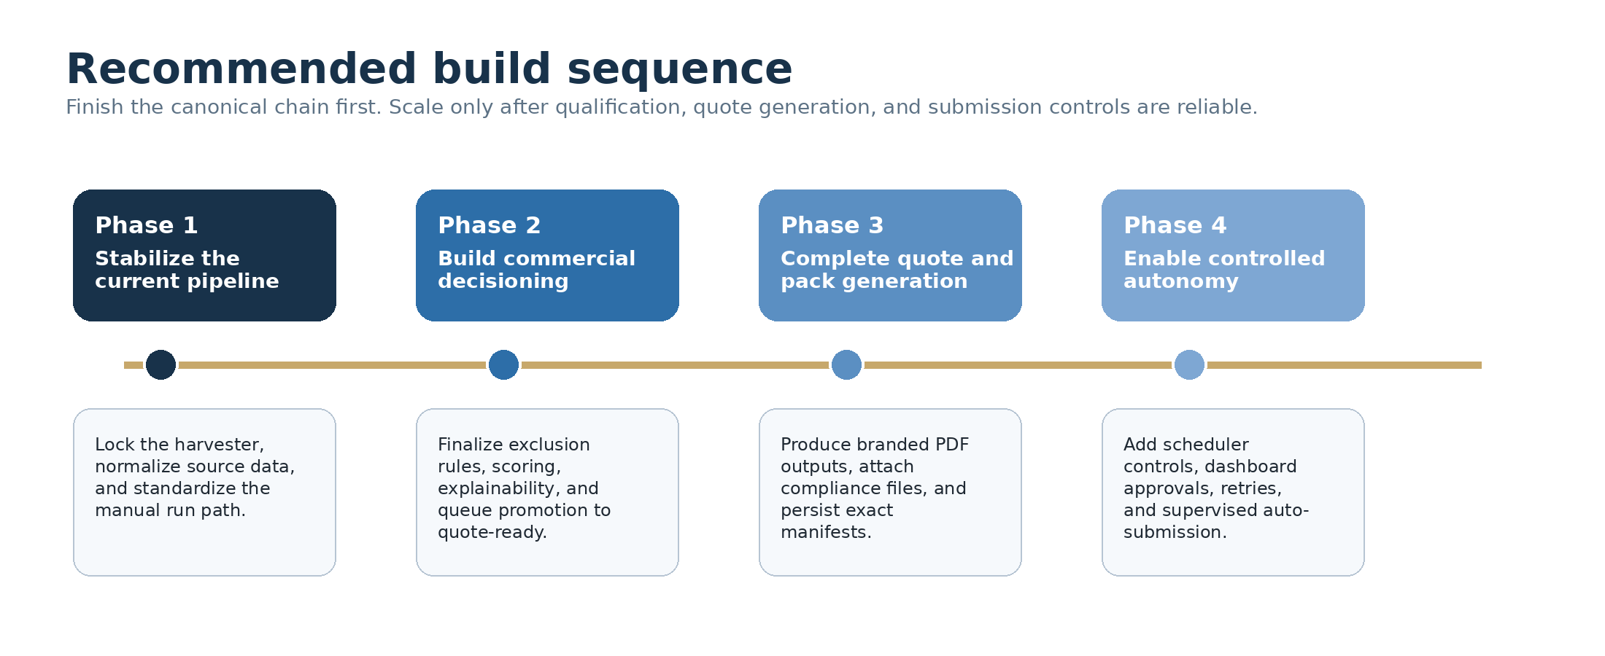
Non-negotiable acceptance criteria  • A single manual trigger can execute the pipeline from harvest to quote-ready without code edits.  • Qualified opportunities are explainable and visibly filtered against LMCP rules.  • Generated quotation PDFs contain real data and correct totals.  • Submission emails can be drafted or sent with the exact quote PDF and required compliance files attached. | Future expansion path  • Broaden source coverage to additional SOEs, departments, and municipalities once the core pipeline is reliable.  • Add richer supplier catalogs and partial pricing intelligence.  • Introduce approval workflows for higher-risk submissions.  • Expand reporting and dashboards once the canonical production path is stable.

10. Final implementation note
The blueprint prioritizes disciplined consolidation over parallel experimentation.

The fastest path to a reliable LMCP AutoQuote production system is disciplined consolidation: qualification, scoring, quote drafting, branded PDF generation, compliance assembly, and submission logging should all remain inside one canonical flow.
If a proposed change does not clearly strengthen that chain, reduce risk inside that chain, or improve observability around that chain, it should be deferred until the core path is stable.
EXECUTIVE CONCLUSION
Build one operating machine: harvest -> qualify -> score -> quote -> brand -> attach -> submit -> audit. Make it visible, explainable, and commercially disciplined before adding scale.

Immediate next actions
Priority | Action | Outcome
1 | Stabilize harvester inputs and normalized RFQ schema | Consistent source data and reliable manual run path
2 | Finalize exclusion rules, scoring, and explainability | Controlled opportunity promotion to quote-ready
3 | Complete branded quote pack generation and attachment manifesting | Submission-ready document output with traceable files
4 | Enable scheduler controls, dashboard review, and supervised auto-submission | Safe operational autonomy with approval points

