UDPtoDMX Hardware:

“Classic” Arduino:

You need an Arduino UNO or Arduino Leonardo (or clone)

an ethernet shield (W5100)

an DMX-shield (diy or commercial)

depending what dmx-library you use, Pin3 / Pin4 or RX/TX is used

also see https://www.loxforum.com/forum/faqs-tutorials-howto-s/34948-günstige-und-bessere-alternative-zur-dmx-extension
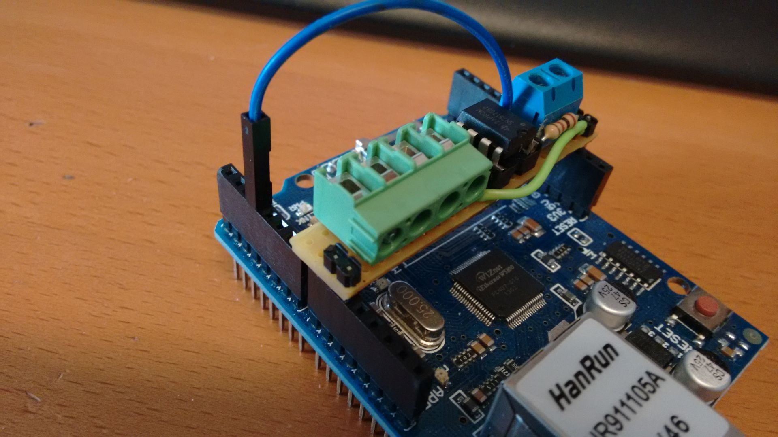
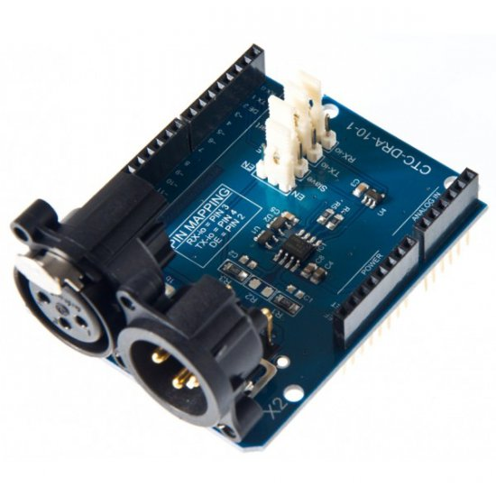

schematic: https://playground.arduino.cc/DMX/DMXShield
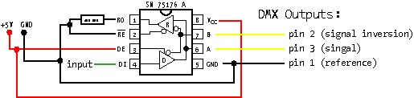

Wemos-D1 mini + DMX-shield

to build WiFi to DMX gateway you need to add MAX485 to your ESP-266 based “arduino-like” board, can OTA-Update after first time flashing
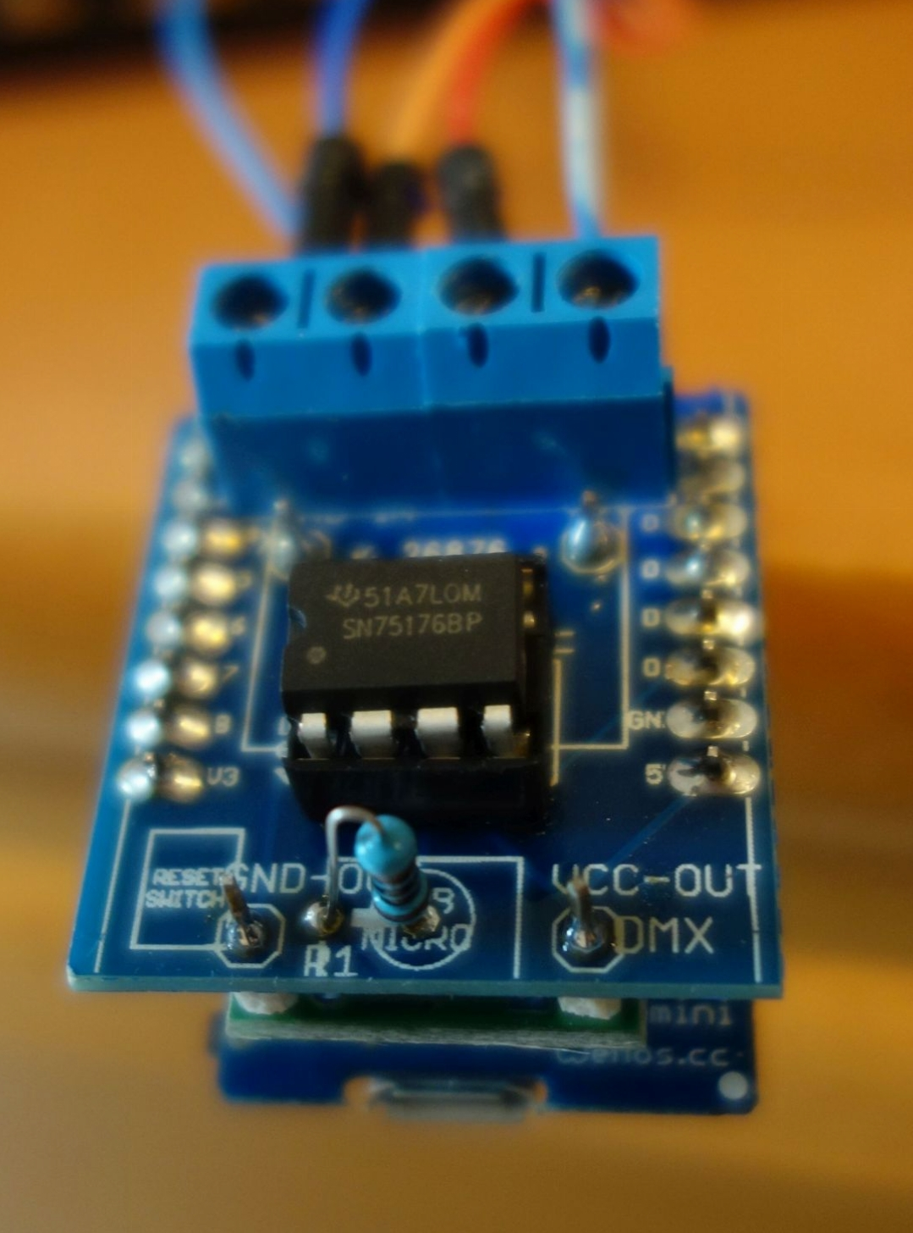
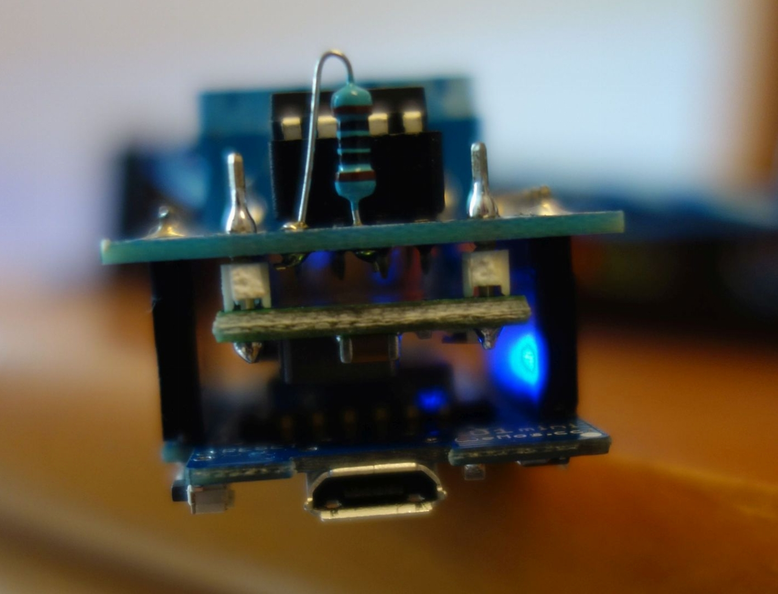

H801:

this Wireless ESP8266 based PWM LED Dimmer does not use DMX but has 5 Channels onboad
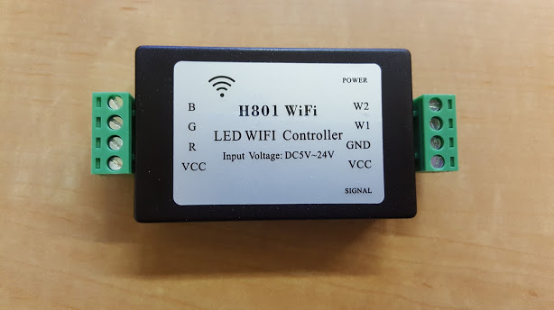

has 5000 Dim-Values (not 255 like DMX) and high PWM Frequency (1000Hz)

you need a USB-TTL adapter with 3.3V to flash new Firmware
PIN header has to be soldered inside for flashing, can OTA-Update after first time flashing

cod.m:

https://shop.codm.de/module/

Professional arduino-like Ethernet to DMX Hardware, with W5500 Ethernet Chip
with pre-installed UDPtoDMX Firmware, with unique MAC, using DHCP

you need a USB-TTL adapter with 3.3V to flash new Firmware

also see:
https://www.loxforum.com/forum/faqs-tutorials-howto-s/161289-professionelle-ethernet-dmx-bridge-als-alternative-zur-dmx-extension

x86:

Windows Version, just for testing/debugging, uses DUMMY DMX device (no real DMX Hardware) at the moment

