UDPtoDMX Software:

current status is: “try at you own risk”

Original project, using Arduino IDE can be found on sf.net https://sourceforge.net/p/udptodmx/code/HEAD/tree/

Has been moved github https://github.com/LechnerRobert/UDPtoDMX

Uses PlatformIO https://platformio.org/
(I am using the Microsoft's Visual Studio Code Version)

Can compile all Platform on “one click”.
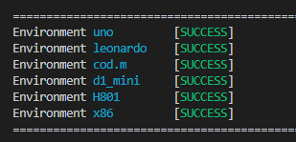

Has many switches to turn on/off different features: DHCP, Debugging, Simulator,..

The Simulator is a Windows GUI Software, Sending UDP Commands, and receiving first 16 Channels, to draw them as as Graph, and Test the gateway: this is “coming soon..”

The Code is self explanatory.. :-)

The Project refers to “MAKERS”, that rudimentary know how to flash arduino, write C++ Programs, have some knowledge about LAN/WiFi/IP/UDP and not to left hands…

