Name: Himangi Bhatt

Uid: 23BCC70020

Section: 23BCC-A

**EXPERIMENT - 1**

**AIM:** 1. Create two tables Authors and Books

2. Input Values into the two tables

3. Implement Inner Join

**Query:** 1.

Create table Authors( author_id INT Primary Key, name VARCHAR(50), country VARCHAR(50));

Create table Books(book_id INT Primary Key, title VARCHAR(100), author_id INT, Foreign Key (author_id ) references Authors(author_id));

Desc Authors;

Desc Books;

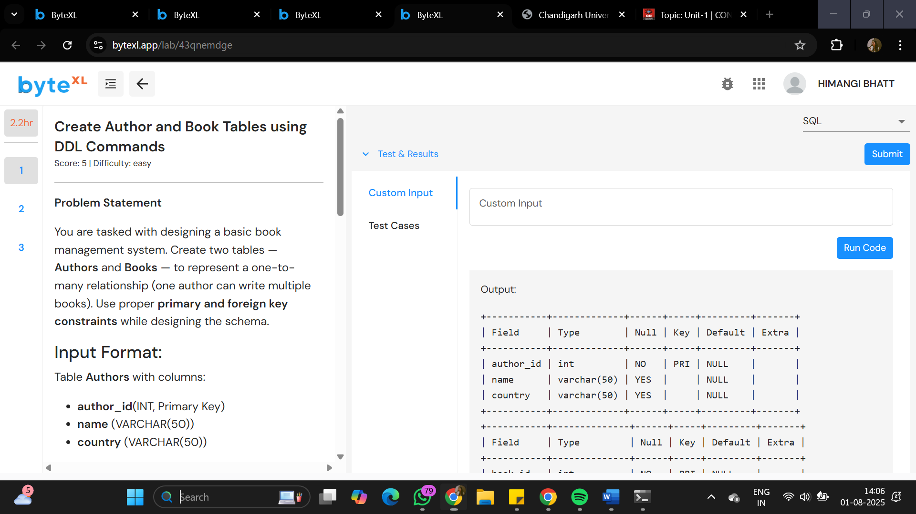

2. -- Insert into Authors table

INSERT INTO Authors (Author_id, name, country) VALUES

(1, 'Ashish', 'India'),

(2, 'Smaran', 'USA'),

(3, 'Vaibhav', 'UK');

-- Insert into Books table (match book_id values exactly)

INSERT INTO Books (Book_id, title, author_id) VALUES

(101, 'Data Science Basics', 1),

(102, 'AI in Education', 2),

(103, 'SQL Simplified', 1);

-- Display the tables

SELECT * FROM Authors;

SELECT * FROM Books;

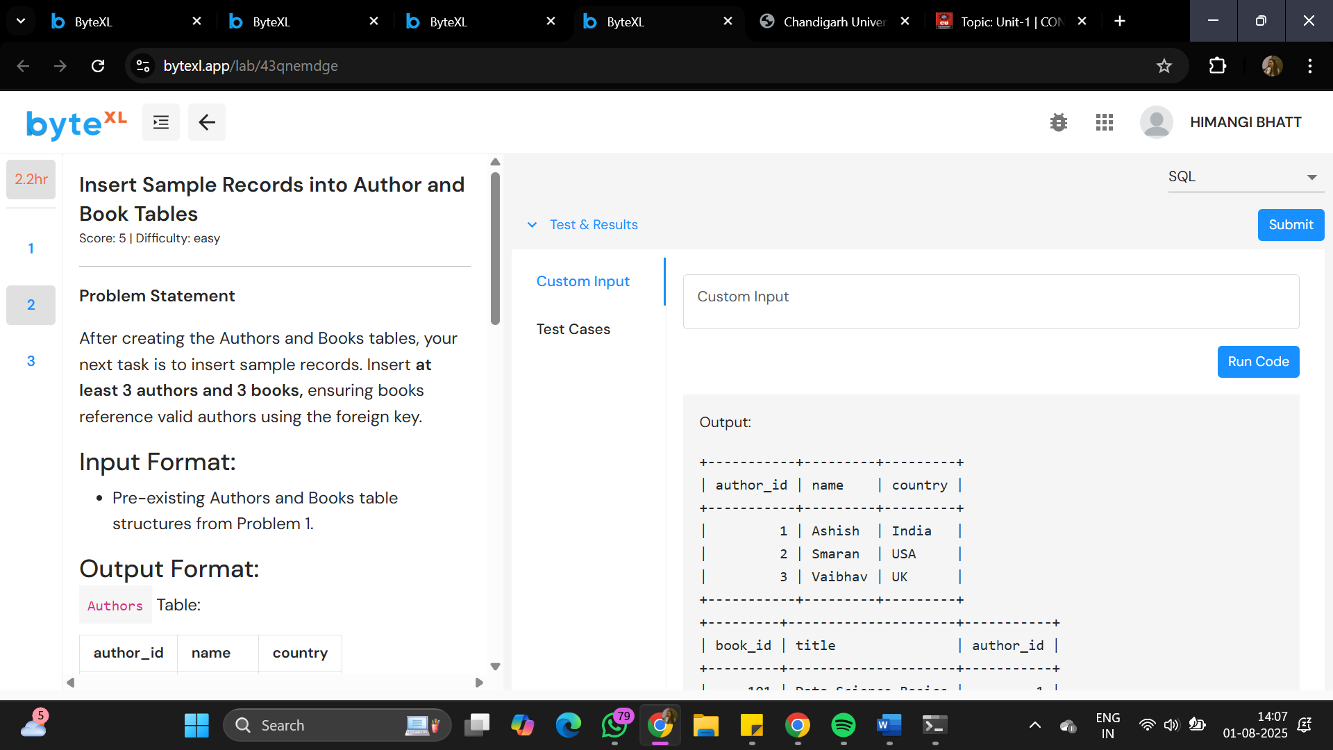

3. SELECT

B.title AS title,

A.name AS name,

A.country AS country

FROM

Books AS B

INNER JOIN

Authors AS A ON B.author_id = A.author_id;

