SDS (Siglent Digital Scope) Class is OO opgezet.

Een SDS bestaat uit 1 SDSScope object met n kanalen (n=1-4). Bij een SDSSscope horen de volgende eigenschappen/properties:`

* AUTO_CALIBRATE, ACAL
* AUTO_SETUP, ASET
* AUTO_TYPESET <type> <type> : = {SP,MP,RS,DRP,RC}
* AVERAGE_ACQUIRE <time>, met <time> : = {4, 16, 32, 64,128,256,etc}
* BUZZER, BUZZ
* *CAL?
* COMM_HEADER, CHD. The COMM_HEADER command controls the way the oscilloscope formats responses to queries. Comm_HeaDeR <mode> <mode> : = {SHORT, LONG, OFF}
* *CLS: The *CLS command clears all the status data registers.
* CMR? The CMR? Query reads and clears the contents of the Command error Register (CMR)
* COMM_NET, CONET. The COMM_NET command changes the IP address of the oscilloscope‘s internal network interface.
* COUNTER,COUN. The COUNTER command enables or disables the cymometer display on the screen of instrument.
* CURSOR_AUTO,CRAU. Alleen voor non-SPO.
* CURSOR_MEASURE, CRMS. Afhankelijk van scope, verschillende formaten?
* CSV_SAVE, CSVS. The CSV_SAVE command selects the specified option of storing CSV format waveform.
* CYMOMETER, CYMT. Waarschijnlijk de frequentiemeting van het signaal op de scoop. Is onduidelijk of dit hoort bij de scoop als geheel, of dat dit een kanaal eigenschap is.
* DATE. The DATE command changes the date/time of the oscilloscope‘s internal real-time clock.
* DDR? The DDR? Query reads and clears the contents of the Device Dependent or device specific error Register (DDR). In the case of a hardware failure, the DDR register specifies the origin of the failure. DDR <value> <value> : = 0 to 65535
* DEFINE, DEF. The DEFINE command specifies the mathematical expression to be evaluated by a function. DEFine EQN,‘<equation>‘. Voorbeeld: Command message: DEFine EQN,'C1*C2'

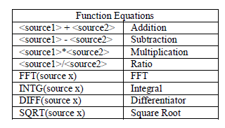

* DELETE_FILE,DELF. The DELETE_FILE command deletes files from the currently selected directory on mass storage.
* DIRECTORY, DIR. The DIRECTORY command is used to manage the creation and deletion of file directories on mass storage devices. It also allows selection of the current working directory and listing of files in the directory.
* DOT_JOIN,DTJN. The DOT_JOIN command controls the interpolation lines between data points.
* *ESE. The *ESE command sets the Standard Event Status Enable register (ESE). This command allows one or more events in the ESR register to be reflected in the ESB summary message bit (bit 5) of the STB register.
* *ESR? The *ESR? query reads and clears the contents of the Event Status Register (ESR). The response represents the sum of the binary values of the register bits 0 to 7.
* EXR? The EXR? query reads and clears the contents of the Execution error Register (EXR). The EXR register specifies the type of the last error detected during execution.
* FILENAME, FLNM. The FILENAME command is used to change the default filename given to any traces, setups and hard copies when they are being stored to a mass storage device. FiLeNaMe TYPE, <type>, FILE, ‗<filename>‘ <type>:={ C1,C2,C3, C4, SETUP,TA, TB, TC, TD, HCOPY} <filename> : = an alphanumeric string of up to 8 characters forming a legal DOS filename.
* FRAME_PARAM, FPAR
* FRAME_SET, FRAM. The FRAME_SET command is used to set history current frame number.
* FORCE_TRIGGER,FRTR. Causes the instrument to make one acquisition. Command message1: TRMD SINGLE;ARM;FRTR Command message2: TRMD STOP;ARM;FRTR
* FRAME_TIME, FTIM. The FRAME_TIME command is used to get current frame Acq. Time.
* FORMAT_VDISK, FVDISK
* FFT_WINDOW,FFTW. The FFT_WINDOW command selects the window of FFT(Fast Fourier Transform algorithm). FFT_WINDOW <window> <window > : = {RECT,BLAC,HANN,HAMM} RECT is short for rectangle. BLAC is short for Blackman. HANN is short for hanning. HAMM is short for hamming.
* FFT_ZOOM,FFTZ. The FFT_ZOOM command selects the specified zoom of FFT. FFT_ZOOM <zoom> < zoom > : = {1,2,5,10}
* FFT_SCALE,FFTS. The FFT_SCALE command selects the specified scale of FFT (Fast Fourier Transform algorithm). The response to the FFT_SCALE? query indicates current vertical scale of FFT waveform. FFT_SCALE <scale> < scale > : = {VRMS,DBVRMS}
* FFT_FULLSCREEN,FFTF. The FFT_FULLSCREEN command enables or disables to display the FFT waveform full screen. The response to the FFT_FULLSCREEN? Query. FFT_FULLSCREEN <state> < state > : = {ON,OFF}
* GRID_DISPLAY,GRDS. GRID_DISPLAY <type> < type > : = {FULL,HALF,OFF}
* GET_CSV,GCSV. The response to the GET_CSV? Query indicates current waveform of CSV format. HOR_MAGNIFY, HMAG.
* <exp_trace>: Hor_MAGnify <factor> <exp_trace>: = {TA, TB, TC, TD} <factor> : = 1 to 2,000,000 The range of <factor> is related to the current timebase and the range of the timebase.
* HOR_POSITION, HPOS. The HOR_POSITION command horizontally positions the geometric center of the intensified zone on the source trace. Allowed positions range from division -7 to 7. If this would cause the horizontal position of any expanded trace to go outside the left or right screen boundaries, the difference of positions is adapted and then applied to the traces. <exp_trace>: Hor_POSition <hor_position> <exp_trace>: = {TA, TB, TC, TD} <hor_position>: = -7 to 7 DIV
* HARDCOPY_SETUP, HCSU
* *IDN?
* ILVD. The INTERLEAVED command enables or disables random interleaved sampling (RIS) for timebase settings where both single shot and RIS mode are available.
* INTENSITY,INTS. The INTENSITY command sets the intensity level of the grid or the trace. INTenSity GRID, <value>, TRACE, <value> <value> : = 0(or 30) to 100 [PCT]
* INR? The INR? query reads and clears the contents of the INternal state change Register (INR). The INR register (table below) records the completion of various internal operations and state transitions.

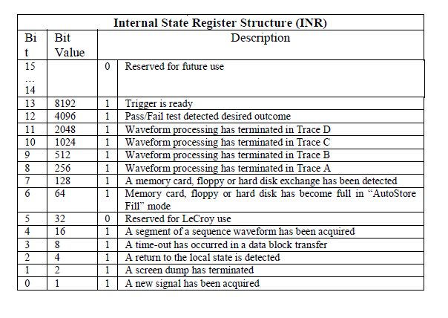

* LOCK, LOCK. The LOCK command enables or disables the panel keyboard of the instrument.
* MENU, MENU. The MENU command enables or disables to display the menu.
* MATH_VERT_POS, MTVP Command/Query. The MATH_VERT_POS command controls the vertical position of the math waveform with specified source.
* MATH_VERT_DIV, MTVD
* MEMORY_SIZE, MSIZ. The MEMORY_SIZE command sets the maximum depth of memory. MEMORY_SIZE <size> <size>:= {7K, 14K, 70K, 140K, 700K, 1.4M,7M,14M}.
* *OPC? The *OPT? query identifies the installed oscilloscope options. The response consists of a series of response fields listing all the installed options. EXAMPLE：The following instruction queries the installed options: *OPT? Return: *OPT RS232,NET,USBTMC
* PEAK_DETECT, PDET. The PEAK_DETECT command switches ON or OFF the peak detector built into the acquisition system.
* PERSIST, PERS. PERSist <mode> <mode> : = {ON, OFF}
* PERSIST_SETUP, PESU. The PERSIST_SETUP command selects the persistence duration of the display, in seconds,in persistence mode. PErsist_SetUp <time>
* <time>：= {1，5，10，30,Infinite}
* PANEL_SETUP, PNSU Command /Query
* PF_DISPLAY,PFDS Command /Query. The PF_DISPLAY command enables or disables to turn the test and display the message in the pass/fail option.
* PF_SET,PFST. The PF_SET command sets the X mask and the Y mask of the mask setting in the pass/fail option. PF_ SET XMASK, <div>,YMASK, <div> <div> : = 0.04div~4.0div
* PF_SAVELOAD,PFSL. The PF_SAVELOAD command saves or recalls the created mask setting.
* PF_CONTROL,PFCT. The PF_CONTROL command controls the pass/fail controlling options: ―operate‖, ―output‖ and the ―stop on output‖.
* PF_CREATEM,PFCM The PF_CREATEM command creates the mask of the pass/fail.
* PF_DATADIS, PFDD. The PF_DATADIS? query returns the number of the fail ,pass and total number that the screen showing.
* *RCL. The *RCL command sets the state of the instrument, using one of the ten non-volatile panel setups, by recalling the complete front-panel setup of the instrument. Panel setup 0 corresponds to the default panel setup.
* RECALL, REC. The RECALL command recalls a waveform file from the current directory on mass storage into any or all of the internal memories M1 to M10(or M20 in the CFL series).
* RECALL_PANEL, RCPN. The RECALL_PANEL command recalls a front-panel setup from the current directory on mass storage.
* *RST. The *RST command initiates a device reset. The *RST sets recalls the default setup.
* REF_SET, REFS. The REF_SET command sets the reference waveform and its options.
* *SAV. The *SAV command stores the current state of the instrument in internal memory. The *SAV command stores the complete front-panel setup of the instrument at the time the command is issued.
* SCREEN_DUMP,SCDP. The SCREEN_DUMP command is used to obtain the screen information of image format .
* SCREEN_SAVE,SCSV. The SCREEN_SAVE command controls the automatic Screen Saver, which automatically shuts down the internal color monitor after a preset time.
* *SRE. The *SRE command sets the Service Request Enable register (SRE). This command allows the user to specify which summary message bit(s) in the STB register will generate a service request.
* *STB? The *STB? query reads the contents of the 488.1 defined status register (STB), and the Master Summary Status (MSS). The response represents the values of bits 0 to 5 and 7 of the Status Byte register and the MSS summary message.
* STOP. The STOP command immediately stops the acquisition of a signal. If the trigger mode is AUTO or NORM.
* STORE, STO. The STORE command stores the contents of the specified trace into the current directory in a USB memory device.
* STORE_PAMEL,STPN. The STORE_PANEL command stores the complete front-panel setup of the instrument, at the time the command is issued, into a file on the specified-DOS path directory in a USB memory device.
* STORE_SETUP,STST. The STORE_SETUP command controls the way in which traces will be stored. A single trace or all displayed traces may be enabled for storage.
* SAMPLE_STATUS,SAST. The SAST? query the acquisition status of the scope.
* SAMPLE_RATE,SARA. The SARA? query returns the sample rate of the scope.
* SAMPLE_RATE,SANU. The SANU? query returns the number of sampled points available from last acquisition and the trigger position.
* SET50,SET50. The SET50 command sets the trigger level of the specified trigger source to the centre of the signal amplitude. This command is suitable for non-SPO models
* SINXX_SAMPLE, SXSA The SINXX_SAMPLE command sets the way of interpolation.
* TIME_DIV,TDIV. The TIME_DIV command modifies the timebase setting. The new timebase setting may be specified with suffixes: NS for nanoseconds, US for microseconds, MS for milliseconds, S for seconds, or KS for kiloseconds. An out-of-range value causes the VAB bit (bit 2) in the STB register to be set.
* TEMPLATE, TMPL. The TEMPLATE? query produces a copy of the template that describes the various logical entities making up a complete waveform. In particular, the template describes in full detail the variables contained in the descriptor part of a waveform.
* TRACE,TRA. The TRACE command enables or disables the display of a trace. An environment error is set if an attempt is made to display more than four waveforms. The TRACE? query indicates whether the specified trace is displayed or not. <trace>: TRAce <mode> <trace> : = {C1, C2, C3, C4, TA, TB, TC, TD} <mode> : = {ON, OFF}
* *TRG. The *TRG command executes an ARM command.
* TRIG_DELAY, TRDL. The TRIG_DELAY command sets the time at which the trigger is to occur with respect to the first acquired data point.
* TRIG_LEVEL, TRLV. TRIG_LEVEL command adjusts the trigger level of the specified trigger source. An out-of-range value will be adjusted to the closest legal value and will cause the VAB bit (bit 2) in the STB register to be set. The TRIG_LEVEL? query returns the current trigger level. <trig_source>: TRig_LeVel <trig_level> <trig_source>: = {C1, C2, C3, C4, EX, EX5} <trig_level>: = -4.5DIV* volt/div to 4.5DIV * volt/div
* TRIG_LEVEL2, TRLV2. The TRIG_LEVEL2 command adjusts the second trigger level of the specified trigger source. An out-of-range value will be adjusted to the closest legal value and will cause the VAB bit (bit 2) in the STB register to be set. The TRIG_LEVEL? query returns the current trigger level. <trig_source>: TRig_LeVel2 <trig_level> <trig_source>: = {C1, C2, C3, C4, EX, EX5} <trig_level>: = -4.5DIV* volt/div to 4.5DIV * volt/div
* TRIG_MODE, TRMD The TRIG_MODE command specifies the trigger mode. TRig_MoDe <mode> <mode>: = {AUTO, NORM, SINGLE,STOP}
* TRIG_SELECT, TRSE. The TRIG_SELECT command selects the condition that will trigger the acquisition of waveforms. Depending on the trigger type, additional parameters must be specified. These additional parameters are grouped in pairs. The first in the pair names the variable to be modified, while the second gives the new value to be assigned.
* Pairs may be given in any order and restricted to those variables to be changed. 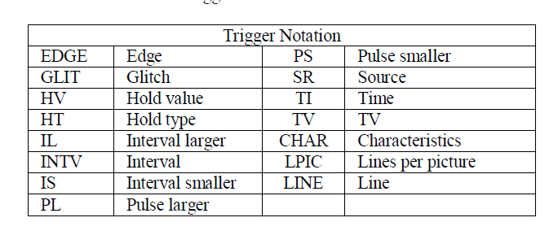
* TRIG_WINDOW, TRWI. The TRIG_WINDOW command sets the relative height of the two trigger line of the trigger window type. The TRIG_WINDOW? query returns relative height of the two trigger line of the trigger window type. TRig_WIndow <value> < value >: -4.5DIV* volt/div to 4.5DIV * volt/div
* WAVEFORM_SETUP, WFSU. The WAVEFORM_SETUP command specifies the amount of data in a waveform to be transmitted to the controller. The command controls the settings of the parameters listed below.
* WAIT,WAIT. The WAIT command prevents the instrument from analyzing new commands until the oscilloscope has completed the current acquisition. The instrument will be waiting for trigger or the limit time over (if we set it) or the device time out when we sent this command
* XY_DISPLAY, XYDS. The XY_DISPLAY command enables or disables the display the XY format. XY_DISPLAY <state> <state>：= {ON, OFF}

Elk kanaal is een SDSChannel object. Bij een kanaal horen de volgende properties, op basis van analyse programming guide SDS1000X:

* Naam = “C” + nummer van kanaal op de fysieke scope.
* De momentele instellingen van het kanaal
  + ATTENUATION, ATTN: selects the vertical attenuation factor of the probe. Values of 1, 5, 10, 50, 100, 500, and 1000 may be specified
  + BANDWIDTH_LIMIT, BWL
  + COUPLING, CPL. <channel>: CouPLing <coupling> <channel> : = {C1, C2, C3, C4}. <coupling> : = {A1M, A50, D1M, D50, GND}
  + CURSOR_SET, CRST. The CURSOR_SET command allows the user to position any one of the eight independent cursors at a given screen location.
  + CURSOR_VALUE?, CRVA? The CURSOR_VALUE? Query returns the values measured by the specified cursors for a given trace.
  + FILTER,FILT. The FILTER command. <channel>:FILTER <state> <channel> : = {C1,C2,C3,C4} <state> : = {ON,OFF}. This command is suitable for non-SPO models.
  + FILT_SET,FILTS. The FILT_SET command selects the specified type of filter, and sets the limit value of filter. The response to the FILT_SET? query indicates current parameter of the filter. <channel>:FILT_SET TYPE,<type>,<limit>,<limit_value> <channel> : = {C1,C2,C3,C4} <type> : = {LP,HP,BP,BR} <limit> : = {UPPLIMIT,LOWLIMIT}.
  + INVERTSET,INVS. <trace>:INVERTSET < state > < trace > : = {C1,C2,C3,C4,MATH} < state >:= {ON,OFF}
  + MEASURE_DELAY,MEADThe MEASURE_DELY command selects the type of delay measure. MEASURE_DELAY <type>,<source> <source>:= {C1-C2, C1-C3, C1-C4, C2-C3, C2-C4, C3-C4} <type>:={PHA,FRR,FRF,FFR,FFF,LRR,LRF,LFR, LFF,SKEW}. The PHA is phase, the others are the same as the specified type of the instrument‘s delay measure.
  + OFFSET, OFST. The OFFSET command allows adjustment of the vertical offset of the specified input channel. The maximum ranges depend on the fixed sensitivity setting. <channel>: OFfSeT <offset> <channel> : = {C1, C2, C3,C4} <offset> : = See the oscilloscope‘s specifications.
  + PARAMETER_CLR, PACL. The PARAMETER_CLR command clears the P/F test counter and starts it again at 0.
  + PARAMETER_CUSTOM, PACU. The PARAMETER_CUSTOM command controls the parameters that have customizable qualifiers. PArameter_CUstom <parameter>,<qualifier> <parameter> : ={PKPK, MAX, MIN, AMPL, TOP, BASE, CMEAN, MEAN, RMS, CRMS, OVSN, FPRE, OVSP, RPRE, PER, FREQ, PWID, NWID, RISE,FALL,WID,DUTY,NDUTY, ALL} <qualifier> : = { C1,C2,C3,C4 } Measurement qualifier specific to each(source option)
  + PARAMETER_VALUE?, PAVA? The PARAMETER_VALUE query returns the measurement values. <trace>:PArameter_VAlue? [<parameter>, ... , <parameter>] <trace>: = { C1, C2, C3, C4} <parameter> : = See table of parameter names on previous table.
  + 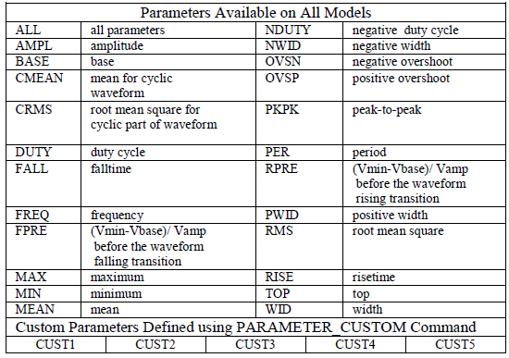
* SKEW,SKEW. The SKEW command sets the skew value of the specified trace. <trace>:SKEW <skew> <trace> : = {C1,C2,C3,C4 } <skew>: = it is a value about time.
* TRIG_COUPLING, TRCP. The TRIG_COUPLING command sets the coupling mode of the specified trigger source. The TRIG_COUPLING? query returns the trigger coupling of the selected source. <trig_source>: TRig_CouPling <trig_coupling> <trig_source>: = {C1, C2, C3, C4, EX, EX5, LINE} <trig_coupling>: = {AC,DC,HFREJ,LFREJ}
* TRig_SElect? TRig_Select <trig_type>, SR, <source>, HT, <hold_type>, HV, <hold_value>
* TRIG_SLOPE, TRSL. The TRIG_SLOPE command sets the trigger slope of the specified trigger source. The TRIG_SLOPE? query returns the trigger slope of the selected source. <trig_source>: TRig_SLope <trig_slope> <trig_source>: = {C1, C2, C3, C4, EX,EX5 } <trig_slope>: = {NEG,POS,WINDOW}
* TRIG_PATTERN, TRPA. The TRIG_PATTERN command sets the condition of the pattern trigger. The TRIG_ PATTERN? query returns the condition of the pattern trigger. TRig_Pattern <source>,<status>[,<source>,<status>][,<source>,<status>] [,<source>,<status>],STATE,<condition> < source >: ={C1, C2, C3, C4} <status>:={X,L,H} < condition >:= {AND, OR, NAND, OR}
* UNIT, UNIT. The UNIT command sets the unit of the specified trace. The UNIT query returns the unit of the specified trace. <channel>: UNIT <type> <channel>：= {C1, C2, C3, C4} <type>：= {V,A}
* VOLT_DIV, VDIV The VOLT_DIV command sets the vertical sensitivity in Volts/div. The VAB bit (bit 2) in the STB register is set if an out-of-range value is entered. <channel>: Volt_DIV <v_gain> <channel>：= {C1, C2, C3, C4} <v_gain>：= 2mV to 10V
* VERT_POSITION,VPOS The VERT_POSITION command adjusts the vertical position of the specified FFT trace on the screen. It does not affect the original offset value obtained at acquisition time. The VERT_POSITION? query returns the current vertical position of the specified FFT trace. <trace>: Vert_POSITION <display_offset> <trace>: = {TA, TB, TC, TD} <display_offset>：=-40 DIV to 40 DIV
* VERTICAL, VTCL. The VERTICAL command controls the vertical position of the slope trigger line. It is related to the TRSE command. The VERT option of the TRSE command changes the controlling type of the slopes trigger line. When the slope trigger lines are both controlled, the vertical position of the slope trigger line is the up one‘s position. The VERTICAL query returns the vertical position of the slope trigger line. <channel>: VERTICAL <pos> <channel>：= {C1, C2, C3, C4} <pos>：= the position is related to the screen vertical center. For example, if we set the vertical position of the slope trigger line to 25, it will be displayed 1 grid up to the screen vertical center. Namely one grid is 25.
* WAVEFORM,WF. A WAVEFORM? Query transfers a waveform from the oscilloscope to the controller. <trace>: WaveForm? [<section>] <trace> : = { C1,C2,C3,C4} <section>: = {DESC, DAT2,ALL}
* Een referentie naar een geldig VISA Instrument object.
* Een referentie naar een geldig logging object