WF? = WAVEFORM?

DESCRIPTION : Query transfers a waveform from the oscilloscope to the controller.

Note: 1. The format of the waveform data depends on the current settings specified by the last WAVEFORM_SETUP command.

2.The format of the waveform data can be seen by the TEMPLATE? Query.

QUERY SYNTAX

<trace>: WaveForm? [<section>] <trace> : = { C1,C2,C3,C4} <section>: = {DESC, DAT2,ALL} DESC: Return descriptor. The length of descriptor is 346 bytes. This includes the information necessary to reconstitute the display of the waveform from the data, including: your oscilloscope name and serial number, the encoding format used for the data blocks, and miscellaneous constants.

DAT2:Return the mian data include the head, the wave data and the ending flag . The length of data is current memory depth.

ALL: Return the descriptor and data.

RESPONSE FORMAT <trace>: WaveForm <waveform_data_block>

EXAMPLE The following command reads waveform data of Channel 1,and current memory depth is 70pts. Command message: C1: WF? DAT2

Response message: See picture below:

1. The head of message: C1:WF ALL. These are followed by the string #900000070, the beginning of a binary block in which nine ASCII integers are used to give the length of the block (70 bytes).
2. After the length of block, is beginning of wave data.
3. At the last meet ―0A 0A‖, means the end of data.

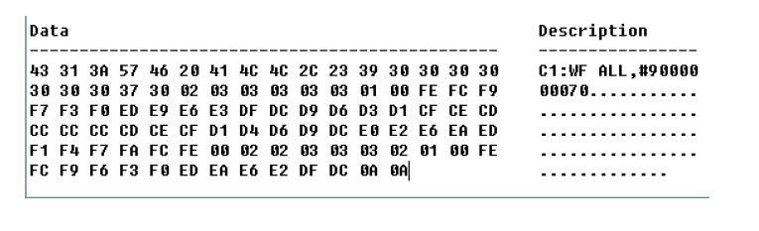

How to use the data recovery waveform:

1. Calculate the voltage value corresponding to the data point.

2. Calculate the time value of the first data point.

Ad 1. To calculate the voltage value corresponding to the data point.

Using the formula : voltage value(V) = **code value** *( **vdiv** /25)- **voffset**.

**code value**: The decimal of wave data .

Note: If the decimal is greater than 127, one should subtract the 255. Then the decimal value is the **code value**. E.g.: conversion to decimal yields 252. So the code value is 252-255=-3.

**vdiv:** The Volts/div value.

**voffset:** The voltage position value.

The following picture as an example:

Send command ―C1:VDIV?

Return C1:VDIV 5.00E-01V.

Get the current Volts/div values: vdiv = 0.5V.

Send command ―

C1:OFST? return C1:OFST -5.00E-01V Get the current voltage position values: voffset = -0.5V. According the wave data, we can know the first point of wave data is the 02 convert to decimal is 2 (Hexadecimal converted to decimal). The first point of wave data voltage value = 2*(0.5/25)-(-0.5) = 0.54V

2. To calculate the time value of the first data point.

Using the formula : time value(S) = trdl-( timebase*grid/2).

trdl: The time value which is center of the screen. timebase: The timebase value. grid: The grid numbers in horizontal direction. The following picture as an example:

Send command ―

TRDL?

return TRDL -5.000000ns. Get the current time value center of the screen: trdl = -5.00E-09s. Send command ―

TDIV?

Return: TDIV 5.00E-09S‖. Get the current timebase: timebase = 5.00E-09S. The time value of the first data point: time value = -5.00E-09 – (5.00E-09*14/2) = -40.00E-09(s)=-40(ns).

Send command: SARA

Return: SARA 1.00GSa/s. Get the current sampling rate: sampling rate= 1.00GSa/s.

The time interval: time inter = 1/ sampling rate = 1ns So the time value of the second data point: value = -40ns+1ns = -39ns RELATED COMMANDS WAVEFORM_

.

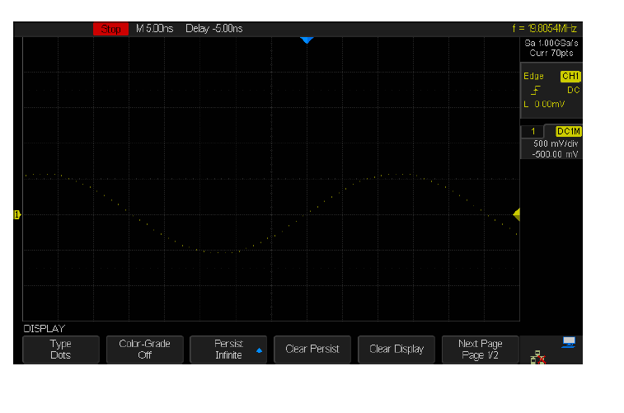

Commando’s die je moet sturen zijn:

* C1:VDIV?
* C1:OFST?
* TRDL?
* TDIV?
* SARA?

voltage value(V) = code value *( vdiv /25)- voffset

time value(S) = trdl-( timebase*grid/2)

Zie ook:

TEMPLATE?