PalmGrocer Electronic Cookbook
Elaboration 3 Document

December 22, 2004

By:
Andrew Alford
Andrej Jechropov
Sharmila Pandith
Adam Zimmerman

1 Vision 4
1.1 Introduction 4
1.2 Positioning 4
1.2.1 Business opportunity 4
1.2.2 Problem Statement 4
1.2.3 Future enhancements 4
1.3 Summary of System Features 5
2 Domain Model 5
3 Use-Case Model 5
3.1 Use Case Diagram 6
3.2 Use Case Specification 6
3.2.1 Use Case UC1: Add recipe 6
3.2.2 Use Case UC2: Modify recipe 7
3.2.3 Use Case UC3: Delete recipe 8
3.2.4 Use Case UC4: Build shopping list 8
3.2.5 Use Case UC5: Find recipe 9
3.2.6 Use Case UC6: Manage Categories 10
4 Supplementary Specifications 10
4.1 Introduction 10
4.2 Functionality 10
4.2.1 Maintainable master lists 11
4.2.2 Logging and Error Handling 11
4.2.3 Security 11
4.3 Usability 11
4.3.1 Human Factors 11
4.4 Performance 11
4.5 Supportability 11
4.5.1 Adaptability 11
4.5.2 Implementation Constraints 11
4.5.3 Purchased Components 11
4.5.4 Free Open Source Components 11
4.6 Interfaces 11
4.6.1 Hardware and Interfaces 11
4.6.2 Software Interfaces 12
4.7 Legal issues 12
5 Design Model 12
5.1 Design Class Diagram 12
5.2 System Sequence Diagrams 13
5.2.1 addRecipe 13
5.2.2 Modify Recipe 13
5.2.3 Retrieve Recipe 14
5.2.4 Select Recipe Ingredient 14
5.3 Sequence Diagrams 15
5.3.1 Add new recipe 15
5.3.2 Modify Recipe 16
5.3.3 Retrieve Recipe 17
5.3.4 Select Recipe Ingredient 17
6 Contracts 18
6.1 Contract CO1: addNewRecipe 18
6.2 Contract CO2: editRecipe 18
6.3 Contract CO3: retrieveRecipe 18
6.4 Contract CO4: addNewSLItem 19
7 Data Model 19
7.1 E-R Diagram 19
7.2 Data Dictionary 20
8 Implementation Model 20
8.1 Database 20
8.2 Source code 20
9 User Interface 21
9.1 Main Menu 21
9.2 Add / Edit Recipe 21
9.3 View Recipe Form—Top 22
9.4 View Recipe Form—Bottom 22
9.5 Table of Contents-- Unfiltered 23
9.6 Find Recipe 23
9.7 Table of Contents--Filtered 24
9.8 Shopping List 24
9.9 Manage Categories 25
10 Project Management – Development Plan 25
11 Test Model 26
11.1 Classes of tests 26
11.2 Expected software response 26
11.3 Performance bounds 26
11.4 Identification of critical components 26
12 Software Architecture 27
12.1 Architectural Factors and Decisions 27
12.2 Logical View 29
12.3 Deployment View 30
13 Appendix 31
13.1 Glossary 31

Vision

Introduction
We envision PalmGrocer as an electronic cookbook for any Palm user who wants to manage recipes and generate grocery lists. It is conceived as a simple, convenient tool for anyone who uses recipes and buys groceries. It is intended for use on the Palm hand-held device.

The system is a “productivity tool” that attempts to mimic a recipe binder with very little deviation while enhancing it with automated features. As such, the user interface should be simple and straightforward. The system is conceived as a relatively low cost package, meant for the casual Palm user.

Positioning

    - Business opportunity
There would appear to be a market for a low-cost, simple system for organizing recipes and building shopping lists. Initially, the product could be marketed on the internet, perhaps by distributing a limited version for free, and charging for a fully functional version.

If the product were to be sold in stores, it is important to keep in mind that this is software that appeals as much to home chefs as it does to computer users. So an attempt should be made to place it in stores other than traditional computer stores (Comp USA, etc). An ideal location would be a bookstore, near the cookbooks.

If the software can be priced low enough, people will buy it as a small gift, or impulse purchase.

    - Problem Statement
Currently, most people get their recipes from a cookbook or custom-made binder, which is bulky and difficult to search. The only way to track ingredients for shopping is to manually copy them from the recipe.

    - Future enhancements
Enhancements, which take advantage of the power of the internet, seem to be a natural extension to this product. For example the ability to use the internet to download or trade recipes—either through a central server or a peer-to-peer network—should be very appealing to users. It might also be possible to sell users a database of recipes, either on CD or through a web site. This would be an additional moneymaking opportunity.

It might also be interesting to offer the ability to send a shopping list to an internet-based grocer, such as FreshDirect, thus completely automating the purchase of the ingredients. This would have to be investigated further with the vendors in question.

Summary of System Features
PalmGrocer is meant to help Palm users with the task of organizing recipes and gathering ingredients to prepare them. The product’s basic functionality is as follows:
- Maintain recipes: the system allows the user to maintain their recipes, and the ingredients required for each recipe. Users can add, edit and delete recipes from the system. The user can also organize recipes by category such as Entrée, Soup, Dessert, etc.
- Shopping list: This is a list of groceries, which need to be purchased. Users normally add ingredients to the list by selecting a recipe from the system. Individual ingredients can also be added directly to the list. As the user shops, they can check off ingredients that they purchased.
- Recipe search: allows the user to look for recipes in the system. There are two basic search modes: search by recipe name, and search by ingredients. The “search by ingredients” mode enables the user to search for recipes that include ingredients, which the user specifies.

Domain Model

PalmGrocer domain model depicts major conceptual classes and interaction between them. Our software is designed around a recipe database. A user can add modify or remove recipes from the database. Each recipe will have one or more ingredients which can be added to the shopping list. A shopping list will only exist if we have selected at least one necessary ingredient to be purchased.

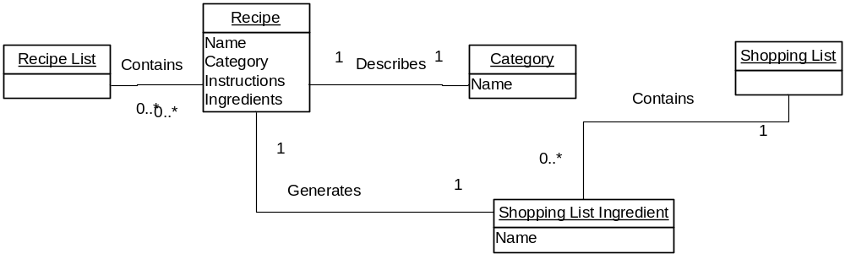

Use-Case Model

PalmGrocer Use-case model illustrates our system from the user’s perspective. Use case diagram shows the actions which a user can perform to the PalmGrocer Software. In addiction to the recipe manipulation our software will be able to generate a shopping list based on the ingredient selection from the recipe list.

Use Case Diagram

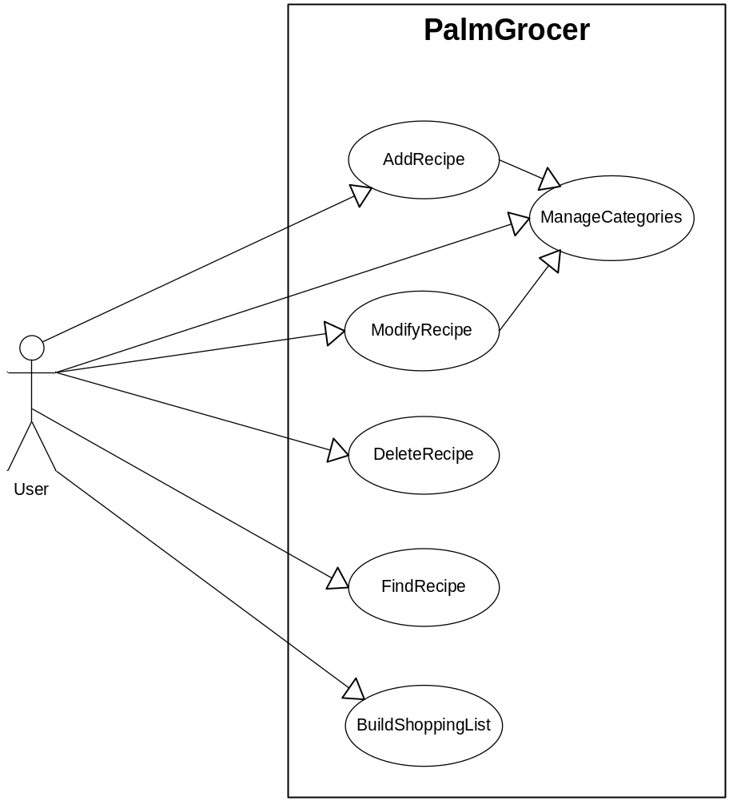

Use Case Specification

    - Use Case UC1: Add recipe

Primary Actor: User

Preconditions: The Main Screen is displayed.

Post conditions: Recipe is saved into the system database.

Main Success Scenario
- User navigates to the “Modify/Create Recipe Screen” by clicking “Add” from the main screen.
- User selects a category for the recipe from a drop-down list[E1].
- User pens in a name and brief description for the recipe.
- User pens in an ingredient name[E1]
- User repeats step 4 for each ingredient in the recipe.
- If desired, user pens in step-by-step instructions for preparing the recipe.
- User presses OK.
- System switches to the “Main Screen”, where the new recipe is displayed.

Exception E1—required Category or Ingredient is not in the drop-down list
  - User selects “New” option from the list.
  - System displays a dialog box which prompts user for the name of the new item (Category) to add.
  - User pens in the name of the new item and presses OK.
  - System adds the new item to the drop-down list.
  - User continues inputting the recipe.

Exception E2—user presses Cancel
- User presses Cancel button at any time during the add process.
- System displays the Main Screen. First recipe is displayed.

    - Use Case UC2: Modify recipe

Primary Actor: User

Preconditions: User has already used the Find function to display the recipe he wants to modify in the main screen (See UC[], Find Recipe).

Post conditions: Modified version of the recipe is saved into the system database.

Main Success Scenario
- User presses Edit button.
- System switches to “Edit” mode—all recipe data is now editable on the screen.
- User uses stylus to make desired modifications to the recipe. User can add a new ingredient to the recipe by scrolling down to the end of the list of ingredients.[E1]. User can delete an ingredient from the list by blanking out its name.
- User taps the OK button.
- System saves the changes and displays the modified recipe in the Main Screen.

Exception E1—required Category or Ingredient is not in the drop-down list
- User selects “New” option from the list.
- System displays a dialog box which prompts user for the name of the new item (Category) to add.
- User pens in the name of the new item and presses OK.
- System adds the new item to the drop-down list.
- User continues modifying the recipe.

Exception E2—user presses Cancel
- User presses Cancel button at any time during the modify process.
- System displays recipe in the Main Screen—no longer in edit mode. Recipe is restored to its original state, before changes were made.

    - Use Case UC3: Delete recipe

Primary Actor: User

Preconditions: User has already used the Find function to display the recipe he wants to delete in the main screen (See UC[], Find Recipe).

Post conditions: The recipe is removed from the database.

Main Success Scenario
- User presses Delete button.
- System displays dialog box to ask user if he is sure he wants to delete the recipe.
- User selects “Yes” [E1].
- System removes the recipe from the database, displays the next recipe in the main screen.

Exception E1—user does not confirm.
- User selects “No” from the dialog box.
- System takes no further action.

    - Use Case UC4: Build shopping list

Primary Actor: User.

Preconditions: Recipe is already in the system database.

Post Condition: Shopping list is saved in the system.

Main Success Scenario
- User finds a recipe (see use case 3—find recipe).
- User selects the ingredients to be included on the shopping list.
- User repeats steps 1 and 2 for each recipe that he is planning on preparing.
- User navigates to the “Shopping List Screen”.
- System displays the shopping list, including all of the ingredients selected in step 2.
- User adds a new item to the list for any groceries that need to be purchased that were not included in a recipe (e.g., cleaning products, etc.).
- User deletes any items from the list, which he does not need to purchase.

    - Use Case UC5: Find recipe

Primary Actor: User.

Preconditions: None.

Post Condition: The recipe is displayed on the main screen.

Main Success Scenarios

Path 1: Find from main screen
- If desired, user selects a category from the drop-down list in order to filter the displayed recipes
- User browses through recipes one by one, using the arrow button, until she finds the desired recipe.

Path 2: Find from Table of Contents Screen
- User looks for the desired recipe in the recipe list, using the scroll buttons if necessary.
- When the user has located the recipe, she opens it by tapping it with the pen.
- The system switches to the main screen, displaying the full details of the selected recipe.

Path 3: Find from Find Recipes Screen
- User pens in the criteria to search by, one of either:
- A fragment of the recipe’s name, or
- One or more ingredients that are used in the recipe.
- User presses the OK button.
- The system switches to the Table of Contents screen, where any recipes that meet the user’s criteria are displayed.
- If the correct recipe is in the list, the user taps it with the pen.
- The system switches to the main screen, displaying the full details of the selected recipe.

    - Use Case UC6: Manage Categories

Primary Actor: User.

Preconditions: None.

Post Conditions:
- Category list has been updated.
- Recipes have been re-classified, if necessary.

Main Success Scenarios

Path 1: Add new category
- User selects “Add New Category”.
- System displays dialog box.
- User inputs category name.
- System adds category to category table.

Path 2: Delete category
- User selects category, presses “Delete” button.
- System removes category from category table.
- System re-classifies any recipes belonging to this category as “un-filed”.

Supplementary Specifications

Introduction

This document is the repository of all PalmGrocer requirements not captured in the use cases.

Functionality
The application should adhere to the standards of Palm OS Application design, as specified by Palm. The Palm OS Interface Guidelines are available from http://www.palmos.com/dev/support/docs/uiguidelines.pdf. This application is not necessarily designed for people who are computer-savvy. The functionality should therefore be as simple and straightforward as possible. To that end, the following guidelines will be adhered to:
- Maximize perceived speed of the application
- Minimize required steps for major functionality
- Minimize taps
- Maintain consistency among application screens
- Minimize number of elements on the screen
- Minimize necessity for data input
- Major functionality is visible and not hidden in menus

    - Maintainable master lists
PalmGrocer allows user to maintain master lists of categories.

    - Logging and Error Handling
(Optional) Keep transaction log on the Palm external memory card for quick data recovery

    - Security
Usage of the system is only available to the Palm owner.

Usability

    - Human Factors

- Text entry through the Palm keyboard will be supported to maximize productivity.
- Alternative text entry would be considered to streamline the use of the system.

Performance

Since the PalmGrocer system is not process intensive, the user input speed is the only bottleneck to system performance.

Supportability

    - Adaptability
PalmGrocer system will be written in non-architecture specific language and can be adopted on platforms other than Palm with minor changes of the User Interface.

    - Implementation Constraints
PalmGrocer development team is written using J2ME and the user needs to have the supporting software to run the application.

    - Purchased Components
Any Palm OS supported device.

    - Free Open Source Components
Java VM platform will be used to support PalmGrocer system.

Interfaces

    - Hardware and Interfaces
- Palm Graffiti will be used as the main user interface.
- Palm External keyboard can be used as an alternative user interface.

    - Software Interfaces
- Palm touch screen can be used as one type of interface to the system with the built in software keyboard by Palm OS.

Legal issues

Since the PalmGrocer is being developed using open source Java technology, our product will be sold separately from the Java VM platform. It is the user’s responsibility to have an updated Java VM platform to run the current version of the PalmGrocer system. Each PalmGrocer version will specify all supported Java VM platform versions.

Design Model

Design Class Diagram

The following diagram describes the design class diagram for this system.

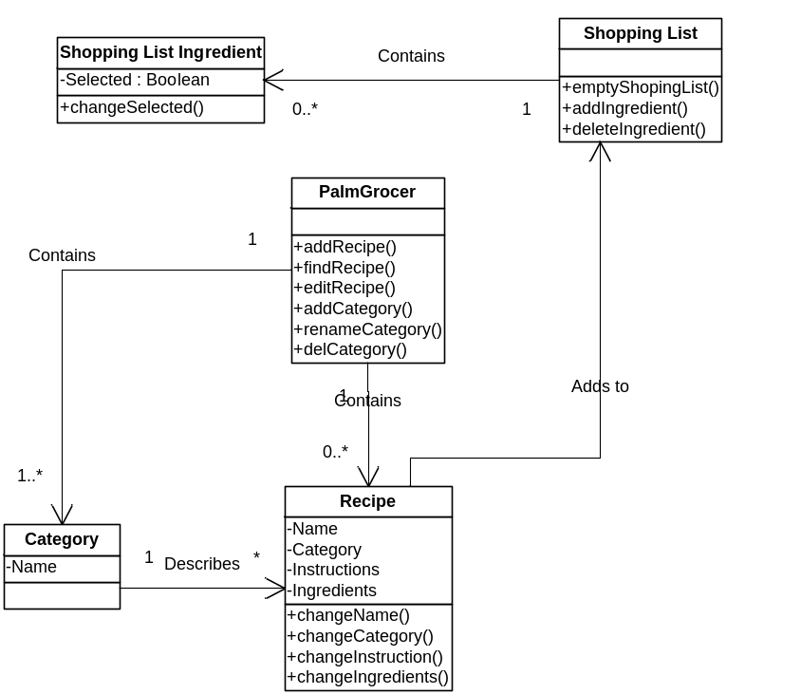

System Sequence Diagrams

    - addRecipe

The following diagram shows the creation of the new recipe with associated ingredients and storing it into the Palm database.

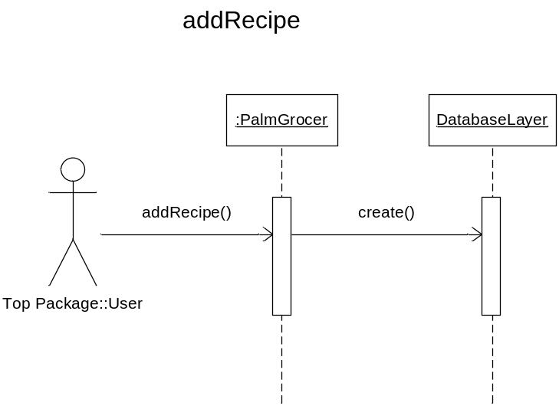

    - Modify Recipe

Extract recipe record from the dataset, make changes to the recipe and store it in the recipe database.

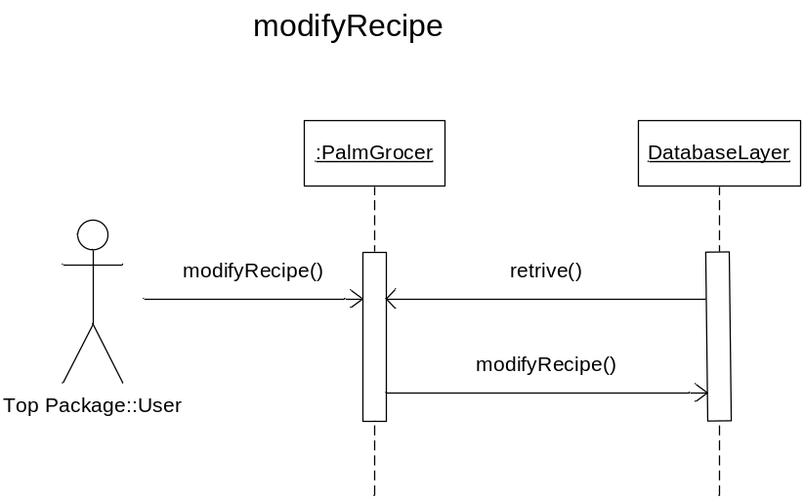

    - Retrieve Recipe

Extracts a recipe from the recipe records database.

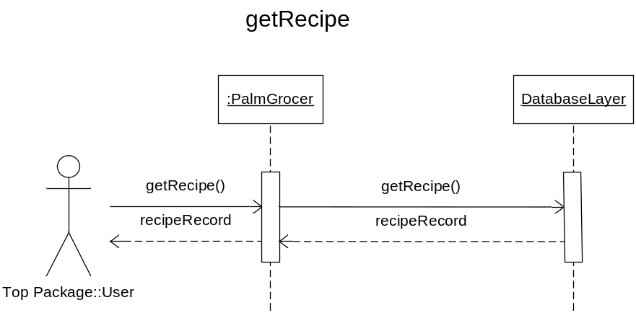

    - Select Recipe Ingredient

Extract ingredients from the recipe records and generate shopping list table.

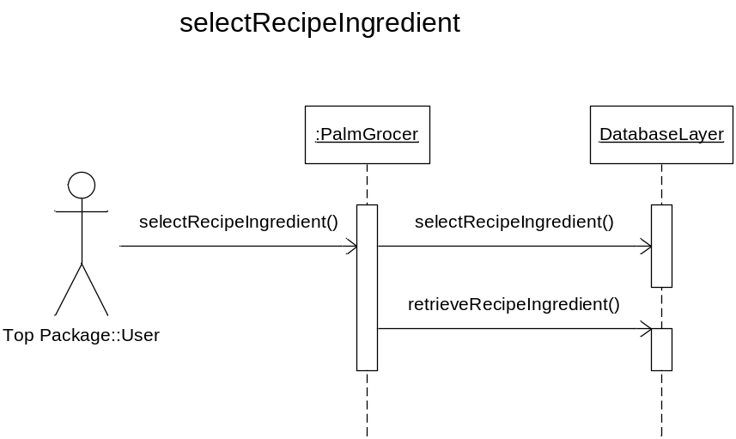

Sequence Diagrams

Add new recipe
Creates new recipe record and stores it in the recipe database.

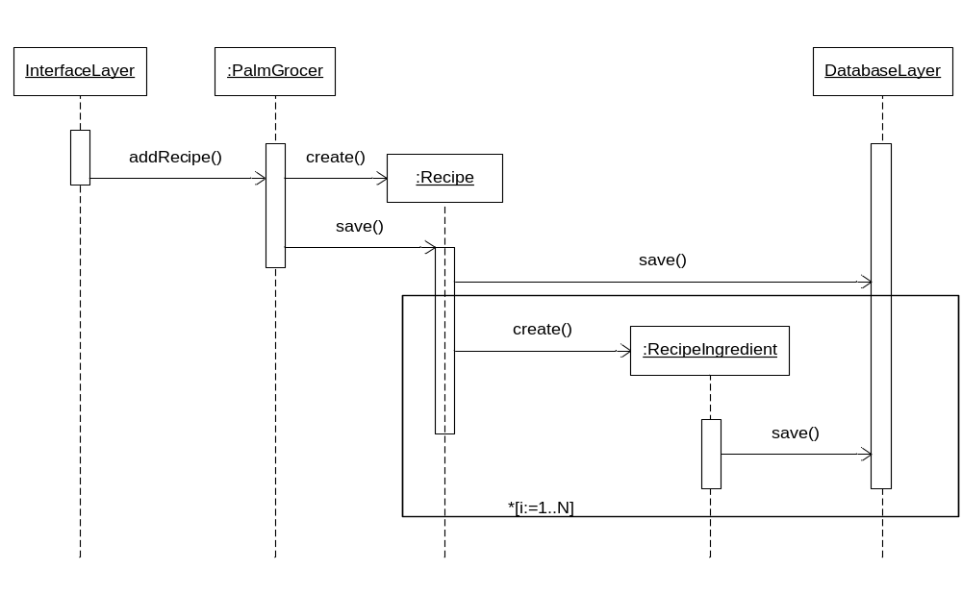

Modify Recipe
Extracts recipe record from the dataset, makes changes to the recipe and stores it in the recipe database.
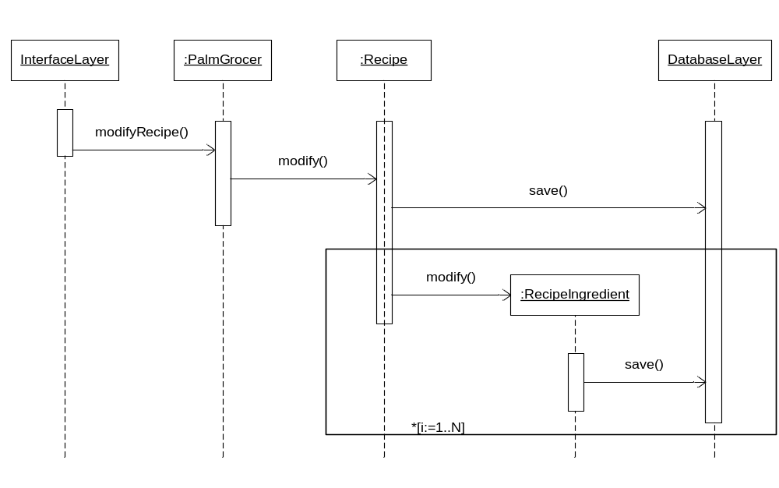

Retrieve Recipe
Extracts a recipe from the recipe records database.

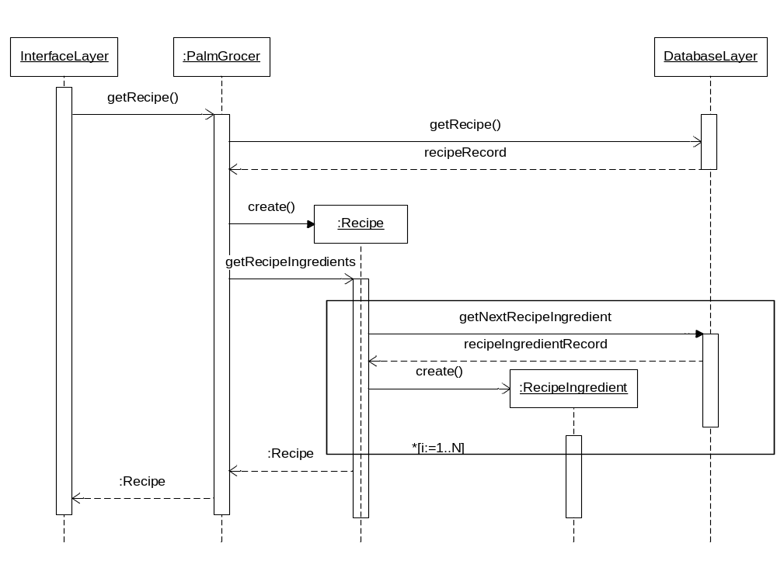
    - Select Recipe Ingredient

Extract ingredients from the recipe records and add it to the shopping list.

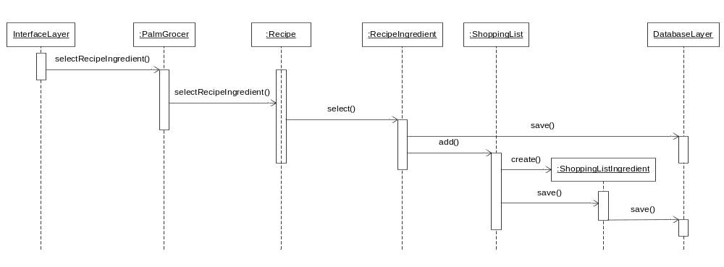

Contracts

Contract CO1: addNewRecipe
Operation: | addNewRecipe ( recipeObject )
Cross References: | Use Cases: UC1: Add recipe
Preconditions: | All items to create a recipe have been entered.
Postconditions: | - a RecipeObject rObj is created  - rObj is associated with a category  - rObj is saved to the datastore

Contract CO2: editRecipe
Operation: | editRecipe ( recipeObject )
Cross References: | Use Cases: UC2: Modify recipe
Preconditions: | All modifications have been made.
Postconditions: | - Modified RecipObject rObj is saved to the datastore

Contract CO3: retrieveRecipe
Operation: | getRecipeById ( recipeId)
Cross References: | Use Cases: UC5: Find recipe
Preconditions: | The recipe to be retrieved is selected
Postconditions: | - a RecipeObject rObj is created  - rObj is filled with the recipe retrieved from the datastore  - rObj is associated with a category  - rObj is returned

Contract CO4: addNewSLItem
Operation: | addNewSLItem (ShoppingListObject)
Cross References: | Use Cases: UC4: BuildShopping
Preconditions: | ShoppingList item has been entered or selected from the recipe.
Postconditions: | - a ShoppingListObject slObj is created  - slObj is saved to the datastore

Data Model

E-R Diagram

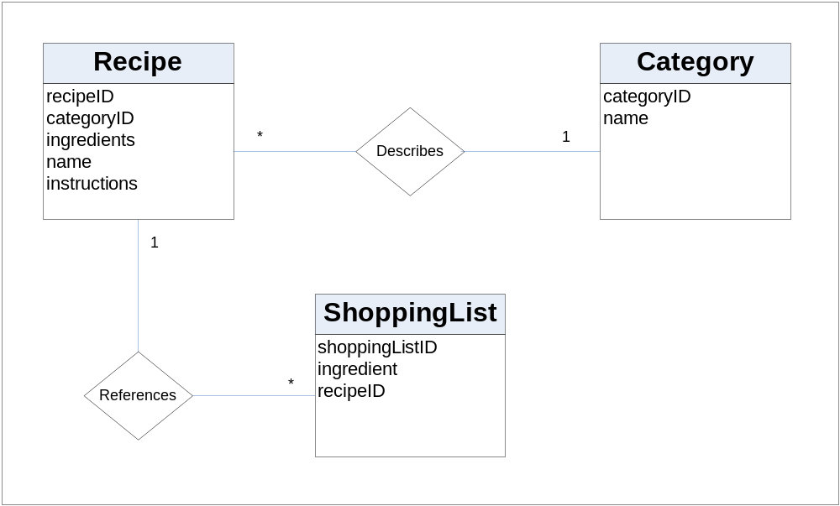

Data Dictionary

Recipe
Attribute | Type | Description
recipeID | int | primary key
categoryID | int | foreign key to Category table
ingredients | String | Used to store the ingredients in the recipe
Name | string | used to store the recipe name
instructions | string | step by step directions to make a recipe

Category
Attribute | Type | Description
categoryId | int | primary key
Name | string | name of the category

ShoppingList
Attribute | Type | Description
ShoppingListId | Int | primary key
Ingredient | string | Name of the ingredient
recipeID | string | foreign key to Recipe table

Implementation Model

Database
Practically every J2ME application that is developed requires persistence. However, the manner in which persistence is maintained in a J2ME application is different from persistence in J2SE or J2EE applications because of the limited resources available in small computing devices that run J2ME applications. J2ME applications must store information in non-volatile memory using the Record Management System (RMS).

The RMS is an application programming interface that is used to store and manipulate data in a small computing device using a J2ME application. It provides a file system-like environment that is used to store and maintain persistence. It is a combination file system and database management system that enables the user to store data similar to the organization of data in a table of a database. However, RMS is not a relational database, and therefore SQL cannot be used to interact with data. Instead, RMS’s application programming interface and enumeration application programming interface must be used to sort, search, and otherwise manipulate information stored in persistence.

Source code
The source code for this application is attached separately as a zip file.

User Interface

Main Menu
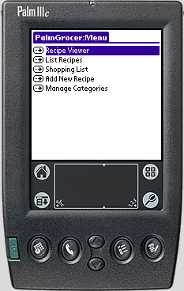

Add / Edit Recipe

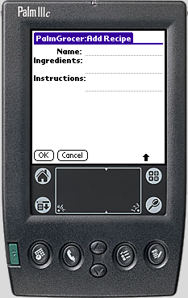

View Recipe Form—Top

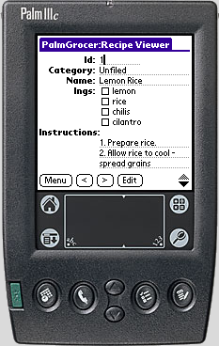

View Recipe Form—Bottom
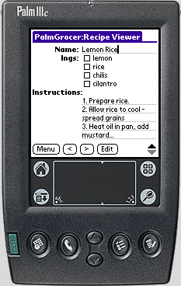

Table of Contents-- Unfiltered

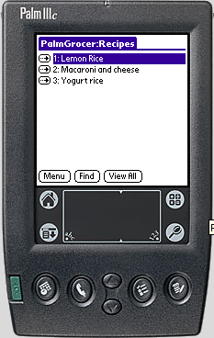

Find Recipe

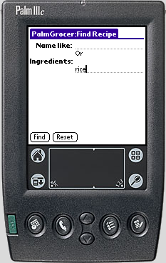

Table of Contents--Filtered

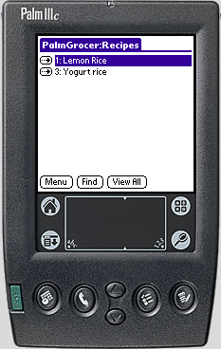

Shopping List
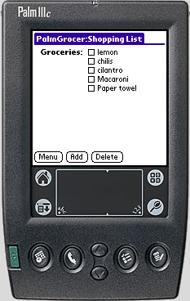

Manage Categories
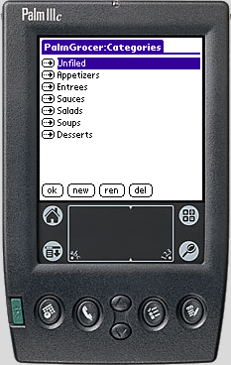

Project Management – Development Plan

 | 10/13 | 10/20 | 10/27 | 11/3 | 11/10 | 11/17 | 12/1 | 12/8 | 12/15 | 12/22
Domain Model |  |  |  | s
IJse-Case Model (SSDs) | s |  |  | r
Vision | s |  |  | r
Supplementary Specification | s |  |  | r
Glossary | s |  |  | r
Design Model |  |  |  | s |  | r
SW Architecture Document |  |  |  | s |  | r
Data Model |  |  |  | s |  | r
Implementation Model |  |  |  | s |  | r
SW Development Plan | s |  |  | r
Test Model |  |  |  | s |  | r
Development Case | s |  |  | r
Table: s - start; r – refine

Test Model

Classes of tests

- Display of individual recipes
- Adding, changing and removing of recipes from database
- Exporting of recipe (and ingredients included) to shopping list
- Display of table of contents
- Display of shopping list
- Adding, removing and retrieving info from ingredients on shopping list
- Adding, removing and retrieving info from the master list
- Error handling

Expected software response
- User is able to add, edit and remove recipes from database
- User is able to specify which recipes are exported to shopping list, and which ingredients are included in the export
- User is able to view all the recipes in a list (Table of Contents), or limit that view to certain categories or other search criteria
- User is able to remove ingredients from the shopping list by unchecking its checkbox
- Errors handled gracefully; application does not “crash”.

Performance bounds
- Major functionality should be accessible with a minimum number of taps of the stylus, and a minimum amount of data entry on the device

Identification of critical components
Communication between main screen and shopping list is essential. Shopping list items can refer to the same ingredient from multiple recipes.

Software Architecture

Architectural Factors and Decisions
The factors that influenced the decisions in the architecture are described in the factor table below:

Factor | Measures and quality scenarios | Variability (current flexibility and future evolution) | Impact of factor (and its variability) on stakeholders, architecture and other factors | Priority for Success | Difficulty or Risk
Functionality – Features
Category dropdown | The user should be able to add a new category while adding a new recipe | Current flexibility – Due to the memory constraints of the handheld device, this feature had to be moved to the Main Menu.  Evolution – This feature can be implemented only when the handheld devices offer more flexibility. | The change in the way this feature works will not affect the functionality as a whole – The users have to use a roundabout approach. | H | H
Ingredients and Units master lists | The users should be able to maintain master lists for Ingredients and Units, the same way as Category | Current flexibility – Due to the memory constraints of the handheld device, these features had to be tabled. The user has to input the ingredients directly into the recipe as opposed to picking from a drop-down list.  Evolution – This feature can be implemented only when the handheld devices offer more flexibility. | Small impact on design | L | H
Usability— human factors
The user must be able to click on “Add” button to add a new recipe from the RecipeViewer | This will reduce the number of taps to get to the screen | Current flexibility – The user will have to go to the main menu and then choose “Add new Recipe”  Evolution – This can only be done when the programmers have the ability to control the layout manager. | It is currently not possible to implement this as the programmer has no control over the layout manager. | L | H
Reliability—Recoverability
Recovery when the handheld crashes | When the handheld crashes, the system should be able to recover to the point when the user last saved the data that they were working with | Current flexibility – The user will be able to get back the data that they backed up before the crash.  Evolution – The next version should be capable of replicating the data to a PC. | It is considerable amount of work to replicate the same features on the PC so that the users can synch to the PC application | H | M
Supportability - Adaptability
Should be able to trade recipes—either through a central server or a peer-to-peer network  It might also be possible to sell users a database of recipes, either on CD or through a web site. | When support for this is added, it does not require a change to design of the architecture. A new feature called “Import” will have to be added to add the recipes from a database of recipes. | current flexibility - not required at present  Evolution – It would be a really great to have this feature in the next release as users might benefit from this. | Small impact on design. | H | L
Legend: H-high. M-medium.

Logical View
The logical view of the architecture is described with the help of the package diagrams and class diagrams of the major elements:

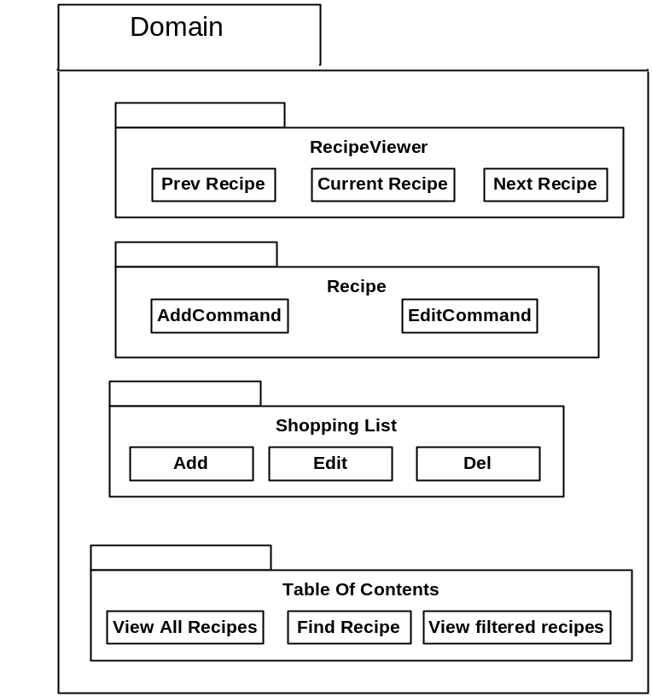
The above diagram represents the application layer. It handles all the business logic of the application.

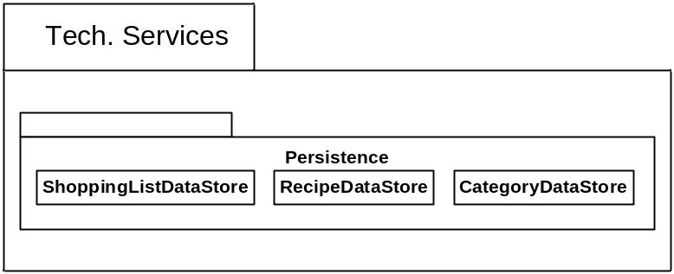
The above diagram represents the high level technical service. In this application it mainly handles persistence.

Deployment View
The following deployment diagram shows how instances of components and processes are configured for run-time execution of the PalmGrocer application. Java HQ is the application runtime environment that supports MIDP for Palm OS.

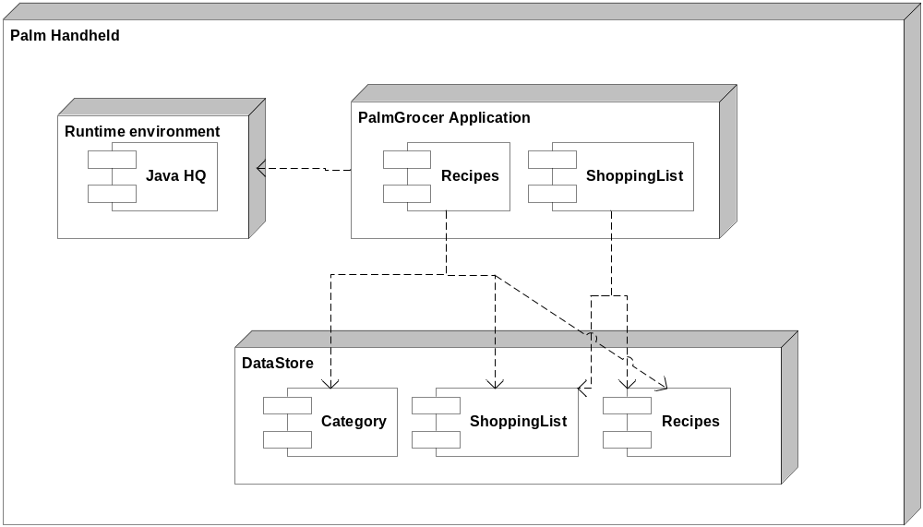

Appendix

Glossary

Term | Definition and Information | Aliases
Category | An indicator which is used to sort recipes into sub-groups. Examples of categories which users might choose are: soups, entrees, desserts, Chinese, Indian, Italian, low-carbohydrate, vegetarian, etc.
graffiti | The simplified alphabet with which the user inputs characters into the Palm.
Ingredient | One item of food or other product which can be purchased in a store, and used to prepare a recipe.
Palm | A hand-held portable computer which runs the Palm OS. | Palm Pilot, hand-held
PalmGrocer | The name of the system.
pen in | The act of inputting information into a Palm device using a stylus.
recipe | The instructions needed to prepare a dish. Normally consists of 3 parts: 1) a name and brief description; 2) a list of ingredients with quantities; 3) step-by-step instructions
shopping list | A list of ingredients. Normally used for shopping.
tap | The method for selecting an item on a Palm device.

