PalmGrocer Electronic Cookbook
Elaboration 2 Document

December 1, 2004

By:
Andrew Alford
Andrej Jechropov
Sharmila Pandith

Adam Zimmerman
Table of Contents

1 Domain Model 2
2 Use-Case Model 4
2.1 Use Case Diagram 4
2.2 Use Case Specification 4
2.2.1 Use Case UC1: Add recipe 4
2.2.2 Use Case UC2: Modify recipe 5
2.2.3 Use Case UC3: Delete recipe 6
2.2.4 Use Case UC4: Build shopping list 6
2.2.5 Use Case UC5: Find recipe 7

Domain Model

PalmGrocer domain model

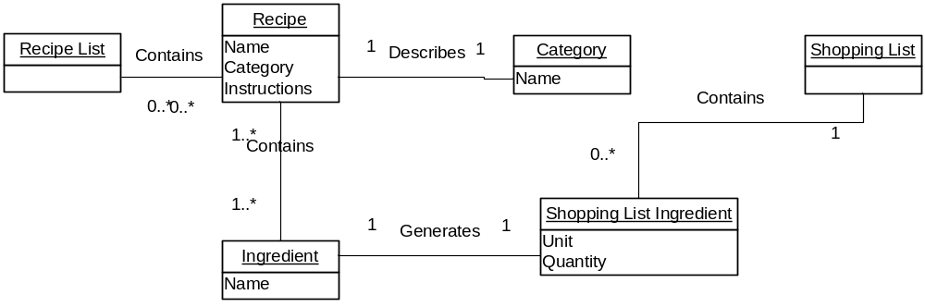

Use-Case Model

Use Case Diagram

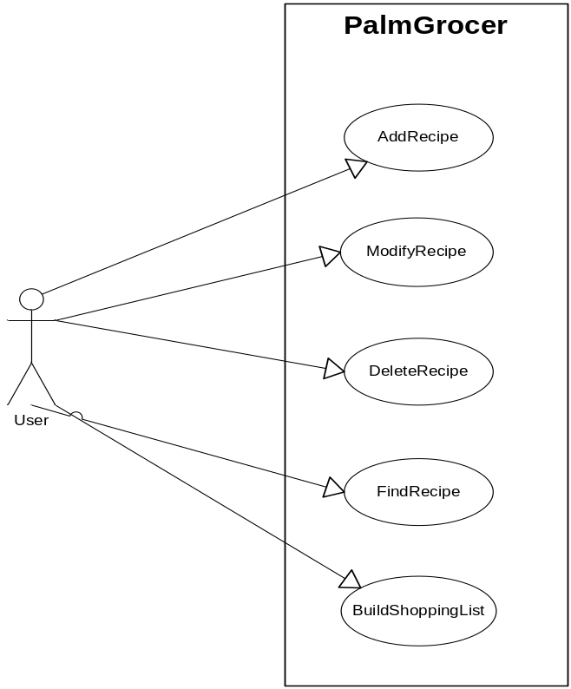

Use Case Specification

Use Case UC1: Add recipe

Primary Actor: User

Preconditions: The Main Screen is displayed.

Post conditions: Recipe is saved into the system database.

Main Success Scenario
- User navigates to the “Modify/Create Recipe Screen” by clicking “new” from the main screen.
- User selects a category for the recipe from a drop-down list[E1].
- User pens in a name and brief description for the recipe.
- User pens in an ingredient name[E1], and a unit of measurement. An auto-complete feature assists the user.
- User pens in a quantity.
- User repeats steps 4-5 for each ingredient in the recipe.
- If desired, user pens in step-by-step instructions for preparing the recipe.
- User presses OK.
- System switches to the “Main Screen”, where the new recipe is displayed.

Exception E1—required Category or Ingredient is not in the drop-down list
  - User selects “New” option from the list.
  - System displays a dialog box which prompts user for the name of the new item (Category or Ingredient) to add.
  - User pens in the name of the new item and presses OK.
  - System adds the new item to the drop-down list.
  - User continues inputting the recipe.

Exception E2—user presses Cancel
- User presses Cancel button at any time during the add process.
- System displays the Main Screen. First recipe is displayed.

Use Case UC2: Modify recipe

Primary Actor: User

Preconditions: User has already used the Find function to display the recipe he wants to modify in the main screen (See UC[], Find Recipe).

Post conditions: Modified version of the recipe is saved into the system database.

Main Success Scenario
- User presses Edit button.
- System switches to “Edit” mode—all recipe data is now editable on the screen.
- User uses stylus to make desired modifications to the recipe. User can add a new ingredient to the recipe by scrolling down to the end of the list of ingredients.[E1]. User can delete an ingredient from the list by blanking out its name.
- User taps the OK button.
- System saves the changes and displays the modified recipe in the Main Screen.

Exception E1—required Category or Ingredient is not in the drop-down list
- User selects “New” option from the list.
- System displays a dialog box which prompts user for the name of the new item (Category or Ingredient) to add.
- User pens in the name of the new item and presses OK.
- System adds the new item to the drop-down list.
- User continues modifying the recipe.

Exception E2—user presses Cancel
- User presses Cancel button at any time during the modify process.
- System displays recipe in the Main Screen—no longer in edit mode. Recipe is restored to its original state, before changes were made.

Use Case UC3: Delete recipe

Primary Actor: User

Preconditions: User has already used the Find function to display the recipe he wants to delete in the main screen (See UC[], Find Recipe).

Post conditions: The recipe is removed from the database.

Main Success Scenario
- User presses Delete button.
- System displays dialog box to ask user if he is sure he wants to delete the recipe.
- User selects “Yes” [E1].
- System removes the recipe from the database, displays the next recipe in the main screen.

Exception E1—user does not confirm.
- User selects “No” from the dialog box.
- System takes no further action.

Use Case UC4: Build shopping list

Primary Actor: User.

Preconditions: Recipe is already in the system database.

Post Condition: Shopping list is saved in the system.

Main Success Scenario
- User finds a recipe (see use case 3—find recipe).
- User selects the ingredients to be included on the shopping list, either by tapping them individually, or by using a “select all” checkbox.
- User repeats steps 1 and 2 for each recipe that he is planning on preparing.
- User navigates to the “Shopping List Screen”.
- System displays the shopping list, including all of the ingredients selected in step 2.
- User adds a new item to the list for any groceries that need to be purchased that were not included in a recipe (e.g., cleaning products, etc.).
- User deletes any items from the list, which he does not need to purchase.

Use Case UC5: Find recipe

Primary Actor: User.

Preconditions: None.

Post Condition: The recipe is displayed on the main screen.

Main Success Scenarios

Path 1: Find from main screen
- If desired, user selects a category from the drop-down list in order to filter the displayed recipes
- User browses through recipes one by one, using the arrow button, until she finds the desired recipe.

Path 2: Find from Table of Contents Screen
- If desired, user selects a category from the category list in order to filter the displayed recipes
- Users looks for the desired recipe in the recipe list, using the scroll buttons if necessary.
- When the user has located the recipe, she opens it by tapping it with the pen.
- The system switches to the main screen, displaying the full details of the selected recipe.

Path 3: Find from Find Recipes Screen
- User pens in the criteria to search by, one of either:
- A fragment of the recipe’s name, or
- One or more ingredients that are used in the recipe.
- User presses the OK button.
- The system switches to the Table of Contents screen, where any recipes that meet the user’s criteria are displayed.
- If the correct recipe is in the list, the user taps it with the pen.
- The system switches to the main screen, displaying the full details of the selected recipe.

