CS865 – Distributed Software Development
Lecture 9
Tannenbaum and Van Steen – Chapter 9

Security
Strategies for securing Distributed Systems

- Generally very similar to techniques used in a non-distributed system, only much more difficult to implement …
- Difficult to get right, impossible to get perfect!

Security Topics
1.Providing a secure communications channel – authentication, confidentiality and integrity.
2.Handling authorization – who is entitled to use what in the system?
3.Providing effective Security Management.
4.Example systems: SESAME and e-payment systems.

Types of Threats
- Interception – unauthorized access to data.
- Interruption – a service becomes unavailable.
- Modification – unauthorized changes to, and tampering of, data.
- Fabrication – non-normal, additional activity.

Security Mechanisms
- Encryption – fundamental technique: used to implement confidentiality and integrity.
- Authentication – verifying identities.
- Authorization – verifying allowable operations.
- Auditing – who did what to what and when/how did they do it?

Key Point
Matching security mechanisms to threats is only possible when a Policy on security and security issues exists.

Example: The Globus Security Architecture (Chervenak et al., 2000).
- Globus is a system supporting largescale distributed computations in which many hosts, files, and other resources are simultaneously used for doing a computation.
- Also referred to as computational grids (Foster et al., 2001 1999).
- Resources in these grids are often located in different administrative domains that may be located in different parts of the world.

Globus Security Policy (Foster et al., 1998):
- The environment consists of multiple administrative domains.
- Local operations (i.e., operations that are carried out only within a single domain) are subject to a local domain security policy only.
- Global operations (i.e., operations involving several domains) require the initiator to be known in each domain where the operation is carried out.
- Operations between entities in different domains require mutual authentication.
- Global authentication replaces local authentication.
- Controlling access to resources is subject to local security only.
- Users can delegate rights to processes.
- A group of processes in the same domain can share credentials.

- The Globus security architecture consists of entities such as users, user proxies, resource proxies, and general processes.
- These entities are located in domains and interact with each other.
- The security architecture defines four different protocols
- The Globus security architecture.
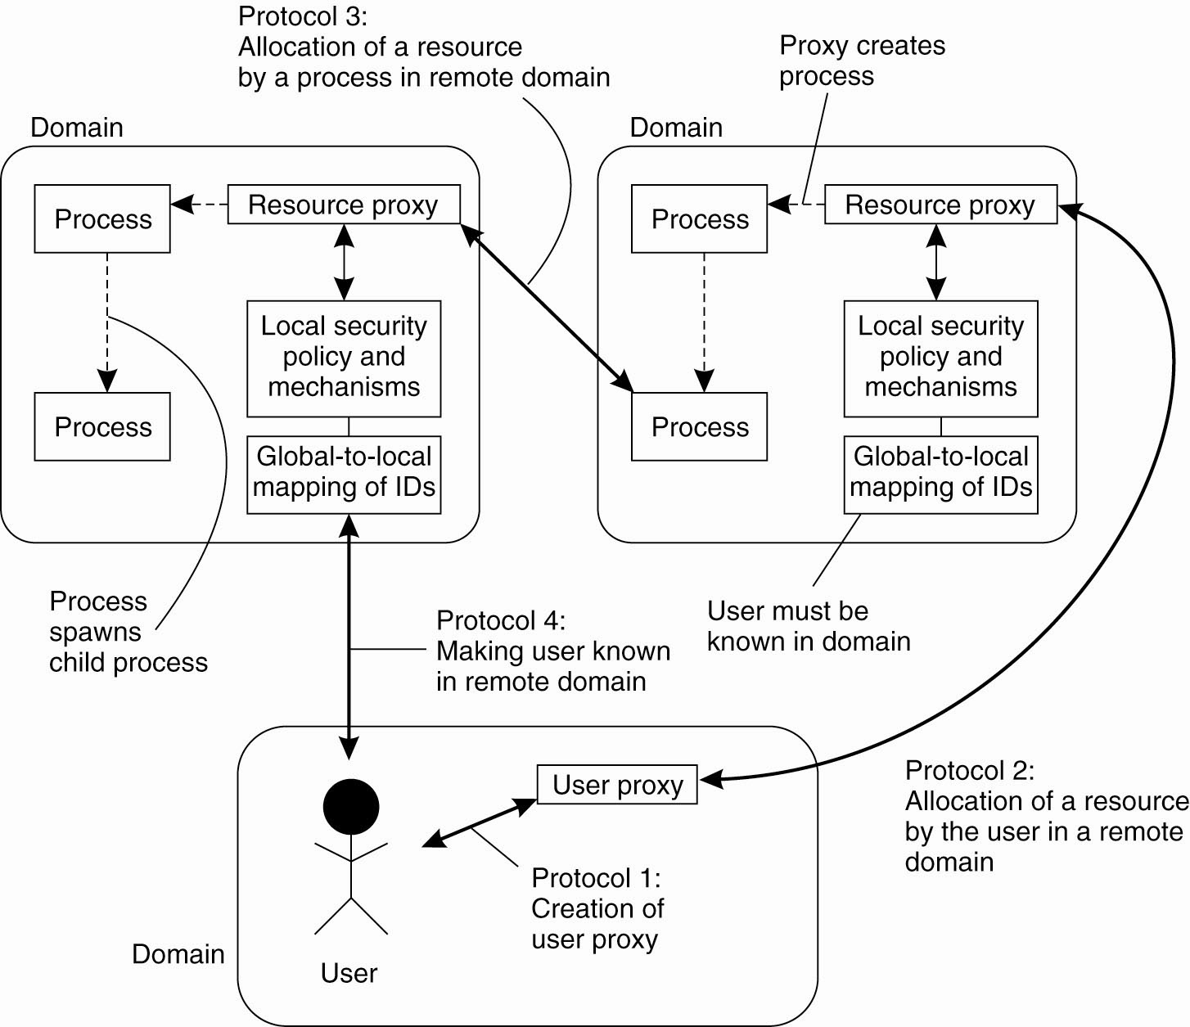

Design Issues
There are three main design issues to consider when considering security:
1.Focus of Control.
2.Layering of Security Mechanisms.
3.Simplicity.

Focus of Control
Three approaches for protection against security threats.
(a) Protection against invalid operations
(b) Protection against unauthorized invocations.
(c) Protection against unauthorized users.
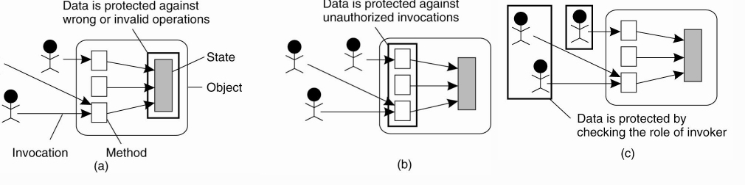

Design Issue: Layering of Security Mechanisms

- The logical organization of a distributed system into several layers.
- A decision is required as to where in the model security the mechanism is to be placed.
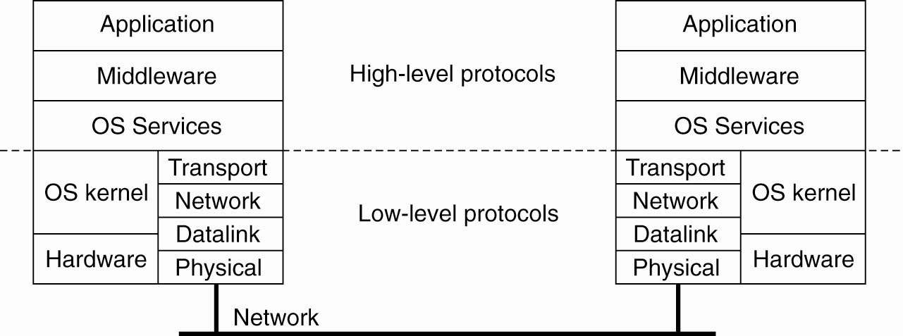

Trust and Security
- A system is either secure or it is not.
- Whether a client considers a systems to be secure is a matter of trust.
- The layer in which security mechanisms are placed depends on the trust a client has in how secure the services are in any particular layer.

Example
Several sites connected through a wide-area backbone service.
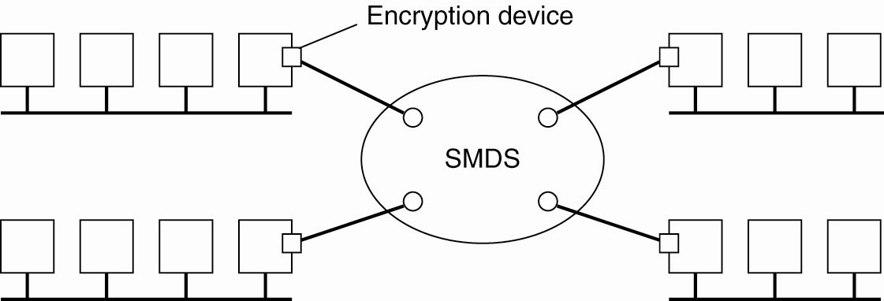
Switched Multi-megabit Data Service (SMDS)

- If the encryption mechanisms cannot be trusted, additional mechanisms can be employed by clients to provide the level of trust required (e.g., using SSL (Secure Sockets Layer).
- Secure Sockets Layer and can be used to securely send messages across a TCP connection.

Distribution of Security Mechanisms
The Trusted Computing Base (TCB) is the set of services/mechanisms within a distributed system required to support a security policy.

Reduced Interfaces for Secure System Components (RISSC)
- Prevents clients and their applications from direct access to critical services. (Neumann 1995)
- Any security-critical server is placed on a separate machine isolated from end-user systems using low-level secure network interfaces.
- Clients and their applications run on different machines and can access the secured server only through these network interfaces.

The principle of RISSC as applied to secure distributed systems.
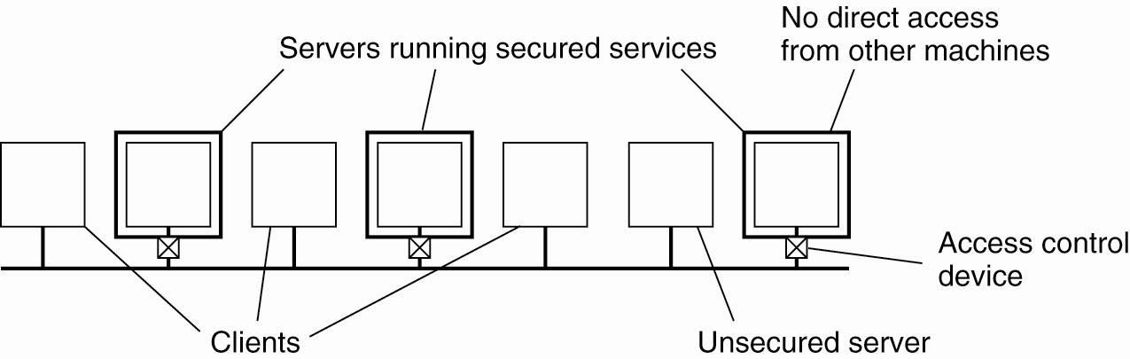

Design Issue: Simplicity

- Designing a secure computer system is considered a difficult task, regardless of whether it is also a DS.
- The use of a few simple mechanisms that are easily understood and trusted to work would be the ideal situation.
- Unfortunately, the real world is not this clear cut, as introducing security mechanisms to an already complex system can often matters worse.
- However, this is still a design goal to aim for!

Security Mechanisms
Fundamental technique within any distributed systems security environment: Cryptography.

- A sender S wanting to transmit message m to a receiver R.
- The sender encrypts its message into an unintelligible message m', and sends m' to R.
- R imust decrypt the received message into its original form m.

Three kinds ofIntruders and eavesdroppers in communication.
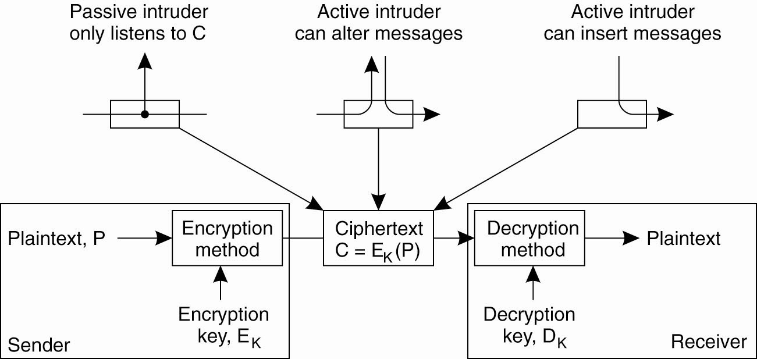
- The original form of the message that is sent is called the plaintext, P
- The encrypted form is referred to as the ciphertext, illustrated as C.

Notation to relate plaintext, ciphertext, and keys.
C = E_{K}(P) denotes that the ciphertext C is obtained by encrypting the plaintext P using key K.
P = D_{K}(C) is used to express the decryption of the ciphertext C using key K, resulting in the plaintext P.

Types of Cryptosystems:

Symmetric: often referred to as conventional cryptography, defined as:
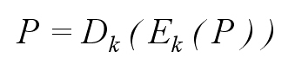
- Symmetric cryptosystems are also referred to as secret-key or shared-key systems, because the sender and receiver are required to share the same key, and to ensure that protection works, this shared key must be kept secret; no one else is allowed to see the key.
- Use the notation K_{A,B} to denote a key shared by A and B.

Asymmetric: often referred to as public-key cryptography, defined as:
- The keys for encryption and decryption are different, but together form a unique pair.
- There is a separate key K_{E} for encryption and one for decryption, K_{D} , such that
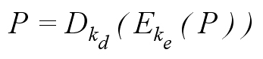
One of the keys in an asymmetric cryptosystem is kept private; the other is made public.
- Notation to denote a public key belonging to A, and as its corresponding private key.

Notation used in cryptography
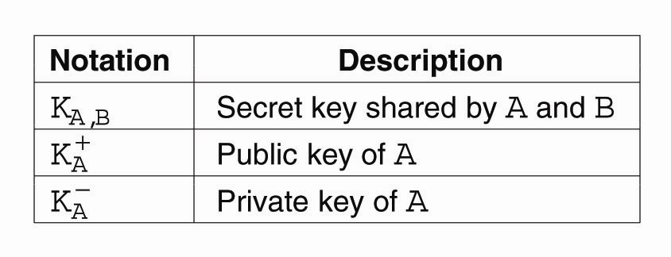

Introducing Alice, Bob & Co.
- Alice and Bob are the good guys.
- Chuck and Eve are usually the bad guys.

Example 1: Bob and Alice
- Alice wants to send a confidential message to Bob
- She should use Bob's public key to encrypt the message.
- Because Bob is the only one holding the private decryption key, he is also the only person that can decrypt the message.

Example 2: Bob and Alice Redux
- Bob wants to know for sure that the message he just received actually came from Alice.
- Alice keeps her encryption key private to encrypt the messages she sends.
- If Bob can successfully decrypt a message using Alice's public key (and the plaintext in the message has enough information to make it meaningful to Bob), he knows that message must have come from Alice, because the decryption key is uniquely tied to the encryption key.

Hash (One-Way) Functions
A hash function H takes a message m of arbitrary length as input and produces a bit string h having a fixed length as output:
h = H( m )

- Given H and m, h is easy to compute.
- However, given H and h, it is computationally infeasible to compute m.
- That is, the function only works One-Way.

Weak Collision Resistence: given m and h = H( m ), it is hard to find another m, say, m2, such that m and m2 produce the same h.
Strong Collision Resistence: Given H, it is infeasible to find an m and an m2 such that H( m ) and H( m2 ) produce the same value.

Similarly:
- For any encryption function E, it should be computationally infeasible to find the key K when given the plaintext P and associated ciphertext C = E_{K}(P)
- Analogous to collision resistance, when given a plaintext P and a key K, it should be effectively impossible to find another key K' such that E_{K}(P) = E_{K'} (P).

Symmetric Cryptosystems: DES

Example of a cryptographic algorithm: Data Encryption Standard (DES) (detailed example)
- Used for symmetric cryptosystems
- DES is designed to operate on 64-bit blocks of data.
- A block is transformed into an encrypted (64 bit) block of output in 16 rounds, where each round uses a different 48-bit key for encryption.
- Each of these 16 keys is derived from a 56-bit master key (see figure).
- Before an input block starts its 16 rounds of encryption, it is first subject to an initial permutation, of which the inverse is later applied to the encrypted output leading to the final output block.

(a) The principle of DES. (b) Outline of one encryption round.
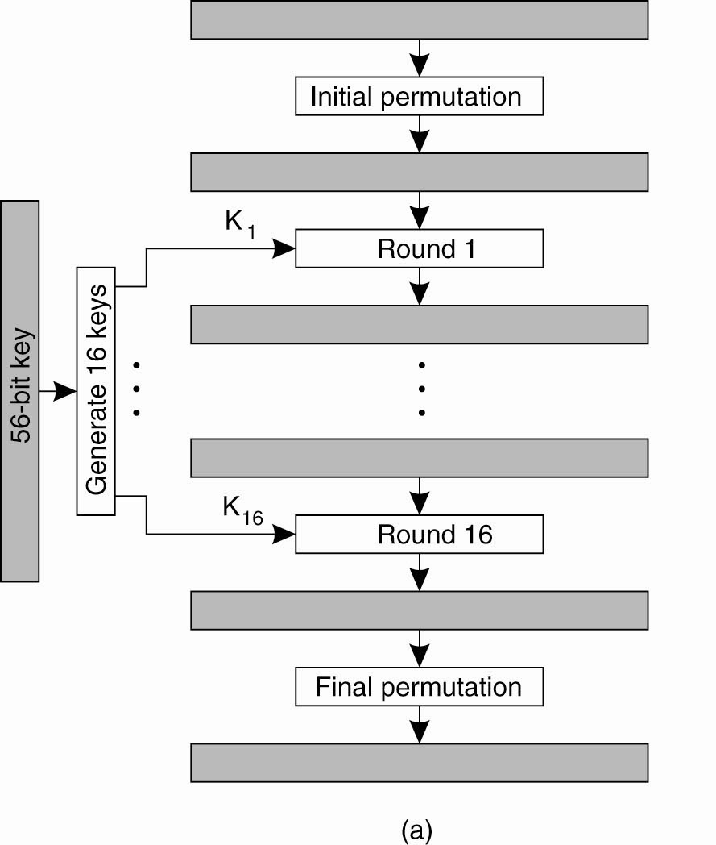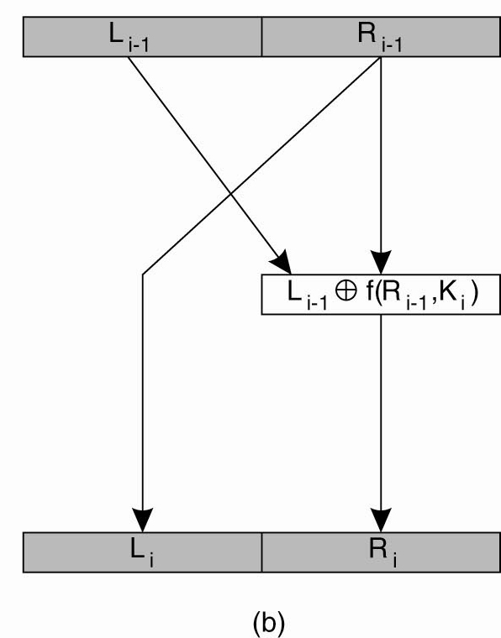

- Each encryption round i takes the 64-bit block produced by the previous round i - 1 as its input.
- The 64 bits are split into a left part Li-1 and a right part Ri-1, each containing 32 bits.
- The right part is used for the left part in the next round, that is, Li = Ri-1.

Work is done in the mangler function f.
- This function takes a 32-bit block Ri-1 as input, together with a 48-bit key Ki, and produces a 32-bit block that is XORed with Li-1 to produce Ri. (XOR is an abbreviation for the exclusive or operation.)
- The mangler function first expands Ri-1 to a 48-bit block and XORs it with Ki. T
- he result is partitioned into eight chunks of six bits each. Each chunk is then fed into a different S-box, which is an operation that substitutes each of the 64 possible 6-bit inputs into one of 16 possible 4-bit outputs.
- The eight output chunks of four bits each are then combined into a 32-bit value and permuted again.

The 48-bit key Ki for round i is derived from the 56-bit master key as follows
- First, the master key is permuted and divided into two 28-bit halves.
- For each round, each half is first rotated one or two bits to the left, after which 24 bits are extracted.
- Together with 24 bits from the other rotated half, a 48-bit key is constructed.

Details of per-round key generation in DES.
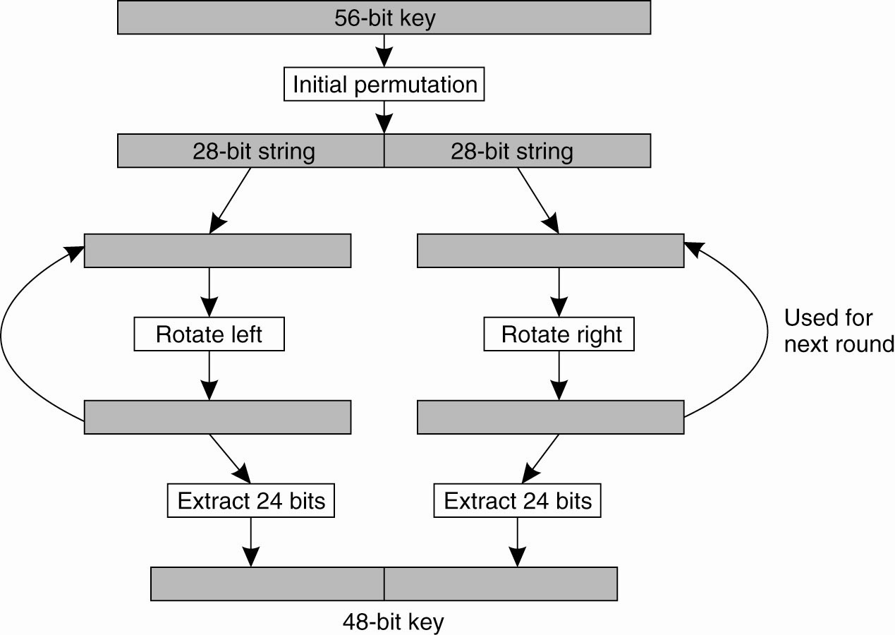

Principle of DES is quite simple:
- Algorithm is difficult to break using analytical methods.
- Brute-force attack by simply searching for a key that will do the job has become easy as has been demonstrated a number of times.
- DES three times in a special encrypt-decrypt-encrypt mode with different keys, also known as Triple DES is much more safe and is still often used .

Public-Key Cryptosystems: RSA
- Public-key systems: RSA : named after its inventors: Rivest, Shamir, and Adleman (1978).
- Security of RSA - no methods are known to efficiently find the prime factors of large numbers.
- It can be shown that each integer can be written as the product of prime numbers.
- For example, 2100 can be written as
2100 = 2 x 2 x 3 x 5 x 5 x 7
making 2, 3, 5, and 7 the prime factors in 2100.
- Private and public keys are constructed from very large prime numbers (consisting of hundreds of decimal digits).
- Breaking RSA is equivalent to finding those two prime numbers.
- So far, this has shown to be computationally infeasible despite mathematicians working on the problem for centuries.

Generating the private and public key requires four steps:
- Choose two very large prime numbers, p and q.
- Compute n = p x q and z = (p – 1) x (q – 1).
- Choose a number d that is relatively prime to z.
- Compute the number e such that e x d = 1 mod z.

- One of the numbers, say d, can subsequently be used for decryption, whereas e is used for encryption.
- Only one of these two is made public, depending on what the algorithm is being used for.

Example 3: Bob and Alice
- Alice wants to keep the messages she sends to Bob confidential.
- She wants to ensure that no one but Bob can intercept and read her messages to him.
- RSA considers each message m to be just a string of bits.
- Each message is first divided into fixed-length blocks, where each block m_{i}, interpreted as a binary number that should lie in the interval 0 mi < n.

- To encrypt message m, the sender calculates for each block m_{i} the value , which is then sent to the receiver.
- Decryption at the receiver's side takes place by computing .
- Note for the encryption, both e and n are needed, whereas decryption requires knowing the values d and n.

- RSA has the drawback of being computationally more complex.
- encrypting messages using RSA is approximately 100–1000 times slower than DES, depending on the implementation technique used.
- Many cryptographic systems use RSA to exchange only shared keys in a secure way, but much less for actually encrypting "normal" data.

Hash Functions: MD5 (Rivest, 1992)

- MD5 is a hash function for computing a 128-bit, fixed length message digest from an arbitrary length binary input string.
- The input string is first padded to a total length of 448 bits (modulo 512), after which the length of the original bit string is added as a 64-bit integer.
- In effect, the input is converted to a series of 512-bit blocks.

The structure of MD5 algorithm.
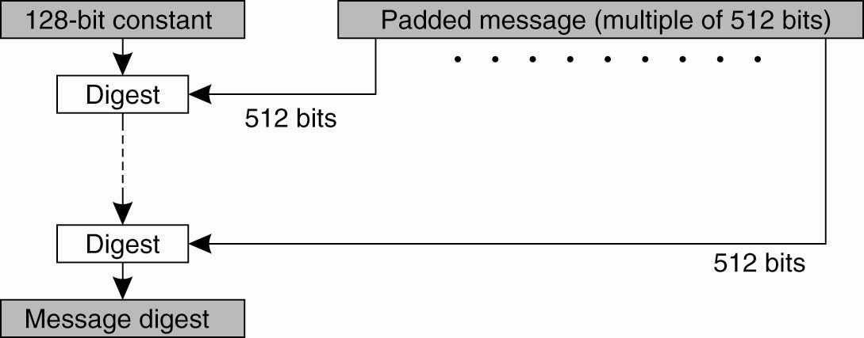
- Starting with some constant 128-bit value, the algorithm proceeds in k phases, where k is the number of 512-bit blocks comprising the padded message.
- During each phase, a 128-bit digest is computed out of a 512-bit block of data coming from the padded message, and the 128-bit digest computed in the preceding phase.

A phase in MD5 consists of four rounds of computations, where each round uses one of the following four functions:

F (x,y,z) = (x AND y) OR ((NOT x) AND z)

G (x,y,z) = (x AND z) OR (y AND (NOT z))

H (x,y,z) = x XOR y XOR z

I (x,y,z) = y XOR (x OR (NOT z))

- Each of these functions operates on 32-bit variables x, y, and z.
- Consider a 512-bit block b from the padded message that is being processed during phase k.
- Block b is divided into 16 32-bit subblocks b0,b1,...,b15.
- During the first round, function F is used to change four variables (denoted as p, q, r, and s, respectively) in 16 iterations
- These variables are carried to each next round, and after a phase has finished, passed on to the next phase.
- There are a total of 64 predefined constants Ci.
- The notation x <<< n is used to denote a left rotate: the bits in x are shifted n positions to the left, where the bit shifted off the left is placed in the rightmost position.

The 16 iterations during the first round in a phase in MD5.
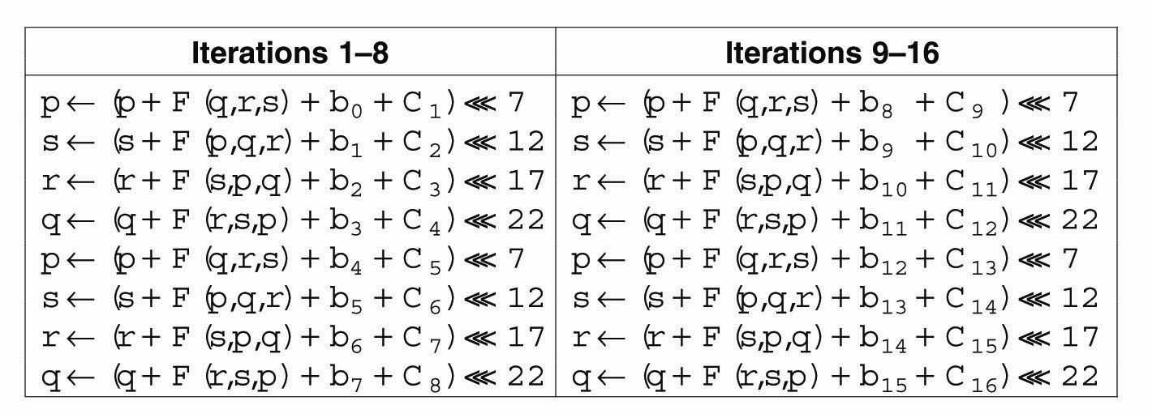

- The second round uses the function G in a similar fashion, whereas H and I are used in the third and fourth round, respectively.
- Each step thus consists of 64 iterations, after which the next phase is started, but now with the values that p, q, r, and s have at that point.

Secure Channels
DS Security: Two Major Issues
1.Secure communications between parties.
2.Authorisation.

Secure channels protect against (protected by): (Voydock and Kent, 1983)
Interception (confidentiality).
Modification (auth. and integrity).
Fabrication (auth. and integrity).

Note that authentication and message integrity as technologies rely on each other

A detailed description of the logics underlying authentication can be found in Lampson et al. (1992).

Applications of Cryptography
1.Authentication.
2.Message Integrity.
3.Confidentiality.

To ensure integrity of the data messages that are exchanged after authentication has taken place, it is common practice to use secret-key cryptography by means of session keys. A session key is a shared (secret) key that is used to encrypt messages for integrity and possibly also confidentiality. Such a key is generally used only for as long as the channel exists. When the channel is closed, its associated session key is discarded (or actually, securely destroyed). We return to session keys below.

Authentication Based on a Shared Secret Key
- Ensure data message integrity exchanged after authentication use secret-key cryptography with session keys.
- Session key - is a shared (secret) key that is used to encrypt messages for integrity
- Generally used only for as long as the channel exists.

Example: Bob and Alice Again
- Alice and Bob are abbreviated by A and B, respectively, and their shared key is denoted as K_{A,B}.
- One party challenges the other to a response that can be correct only if the other knows the shared secret key.
- also known as challenge-response protocols.

- Alice sends her identity to Bob (message 1), indicating that she wants to set up a communication channel between the two.
- Bob sends a challenge R_{B} to Alice, shown as message 2.
- Such a challenge could take the form of a random number.
- Alice must encrypt the challenge with the secret key K_{A,B}. that she shares with Bob, and return the encrypted challenge to Bob. This response is shown as message 3 containing K_{A,B}.(R_{B}).

Authentication based on a shared secret key, using a ‘challenge response’ protocol.
Note: R is a random number.
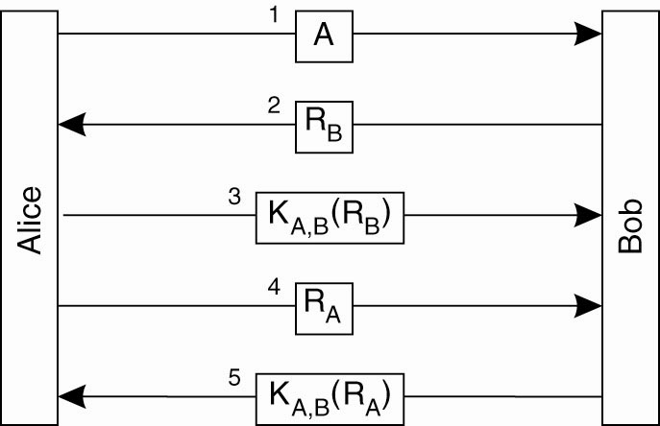

- When Bob receives the response K_{A,B}.(R_{B}) to his challenge R_{B}, he can decrypt the message using the shared key again to see if it contains R_{B}.
- If so, he then knows that Alice is on the other side, for who else could have encrypted R_{B} with K_{A,B} in the first place?
- Alice has not yet verified that it is Bob is on the other side of the channel.
- She sends a challenge R_{A} (message 4), which Bob responds to by returning K_{A,B}.(R_{A}), shown as message 5.
- When Alice decrypts it with KA,B and sees her RA, she knows she is talking to Bob.
[
One of the harder issues in security is designing protocols that actually work. To illustrate how easily things can go wrong, consider an "optimization" of the authentication protocol in which the number of messages has been reduced from five to three, as shown in Fig. 9-13. The basic idea is that if Alice eventually wants to challenge Bob anyway, she might as well send a challenge along with her identity when setting up the channel. Likewise, Bob returns his response to that challenge, along with his own challenge in a single message.

Example: Bob and Alice – Taking Shortcuts
Optimization of the Authentication based on a shared secret key, but using three instead of five messages.
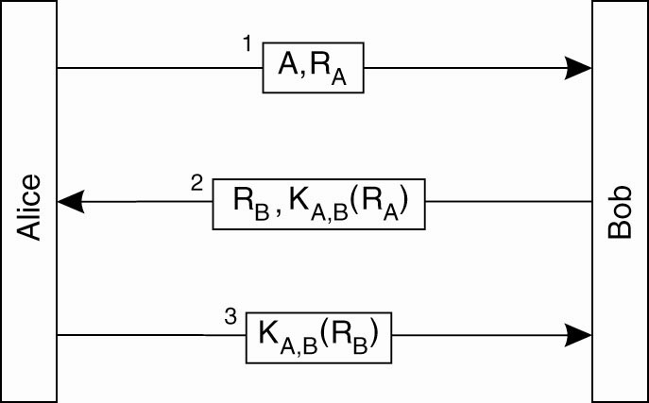
Idea:
- If Alice eventually wants to challenge Bob anyway, she might as well send a challenge along with her identity when setting up the channel.
- Bob returns his response to that challenge, along with his own challenge in a single message

This protocol can easily be defeated by a reflection attack.
- A reflection attack is a potential way of attacking achallenge-response authentication system which uses the same protocol in both directions.
- The basic idea is to trick the target into providing the answer to its own challenge.

The general attack outline is as follows:
- The attacker initiates a connection to a target.
- The target attempts to authenticate the attacker by sending it a challenge.
- The attacker opens another connection to the target, and sends the target this challenge as its own.
- The target responds to that challenge.
- The attacker sends that response back to the target ("reflects" it) on the first connection.
NOTE: If the authentication protocol is not carefully designed, the target will accept that response as valid, thereby leaving the attacker with one fully-authenticated channel connection (the other one is simply abandoned).

Example: Bob and Chuck – When Things Go Wrong
The ‘reflection attack’. - Chuck wants Bob to think he is Alice, so he starts up a second session to trick Bob.

- Chuck's goal is to set up a channel with Bob so that Bob believes he is talking to Alice.
- Chuck can establish this if he responds correctly to a challenge sent by Bob
- e.g, by returning the encrypted version of a number that Bob sent.
- Without knowledge of K_{A,B}., only Bob can do such an encryption, and this is precisely what Chuck tricks Bob into doing.

- Chuck starts out by sending a message containing Alice's identity A, along with a challenge R_{C}.
- Bob returns his challenge R_{B} and the response K_{A,B}(R_{C}) in a single message.
- Chuck needs to prove he knows the secret key by returning K_{A,B}(R_{B}) to Bob.
- He does not have K_{A,B}.
- He attempts to set up a second channel to let Bob do the encryption for him.
- Chuck sends A and R_{B} in a single message as before, but now pretends that he wants a second channel. This is shown as message 3

The reflection attack.
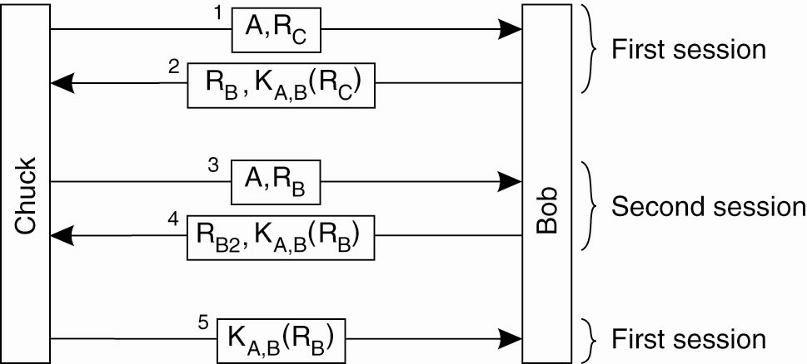

- Bob not recognizing that he, himself, had used R_{B} before as a challenge, responds with K_{A,B}(R_{B}) and another challenge R_{B2}, shown as message 4.
- At that point, Chuck has K_{A,B}(R_{B}) and finishes setting up the first session by returning message 5 containing the response K_{A,B}(R_{B}), which was originally requested from the challenge sent in message 2.

Mistake 1: the two parties in the new version of the protocol were using the same challenge in two different runs of the protocol.

Better Design: always use different challenges for the initiator and for the responder.
- In general, letting the two parties setting up a secure channel do a number of things identically is not a good idea.

Mistake 2: Bob gave away valuable information in the form of the response K_{A,B}(R_{C}) without knowing for sure to whom he was giving it.
- Not violated in the original protocol, in which Alice first needed to prove her identity, after which Bob was willing to pass her encrypted information.

More on design principles for protocols can be found in Abadi and Needham (1996).

Authentication Using a Key Distribution Center

Problem with a shared secret key for authentication: scalability.
- Given N hosts - each host is required to share a secret key with each of the other N - 1 hosts
- System as a whole must manage N (N - 1)/2 keyes
- Each host has to manage N - 1 keys.

Alternative: use a centralized approach by means of a Key Distribution Center (KDC).
- This KDC shares a secret key with each of the hosts
- No pair of hosts is required to have a shared secret key as well.
- Using a KDC requires that we manage N keys instead of N (N - 1)/2

- If Alice wants to set up a secure channel with Bob, she can do so with the help of a (trusted) KDC.
- The KDC hands out a key to both Alice and Bob that they can use for communication,
Principle of using a KDC.
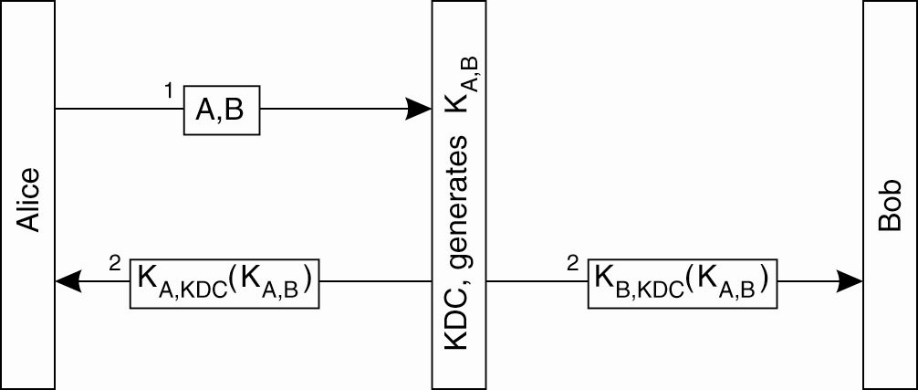

- Alice sends a message to the KDC, telling it that she wants to talk to Bob.
- The KDC returns a message containing a shared secret key K_{A,B} that she can use.
- The message is encrypted with the secret key K_{A,KDC} that Alice shares with the KDC.
- The KDC sends K_{A,B} to Bob, but now encrypted with the secret key K_{B,KDC} it shares with Bob.

Drawbacks :
- Alice may want to set up a secure channel with Bob even before Bob had received the shared key from the KDC.
- The KDC is required to pass Bob the key.

Solution: ticket
- KDC passes K_{B,KDC}(K_{A,B}) back to Alice and lets her connect to Bob.
- The message K_{B,KDC}(K_{A,B}) is also known as a ticket.
- It is Alice's job to pass this ticket to Bob.
- Note that Bob is still the only one that can make sensible use of the ticket, as he is the only one besides the KDC who knows how to decrypt the information it contains.

Using a ticket and letting Alice set up a connection to Bob.
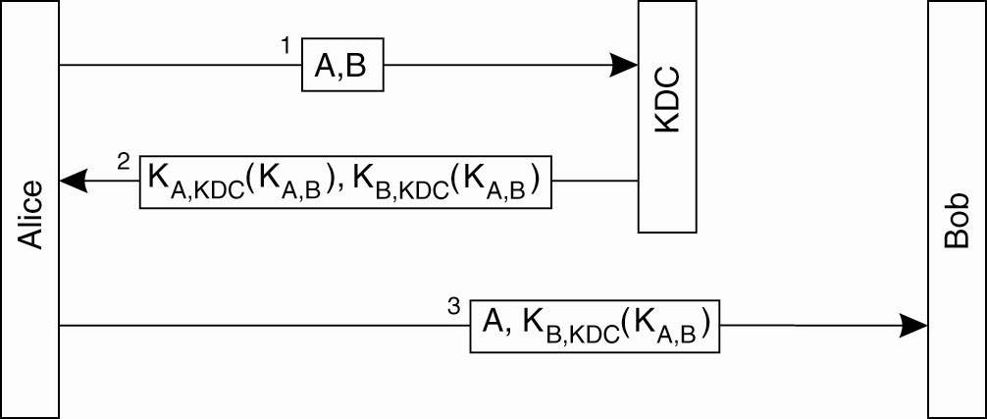

- Protocol is a variant of a well-known example of an authentication protocol using a KDC, known as the Needham-Schroeder authentication protocol, named after its inventors (Needham and Schroeder, 1978).

The Needham-Schroeder protocol is a multiway challenge-response protocol and works as follows.
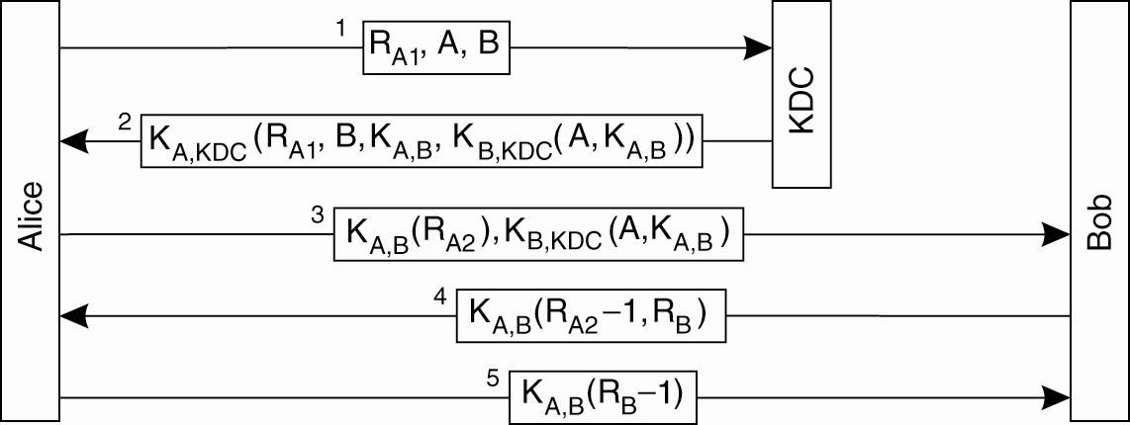

- When Alice wants to set up a secure channel with Bob, she sends a request to the KDC containing a challenge R_{A}, along with her identity A and that of Bob.
- The KDC responds by giving her the ticket K_{B,KDC}(K_{A,B}), along with the secret key K_{A,B} that she can subsequently share with Bob.
- The challenge R_{A1} that Alice sends to the KDC along with her request to set up a channel to Bob is also known as a nonce.
- A nonce is a random number that is used only once, such as one chosen from a very large set.
- Purpose of a nonce is to uniquely relate two messages to each other
- e.g. message 1 and message 2.
- by including R_{A1} again in message 2, Alice will know for sure that message 2 is sent as a response to message 1, and that it is not a replay of an older message.

- Message 2 also contains B, the identity of Bob.
- By including B, the KDC protects Alice against the following attack.

- After the KDC has passed the ticket to Alice, the secure channel between Alice and Bob can be set up.
- Alice sends message 3, which contains the ticket to Bob, and a challenge R_{A2} encrypted with the shared key K_{A,B} that the KDC had just generated.
- Bob then decrypts the ticket to find the shared key, and returns a response R_{A2} - 1 along with a challenge R_{B} for Alice.
NOTE: by returning R_{A2} - 1 and not just R_{A2}, Bob not only proves he knows the shared secret key, but also that he has actually decrypted the challenge.
- This ties message 4 to message 3 in the same way that the nonce R_{A} tied message 2 to message 1.

Weak Point:
- If Chuck got an old key K_{A,B}, he could replay message 3 and get Bob to set up a channel.
- Bob will then believe he is talking to Alice, while, in fact, Chuck is at the other end.
- Need to relate message 3 to message 1 - make the key dependent on the initial request from Alice to set up a channel with Bob.

Protection against malicious reuse of a previously generated session key in the Needham-Schroeder protocol.
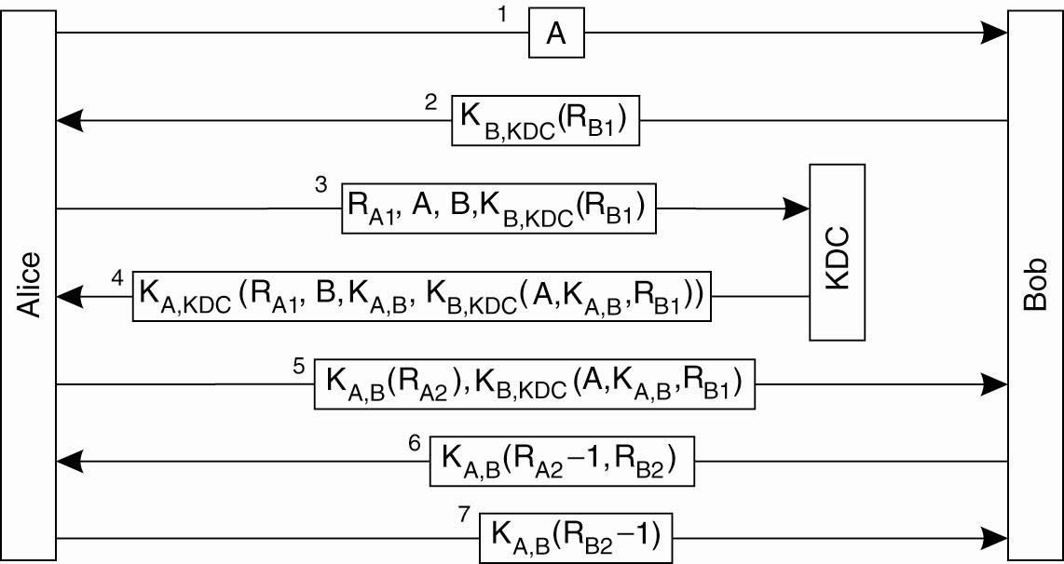

Solution: incorporate a nonce in the request sent by Alice to the KDC.
- The nonce has to come from Bob: this assures Bob that whoever wants to set up a secure channel with him, will have gotten the appropriate information from the KDC.
- Alice first requests Bob to send her a nonce R_{B1}, encrypted with the key shared between Bob and the KDC.
- Alice incorporates this nonce in her request to the KDC, which will then decrypt it and put the result in the generated ticket.
- Bob will know for sure that the session key is tied to the original request from Alice to talk to Bob.

Authentication Using Public-Key Cryptography
Mutual authentication in a public-key cryptosystem.
- Note that the KDC is missing …
- But, this assumes that some mechanism exists to verify everyone’s public key.

Example: Bob and Alice
- Alice wants to set up a secure channel to Bob
- Both are in the possession of each other's public key.

Mutual authentication in a public-key cryptosystem.
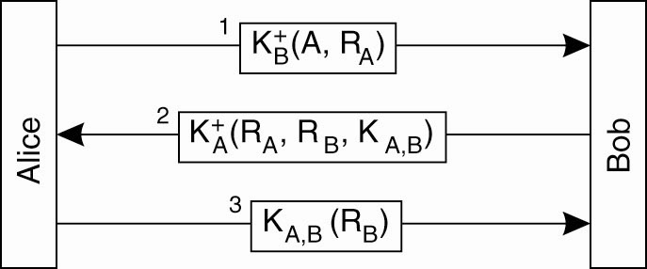

- Alice sends a challenge R_{A} to Bob encrypted with his public key .
- Bob's must decrypt the message and return the challenge to Alice.
- Because Bob is the only person that can decrypt the message (using the private key that is associated with the public key Alice used), Alice will know that she is talking to Bob.
- When Bob receives Alice's request to set up a channel, he returns the decrypted challenge, along with his own challenge RB to authenticate Alice.
- He also generates a session key K_{A,B} that can be used for further communication.
- Bob's response to Alice's challenge, his own challenge, and the session key are put into a message encrypted with the public key belonging to Alice, shown as message 2 .
- Only Alice will be capable of decrypting this message using the private key associated with .
- Alice, finally, returns her response to Bob's challenge using the session key K_{A,B} generated by Bob.

More on Secure Channels
In addition to authentication, a secure channel also requires that messages are confidential, and that they maintain their integrity.

For example:
- Alice needs to be sure that Bob cannot change a received message and claim it came from her.
- Bob needs to be sure that he can prove the message was sent by/from Alice, just in case she decides to deny ever having sent it in the first place.

Solution: Digital Signing.

Digital Signatures
- Digital signing a message using public-key cryptography.
- This is implemented in the RSA technology.
- Note: the entire document is encrypted/signed - this can sometimes be a costly overkill.

Example: Bob and Alice use RSA
- When Alice sends a message m to Bob, she encrypts it with her private key
- If she wants to keep the message content a secret, she can use Bob's public key and send , which combines m and the version signed by Alice.
- Digital signing a message using public-key cryptography.
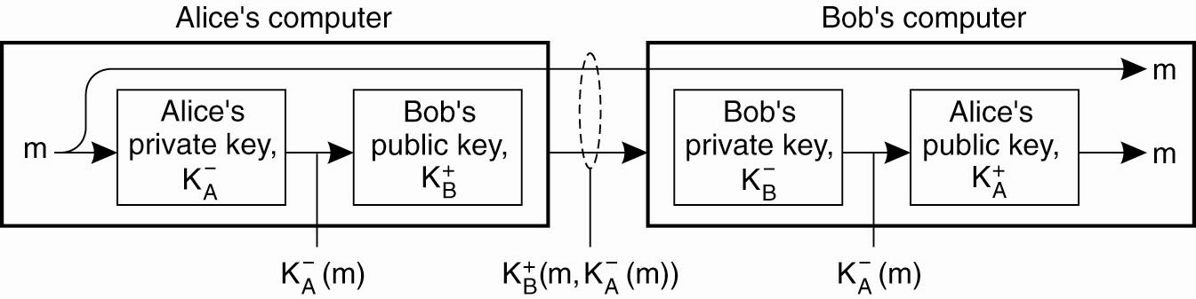

- When the message arrives at Bob, he can decrypt it using Alice's public key.

Problems:
- The validity of Alice's signature holds only as long as Alice's private key remains a secret.
- If Alice changes her private key her message to Bob becomes worthless.
- Alice encrypts the entire message with her private key.
- Such an encryption may be costly in terms of processing requirements (or even mathematically infeasible as we assume that the message interpreted as a binary number is bounded by a predefined maximum), and is actually unnecessary.

Solution: more elegant scheme is to use a message digest.
- A message digest is a fixed-length bit string h that has been computed from an arbitrary-length message m by means of a cryptographic hash function H.
- If m is changed to m', its hash H (m') will be different from h = H (m) so that it can easily be detected that a modification has taken place.

Example: Bob and Alice use a message digest
- To digitally sign a message, Alice first computes a message digest and encrypts the digest with her private key
- The encrypted digest is sent along with the message to Bob.
- When Bob receives the message and its encrypted digest, he decrypts the digest with Alice's public key, and separately calculates the message digest.
- If the digest calculated from the received message and the decrypted digest match, Bob knows the message has been signed by Alice.
Note -the message itself is sent as plaintext: everyone is allowed to read it.
- If confidentiality is required, then the message should also be encrypted with Bob's public key.

Digitally signing a message using a message digest.
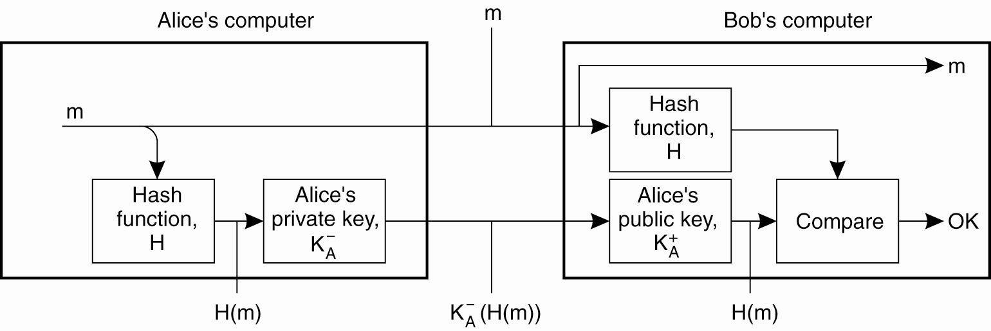

Secure Group Communication
- Within Distributed Systems, it is often necessary to enable a secure channel between a group of processes (not just 2).
- Think of replicated processes …

Solution 1: all replicas use same shared key!!!
Solution 2: each pair share a secret key – this results in N(N-1)/2 key pairs in the system!!
Solution 3: use public-key crytpography – which results in N key pairs in the system!

But … what happens if a replicated process is compromised?

Secure Replicated Servers

Problem: a client issues a request to a group of replicated servers. - the client expects the response to be trustworthy.

Solution: Reiter et al. (1994) - solution to a secure, replicated server in which replication transparency is maintained.
- Advantage: because clients are unaware of the actual replicas, it becomes much easier to add or remove replicas in a secure way.
- Secret sharing -When multiple users (or processes) share a secret, none of them knows the entire secret.
- secret can be revealed only if they all get together.

Example: Actively Replicated Servers
- A request is sent to all servers simultaneously and handled by each of them.
- Each server produces a response that it returns to the client.
- For a securely replicated group of servers, each server must accompany its response with a digital signature. I
- if r_{i} is the response from server S_{i} , let md(r_{i}) denote the message digest computed by server S_{i}.
- This digest is signed with server S_{i}'s private key .

- Want to protect the client against at most c corrupted servers.
- Let the replicated servers generate a secret valid signature with the property that c corrupted servers alone are not enough to produce that signature.

- Begin with consider a group of five replicated servers that should be able to tolerate two corrupted servers, and still produce a response that a client can trust.
- Each server S_{i} sends its response r_{i} to the client, along with its signature sig (S_{i},r_{i}) = (md(r_{i})).
- The client will receive five triplets <r_{i}, md(r_{i}), sig (S_{i},r_{i})> from which it should derive the correct response.

Sharing a secret signature in a group of replicated servers.
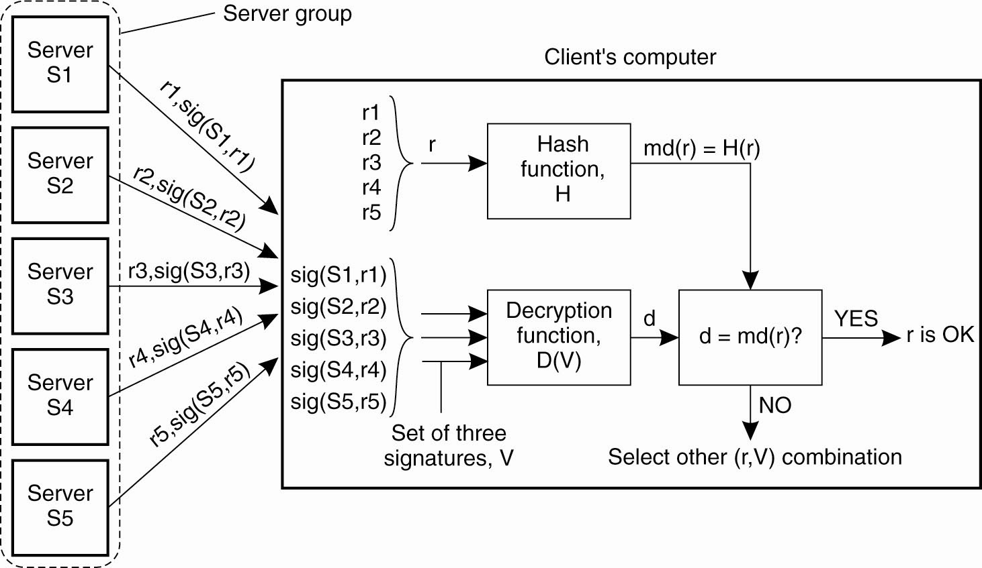

- Each digest md(r_{i}) is calculated by the client.
- The client uses a special, publicly-known decryption function D, which takes a set V = {sig (S,r),sig (S',r'),sig (S",r")} of three signatures as input, and produces a single digest as output:

d_{out} = D (V) = D (sig (S,r),sig (S',r'),sig (S",r"))

- There are 5!/(3!2!)=10 possible combinations of three signatures that the client can use as input for D.
- If one of these combinations produces a correct digest md(r_{i}) for some response r_{i}, then the client can consider r_{i} as being correct.
- It can trust that the response has been produced by at least three honest servers.

Example: Kerberos (Steiner et al., 1988; and Kohl et al., 1994).
- Kerberos is a computer network authentication protocol, which allows individuals communicating over an insecure network to prove their identity to one another in a secure manner.
- Kerberos prevents eavesdropping or replay attacks, and ensures the integrity of the data. Its designers aimed primarily at a client-server model, and it provides mutual authentication — both the user and the server verify each other's identity.

- Kerberos builds on symmetric key cryptography and requires a trusted third party.

- Kerberos protocol name is based on the three- headed dog figure from Greek mythology known as Kerberos who guarded the gates of Hades .
- The three heads of Kerberos comprise the Key Distribution Center (KDC), the client user and the server with the desired service to access.

- Kerberos was developed at M.I.T. and is based on the Needham-Schroeder authentication protocol.
- Two different versions of Kerberos in use, version 4 (V4) and version 5 (V5).
- Both versions are conceptually similar, with V5 being much more flexible and scalable. A detailed description of V5 can be found in Neuman et al. (2005),

- Kerberos lets a user request an encrypted "ticket" from an authentication process that can then be used to request a particular service from a server. The user's password does not have to pass through the network.

Briefly and approximately, here's how Kerberos works:
- Suppose you want to access a server on another computer.
- You know that this server requires a Kerberos "ticket" before it will honor your request.
- To get your ticket, you first request authentication from the Authentication Server (AS).
- The Authentication Server creates a "session key" (which is also an encryption key) basing it on your password (which it can get from your user name) and a random value that represents the requested service.
- The session key is effectively a "ticket-granting ticket."
- You next send your ticket-granting ticket to a ticket-granting server (TGS).
- The TGS may be physically the same server as the Authentication Server, but it's now performing a different service.
- The TGS returns the ticket that can be sent to the server for the requested service.
- The service either rejects the ticket or accepts it and performs the service.
- Because the ticket you received from the TGS is time-stamped, it allows you to make additional requests using the same ticket within a certain time period (typically, eight hours) without having to be reauthenticated.
- Making the ticket valid for a limited time period make it less likely that someone else will be able to use it later.

Authentication in Kerberos.
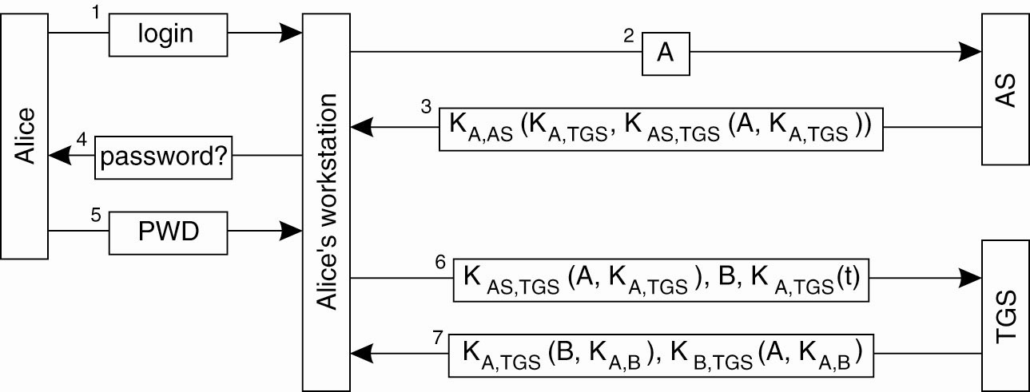

Access Control
- Authorization is the process of “granting access rights” to a user/process.

- Access Control is the process of “verifying access rights” for an authorized user/process.

General Model for Access Control

- A Subject is a process that acts on behalf of users or an object that needs the services of other objects in order to carry out its work, that issues a request to access an object.
- An Object encapsulates its own state and implements the operations on that state.
- Operations of an object that a subject can request to be carried out are made available through Interfaces.

General model of controlling access to objects, via a tamper-proof reference monitor.
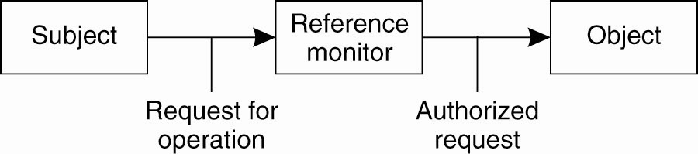
Protection:
- Controlling access to an object protects the object against invocations by subjects that are not allowed to have any of the methods carried out.
- May include object management issues, such as creating, renaming, or deleting objects.
- enforced by a program called a reference monitor.
- A reference monitor records which subject may do what, and decides whether a subject is allowed to have a specific operation carried out.
- This monitor is called each time an object is invoked.

Access Control Matrix

Access control matrix - A model of the access rights of subjects with respect to objects.
- Each subject is represented by a row in this matrix
- Each object is represented by a column.
- Given a matrix M, then an entry M [s,o] lists which operations subject s have access rights to object o.

Sample Access Control Matrix
Subjects p and q
Objects f, g, p, q
Access rights:, write, execute, own

 | f | g | p | q
p | rights:, write, own | read | read, write, execute | write
q | - | read | read | read, write, execute, own

Problem:
- Support for thousands of users and millions of objects that require protection
- Many entries in the matrix will be empty: a single subject will generally have access to relatively few objects.
- More efficient ways are followed to implement an access control matrix.

Solution:
- Maintain a list of the access rights of subjects that want to access the object. - Access Control List (ACL).
- Each object is assumed to have its own associated ACL.

- Another approach - distribute the matrix row-wise by giving each subject a list of capabilities it has for each object.
- a capability corresponds to an entry in the access control matrix.
- Not having a capability for a specific object means that the subject has no access rights for that object.

- A capability can be compared to a ticket: its holder is given certain rights that are associated with that ticket.
- A ticket should be protected against modifications by its holder.
- e.g. protect a list of capabilities with a signature(Tanenbaum et al., 1990)

Comparison between ACLs and capabilities for protecting objects. (a) Using an ACL. (b) Using capabilities.
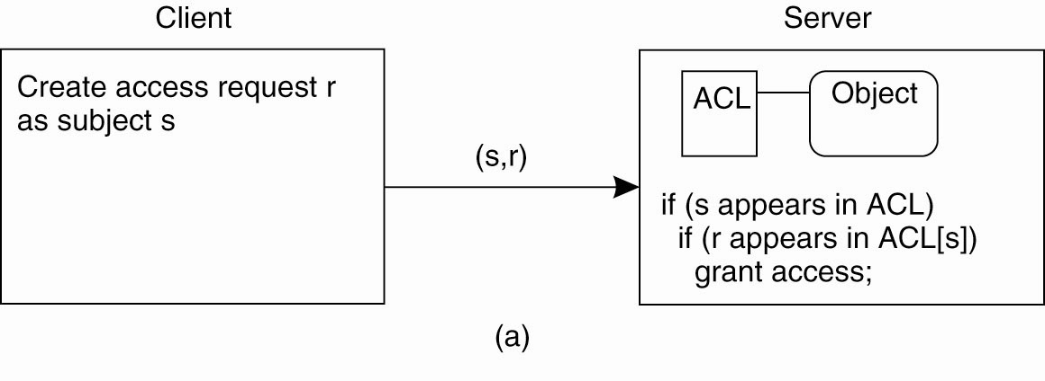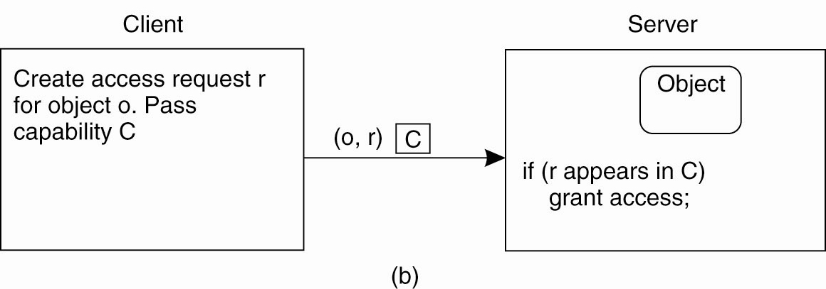

ACLs - when a client sends a request to a server, the server's reference monitor will check whether it knows the client and if that client is known and allowed to have the requested operation carried out

Capabilities - a client sends its request to the server.
The server only needs to check whether the capability is valid and whether the requested operation is listed in the capability.

Protection Domains

Problem: ACLs or a capability lists can become quite large

Solution: Protection domains.
- A protection domain is a set of (object, access rights) pairs.
- Each pair specifies for a given object exactly which operations are allowed to be carried out (Saltzer and Schroeder, 1975).
- Requests for carrying out an operation are always issued within a domain.
- Whenever a subject requests an operation to be carried out at an object, the reference monitor first looks up the protection domain associated with that request.
- Given the domain, the reference monitor can check whether the request is allowed to be carried out.

The hierarchical organization of protection domains as groups of users.
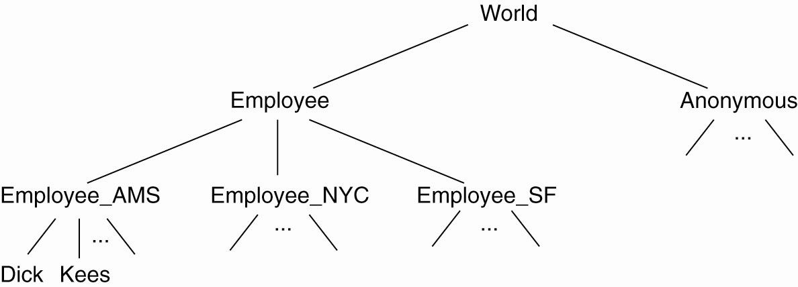

Refinements:
- Implement protection domains as roles. (Sandhu et al., 1996)

- Combine protection domains with grouping of objects. (Gladney 1997)

Firewalls

A common implementation of a firewall.
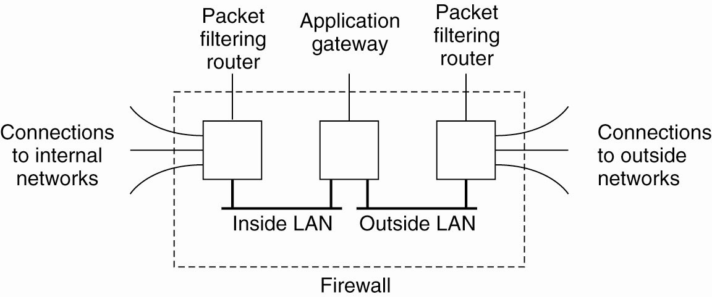

Firewalls come in one of two types:

Packet-filtering gateway - operates as a router and makes decisions as to whether or not to pass a network packet based on the source and destination address as contained in the packet's header.

Application-level gateway - inspects the content of an incoming or outgoing message.
- Special kind of application-level gateway is what is known as a proxy gateway.
- Works as a front end to a specific kind of application, and ensures that only those messages are passed that meet certain criteria.

Secure Mobile Code
Two main issues:
- Securing against malicious agents that attempt to damage a mobile agent environment.
- Securing a mobile agent from a malicious environment that attempts to interfere with the working of the mobile agent.

Protecting an Agent
- It has proved impossible to protect an agent against all types of attack. (Farmer et al., 1996)
- The emphasis is on being able to detect modifications (or tampering) to an agent.

Alternative: Organize agents in such a way that modifications can at least be detected
- The Ajanta System uses public-key technologies to implement this idea: (Tripathi et al. 1999)(Karnik and Tripathi, 2001)
- Read-only state - a collection of data items that is signed by the agent's owner
- Append-only logs. - data can neither be removed nor modified without the owner's detection (uses sequence of checksums)
- Selective revealing of state - an array of data items, where each entry is encrypted with a designated server's public key

Protecting the Target

Protect all resources against unauthorized access by downloaded code.

Solution: Construct a sandbox.
- A sandbox is a technique by which a downloaded program is executed in such a way that each of its instructions can be fully controlled.
- If an attempt is made to execute an instruction that has been forbidden by the host, execution of the program will be stopped.

Approaches to Impementation
- Executable code – check at download and insert additional instructions for situations that can be checked only at runtime (Wahbe et al., 1993). - Flying Blind!!!
- Interpreted code – Use a sandbox.

Example: Java sandbox
- Exclusively trusted class loaders are used.
- A Java program is not allowed to create its own class loaders by which it could circumvent the way class loading is normally handled.
- A byte code verifier, which checks whether a downloaded class obeys the security rules of the sandbox.
- Tthe verifier checks that the class contains no illegal instructions or instructions that could somehow corrupt the stack or memory.
- Not all classes are checked, only those downloaded from an external server to the client.
- Classes that are located on the client's machine are generally trusted, although their integrity could also be easily verified.

The organization of a Java sandbox.
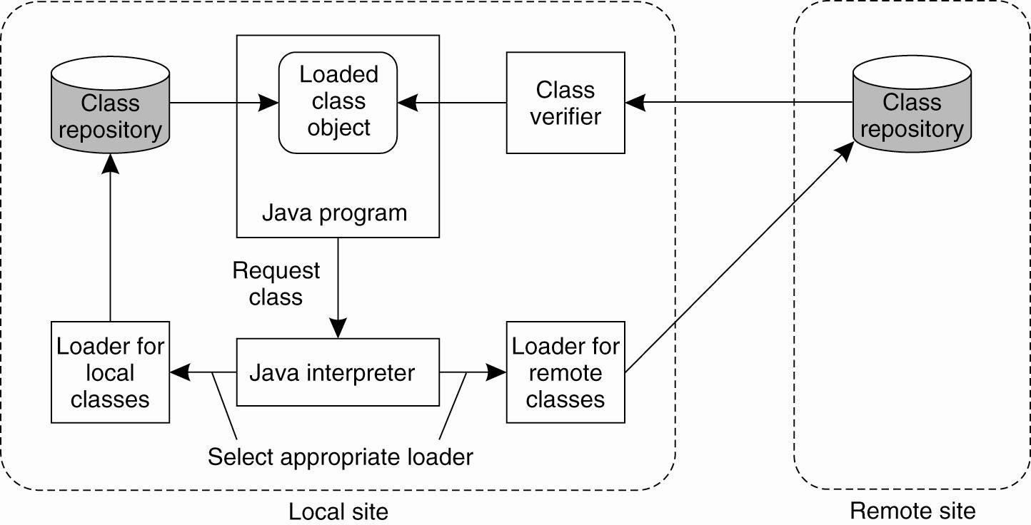

- When a class has been securely downloaded and verified, the JVM can instantiate objects from it and execute those object's methods.
- To further prevent objects from unauthorized access to the client's resources, a security manager is used to perform various checks at runtime.
- Java programs intended to be downloaded are forced to make use of the security manager; there is no way they can circumvent it.
- The security manager thus plays the role of a reference monitor .

Variation:
Create a playground for downloaded mobile code (Malkhi and Reiter, 2000).
- A playground is a separate, designated machine exclusively reserved for running mobile code.
- Resources local to the playground, such as files or network connections to external servers are available to programs executing in the playground, subject to normal protection mechanisms. H

(a) A sandbox. (b) A playground.
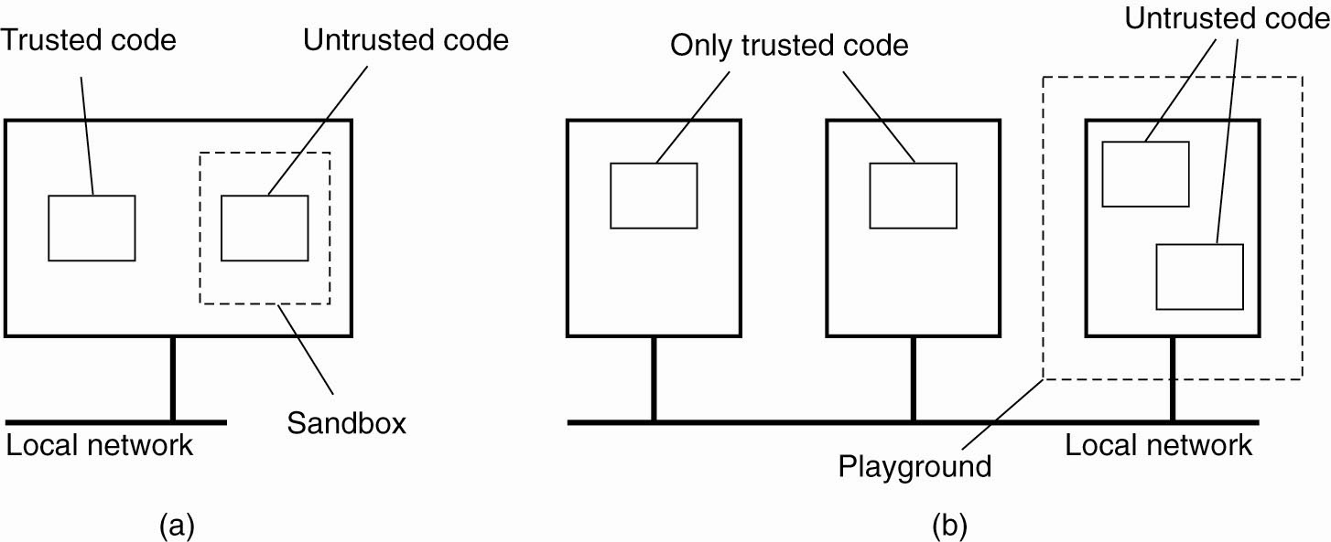

Difficult to enforce a security policy
Three mechanisms for Java programs (Wallach et al. 1997):
- Use of object references as capabilities.
- e.g To access a local resource such as a file, a program must have been given a reference to a specific object that handles file operations when it was downloaded.
- If no such reference is given, there is no way that files can be accessed. T

The principle of using Java object references as capabilities.
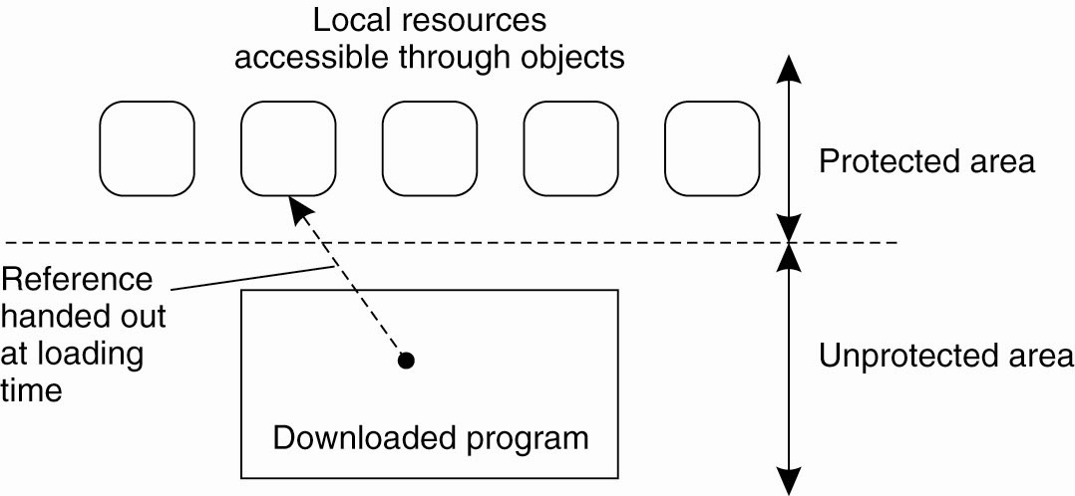

- Extended stack introspection.
- Any call to a method m of a local resource is preceded by a call to a special procedure enable_privilege that checks whether the caller is authorized to invoke m on that resource.
- If the invocation is authorized, the caller is given temporary privileges for the duration of the call.
- Before returning control to the invoker when m is finished, the special procedure disable_privilege is invoked to disable these privileges.

Implementation: Whenever an invocation to a local resource is made, the Java interpreter automatically calls enable_privilege, which subsequently checks whether the call is permitted.
- If so, a call to disable_privilege is pushed on the stack to ensure that privileges are disabled when the method call returns.
- This approach prevents malicious programmers from circumventing the rules.

- Using the stack enables a better way of checking privileges.
- Stack introspection allows for the attachment of privileges to classes or methods, and the checking of those privileges for each caller separately.
- Allows implementation of class-based protection domains, as is explained in detail in Gong and Schemers (1998)
The principle of stack introspection.
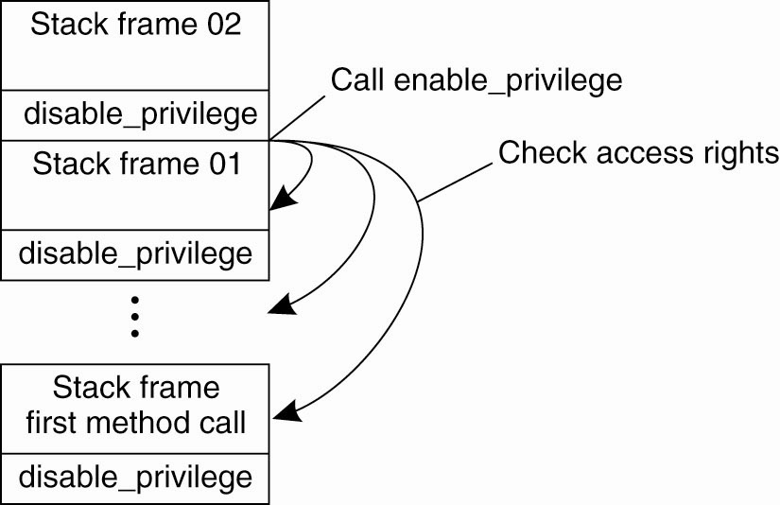

- Name space management. Name resolution is handled by class loaders, which need to be adapted to implement this approach.

Denial of Service

Access control is generally about carefully ensuring that resources are accessed only by authorized processes. A particularly annoying type of attack that is related to access control is maliciously preventing authorized processes from accessing resources. Defenses against such denial-of-service (DoS) attacks are becoming increasingly important as distributed systems are opened up through the Internet. Where DoS attacks that come from one or a few sources can often be handled quite effectively, matters become much more difficult when having to deal with distributed denial of service (DDoS).

In DDoS attacks, a huge collection of processes jointly attempt to bring down a networked service. In these cases, we often see that the attackers have succeeded in hijacking a large group of machines which unknowingly participate in the attack. Specht and Lee (2004) distinguish two types of attacks: those aimed at bandwidth depletion and those aimed at resource depletion.

Bandwidth depletion can be accomplished by simply sending many messages to a single machine. The effect is that normal messages will hardly be able to reach the receiver. Resource depletion attacks concentrate on letting the receiver use up resources on otherwise useless messages. A well-known resource-depletion attack is TCP SYN-flooding. In this case, the attacker attempts to initiate a huge amount of connections (i.e., send SYN packets as part of the three-way handshake), but will otherwise never respond to acknowledgments from the receiver.

There is no single method to protect against DDoS attacks. One problem is that attackers make use of innocent victims by secretly installing software on their machines. In these cases, the only solution is to have machines continuously monitor their state by checking files for pollution. Considering the ease by which a virus can spread over the Internet, relying only on this countermeasure is not feasible.

Much better is to continuously monitor network traffic, for example, starting at the egress routers where packets leave an organization's network. Experience shows that by dropping packets whose source address does not belong to the organization's network we can prevent a lot of havoc. In general, the more packets can be filtered close to the sources, the better.
[Page 428]

Alternatively, it is also possible to concentrate on ingress routers, that is, where traffic flows into an organization's network. The problem is that detecting an attack at an ingress router is too late as the network will probably already be unreachable for regular traffic. Better is to have routers further in the Internet, such as in the networks of ISPs, start dropping packets when they suspect that an attack is going on. This approach is followed by Gil and Poletto (2001), where a router will drop packets when it notices that the rate between the number of packets to a specific node is disproportionate to the number of packets from that node.

In general, a myriad of techniques need to be deployed, whereas new attacks continue to emerge. A practical overview of the state-of-the-art in denial-of-service attacks and solutions can be found in Mirkovic et al. (2005); a detailed taxonomy is presented in Mirkovic and Reiher (2004).

9.4. Security Management

So far, we have considered secure channels and access control, but have hardly touched upon the issue how, for example, keys are obtained. In this section, we take a closer look at security management. In particular, we distinguish three different subjects. First, we need to consider the general management of cryptographic keys, and especially the means by which public keys are distributed. As it turns out, certificates play an important role here.

Second, we discuss the problem of securely managing a group of servers by concentrating on the problem of adding a new group member that is trusted by the current members. Clearly, in the face of distributed and replicated services, it is important that security is not compromised by admitting a malicious process to a group.

Third, we pay attention to authorization management by looking at capabilities and what are known as attribute certificates. An important issue in distributed systems with respect to authorization management is that one process can delegate some or all of its access rights to another process. Delegating rights in a secure way has its own subtleties as we also discuss in this section.

9.4.1. Key Management

So far, we have described various cryptographic protocols in which we (implicitly) assumed that various keys were readily available. For example, in the case of public-key cryptosystems, we assumed that a sender of a message had the public key of the receiver at its disposal so that it could encrypt the message to ensure confidentiality. Likewise, in the case of authentication using a key distribution center (KDC), we assumed each party already shared a secret key with the KDC.
[Page 429]

However, establishing and distributing keys is not a trivial matter. For example, distributing secret keys by means of an unsecured channel is out of the question and in many cases we need to resort to out-of-band methods. Also, mechanisms are needed to revoke keys, that is, prevent a key from being used after it has been compromised or invalidated. For example, revocation is necessary when a key has been compromised.

Key Establishment

Let us start with considering how session keys can be established. When Alice wants to set up a secure channel with Bob, she may first use Bob's public key to initiate communication as shown in Fig. 9-19. If Bob accepts, he can subsequently generate the session key and return it to Alice encrypted with Alice's public key. By encrypting the shared session key before its transmission, it can be safely passed across the network.

A similar scheme can be used to generate and distribute a session key when Alice and Bob already share a secret key. However, both methods require that the communicating parties already have the means available to establish a secure channel. In other words, some form of key establishment and distribution must already have taken place. The same argument applies when a shared secret key is established by means of a trusted third party, such as a KDC.

An elegant and widely-applied scheme for establishing a shared key across an insecure channel is the Diffie-Hellman key exchange (Diffie and Hellman, 1976). The protocol works as follows. Suppose that Alice and Bob want to establish a shared secret key. The first requirement is that they agree on two large numbers, n and g that are subject to a number of mathematical properties (which we do not discuss here). Both n and g can be made public; there is no need to hide them from outsiders. Alice picks a large random number, say x, which she keeps secret. Likewise, Bob picks his own secret large number, say y. At this point there is enough information to construct a secret key, as shown in Fig. 9-33.

Figure 9-33. The principle of Diffie-Hellman key exchange.
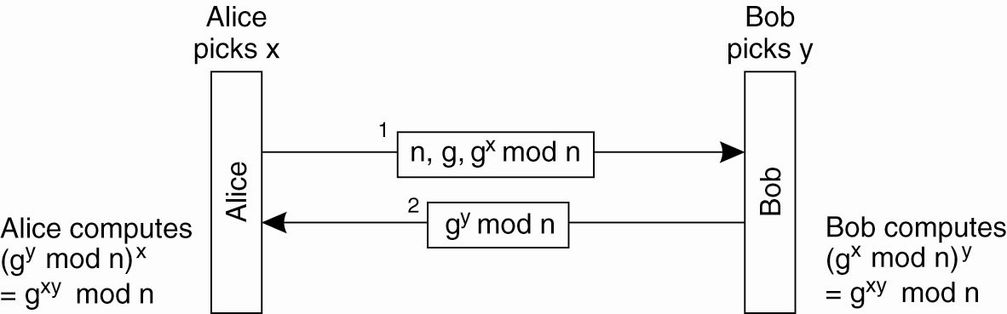

Alice starts by sending gx mod n to Bob, along with n and g. It is important to note that this information can be sent as plaintext, as it is virtually impossible to compute x given gx mod n. When Bob receives the message, he subsequently calculates (gx mod n)y which is mathematically equal to gxy mod n. In addition, he sends gy mod n to Alice, who can then compute (gy mod n)x = gxy mod n. Consequently, both Alice and Bob, and only those two, will now have the shared secret key gxy mod n. Note that neither of them needed to make their private number (x and y, respectively), known to the other.
[Page 430]

Diffie-Hellman can be viewed as a public-key cryptosystem. In the case of Alice, x is her private key, whereas gx mod n is her public key. As we discuss next, securely distributing the public key is essential to making Diffie-Hellman work in practice.

Key Distribution

One of the more difficult parts in key management is the actual distribution of initial keys. In a symmetric cryptosystem, the initial shared secret key must be communicated along a secure channel that provides authentication as well as confidentiality, as shown in Fig. 9-34(a). If there are no keys available to Alice and Bob to set up such a secure channel, it is necessary to distribute the key out-ofband. In other words, Alice and Bob will have to get in touch with each other using some other communication means than the network. For example, one of them may phone the other, or send the key on a floppy disk using snail mail.

Figure 9-34. (a) Secret-key distribution. (b) Public-key distribution [see also Menezes et al. (1996)].
(This item is displayed on page 431 in the print version)
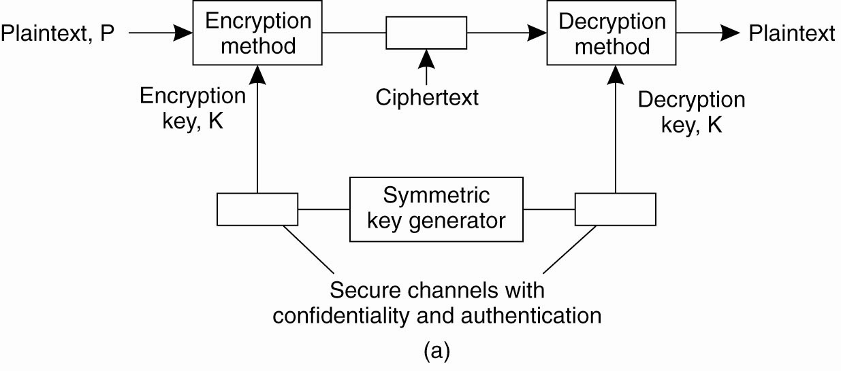

In the case of a public-key cryptosystem, we need to distribute the public key in such a way that the receivers can be sure that the key is indeed paired to a claimed private key. In other words, as shown in Fig. 9-34(b), although the public key itself may be sent as plaintext, it is necessary that the channel through which it is sent can provide authentication. The private key, of course, needs to be sent across a secure channel providing authentication as well as confidentiality.

When it comes to key distribution, the authenticated distribution of public keys is perhaps the most interesting. In practice, public-key distribution takes place by means of public-key certificates. Such a certificate consists of a public key together with a string identifying the entity to which that key is associated. The entity could be a user, but also a host or some special device. The public key and identifier have together been signed by a certification authority, and this signature has been placed on the certificate as well. (The identity of the certification authority is naturally part of the certificate.) Signing takes place by means of a private key that belongs to the certification authority. The corresponding public key is assumed to be well known. For example, the public keys of various certification authorities are built into most Web browsers and shipped with the binaries.

Using a public-key certificate works as follows. Assume that a client wishes to ascertain that the public key found in the certificate indeed belongs to the identified entity. It then uses the public key of the associated certification authority to verify the certificate's signature. If the signature on the certificate matches the (public key, identifier)-pair, the client accepts that the public key indeed belongs to the identified entity.
[Page 431]

It is important to note that by accepting the certificate as being in order, the client actually trusts that the certificate has not been forged. In particular, the client must assume that the public key indeed belongs to the associated certification authority. If in doubt, it should be possible to verify the validity of through another certificate coming from a different, possibly more trusted certification authority.

Such hierarchical trust models in which the highest-level certification authority must be trusted by everyone, are not uncommon. For example, Privacy Enhanced Mail (PEM) uses a three-level trust model in which lowest-level certification authorities can be authenticated by Policy Certification Authorities (PCA), which in turn can be authenticated by the Internet Policy Registration Authority (IPRA). If a user does not trust the IPRA, or does not think he can safely talk to the IPRA, there is no hope he will ever trust e-mail messages to be sent in a secure way when using PEM. More information on this model can be found in Kent (1993). Other trust models are discussed in Menezes et al. (1996).
[Page 432]

Lifetime of Certificates

An important issue concerning certificates is their longevity. First let us consider the situation in which a certification authority hands out lifelong certificates. Essentially, what the certificate then states is that the public key will always be valid for the entity identified by the certificate. Clearly, such a statement is not what we want. If the private key of the identified entity is ever compromised, no unsuspecting client should ever be able to use the public key (let alone malicious clients). In that case, we need a mechanism to revoke the certificate by making it publicly-known that the certificate is no longer valid.

There are several ways to revoke a certificate. One common approach is with a Certificate Revocation List (CRL) published regularly by the certification authority. Whenever a client checks a certificate, it will have to check the CRL to see whether the certificate has been revoked or not. This means that the client will at least have to contact the certification authority each time a new CRL is published. Note that if a CRL is published daily, it also takes a day to revoke a certificate. Meanwhile, a compromised certificate can be falsely used until it is published on the next CRL. Consequently, the time between publishing CRLs cannot be too long. In addition, getting a CRL incurs some overhead.

An alternative approach is to restrict the lifetime of each certificate. In essence, this approach is analogous to handing out leases as we discussed in Chap. 6. The validity of a certificate automatically expires after some time. If for whatever reason the certificate should be revoked before it expires, the certification authority can still publish it on a CRL. However, this approach will still force clients to check the latest CRL whenever verifying a certificate. In other words, they will need to contact the certification authority or a trusted database containing the latest CRL.

A final extreme case is to reduce the lifetime of a certificate to nearly zero. In effect, this means that certificates are no longer used; instead, a client will always have to contact the certification authority to check the validity of a public key. As a consequence, the certification authority must be continuously online.

In practice, certificates are handed out with restricted lifetimes. In the case of Internet applications, the expiration time is often as much as a year (Stein, 1998). Such an approach requires that CRLs are published regularly, but that they are also inspected when certificates are checked. Practice indicates that client applications hardly ever consult CRLs and simply assume a certificate to be valid until it expires. In this respect, when it comes to Internet security in practice, there is still much room for improvement, unfortunately.

9.4.2. Secure Group Management

Many security systems make use of special services such as Key Distribution Centers (KDCs) or Certification Authorities (CAs). These services demonstrate a difficult problem in distributed systems. In the first place, they must be trusted. To enhance the trust in security services, it is necessary to provide a high degree of protection against all kinds of security threats. For example, as soon as a CA has been compromised, it becomes impossible to verify the validity of a public key, making the entire security system completely worthless.

On the other hand, it is also necessary that many security services offer high availability. For example, in the case of a KDC, each time two processes want to set up a secure channel, at least one of them will need to contact the KDC for a shared secret key. If the KDC is not available, secure communication cannot be established unless an alternative technique for key establishment is available, such as the Diffie-Hellman key exchange.

The solution to high availability is replication. On the other hand, replication makes a server more vulnerable to security attacks. We already discussed how secure group communication can take place by sharing a secret among the group members. In effect, no single group member is capable of compromising certificates, making the group itself highly secure. What remains to consider is how to actually manage a group of replicated servers. Reiter et al. (1994) propose the following solution.

The problem that needs to be solved is to ensure that when a process asks to join a group G, the integrity of the group is not compromised. A group G is assumed to use a secret key CKG shared by all group members for encrypting group messages. In addition, it also uses a public/private key pair for communication with nongroup members.

Whenever a process P wants to join a group G, it sends a join request JR identifying G and P, P's local time T, a generated reply pad RP and a generated secret key KP,G. RP and KP,G are jointly encrypted using the group's public key , as shown as message 1 in Fig. 9-35. The use of RP and KP,G is explained in more detail below. The join request JR is signed by P, and is sent along with a certificate containing P's public key. We have used the widely-applied notation [M ]A to denote that message M has been signed by subject A.

Figure 9-35. Securely admitting a new group member.
(This item is displayed on page 434 in the print version)
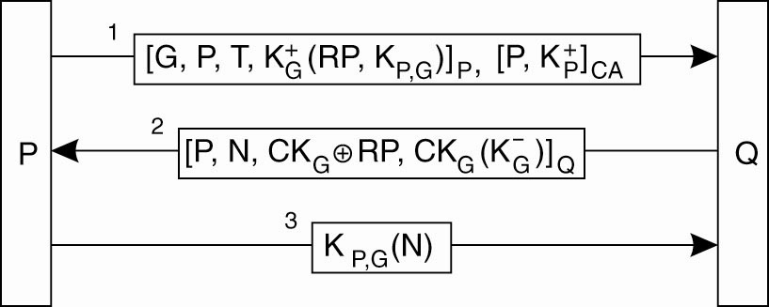

When a group member Q receives such a join request, it first authenticates P, after which communication with the other group members takes place to see whether P can be admitted as a group member. Authentication of P takes place in the usual way by means of the certificate. The timestamp T is used to make sure that the certificate was still valid at the time it was sent. (Note that we need to be sure that the time has not been tampered with as well.) Group member Q verifies the signature of the certification authority and subsequently extracts P's public key from the certificate to check the validity of JR. At that point, a group-specific protocol is followed to see whether all group members agree on admitting P.
[Page 434]

If P is allowed to join the group, Q returns a group admittance message GA, shown as message 2 in Fig. 9-35, identifying P and containing a nonce N. The reply pad RP is used to encrypt the group's communication key CKG. In addition, P will also need the group's private key , which is encrypted with CKG. Message GA is subsequently signed by Q using key KP,G.

Process P can now authenticate Q, because only a true group member can have discovered the secret key KP,G. The nonce N in this protocol is not used for security; instead, when P sends back N encrypted with KP,G (message 3), Q then knows that P has received all the necessary keys, and has therefore now indeed joined the group.

Note that instead of using the reply pad RP, P and Q could also have encryptted CKG using P's public key. However, because RP is used only once, namely for the encryption of the group's communication key in message GA, using RP is safer. If P's private key were ever to revealed, it would become possible to also reveal CKG, which would compromise the secrecy of all group communication.

9.4.3. Authorization Management

Managing security in distributed systems is also concerned with managing access rights. So far, we have hardly touched upon the issue of how access rights are initially granted to users or groups of users, and how they are subsequently maintained in an unforgeable way. It is time to correct this omission.

In nondistributed systems, managing access rights is relatively easy. When a new user is added to the system, that user is given initial rights, for example, to create files and subdirectories in a specific directory, create processes, use CPU time, and so on. In other words, a complete account for a user is set up for one specific machine in which all rights have been specified in advance by the system administrators.

In a distributed system, matters are complicated by the fact that resources are spread across several machines. If the approach for nondistributed systems were to be followed, it would be necessary to create an account for each user on each machine. In essence, this is the approach followed in network operating systems. Matters can be simplified a bit by creating a single account on a central server. That server is consulted each time a user accesses certain resources or machines.
[Page 435]

Capabilities and Attribute Certificates

A much better approach that has been widely applied in distributed systems is the use of capabilities. As we explained briefly above, a capability is an unforgeable data structure for a specific resource, specifying exactly the access rights that the holder of the capability has with respect to that resource. Different implementations of capabilities exist. Here, we briefly discuss the implementation as used in the Amoeba operating system (Tanenbaum et al., 1986).

Amoeba was one of the first object-based distributed systems. Its model of distributed objects is that of remote objects. In other words, an object resides at a server while clients are offered transparent access to that object by means of a proxy. To invoke an operation on an object, a client passes a capability to its local operating system, which then locates the server where the object resides and subsequently does an RPC to that server.

A capability is a 128-bit identifier, internally organized as shown in Fig. 9-36. The first 48 bits are initialized by the object's server when the object is created and effectively form a machine-independent identifier of the object's server, referred to as the server port. Amoeba uses broadcasting to locate the machine where the server is currently located.

Figure 9-36. A capability in Amoeba.
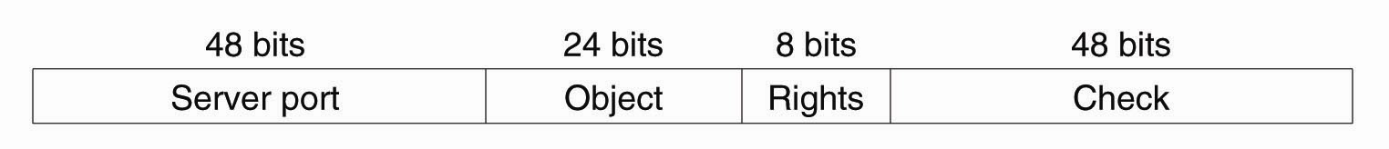

The next 24 bits are used to identify the object at the given server. Note that the server port together with the object identifier form a 72-bit systemwide unique identifier for every object in Amoeba. The next 8 bits are used to specify the access rights of the holder of the capability. Finally, the 48-bits check field is used to make a capability unforgeable, as we explain in the following pages.

When an object is created, its server picks a random check field and stores it both in the capability as well as internally in its own tables. All the right bits in a new capability are initially on, and it is this owner capability that is returned to the client. When the capability is sent back to the server in a request to perform an operation, the check field is verified.

To create a restricted capability, a client can pass a capability back to the server, along with a bit mask for the new rights. The server takes the original check field from its tables, XORs it with the new rights (which must be a subset of the rights in the capability), and then runs the result through a one-way function.
[Page 436]

The server then creates a new capability, with the same value in the object field, but with the new rights bits in the rights field and the output of the one-way function in the check field. The new capability is then returned to the caller. The client may send this new capability to another process, if it wishes.

The method of generating restricted capabilities is illustrated in Fig. 9-37. In this example, the owner has turned off all the rights except one. For example, the restricted capability might allow the object to be read, but nothing else. The meaning of the rights field is different for each object type since the legal operations themselves also vary from object type to object type.

Figure 9-37. Generation of a restricted capability from an owner capability.
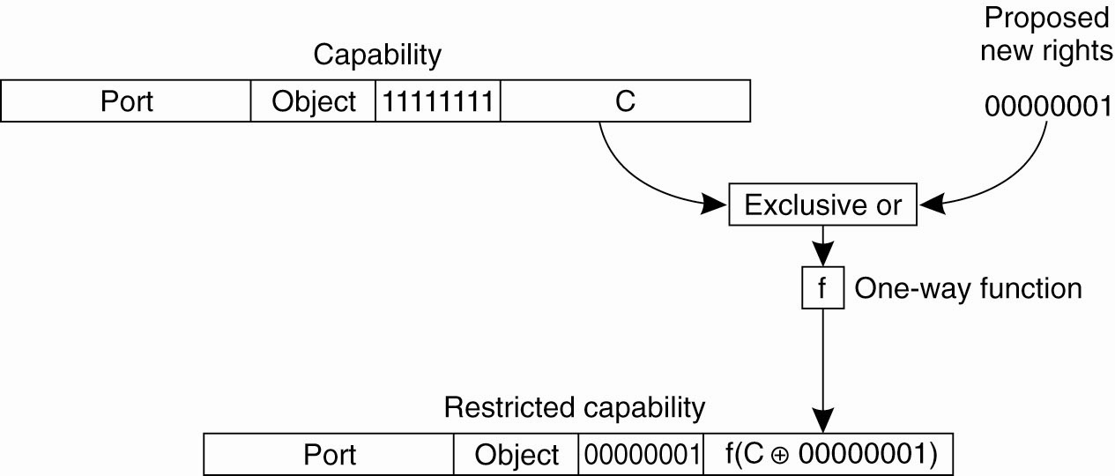

When the restricted capability comes back to the server, the server sees from the rights field that it is not an owner capability because at least one bit is turned off. The server then fetches the original random number from its tables, XORs it with the rights field from the capability, and runs the result through the one-way function. If the result agrees with the check field, the capability is accepted as valid.

It should be obvious from this algorithm that a user who tries to add rights that he does not have will simply invalidate the capability. Inverting the check field in a restricted capability to get the argument (C XOR 00000001 in Fig. 9-37) is impossible because the function f is a one-way function. It is through this cryptographic technique that capabilities are protected from tampering. Note that f essentially does the same as computing a message digest as discussed earlier. Changing anything in the original message (like inverting a bit), will immediately be detected.

A generalization of capabilities that is sometimes used in modern distributed systems is the attribute certificate. Unlike the certificates discussed above that are used to verify the validity of a public key, attribute certificates are used to list certain (attribute, value)-pairs that apply to an identified entity. In particular, attribute certificates can be used to list the access rights that the holder of a certificate has with respect to the identified resource.
[Page 437]

Like other certificates, attribute certificates are handed out by special certification authorities, usually called attribute certification authorities. Compared to Amoeba's capabilities, such an authority corresponds to an object's server. In general, however, the attribute certification authority and the server managing the entity for which a certificate has been created need not be the same. The access rights listed in a certificate are signed by the attribute certification authority.

Delegation

Now consider the following problem. A user wants to have a large file printed for which he has read-only access rights. In order not to bother others too much, the user sends a request to the print server, asking it to start printing the file no earlier than 2 o'clock in the morning. Instead of sending the entire file to the printer, the user passes the file name to the printer so that it can copy it to its spooling directory, if necessary, when actually needed.

Although this scheme seems to be perfectly in order, there is one major problem: the printer will generally not have the appropriate access permissions to the named file. In other words, if no special measures are taken, as soon as the print server wants to read the file in order to print it, the system will deny the server access to the file. This problem could have been solved if the user had temporarily delegated his access rights for the file to the print server.

Delegation of access rights is an important technique for implementing protection in computer systems and distributed systems, in particular. The basic idea is simple: by passing certain access rights from one process to another, it becomes easier to distribute work between several processes without adversely affecting the protection of resources. In the case of distributed systems, processes may run on different machines and even within different administrative domains as we discussed for Globus. Delegation can avoid much overhead as protection can often be handled locally.

There are several ways to implement delegation. A general approach as described in Neuman (1993), is to make use of a proxy. A proxy in the context of security in computer systems is a token that allows its owner to operate with the same or restricted rights and privileges as the subject that granted the token. (Note that this notion of a proxy is different from a proxy as a synonym for a client-side stub. Although we try to avoid overloading terms, we make an exception here as the term "proxy" in the definition above is too widely used to ignore.) A process can create a proxy with at best the same rights and privileges it has itself. If a process creates a new proxy based on one it currently has, the derived proxy will have at least the same restrictions as the original one, and possibly more.

Before considering a general scheme for delegation, consider the following two approaches. First, delegation is relatively simple if Alice knows everyone. If she wants to delegate rights to Bob, she merely needs to construct a certificate saying "Alice says Bob has rights R," such as [A,B,R ]A. If Bob wants to pass some of these rights to Charlie, he will ask Charlie to contact Alice and ask her for an appropriate certificate.
[Page 438]

In a second simple case Alice can simply construct a certificate saying "The bearer of this certificate has rights R." However, in this case we need to protect the certificate against illegal copying, as is done with securely passing capabilities between processes. Neuman's scheme handles this case, as well as avoiding the issue that Alice needs to know everyone to whom rights need to be delegated.

A proxy in Neuman's scheme has two parts, as illustrated in Fig. 9-38. Let A be the process that created the proxy. The first part of the proxy is a set , consisting of a set R of access rights that have been delegated by A, along with a publicly-known part of a secret that is used to authenticate the holder of the certificate. We will explain the use of below. The certificate carries the signature sig (A,C) of A, to protect it against modifications. The second part contains the other part of the secret, denoted as . It is essential that is protected against disclosure when delegating rights to another process.

Figure 9-38. The general structure of a proxy as used for delegation.
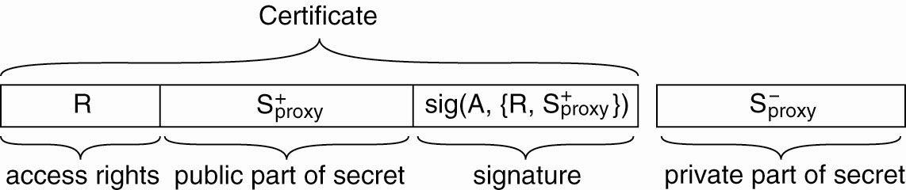

Another way of looking at the proxy is as follows. If Alice wants to delegate some of her rights to Bob, she makes a list of rights (R) that Bob can exercise. By signing the list, she prevents Bob from tampering with it. However, having only a signed list of rights is often not enough. If Bob wants to exercise his rights, he may have to prove that he actually got the list from Alice and did not, for example, steal it from someone else. Therefore, Alice comes up with a very nasty question that only she knows the answer to. Anyone can easily verify the correctness of the answer when given the question. The question is appended to the list before Alice adds her signature.

When delegating some of her rights, Alice gives the signed list of rights, along with the nasty question, to Bob. She also gives Bob the answer ensuring that no one can intercept it. Bob now has a list of rights, signed by Alice, which he can hand over to, say, Charlie, when necessary. Charlie will ask him the nasty question at the bottom of the list. If Bob knows the answer to it, Charlie will know for sure that Alice had indeed delegated the listed rights to Bob.

An important property of this scheme is that Alice need not be consulted. In fact, Bob may decide to pass on (some of) the rights on the list to Dave. In doing so, he will also tell Dave the answer to the question, so that Dave can prove the list was handed over to him by someone entitled to it. Alice never needs to know about Dave at all.
[Page 439]

A protocol for delegating and exercising rights is shown in Fig. 9-39. Assume that Alice and Bob share a secret key KA,B that can be used for encrypting messages they send to each other. Then, Alice first sends Bob the certificate C = {R,}, signed with sig (A,C) (and denoted again as [R,]A). There is no need to encrypt this message: it can be sent as plaintext. Only the private part of the secret needs to be encrypted, shown as KA,B() in message 1.

Figure 9-39. Using a proxy to delegate and prove ownership of access rights.
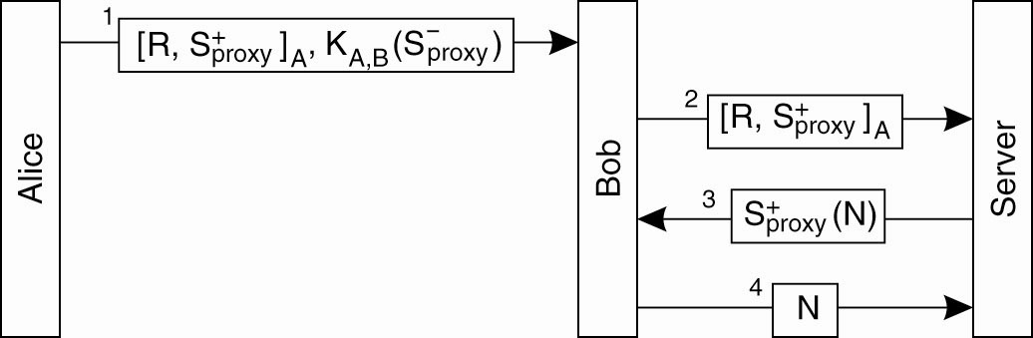

Now suppose that Bob wants an operation to be carried out at an object that resides at a specific server. Also, assume that Alice is authorized to have that operation carried out, and that she has delegated those rights to Bob. Therefore, Bob hands over his credentials to the server in the form of the signed certificate [R,]A.

At that point, the server will be able to verify that C has not been tampered with: any modification to the list of rights, or the nasty question will be noticed, because both have been jointly signed by Alice. However, the server does not know yet whether Bob is the rightful owner of the certificate. To verify this, the server must use the secret that came with C.

There are several ways to implement and . For example, assume is a public key and the corresponding private key. Z can then challenge Bob by sending him a nonce N, encrypted with . By decrypting (N) and returning N, Bob proves he knows the secret and is thus the rightful holder of the certificate. There are other ways to implement secure delegation as well, but the basic idea is always the same: show you know a secret.

