Question 1 - 15 points

1a (5 points) Suppose that a decision tree is trained on 1000 training examples, and achieves 90% accuracy on the training examples. What is the smallest and largest accuracy that this decision tree can possibly achieve on a test set of 1000 examples? Justify your answer. You can assume there are only two classes.

The accuracy on the training set provides no guarantee whatsoever about accuracy on the test set, so the accuracy on the test set could be anywhere from 0% to 100%.

1b (5 points). Suppose that a decision tree is trained on 1000 training examples, and achieves 80% accuracy on the training examples. What is the smallest and largest possible value for the entropy at a leaf node of this decision tree? Remember that entropy is measured on the training set. You can assume there are only two classes.

Since some training examples are classified correctly, it is possible that some leaf node of the decision tree only receives training examples from a single class, in which case the entropy of that leaf node would be 0.

Since some training examples are classified incorrectly, it is possible that some leaf node of the decision tree receives equal numbers of training examples from both classes, in which case the entropy of that leaf node would be 1.

So, the entropy at a leaf node can be as small as 0 and as large as 1.

1c (5 points). Suppose that a decision tree is trained on 1000 training examples, and achieves 100% accuracy on the training examples. What is the smallest and largest possible value for the entropy at a leaf node of this decision tree? Again, remember that entropy is measured on the training set. You can assume there are only two classes.

Since no training examples are classified incorrectly, it is impossible that some leaf node of the decision tree receives training examples from both classes. Each leaf node receives training examples from a single class, and has entropy 0.

So, the entropy at a leaf node can be as small as 0 and as large as 0.
Question 2 - 5 points

We want to build a decision tree that determines whether a new laptop is going to break down or not during its first week. This decision tree is trained on 200 training examples (i.e., 200 cases of new laptops). The only thing that we know about each training example is the operating system that the laptop was running. In particular:

100 laptops in the training set crashed within their first week.
70 of those laptops were running operating system AA.
20 of those laptops were running operating system BB.
10 of those laptops were running operating system CC.

100 laptops in the training set did not crash within their first week.
10 of those laptops were running operating system AA.
20 of those laptops were running operating system BB.
70 of those laptops were running operating system CC.

Determine the entropy gain of choosing, at the root node, the predicate
(Operating System = CC) as the test to apply at that node. You do not have to carry out numerical calculations, but you have to write an expression that fully specifies the answer numerically.

Let C1 be the child receiving examples where the operating system = CC.
Let C2 be the child receiving examples where the operating system != CC.

Entropy Gain = Entropy(parent) – 80/200 * Entropy(C1) – 120/200 * Entropy(C2)

Entropy(parent) = -0.5 * log2 (0.5) – 0.5 * log2 (0.5) = 1.

Entropy(C1) = -10/80 * log2 (10/80) – 70/80 * log2 (70/80) = 0.5436

Entropy(C2) = -90/120 * log2 (90/120) - 30/120 * log2 (30/120) = 0.8113

Entropy(parent) – 80/200 * Entropy(C1) – 120/200 * Entropy(C2)
= 1 – 80/200 * 0.5436 – 120/200 * 0.8113 = 0.2958.

Consequently, the entropy gain is 0.2958.
Question 3 - 10 points

3a (5 points). Design a perceptron that takes (in addition to the bias input) three inputs x, y, z, and outputs: 1 if x-2y-5 >= z, and 0 otherwise. Fully specify bias input and all weights. Your activation function g should return 1 if the weighted sum of inputs (including the bias input) is greater than or equal to 0, and g should return 0 otherwise.

x-2y-5 >= z => x-2y-z-5 >= 0.

Bias input has weight 5.
x has weight 1
y has weight -2
z has weight -1

3b (5 points). Design a neural network that takes X and Y as inputs, outputs 0 if X/Y > 5, and outputs 1 if X/Y <= 5. Fully specify bias input and all weights. Your activation function g should return 1 if the weighted sum of inputs (including the bias input) is greater than or equal to 0, and g should return 0 otherwise. Just for this question, you SHOULD ASSUME THAT X AND Y ARE GREATER THAN 0.

Since Y > 0, then X/Y <= 5 => X <= 5Y => X – 5Y <= 0 => 5Y - X >= 0. This can be recognized with a neuron P1 with weights:
0 for the bias input
-1 for X
5 for Y.

Question 4 - 10 points

Design a neural network that takes X and Y as inputs, and outputs 1 if X - 3 = 2Y, and 0 otherwise. Fully specify bias input and all weights. Your activation function g should return 1 if the weighted sum of inputs (including the bias input) is greater than or equal to 0, and g should return 0 otherwise. If you are using a perceptron whose weights are fully specified in the textbook, just give the name of the perceptron, you do not have to specify those weights.

X – 3 = 2Y <=> (X – 3 >= 2Y) AND (X – 3 <= 2Y)

X – 3 >= 2Y => X – 2Y – 3 >= 0. We can recognize this case with a neuron N1 with the following weights:
3 for the bias input
1 for X
-2 for Y.

X – 3 <= 2Y => X – 2Y – 3 <= 0 => -X + 2Y + 3 >= 0. We can recognize this case with a neuron N1 with the following weights:
-3 for the bias input
-1 for X
2 for Y.

Using the neurons N1 and N2 defined above, and the AND neuron defined in the textbook, the final neural network is this:

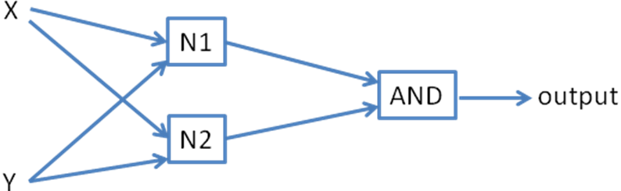
Question 5 - 10 points

Calculate the distance between these patterns using L1 and L2 norm.

Attribute 1 | Attribute 2 | Attribute 3
25 | 33 | 16
22 | 39 | 42

L1 Norm:

| 25 – 22 | + | 33 – 39 | + | 16 – 42 | = 3 + 6 + 26 = 35

L2 Norm:

√ [(25-22)² + (33-39)² + (16-42)²] = √ [721] = 26.8514

