Question 1

40 points.

Your job is to color the various sections such that no two sections sharing a border have the same color. You can use the colors (Red, Green, Blue).
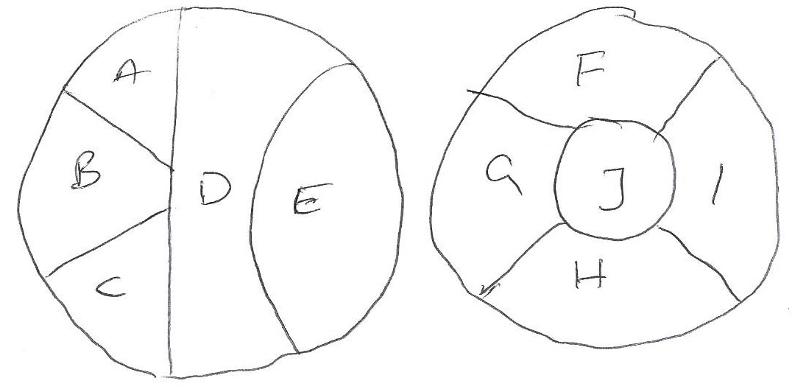
1a. Draw the Constraint Graph for this problem. Use it to separate the problem into subproblems
1b. Assuming you are using Backtracking search to solve this problem and that you are using both MRV and Degree heuristic to select the variable, Which variable will be selected at each level of the search tree of each subproblems.

1c. For each of the subproblems, show how forward chaining is used to select values.

1d. Assuming you have already assigned A = Red, D = Blue check the arc consistency.

Question 2 - 30 points

2a. Consider the following knowledge base:

A AND B
C OR D
(A => (C OR D)) AND (NOT (A => C))

How many rows are there in the truth table for this knowledge base? How did you determine this number?

2b. Which sentences, if any, do you obtain by applying the resolution inference rule to the following pair of sentences? Do not do any simplifications to either the input or the output sentences, just blindly apply the resolution rule.

A OR (NOT B) OR C OR (NOT D)
(NOT B) OR (NOT C) OR D OR H

2c. Which sentences, if any, do you obtain by applying the resolution inference rule to the following pair of sentences? Do not do any simplifications to either the input or the output sentences, just blindly apply the resolution rule.

A OR (NOT B) OR C OR (NOT D)
(NOT B) OR C OR (NOT G) OR H

2d. Put the following knowledge base in conjunctive normal form:

A => (B OR NOT C)
C OR (A AND (NOT B))

2e. (hard) John and Mary sign the following binding contract in front of their parents:
1. On Sunday, John will mow the lawn or buy groceries.
2. On Sunday, Mary will mow the lawn or wash the car.

This is an all-inclusive list of what actually happens on Sunday:
1. Mary mows the lawn on Sunday.
2. Mary washes the car on Sunday.
3. Mary buys groceries on Sunday.

How can the above statements be represented using propositional logic? First, define literals and specify what English phrase each literal corresponds to. Second, represent the knowledge base (i.e., what happens on Sunday) using those literals. Third, represent the contract as a single logical statement, using those literals. Four, determine (in any way you like) whether, according to the rules of propositional logic, the contract was violated or not.
2f. (harder) Suppose that a knowledge base contains only symbols A, B, and C. When does such a knowledge base entail the statement D (i.e., the statement consisting of a single symbol that does not appear in the knowledge base)? Always, sometimes, or never? If sometimes, then identify precisely the conditions that determine whether this knowledge base entails the statement D.

Question 3 – 15 points

3a. (7 points) Put the following propositional-logic knowledge base in conjunctive normal form:

((NOT A) AND B) => (C OR A)
A AND B AND (C OR D)

3b. (8 points) Suppose that some knowledge base contains various propositional-logic sentences that utilize symbols A, B, C, D, E (connected with various connectives). There are only two cases when the knowledge base is false:
- First case: when A is true, B is true, C is false, D is false, E is false.
- Second case: when A is true, B is false, C is false, D is false, E is true.
In all other cases, the knowledge base is true. Write a conjunctive normal form for the knowledge base. (Hint: there is a much simpler and quicker way to get the right answer, compared to considering all 32 entries in the truth table).

Question 4 - 15 points

Determine if the following pairs of sentences are logically equivalent, meaning that one is true if and only iff the other is true. You do not have to justify your answer.

4a.
A or B or not(B) or C
A or B or (C <=> C)

4b
(A and B) => (E and G)
not(A) or not(B) or (E and G)

