Question 1

20 points.

For of the following pairs of sentences, determine if they are logically equivalent (i.e., if each sentence of the pair implies the other sentence in the pair). Do not assume anything except the laws of propositional and first order logic.

1a. for-every x, exists y: color(x) = y
not (exists x, for-every y: not (color(x) = y) )

logically equivalent

1b. for-every x, exists y: f(x, y)
exists y, for-every x,: f(x, y)

not logically equivalent

1c. for-every x, exists y: color(x) = y
Not (for-every x, exists y: not (color(x) = y) )

not logically equivalent

1d. for-every x, exists y: son(x) = y
for-every x, exists y: father(y) = x

not logically equivalent
Question 2

20 points.

Determine what is the most general unifier for each of the following pairs of expressions. The following conventions hold:
F and G are relations.
x, y, z are variables.
John and Mary are grounded symbols.

2a. F(x, y), F(y, x)

{x/y}

2b. F(x, y), F(John, z)

{x/John, y/z}

2c. F(x, y, z), F(z, G(Mary), John)

{x/Z, y/G(Mary), z/John}

2d. F(x, g(y)), G(John, Mary)

No unification is possible here.

Question 3 - 30 points

3a. (5 points) Consider the following knowledge base:

A AND B
C OR D
(A => (C OR D)) AND (NOT (A => C))

How many rows are there in the truth table for this knowledge base? How did you determine this number?

There are four symbols, A, B, C, D, so there are 2^4=16 rows in the truth table.

3b. (5 points) Which sentences, if any, do you obtain by applying the resolution inference rule to the following pair of sentences? Do not do any simplifications to either the input or the output sentences, just blindly apply the resolution rule.

A OR (NOT B) OR C OR (NOT D)
(NOT B) OR (NOT C) OR D OR H

- A OR (NOT B) OR (NOT D) OR (NOT B) OR D OR H
- A OR (NOT B) OR C OR (NOT B) OR (NOT C) OR H

3c. (5 points) Which sentences, if any, do you obtain by applying the resolution inference rule to the following pair of sentences? Do not do any simplifications to either the input or the output sentences, just blindly apply the resolution rule.

A OR (NOT B) OR C OR (NOT D)
(NOT B) OR C OR (NOT G) OR H

The resolution rule is not applicable here.

3d. (5 points) Put the following knowledge base in conjunctive normal form:

A => (B OR NOT C)
C OR (A AND (NOT B))

(NOT A) OR B OR (NOT C)
C OR A
C OR (NOT B)

3e. (5 points) John and Mary sign the following binding contract in front of their parents:
1. On Sunday, John will mow the lawn or buy groceries.
2. On Sunday, Mary will mow the lawn or wash the car.

This is an all-inclusive list of what actually happens on Sunday:
1. Mary mows the lawn on Sunday.
2. Mary washes the car on Sunday.
3. Mary buys groceries on Sunday.

How can the above statements be represented using propositional logic? First, define literals and specify what English phrase each literal corresponds to. Second, represent the knowledge base (i.e., what happens on Sunday) using those literals. Third, represent the contract as a single logical statement, using those literals. Four, determine (in any way you like) whether, according to the rules of propositional logic, the contract was violated or not.

We define the following literals:
JM: John mows the lawn on Sunday
JB: John buys groceries on Sunday
MB: Mary buys groceries on Sunday
MM: Mary mows the lawn on Sunday
MW: Mary washes the car on Sunday

This is what happens on Sunday:
MM and MW and MB and (not JM) and (not JB)

Note: (not JM) and (not JB) are included because the question explicitly says that the given list of what happens on Sunday is all-inclusive (so, whatever is not specified there, did not happen).

The contract is represented as:
(JM or JB) and (MM or MW)

The contract was violated, since (JM or JB) was false.
3f. (5 points, harder) Suppose that a knowledge base contains only symbols A, B, and C. When does such a knowledge base entail the statement D (i.e., the statement consisting of a single symbol that does not appear in the knowledge base)? Always, sometimes, or never? If sometimes, then identify precisely the conditions that determine whether this knowledge base entails the statement D.

There is only one case where this knowledge base entails D: the case where the knowledge base is always false. A knowledge base that is always false entails everything.

Question 4

40 points.

Your job is to color the various sections such that no two sections sharing a border have the same color. You can use the colors (Red, Green, Blue).
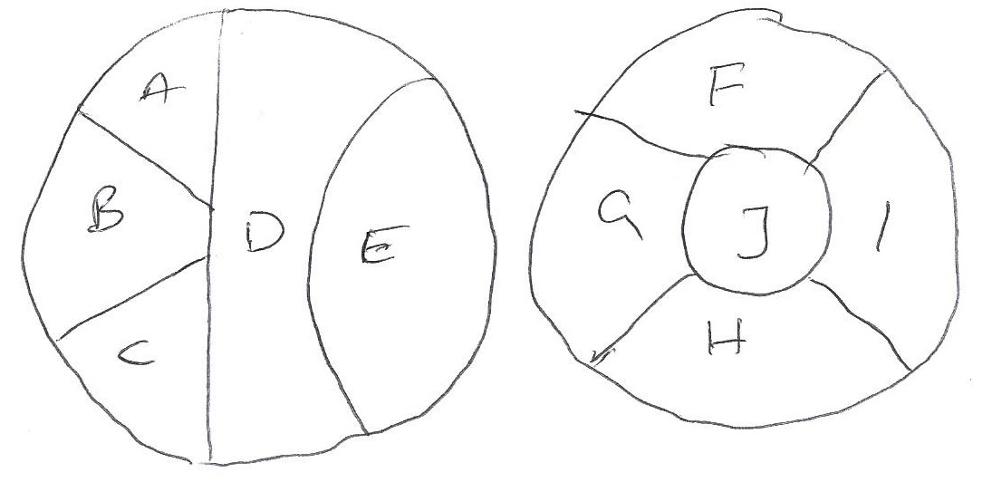
4a. Draw the Constraint Graph for this problem. Use it to separate the problem into subproblems

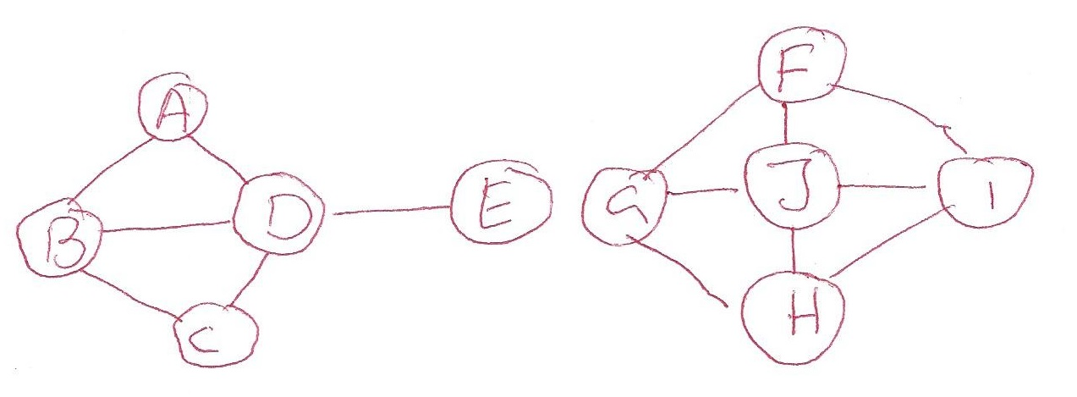

The 2 connected subgraphs shown here correspond to 2 separate sub-problems. Each of these can be solved separately and the solutions concatenated to solve the entire problem.

4b. Assuming you are using Backtracking search to solve this problem and that you are using both MRV and Degree heuristic to select the variable, Which variable will be selected at each level of the search tree of each subproblems.

Subproblem 1:

- Unassigned variables are {A,B,C,D,E}
  - A: RV: 3 Deg: 2, B: RV: 3 Deg: 3, C: RV: 3 Deg: 2, D: RV: 3 Deg: 4, E: RV: 3 Deg: 1
  - Chosen Variable: D.
- Unassigned variables are {A,B,C,E}
  - A: RV: 2 Deg: 1, B: RV: 2 Deg: 2, C: RV: 2 Deg: 1, E: RV: 2 Deg: 0
  - Chosen Variable: B.
- Unassigned variables are {A,C,E}
  - A: RV: 1 Deg: 0, C: RV: 1 Deg: 0, E: RV: 2 Deg: 0
  - Chosen Variable: A or C (Chose A).
- Unassigned variables are {C,E}
  - C: RV: 1 Deg: 0, E: RV: 2 Deg: 0
  - Chosen Variable: C.
- Unassigned variables are {E}
  - E: RV: 2 Deg: 0
  - Chosen Variable: E.

Subproblem 2:

- Unassigned variables are {F,G,H,I,J}
  - F: RV: 3 Deg: 3, G: RV: 3 Deg: 3, H: RV: 3 Deg: 3, I: RV: 3 Deg: 3, J: RV: 3 Deg: 4
  - Chosen Variable: J.
- Unassigned variables are {F,G,H,I}
  - F: RV: 2 Deg: 2, G: RV: 2 Deg: 2, H: RV: 2 Deg: 2, I: RV: 2 Deg: 2
  - Chosen Variable: F or G or H or I (Chose F).
- Unassigned variables are {G,H,I}
  - G: RV: 1 Deg: 1, H: RV: 2 Deg: 2, I: RV: 1 Deg: 1
  - Chosen Variable: G or I (Chose G).
- Unassigned variables are {H,I}
  - H: RV: 1 Deg: 1, I: RV: 1 Deg: 1
  - Chosen Variable: H or I (Chose H).
- Unassigned variables are {I}
  - I: RV: 1 Deg: 0
  - Chosen Variable: I.

4c. For each of the subproblems, show how forward chaining is used to select values.

Subproblem 1:

- A: RGB, B: RGB, C: RGB, D: RGB, E: RGB
- A: GB, B: GB, C: GB, D: R, E: GB
- A: B, B: G, C: B, D: R, E: GB
- A: B, B: G, C: B, D: R, E: G

Subproblem 2:

- F: RGB, G: RGB, H: RGB, I: RGB, J: RGB
- F: GB, G: GB, H: GB, I: GB, J: R
- F: G, G: B, H: GB, I: B, J: R
- F: G, G: B, H: G, I: B, J: R

4d. Assuming you have already assigned A = Red, D = Blue check the arc consistency.

A: R, B: RGB, C: RGB, D: B, E: RGB

A-B
A: R, B: RGB, C: RGB, D: B, E: RGB
A-D
A: R, B: RGB, C: RGB, D: B, E: RGB
B-D
A: R, B: RGB, C: RGB, D: B, E: RGB
B-C
A: R, B: RGB, C: RGB, D: B, E: RGB
C-D
A: R, B: RGB, C: RGB, D: B, E: RGB
D-E
A: R, B: RGB, C: RGB, D: B, E: RGB

Remaining Legal values
A: R, B: RGB, C: RGB, D: B, E: RGB

