Question 1 (Agents) - 15 points

An agent lives in a grid world of size 10 x 10. The goal of the agent is to find a pot of gold. Only one pot of gold exists in the grid. At every step, the agent can move left, right, up, or down. The agent has two sensors:

- a sensor that detects the brightness level at the current square, and

- a sensor that detects if the current square is the square with the pot of gold or not.

The brightness level of a square is related to the location of the pot of gold as follows:

- Squares having a distance of 3 steps or less from the pot of gold have a brightness level of 10.

- All other squares have a brightness level of 0.

1a. (3 points) Is this environment deterministic or not? It is deterministic.

1b. (3 points) Is this environment fully observable or not? It is only partially observable.

1c. (2 points) Is this environment static or not? It is static.

1d. (2 points) Is this environment discrete or not? It is discrete.

1e. (5 points) The agent determines the next move as follows: if there are adjacent positions that the agent has not visited yet, then it chooses randomly to move to one of those positions. Otherwise, it chooses randomly from all possible legal moves. Is this agent a reflex agent or not? Why?

No, it is not a reflex agent, because the next action is not determined by its sensory input, nor by a combination of sensory input plus memory of previous states.
Question 2 (Search) - 25 points

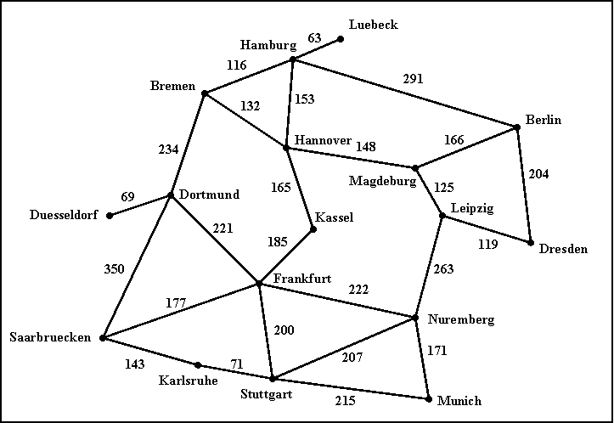

The above (hopefully familiar) map defines a search space, where each city is a state, and each road represents an action that can take the agent from one city to another. The cost of going through a road is simply the length of the road.

2a. (8 points) Given Hamburg as the start node and Munich as the goal node, draw the first three levels of the search tree (the root is the first level).

2b. (8 points) (NOTE: multiple answers may be correct here.) Assuming that the search does not keep track of cities already visited, list (in the order in which they are expanded) the first five nodes (including the start node corresponding to Hamburg) expanded by uniform cost search and iterative deepening search. For each of those first five nodes you just have to give the name of the corresponding city.

Uniform cost search:
Hamburg (cost 0), Luebeck (cost 63), Bremen (cost 116), Hamburg (cost 126), Hannover (cost 153)

Iterative deepening search:
Hamburg
Hamburg Luebeck Bremen Hannover Berlin

2c. (4 points, harder) For our route-finding search problem, precisely define an admissible heuristic function that makes A* behave exactly like uniform cost search (i.e., the sequence of nodes visited by A* is always the same as the sequence of nodes visited by uniform cost search, as long as there are no ties among nodes).

Hint 1: don't look for a smart heuristic here, just identify a function that is a legal admissible heuristic and that does what the question asks.

Hint 2: there is an answer that works for arbitrary search problems, and not just this specific search problem of finding routes in Germany.

Heuristic: h(n) = 0

2d. (5 points, harder) For our route-finding search problem, suppose that the search algorithm is given a pollution rating for each city on the map. Suppose that pollution ratings are related with distances to Munich as follows:

- any city within 300 km of driving distance from Munich has a pollution rating of 10.
- any city with driving distance from Munich between 301 km and 500 km has a pollution rating of 5.
- all other cities have a pollution rating of 0.

Using this information, and assuming that Munich is always the goal node, define a maximal admissible heuristic for A* (i.e., a heuristic that is not dominated by any other admissible heuristic that can be defined using this knowledge).

h(n) = 500 if polution rating of n is 0
h(n) = 300 if polution rating of n is 5
h(n) = 0 if polution rating of n is 10

Question 3 - 20 points

Consider a search tree for which we know the following:
- Each node has 0, 1, or 2 children, never more than 2.
- The depth of the tree is 100.
- There is one and only one goal node in the entire tree, and it is located at level 20.
- The entire tree contains exactly 500 million nodes.
- The tree contains exactly 1000 nodes with depth less than or equal to 20.
- We define the depth of the root to be 1 (not 0).

1a (10 points). For each of breadth-first search (BFS), depth-first search (DFS), and iterative deepening search (IDS), what is the maximum size (MEASURED IN NUMBER OF NODES) that can be reached by the list of nodes to visit, given the information above? In other words, what is the maximum number of nodes that the list can possibly contain at the same time? For question 1a, reasonable upper bounds that are no more than 5 times the correct answer, will get full credit.

BFS: 1000 nodes or 2^20 nodes.

DFS: 200 nodes (b*m)

IDS: 40 nodes (b*d)

3b (4 points). What is the maximum number of nodes that BFS may visit?
1000 nodes

3c (3 points). Is it possible for DFS to visit more than 1000 times more nodes than the maximum possible number for BFS? Justify your answer.
Yes. DFS can visit almost all of the 500 million nodes

3d (3 points). Is it possible for IDS to visit more than 1000 times more nodes than the maximum possible number for BFS? Justify your answer.
Here we assume that if IDS visits a node multiple times, we count each visit separately. Then, the answer is no. If BFS visits a node A, IDS will not visit that node more than 20 times, since the goal is at level 20. So, IDS can at most visit 20 times more nodes than BFS.
Question 4 – 20 points

Consider a search problem for which we have both an A* implementation and a uniform cost search (UCS) implementation. Remember that, in A*, the order in which nodes n are visited is increasing in f(n), where f(n) is an estimate of the cost of a solution going through node n. Remember that f(n) = g(n) + h(n), where g(n) is the actual cost of the path from the root to n (i.e., g(n) is the sum of the costs of all edges traversed to get from the root to n), and h(n) is a (not necessarily accurate) heuristic estimate of the cost of the path from n to the nearest goal node.

In this question, the heuristic function h(n) that we use for A* is:

h(n) = 10.

In other words, according to this heuristic, the estimated cost of the path from EVERY node n to the goal is 10. We also know that every search tree in which we apply these implementations will have one and only one goal node.

4a (10 points). Is the heuristic function h(n) = 10 admissible? Justify your answer.

No. For the goal node g, the true cost of getting from g to the goal is 0, but h(n) = 10 > 0.

4b (5 points). Will A*, using this heuristic function h(n) = 10, always find the smallest-cost solution? Justify your answer. THROUGHT THIS EXAM YOU CAN ASSUME THAT ALL EDGES OF THE SEARCH TREE HAVE NON-ZERO POSITIVE COSTS.

Yes, because A* will visit the exact same nodes and in the exact same order as UCS. UCS visits nodes in an order determined by f(n) = true cost from root to n. A* with h(n) = 10 will visit nodes in an order determined by g(n) = f(n) + 10, so the order will not change compared to the order imposed by f(n).

4c (5 points). Is it possible that A*, using this heuristic function h(n) = 10, will ever visit more nodes than uniform cost search (UCS)? Is it possible that A*, using this heuristic function h(n), will ever visit fewer nodes than UCS? Justify your answer. A node n is considered to be visited at the point where the program checks if n is the goal node (if n is the goal node, the search finishes).

No, A* will always visit the exact same number of nodes as UCS for the same reason as in question 2b.

Question 5 – 20 points

We want to find optimal paths in a maze, which is a grid of size 100x100. At each step we can move to an immediately adjacent square that is up, down, left, or right from the current square. However, some squares are blocked, and it is not possible to be at or move to those squares. We want to find an optimal path (i.e., a path with the smallest possible number of moves) that leads to square (92,28), where there is a pot of gold. In addition to the above, we also know the following:

- the starting position,
- the location of the goal square (which is (92,28)).
- the location of all blocked squares.
- that there exists at least one path to the goal.

However, because of limited memory, the search algorithm cannot keep track of all positions already visited during search.

5a. (10 points) Given the above information, define a maximally admissible heuristic to be used in conjunction with A* search.

Since we know the starting position, we can know the current position, by updating our position every time we move. Then, a maximally admissible heuristic is the Manhattan distance.

5b. (10 points) Suppose that A* uses an admissible heuristic h such that h(n) > 0 for at least one node n in the search tree. Are there scenarios where A* will visit fewer nodes than uniform cost search (UCS)? Are there scenarios where A* will visit more nodes than UCS? Justify your answer.

A* will never visit more nodes, because h(n) is admissible and dominates the zero heuristic which is used by UCS. Since h(n) dominates the zero heuristic, there are cases where A* will visit fewer nodes. An example is given in the textbook for the 8-puzzle, where using A* a very small number of nodes is visited.

