Question 1 (Games) - 30 points

a. (10 points) Trace minimax (i.e., draw the search tree and show the utility value for each terminal and non-terminal node), starting at the following board state, and assuming that X makes the next move. Utility values are +1 if X wins, 0 for a tie, and -1 if O wins.

Starting board state:
X | X | o
X | o | o

b. (10 points) In the search tree below, indicate what nodes will be pruned using alpha-beta search, and what the estimated utility values are for the rest of the nodes. Assume that, when given a choice, alpha-beta search expands nodes in a left-to-right order. Assume that the max player plays first.

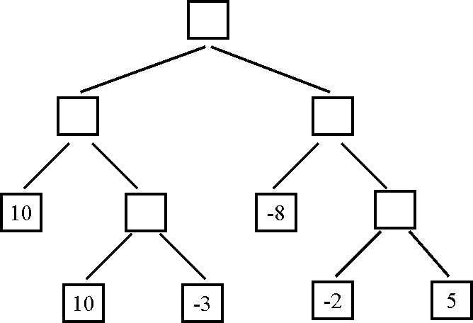
>=10
10
10
<= -8

c. (10 points, harder) The search tree below is the same as the one shown for question 3b. For this question (question 3c only) we are given some additional knowledge about the game: the maximum utility value is 10, i.e., it is not mathematically possible for the MAX player to get an outcome greater than 10. How can this knowledge be used to further improve the efficiency of alpha-beta search? Indicate below the nodes that will be pruned using this improvement.

Question 2

20 points.

For of the following pairs of sentences, determine if they are logically equivalent (i.e., if each sentence of the pair implies the other sentence in the pair). Do not assume anything except the laws of propositional and first order logic.

a. for-every x, exists y: color(x) = y
not (exists x, for-every y: not (color(x) = y) )

logically equivalent

b. for-every x, exists y: f(x, y)
exists y, for-every x,: f(x, y)

not logically equivalent

c. for-every x, exists y: color(x) = y
Not (for-every x, exists y: not (color(x) = y) )

not logically equivalent

d. for-every x, exists y: son(x) = y
for-every x, exists y: father(y) = x

not logically equivalent
Question 3

20 points.

Determine what is the most general unifier for each of the following pairs of expressions. The following conventions hold:
F and G are relations.
x, y, z are variables.
John and Mary are grounded symbols.

a. F(x, y), F(y, x)

{x/y}

b. F(x, y), F(John, z)

{x/John, y/z}

c. F(x, y, z), F(z, G(Mary), John)

{x/Z, y/G(Mary), z/John}

d. F(x, g(y)), G(John, Mary)

No unification is possible here.

Question 4 - 30 points

a. (5 points) Consider the following knowledge base:

A AND B
C OR D
(A => (C OR D)) AND (NOT (A => C))

How many rows are there in the truth table for this knowledge base? How did you determine this number?

There are four symbols, A, B, C, D, so there are 2^4=16 rows in the truth table.

b. (5 points) Which sentences, if any, do you obtain by applying the resolution inference rule to the following pair of sentences? Do not do any simplifications to either the input or the output sentences, just blindly apply the resolution rule.

A OR (NOT B) OR C OR (NOT D)
(NOT B) OR (NOT C) OR D OR H

- A OR (NOT B) OR (NOT D) OR (NOT B) OR D OR H
- A OR (NOT B) OR C OR (NOT B) OR (NOT C) OR H

c. (5 points) Which sentences, if any, do you obtain by applying the resolution inference rule to the following pair of sentences? Do not do any simplifications to either the input or the output sentences, just blindly apply the resolution rule.

A OR (NOT B) OR C OR (NOT D)
(NOT B) OR C OR (NOT G) OR H

The resolution rule is not applicable here.

d. (5 points) Put the following knowledge base in conjunctive normal form:

A => (B OR NOT C)
C OR (A AND (NOT B))

(NOT A) OR B OR (NOT C)
C OR A
C OR (NOT B)

e. (5 points) John and Mary sign the following binding contract in front of their parents:
1. On Sunday, John will mow the lawn or buy groceries.
2. On Sunday, Mary will mow the lawn or wash the car.

This is an all-inclusive list of what actually happens on Sunday:
1. Mary mows the lawn on Sunday.
2. Mary washes the car on Sunday.
3. Mary buys groceries on Sunday.

How can the above statements be represented using propositional logic? First, define literals and specify what English phrase each literal corresponds to. Second, represent the knowledge base (i.e., what happens on Sunday) using those literals. Third, represent the contract as a single logical statement, using those literals. Four, determine (in any way you like) whether, according to the rules of propositional logic, the contract was violated or not.

We define the following literals:
JM: John mows the lawn on Sunday
JB: John buys groceries on Sunday
MB: Mary buys groceries on Sunday
MM: Mary mows the lawn on Sunday
MW: Mary washes the car on Sunday

This is what happens on Sunday:
MM and MW and MB and (not JM) and (not JB)

Note: (not JM) and (not JB) are included because the question explicitly says that the given list of what happens on Sunday is all-inclusive (so, whatever is not specified there, did not happen).

The contract is represented as:
(JM or JB) and (MM or MW)

The contract was violated, since (JM or JB) was false.

4f. (5 points, harder) Suppose that a knowledge base contains only symbols A, B, and C. When does such a knowledge base entail the statement D (i.e., the statement consisting of a single symbol that does not appear in the knowledge base)? Always, sometimes, or never? If sometimes, then identify precisely the conditions that determine whether this knowledge base entails the statement D.

There is only one case where this knowledge base entails D: the case where the knowledge base is always false. A knowledge base that is always false entails everything.

