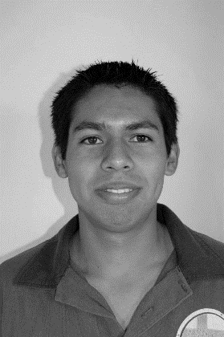

**Óscar David López Bárcenas**

*Técnico Superior Universitario*



**DATE OF BIRTH: May/19/93 TELEPHONE: 447 109 7797 E-mail: oskr.25.lopez@gmail.com**

*1st May Avenue #1245, Valle Dorado Street. Maravatío Mich.*

**WORK EXPERIENCE**

**ACADEMIC TRAINING**

Provide efficient, accurate and quality service, according to my experience and knowledge in the company that is enrolled in my student profile during the period marked in the contract, using the tools, bases and resources provided.

**PERSONAL OBJECTIVE**

Work in accordance with the knowledge acquired in the work area assigned by the company in a satisfactory and successful manner with the resources available to me, during the period stipulated in this quarter.

**PROFESSIONAL OBJECTIVE**

**I created a website for administration of the Tonantzin HGS Educational Center, as part of my service for qualification during the fourth semester of May - August of 2017.**

**In addition to having the experience of 3 projects that I developed during the course of the career, which I presented and developed as a project for a company**

**Technological University of León, Acámbaro Campus**

Engineer in "Information and Communication Technologies" Electronic Commerce Area.

August 2017 - Currently studying. Certificate of Engineer.

Acámbaro-Tarandacuao road kilometer #8.

**2017 - 2018**

**2015 - 2017**

**Technological University of León, Acámbaro Campus**

Superior University Technician in "Information and Communication Technologies" Electronic Commerce Area.

August 2015 - Currently studying. Certificate of University Superior Technician. Acámbaro-Tarandacuao road kilometer 8.

**2008 - 2011**

**QUALIFICATIONS**

*• Attitude of Service*

*• Punctuality*

*Creative*

*• With Aesthetic Sense*

*• Judgment and Criterion*

*• Ingenious*

* *Responsibility*

*• Constancy*

*• Delivery*

*• Honesty*

**CERTIFICATIONS**



* Cellular repair course.
* Basic Course of Videogame Programming with Platform (Stencil).
* Course of Urbanity.
* Social Development Workshop.
* Organic Agriculture Workshop.
* Knowledge of 3D editing and modeling programs.
* Management of software design and editing of Photos, Audio and Video.
* Preparation of Multimedia Guides
* Knowledge of Support and Maintenance of computer equipment.
* Knowledge of installation and basic configuration of local area networks.
* Basic Knowledge of S.O.
* Knowledge of programming languages ​​(HTML5, PHP, Java).
* Extensive knowledge of the office suite.

**2008 - 2011**

**Sto Tomás de Aquino High School.**

*Bachelor of Humanities*

*August 2008 - June 2011.*

*Certificate of Studies.*

*Lomas Verdes Street. Avenue Vista Bella.*

**2005 - 2008**

**Federal High School "March 18". Secondary schooling.**

**.**

*August 2005 to July 2008*

*Secondary School Certificate of Studies.*

*Calzada de las piedras s / n*

**LANGUAGES**

* **Spanish: Native Language**
* **English: Basic**

**ADDITIONAL INFORMATION**

* **Taste for new Knowledge.**
* **Interest in learning new programming languages.**
* **Availability of Mobility**
* **Schedule availability**