**ASSIGNMENT 1 FRONT SHEET**

|  |  |  |  |
| --- | --- | --- | --- |
| **Qualification** | **BTEC Level 5 HND Diploma in Computing** | | |
| **Unit number and title** | Unit 13: Computing Research Project | | |
| **Submission date** |  | **Date Received 1st submission** |  |
| **Re-submission Date** |  | **Date Received 2nd submission** |  |
| **Student Name** |  | **Student ID** |  |
| **Class** |  | **Assessor name** |  |
| **Student declaration**  I certify that the assignment submission is entirely my own work and I fully understand the consequences of plagiarism. I understand that making a false declaration is a form of malpractice. | | | |
|  |  | **Student’s signature** |  |

**Grading grid**

|  |  |  |  |  |  |  |  |  |  |
| --- | --- | --- | --- | --- | --- | --- | --- | --- | --- |
| P1 | P2 | P3 | P4 | P5 | M1 | M2 | M3 | D1 | D2 |
|  |  |  |  |  |  |  |  |  |  |

|  |  |  |
| --- | --- | --- |
| **❒ Summative Feedback: ❒ Resubmission Feedback:** | | |
| **Grade:** | **Assessor Signature:** | **Date:** |
| **Internal Verifier’s Comments:** | | |
| **Signature & Date:** | | |

1. **INTRODUCTION**
2. **CONTENTS**

**P1 Produce a research proposal that clearly defines a research question or hypothesis supported by a literature review**

1. **Research topic**

Environmental Impacts and the Search for Alternative Materials in Big Data Storage Models

1. **Project type**

The topic "Environmental impact and search for alternative materials in large-scale data storage models" can be considered a scientific research project in the field of information technology and environment. It includes:

* Improve understanding of the environmental impact of different storage methods.
* Identifying strengths and weaknesses in the field of big data storage for environmental sustainability.
* Discuss how the field of big data storage has evolved in relation to environmental concerns and advances in sustainable practices.
* Acknowledge areas where further development and research is appropriate, such as exploration of alternative materials and technologies for more sustainable storage solutions.
* Main activities include document research, environmental impact assessment, data collection and analysis, and synthesis of findings to provide further research directions.

Development: In the context of a research project, development refers to the creation and advancement of alternative materials, technologies, and methods that address environmental concerns in data storage big. It includes:

* Design and implement new materials or technologies that reduce the environmental impact of data storage systems.
* Develop process models, algorithms, and design specifications to integrate sustainable operations into big data storage infrastructure.
* Create interim documents such as requirement specifications and design proposals to develop environmentally friendly storage solutions.
* Key activities may include materials research, prototyping, software development, and testing of alternative storage models.
* Evaluation: The evaluation aspect of the project includes evaluating and comparing different approaches to minimizing the environmental impact of big data storage. This includes:
* Compare the environmental performance of different storage models and technologies.
* Analyze the implementation process of sustainable storage solutions across industries.
* Evaluate the user interface and user experience of alternative storage systems from an environmental perspective.
* Consider new and alternative technological methods to reduce the environmental impact of data storage.
* Evaluate developed methods for their effectiveness in addressing environmental issues in big data storage.
* Key activities may include comparative analysis, case studies, user testing, environmental impact assessments, and evaluation of development methods.

1. **Abstracts**

* This project aims to investigate the environmental impact of large-scale data storage models and explore alternative materials that can be used in these models. Taking a preliminary and open approach, the project aims to identify materials that not only overcome the limitations of traditional storage technology but also prioritize environmental sustainability.
* The focus of this project is to examine how current data storage practices contribute to environmental problems and find sustainable solutions to minimize their impact. The project involves conducting research and analysis to assess the environmental impact of existing data storage technologies and identify potential alternative materials that are more environmentally friendly.
* This exploratory research project is poised to make a significant contribution to the scientific community's understanding of alternative materials for Big Data storage, especially with regard to environmental considerations. contributing to the development of more sustainable and environmentally friendly data storage methods, ultimately reducing the environmental impact of large-scale data storage systems.

1. **Situation**

The situation of the project "Environmental Impact and Search for Alternative Materials in Large-Scale Data Storage Models" is the significant increase in the amount of data being generated and stored in current large-scale data storage systems. This growth poses serious environmental challenges as these systems consume substantial amounts of energy and utilize environmentally unfriendly materials.

Data centers, servers, and large-scale data storage systems require a significant amount of electricity to operate and cool, contributing to global energy consumption and greenhouse gas emissions. Additionally, the materials used in technology components such as hard drives and flash memory often contain hazardous and non-biodegradable compounds, posing environmental and human health risks.

Therefore, the situation of the project is the need to seek solutions to reduce the environmental impact of large-scale data storage systems. This involves researching and developing alternative materials that are high-performing yet energy-efficient and environmentally friendly. The research also focuses on understanding how to optimize energy and resource usage, as well as promoting recycling and reuse methods in the construction and operation of large-scale data storage systems. The ultimate goal is to ensure that data storage and processing are carried out in a sustainable and environmentally beneficial manner.

1. **Define the main aims and objectives of the report**
   1. **Aims**

Learn about the operating environment and search for alternative materials in large data archives

* 1. **Objectives**
* Assess the environmental impacts associated with current big data storage models and technologies.
* Identify the key challenges and limitations of existing data storage materials in terms of sustainability and environmental concerns.
* Explore and evaluate alternative materials and technologies for big data storage that are environmentally friendly and sustainable.
* Analyze the potential benefits and drawbacks of adopting alternative materials in big data storage models.
* Propose recommendations and guidelines for the adoption of sustainable materials and practices in the field of big data storage.

1. **Project plan**
   1. **Work breakdown**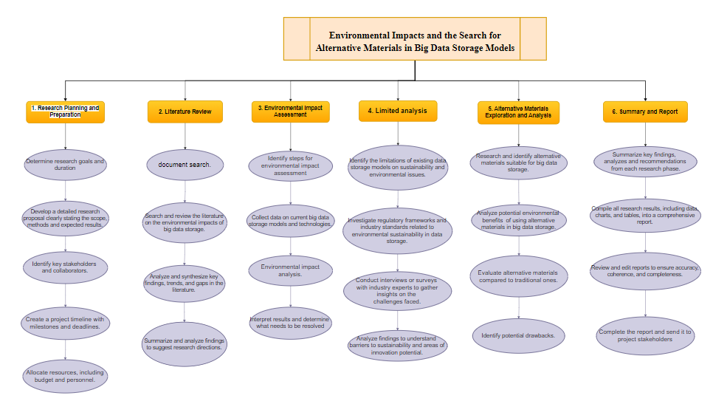
   2. **Time estimates**

|  |  |
| --- | --- |
| Activity | Estimation duration |
| 1. Research Planning and Preparation | 5 weeks |
| 2. Literature Review | 3 weeks |
| 3. Environmental Impact Assessment | 4 weeks |
| 4. Limited analysis | 3 weeks |
| 5. Alternative Materials Exploration and Analysis | 4 weeks |
| 6. Summary and Report | 4 weeks |

* 1. **Milestone identification**

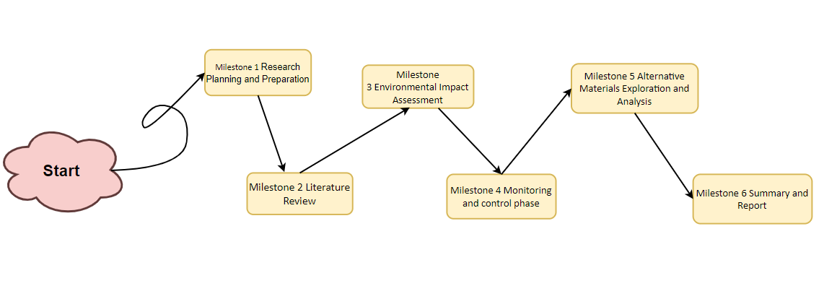

* 1. **Activity sequencing**

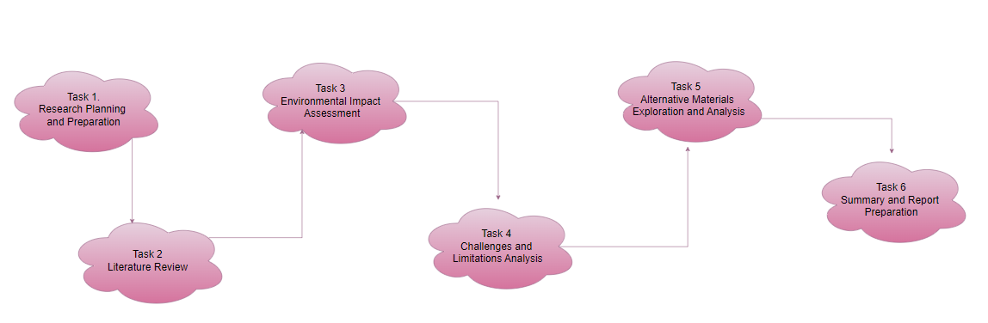

* 1. **Scheduling**

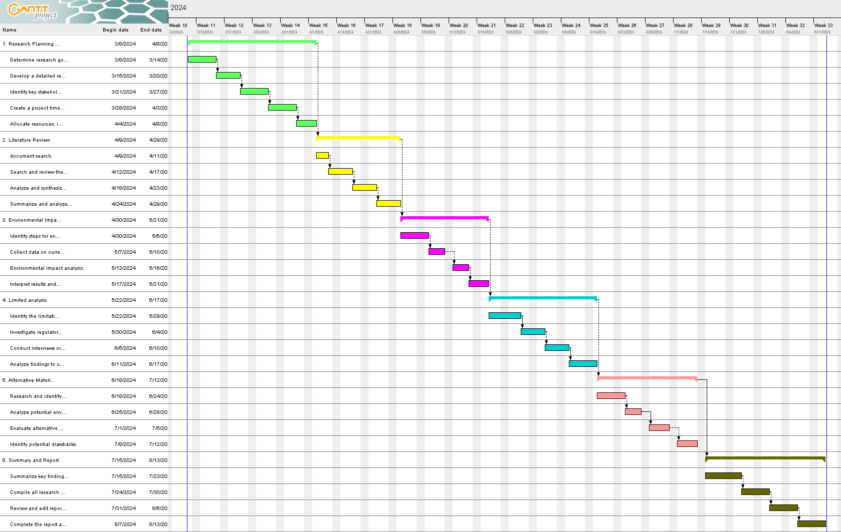

**P2 Examine appropriate research methods and approaches to primary and secondary research**

1. **Research Methods**

A research method for the topic "Environmental Impacts and the Search for Alternative Materials in Big Data Storage Models." is a mixed-methods approach, which combines both quantitative and qualitative research methods. One research method is a case study approach. This method involves in-depth exploration and analysis of a specific case or situation to gain insights and understanding of a complex phenomenon. In this case, the research could focus on a specific e-waste treatment facility in Vietnam and examine the effectiveness of the treatment methods used in the facility. The research could use both quantitative and qualitative data collection methods to gather information about the facility's operations, the types and amounts of e-waste processed, and the outcomes of the treatment process. Quantitative data could be collected through surveys and direct measurements of e-waste quantities, chemical composition, and pollutant levels before and after treatment. Qualitative data could be gathered through interviews with the facility's management and staff, as well as with local community members and stakeholders, to understand their perceptions and experiences related to

e-waste management. The case study approach can provide a detailed and nuanced understanding of the challenges and opportunities associated with e-waste treatment in Vietnam. It can also help identify best practices and potential areas for improvement in e-waste management, which can inform policy and decision-making in the country.

1. **Primary research**

Primary research is a research method that relies on direct data collection, rather than relying on data that’s already been collected by someone else. In other words, primary research is any type of research that you undertake yourself, firsthand, while using data that has already been collected is called secondary research. *(George, 2023)*

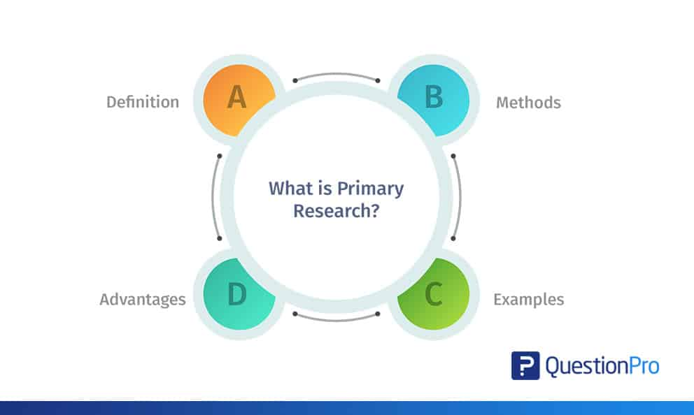

* 1. **Types of Primary research**

Primary research can take many forms, but the most common types are:

* Surveys and questionnaires
* Observational studies
* Interviews and focus groups
* **Surveys and questionnaires**

Surveys and questionnaires collect information about a group of people by asking them questions and analyzing the results. They are a solid choice if your research topic seeks to investigate something about the characteristics, preferences, opinions, or beliefs of a group of people.

Surveys and questionnaires can take place online, in person, or through the mail. It is best to have a combination of open-ended and closed-ended questions, and how the questions are phrased matters. Be sure to avoid leading questions, and ask any related questions in groups, starting with the most basic ones first.

* **Observational studies**

Observational studies are an easy and popular way to answer a research question based purely on what you, the researcher, observes. If there are practical or ethical concerns that prevent you from conducting a traditional experiment, observational studies are often a good stopgap.

There are three types of observational studies: cross-sectional studies, cohort studies, and case-control studies. If you decide to conduct observational research, you can choose the one that’s best for you. All three are quite straightforward and easy to design—just beware of confounding variables and observer bias creeping into your analysis.

* **Interviews and focus groups**

Similarly to surveys and questionnaires, interviews and focus groups also rely on asking questions to collect information about a group of people. However, how this is done is slightly different. Instead of sending your questions out into the world, interviews and focus groups involve two or more people—one of whom is you, the interviewer, who asks the questions.

There are 3 main types of interviews:

* Structured interviews ask predetermined questions in a predetermined order.
* Unstructured interviews are more flexible and free-flowing, proceeding based on the interviewee’s previous answers.
* Semi-structured interviews fall in between, asking a mix of predetermined questions and off-the-cuff questions.

While interviews are a rich source of information, they can also be deceptively challenging to do well. Be careful of interviewer bias creeping into your process. This is best mitigated by avoiding double-barreled questions and paying close attention to your tone and delivery while asking questions.

Alternatively, a focus group is a group interview, led by a moderator. Focus groups can provide more nuanced interactions than individual interviews, but their small sample size means that external validity is low.

* 1. **Advantages of Primary research**
* The data is drawn from first-hand sources and will be highly accurate and, perhaps that is the most significant advantage of primary research. The questions or experimental setups can be constructed as a unique method to achieve the research objectives.
* Doing so ensures that the data you gather is related and relevant to the research you are conducting and is intended to address your research objectives.
* Primary research ought to be directed towards addressing the core problem or objective of the research study. In other words, there is a clearly defined problem and the design of the research, the data collection methods, and the final data set can all be tailored to that problem.
* You can be sure that the collected data is aligned with your specific problem, improving the probability that the data will give you the desired responses. In other words, the data you will gather for your research will be concrete and unambiguous, and directly related to your research objectives.
* With primary data collection, you don’t need to modify the data collected (secondary data), by another researcher who may have a slightly different focus, because you are the owner of your own data.
* Maintaining this degree of scrutiny means that the data you collect from primary sources will be more pertinent and therefore more effective for your research. Since you will be in charge of the data, it is easier to regulate the time span, the scope, and the volume of the dataset being used.

*(Walker, 2021)*

* 1. **Disadvantages of Primary research**

Although primary research is hugely beneficial for your business or website, it does come with some limitations that you need to be mindful of.

* **Time consuming**

It can be a time-consuming exercise in comparison to secondary research, where a duration of time needs to be taken to research accurately.

* **Can be expensive**

Can be costly when carrying out large international studies or on a continuous basis as it’s been developed for a customized purpose. However, online surveys are relatively inexpensive, especially DIY online surveys.

* **Amount of resources required**

More resources may be required in terms of manpower and material dependent on the size of the research project such as a large multi-country continuous survey that runs every quarter. This is in terms of survey setup and data collection. *(Anpar Research, 2020)*

1. **Secondary research**

Secondary research is a research method that uses data that was collected by someone else. In other words, whenever you conduct research using data that already exists, you are conducting secondary research. On the other hand, any type of research that you undertake yourself is called primary research. *(George, 2023)*

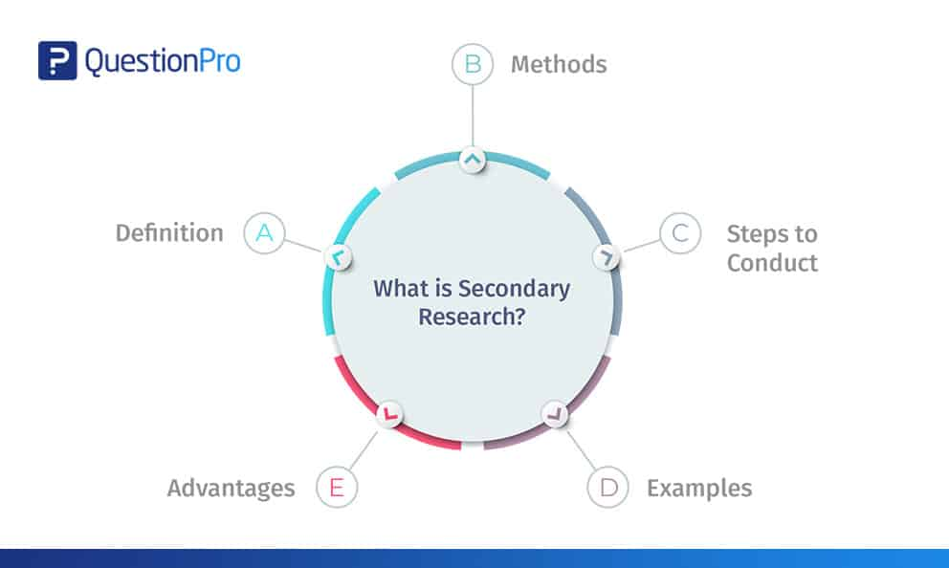

* 1. **Types of Secondary research**

Secondary sources allow you to broaden your research by providing background information, analyses, and unique perspectives on various elements for a specific campaign. Bibliographies of these sources can lead to the discovery of further resources to enhance research for organizations.

There are two common types of secondary data: Internal data and External data. Internal data is the information that has been stored or organized by the organization itself. External data is the data organized or collected by someone else.

* **Internal Secondary Sources**

Internal secondary sources include databases containing reports from individuals or prior research. This is often an overlooked resource—it’s amazing how much useful information collects dust on an organization’s shelves! Other individuals may have conducted research of their own or bought secondary research that could be useful to the task at hand. This prior research would still be considered secondary even if it were performed internally because it was conducted for a different purpose.

* **External Secondary Sources**

A wide range of information can be obtained from secondary research. Reliable databases for secondary sources include Government Sources, Business Source Complete, ABI, IBISWorld, Statista, and CBCA Complete. This data is generated by others but can be considered useful when conducting research into a new scope of the study. It also means less work for a not-for-profit organization as they would not have to create their own data and instead can piggyback off the data of others. *(Niosi and Summer, 2020)*

* 1. **Advantages of Secondary research**

Secondary research offers a number of advantages to researchers, including efficiency, the ability to build upon existing knowledge, and the ability to conduct research in situations where primary research may not be possible or ethical. By carefully selecting their sources and being thoughtful in their approach, researchers can leverage secondary research to drive impact and advance the field. Some key advantages are the following:

* Most information in this research is readily available. There are many sources from which relevant data can be collected and used, unlike primary research, where data needs to be collected from scratch.
* This is a less expensive and less time-consuming process as the data required is easily available and doesn’t cost much if extracted from authentic sources. A minimum expenditure is associated with obtaining data.
* The data that is collected through secondary research gives organizations or businesses an idea about the effectiveness of primary research. Hence, organizations or businesses can form a hypothesis and evaluate the cost of conducting primary research.
* Secondary research is quicker to conduct because of the availability of data. It can be completed within a few weeks depending on the objective of businesses or the scale of data needed.

*(Bhat, 2018)*

* 1. **Disadvantages of Secondary research**

On the other hand, we have some disadvantages that come with doing secondary research. Some of the most notorious are the following:

* Although data is readily available, credibility evaluation must be performed to understand the authenticity of the information available.
* Not all secondary data resources offer the latest reports and statistics. Even when the data is accurate, it may not be updated enough to accommodate recent timelines.
* Secondary research derives its conclusion from collective primary research data. The success of your research will depend, to a greater extent, on the quality of research already conducted by primary research. *(Bhat, 2018)*

1. **Compare Primary research with Secondary research**

|  |  |  |
| --- | --- | --- |
|  | **Primary research** | **Secondary research** |
| Perform | Primary research is done by the person requesting the information | Secondary research is not conducted by the researcher himself. |
| Source of Data | Involves the collection of firsthand, original data directly from individuals or sources. | The researcher finds information from sources that have been collected and published, such as journals, dissertations, etc. |
| Objectives of the study | proceed to collect raw data for the specific goal at hand. It is designed specifically for that purpose | The objective of secondary research is to collect information from various antecedent documents. |
| Cost and Time | Primary research is done by the person requesting the information | This is a very economical research method and requires less time to collect data. |
| Flexibility | Researchers have less control over the data collection process, as they are reliant on existing data. | Researchers have less control over the data collection process because they depend on existing data. |

1. **Qualitative research**

Qualitative research is a method of collecting information and data in 'non-numerical' form to obtain detailed information about the object of research, survey or investigation (hereinafter referred to as 'research object'). ) for in-depth analysis or evaluation purposes. This information is often collected through interviews, direct observations or focus group discussions using open questions, and is often applied in cases of small, focused research samples. *(MCG Management Consulting, 2021)*

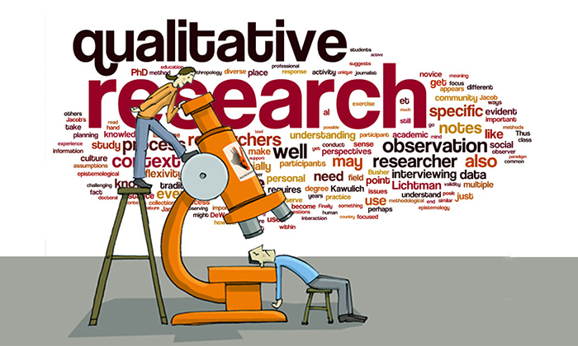

* 1. **Qualitative research methods**

Qualitative research methods are designed in a manner that helps reveal the behavior and perception of a target audience with reference to a particular topic. There are different types of qualitative research methods, such as in-depth interviews, focus groups, ethnographic research, content analysis, and case study research that are usually used.

The results of qualitative methods are more descriptive, and the inferences can be drawn quite easily from the obtained data.

Qualitative research methods originated in the social and behavioral research sciences. Today, our world is more complicated, and it is difficult to understand what people think and perceive. Online research methods make it easier to understand that as it is a more communicative and descriptive analysis.

*(Bhat, 2018)*

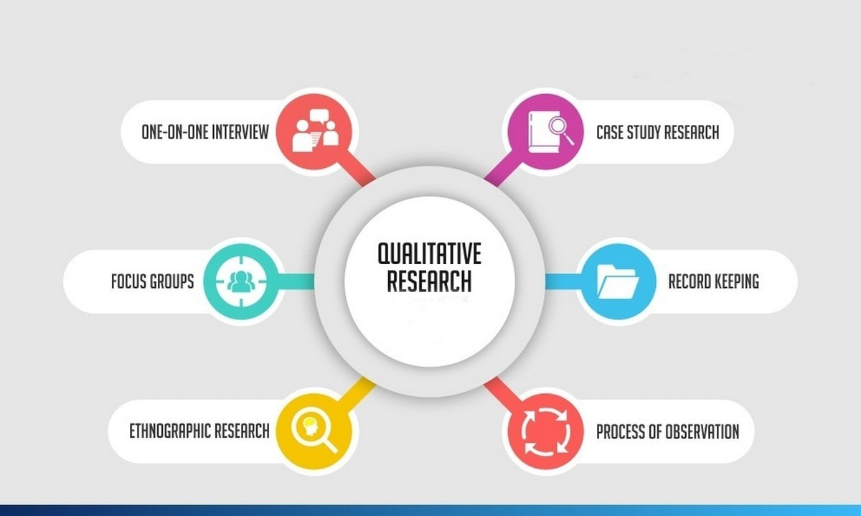

* **One-on-one Interview**

Conducting in-depth interviews is one of the most common qualitative research methods. It is a personal interview that is carried out with one respondent at a time. This is purely a conversational method and invites opportunities to get details in depth from the respondent.

One of the advantages of this method is that it provides a great opportunity to gather precise data about what people believe and their motivations. If the researcher is well experienced, asking the right questions can help him/her collect meaningful data. If they should need more information, the researchers should ask such follow-up questions that will help them collect more information.

These interviews can be performed face-to-face or on the phone and usually can last between half an hour to two hours or even more. When the in-depth interview is conducted face to face, it gives a better opportunity to read the respondents’ body language and match the responses.

* **Focus groups**

A focus group is also a commonly used qualitative research method used in data collection. A focus group usually includes a limited number of respondents (6-10) from within your target market.

The main aim of the focus group is to find answers to the “why,” “what,” and “how” questions. One advantage of focus groups is you don’t necessarily need to interact with the group in person. Nowadays, focus groups can be sent an online survey on various devices, and responses can be collected at the click of a button.

Focus groups are an expensive method compared to other online qualitative research methods. Typically, they are used to explain complex processes. This method is very useful for market research on new products and testing new concepts.

* **Ethnographic research**

Ethnographic research is the most in-depth observational research method that studies people in their naturally occurring environment.

This method requires the researchers to adapt to the target audiences’ environments, which could be anywhere from an organization to a city or any remote location. Here, geographical constraints can be an issue while collecting data.

This research design aims to understand the cultures, challenges, motivations, and settings that occur. Instead of relying on interviews and discussions, you experience the natural settings firsthand.

This type of research method can last from a few days to a few years, as it involves in-depth observation and collecting data on those grounds. It’s a challenging and time-consuming method and solely depends on the researcher’s expertise to analyze, observe, and infer the data.

* **Case study research**

The case study method has evolved over the past few years and developed into a valuable quality research method. As the name suggests, it is used for explaining an organization or an entity.

This type of research method is used within a number of areas like education, social sciences, and similar. This method may look difficult to operate; however, it is one of the simplest ways of conducting research as it involves a deep dive and thorough understanding of the data collection methods and inferring the data.

* **Record keeping**

This method makes use of the already existing reliable documents and similar sources of information as the data source. This data can be used in new research. This is similar to going to a library. There, one can go over books and other reference material to collect relevant data that can likely be used in the research.

* **Process of observation**

Qualitative Observation is a process of research that uses subjective methodologies to gather systematic information or data. The focus on qualitative observation is the research process of using subjective methodologies to gather information or data. Qualitative observation is primarily used to equate quality differences.

Qualitative observation deals with the 5 major sensory organs and their functioning – sight, smell, touch, taste, and hearing. This doesn’t involve measurements or numbers but instead characteristics.

* 1. **Qualitative data analysis**

There are 5 steps to analyzing qualitative data. Below are the steps for qualitative analysis

*(Anup Surendran, 2018)*

**Step 1: Arrange your data**

Once you have collected all the data, it is largely unstructured and sometimes makes no sense when viewed at a glance. Therefore, it is essential that as a researcher, you first need to transcribe the data collected.

The first step in analyzing your data is arranging it systematically. Arranging data means converting all the data into a text format. You can either export the data into a spreadsheet manually type in the data, or choose from any of the computer-assisted qualitative data analysis tools.

**Step 2: Organize all your data**

After transforming and arranging your data, the immediate next step is to organize your data. You may have a large amount of information that still needs to be arranged in an orderly manner. One of the best ways to organize the data is by going back to your research objectives and then organizing the data based on the questions asked.

Arrange your research objective in a table so it appears visually clear. At all costs, avoid the temptations of working with unorganized data. You will waste time, and no conclusive results will be obtained.

**Step 3: Set a code to the data collected**

Setting up proper codes for the collected data takes you a step ahead. The coding process is one of the best ways to compress a tremendous amount of information collected. Data coding means categorizing and assigning properties and patterns to the collected data.

Coding is important in this data analysis, as you can derive theories from relevant research findings. After assigning codes to your data, you can build on the patterns to gain in-depth insight into the data that will help make informed decisions.

**Step 4: Validate your qualitative data**

Validating data is one of the crucial steps of qualitative data analysis for successful research. Since data is quintessential for research, ensuring that the data is not flawed is imperative. Please note that data validation is not just one step in this analysis; this is a recurring step that needs to be followed throughout the research process. There are two sides to validating data:

* Accuracy of your research design or methods.
* Reliability is the extent to which the methods consistently produce accurate data.

**Step 5: Concluding the analysis process**

It is important to finally conclude your data. The report should state the method you used as a researcher to conduct the research studies, the positives and negatives, and the study limitations. In the report, you should also state the suggestions/inferences of your findings and any related areas for future research. Practical business intelligence relies on the synergy between analytics and reporting, where analytics uncovers valuable insights, and reporting communicates these findings to stakeholders.

* 1. **Advantages of Qualitative research**
* **Improving reliability**

Researchers who collect accurate data have more reliable results. Quantitative data research offers an outcome based on numbers rather than subjective judgments. The study results reflect data regardless of whether that outcome aligns with a preconceived theory.

* **Limiting variables**

Researchers set up controls to reduce the number of potential variables. Researchers usually divide data into subsets of demographics or other qualifying categories. Limiting and controlling the research environment allows researchers to draw correlations between the most relevant variables included in the study.

* **Broadening studies**

A quantitative study can provide a macro data set for researchers who study social science issues. For example, a study might involve evaluating the home buying power of people of different backgrounds. A researcher who uses information from the federal government's census could include millions of different families of different income levels and backgrounds. The researcher then might look for patterns and correlations in the data.

* **Eliminating bias**

Quantitative research can help avoid potential bias from a study. The study uses quantitative data with no pre-determined outcome. If the data produces an unexpected result, the researchers report the results. Also, a quantitative study allows other researchers to double-check the original researcher's process.

* **Comparing results**

Researchers can replicate quantitative studies. As part of a quantitative study, researchers publish their data and what process they followed to carry out the study. This allows other researchers to follow their work. For example, if a researcher publishes a study that states smoking can increase the risk of lung cancer, other researchers can replicate the study and see if their findings corroborate its results.

*(Indeed.com, 2022)*

* 1. **Disadvantages of Qualitative research**

Qualitative research is an effective way to gain insight into the attitudes and beliefs of people. However, there are some significant disadvantages to consider. In this article, we will explore some of the drawbacks of qualitative research.

* **Time-Consuming**

One of the primary drawbacks of qualitative research is that it is often time-consuming. Qualitative research typically involves a great deal of data collection and analysis, which can take an extended period of time to complete. Additionally, qualitative research often requires interviews and focus groups to be conducted, which can be difficult to arrange and require additional time.

* **Subjective**

Another disadvantage of qualitative research is that it is highly subjective. Qualitative research relies on the interpretation and analysis of observations, which can be difficult to quantify and measure objectively. Additionally, the researcher’s own biases can influence the results of the study.

* **Expensive**

Qualitative research can also be expensive to conduct. It requires a considerable amount of time, which can translate to a significant amount of money. Additionally, the cost of data collection, such as traveling to conduct interviews and focus groups, can add to the overall cost of the research.

* **Difficult to Analyze**

Qualitative research data can also be difficult to analyze. Since the data is often subjective and open to interpretation, it can be difficult to make sense of the data and draw valid conclusions from it. Additionally, the analysis of qualitative research data is often labor-intensive and time-consuming.

* **Inaccurate Results**

Finally, qualitative research can also lead to inaccurate results. Since the data is often subjective and open to interpretation, the researcher’s own biases can influence the results of the study. Additionally, the researcher must be careful to interpret the data accurately in order to draw valid conclusions.

* **Conclusion**

Qualitative research can be an effective way to gain insight into people’s attitudes and beliefs. However, it also has several drawbacks, such as being time-consuming, subjective, expensive, difficult to analyze, and potentially leading to inaccurate results. Researchers should carefully consider the pros and cons of qualitative research before deciding to pursue it.

*(Team, 2023)*

1. **Quantitative research**

Quantitative research is the process of collecting and analyzing numerical data to describe, predict, or control variables of interest. This type of research helps in testing the causal relationships between variables, making predictions, and generalizing results to wider populations. The purpose of quantitative research is to test a predefined theory or hypothesis and eventually either accept or reject it based on the results. Quantitative data analysis is used when researchers are interested in understanding data sets over time to identify patterns. This type of research is typically used in the fields of psychology, economics, sociology, and marketing. Quantitative research methods include few key steps as illustrated in the figure.

*(Divya Sreekumar, 2023)*

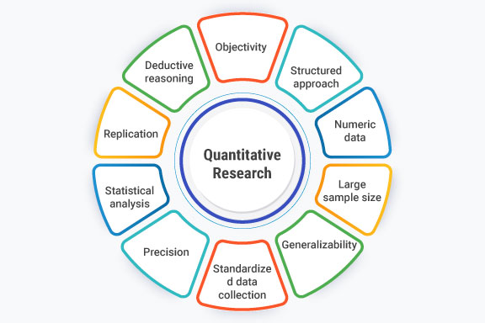

* 1. **Quantitative research methods**

Let us understand the different methods through which a quantitative research methodology is carried out during research. These methods vary on the data size, nature of research, and the heterogeneity of the data collected.

* **Survey Research**

Using survey research as the method of research, an organization conducting a survey asks different survey questions from the respondents using various types like online surveys, online polls, paper questionnaires, etc., and then collects and analyzes collected data to produce numerical results.

* **Causal-Comparative Research**

The Causal-Comparative Research method is used to conclude the cause-and-effect equation between two or more two variables, where one variable will be dependent on other variables, which will be independent.

* **Experimental Research**

This analysis is done to prove or disprove the statement. It is generally used in the field of natural sciences or the field of social sciences as in those areas, various statements are required to be proved as right or wrong

* **Correlation Research**

Correlation Research was conducted to establish a relationship between the two closely associated entities to know the impact of one on the other and the changes that were eventually observed. It is carried for giving value to naturally occurring relationships. For this research minimum, two different groups will be required.

* 1. **Quantitative data analysis**

Quantitative data has to be gathered and cleaned before proceeding to the stage of analyzing it. Below are the steps to prepare data before quantitative research analysis:

**Step 1: Data Collection**

Before beginning the analysis process, you need data. Data can be collected through rigorous quantitative research, which includes methods such as interviews, focus groups, surveys, and questionnaires.

**Step 2: Data Cleaning**

Once the data is collected, begin the data cleaning process by scanning through the entire data for duplicates, errors, and omissions. Keep a close eye for outliers (data points that are significantly different from the majority of the dataset) because they can skew your analysis results if they are not removed.

This data-cleaning process ensures data accuracy, consistency, and relevancy before analysis.

**Step 3: Data Analysis and Interpretation**

Now that you have collected and cleaned your data, it is now time to carry out the quantitative analysis. There are two methods of quantitative data analysis, which we will discuss in the next section.

However, if you have data from multiple sources, collecting and cleaning it can be a cumbersome task. This is where Hevo Data steps in. With Hevo, extracting, transforming, and loading data from source to destination becomes a seamless task, eliminating the need for manual coding. This not only saves valuable time but also enhances the overall efficiency of data analysis and visualization, empowering users to derive insights quickly and with precision. *(Ofem Eteng, 2022)*

* 1. **Advantages of Quantitative research**
* Higher Sample Size: Surveys online and social media polls are easily accessible to anyone, and they can be posted across multiple platforms. Having a higher sample size makes results more reliable. By reliable we mean the results have a smaller Margin of Error.
* Numerical data: The nature of numerical data is that it can be viewed at scale and is easier to interpret in a general sense. Analyzing data collected for the intention of consumer feedback would take substantial time if it came in the form of an email response or even via phone call. Compiling such data and then attempting to fit it all into a structure that can be strategically interpreted is effort-consuming.
* When needing data in its purest form, collecting data through long-form, individualized, response, is time-consuming and requires interpretation. Sometimes a quick poll is all that is needed. This allows for quick analysis with little need for translation, with conclusions drawn from large samples of participants who each followed the same steps and were restricted to the same response options.

*(gemma.dolby@crunchdigitalmedia.com, 2022)*

* 1. **Disadvantages of Quantitative research**

**High cost**

Creating new data through surveys or polls is costly. Researchers often have to hire individuals to assist with the work of collecting and analyzing the data. Even accessing massive databases and securing secondary data can be expensive.

**Results without explanation**

Quantitative data can show trends in data and correlations between variables, but it can't explain why the correlation exists. When researchers publish their study's data, other professionals and readers may extrapolate reasons for the results. However, the research itself doesn't provide a reason for the outcome of the study. *(Indeed.com, 2022)*

1. **Compare Qualitative research with Quantitative research**

In general, **quantitative research** seeks to understand the causal or correlational relationship between variables through testing hypotheses, whereas **qualitative research** seeks to understand a phenomenon within a real-world context through the use of interviews and observation. Both types of research are valid, and certain research topics are better suited to one approach or the other. However, it is important to understand the differences between qualitative and quantitative research so that you will be able to conduct an informed critique and analysis of any articles that you read, because you will understand the different advantages, disadvantages, and influencing factors for each approach.

The table below illustrates the main differences between qualitative and quantitative research.

|  |  |  |
| --- | --- | --- |
|  | **Qualitative** | **Qualitative** |
| **Keywords** | Complexity, contextual, inductive logic, discovery, exploration | Experiment, random assignment, independent/dependent variable, causal/correlational, validity, deductive logic |
| **Purpose** | Understand a phenomenon | Discover causal relationships or describe a phenomenon |
| **Sample** | Purposive sample, small | Random sample, large |
| **Data** | Focus groups, interviews, field observation | Tests, surveys, questionnaires |
| **Methods/Design** | Phenomenological, grounded theory, ethnographic, case study, historical/narrative research, participatory research, clinical research | Experimental, quasi-experimental, descriptive, methodological, exploratory, comparative, correlational, developmental (cross-sectional, longitudinal/prospective/cohort, retrospective/ex post facto/case control) |

Systematic reviews, meta-analyses, and integrative reviews are not exactly designs, but they synthesize, analyze, and compare the results from many research studies and are somewhat quantitative in nature. However, they are not truly quantitative or qualitative studies.

1. **Scientific method**
   1. **The scientific method in technology and computers**

The scientific method serves as a structured approach utilized by scientists and researchers across various disciplines to explore natural phenomena, formulate hypotheses, conduct experiments, and analyze outcomes. In the realms of technology and computer science, this method is instrumental in the development, testing, and enhancement of theories, algorithms, and systems. Here's how the scientific method is commonly applied in research within the fields of technology and computer science:

* **Observation and Inquiry:** Researchers keenly observe phenomena or identify challenges within the domains of technology or computer science, often arising from practical hurdles, industry requirements, or gaps in existing knowledge.
* **Question Formulation:** Drawing from observations, researchers articulate precise questions or issues suitable for research exploration.
* **Literature Review:** Researchers systematically review existing knowledge domains through extensive literature exploration, encompassing theories, technologies, and methodologies pertinent to the identified challenges. This stage establishes a foundational understanding and identifies gaps in current knowledge.
* **Hypothesis Development:** Based on the literature review, researchers propose hypotheses or sets of hypotheses suggesting potential solutions or explanations for the observed challenges. In technology and computer science, these hypotheses may pertain to algorithms, system architectures, or software design principles.
* **Experimental Design:** Researchers meticulously design experiments, simulations, or studies aimed at scrutinizing the proposed hypotheses. This phase often involves prototyping software, implementing algorithms, or conducting simulations to accumulate data.
* **Variable Identification:** Researchers discern and regulate variables that may influence experiment outcomes, ensuring controlled and systematic investigations.
* **Data Collection:** Through experiments or simulations, researchers gather pertinent data germane to the research questions, which may encompass performance metrics, user feedback, or other measurable parameters.
* **Data Analysis:** Researchers employ statistical methods and data analysis techniques to decipher the accumulated data, discerning patterns and trends to ascertain the validity of the hypotheses and draw substantive conclusions.
* **Interpretation and Conclusion:** Researchers interpret the outcomes within the framework of the original hypotheses, evaluating whether the data corroborates or refutes the proposed explanations or solutions.
* **Conclusion Formulation:** Predicated on the analyses, researchers delineate conclusions and deliberate on the implications of their findings.
* **Peer Review and Dissemination:** The research undergoes rigorous peer review, where subject matter experts scrutinize the methodology, outcomes, and conclusions. Subsequently, if accepted, the research is disseminated via scientific journals or conference proceedings, thereby enriching the collective knowledge pool.
* **Iteration and Enhancement:** Researchers receive feedback from the scientific community, industry stakeholders, or end-users, which they utilize to refine hypotheses, methodologies, or technologies, thereby iterating the scientific method.
* **Application and Implementation:** Successful research outcomes are frequently translated into real-world applications, often entailing the development of novel software, algorithms, or systems, thus fostering tangible advancements in technology and computer science.

The scientific method epitomizes a dynamic and iterative process propelling advancements in technology and computer science, underpinning systematic inquiry, experimentation, and the perpetual augmentation of knowledge and applications.

* 1. **Step of the scientific method**

**Steps of the scientific method.**

The scientific method consists of several processes for establishing facts or gathering information. Although the general technique is well-established, the specifics of each

phase may differ depending on what is being researched and who is doing it. The scientific method can only be used to address questions that can be demonstrated or disproven by testing.

* **Make an observation or ask a question:** The first step is to become aware of something you wish to learn more about or to pose a query that needs to beaddressed. These might be specialized as well as generic. "I see that our total available network bandwidth decreases every workday at lunchtime," for example, or "How can we increase our website registration numbers?" Puttingforth the effort to create a well-defined query will benefit you in following steps.
* **Gather background information:** This entails conducting research on what is already known about the subject. This can also include looking to see whether anyone else has asked the same question.
* **Create a hypothesis:** A hypothesis is an explanation for an observation or question. It can become a fact if it is later verified. "Our workers are using our internet bandwidth at lunch," for example, or "Our website visitors do not view our registration form."
* **Create a prediction and perform a test:** Make a testable prediction based on the hypothesis. The test should result in a discernible change that can be measured or observed empirically. It is also necessary to adjust for other circumstances throughout the test. "If we forbid video-sharing sites during lunch," for example, or "If we make our registration box larger, a higher percentage of visitors will register for our website than before the change,"
* **Analyze the results and draw a conclusion:** Use the metrics created before to the test to assess whether the outcomes match the forecast. "After blocking video-sharing sites, our bandwidth utilization decreased by 10% compared to before; this is insufficient of a change to be the primary cause of network ongestion," for example, or "After increasing the size of the registration box, the

1. **Research process**

The research process is a set of ordered steps a researcher takes to ensure that all parts of an investigation are completed to a high standard. Following the research process allows the researcher to cover all angles and ensure that the information they gather is reliable and effectively presented. *(StudySmarter UK, 2019)*

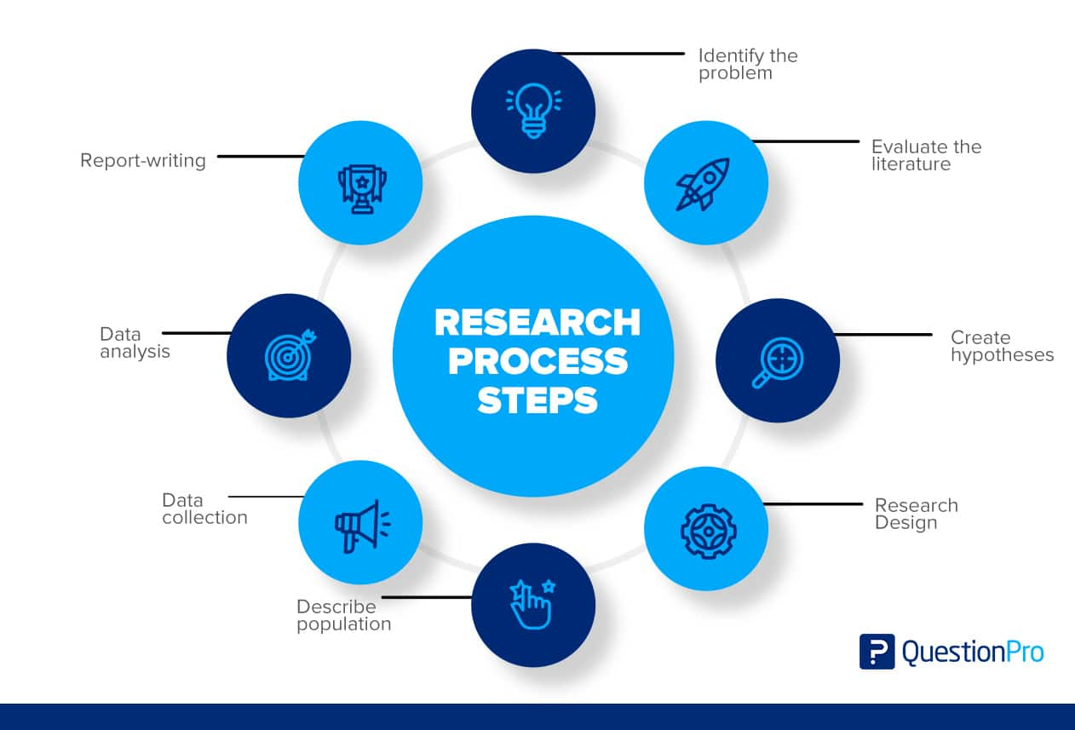

* 1. **Step**

To conduct effective research, we must understand the research process steps and follow them. Here are a few steps in the research process:

* **Step 1: Identify the Problem.**

The first step is to identify a problem or develop a research subject. From goal formulation through technique selection, a well-defined problem will guide the researcher through all stages of the research process. There are various approaches for getting insight into and a greater understanding of a topic. Here are several examples:

* An initial poll
* Study of Cases
* Interviews with a select set of individuals
* Observational study
* **Step 2: Evaluate the Literature.**

The research approach necessitates a thorough examination of the relevant studies. It assists the researcher in identifying distinct components of the problem. After identifying a problem, the investigator or researcher needs learn more about it. This step establishes the context for the problem zone. It instructs the investigator on past study, how it was performed, and its findings. A survey of the literature can assist the researcher in creating consistency between his work and that of others. A review of this type exposes the researcher to a bigger body of material and helps him follow the research process more efficiently.

* **Step 3: Create Hypotheses.**

The next obvious step after narrowing down and defining the study problem is to propose an original hypothesis. The answer to logical relationships between variables is a belief. To create a hypothesis, a researcher needs have some level of expertise in the issue. Researchers must keep in mind while formulating a hypothesis that it must be relevant to the study problem. When researchers develop theories to guide their work, they are able to focus their efforts and stay committed to their objectives.

* **Step 4: The Research Design.**

The research design is the strategy for achieving objectives and answering research questions. It describes how to collect the required information. Its goal is to conduct research that will test hypotheses, provide answers to research questions, and provide decision-making insights. The research design attempts to limit the amount of time, money, and effort required to collect valuable data. This method is divided into four categories:

* Exploration and surveying
* Experiment
* Data Analysis
* Observation
* **Step 5: Describe Population.**

Typically, research projects concentrate on a certain group of people, facilities, or how technology is applied in business. In research, the term population refers to this study group. The research subject and purpose decide the study group. Assume a researcher want to investigate a certain group of people in the community. In that case, the research may concentrate on a certain age group, gender, geographic location, or ethnic group. The final stage of study design is determining the sample or population so that the results may be generalized.

* **Step 6: Data Collection.**

Data collection is essential for obtaining the knowledge or information required to answer the research question. Every research acquired data, either from the literature or from the people being studied. Data must be collected from both sorts of researchers. Original data may be included in these sources.

* Experiment
* Questionnaire
* Observation
* Interview

Secondary data categories include the following:

* A study of the literature
* Official and unconfirmed reports
* An approach based on library materials
* **Step 7: Data Analysis.**

During the research design process, the researcher plans data analysis. Once the data has been obtained, the researcher reviews it. The data is examined using the

approach at this step. The study findings are analyzed and reported. Data analysis includes creating categories, applying these categories to raw data via coding and tabulation, and then deriving statistical inferences. A variety of statistical approaches can be utilized to analyze the researcher's obtained data.

* **Step 8: The Report – Writing.**

After completing these phases, the researcher must prepare a report explaining his findings. The report must be appropriately drafted while keeping the following

factors in mind:

* **The Layout:** The report's title, date, acknowledgments, and prologue should all be on the first page. After the table of contents, any tables, graphs, or charts should be listed.
* **Introduction:** It should cover the study's objectives and methods. This section should describe the research's scope and limits.
* **Summary of Findings:** Following the introduction, there will be a nontechnical assessment of findings and recommendations. If the findings are lengthy, they should be condensed.
* **Principal Report:** The report's main information should make sense and be organized into easy-to-understand sections.
* **Conclusion:** The researcher should restate his findings at the end of the main paragraph. It is the end outcome.

1. **Population in research**
   1. **Collecting data from a population**

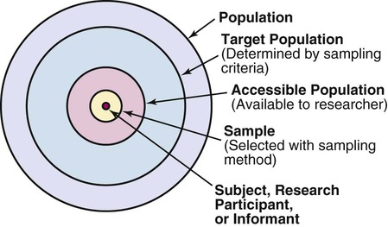

The population refers to a comprehensive group of individuals, institutions, objects, etc. that share common characteristics and are of interest to a researcher. The population is a large collection of individuals or objects that is the main focus of a scientific study, with the purpose of improving the population's well-being. However, due to the large size of populations, it is not feasible to study every individual or object, leading to the use of sampling techniques. A research population is a well-defined collection of individuals or objects that possess similar characteristics and traits.

The population can be described as a comprehensive group of individuals, entities, objects, etc. that share common traits of interest to a researcher. The unique characteristics of these groups set them apart from other individuals, entities, objects, etc. In research, the population refers to a vast collection of individuals or objects that are the

main focus of investigation. Research is conducted for the benefit of the population, but because of its large size, researchers cannot study every member of the population as it is cost- and time-prohibitive. This is why researchers use sampling methods. A population in research is considered a well-defined collection of individuals or objects known to have similar traits. Members of a population usually possess a common, defining characteristic or feature.

There are several subsets of the population:

* **Target Population:** This refers to the complete group of individuals or objects that researchers aim to generalize their conclusions to. The target population encompasses a range of traits and is also referred to as the theoretical population.
* **Accessible Population:** This is the population in research to which researchers can apply their findings. It is a subset of the target population and is also known as the study population. Researchers draw their samples from the accessible population.
* **Sample:** A sample is a subset of the population that is selected due to the inability of researchers to test all individuals in the population. The sample must accurately represent the population it was drawn from and have a sufficient size to support statistical analysis. The approaches that will be used to conduct the research are specialist research procedures. The choice of an effective research technique is critical in the design of the study since it affects the quality of data obtained. To acquire reliable findings, I will do Primary Research and employ the Survey technique in this study.

**P3 Conduct primary and secondary research using appropriate methods for a computing research project that consider costs, access and ethical issues**

1. **Secondary research**
   1. **Source**
   2. **Interpretation and implications of the findings**
2. **Primary research**
   1. **Interview**
   2. **Survey**

**P4 Apply appropriate analytical tools, analyse research findings and data**

1. **Interview**
   1. **Interview 1**

|  |
| --- |
| Ms. Ly Thien Kim - Director of VCCorp Joint Stock Company.  Full name: Ms. Ly Thien Kim  Age: 30  Occupation: Director of VCCorp Joint Stock Company.  Company: VCCorp Joint Stock Company  **1. Environmental impact of big data:**  **A.** Ms. Thien Kim, how do you think big data contributes to environmental issues?  **B.** Big data can make a major contribution to solving environmental problems through many different ways.  Predict and respond to climate change: Big data from sensors, satellites, and other information sources can be used to monitor and predict climate change. Analyzing this data helps researchers and environmental managers better understand climate fluctuations and develop response measures.  Natural Resource Management: Big data can assist in the effective management of natural resources such as water, forests, and land. By monitoring and analyzing data, we can make smart decisions about how to use resources sustainably.  Monitoring and assessing environmental pollution: Sensor systems and big data monitoring networks can be deployed to monitor air, water, and land quality. This data helps determine the source and extent of pollution, from which measures can be developed to reduce and prevent environmental pollution.  **A.** What challenges do you face in minimizing this impact?  **B.** A significant challenge is to develop algorithms and data processing techniques that are both more efficient and less energy consuming, in addition to promoting the use of green energy sources in data centers.  **2. Role of alternative materials:**  **A.** How do alternative materials contribute to reducing the environmental impact of big data?  **B.** In the technology sector, especially in data centers, alternative materials that are more energy efficient and have less environmental impact can play a key role. This includes innovations in cooling technology and the use of recycled materials to build infrastructure.  **A.** Can you provide examples of how to use these documents?  B. One example is the use of a liquid cooling system that significantly reduces energy consumption compared to traditional air cooling. Additionally, building data centers from recycled steel and concrete can reduce carbon emissions.  **3. Emerging technology:**  **A.** What emerging technologies support the use of alternative materials for big data?  **B.** AI and ML can optimize data center operations, reducing energy consumption. IoT technology can also monitor environmental conditions, allowing for more efficient resource management.  **A.** How do these technologies improve efficiency?  **B.** They enable real-time adjustments in data processing and cooling systems, minimizing energy usage and extending the life of hardware through predictive maintenance.  **4.Build a better system:**  **A.** What strategies should organizations adopt to have a sustainable materials system?  **B.** Emphasizing research into low-impact materials, using renewable energy sources, and designing data centers with sustainability in mind are important strategies.  **A.** Are there any specific methods or best practices?  B. Implementing modular data center designs that can be easily upgraded or reused will help reduce waste and encourage the use of sustainable materials.  B. Thank you Ms. Thien Kim for participating in today's interview |

* 1. **Interview 2**

|  |
| --- |
| Mr. Ta Quang Dung - Deputy Director and CEO of Ho Chi Minh City  Full name: Mrs. Ta Quang Dung  Age: 45  Occupation: Deputy Director, CEO of Ho Chi Minh City  Company: Ho Chi Minh City CEO Group Joint Stock Company  **Interview:** According to Mr. Dung, how do current large-scale data storage models affect the environment?  **Mr. Dung:** Large-scale data storage models can impact the environment in many ways. Here are some important factors that can be considered to better understand the environmental impact of these systems:  Data Centers: Data centers, which store and process large amounts of data, consume large amounts of energy to maintain servers, cooling systems, and other equipment. The rapid increase in data is also increasing the demand for energy.  Manufacturing process: The production of data storage devices, such as hard drives and servers, requires large amounts of raw materials and energy. The manufacturing process can create emissions and waste that are harmful to the environment.  Equipment Condition: Discarding old or unused equipment also creates problems with e-waste disposal, hazardous waste, and recycling.  Cooling system: To keep servers and equipment working stably, data centers often use cooling systems. This also increases energy consumption and can affect water resources and local climate.  Air pollution: The operation of data centers and servers can create emissions and fine dust, contributing to air pollution.  Water consumption: Some data centers use large amounts of water for system cooling or for power generation.  Mining and material supply: Mining resources such as metals and minerals to produce data storage device components can cause land and forest loss.  Natural disaster risk: Data centers need to face risks from natural disasters such as floods, earthquakes, and storms, posing a challenge to protect the environment.  To reduce the environmental impact of large-scale data storage models, measures such as energy optimization, equipment recycling, use of environmentally friendly materials, and adoption of industrial solutions are recommended. Green technology can be considered and implemented.  **Interview:** What significance do alternative materials hold in lessening the environmental impact of big data?  **Mr. Quang:** They are crucial for the transition towards more sustainable data center operations, offering possibilities for reducing energy consumption and minimizing waste production through renewable resources and recyclable materials.  **Interview:** Thank you for participating in my interview. |

* 1. **Interview 3**

|  |
| --- |
| Ms. Ha Anh Thu - Head of FPT Corporation  Full name: Mrs. Ta Quang Dung  Age: 45  Occupation: Head of FPT Corporation  Company: FPT Group Company  interview: How do current policies and regulations affect material usage in data storage models?  Ms. Thu: Sustainability Standards: Many countries and international organizations set sustainability standards for industry, including the data storage sector. These policies often require transparency about the origin of materials, encouraging the use of recycled and environmentally friendly materials. Security and Privacy Regulations: Information security regulations may place special requirements on the materials used to protect information, which can affect material selection as well as as production methods. Businesses operating in the large-scale data storage sector often need to comply with these regulations and policies to ensure that their operations meet environmental and resource protection standards and requirements. .  interview: How do businesses and organizations in the data storage sector interact and dialogue with the community to achieve sustainability goals?  Ms. Thu: Organize events, seminars, and community meetings to share information about businesses' efforts and commitments to sustainability in the field of data storage. Organize in-person visits, meetings, or events with the local community to listen to community opinions, suggestions, and needs. Provide announcements and educational programs to increase public awareness of environmental issues and how businesses are contributing to solving them. Share information on results and progress in implementing sustainable measures, including energy savings, waste reduction, and use of environmentally friendly materials.  Interview: Thank you for answering our questions. |

1. **Interview summary**

The above interviews have given us more knowledge and below are the questions I asked:

Ms. Thien Kim: focuses on solving environmental problems through many different ways.

Predict and respond to climate change: Big data from sensors, satellites and other information sources can be used to monitor and predict climate change. Analyzing this data helps researchers and environmental managers better understand climate fluctuations and develop responses.

Mr. Quang Dung: Large-scale data storage models can impact the environment in many aspects. Below are some important factors that can be considered to better understand the environmental impact. What it means to minimize the environmental impact of big data.

Ms. Thu: How do current policies and regulations affect the use of materials in data storage models? How businesses and organizations in the storage sector engage with data and dialogue with the community to achieve sustainability goals

After asking questions related to big data, they helped us understand it better and come up with ways to solve problems when encountering difficulties for the project.

1. **Survey**

After the interview, I have a survey article on Environmental Impacts and the Search for Alternative Materials in Big Data Storage Models. Below are the questions:

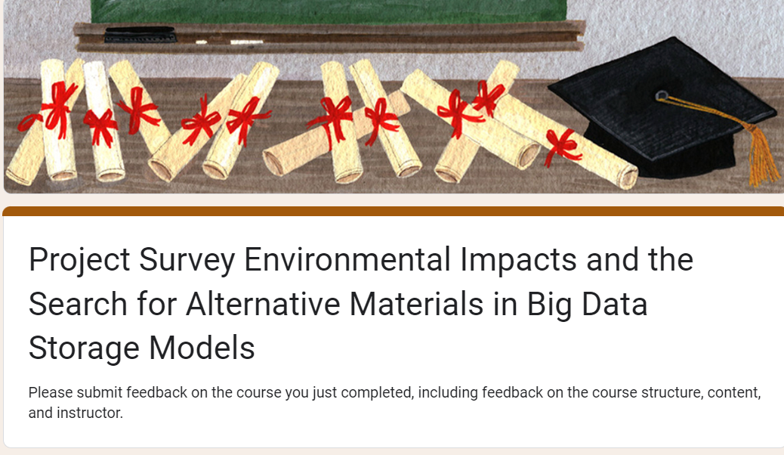



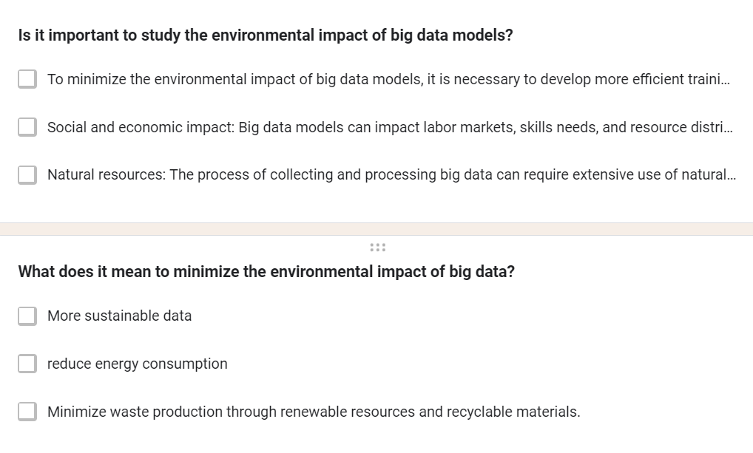

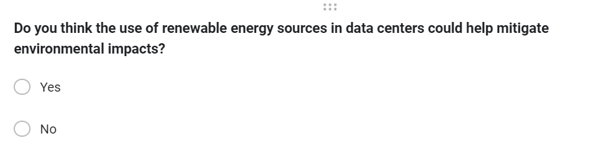

1. **Survey summary**
2. **Analyze the results of the Primary research**

**P5 Communicate research outcomes in an appropriate manner for the intended audience**

1. **Conclusion**

* Rút ra kiến thức, kết luận gì cho đề tài này

1. **Recommendation**

* Đề xuất cải tiến/thông điệp

1. **CONCLUSION**
2. **REFERENCES**

George, T. (2023). *Primary Research | Definition, Types, & Examples*. [online] Scribbr. Available at: [https://www.scribbr.com/methodology/primary-research/](https://www.scribbr.com/methodology/primary-research/%20) [Accessed 15 Jan. 2024].

Walker, J. (2021). *Advantages of Primary Research*. [online] ResearchProspect. Available at: [https://www.researchprospect.com/advantages-of-primary-research/](https://www.researchprospect.com/advantages-of-primary-research/%20) [Accessed 15 Jan. 2024].

Niosi, A. and Summer (2020). *Types of Secondary Research Data*. [online] Pressbooks.pub. Available at: [https://kpu.pressbooks.pub/openimc/chapter/primary-data-v-s-secondary-data/](https://kpu.pressbooks.pub/openimc/chapter/primary-data-v-s-secondary-data/%20) [Accessed 15 Jan. 2024].

Bhat, A. (2018). *Secondary Research: Definition, Methods & Examples*. [online] QuestionPro. Available at: <https://www.questionpro.com/blog/secondary-research/> [Accessed 15 Jan. 2024].

MCG Management Consulting. (2021). *Nghiên cứu định tính và nghiên cứu định lượng trong nghiên cứu và khảo sát điều tra - Định nghĩa và các công cụ phổ biến - MCG Management Consulting*. [online] Available at: [https://mcg.com.vn/nghien-cuu-dinh-tinh-va-nghien-cuu-dinh-luong-trong-nghien-cuu-va-khao-sat-dieu-tra-ky-1-dinh-nghia-va-cac-cong-cu-pho-bien/](%20https:/mcg.com.vn/nghien-cuu-dinh-tinh-va-nghien-cuu-dinh-luong-trong-nghien-cuu-va-khao-sat-dieu-tra-ky-1-dinh-nghia-va-cac-cong-cu-pho-bien/%20) [Accessed 15 Jan. 2024].

Bhat, A. (2018). *Qualitative Research: Definition, Types, Methods and Examples*. [online] QuestionPro. Available at: [https://www.questionpro.com/blog/qualitative-research-methods/#Types_of_qualitative_research_methods_with_examples](https://www.questionpro.com/blog/qualitative-research-methods/%23Types_of_qualitative_research_methods_with_examples%20) [Accessed 26 Jan. 2024].

Anup Surendran (2018). *Qualitative Data: Definition, Types, Analysis and Examples*. [online] QuestionPro. Available at: [https://www.questionpro.com/blog/qualitative-data/#Qualitative_data_analysis_methods](https://www.questionpro.com/blog/qualitative-data/%23Qualitative_data_analysis_methods%20) [Accessed 26 Jan. 2024].

Indeed.com. (2022). *What Is Quantitative Research? (With Advantages and Disadvantages) | Indeed.com*. [online] Available at: [https://www.indeed.com/career-advice/career-development/what-is-quantitative-research#:~:text=Advantages%20of%20quantitative%20research&text=Researchers%20who%20collect%20accurate%20data,aligns%20with%20a%20preconceived%20theory.](https://www.indeed.com/career-advice/career-development/what-is-quantitative-research%23:~:text=Advantages%20of%20quantitative%20research&text=Researchers%20who%20collect%20accurate%20data,aligns%20with%20a%20preconceived%20theory.%20) [Accessed 26 Jan. 2024].

Team, S. (2023). *The Disadvantages Of Qualitative Study - Speak Ai*. [online] Speak Ai. Available at: [https://speakai.co/the-disadvantages-of-qualitative-study/](https://speakai.co/the-disadvantages-of-qualitative-study/%20) [Accessed 26 Jan. 2024].

Divya Sreekumar (2023). *What is Quantitative Research? Definition, Methods, Types, and Examples | Researcher.Life*. [online] Researcher.life. Available at: [https://researcher.life/blog/article/what-is-quantitative-research-types-and-examples/#What_is_quantitative_research12](https://researcher.life/blog/article/what-is-quantitative-research-types-and-examples/%23What_is_quantitative_research12) [Accessed 26 Jan. 2024].

Ofem Eteng (2022). *Quantitative Data Analysis: A Comprehensive Guide*. [online] Learn | Hevo. Available at: [https://hevodata.com/learn/quantitative-data-analysis/](https://hevodata.com/learn/quantitative-data-analysis/%20) [Accessed 28 Jan. 2024].

gemma.dolby@crunchdigitalmedia.com (2022). *Quantitative Research Advantages – Spark Market Research*. [online] Spark Market Research. Available at: <https://www.sparkmr.com/quantitative-market-research-advantages/> [Accessed 28 Jan. 2024].

Indeed.com. (2022). *What Is Quantitative Research? (With Advantages and Disadvantages) | Indeed.com*. [online] Available at: https://www.indeed.com/career-advice/career-development/what-is-quantitative-research [Accessed 28 Jan. 2024].

StudySmarter UK. (2019). *Research Process: Definition & Steps | StudySmarter*. [online] Available at: https://www.studysmarter.co.uk/explanations/english/research-and-composition/research-process/#:~:text=The%20research%20process%20is%20a%20set%20of%20ordered%20steps%20that,data%2C%20and%20reporting%20the%20findings. [Accessed 7 Mar. 2024].

‌

‌

‌

‌

‌

‌

‌

‌

‌

‌

‌

‌

‌

‌