Project Proposal No. 1

Title: AI-Powered Robotic Car with Human Gesture and Voice Recognition
Short Description: The project develops an AI-powered robotic car that can be controlled through human gestures and voice commands. Using a camera and microphone, the system recognizes specific hand movements and spoken instructions, which are processed by AI models and sent to the Arduino to control the car’s movement. This project demonstrates an intelligent, touch-free interaction between humans and machines using gesture and voice recognition technologies.

Features
Voice Command Control - The car recognizes spoken commands such as: “Forward”, “Backward”, “Left”, “Right”, “Stop”. Uses a voice recognition AI model (on phone or PC) to convert speech to text, then sends the command to Arduino via Bluetooth or Serial Communication.




Obstacle Avoidance - An ultrasonic sensor stops the car automatically if an obstacle is too close.
Gesture Recognition Control - The camera detects hand gestures and interprets them into commands. Implemented using OpenCV and Media Pipe in Python or Edge Impulse for lightweight ML gesture classification.
Dual AI Input - Either gesture or voice can control the car — AI chooses the latest valid command. Ensures flexible and touch-free operation.

Architecture Diagram
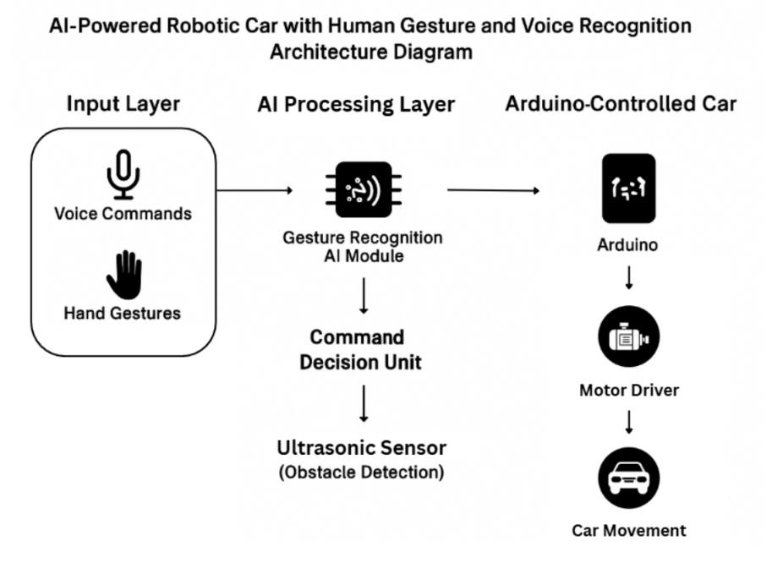

List of Components
Component | Purpose
Arduino Uno | main microcontroller
Ready-to-Build Arduino Robotic Car Kit | Includes chassis, DC motors, wheels, motor driver, and other basic parts for movement.
Motor Driver Module | Controls the direction and speed of the DC motors.
Ultrasonic Sensor (HC-SR04) | Detects obstacles in front of the car to avoid collisions.
Camera Module | Captures hand gestures
Microphone Module | Captures voice commands
Raspberry pi / Laptop | Processes gesture and voice recognition using AI models before sending commands to Arduino.
Bluetooth Module (HC-05) | Enables wireless communication between the Arduino and the AI processor

SDG Alignment:
- SDG 4 (Quality Education): Ensure inclusive and equitable quality education and promote lifelong learning opportunities for all.
- SDG 9 (Industry, Innovation, and Infrastructure): Uses AI and IoT technology to create an innovative childcare solution.
- SDG 11 (Sustainable Cities and Communities): Supports smart and safe home environments for families.

Team Composition




Abao, Christopher Aron
Team Member
Gaceta, Shekainah P.
Team Member
Balberos, Andrian S.
Team Member
Patuasic, Jun-del S.
Team Leader

