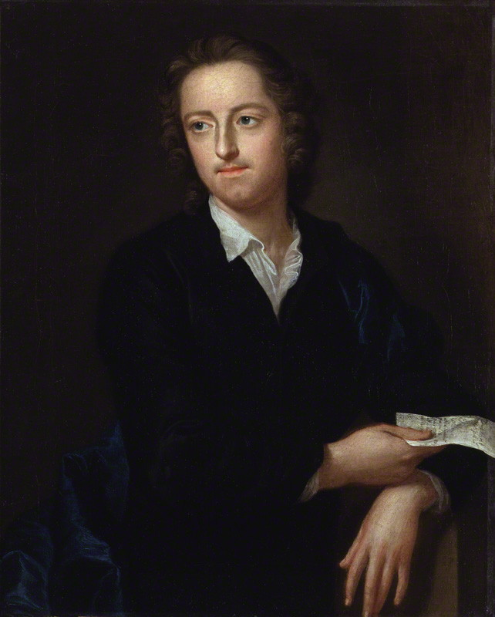

Thomas Gray (1716–1771) was an English poet, classical scholar, and a pivotal figure in the transition from neoclassicism to Romanticism. He is best known for his poem, "An Elegy Written in a Country Churchyard," and was known for being a self-critical writer who published little despite his popularity. Gray received a classical education at Eton College and Cambridge University, where he formed important friendships with Horace Walpole and Richard West. He lived a reclusive life, valued artistic integrity, and declined the offer to become Poet Laureate.
Early life and education
- Birth and childhood: Born in London in 1716, Gray was the sole surviving child of twelve; his childhood was marked by a difficult relationship with his abusive father. His mother, a milliner, was instrumental in sending him to Eton College.
- Eton College: Gray attended Eton from 1725 to 1734, where he formed a close friendship with Horace Walpole, Richard West, and Thomas Ashton, calling themselves the "Quadruple Alliance".
- Cambridge University: He entered Peterhouse, Cambridge, in 1734, where he began writing Latin poetry. He later returned to Peterhouse and eventually graduated with a law degree in 1744.
Career and later life
- Travel: From 1739 to 1741, he took a Grand Tour through Europe with Horace Walpole, a trip that broadened his appreciation for picturesque landscapes and classical learning.
- Writing and publications: Despite his high standing in his own time, Gray was a perfectionist who published very few poems in his lifetime, with "Elegy Written in a Country Churchyard" being his most famous work. He also wrote many letters that are considered to be masterful examples of the form.
- Personal life: He was deeply affected by the death of his friend Richard West in 1742, writing the poem "On the Death of Richard West" in his memory. In 1757, he was offered the position of Poet Laureate, but he declined.
- Final years: Gray was made Professor of Modern History at Cambridge in 1768, though he never gave lectures on the subject. He died in Cambridge on July 30, 1771, and was buried in Stoke Poges alongside his mother.

