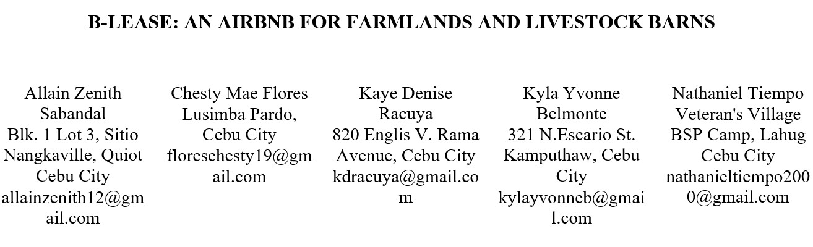

ABSTRACT

The problems of income instability for farmers and barn owners and difficulties in business scaling for agribusinesses are pertinent in today's society. B-Lease is a mobile application that links farmland and barn owners with agribusinesses interested in leasing their properties for business purposes. This study examines the B-Lease application, its features, and its potential impact on the agricultural industry.
The research methodology included a thorough examination of relevant literature and legal bases on land leasing. It also highlighted studies conducted for different land-leasing platforms employed by most users. The method also incorporated an evaluation of the B-Lease application via user validation and testing.

The analysis's findings suggested that B-Lease had a great deal of potential to simplify the renting process for both lessors and lessees, as well as to increase the overall effectiveness and profitability of the agricultural sector. Furthermore, the study revealed some obstacles and limits with the B-Lease program, such as legal and regulatory constraints, security concerns, and user interface design.

The study finishes with recommendations for dealing with these issues and improving the functionality, legal security, and usability of B-Lease. Overall, this study emphasizes the necessity and potential benefits of innovative mobile and online applications in

improving access to farms and promoting sustainable agriculture practices.

OBJECTIVES OF THE STUDY

The primary objective of the study is to design and develop a mobile online platform that aims to connect farmlands and barn owners with agribusinesses interested in renting farmlands and livestock barn properties.

Specifically, the proposed study aims to:
- Identify the root causes of the observed problem of the income instability of farmland and barn owners;
- Determine the strengths and weaknesses of existing solutions through a thorough review of related literature and studies;
- Develop an online platform that will serve as a medium for farmland and barn owners to connect with agribusinesses interested in leasing properties;
- Test the system to determine the problem-solution fit.

SCOPE AND LIMITATIONS OF THE STUDY

Scope of the Study

This study focuses on mobile applications for farmland owners, barn owners, and agribusinesses. The study aims to identify the root cause of why farmland and barn owners have unstable income, determine the efficient earning alternatives for farmland and barn owners using innovative platforms, and assess the interest level of agribusinesses in renting farms or barns for lease.

Locale of the Study

Because most Filipino owners of farmland and barns who face the validated problem have little to no access to technology to solve their concerns, the study will be carried out in the Philippines. On the other hand, customer validation covers the Visayas region, particularly Cebu. The research team gathered data only in these areas due to pre and during-pandemic restrictions and researchers' limited access to these areas.

Timeframe of the Study

This study began in August 2021 under the subject CC-RESCOM31 and will conclude in 2023 under the CAPSTONE42 course. The first phase was during CC-RESCOM31, starting with the formulation of an initial capstone project title, in which the researchers gathered ideas to decide what particular problem to address. In October, the researchers began formulating a hypothesis and, in parallel, finished the review of related literature, studies, theories, and legal bases. The research team accomplished the validation plan in the first week of November 2021. The second phase began with the subject CC-TECHNO32, which was taken in the second semester, January 2022, with researchers completing the second-stage validation, business modeling, and start-up pitching. CAPSTONE41, taking part in the project's third phase, includes producing the capstone project manuscript with chapters 1 and 2. In addition, the research team must develop the minimum viable product (MVP) that they would use for stage 3 validation/testing. The last phase will be completed in CAPSTONE42 during the second semester of class 2022-2023, with the researchers conducting user acceptance testing to obtain input from target users. The team should also be able to complete the full capstone manuscript by the subject's end and go on to the colloquium or research poster.

Respondents of the Study

Farmland owners, barn owners, and agribusinesses are the three selected target customers in this study. Farmland owners are people with an average age of 50 who have farmlands for planting crops like rice and maize to earn income and sustain families' needs. On the other hand, barn owners are individuals with an average age of 40 and above who own a barn to raise domesticated animals to produce various products like meat, dairy products, wool, fur, and the like to earn more money and support their families. The last respondents are agribusinesses with an average age of 40 who work in agricultural companies in Cebu that aim to look for pieces of land to grow various crops for their line of products. The participants of our first-stage validation are five farmland owners from Cebu, aged 28 and above. Another set of participants is the five barn owners aged 30 and up who are from Cebu City. The research team reached out to both sets of participants via Facebook Messenger. They gave their phone numbers and participated in a phone call interview. On the other hand, the researchers contacted agribusiness owners or representatives in Cebu via email, Facebook Messenger, and phone numbers. They received the survey link through their Facebook Messenger accounts. On the other hand, the team interviewed ten farmland and barn owners and ten agribusinesses during the second-stage validation through in-person interviews and online surveys. The responses, with the respondents' permission, were recorded for future reference and transcript recording.

Descriptive Research Design

The study employs a descriptive research approach in which the researchers observed and recorded the answers without providing any factors that might influence their responses. The team gathered insights through interviews (in-person and phone) and online surveys. Since the research design is quantitative, the team included survey questions that are answerable by yes or no to collect quantifiable information that will be used for analysis. However, the team also supplied open-ended questions to properly describe the research problem and the respondents’ feedback about the proposed solution. Lastly, since the researchers cannot influence the variables, the proponents executed the validation activities the same way for all respondents and did not provide changes to the environment and other conditions while conducting the interviews and surveys.

Lean Startup Methodology

For the startup development part of the proposed system, the researchers employed the Lean Startup Methodology. A lean startup methodology is an approach to developing and launching a new product or service through business-hypothesis-driven experimentations and iterative product releases. It follows the build-measure-learn cycle, so the researchers will build a Minimum Viable Product (MVP) and test if it provides value to the target beneficiaries. This methodology ensures that the proposed capstone project study achieves the product-market fit. The researchers will conduct two early-stage validations before the Lean Startup process: Problem Validation (Stage 1) and Solution Concept Validation (Stage 2). These early stages of validation will ensure that the researchers’ assumptions about the problems and solutions are correct through the design thinking process.

Stage 1 Problem Validation: Stage 1 validation, under the CC-RESCOM31 subject, was conducted to assess and prove whether the problem does exist. It aims to identify the root cause of the farmland and livestock barn owners’ income instability, determine efficient earning alternatives for them using innovative platforms, and assess the interest level of agribusiness owners in renting farms or barns for lease. There were 10 participants in the validation consisting of seven farmland and barn owners and three agribusiness owners. The proponents carried out the validation through interviews and surveys with prospective participants. Results show that 100% of farmland and barn owners confirm that the perceived problem of income instability exists, and 3/3 of agribusiness owners stated that it is important to find properties suitable for their lines of business.

Stage 2 Solution-Concept Validation: Stage 2 validation was conducted under the CC-TECHNO32 subject with early mid-fidelity prototypes. It aims to determine if the proposed solution fits the validated problem, identify the unmet needs of the existing solutions, and identify the issues that may arise when using the proposed solution. There were 20 participants consisting of 10 farmland and barn owners and 10 agribusiness owners. The validation happened through in-person and online interviews and online surveys. The proponents conducted the online interviews and surveys using Google Meet and Forms, which were provided through their Messenger accounts. The team utilized Figma to produce a mid-fidelity prototype to be shown to the testers. Results from the validation show that 100% of the farmland and barn owners agree that B-Lease solves their problem of unstable income, while 8 out of 10 agribusiness owners agree that using the solution helps them find suitable properties for their lines of business.

Stage 3 MVP Validation: Stage 3 validation will begin during IT-FRELEAN by making a Minimum Viable Product (MVP) tested by farmland owners, barn owners, and agribusinesses. It aims to ensure that farmland and barn owners are willing to lease their farmland/livestock barns to strangers and that agribusinesses are willing to use the online platform in seeking properties available for lease. It also aims to assess the most cost-effective transactional fee for the lessors. The proponents will determine if the first objective is met by measuring the number of property listings and formed contracts, customer feedback, and satisfaction rating. On the other hand, the number of leasing requests and formed contracts, customer feedback, satisfaction rating, and cost saved by the agribusinesses are the KPIs for the second objective. Lastly, survey responses will determine whether the third objective is achieved. The first set of participants for this validation are farmland and barn owners with small to large-scale farmlands and barns who want to lease their properties to agribusinesses, have the means to connect online and aim to reach a wider market to increase their income. The second respondents are agribusiness owners who are seeking a convenient way to look for farmlands/barns, have the means to connect online, and rent out farmlands/barns to grow crops/raise animals for their line of products.

During the validation, there were different methods for the two market types. The proponents created an ad campaign for farmland and barn owners through their Facebook page containing an explainer video about the concept of B-Lease. In addition, we added a “Send Message” so that they can send their property details for us to include them in our existing listings. On the other hand, the proponents launched a separate ad campaign for our target agribusinesses, containing a call-to-action button to our single-feature website where they can request to lease the available property listings.

Results from the validation showed that farmland and barn owners are willing to lease their properties as the MVP garnered six property listings. The MVP was able to collect four lease requests as the solution was given an average rating of 3.7. The lessees expressed that the solution is a good platform, has a potentially growing market, and is helpful to agribusinesses.

This study does not cover the following:
- Participants of the customer validation residing outside Cebu;
- Conducting ethnographic/field studies to places that are discouraged by the government due to safety health protocols;
- A sample size of more than 20 participants;
- Intervention regarding the contract agreement between farmland or barn owners and agribusiness owners.

Although there is already a reduction in pandemic restrictions, the government is still monitoring safety health protocols and may impose rules on some areas, which is why researchers are still limiting ethnographic/field studies, depending on the government’s announcements. The maximum number of respondents to be included in the survey was set at 20, limiting participation during the pandemic, relatively restricted, and tough to obtain. In terms of the contract agreement, the system only provides an editable template for contracts and storage for contracts management but does not intervene with the agreed negotiation between the two parties unless it violates the user terms and conditions defined by B-Lease.

SIGNIFICANCE OF THE STUDY

Given the importance of current technology in the agricultural and livestock sectors today, the outcomes of this study will assist farmlands, barn owners, and enterprises. If there are more available properties for lease, there are greater possibilities for agricultural and livestock production. Consequently, the outcome would justify the need for a faster and more life-changing solution with the assistance of modern technology. The planned research intends to provide farmlands, barn owners, and agribusinesses with a stable income.

Farmland Owners: With the help of the system, farmland owners can make a portion or the entirety of their property available for leasing. They can make their plots of land available for rent so agribusinesses can grow crops for commercial purposes. As a result, their income will be stable because firms would undoubtedly pay them regularly for their land.

Barn Owners: With the aid of the system, barn owners can provide a consistent revenue return on their land investment. Agribusinesses will utilize their area and will help them in making it conducive for livestock breeding. In addition, the majority of their property is for agricultural production, giving them the freedom to scale up or down their farm as needed.

Agribusinesses: Agribusinesses will have easy access to the available farm and barn leases in Cebu, as well as the property and its owner's basic information. They will get information on the land for lease, its size, location, price, and the land's legal documents as proof of authenticity. Finding properties to cultivate their crops or breed their livestock would be much easier since it would save them time searching for and certifying the legitimacy of the property.

Researchers: The researchers can develop a platform that will assist Barn Owners and farmland owners in marketing their holdings and ensuring a stable income. The researchers intend to commercialize the study's findings to solve the previously mentioned issues. The research will provide them with valuable insights into the system's progress to the proposed research.

Future Researchers: They are individuals looking for studies related to property leases and would like to obtain insights and relevant studies to back up their research. They can use this paper as a reference and cite it to support their analysis. In addition, this study about farmland leasing would provide them with further ideas on how to improve their research.

FUNCTIONAL DECOMPOSITION DIAGRAM

Functional Decomposition is a fundamental analysis technique that explains how every function in the design works and interacts together. It helps the proponents by breaking the overall system into successive layer pieces that hierarchically decompose the system into its functional components, decompose a business and transaction process into sub-process and provide a definition of all the functions and sub-functions identified as system requirements. The decomposition diagram, along with the associated dependency diagrams, forms a basis for system structure design and procedure design during the Design Stage. B-Lease's main functionalities include management, transactions, notifications, and reports.

"Management" is the first main functionality of the system. This consists of sub-functionalities that manage the system. Management includes sub-functionalities, one of which is the user account management that comprises the lessor, lessee, and admin accounts. Another sub-functionality is verification management consisting of user verification and property listing verification. The next sub-functionalities are property listings management, leasing management, and system admin management, which consists of admin account management and complaints management.

The second main functionality, "Transactions", consists of sub-functionalities that a user performs as he transacts with the system. Transactions consist of sub-functionalities: account registration, account verification, property listing, leasing, messaging, payments, ratings and feedback, and complaints.

The "Notifications" functionality consists of updates of the user's transactions within the system. Here, the user is notified of any changes happening in the system following the user's interaction. Its sub-functionalities include property listing approval, property inquiries, leasing contract, complaint, and payments. These sub-functionalities depend on other sub-functionalities under the other main functionalities.

Lastly, "Reports" is the fourth main functionality of the system. The sub-functionalities under it are leasing contracts, payments, user account list, admin account list, complaints list, and log-in.

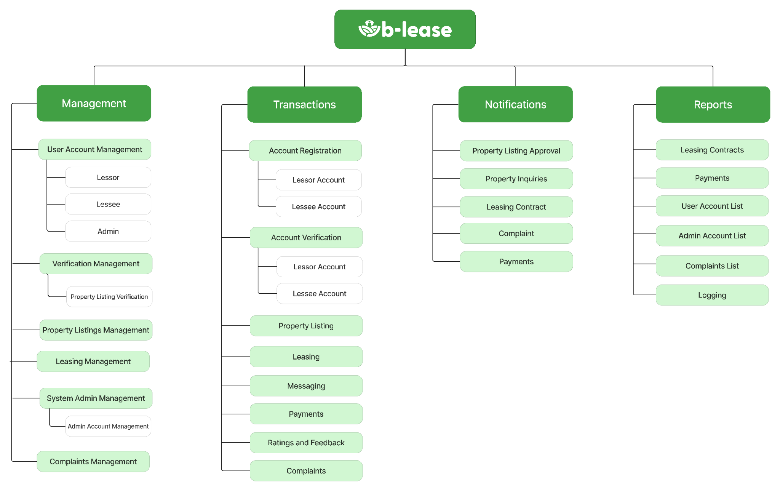

Figure 7: B-Lease Functional Decomposition Diagram

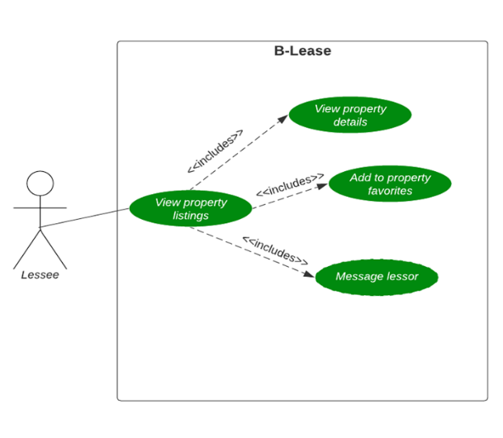
Analysis-Design Phase

This section includes the use case diagrams, storyboard, database design, and network design for the analysis and design of the proposed system.

USE CASE DIAGRAMS

A use case diagram is a graphical visualization of a user’s interaction with a system. The figures below emphasize the different types of users and their corresponding use cases in a high-level overview.

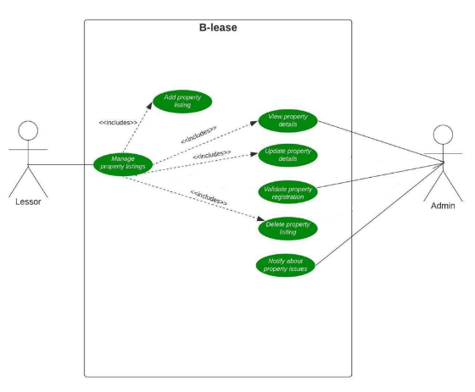
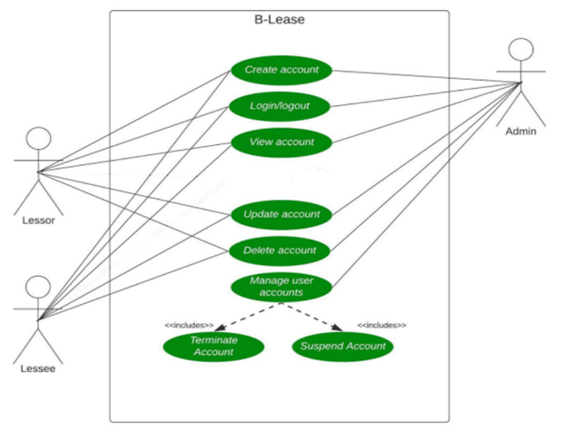

Figure 8: User Account Management Use Case Diagram

Figure 8 shows the functionalities available to the users of B-lease. It shows that they can register and log in to their accounts. They can also view and update their account. Admins can perform all the actions a user can do, including managing user accounts. They can terminate or suspend an account, given that the user violates the terms and conditions of the application B-lease.

Figure 9: Property Management Use Case Diagram
Figure 9 shows the lessors’ property management. With their available properties, the lessor can add and view property listings. They can update their land details, as well as delete listings. As for the admin side, they can view and validate property listings. Lastly, they are also responsible for notifying lessors about property issues. Lastly, they are also responsible for notifying lessors about property issues.
Figure 10: Lessees’ Use Case Diagram
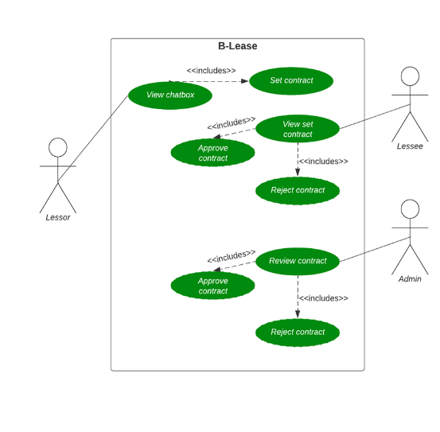
Figure 10 represents the lessees’ use case diagram. The lessee can view available listed properties and add them to the property favorites. Once it suits their choice of property, the lessee can contact the lessor, make negotiations, and wait for the contract set by the lessor.
Figure 11: Contract Management Use Case Diagram
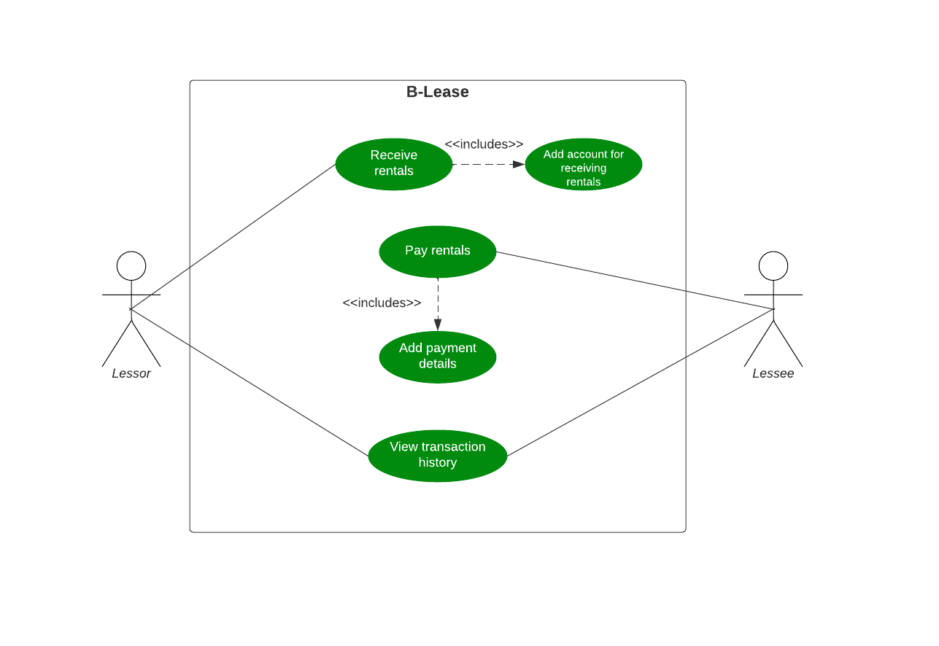
Figure 11 shows the lease request management. Lessors can set a contract by going to the chatbox between them and the lessees. Once done, lessees can view it and approve or reject it. Once both parties have a binding agreement, that contract will proceed to the admin for further review. Once the admin confirms that it goes with the terms and conditions set by B-Lease, they can approve the agreement for it to become “ongoing” (active).
Figure 12: Payment Management Use Case Diagram
Figure 12 represents the payment management in B-lease and how the lessee and lessor interact with the app during the payment process. It shows that the lessee will pay the rental fee by adding their payment details while the lessor can receive the rental fee from the account they specified on the system. Both the lessee and the lessor can view their transaction history to track the status of their payments and received rentals, respectively.
Database Design

ENTITY-RELATIONSHIP DIAGRAM

An entity-relationship diagram serves as a high-level logical data model that proves beneficial in creating a conceptual design for databases. This diagram is deemed essential and assists the team in developing a robust database design.
The Entity-Relationship Diagram for B-Lease, illustrated in Figure 29, comprises 12 logically arranged tables to represent specific interactions with other entities, thereby demonstrating the system's functionality.
These 12 tables include the user table, which encompasses data columns for the user of the proposed system, followed by the message table that stores the user's messages with other users. The third table is the property_favorites, which houses the favorite properties added by the user. The fourth table is Property, where the listed properties for leasing are stored. The leasing table, which is the fifth table, stores the leasing between the lessor and lessee. Payment, the sixth table, is where user payments within the system are stored. User_feedback is the seventh table in the system, where feedback from the users following a leasing contract is saved. The complaint table, which is the eighth table, stores the details of the complaints filed by the users. The complant_thread table, which is the ninth table, stores the updates of the complaints filed by the user. On the other hand, the admin table, which is the tenth table, stores the account credentials of the administrator. The eleventh table is the session table, where the user's sessions are stored. Lastly, the notifications table stores the notification details.
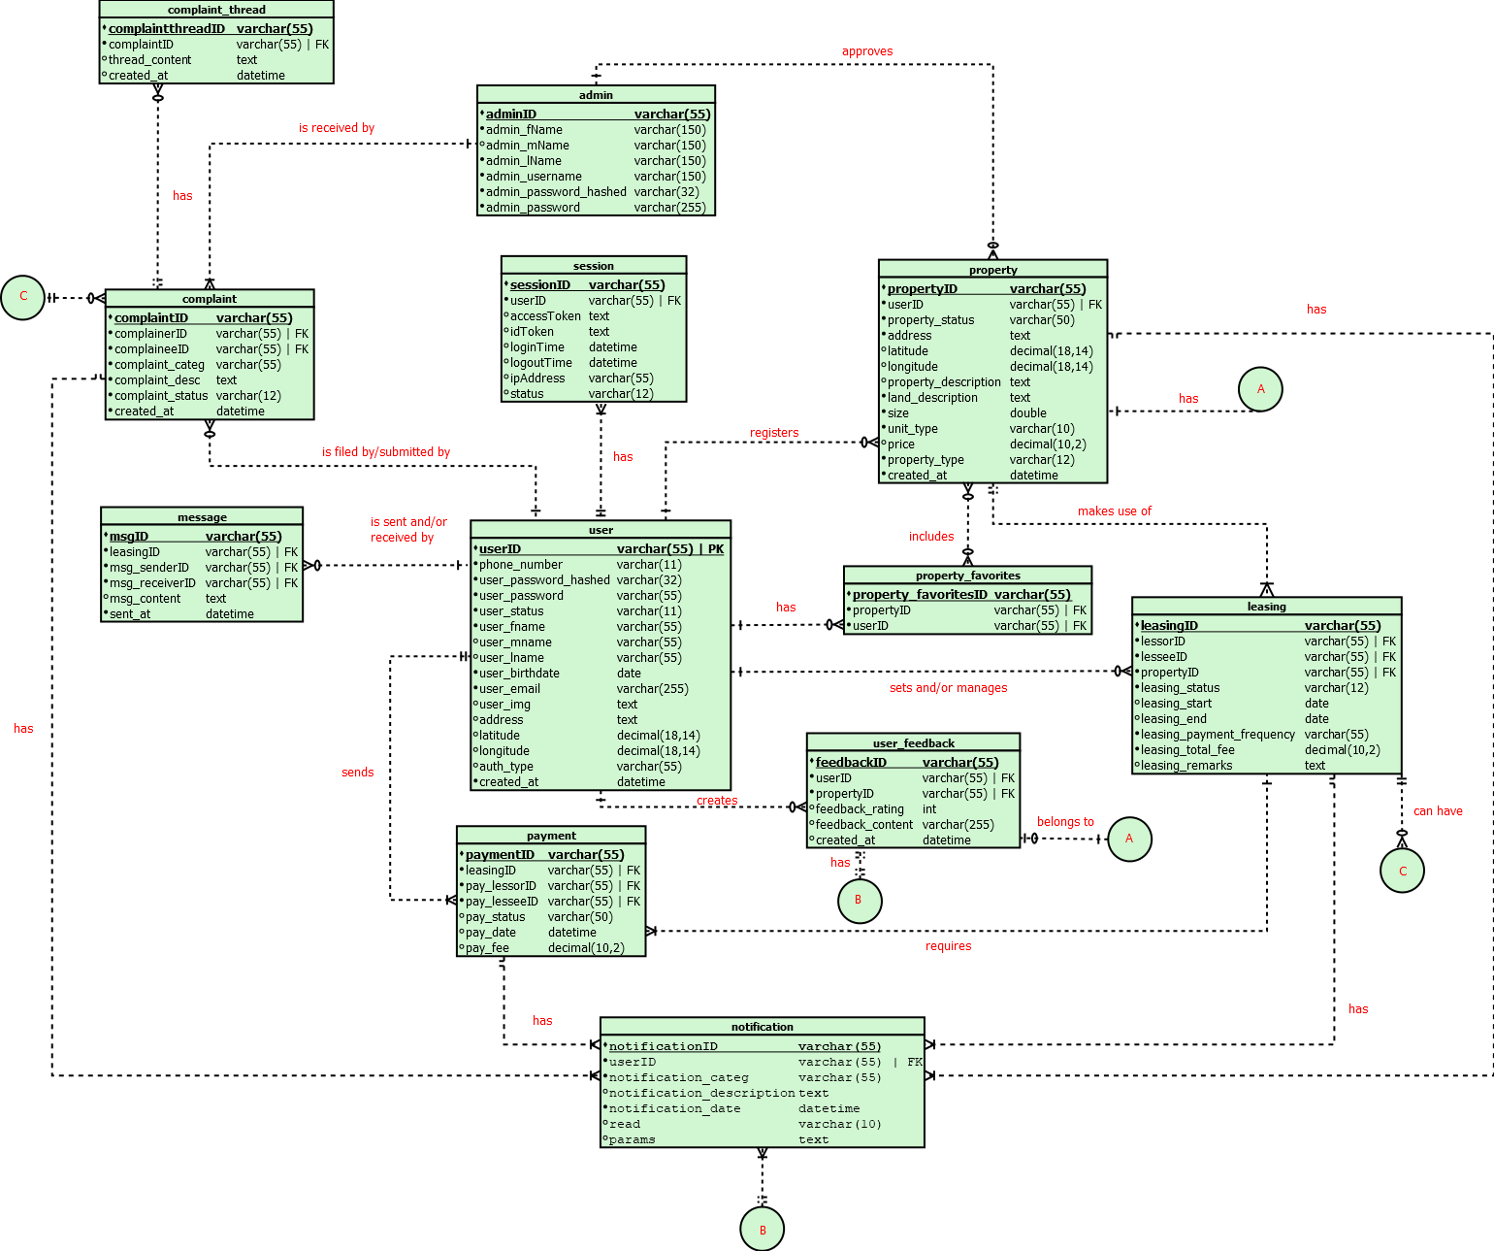
Figure 29: B-Lease Entity-Relationship Diagram

TECHNOLOGY STACK DIAGRAM

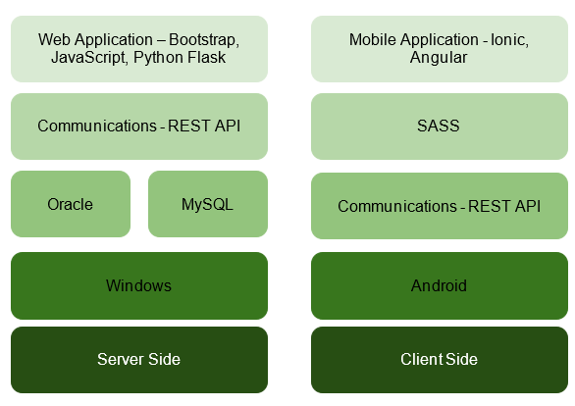

Figure 31: B-Lease Technology Stack Diagram

The technological stack of B-lease is depicted in Figure 31 above. Developers will utilize Ionic Framework and Angular for the mobile application and Python Flask, Bootstrap, and JavaScript for the web application. The team will also use REST API to send requests as well as MYSQL for database management. The mentioned technologies for the web and mobile applications offer a clean, fluid, and responsive user experience. The developed web application can be accessed primarily through Windows OS and will function as the server side. Meanwhile, the mobile application would serve as the client side and is compatible with an Android OS device.

Network Design

NETWORK MODEL
The network model of B-lease shows how nodes, network equipment, and links are connected. As long as the internet connection is available, all users can access and use the platform. Admins can access the system directly during the design phase because it is locally hosted. Since all interactions will be handled by a local server and all data will be saved in a cloud database, administrators must be online at the time of release.

NETWORK TOPOLOGY

B-Lease uses a star topology, wherein end and intermediary devices or nodes link to a central hub. The team used this topology because although a connection between an end device and the internal hub fails, it does not affect others. Moreover, since the nodes are connected directly to the hub, using the star design avoids data collisions. One disadvantage is that the entire network will fail if the central hub fails. Therefore, the hub is managed and maintained accordingly by the team.

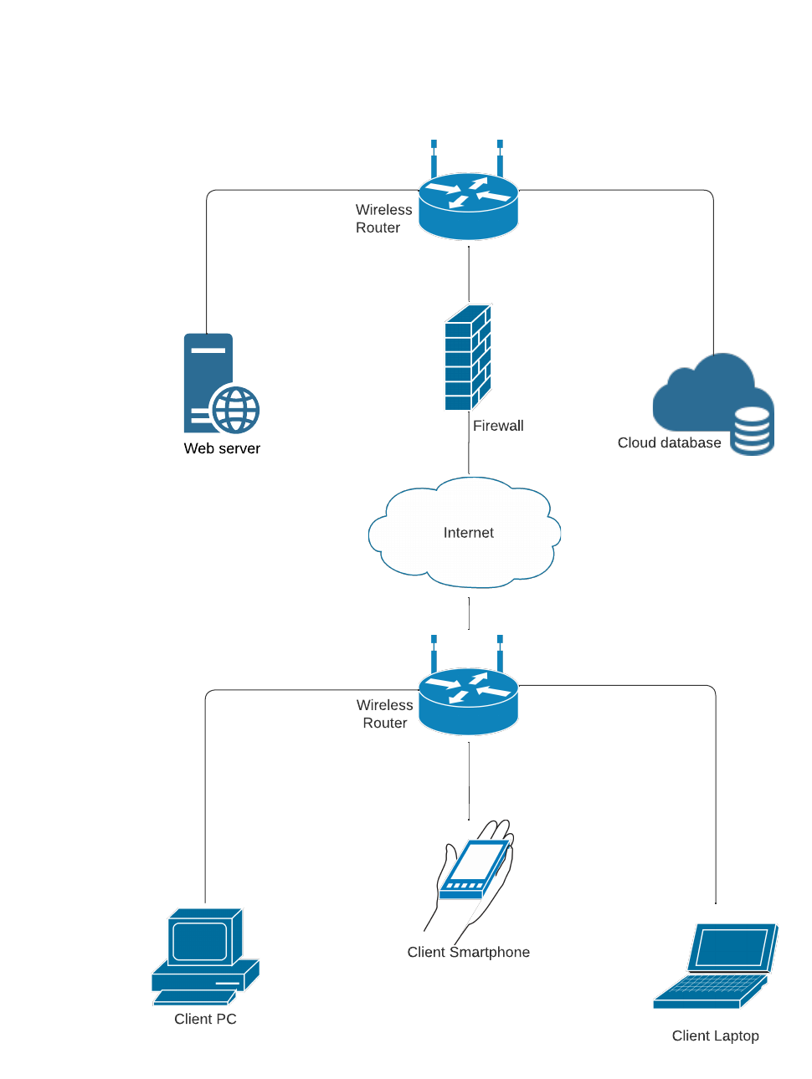

Figure 30: B-Lease Network Topology

Table 12
LIST OF MODULES
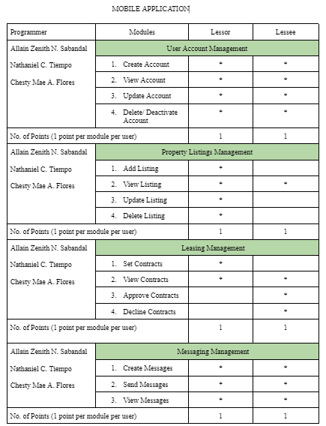
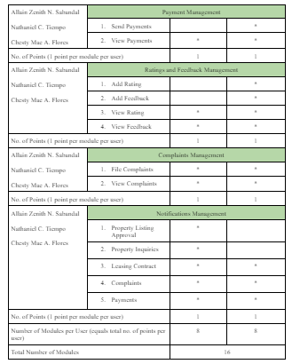
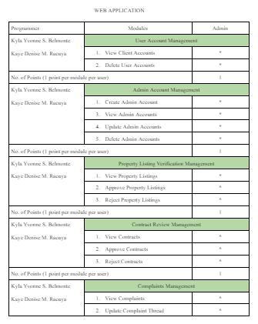
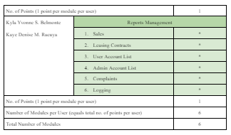

CONCLUSION
The overall purpose of this study is to create an Airbnb for farmland and barns, an online platform for farmland and barn owners to market a portion or the entirety of farmlands or livestock barns available for lease to businesses. Since the revenue generated is lease-based, farmers and stockmen will receive a stable and regular amount of earnings according to the contract established from the negotiation between the two parties.
The concept of B-Lease is to solve the unstable income of farmland and livestock barn owners and the agribusinesses' difficulty finding properties. Farmland owners who grow traditional crops, barn owners with little knowledge of livestock breeding, and agribusinesses have encountered this problem.
This difficulty arises because farmland owners have no other products they can market, and barn owners have no professional breeders to help them. On the other hand, agribusinesses need to invest resources to find suitable properties. The first problem happens as often when large crop production and livestock disease outbreaks occur.
As of now, the methods to lease farmland and barns are either through Facebook, call, or text. Some lands for lease systems may have their website or are in partnership with other businesses.
These methods are currently only applicable in a few regions. The lack of reach for lessees and lessors is a big barrier because some are not an expert at marketing their available lands and barns. Finding suitable properties for lease via social media, phone calls, and tests suffers from the same logistical issues.
As this research study concludes, the objectives outlined in Chapter 1 have been met. The study's proponents have established and built a platform for lessors to lease available lands and barns with local farm and barn owners in Cebu. Proponents believe that this study will meet the demands of lessors, land and barn owners, and agri-business owners.

RECOMMENDATIONS
B-Lease is currently in its early stages at the time of writing. It was developed within a limited timeframe and resources and therefore still has a lot to improve in terms of features, performance, and overall user experience. For future researchers who will embark on a project with the same nature as B-Lease and for the concerned people who will continue working on this project, the proponents of this study recommend the following:
- Form alliances and collaborate closely with lessors, agribusiness, lessees, organizations, and local governments.
- Partnership with Professional Lawyers and Registry of Deeds for the security and assurance of both parties;
- Detailed 3D Map integration;
- Include more payment APIs;
- Wide-range marketplace for land and barns;
- Improved dashboard with reporting from the admin and lessor’s interface;
- Partner with insurance companies and improve current policies and processes and;
- Create the app with the intention of centralizing available lands and barns for leasing in the future.

REFERENCES

Adriano, D. D. (2020, August 27). Why Filipino small farmland owners remain poor. Retrieved from https://www.manilatimes.net/2020/08/27/business/agribusiness/why-filipino-small-farmland owners-remain-poor/759852

Alvarez, J., Bakker, D., & Bezos, J. (2019, February 26). Editorial: Epidemiology and Control of Notifiable Animal Diseases. Retrieved from https://www.frontiersin.org/articles/10.3389/fvets.2019.00043/full?fbclid=IwAR3Wm2RJfaH3CG5autAVoHc3mFGG78or0UY0w7iGW3-7Xik4N_teOrEvihI#h1

APEDA. (2019, March 29). Philippines Introduces Rice Tariffication Law. Retrieved October 27, 2021, from Rice Tariffication Announcements: https://bit.ly/2ZH4kNq

Briones, R. M. (2021, February 19). Does rice tariffication in the Philippines worsen income poverty and inequality? Retrieved October 29, 2021, from Policy Notes: https://bit.ly/31lxsup

Clegg, T. A., Good, M., Hayes, M., Duignan, A., McGrath, G., & More, S. J. (2018, May 23). Frontiers in Veterinary Science. Trends and predictors of large tuberculosis episodes in cattle herds in ireland. Retrieved from https://bit.ly/3EsLqJ2

Diaz, A. C., Sasaki, N., Tsusaka, T. W., & Szabo, S. (2021, October). Factors affecting farmland owners’ willingness to adopt a mobile app in the marketing of bamboo products. Retrieved from https://bit.ly/3nMfM2k

Kime, L. (2016, March 11). Owning and leasing agricultural real estate. Retrieved from https://bit.ly/3bstba1
Paladino, S., & Janssen, B. (2016, June 3). Theories of farmer knowledge and food security. Retrieved from AnthroSource: https://bit.ly/3BuoxmF

Portera, E., & Hila, A. (2021, June). Liberating Farmland Owners from Tenancy Bondage: The Land and Agrarian Reform Programs of President Ramon Magsaysay (1954-1957). Liberating Farmland Owners from Tenancy Bondage: The Land and Agrarian Reform Programs of President Ramon Magsaysay (1954-1957), 3, 1. https://philssj.org/index.php/main/article/view/118
Republic Act No. 1199. (1969, December 31). Official Gazette of the. Retrieved December 11, 2021, from https://mirror.officialgazette.gov.ph/1954/08/30/republic-act-no-1199/

Tobias, A. M. (2019, May 23). The Philippine Rice Tariffication Law: Implications and Issues. FFTC Agricultural Policy Platform. Retrieved from https://ap.fftc.org.tw/article/1372
Udemezue, J., & Osegbue, E. (2018, April 25). Theories and models of agricultural development. Retrieved from Juniper Publishers: https://juniperpublishers.com/arr/pdf/ARR.MS.ID.555574.pdf

