**BT MYSQL**

USE classicmodels123;  
  
các bước thao tác

1

CREATE TABLE RFM_model(

CustomerNumber INT PRIMARY KEY,

CustomerName VARCHAR(255) NOT NULL,

Recency INT,

Frequency INT NOT NULL,

Monetary DOUBLE NOT NULL

);

2

USE classicmodels123;

INSERT INTO RFM_model

SELECT customerNumber, customerName, (SELECT MIN(DATEDIFF('2005/06/02', orderDate))

FROM orders

WHERE customerNumber = c.customerNumber) AS Recency,

(SELECT COUNT(*)

FROM orders

WHERE customerNumber = c.customerNumber) AS Frequency,

(SELECT IF(SUM(quantityOrdered * priceEach) IS NULL, 0, SUM(quantityOrdered * priceEach))

FROM orderDetails

WHERE orderNumber IN (SELECT orderNumber

FROM orders

WHERE customerNumber = c.customerNumber)) AS Monetary

FROM customers c;

Câu 1,2,3,4

SELECT

MAX(Recency) ,

MIN(Recency),

MAX(Frequency) ,

MIN(Frequency)

FROM RFM_Model;

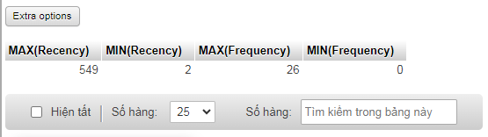

Câu 5, 6

ALTER TABLE RFM_model

ADD COLUMN Recency_score DOUBLE,

ADD COLUMN Frequency_score DOUBLE;

UPDATE RFM_model

SET Recency_score =

CASE

WHEN Recency IS NULL THEN 0

ELSE

((SELECT MAX(Recency) FROM RFM_model) - Recency) * 4 /

((SELECT MAX(Recency) FROM RFM_model WHERE Recency IS NOT NULL) - (SELECT MIN(Recency) FROM RFM_model WHERE Recency IS NOT NULL)) + 1

END,

Frequency_score =

CASE

WHEN Frequency IS NULL THEN 0

ELSE

(Frequency - (SELECT MIN(Frequency) FROM RFM_model WHERE Recency IS NOT NULL)) * 4 /

((SELECT MAX(Frequency) FROM RFM_model WHERE Recency IS NOT NULL) - (SELECT MIN(Frequency) FROM RFM_model WHERE Recency IS NOT NULL)) + 1

END;

câu 7

ALTER TABLE RFM_model

ADD COLUMN (Type VARCHAR(255));

UPDATE RFM_model

SET Type =

CASE

WHEN (0 <= Recency_Score AND Recency_Score < 2) AND (0 <= Frequency_Score AND Frequency_Score < 2) THEN 'Hibernating'

WHEN (0 <= Recency_Score AND Recency_Score < 2) AND (2 <= Frequency_Score AND Frequency_Score < 4) THEN 'At Risk'

WHEN (0 <= Recency_Score AND Recency_Score < 2) AND (4 <= Frequency_Score AND Frequency_Score <= 5) THEN "Can't Lose Them"

WHEN (2 <= Recency_Score AND Recency_Score < 3) AND (0 <= Frequency_Score AND Frequency_Score < 2) THEN 'About To Sleep'

WHEN (2 <= Recency_Score AND Recency_Score < 3) AND (2 <= Frequency_Score AND Frequency_Score < 3) THEN 'Need Attention'

WHEN (3 <= Recency_Score AND Recency_Score < 4) AND (0 <= Frequency_Score AND Frequency_Score < 1) THEN 'Promising'

WHEN (4 <= Recency_Score AND Recency_Score <= 5) AND (0 <= Frequency_Score AND Frequency_Score < 1) THEN 'New Customer'

WHEN (3 <= Recency_Score AND Recency_Score <= 5) AND (1 <= Frequency_Score AND Frequency_Score < 3) THEN 'Potential Loyallists'

WHEN (2 <= Recency_Score AND Recency_Score < 4) AND (3 <= Frequency_Score AND Frequency_Score <= 5) THEN 'Loyal Customers'

ELSE 'Champions'

END;

NOTE: Số lượng người trong mỗi kiểu khách hàng

SELECT type, COUNT(*) AS people

FROM RFM_model

GROUP BY type;

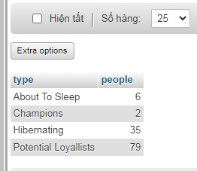

Kết quả truy vấn có 122 hàng, Bảng rfm_model hiển thị  
