Report

Group members:

Lee Hon Man Hammond (Leader)

Tsui Nok Hin Michael​

Poon Chun Hei​

Chew Ching Lam​

Wan Kwok Ho

1. Background of Path Planning to Aviation Engineering

Path planning is essential to aviation engineering as it gives well-prepared flight planning to pilots. In the sky, there are not only numerous of obstacles like mountains and aircraft, but also some special area such as time-consuming area, fuel-consuming area and jet stream area which can minimize the use of fuel and time.**[3]** Airline company wants to find the safest and the cheapest way to operate their flight in order to gain more profits and be more environmentally friendly. Aviation engineers may need to make use of the area and avoid the obstacles. However, if pilots who fly without any flight instructions, they will not know the exact way to fly correctly. As a result, they need path planning. [2]

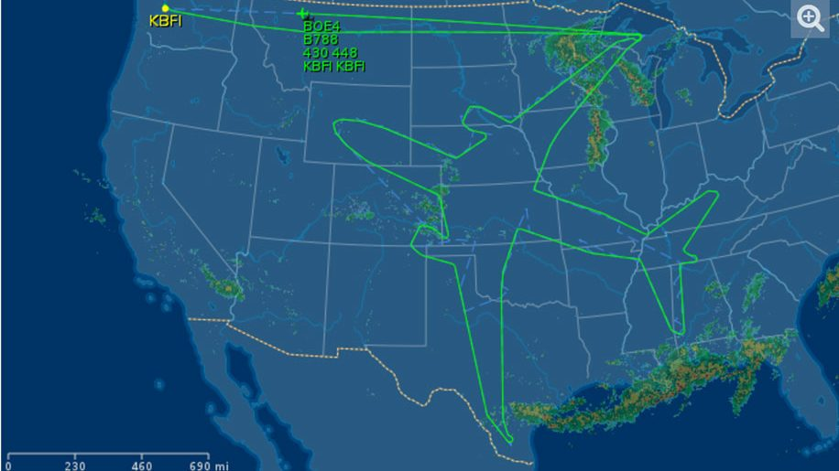

**Fig 1.**

Additionally, there are some airspace like Hong Kong have a lot of airplanes keep hovering in the sky to wait for landing. Aviation engineer can make good use of path planning to manage them in a safe and effective way. Aircraft can hover in between certain distance to avoid the thrust from one airplane cause turbulence to affect another airplane stability. Also, pilot can enter the details of path planning to the flight managing system before takeoff. Therefore, when they are cruising, they can turn on autopilot and system will follow the information of the path planning to control the aircraft. Pilot just need to check the flight instruments and thus path planning can highly reduce the workload for the pilot.

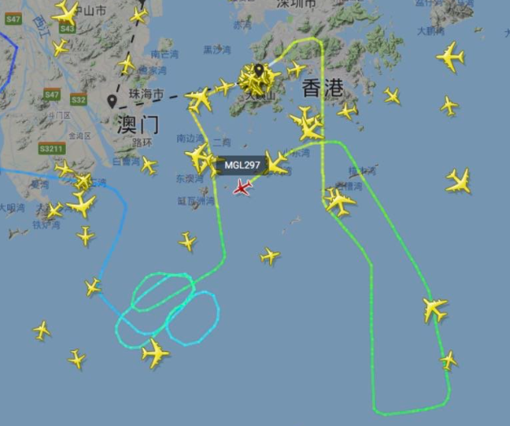 **[4]**

**Fig 2.**

1. Theory of Path Planning Algorithm

Path planning algorithm is computational problem to find the sequence of the objects like aircraft movement that move from origin to destination. The theory of Path Planning Algorithm is a very complex task. The required space will be coverd with grid and each intersection point will be grid point. The object origin and the destination will become the starting point and the end point. Obstacles and some special area can be set. The starting point will move to the near point around the starting point in order to discover the shortest distance from the starting point to the end point without touching the obstacles. Equation can be added in order to help people find the required information. For example, the definition of cost is f(x,y)=g(x,y)+h(x,y) which g(x,y) is represent to the exact cost of the path for the starting point to the coordinate of the current point, h(x,y) is representing the heuristic cost from the coordinate of current point and f(x,y) is representing the cost of the coordinate of neighboring point. Therefore, the distance of the path is directly proportional to the cost of the path needed. Path Planning Algorithm help people to find the shortest way and thus people can used it to discover the cheapest way from starting point to end point.

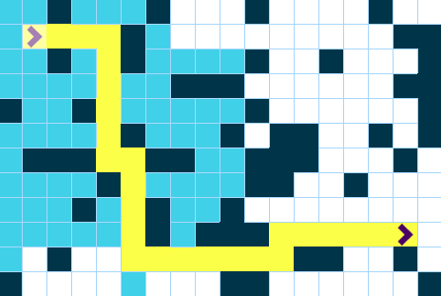

**Fig 3.**

1. Introduction of the Engineering Tools
   1. Python:

Python is a popular programming. It was created by Guido van Rossum, and released in 1991. Which is used for web development, software development, mathematics and system scripting. Engineer choose python is because it can work on different platforms. For example, Windows, Mac, Linux, Raspberry Pi. Also, it is similar to English language which makes it easy to handle and understandable.[7]



**Fig.4** The logo of python

* 1. GitHub:

GitHub is a code hosting platform for version control and collaboration. It lets you and others work together on projects from anywhere. This tutorial teaches you GitHub essentials like repositories, branches, commits, and Pull Requests. You’ll create your own Hello World repository and learn GitHub’s Pull Request workflow, a popular way to create and review code.[6]



**Fig.5** The logo of GitHub

1. Task 1: Methodology, Results and Discussion
   1. Methodology

Watch video recording and lecture notes for answer.**[1]**

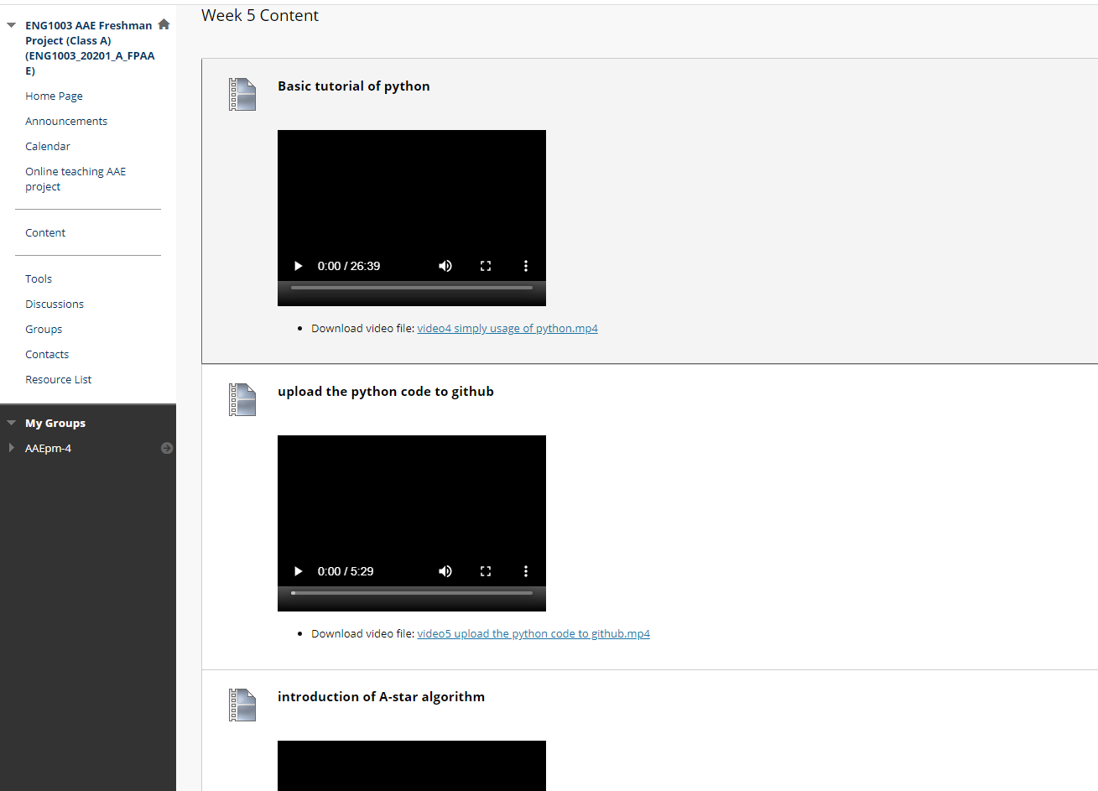

**Fig 6.** The tool for learning python

* 1. Results

Understanding the basic of python coding of A star algorithm

-path finding.

Task 1 was successfully finished with minor problems.

* 1. Discussion

During in this task, we decided to meet up in PolyU and have discussion which really helped a lot since online meeting were difficult to have instant response of others and we split up to solve different problems. For example, how we move red box and yellow box to correct area, the wall to correct place and moving start and end point to their exact location. Although, two of our members couldn’t show up, we still have discord to keep contact with them. Then we had a minor problem which we couldn’t figure out why path finding would go through walls and straight to the end point. As below Fig 7 shown.

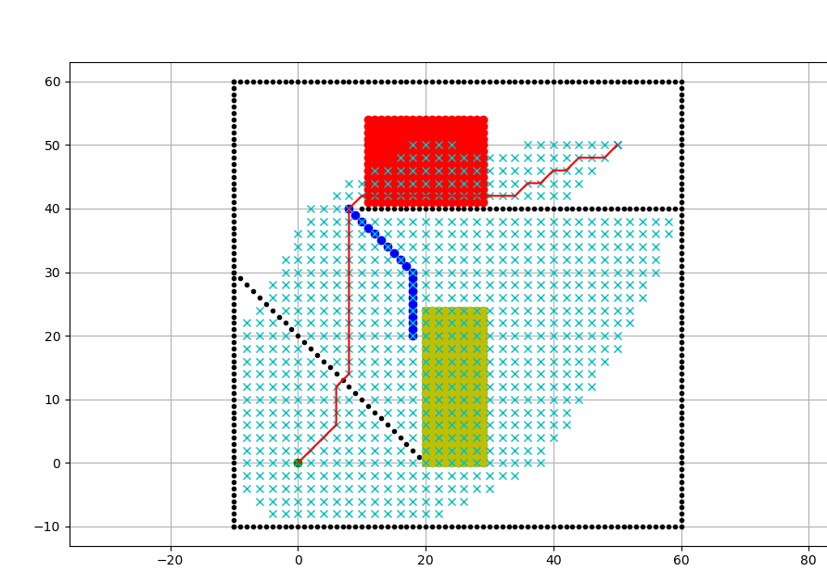

**Fig 7.**

However, we soon found out that grid size could solve the problem. As below Fig 8 shown.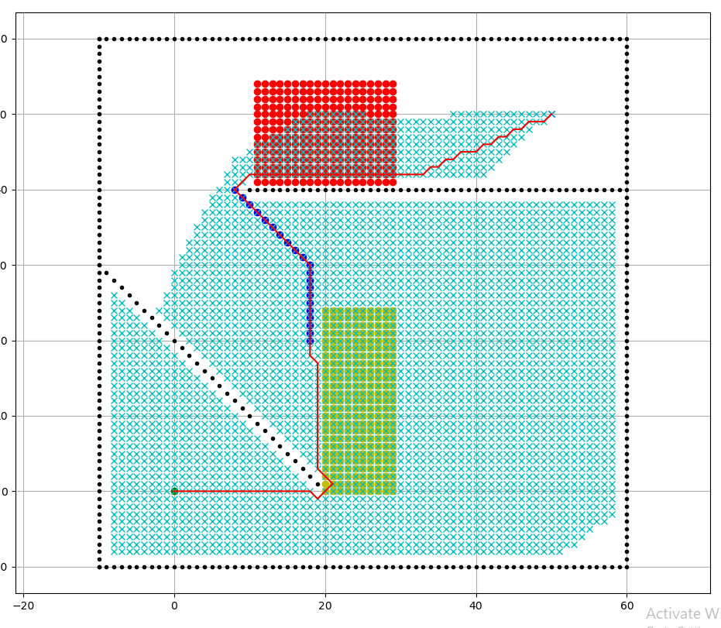

**Fig 8.**

But it took a long time to find the path, which is time-consuming, so we decided to change the program a bit and speed things up. As below Fig 9 shown.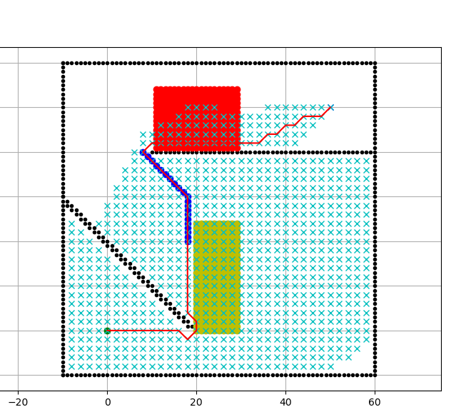

**Fig 9.**

Since we notice that grid size was 2 and the path finding only had sqrt {2} <2

Which making it phase through the wall. So, we decided to add a second line to block the gap between each point. And it turns out more convenient.

1. Task 2.1: Methodology, Results and Discussion
   1. Methodology

By using linear programming, linear programming can help us achieve the best outcome which means the lowest cost is given.

* 1. Results

The result was successful, we didn’t go into any trouble during this task.

* 1. Discussion

We were discussing how we could solve the problem since there were two constraints, then one of our groupmates said how about using linear programming, so we decided to draft the graph. However, we were afraid that we could calculate the wrong answer. Therefore, one of us suggested using desmos which is a graph calculator as shown in Fig 10.

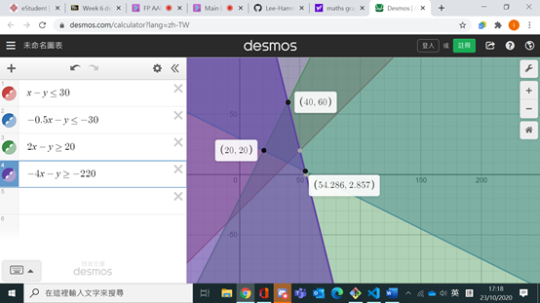

**Fig 10.**

As you could see, there are three points which represent the maximum and minimum cost for the flight, and the one with the closet to the (0,0) point will be the minimum of the cost so the answer will be (20,20).

1. Task 2.2: Methodology, Results and Discussion
   1. Methodology

To use the similar method as the task 2.2. But as there are more variables we will not be able to use linear programming to plat the graph to find out the lowest cost for the algorithm. Hence, we had tried to use the Lagrange multiplier method to find out the lowest cost for the task.

* 1. Results

We succeed to find the result in the end by using the simplest way- substitution for a few times and to calculate the lowest cost. Although we had encountered a few mistakes when substituting the results to the function, it didn’t affect the outcome to our group’s algorithm.

* 1. Discussion

As the task 2.2 has more variables than the task 2.1, which can’t be calculated by simple methods such as plotting the graph or by linear programming, hence we used the Lagrange multiplier to solve the 6 variables. From the calculation process of the algorithm and substitute the different data into the Lagrange multiplier which is to find the lowest or highest amount or several variables. However, it failed. So, in the end we decided to use substitution for the equation we had the answer of “1(9+9) +9(1+1) =36”. But when later we find out that we cannot substitute numbers with decimal points. Which after the correction, we then substitute the equation and has the answer as “2(8+9) +8(2+1) =58” and this is the final answer has been found out that the lowest cost with 4 constrains same as the task 2.1 and the 6 variables and the outcome is 58.

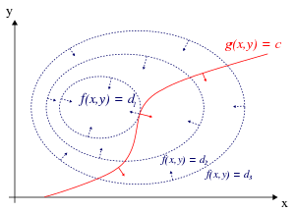

**Fig 11.** The sample of lagrange multiplier

1. Task 3: Methodology, Results and Discussion
   1. Methodology

Do research on GitHub-a star algorithm and find solution on Internet. [5]

* 1. Results

Having some problem, but in the end, task was solved.

Task was difficult, so we need to do a lot of research for the solution and it was a long journey

* 1. Discussion

We found out that task 3 was difficult than other tasks and require some knowledge on python or else will end up lost. At first, we tried copying the method how they create the fuel cost area. But it gives some error report and couldn’t run the program and check on the problems we had, keep on changing the code but no luck and nothing happened then we tried to search the problem on the Internet, but none had talked about the problem. Next, we had thought of maybe we don’t need the code that causing error because it might not be necessary as no one on the Internet talk about it. So, we decide to delete the code which cause the problem and it worked, blue box was showing, and we decided where the blue area placed. Task 3 was a challenge since we been having zero progress for few days. But in the end, we figure out the problem, and we decided to add the blue area in a unique way which result come out interesting. (Blue area is shown in Fig. 9)

1. Reflective Essay (no more than one-page for each member)
   1. Member 1-Lee Hon Man Hammond

During the freshman group project, I discovered university is different from secondary. As secondary a lot of things were prepared for us, teaching materials from start to finish are already prepared even including the solution. Therefore, not much for developing problem-solving skills. For example, in English reading questions asking about writers feeling, the teacher always has a standard answer for us about it. However, in university, there are no such things as a standard answer. We got our own method to solve the task, so when even the tutor prepared for the material, the tutor couldn’t cover that large amount of work.

In this project, I developed how to solve the problem on our own. From

asking people to search for answers on the Internet. At first, I will keep asking questions on the problem to tutor or other groupmates, but I soon find out that doesn’t work as group mates are on the same level and it is our own group project, so it is best not to ask for the answer, so I decided to search answer my own through books or Internet. And I found it effective and not troubling others. Also, I noticed that I could do a lot more than I thought as I originally thought I wouldn’t be able to understand tasks by myself as I never touched python before and before python, GitHub was chipping away my self-esteem as I was having trouble with it but later on, I also solved the problems by my own. For example, having difficulty on how to push things to GitHub since it keeps showing the error that I already push all the things, but I didn’t. I thought I was done for but when I searched for the answer the issues were taken care and I was surprised I fixed the error on my own. I never thought I could solve a problem that I don’t know much and when I am still new to it. Through this group project, I find out how much I can really handle. In the end, I master the basic knowledge on GitHub and python which I am proud of as I learned it in 5 weeks.

In conclusion, I am glad that I choose this group project. It brings me knowledge of GitHub, python, and got to know more about my limitations. From now on, I am a more independent person, not rely on others.

* 1. Member 2 Poon Chun Hei

In this freshmen project, I find out try is much better than just think and online meeting is quite difficult to communicate with others. For the first lesson, I learnt about the github and I have to open an account. I think it is quite easy so i did it quickly. However, when I need to use gitbash, I am hesitated to type the commend because I have never typed commend before, at that time I just keep finding the lecture notes and follow it but I do not know the meaning of it despite the notes have. Since online meeting is quite so difficult for me to learn, so in third lesson, i dated some of our groupmates to go back PolyU and communicate together. It is much better for me to understand the use of gitbash, github and python.

For the python, I downloaded all the software and the coding of A star algorithm from the github but I still cannot open it. It made me so annoying that I found all the lecture notes but still cannot find the solution. I started to think it is impossible for me to solve it. But then I started to search my problem from internet. I discovered some possible solutions and I tried to apply into my problem. One of the solutions work and I finally can work the coding. For changing the coding, I kept finding the notes and try to understand the concept to write the coding. But it is pretty tough to understand the concept without any trial, so I kept change it and observed the result. If it works for one step, I can mark it down and for further use. It is useful for me to understand coding and finish this task.

To conclude, in this project, i figure out that university is totally different to secondary school. Now it is focus on how we are thinking and how to solve the problem. Internet is like a huge database which we can find a lot of information form it. Secondary school will feed the information to us, but university is not. We need to be creative and think everything is possible to happen. Also, we need to learn active instead of waiting to learn.

* 1. Member 3- Michael Tsui

In this freshman project, we are required to do a flight route planning by using python and to have some special areas to simulate the different areas to be encountered in the actual world of flying. I found out that doing project is different in universities than in secondary schools. In secondary schools, we can do projects with our classmates and we know each other well. Which can have better cooperation and have a better teamwork. But in university, as the COVID-19 strikes, we can only do the project via online meetings and through the cloud systems to share our work. Which I can only see my groupmates rarely and each of us will need to rely on ourselves very much as to solve our own problem encountered.

Before the project, I have not touched python programming before and I found that it is hard to catch up for me to understand the programming language of python when I opened the path program provided by the tutors and I had to search on the internet to figure out the working principle and the grammars of the python program. I tried to ask the teammates for explanation but they also have a bit confused of the python and are also working out to figure out the grammar of the program, hence I need to figure the program language out on internet sites and thus I know how to correct the program onto our group’s own version of the program. Also, for myself, as I had not been familiar with the git hub and the git bash which I had make a few mistakes while doing the tasks 1 and uploading the photo. When I upload the photo, I had accidently covered the folder my groupmates had uploaded and needed to ask group leader to undo it which caused inconvenience to the group mates. Also, during the first task with my groupmates, my computer has experienced problem which I cannot launch the Mat plot application and thus need to find the solution online.

To conclude this project made me found out that doing a project is very different in university which I will need to depend on myself very heavily and need to solve the problem by myself or search online for the solution. Also, it's difficult for us to discuss the project as the pandemic is serious and we will need to find out the solutions to our own problem by ourselves.

* 1. Member 4- Chew Ching Lam Janette

Within this freshman seminar period, our mission is to complete a flight routine planning with GitHub and Python, which is actually quite challenging for me. As I am not familiar and good at computing, I spent much time on just opening the account and finish the first them, additionally my camper has shut down and reset itself for a few times that makes me need to start over all the work, I wasted a lot of time and brought many troubles to my teammates. Luckily, they didn't blame on me and gave me enough space and time to finish my work, and they gave me a lot of helping hands. However, because of COVID 19, we didn't discuss about the project face to face and do it together, we still tried our best and contributed great effort.

During this project, I learnt some basic knowledge and operation about computing, which I have never access before, although the process was challenging, I still enjoyed it and I am glad that I can have this opportunity to finish it with my great teammates. The hardest part is to understand some professional computing wordings, since I have to understand how and what to do before I started up the process, and I kept asking my teammates for help until I understand what they meant. And another difficult part is that I have to deal with my computer as there are many unknown problems happening in my computer but I can't solve them myself, which them makes my much harder to access to success for this project.

After finishing this project, I found out that university is really a new stage in my life, there are lots of information and references prepared for in in secondary school, but oppositely we need to find the information we need ourselves instead of just use what we have to complete a task. I learnt some new concepts about programming and gained a lot of experiences about working and communication skills, and also problem solving, this gave me a chance to know my classmates and cooperate with them.

* 1. Member 5 Wan Kwok Ho

When the lecturer was introducing the path planning by coding, I chose the AAE project as my freshman project without any hesitation, not because I am familiar with coding, but programming looks cool. However, the result is really unexpected that I faced a lot of challenges.

To begin , the teaching style in university is totally different from secondary school. The lecturers would not teach you bit by bit, hand by hand; instead, they emphasize self-directed learning. If you have any problem, try to search on the Internet by yourself first. Honestly, I feel challenged at first since I am using Macbook which its system mac os is quite different from the Windows. In the first and second lectures, I spend a while on the Internet searching “ How to install python and matplotlib on mac”. Finally, I installed it by myself and did the task 1 smoothly. However, it still leads to a severe problem after that.

The real problem had appeared during the third lecture. I can’t run the matplotlib although I have successfully installed python and matplotlib. Then I try to search for solutions as what I did before. I typed numerous command, but it still can’t work. I even created an issue on the Github looking for advice. Fortunately, one of the teaching assistants who is also using mac helped me a lot . Finally, the matplotlib works. I am sorry to my groupmates that I lost to catch up with them. Once I solved the problem, they had finished task 2 and was working on task 3.

To conclude, although facing many challenges, coding is still interesting that there are many possibilities to develop. I will definitely keep leaning programming.

1. References

[1]"Week 5 content", Learn.polyu.edu.hk, 2020. [Online]. Available: https://learn.polyu.edu.hk/webapps/blackboard/content/listContent.jsp?course_id=_88135_1&content_id=_4539869_1. [Accessed: 09- Nov- 2020].

[2] 3 Aug 2017 by Mark Caswell, Boeing uses flight path to "draw" Dreamliner across the US, Business traveler Asia-pacific

<https://www.businesstraveller.com/business-travel/2017/08/03/boeing-uses-flight-path-draw-dreamliner-across-us/>

[3] "Week 3 content", Learn.polyu.edu.hk, 2020. [Online]. Available:

<https://learn.polyu.edu.hk/webapps/blackboard/execute/content/file?cmd=view&content_id=_4516656_1&course_id=_88135_1>

[4] 7/6/2018, Variflight, twitter

<https://twitter.com/variflight/status/1004633215146045440>

[5]W. Wen, "qmohsu/test", GitHub, 2020. [Online]. Available: https://github.com/qmohsu/test/tree/master/PathPlanning. [Accessed: 10- Nov- 2020].

[6]"Hello World · GitHub Guides", Guides.github.com, 2020. [Online]. Available: https://guides.github.com/activities/hello-world/. [Accessed: 11- Nov- 2020].

[7] "Introduction to Python", W3schools.com, 2020. [Online]. Available: https://www.w3schools.com/python/python_intro.asp. [Accessed: 11- Nov- 2020].