**Document 10 – Sprint 2 Design & Video**

CS 4321 – Fall 2022

Contents

1 Document Ownership 1

2 Class Diagram 1

# Document Ownership

**This document is contained in your GitHub repository in a folder named *docs*.**

|  |  |  |  |  |
| --- | --- | --- | --- | --- |
| |  |  | | --- | --- | | Team | 5 | | Team Member Names |  |
|  | |  |  | | --- | --- | | 1. | Nakota Szymoniak | | 2. | Chris Wood | | |  |  | | --- | --- | | 3. | Lee Owen | | 4. | Munyeul Lee | |  |  | |

**Provide the link(s) to your Sprint 2 Demo. Verify that it is accessible by me if not posting on a public website like youtube. Directions for the Sprint 2 Demo are in Document 9 – Sprint 2 Plan.**

|  |  |
| --- | --- |
| Video Link(s) | https://youtu.be/W4O_0e-F30U |

# Class Diagram

|  |
| --- |
| **Deliverable**  At the conclusion of this sprint, you should make a class diagram using StarUML. You can make multiple diagrams at different levels of granularity, or just break it up. **The diagram should be included in this document along with brief remarks to explain your design. The diagram(s) must be readable. Also, include the diagrams saved as image files (jpg or png) in your *docs* folder on GitHub.** |

The images are in 4K so please zoom in. Model was not changed much from split 1. Indicators of where the GUI accesses it were added, and a new ReportHelper class was added to help in sorting objects needed for displays in various reports. Other major design changes include turning all IDs into Strings instead of ints, and making the store, customer, and order IDs generate instead of being hand entered and validated.

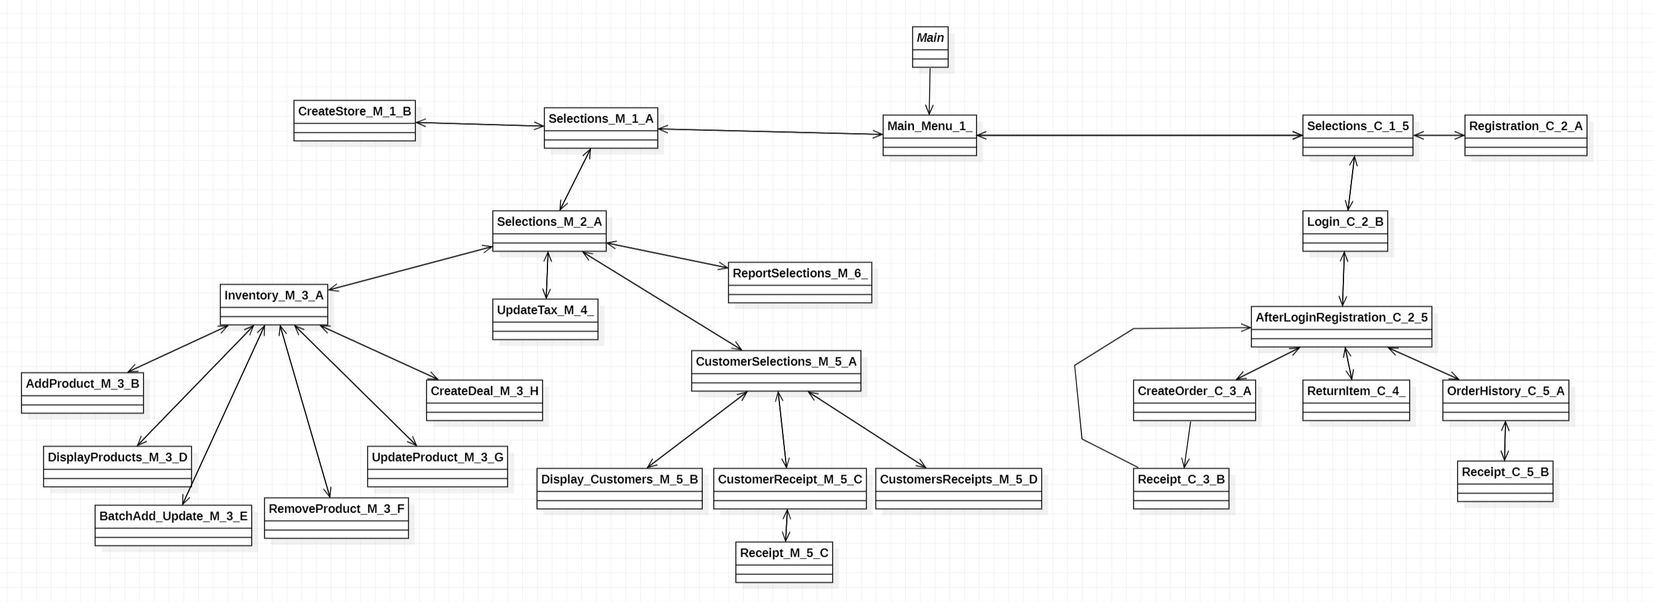

GUI was designed to for back-and-forth mobility. Every page except for after paying for an order can go all the way back to the main page. Each page is its own class so we had more clarity while designing and named based off of function, if it was manager or customer based, how deep down that “tree” it is, and then with a sub letter.