# 附录 英文翻译

英文原文

**Mining Worker Safety Helmet Using IOT**

**Abstract**

Among all professions, mining is one of the riskiest. In some nations, there are no social or safety guarantees for underground miners, and they could be left to manage on their own in the event of an injury. Displacement and destroyed livelihoods are just two examples of the detrimental societal effects. All industries included, the mining sector has the greatest rate of occupational fatalities. Rock falls, fires, explosions, methane poisoning, and electrocution are a few common reasons for workplace fatalities. Numerous case studies have been done on underground mines; nevertheless, a recent case study in China and India showed that this industry is the deadliest in the entire globe. Our improved communication technology, which must be used for an intelligent sensing and warning system in order to prevent all of these calamities, has been developed to address this problem. The communication inside the mines is done so using Wireless communication technology. Any type of industry must prioritize safety. Safety and security are key components of everything in the mining business.The mining industry takes a few simple steps to prevent accidents of all kinds.

**Keywords:** Temperature Sensors, Gas Sensors, Wireless Communication, GPS, Blynk.

# 1. INTRODUCTION

Are worried these dangers are associated with coal Industries. Therefore, worker safety should always be a top priority in all underground mining activities. Underground mining operations can be dangerous for both the health and safety of workers. These dangers result from the various methods used to extract the various minerals. The risk increases with the depth of the mine. These safety concerns are quite important, particularly for the coal industry. Therefore, whether mining for coal or any other minerals, worker safety should always be a top priority. Due to ventilation issues and the possibility of a collapse; underground coal mining entails a higher risk than open pit mining. However, all types of mining have safety risks due to the use of heavy equipment and excavation techniques.

As a result of the numerous safety measures, worker education and training programs, and health and safety regulations that are frequently implemented in modern mines, both open-pit and underground mining have seen significant changes and advancements in safety. The principal source of energy in India has always been coal, and this has greatly accelerated the country's industrial development.

It is essential to the generation of about 70% of the power. Consequently, coal's significance in the energy sector is crucial. However, the process also creates additional byproducts, which pose a possible risk to the environment and the nearby population. Instead, the current study is a sincere effort to evaluate the seriousness and create a real-time monitoring system of detection using Wireless Technology (Wi-Fi) and RF transmitter and receiver.

# 2. LITERATURE REVIEW

Safety of the mining workers is the most important aspect in the mining industry as the mining workers will face lot of risk in the deep mines like Miners collide with heavy objects which risk their life. And miners can inhale hazardous gases that put their life in danger. When there are situations like these occur the miners will be not able to communicate with outside mining people or staff. No sensors have been used in the mining industries back then and there was no information available about environmental conditions around mining areas. And there was no tracking system available to track miners location when the miners are in danger and miners helmet were not deployed with panic button or emergency button when the mining worker is at risk so it was very difficult for miners to communicate to the control room earlier days.

Now with the proposed safety helmet miners can interact with the outside control unit and take the necessary steps when there life is in stake. And there are sensors which can check the environmental conditions in the mining area and can give clue about the upcoming hazardous situations which can be faced by the mining worker during mining job through wireless network or through RF technology and there is a GPS system to track miners location and a panic button is available in the miners helmet he/she can press the panic button when there life is in danger.

# 3. COMPONENTS USED

## 3.1 Ardunio UNO Mircocontroller

A microcontroller board based on the Atmega328P.It has 14 digital input/output pins (of which 6 can be used as PWM outputs), 6 analog inputs, a 16MHz quartz crystal, a USB connection, a power jack, an ICSP header and a reset button. Connect it to a computer with a USB cable or power it with an AC-to-DC adapter or battery to get started.

## 3.2 Node MCU

NodeMCU is an open source firmware developed on the ESP8266 that enables Wi-Fi connectivity and data transmission. The firmware uses the Lua scripting language. It has micro-controller Tensilica 32-bit RISC CPU Xtensa LX106 and has 16 digital I/O pins and 1analog input pin and has a Input Voltage of 7-12V.

## 3.3 Temperature Sensor

A tool used to measure temperature is called a temperature sensor. This might refer to the temperature of the air, a liquid, or a solid. There are various kinds of temperature sensors available, and they all monitor temperature using various technologies and philosophies.

## 3.4 Gas Sensor

A gas detector is a tool that checks for the presence of gases in a space, frequently as a safety measure. Operators in the vicinity of the leak may hear an alarm from a gas detector, giving them the chance to flee.

## 3.5 GPS Module

Small processors and antennas found in GPS modules are used to directly receive data from satellites using specific RF frequencies. From there, it will get data from various sources, including timestamps from all visible satellites.

## 3.6 Push Button

A push-button, often known as a pushbutton or just a button, is a basic switch mechanism used to regulate various functions of a machine or process. Usually constructed of metal or plastic, buttons are made of strong materials.

## 3.7 RF transmitter

A tiny PCB sub-assembly called an RF transmitter module may send a radio signals and modulate that signal to carry data. Typically, microcontrollers are used in conjunction with transmitter modules to supply the module with data that may be communicated.

## 3.8 RF Receiver

The RF Receiver has four pins namely: Vcc, Dout, Linear Out, and Ground. The Vcc pin should be supplied by a controlled 5V supply. Less than 5.5mA is the working current for this module. The pins Dout and Linear out are coupled by a short circuit in order to collect the 433 MHz signal from of the air. This signal is then transferred via the data port following demodulation to obtain data.

## 3.9 Software Used

### 3.9.1 Arduino IDE

A program for Arduino may be written in any programming language for a compiler that produces the binary machine code for the target processor. Atmel provides a development environment for their microcontrollers, AVR studio and the newer Atmel Studio. The Arduino project provides the Arduino integrated development environment, which is cross platform application written in the programming language Java. It originated from the IDE for the languages Processing and Wiring.

### 3.9.2 Blynk Cloud

For online control of devices like Arduino, Raspberry Pi, and others, there is a platform called Blynk that has apps for iOS and Android. You can create a graphic interface for your project by simply dragging and dropping widgets on a digital dashboard.

# 4. PROPOSED SYSTEM

Ensuring the protection of miners in the event of mining mishaps brought on by a rise in temperature and pressure. To facilitate communication between underground coal mine workers and those outside the mines.

Must monitor the conditions in the mines and notify miners of any emergencies.

The location of miners can be followed via GPS. The suggested system uses the Internet of Things (IOT) so that it can early on detect and track the location of miners as well as dangerous gases at the mining area.

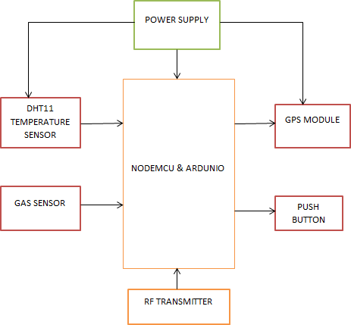

Fig4.1 Helmet Unit

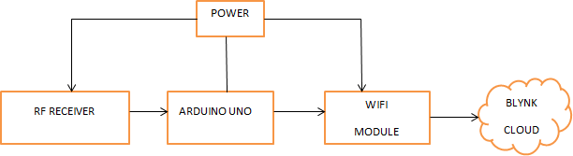

Fig4.2 Control Unit

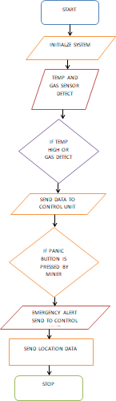

Fig4.3 Flowchart Helmet Unit

Two modules are included in the design: a helmet module and a control room module.

Numerous sensors, a microprocessor, antennae, encoders, decoders, etc. are included in the helmet module. In the wireless sensor network, the helmet unit side functions as an clever, transmitter. The GPS module and push button for location tracking and notifications are part of the control room module. The sensors are used to assess fluctuations in temperature, humidity and gas in order to preserve the security of the mine workers, and judgments regarding the necessary actions are made based on historic data. The geolocation of the mining area miners for their protection on a hazardous operation base is likewise guaranteed by Wi-Fi technology and RF transmitter and receiver. As a result, the suggested method guarantees security and trustworthy wireless communication inside the mines.

For monitoring the temperature, humidity, and gas sensor data in this project, we're using the Blynk cloud. The Blynk software will be updated with new sensor data. The Blynk software will notify the control room if the temperature exceeds the set value. Similarly, the control room will be notified by the Blynk software if the gas sensor detects any gas. Additionally, the helmet module has a push button that, when activated in the event of an accident, notifies the control room. Additionally, the helmet has a GPS module that allows the control room to follow the miner's location in the event of an accident, saving the miner from harm.

# 5. EXPERIMENTAL RESULTS

Thus, the suggested system was effectively built as illustrated in fig.3, and it aids in warning the centralized terminal in the event of emergency situations. When there are anomalies in the sensor data, GPS can be used to track the miners' location.

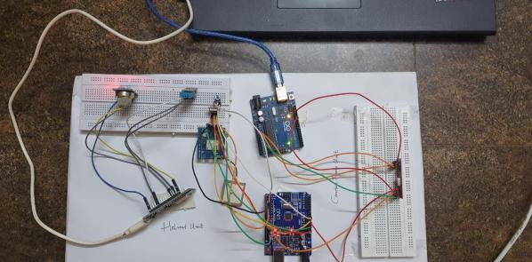

Fig5.1 Prototype of the project

In underground coal mining locations, the sensors are connected to an Atmega microcontroller or Ardunio Uno that reads the value and transmits it over Wi-Fi to the blynk application installed for the helmet. One can view the real-time sensor readings using the Blynk application. The Blynk application will notify the control room if the sensor reading exceeds. Additionally, there is an RF transmitter and receiver to transmit data in the event that Wi-Fi is unavailable.

Additionally, the helmet device has an alarm button that, when pressed in an emergency, notifies the control room.

Additionally, a GPS tracker is built into the helmet module to allow emergency personnel to locate the miner.

When Wi-Fi is unavailable, we can still transfer data using RF technology because the helmet unit has an embedded RF transmitter and the control room unit has an attached RF receiver.

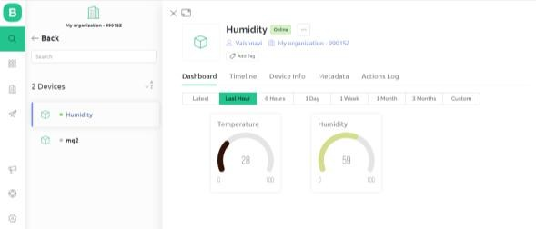

Fig5.2 Temperature and Humidity Readings in Blynk

# 6. CONCLUSION AND FUTURE SCOPE

In the mining industry, safety has always been a concern, particularly in depth level mining. Even while mining is much safer now than it was in earlier decades, accidents sometimes happen. According to official statistics, 5,000 Chinese miners perish in accidents every year. Worldwide, there are still many mining mishaps that result in dozens of fatalities at once, such as the 2009 Heilongjiang mine explosion in China, the 2010 Upper Big Branch Mine disaster in the United States, and the 2007 Ulyanovskaya Mine tragedy in Russia. There are numerous safety devices.

Are offered on the market. But the Smart Helmet distinguishes out from the rest because to its advantageous design and potential. Because, in contrast to other safety equipment, it facilitates ongoing worker monitoring in mines. Alteration in the environment can be tracked with the use of a smart helmet, and the required safety measures can be implemented. Additionally, it provides a method for tracking the location of the mining worker, allowing the evacuation crew to offer timely assistance in dangerous situations. The future developments and process operations for the control room unit can be made for the mentioned purposes.

Future smart helmets may have additional sensors to increase the level of safety they offer. Using a more advanced power source that can give electricity for a very long time can also improve the functioning of the smart helmet. A power source that provides continuous protection over a long length of time will reduce the likelihood of danger. Thus, the Smart Helmet technology can stop accidents in deep mines all around the world. When compared to other communication methods, radio frequency technology and Wi-Fi is less expensive. Thus, radio frequency technology-based and Wi-Fi technology smart helmets are the nations underground miners' lifesaver.

# REFERENCES

1. C.J Behr, A.Kumar and G.P Hancke proposed “A Smart Helmet for Air Quality and Hazardous Event Detection for Mining Industry”.
2. Shabina .S, “Smart Helmet Using RF and WSN Technology for Underground Mines Safety”.
3. “An Intelligent Helmet for Miners with Air Quality and Destructive Event Detection using Zigbee”
4. GPS Based Real Time Vehicle Tracking System for Kid’s Safety Using RFID and GSM Amit Bhoyar, Nagpur Institute of Technology , Nagpur, Maharashtra Rajeev Varma raj, Nagpur Institute of Technology, Nagpur Maharashtra.
5. GPS Tracking System Amany El Goubary, Richard Wells, Anthony Thatcher.
6. Burke, S.E. and Rosenstrach proposed a novel sonar sensor is described which utilizes two coincident, distributed shaded methane sensor, and C02 sensors to provide high resolution target bearing estimates.
7. Michael Zuba, Carlos Villa, Alexandra Byrd proposed about an Autonomous Coalmine System (AUV) networks are becoming increasingly popular in scientific commercial.
8. “A Smart Helmet for Improving Safety in Mining Industry” by A. Dhanalakshmi and P. LathaPriya.K.Divya, Panimalar Engineering College, Chennai India.
9. “Smart Helmets for Safety in Mining Industry” by Rohith Revindran (Department of Electrical and Computer Engineering, Technical University of Munich,Germany), Hansini Vijayaraghavan(Department of Electrical and Computer Engineering , Technical University of Munich , Germany) , Mei-Yuan Huang (Department of Electrical and Computer Engineering , Technical University Of Munich, Germany).
10. “Wireless Sensor Network based Coal Mine Wireless and Integrated Security Monitoring Information System”-Yang Wei, Huang Ying, ICN ’07 Sixth International Conference, pp.13-17, 22-28 April, 2007.
11. “Underground Structure Monitoring with Wireless Sensor Networks. Information Processing in Sensor Networks”,-Mo Li, Yunhao Liu, IPSN 2007.6th International Symposium on 25-27 April 2007, pp 69-78.
12. “Multi-parameter Monitoring System for Coal Miners based on Wireless Sensor Network Technology” – S Wei, Li-li, Proc. International IEEE Conference on Industrial Mechatronics and Automation, pp 225-27, 2009.
13. “A survey of wireless Communications and propagation modeling in underground mines”-E Forooshani,
14. B. Bashir, D.G Michelson and S.Noghanian, IEEE Communications Surveys and Tutorials, B vol.15, no.4, pp.1524-1545, Nov 2013.
15. “Truck Traffic Speed Prediction under Non-Recurrent Congestion: Based on Optimized Deep Learning Algorithms and GPS data” – Jiandong zhao, Yuan Gao3 Jiangtao Li, Yingzi Fengi.
16. “Analysis of Radio Frequency Interference due to High-Speed digital Signals”- Jihoon Kim, Jisoo Hwang, Eunseok Song and Soyoung Kim.

中文翻译

基于物联网的矿工安全头盔

摘要

在所有职业中，采矿是风险最高的职业之一。在一些国家，地下矿工没有社会或安全的保障，受伤时可能只能自行应对。采矿还会导致流离失所和生计破坏等负面社会影响。在所有行业中，采矿业的职业死亡率最高。岩石坠落、火灾、爆炸、甲烷中毒和触电是导致工作死亡的常见原因。尽管已经对地下矿井进行了许多案例研究，但中国和印度最近的案例研究表明，该行业是全球最致命的行业。我们开发了改进的通信技术，用于智能传感和预警系统，以防止所有这些灾难，解决了这一问题。矿井内的通信使用无线通信技术完成。任何类型的行业都必须将安全放在首位。安全和保障是采矿业一切工作的关键组成部分。采矿业采取了一些简单的措施来预防各种事故。

**关键词**：温度传感器；气体传感器；无线通信；全球定位系统；Blynk

# 第1章 引言

煤炭行业面临着很多的危险，因此，在所有地下采矿活动中，工人的安全应始终是首要任务。地下采矿作业对工人的健康和安全构成威胁，这些危险源于开采各种矿物的不同方法。随着矿井深度的增加，风险也随之增加。这些安全问题对于煤炭行业尤为重要。因此，无论是开采煤炭还是其他矿物，工人的安全都应始终是重中之重。由于通风问题和坍塌的可能性，地下煤矿开采比露天开采风险更高。然而，由于使用重型设备和挖掘技术，所有类型的采矿都存在安全风险。

由于现代矿井经常实施大量安全措施、工人教育和培训计划以及健康和安全法规，露天采矿和地下采矿在安全方面都发生了重大变化和进步。煤炭一直是印度的主要能源，极大地促进了该国的工业发展，约70%的电力生产都依赖煤炭。因此，煤炭在能源领域的重要性至关重要。然而，这一过程也会产生其他副产品，可能对环境和附近居民构成一定的风险。当前的研究是一项真正致力于旨在评估危险性，并利用无线技术（Wi-Fi）和射频发射器及接收器创建一个实时监测的检测系统。

# 第2章 文献综述

采矿工人的安全是采矿业最重要的方面，因为矿工在深矿中面临许多风险，例如与重物碰撞，这会危及他们的生命，还可能吸入危险气体。当这些情况发生时，矿工无法与矿外人员或工作人员沟通。过去，采矿业没有使用传感器，也没有关于采矿区域周围环境条件的信息，当矿工处于危险之中的时候，没有可用的跟踪系统来跟踪他们的位置，矿工的头盔也没有配备紧急按钮，因此在早期，矿工很难与控制室沟通。

现在，使用建议的安全头盔，矿工可以与外部控制单元互动，并在生命受到威胁时采取必要措施。还有传感器可以检查采矿区的环境条件，并通过无线网络或射频技术提示矿工在采矿作业中可能面临的即将发生的危险情况，还有一个全球定位系统来跟踪矿工的位置，矿工的头盔上有一个紧急按钮，当他们的生命处于危险之中时，可以按下该按钮。

# 第3章 所用组件

## 3.1 Arduino UNO微控制器

基于Atmega328P的微控制器板，它有14个数字输入/输出引脚（其中6个可用作PWM输出）、6个模拟输入、一个16MHz石英晶体、一个USB接口、一个电源插孔、一个ICSP插头和一个复位按钮。通过USB电缆将其连接到计算机，或使用交流到直流适配器或电池为其供电即可启动。

## 3.2 Node MCU

NodeMCU是在ESP8266上开发的开源固件，支持Wi-Fi连接和数据传输，该固件使用Lua脚本语言，具有Tensilica 32位RISC CPU Xtensa LX106微控制器，有16个数字I/O引脚和1个模拟输入引脚，输入电压为7-12V。

## 3.3 温度传感器

温度传感器是一种用于测量温度的工具，这可能指的是空气、液体或固体的温度。有多种类型的温度传感器可用，它们都使用不同的技术和原理来监测温度。

## 3.4 气体传感器

气体探测器是一种检查空间中是否存在气体的工具，通常作为安全措施。泄漏附近的操作人员可能会听到气体探测器发出的警报，从而有机会逃离。

## 3.5 全球定位系统模块

全球定位系统模块中的小型处理器和天线用于通过特定射频直接从卫星接收数据，从那里，它将从各种来源获取数据，包括所有可见卫星的时间戳。

## 3.6 按钮

按钮，通常称为按钮或按键，是一种用于调节机器或过程的各种功能的基本开关机制。按钮通常由金属或塑料制成，采用坚固的材料。

## 3.7 射频发射器

射频发射器模块是一个小型PCB子组件，可以发送无线电信号并对该信号进行调制以承载数据。通常，发射器模块与微控制器结合使用，为模块提供可通信的数据。

## 3.8 射频接收器

射频接收器有四个引脚，分别是：电源引脚（Vcc）、数据输出引脚（Dout）、线性输出引脚（Linear Out）和接地引脚（Ground）。电源引脚（Vcc）应由受控的5V电源供电。该模块的工作电流小于5.5毫安。数据输出引脚（Dout）和线性输出引脚（Linear Out）通过短路耦合，以便从空气中收集433兆赫兹的信号。然后，该信号在解调后通过数据端口传输以获取数据。

## 3.9 所用软件

### 3.9.1 Arduino集成开发环境

Arduino程序可以用任何编程语言编写，用于为目标处理器生成二进制机器代码的编译器。Atmel为其微控制器提供了一个开发环境，即AVR studio和较新的Atmel Studio。Arduino项目提供了Arduino集成开发环境，这是一个用编程语言Java编写的跨平台应用程序，它源自Processing和Wiring语言的集成开发环境。

### 3.9.2 Blynk云

Blynk是一个平台，用于在线控制Arduino、树莓派等设备，有iOS和Android应用程序。你可以通过在数字仪表板上拖放小部件来为你的项目创建图形界面。

# 第4章 拟议系统

确保在温度、压力升高导致采矿事故时保护矿工，便于地下煤矿工人与矿外人员进行外部通信，必须密切关注矿井中的情况，并在任何紧急情况下通知矿工，矿工的位置可以通过全球定位系统跟踪。拟议的系统使用物联网（IOT），以便及早检测和跟踪矿工的位置以及采矿区的危险气体。



图4.1 安全帽单元



图4.2 控制单元



图4.3 安全帽流程图

设计中包括两个模块：头盔模块和控制模块。

头盔模块包括许多传感器、微处理器、天线、编码器、解码器等。在无线传感器网络中，头盔单元端用作智能发射器。控制室模块包括用于位置跟踪和通知的全球定位系统模块和按钮。传感器用于评估温度、湿度和气体的波动，以确保矿工的安全，并根据历史数据做出必要行动的判断。Wi-Fi技术和射频发射器及接收器也确保了采矿区矿工在危险作业基地的地理位置安全。因此，建议的方法确保了矿井内的安全和可靠的无线通信。

在这个项目中，我们使用Blynk云来监控温度、湿度和气体传感器数据，新的传感器数据将更新到Blynk软件中。如果温度超过设定值，Blynk软件将通知控制室。同样，如果气体传感器检测到任何气体，控制室也会收到Blynk软件的通知。此外，头盔模块有一个按钮，在发生事故时按下该按钮会通知控制室。此外，头盔有一个全球定位系统模块，允许控制室在发生事故时跟踪矿工的位置，使矿工免受伤害。

# 第5章 实验结果

在实验中，成功构建预期的系统，它有助于在紧急情况下警告集中终端。当传感器数据出现异常时，全球定位系统可用于跟踪矿工的位置。

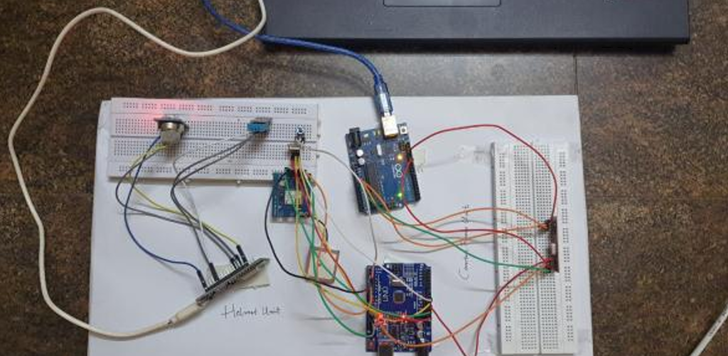

图5.1 工程原型

在地下煤矿地点，传感器连接到Atmega微控制器或Arduino Uno，微控制器读取数值并通过Wi-Fi传输到为头盔安装的Blynk应用程序。人们可以使用Blynk应用程序查看实时传感器读数，如果传感器读数超过设定值，Blynk应用程序将通知控制室。此外，还有一个射频发射器和接收器，用于在Wi-Fi不可用时传输数据。

此外，头盔设备有一个报警按钮，在紧急情况下按下该按钮会通知控制室。此外，头盔模块内置了一个全球定位系统跟踪器，以便应急人员可以定位矿工。

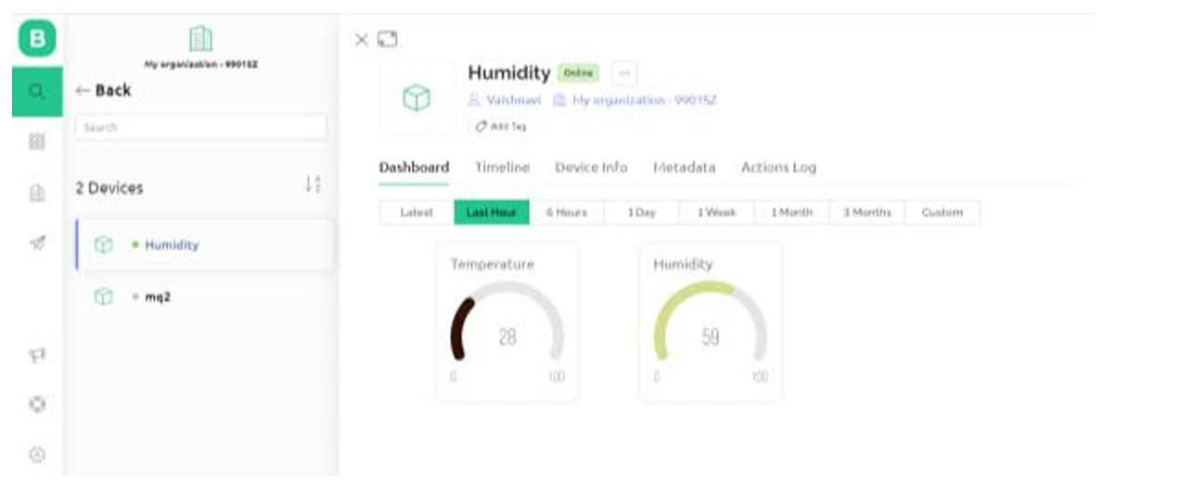

图5.2 Blynk中的温度和湿度读数

# 第6章 结论与未来展望

在采矿业中，安全一直是一个关注点，尤其是在深度采矿中。尽管现在采矿比前几十年安全得多，但事故有时仍会发生。官方统计数据显示，中国每年有5000名矿工死于事故。在全球范围内，仍有许多采矿事故一次导致数十人死亡，如中国2009年黑龙江矿难、美国2010年上大分支矿难和俄罗斯2007年乌里扬诺夫斯卡亚矿难。市场上有许多安全设备，但智能头盔因其有利的设计和潜力而与众不同。因为与其他安全设备不同，它有助于持续监控矿井中的工人。使用智能头盔可以跟踪环境的变化，并采取必要的安全措施。此外，它还提供了一种跟踪采矿工人位置的方法，使疏散人员能够在危险情况下及时提供帮助。为了上述目的，可以对控制室单元进行未来的开发和工艺操作。

未来的智能头盔可能会配备更多传感器，以提高其提供的安全水平。使用可以长时间供电的更先进电源也可以改善智能头盔的功能。提供长时间持续保护的电源将降低危险的可能性。因此，智能头盔技术可以阻止世界各地深矿中的事故。与其他通信方法相比，射频技术和Wi-Fi成本较低。因此，基于射频技术和Wi-Fi技术的智能头盔是各国地下矿工的救星。

# 参考文献

1. C.J Behr, A.Kumar and G.P Hancke proposed “A Smart Helmet for Air Quality and Hazardous Event Detection for Mining Industry”.
2. Shabina .S, “Smart Helmet Using RF and WSN Technology for Underground Mines Safety”.
3. “An Intelligent Helmet for Miners with Air Quality and Destructive Event Detection using Zigbee”
4. GPS Based Real Time Vehicle Tracking System for Kid’s Safety Using RFID and GSM Amit Bhoyar, Nagpur Institute of Technology , Nagpur, Maharashtra Rajeev Varma raj, Nagpur Institute of Technology, Nagpur Maharashtra.
5. GPS Tracking System Amany El Goubary, Richard Wells, Anthony Thatcher.
6. Burke, S.E. and Rosenstrach proposed a novel sonar sensor is described which utilizes two coincident, distributed shaded methane sensor, and C02 sensors to provide high resolution target bearing estimates.
7. Michael Zuba, Carlos Villa, Alexandra Byrd proposed about an Autonomous Coalmine System (AUV) networks are becoming increasingly popular in scientific commercial.
8. “A Smart Helmet for Improving Safety in Mining Industry” by A. Dhanalakshmi and P. LathaPriya.K.Divya, Panimalar Engineering College, Chennai India.
9. “Smart Helmets for Safety in Mining Industry” by Rohith Revindran (Department of Electrical and Computer Engineering, Technical University of Munich,Germany), Hansini Vijayaraghavan(Department of Electrical and Computer Engineering , Technical University of Munich , Germany) , Mei-Yuan Huang (Department of Electrical and Computer Engineering , Technical University Of Munich, Germany).
10. “Wireless Sensor Network based Coal Mine Wireless and Integrated Security Monitoring Information System”-Yang Wei, Huang Ying, ICN ’07 Sixth International Conference, pp.13-17, 22-28 April, 2007.
11. “Underground Structure Monitoring with Wireless Sensor Networks. Information Processing in Sensor Networks”,-Mo Li, Yunhao Liu, IPSN 2007.6th International Symposium on 25-27 April 2007, pp 69-78.
12. “Multi-parameter Monitoring System for Coal Miners based on Wireless Sensor Network Technology” – S Wei, Li-li, Proc. International IEEE Conference on Industrial Mechatronics and Automation, pp 225-27, 2009.
13. “A survey of wireless Communications and propagation modeling in underground mines”-E Forooshani,
14. B. Bashir, D.G Michelson and S.Noghanian, IEEE Communications Surveys and Tutorials, B vol.15, no.4, pp.1524-1545, Nov 2013.
15. “Truck Traffic Speed Prediction under Non-Recurrent Congestion: Based on Optimized Deep Learning Algorithms and GPS data” – Jiandong zhao, Yuan Gao3 Jiangtao Li, Yingzi Fengi.
16. “Analysis of Radio Frequency Interference due to High-Speed digital Signals”- Jihoon Kim, Jisoo Hwang, Eunseok Song and Soyoung Kim.