Bayesian multinomial mixed models (tables and diagnostics)
Models were fitted with weakly informative priors to support estimation with a small number of paper-level clusters. Convergence diagnostics (R-hat, effective sample sizes, divergent transitions, trace plots) were assessed and were adequate.

Model B: Estimate category

Parameter estimates
effect | group | term | estimate | std.error | conf.low | conf.high
fixed |  | muNotReproduced_(Intercept) | -0.819 | 1.033 | -2.959 | 1.219
fixed |  | muIncorrectRounding_(Intercept) | -2.306 | 0.553 | -3.516 | -1.349
ran_pars | paper_ID | sd__muNotReproduced_(Intercept) | 3.748 | 1.128 | 2.045 | 6.440
ran_pars | paper_ID | sd__muIncorrectRounding_(Intercept) | 0.751 | 0.583 | 0.030 | 2.166
Note. Estimates are presented on the multinomial logit scale relative to the reference outcome category (Reproduced). SD denotes the standard deviation of the paper-level random intercept.

MCMC diagnostic plot
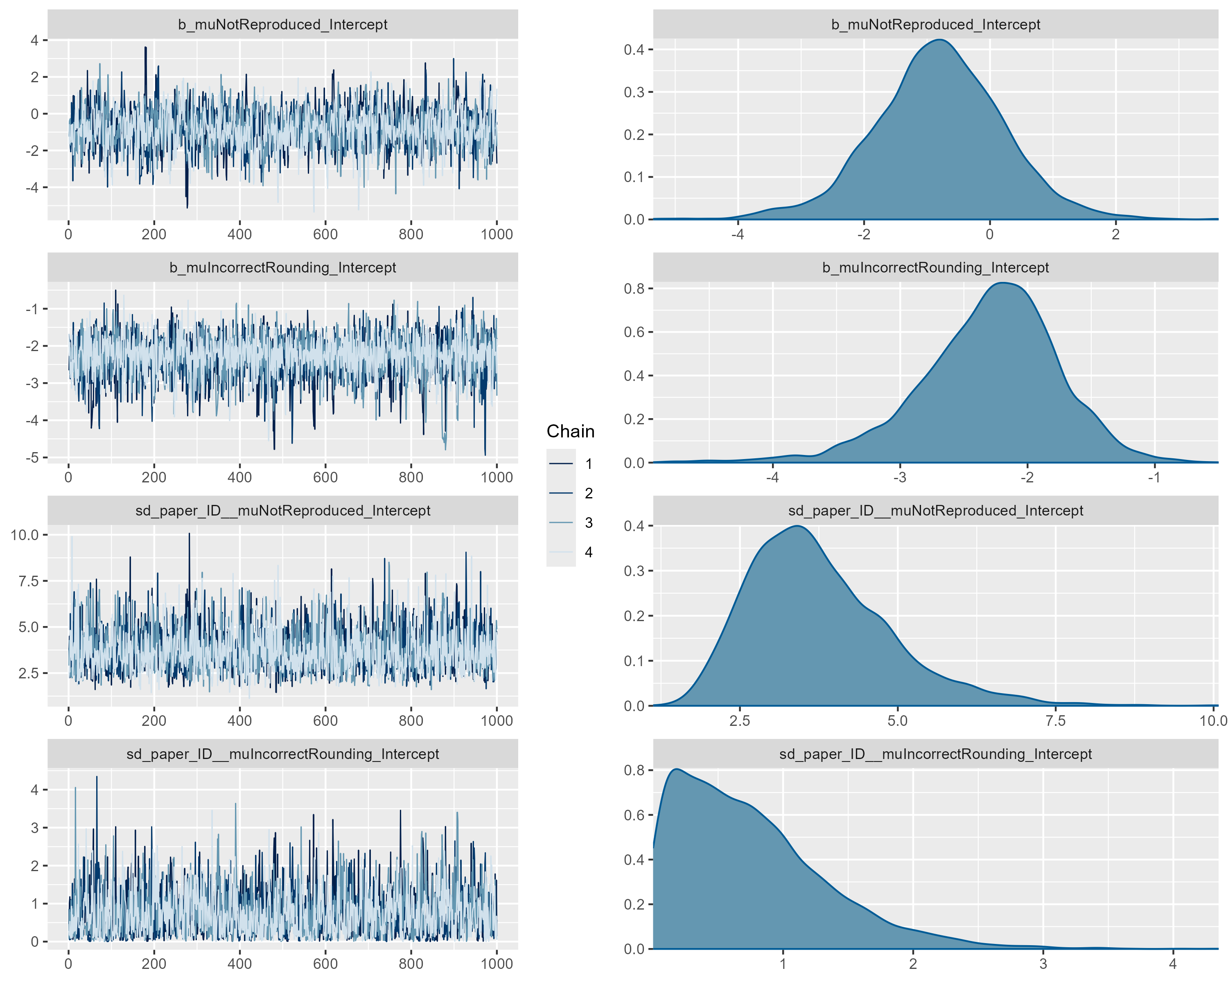

Model: Lower CI category

Parameter estimates
effect | group | term | estimate | std.error | conf.low | conf.high
fixed |  | muNotReproduced_(Intercept) | -1.246 | 1.118 | -3.605 | 0.902
fixed |  | muIncorrectRounding_(Intercept) | -1.915 | 0.564 | -3.126 | -0.853
ran_pars | paper_ID | sd__muNotReproduced_(Intercept) | 3.248 | 1.128 | 1.546 | 5.953
ran_pars | paper_ID | sd__muIncorrectRounding_(Intercept) | 0.871 | 0.642 | 0.037 | 2.399
Note. Estimates are presented on the multinomial logit scale relative to the reference outcome category (Reproduced). SD denotes the standard deviation of the paper-level random intercept.

MCMC diagnostic plot
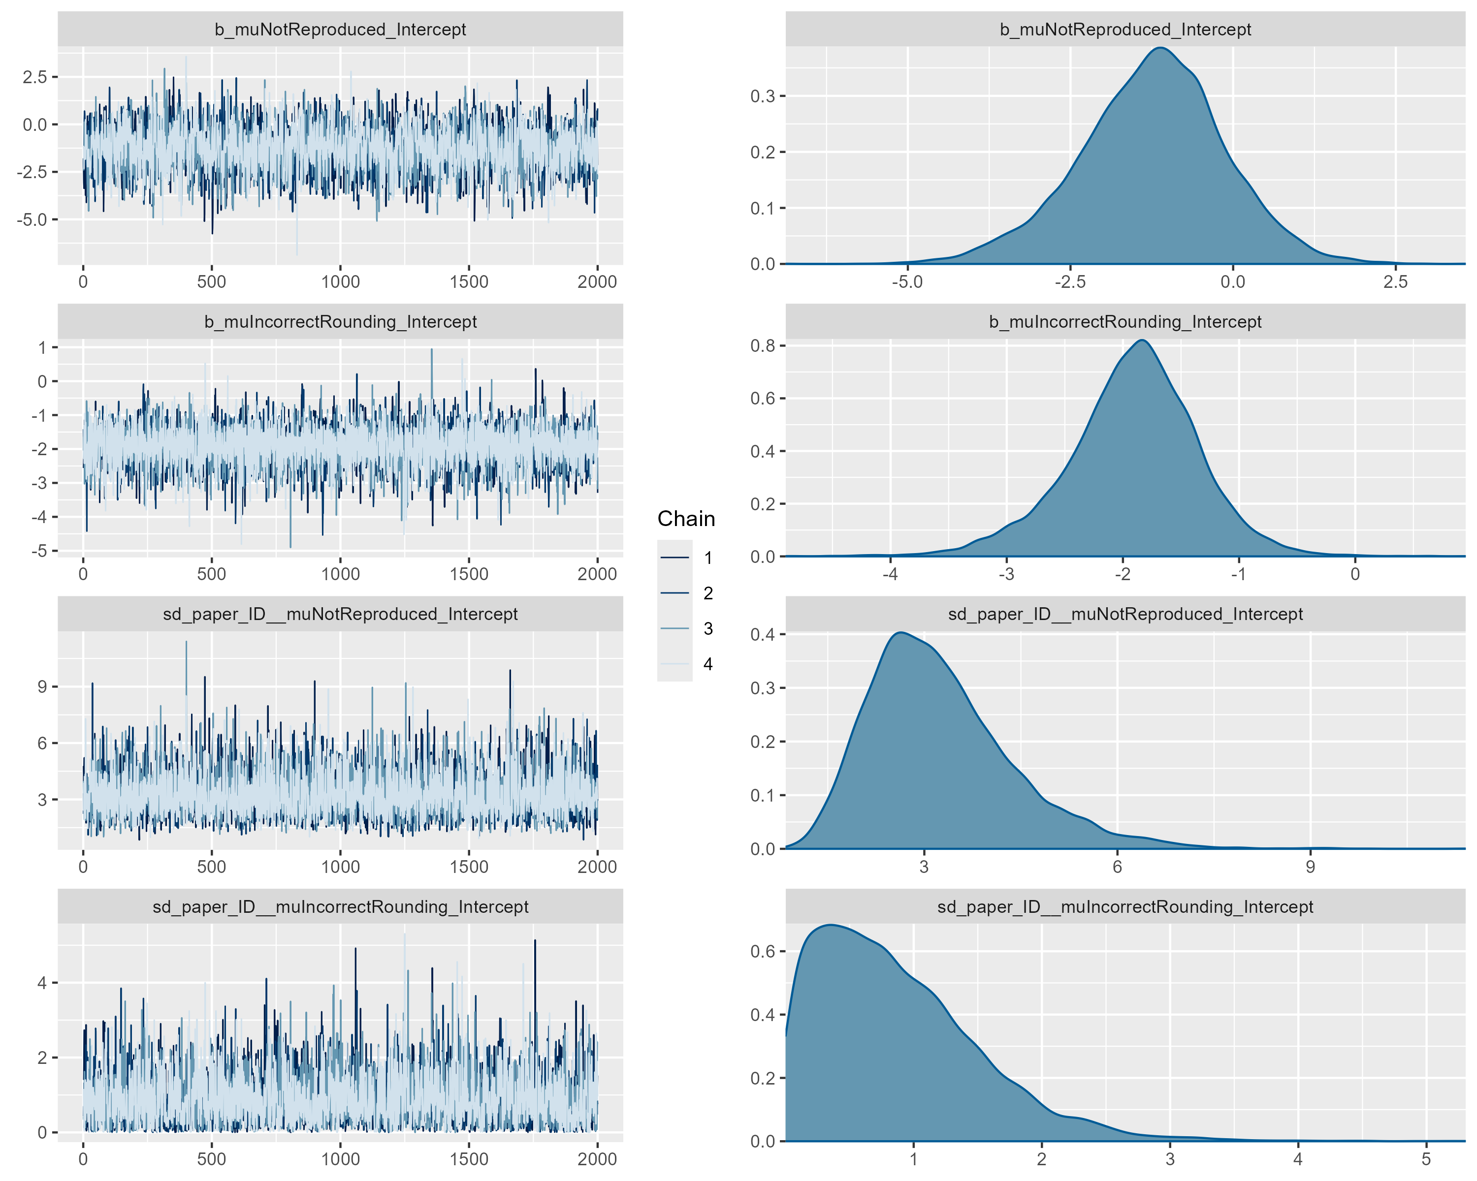

Model: Upper CI category

Parameter estimates
effect | group | term | estimate | std.error | conf.low | conf.high
fixed |  | muNotReproduced_(Intercept) | -0.473 | 1.076 | -2.582 | 1.654
fixed |  | muIncorrectRounding_(Intercept) | -2.237 | 0.581 | -3.504 | -1.188
ran_pars | paper_ID | sd__muNotReproduced_(Intercept) | 2.973 | 1.050 | 1.419 | 5.437
ran_pars | paper_ID | sd__muIncorrectRounding_(Intercept) | 0.737 | 0.613 | 0.025 | 2.281
Note. Estimates are presented on the multinomial logit scale relative to the reference outcome category (Reproduced). SD denotes the standard deviation of the paper-level random intercept.

MCMC diagnostic plot
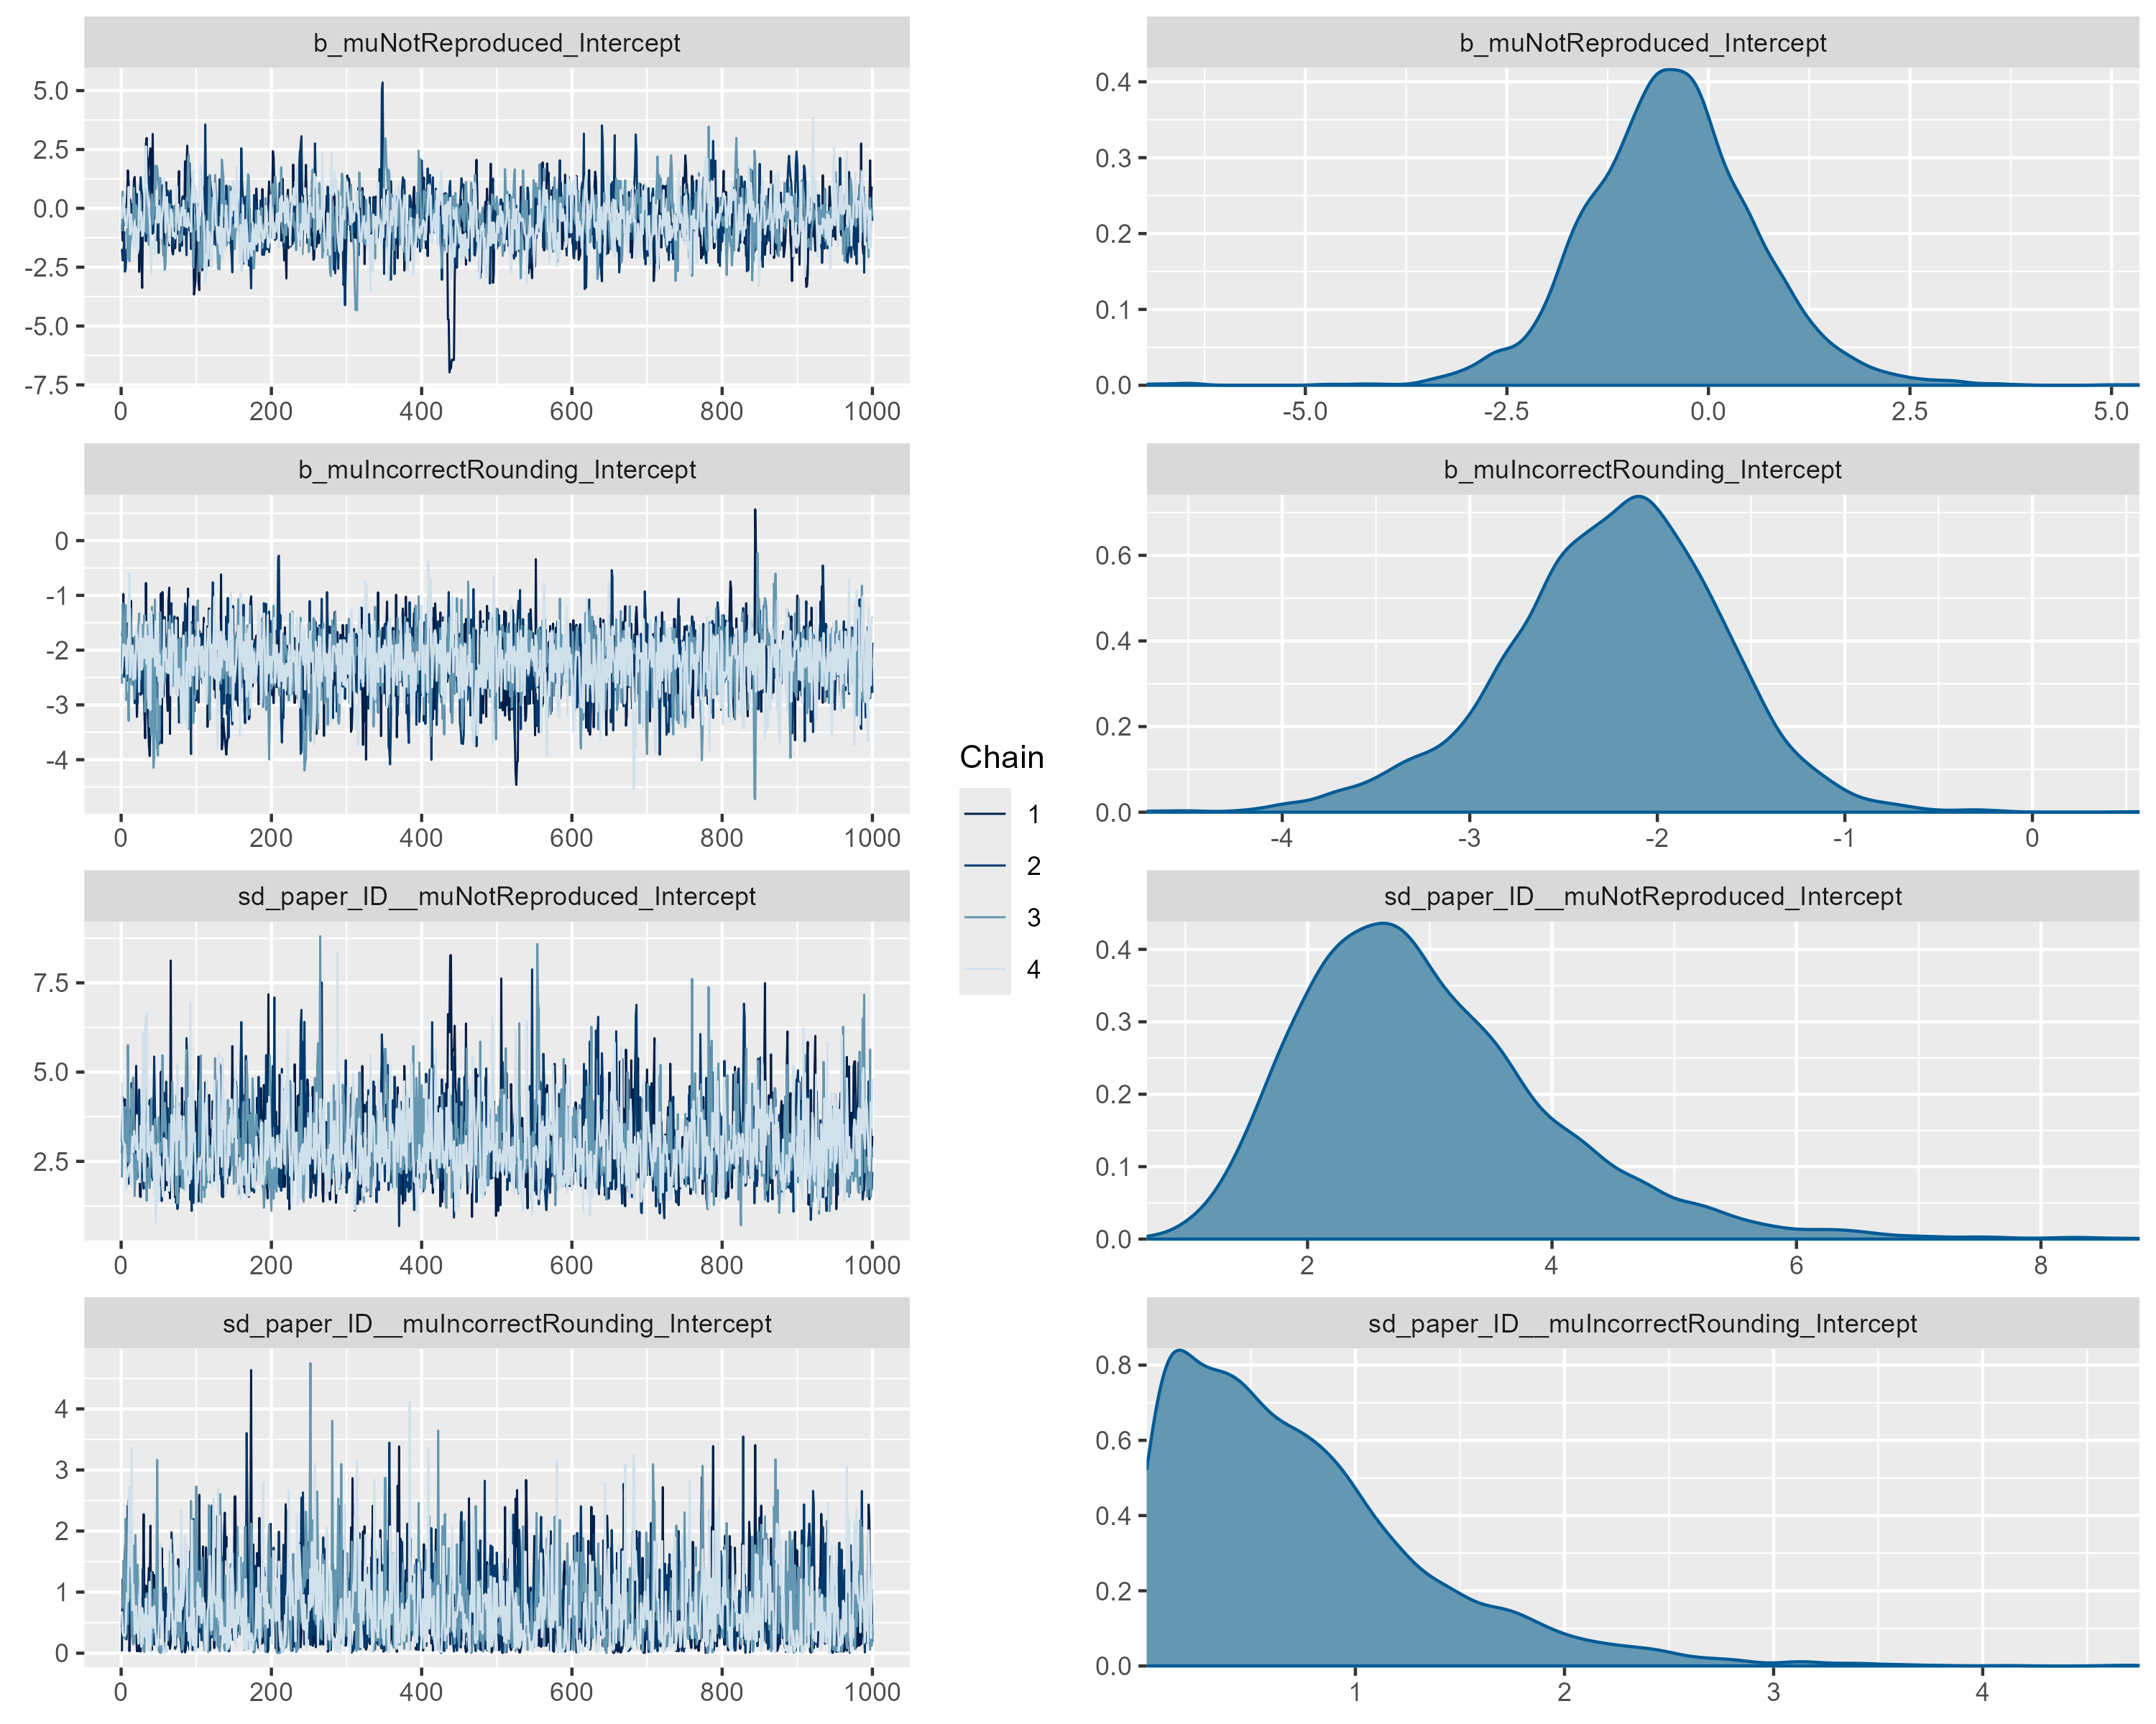

Model: p-value category

Parameter estimates
effect | group | term | estimate | std.error | conf.low | conf.high
fixed |  | muNotReproduced_(Intercept) | -0.754 | 0.799 | -2.380 | 0.785
fixed |  | muIncorrectRounding_(Intercept) | -3.525 | 0.914 | -5.556 | -2.053
ran_pars | paper_ID | sd__muNotReproduced_(Intercept) | 2.978 | 0.876 | 1.647 | 4.972
ran_pars | paper_ID | sd__muIncorrectRounding_(Intercept) | 1.524 | 0.753 | 0.248 | 3.263
Note. Estimates are presented on the multinomial logit scale relative to the reference outcome category (Reproduced). SD denotes the standard deviation of the paper-level random intercept.

MCMC diagnostic plot
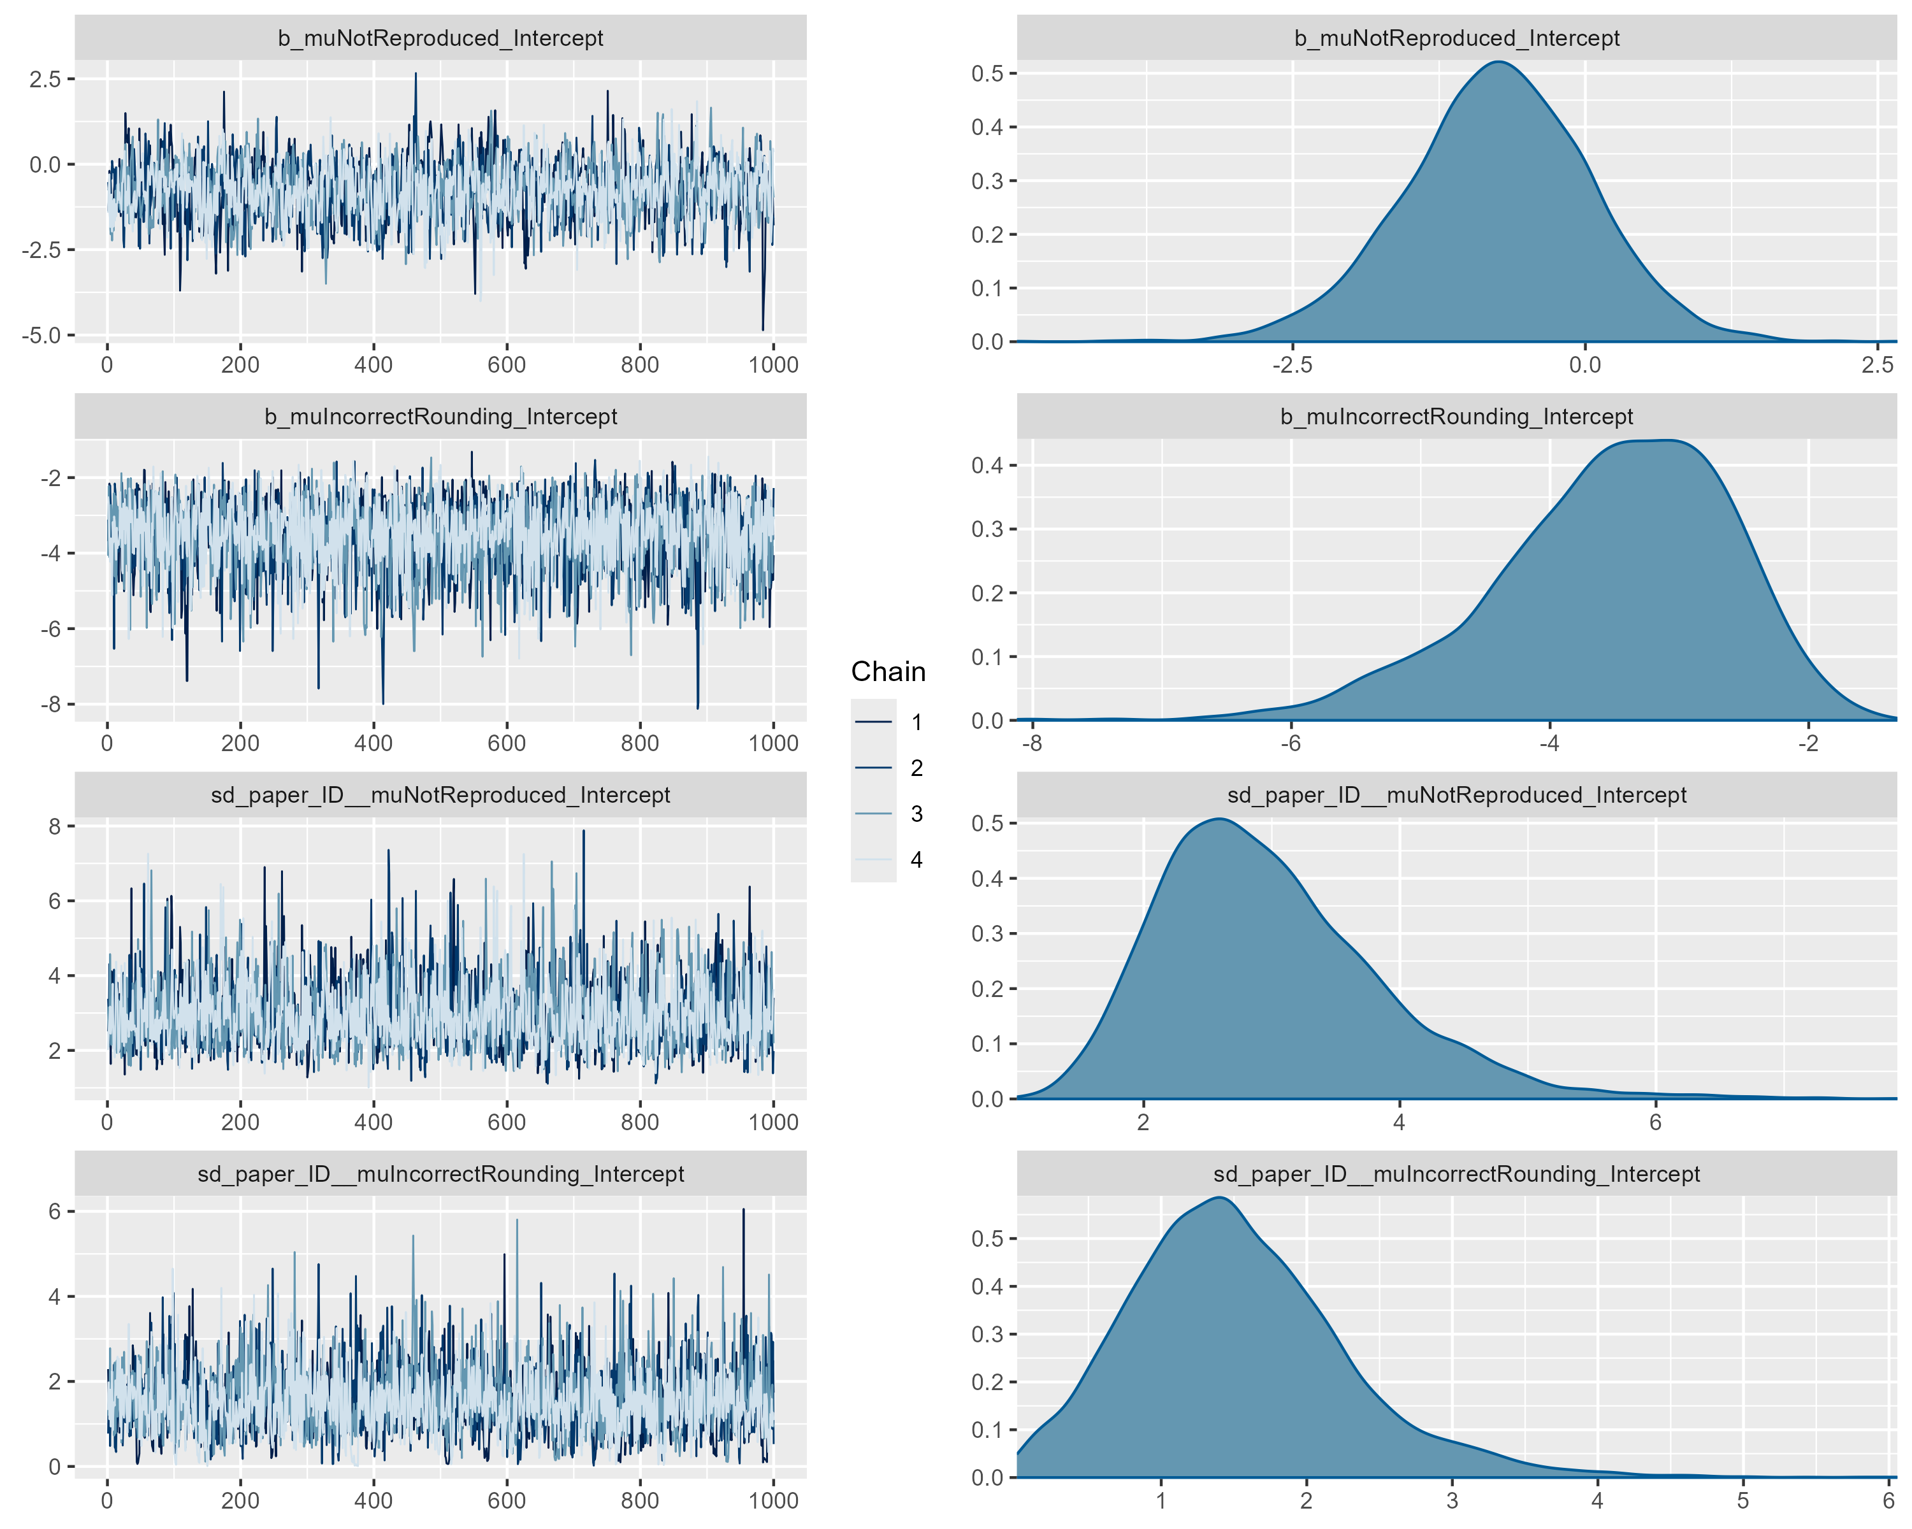

Model Computational Reproducibility

Parameter estimates
effect | group | term | estimate | std.error | conf.low | conf.high
fixed |  | muMostlyreproduced_(Intercept) | -0.597 | 0.972 | -2.860 | 1.040
fixed |  | muPartiallyreproduced_(Intercept) | -2.362 | 1.248 | -5.246 | -0.336
fixed |  | muNotreproduced_(Intercept) | 0.418 | 0.687 | -1.022 | 1.756
ran_pars | paper_ID | sd__muMostlyreproduced_(Intercept) | 2.896 | 1.243 | 0.875 | 5.789
ran_pars | paper_ID | sd__muPartiallyreproduced_(Intercept) | 2.485 | 1.209 | 0.358 | 5.261
ran_pars | paper_ID | sd__muNotreproduced_(Intercept) | 1.871 | 1.115 | 0.163 | 4.325
Note. Estimates are presented on the multinomial logit scale relative to the reference outcome category (Reproduced). SD denotes the standard deviation of the paper-level random intercept.

MCMC diagnostic plot
