Questions:
- Participants and context
- Interview: number of interviewers and participant selection criteria
- Data source: Student worksheet…
- Observation note - experiment set up (shared codebook?)

Aladdin System Design
Learning Objectives
Aladdin is a GenAI-enabled computer-aided design (CAD) tool that helps learners visualize scientific concepts and operationalize inquiry practices in engineering design (Xie et al., 2023). In this activity, learners use GenAI to design an eco-friendly house with the goal of reducing energy consumption as much as possible. The activity enhances inquiry in design by engaging learners in the process of generating design ideas, analyzing energy performance through simulation, and revising their solutions toward the net-zero goal. Through this process, learners practice using GenAI in engineering design, a critical skill aligned with the Next Generation Science Standards (NGSS). By assessing, refining, and changing their designs with GenAI, learners can also develop an understanding of the potential benefits and limitations of introducing GenAI into engineering design.
Core Activity Supported by Aladdin
- Generate a design solution
Students begin by using GenAI in Aladdin to generate an initial net-zero house design. They create a Building Design project and write a prompt describing the house they want to design. This step introduces prompting as a way for students to translate design ideas into AI-generated building solutions. To support this process, students are provided with general prompt-writing guidelines, such as writing concise prompts, combining multiple design ideas when appropriate, and using specific technical terms. Although the activity constrains students to a colonial-style house format, they can still adjust key design variables in their prompts, such as location, orientation, roof type, insulation values, window properties, HVAC settings, and solar panel coverage.
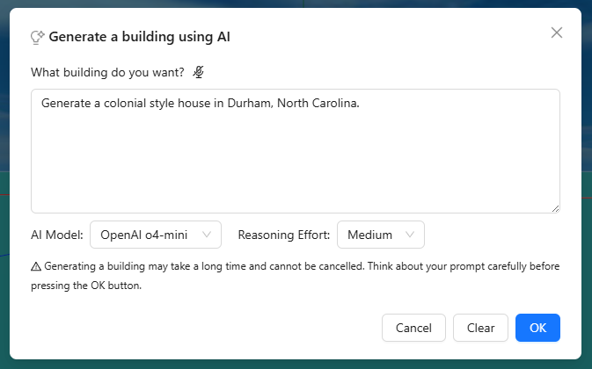
- Analyze the design solution
After generating a house design, students use Aladdin’s built-in non-AI energy simulation tool, Analyze Yearly Building Energy, to evaluate the design. The tool calculates the house’s monthly and annual energy performance, including heater use, AC use, solar panel output, and net energy use. These results provide quantitative evidence for students to evaluate whether the AI-generated design moves toward the net-zero goal. This step encourages multi-source verification by asking students to compare AI-generated design suggestions with evidence from Aladdin’s built-in non-AI energy simulation.
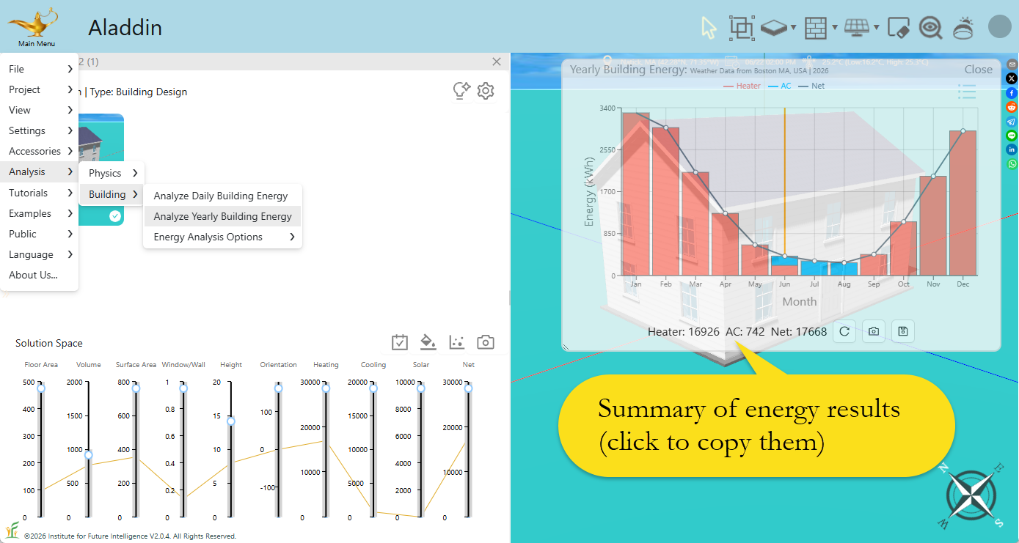
- Iteratively Improve the Design Solution
Based on the simulation results, students revise their prompts and generate improved versions of the house to reduce its energy usage. Students are introduced to the default variables that Aladdin assumes when these variables are not specified in prompts, which also points them to multiple ways of further reducing energy use. In this sense, students learn how to modify design parameters and iteratively improve their house design toward the net-zero goal.
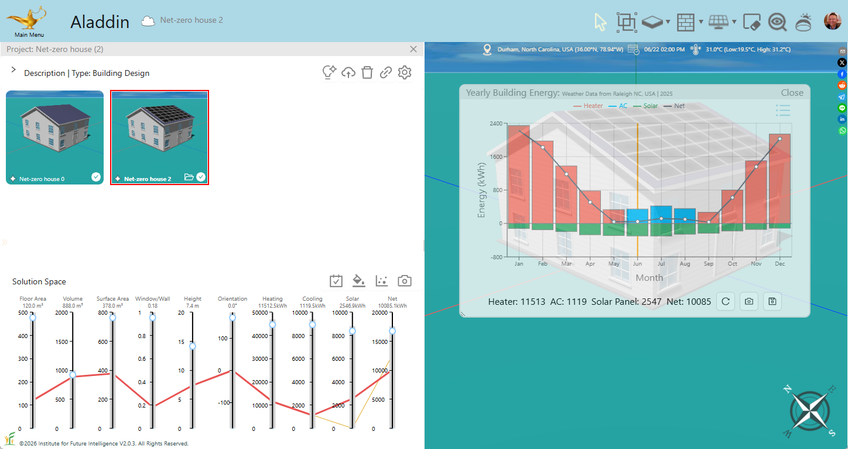
- Document interaction with AI
Students are required to document their prompts, AI’s reasoning, and relevant simulation results in the worksheet for up to five important design rounds. This documentation not only helps students keep track of their progress toward the net-zero goal, but also makes the human-AI design process visible. By reviewing these records, students can more easily examine their design decisions, pay attention to AI’s reasoning, and reflect on the implications of AI-generated suggestions.
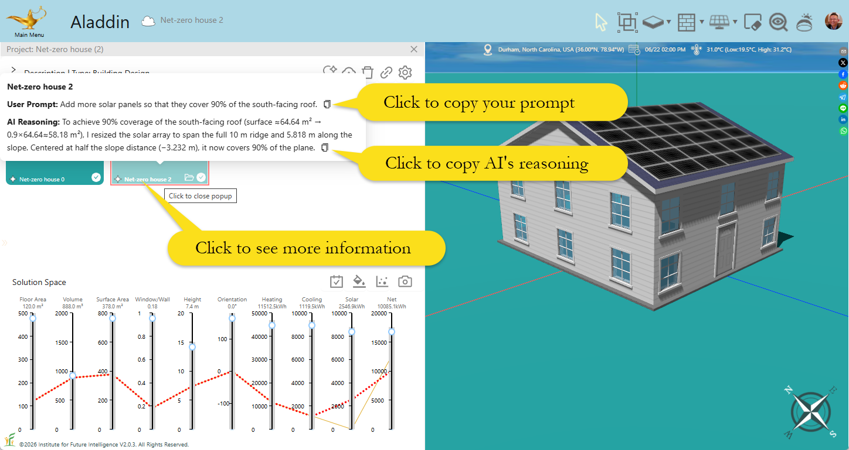
- Reflection
At the end of the activity, students complete a final reflection. They share their Aladdin project link and reflect on three questions: what science and engineering concepts they learned from AI, what strategies they learned for designing toward the net-zero goal, and what they see as the advantages and limitations of using AI in engineering design. This final step connects the design experience to broader learning about sustainable engineering and responsible GenAI use.
Study Procedure
To examine how generative AI may support students’ learning of engineering design, the study was conducted in a high school setting with students from six class sections across two groups. Participants were students in Grades…(student info).

Participants
- Demographics of the school?
- Grade of students: all 10 - 11?
- Number of teachers; demographic of teachers?
- Context: what subject is the class situated in?

Experiment Design
Participating students completed a two-session engineering design activity using Aladdin, a generative AI-supported design environment for energy-efficient home design. The activity asked students to work toward the goal of reducing a house’s energy cost by testing and refining different design strategies. Each implementation group included three class blocks and followed the same two-session structure. During the first session, students were introduced to the project, completed a pre-survey assessing their prior knowledge of relevant engineering concepts, and began exploring the design task in Aladdin and set the model to colonial style. During the second session, students continued working on the design task by testing and revising design strategies in relation to the energy-cost reduction goal. At the end of the second session, students completed a post-survey that used the same knowledge questions as the pre-survey to examine changes in conceptual understanding after the Aladdin-supported design activity.
In addition to the pre- and post-surveys, a subset of students was invited to participate in individual semi-structured interviews after completing the two sessions. The selection criteria for interview participants were … (more info). In total, 13 (notes said 11) students participated in interviews. Each interview lasted approximately 30 to 45 minutes and focused on students’ experiences using generative AI in Aladdin for engineering design.
An additional student learning agency survey was also administered after the design activity. This survey was intended to capture students’ reflections on their own role, decision-making, and self-regulation while interacting with generative AI during the design process.

Pre- and Post-Test
The pre-test included 12 questions designed to assess students’ prior understanding of concepts relevant to energy-efficient home design. The questions mapped onto four conceptual areas: thermal insulation and heat transfer, solar geometry and radiation, HVAC controls and strategy, and sustainable engineering goals. The post-survey used the same set of questions as the pre-survey, with one response option revised from “I don’t know” to “I still don’t know.”. The full pre- and post-survey are included in Appendix.

Interview Design
How many experimenter were involved in the interviews?
The semi-structured interview protocol was organized around three main primary questions (add areas?). The main interview questions then focused on three topics: concept learning, design strategies and problem solving, and critical evaluation. First, students were asked about the science and engineering concepts they learned through interacting with AI. Second, students were asked about the design strategies they learned from AI when designing toward the net-zero goal. Third, students were asked to evaluate the advantages and limitations of using AI in engineering design. Below is the interview questions:
- Which GenAI tools have you used before this project?
- What was your first impression of using AI for a complex engineering task like this?
- What new science and engineering concepts have you learned from AI?
- What strategies have you learned from AI in designing towards the net-zero goal?
- What is your opinion about the pros and cons of using AI in engineering design?

Student Learning Agency Survey
The student learning agency survey was adapted from the Student Learning Agency in Generative AI-supported Contexts scale developed by Xia et al. (2025). This scale was developed to measure student agency specifically in learning environments that involve generative AI. The survey in this study was designed to examine how students perceived their own role, decision-making, and self-regulation while using Aladdin.
The survey included Likert Scale items organized around ten dimensions of student agency: self-cognition, goal setting, self-adjustment, self-reflection, selective action, responsible action, participative action, motivation, self-efficacy, and volition. These dimensions correspond to Xia et al.’s framework, which groups student learning agency into key abilities, active actions, and essential mental characteristics in generative AI-supported contexts (2025). In this study, these items were used to examine how students understood their strengths and challenges, set design goals, revised prompts or AI-generated content, reflected on AI interactions, decided when to rely on AI support, and maintained responsibility for their own design decisions.
The agency survey also included four open-ended questions:
- When working on your design with AI, how did you plan, adjust, and reflect on your work? Please give one example.
- How did you decide what to do yourself and what support to use during your design process? Please give one example.
- How did you evaluate your own ability to use generative AI during your design process? Please give one example.
- How do you see your role when interacting with generative AI in designing your house?
Together, the pre/post surveys, student learning agency survey, classroom observations, and interviews were designed to provide complementary data sources for examining students’ conceptual learning and their experiences of agency in AI-supported engineering design.

Data Analysis
- How did we clean the data?
- How did we analyze the data?

References
Charles Xie, Xiaotong Ding, & Rundong Jiang, Using Computer Graphics to Make Science Visible in Engineering Education, IEEE Computer Graphics and Applications, 43(5), 99–106, 2023. DOI:10.1109/MCG.2023.3298386
Xia, L., Shen, K., Sun, H., An, X., & Dong, Y. (2025). Developing and validating the student learning agency scale in generative artificial intelligence (AI)-supported contexts. Education and Information Technologies. https://doi.org/10.1007/s10639-024-13137-5

