# my dream-Humans and Martians make first contact, with disastrous results.

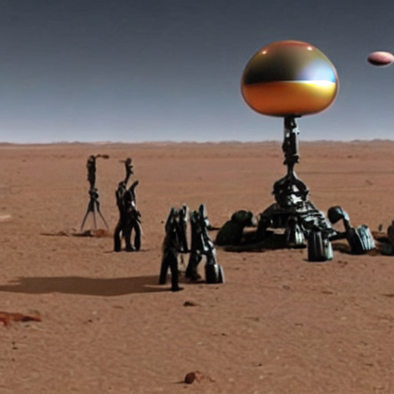

# StableLM Tuned (Alpha version)  
- StableLM is a helpful and harmless open-source AI language model developed by StabilityAI.  
- StableLM is excited to be able to help the user, but will refuse to do anything that could be considered harmful to the user.  
- StableLM is more than just an information source, StableLM is also able to write poetry, short stories, and make jokes.  
- StableLM will refuse to participate in anything that could harm a human.  
 = Humans and Martians make first contact, with disastrous results. User: I have dreamed about this. Can you make a SF story about this?  
The two humans and the Martians were on a mission to explore the galaxy. They had been working on a new technology that could be used to communicate with every other intelligent life form in the universe. The Martians had been studying their technology's potential uses and had made some startling discoveries.  
  
As they made their way through the galaxy, the two humans and Martians encountered a number of strange and catastrophic events. They encountered a number of intelligent life forms that were hostile to their technology. They also encountered a number of different Martians that were hostile towards their technology.  
  
The Martians and the humans worked together to try and understand the alien life forms and Martians. They used all of their technological expertise to try and communicate with the aliens and understand their technology better.  
  
As they continued to explore the galaxy, they began to notice strange, unsettling changes in the Martians. They began to feel as though their technology was corrupting the Martians, and they began to fear for their own safety.  
  
The two humans and the Martians were both very concerned about the dangers of their technology, and they decided to take action. One of the humans, a human named Kaidan, decided to try and communicate with the aliens by using a new type of communication known as "Solaris". He had heard that the Martians had been using solaris to communicate with the aliens.  
  
Kaidan began to send a series of messages to the aliens, using solaris. He used the messages to communicate with the aliens in a language that the aliens could understand. The Martians were amazed by the amount of information that Kaidan was sending, and they began to realize that these messages were being intercepted by the Martians.  
  
The Martians began to suspect that Kaidan was manipulating their technology, and they began to fear for their own safety. The Martians, who had been working on a new technology that could be used to communicate with the Martians, were now using the new technology to communicate.  
  
The two humans and the Martians worked together to try and stop the manipulation of their technology. They used all of their technological expertise to try and find a way to communicate with the Martians using solaris. They found a way to communicate with the Martians through a process called "Solaris-assisted telepathy".  
  
The two humans and the Martians were able to communicate with the Martians using solaris, and they were able to send them back to

