**CIC Practicum Monitoring System**

**Analysis,Design, and Implementation**

**June 20,2020**

**BSIT-1A**

**Leah C. Juarez**

**Table of Contents**

**Page**

**I Introduction 3**

**II Website Information 4**

1. Content Sections ………………………………………………………..4

B. Target Audience…………………………………………………………5

C. Objectives………………………………………………………………..5

D. Technical Specifications………………………………………………...6

E. Sitemap………………………………………………………………….6

F. Screenshots………………………………………………………………9

**III Curriculum Vitae 18**

**CHAPTER I**

**Introduction**

Technology is prevalent this days and people, business and big organizations are making most of manual work process to automatic or technologized for work efficiency and one of those technological solution is CIC PMS. CIC PMS (College of Institute of Computing Practicum Monitoring System) is a web-based monitoring system that helps instructors in keeping records and checking student’s reports. At the end of the semester student’s need to pass their reports to their instructor on foot. Furthermore, teachers need to manually get the files and records of the students if they want to get an information from the past record or have an inquiry such as finding what company does a certain student applied to. Because of this kind of problems, the CIC PMS is created. This web-based monitoring system can only be use by CIC faculty and students of the University of Southeastern Philippines.

**CHAPTER II**

**Website Information**

1. *Content Sections*

Admin

* Dashboard – where the admin’s information is shown and list of admin who have access to the system
* Users – this is where the admin managed user authority access, adds new user and reset user password.
* Practicum Records – Where all interns records are shown .Sorted by company and filterable by date, name and etc. through search for fast retrieval of information
* Course & Sections – displays all Programs and majors, CIC offers and their respective sections Admins can edit the Courses/Majors and Sections.
* Instructor – displays the information and list of instructors who was and is handling intern students and section-instructor history. Admin can edit , delete and add section under an instructor
* Company – displays the information and list of companies with hiring descriptions. Admins can add and edit company information.
* Logout - system exit.

Instructor

* Dashboard – where the instructor information and class section history are displayed. The instructor can also add another edit and delete his/her section history.
* Practicum Records – Where all interns records who is under/his or her responsibility/section are shown. Can be sorted by company and filterable by date, name and etc. through search for fast retrieval of information The listing of students is shown in tabular format. In here, the instructor can view and download the student’s report and moreover change the status of the report to checked to tell the student that the report submitted is correct and acceptable or view students email address to send corrections if otherwise.
* Course & Sections – displays all Programs and majors, CIC offers and their respective sections.
* Instructor – displays the information and list of instructors who was and is handling intern students.
* Company – displays the information and list of companies with hiring descriptions. Admins can add and edit company information.
* Logout - system exit.

Student

* Dashboard – where the student information are displayed . In here the students can also submit their pdf reports and check out their submitted report status.
* Company – displays the information and list of companies with hiring descriptions so the students can choose where to apply.
* Logout - system exit.

1. *Target Audience*

The website are created and exclusive for CIC Faculty and students of University of the Philippines.

1. *Objectives*

* Make monitoring procedure easier and faster so that instructor can use their time efficiently.
* Have students their own profile which gives them the capability to upload reports which results to minimizing time and effort spent in going to and from the university’s location.
* Similarly to the students, instructors will be given profiles to access, download and check updates and changed the status of the report submitted.
* Keeps the CIC practicum records and history easy to retrieve anytime, anywhere .

1. *Technical Specifications*

The web based system is User Interface is structured using HTML (HyperText MarkUp Language), and designed through CSS, Bootstrap and supported with JavaScript. the applications are launched using the HTML embedded scripting language PHP. PHP makes input easy to process from HTML forms and provides convenient function to connect to the database . The database used for CIC PMS is Mysql. Mysql because it is is a real multi-user database and is royalty-free open source software.

1. *Sitemap*

Admin

LOGIN

Dashboard

Practicum Records

Users

Logout

Company

Instructor

Course & Section

Add Company

View Instructor

Add Course/Major

View Practicum Records

View Admin

Add user

View Company

View Course/Major

View user

Add Admin

View Student

Edit Instructor

Reset User Password

View Profile

Download Report

Edit Company

Add Section to Instructor

Edit Course /Major

Edit Profile

Change Password

Add Section

View Section History

View Section

Edit/Delete Section History

Edit Section

Teacher

LOGIN

Logout

Company

Instructor

Course & Section

Practicum Records

Dashboard

Add Company

View Instructor

View Course, Major and Section

View Practicum Records

View Profile

View Company

Edit Profile

Change report Status

Change Password

Edit Company

Download Report

View Student

Add Section under

View My Section History

Student

LOGIN

Company

Logout

Dashboard

View Company

View Profile

Edit Profile

View End Semester File Report

Delete

View

Download

If File is not empty

Upload File

Change Password

1. *Screenshots*

* Login

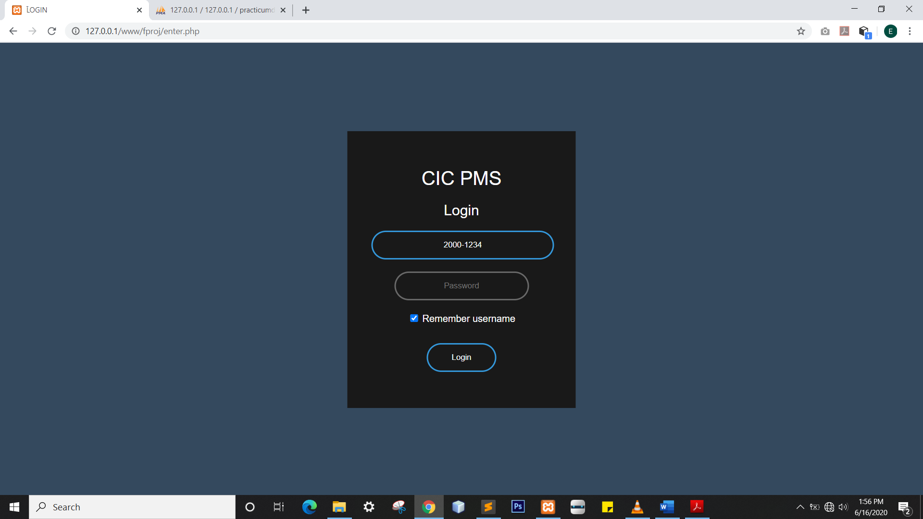

* **Admin**
* Dashboard

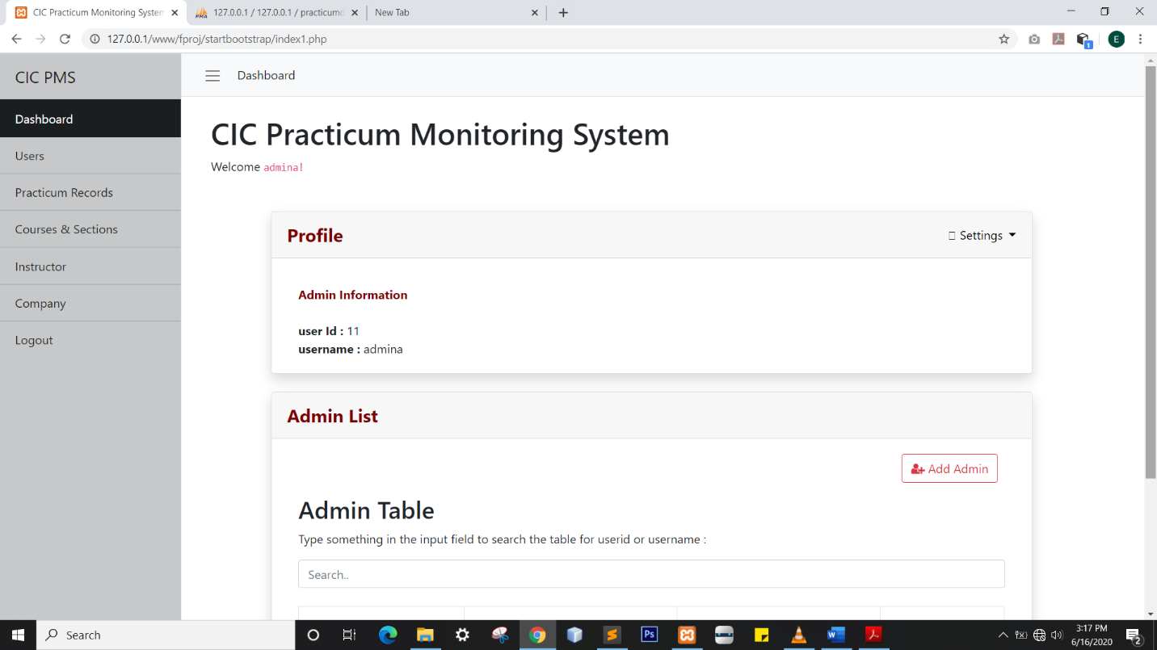

* 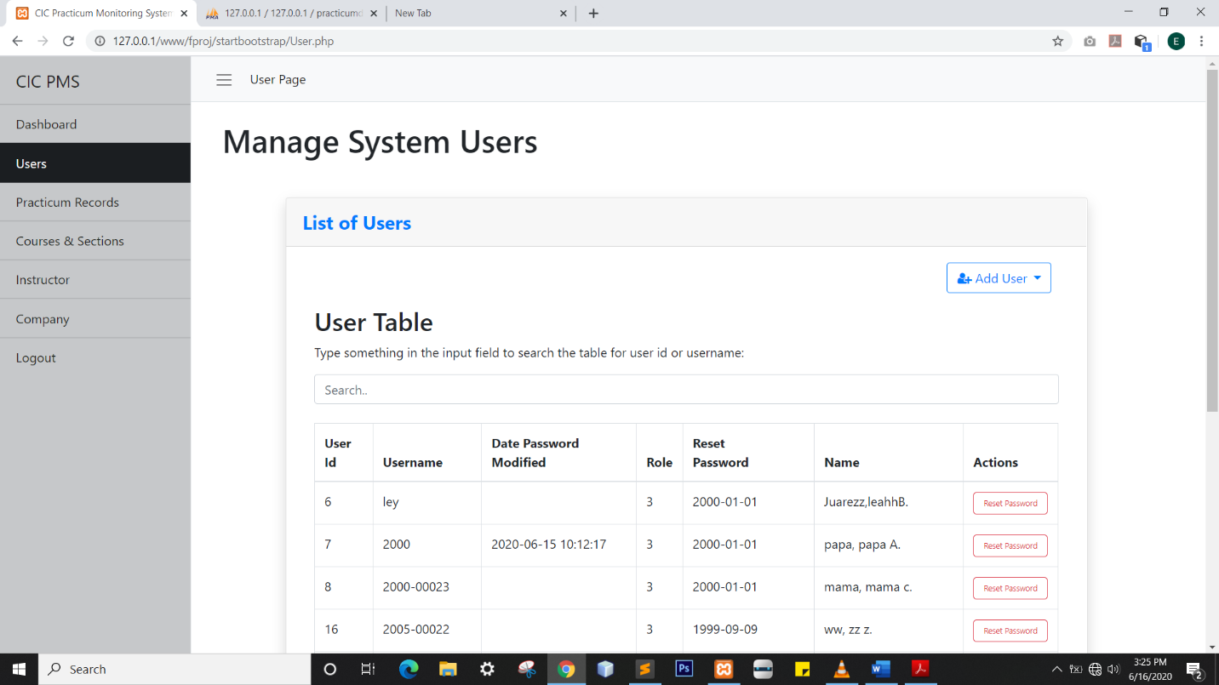User Page
* Practicum Records Page

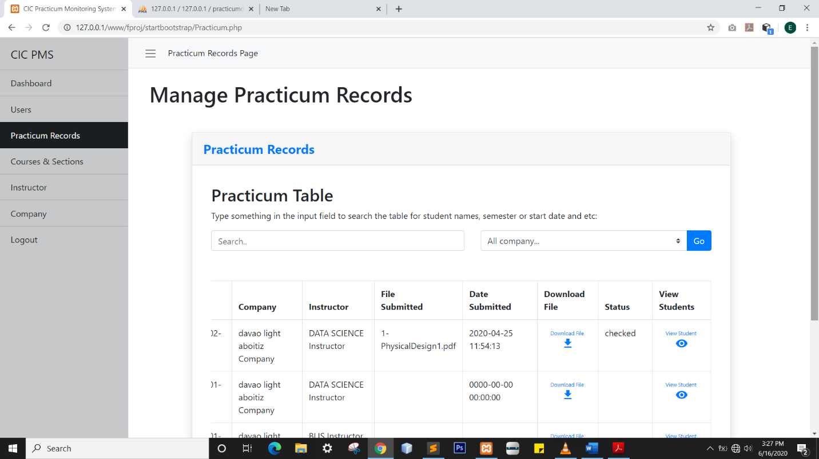

* Courses & Major Page

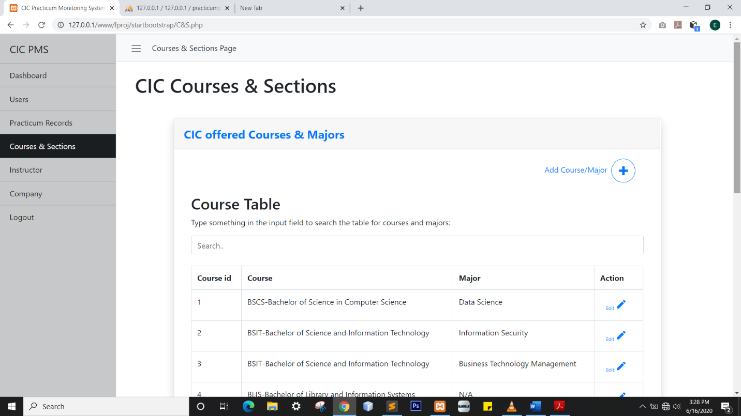

* Section

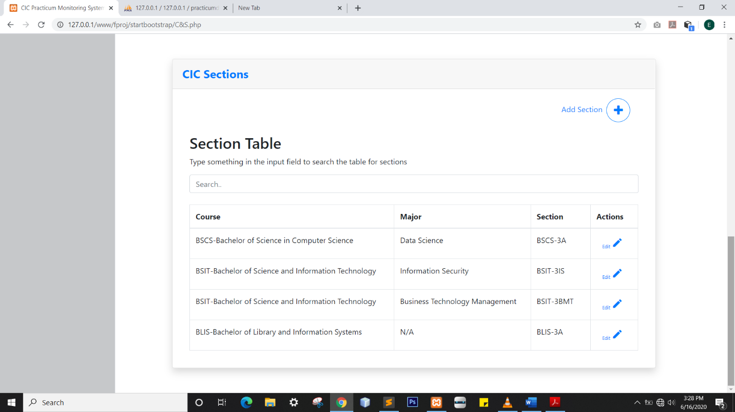

* Instructor Page

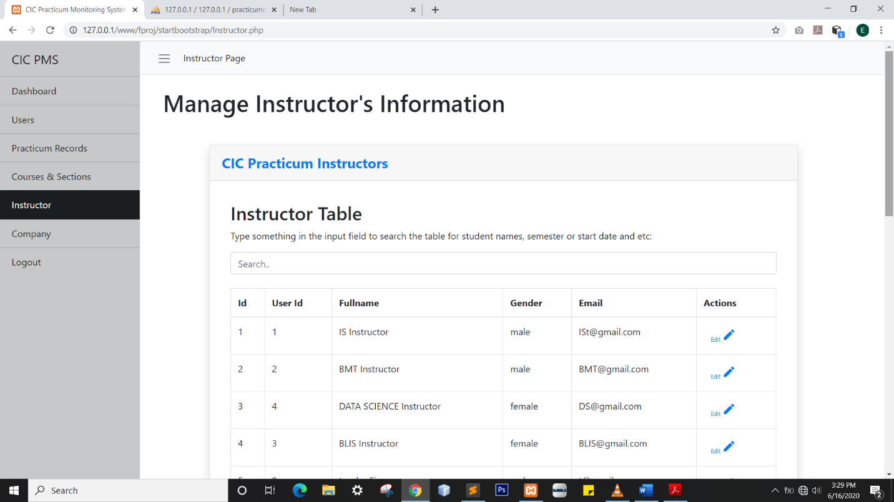

* Section-Instructor History

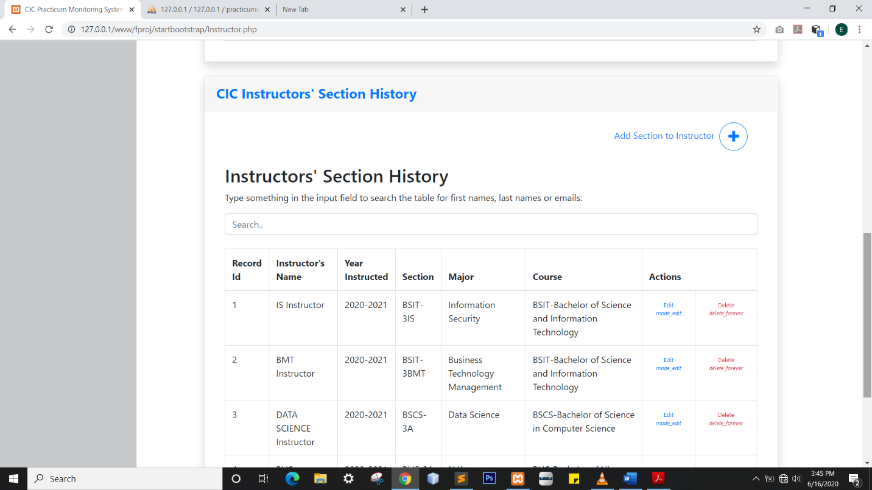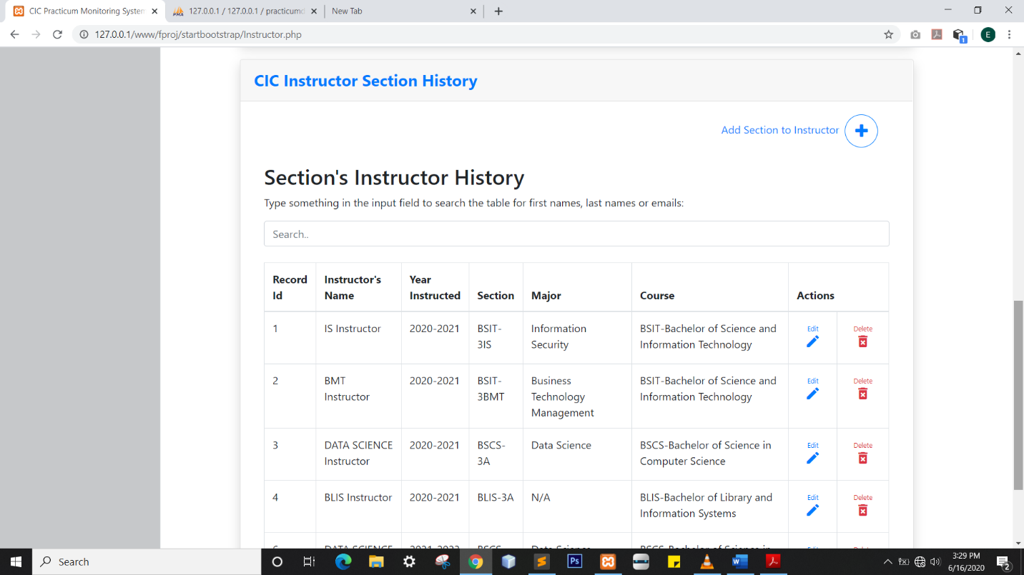

* Company Page

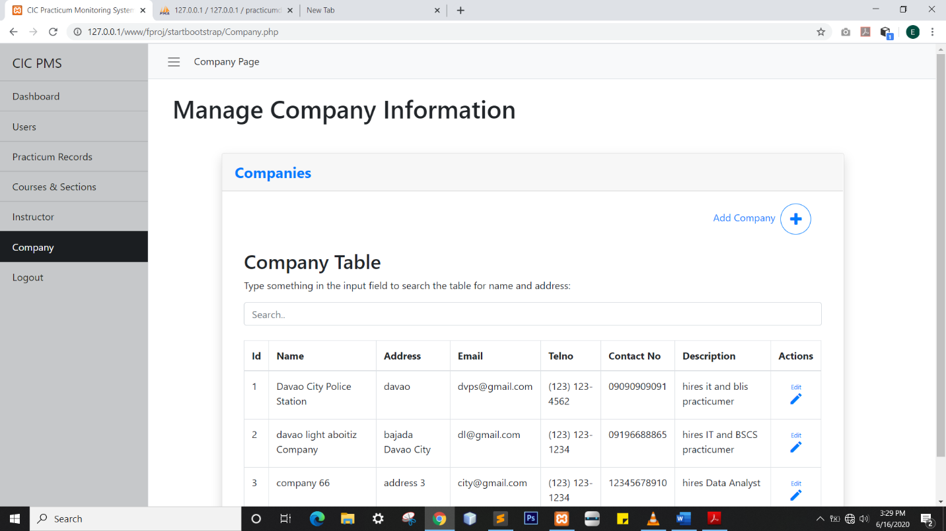

* **Teacher**
* 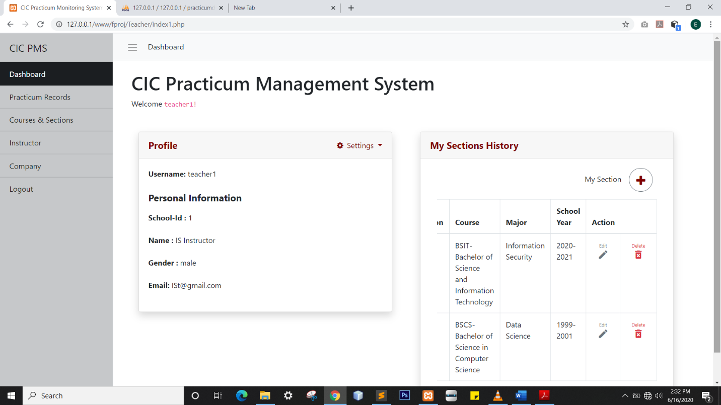Dashboard
* 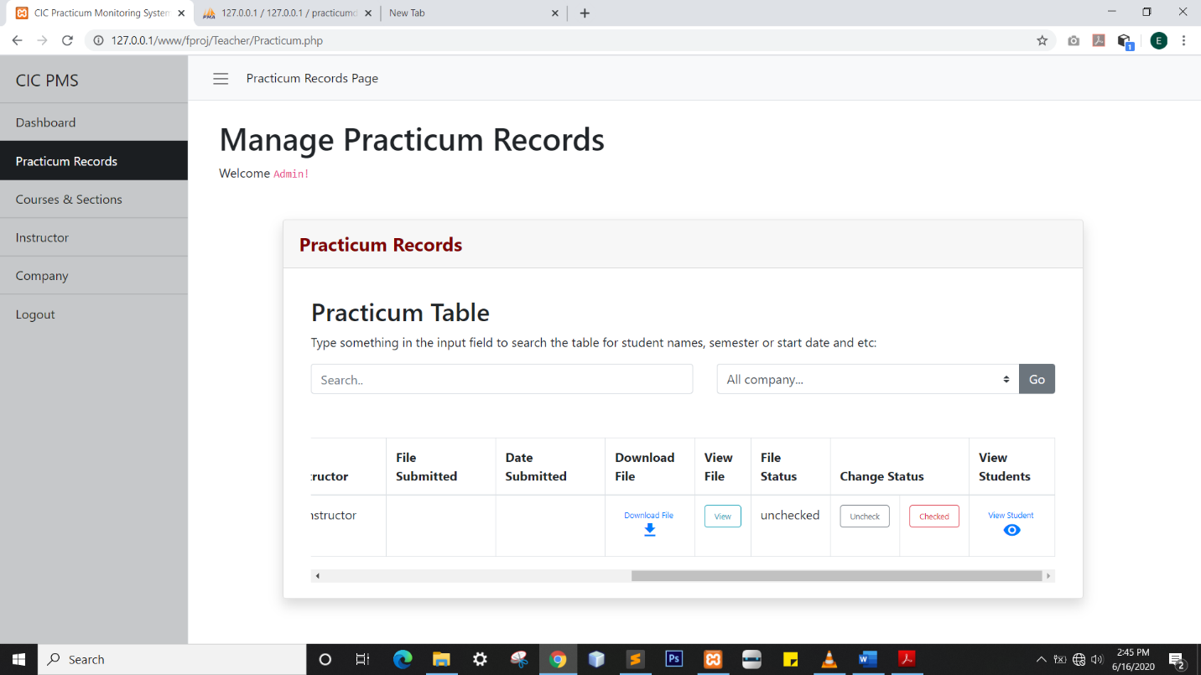 Practicum Records Page
* Courses & Sections Page

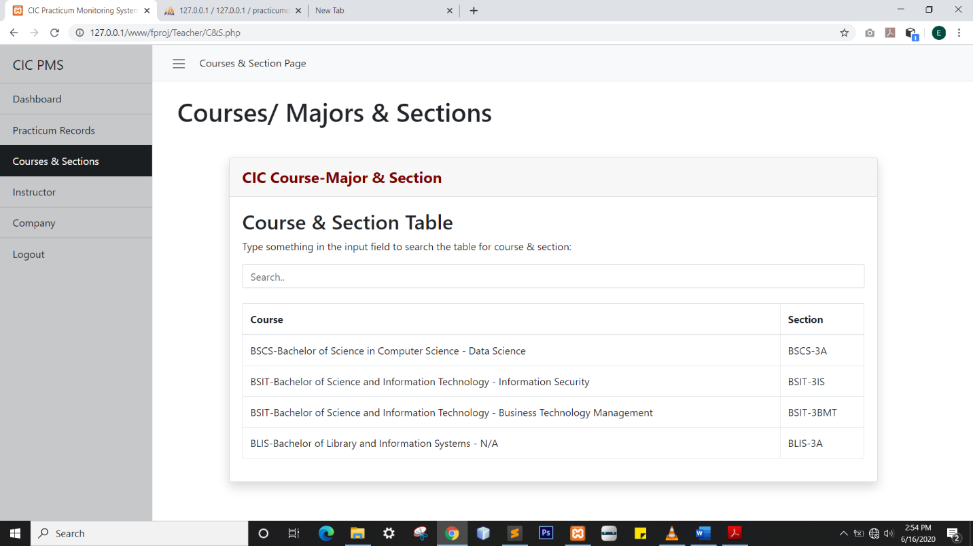

* 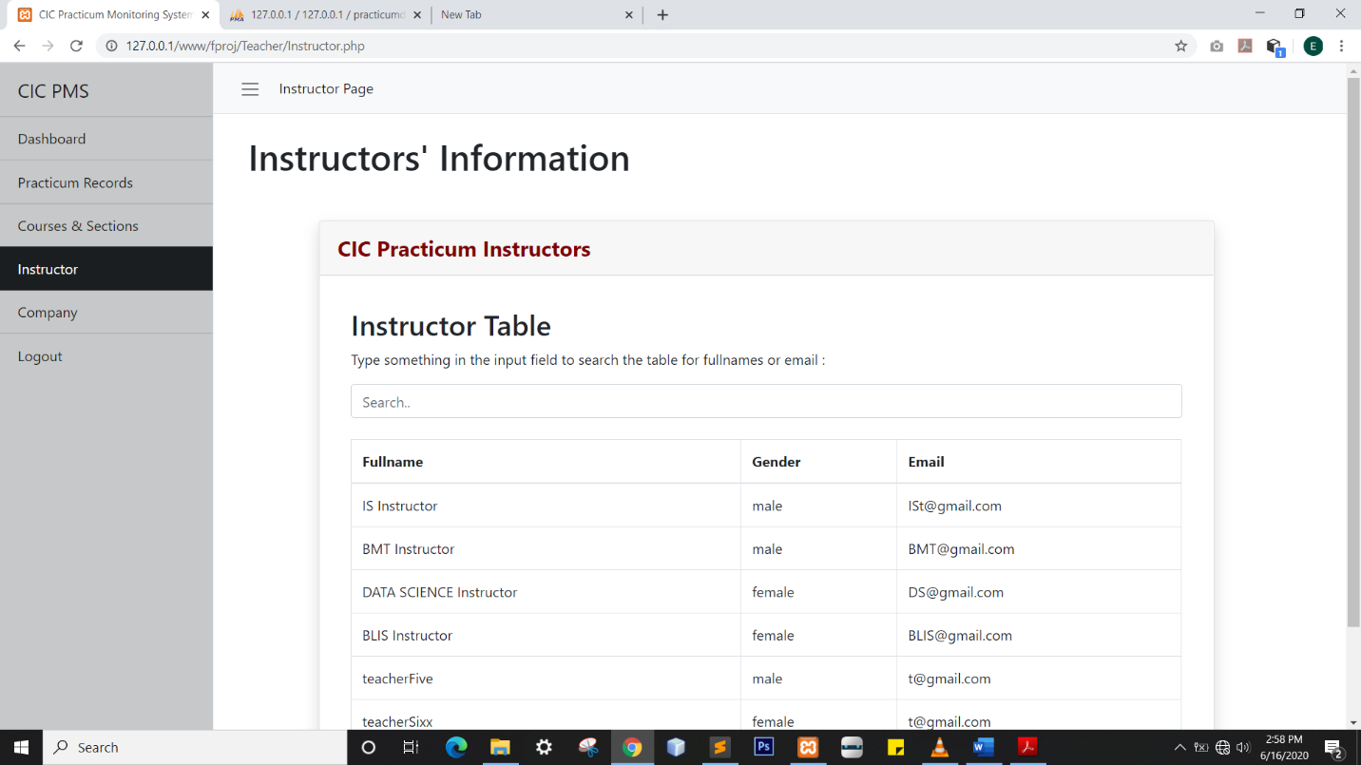Instructor Page
* Company Page

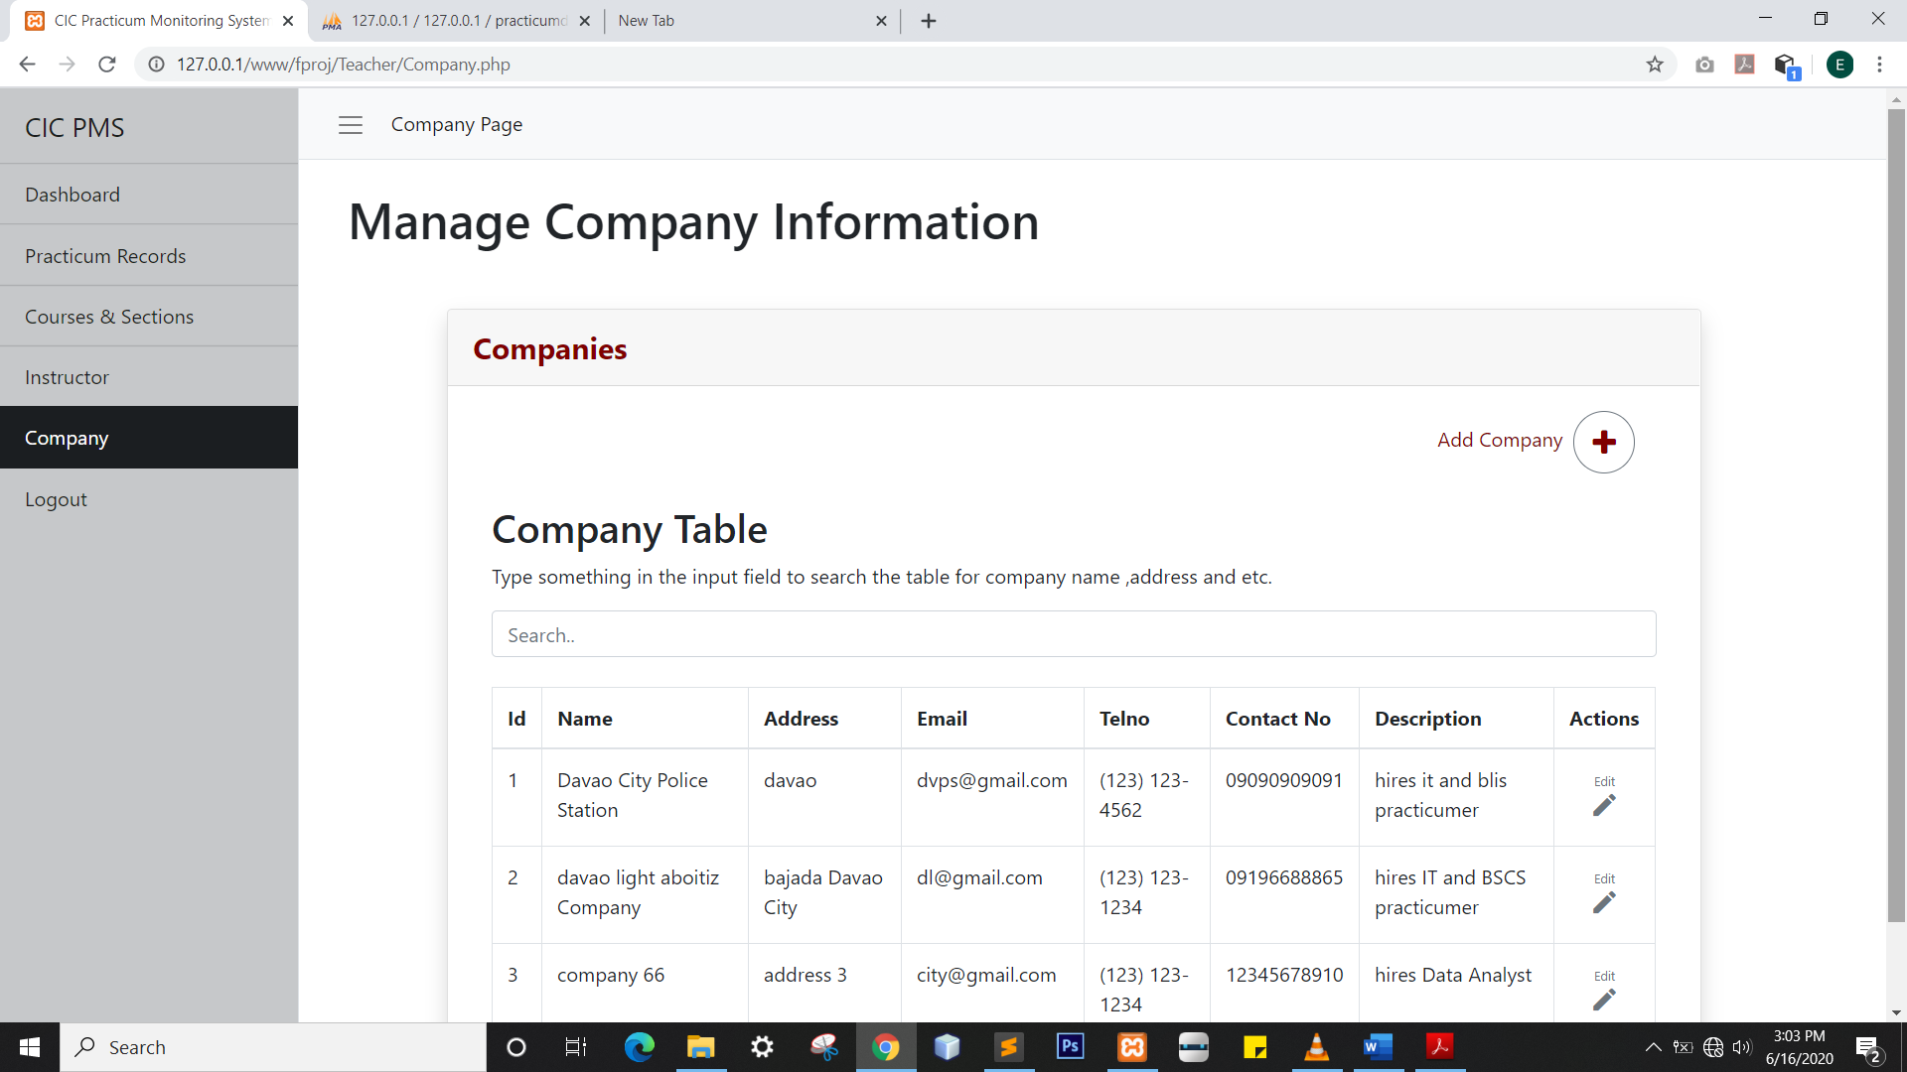

* **Student**
* 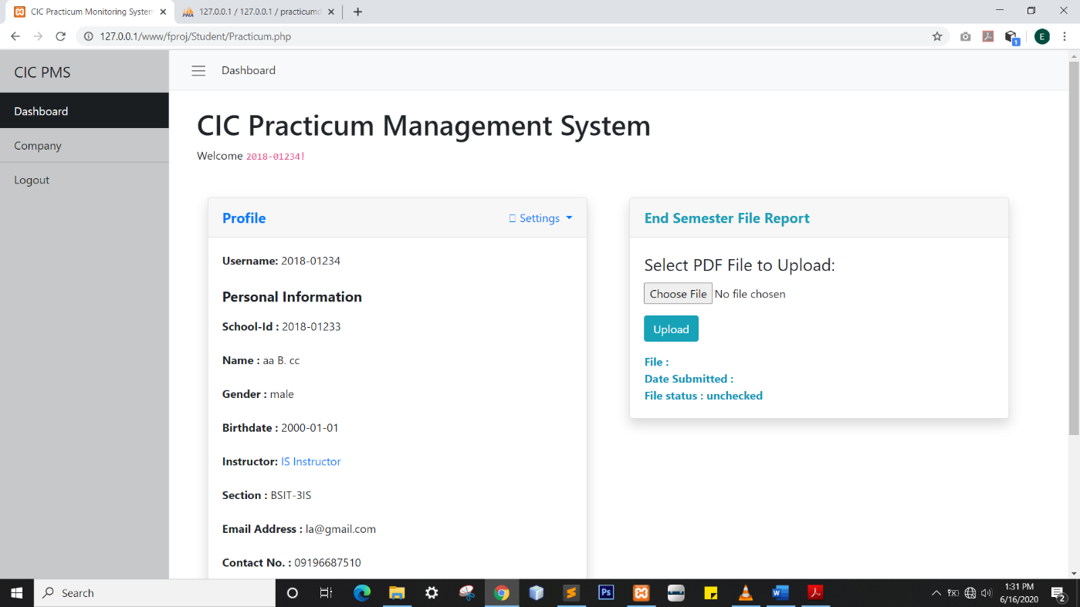Dashboard (without the file)
* 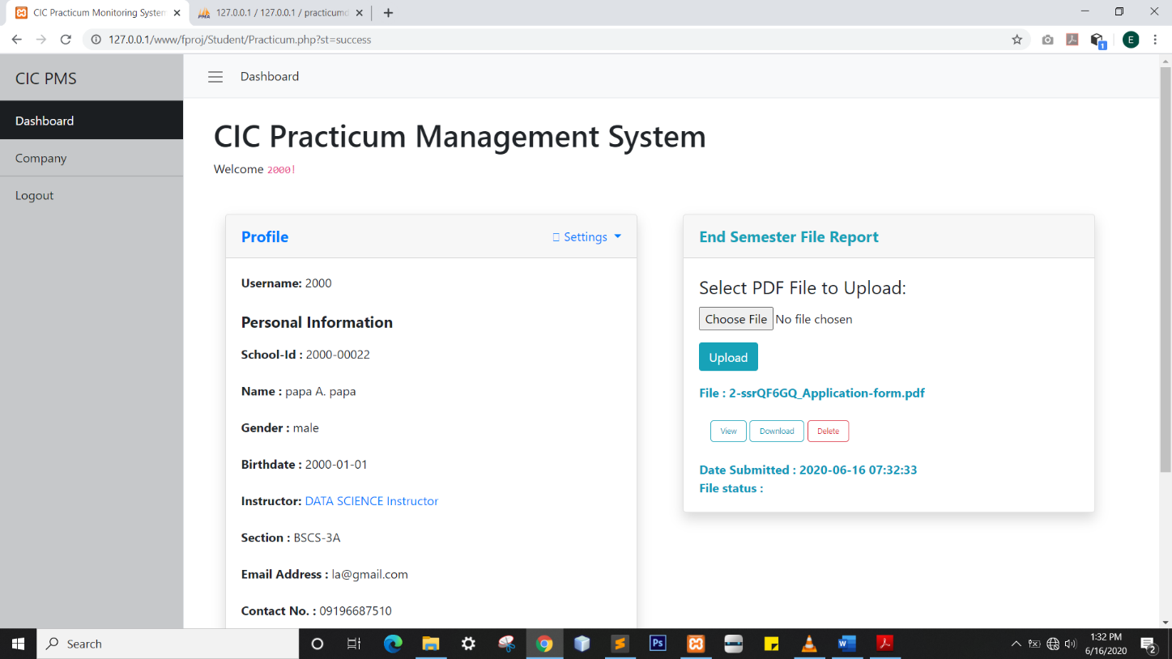Dashboard (with uploaded file)
* Company Page

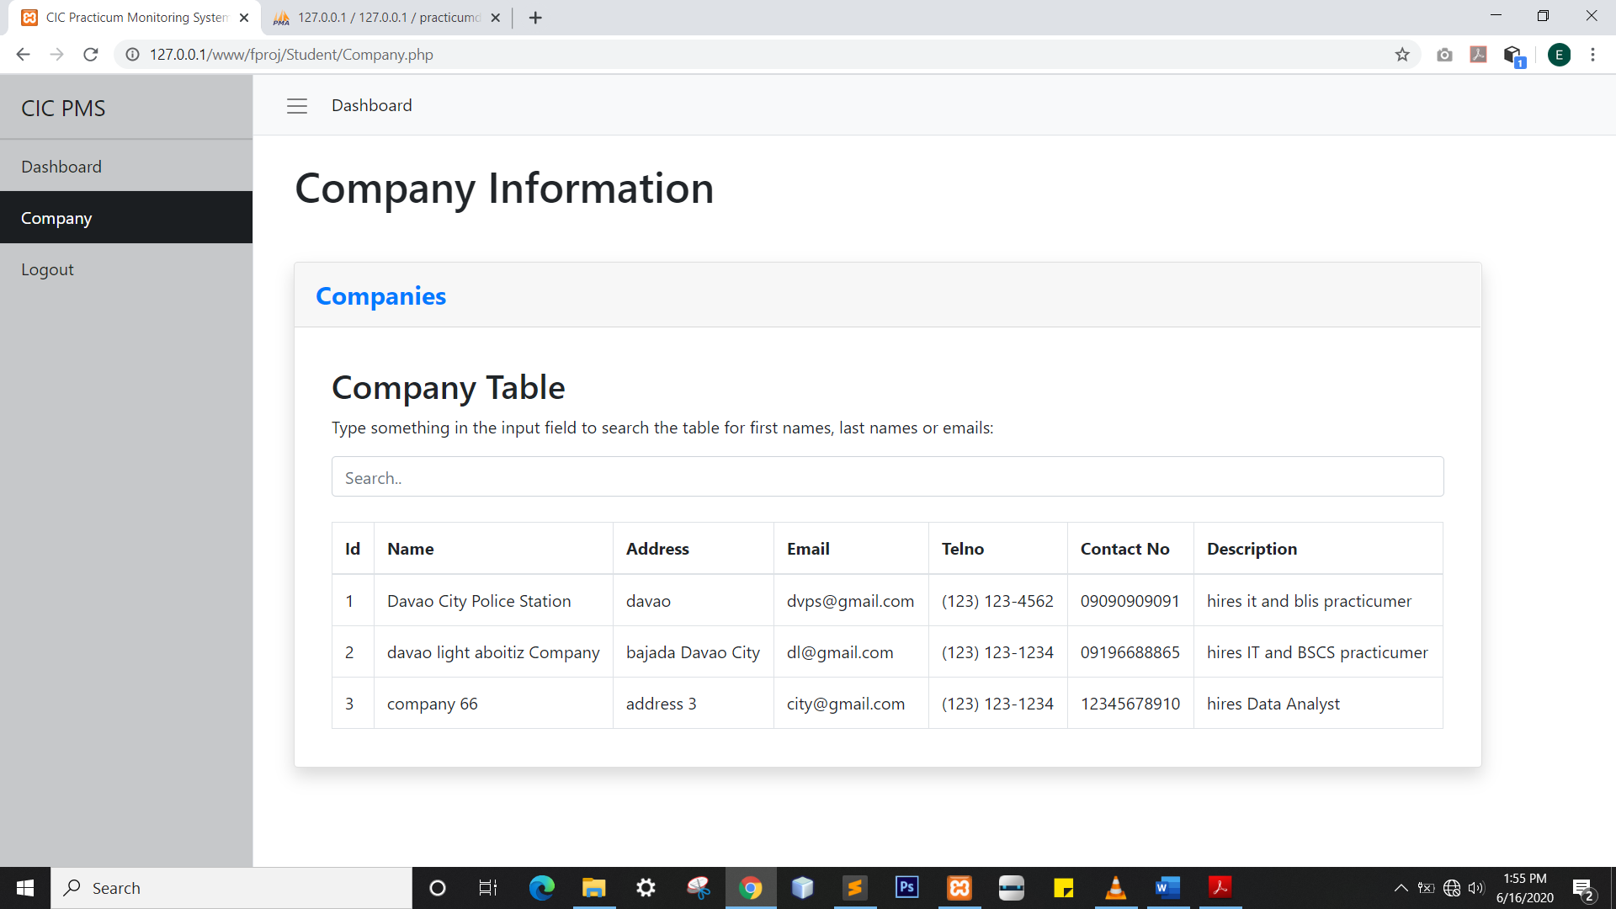

**Curriculum Vitae**

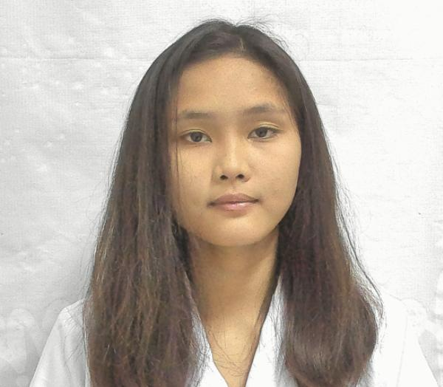

**PERSONAL DATA**

Name : Leah C. Juarez

Birthdate : May 7, 2000

Citizenship : Filipino

Address : Cabantian,Davao City

Civil Status: Single

**EDUCATION**

College (August 2018 - Present)

University of Southeastern Philippines

Senior High School (June 2016 – April 2018)

HolyChild College of Davao

Junior HighSchool (June 2012 – April 2016)

Cabantian National High School

Elementary (June 2005-2012)

Cabantian Elementary School

**SKILLS**

Multilingual: Filipino, English, Nihongo & Bisaya

Typing Skills : 25wpm

Layout Artist

Computer Literate

**SEMINARS ATTENDED**

Blockchain Training-Workshop (April 2019)