Transactions of the Institute of Measurement and Control
Special Issue: Focus on research student contributions

Aircraft flight controller tracking design using H-Infinity Static Output-Feedback

J. Gadewadikar¹ and F. L. Lewis²
¹Research Assistant, Automation and Robotics Research Institute, U. T. Arlington, Texas, USA.
² Senior Research Fellow and Professor, Automation & Robotics Research Institute and Department of Electrical Engineering, U. T. Arlington, Texas, USA.

This paper presents an approach for designing compensators of specified structure for shaping the closed loop step response that uses H-Infinity output-feedback design techniques. This approach results in controllers that take advantage of the wealth of experience in aircraft control design. Simplified conditions are presented which only require the solution of two coupled matrix design equations. A new numerically efficient algorithm to solve the H-Infinity disturbance attenuation is given. An F-16 normal acceleration design example is solved to illustrate the power of the proposed approach.

Key words: Output feedback, Linear Systems, Disturbance Attenuation, System theory, Tracking.

1. Introduction

Static output-feedback (OPFB), despite its apparent simplicity is one of the most researched problems in control theory and applications even since the first fixed control synthesis equations were derived for the Linear Quadratic Regulator problem (Levine and Athens, 1970). Main advantage of the static OPFB is the ability it provides for designing controllers of desired structure (Davidson and Ferguson, 1981). Static output-feedback is especially important in practical applications like flight control systems (Stevens and Lewis, 2003). A survey of OPFB design results is presented by (Syrmos et al., 1994). Traditionally the flight controllers use simple controllers and the design is done using linearized system description. It is well known that the OPFB optimal control solution can be prescribed in terms of three coupled matrix equations (Lewis and Syrmos, 1995), namely two associated Riccati equations and a spectral radius coupling equation. A sequential numerical algorithm to solve these equations is presented by (Moerder and Calise, 1985). Some LMI approaches for OPFB design are presented by (Ghaoui et al., 1997; Cao et al., 1998), these allow the design of OPFB controllers using numerically efficient software, e.g., the MATLAB LMI toolbox (Gahinet et al., 1995). However several problems are still open. Most of the solution algorithms are hard to implement, are difficult to solve for higher order systems, and may impose numerical problems.
H-Infinity design has played an important role in the study and analysis of control theory since its original formulation in an input-output setting (Zames, 1981). State-space H-Infinity solutions were rigorously derived for the linear time-invariant case that required solving several associated Riccati equations (Doyle et al., 1989). Recently H-Infinity design has been considered for static OPFB for the fundamental regulator problem, where it is necessary to regulate the outputs of the system to zero while ensuring that they exhibit desirable time response characteristics. (Hol and Scherer, 2004) addressed the applicability of matrix-valued sum-of-squares (sos) techniques for the computations of LMI lower bounds. A thorough treatment of H-Infinity design is given by (Knobloch et al., 2002), which also considers the case of OPFB using dynamic feedback. An excellent treatment of H₂ and H-Infinity control is given in (Colaneri et al., 1997). A recent result by (Gadewadikar, Lewis, and Abu-Khalaf, 2005) offers new possibilities for flight control using H-Infinity output feedback control theory.
A fundamental design problem is the tracker problem, where it is desired for an aircraft to follow or track a command signal (Stevens and Lewis, 2003). The tracker problem is important in the design of Control Augmentation Systems, where for instance, the command signal may be a desired pitch rate or normal acceleration command. The modern control technique in, for instance LQG and LTR is not the standard one- it has been modified in several respects to make it more suitable for the purpose of aircraft control design. An approach to the design of the tracking control systems which is more useful in aircraft control applications is proposed by (Stevens, Lewis, and Al-Sunni, 1992), here direct techniques for designing a compensator of desired structure is reviewed, which resulted in an output-feedback step response shaping problem. This approach allows designing a servo control system that has any structure desired.
This paper aims to analyze the effects by combining aircraft control design techniques for tracking with H-Infinity output-feedback design. We present a new output feedback solution algorithm and use of H-Infinity regulator design for the tracker. It is shown that for the F-16 Aircraft model H-Infinity OPFB performs better than Optimal OPFB if disturbance exists.

2. Structure of Aircraft tracking System
In aircraft control design, experience is often utilized to make the decisions about the compensator, Figure (1) describes an approach to the design of tracking control system which is very useful in aircraft control application; this approach will allow one to design a servo control system that has any structure desired.

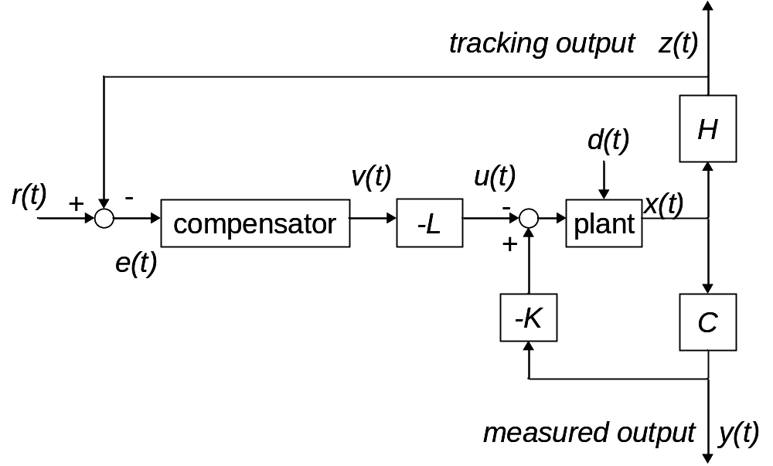
Figure 1 Plant with compensator of desired structure under disturbance
A dynamic compensator of prescribed structure may be incorporated into
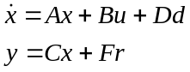 | (1)

with state 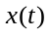, control input 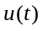, exogenous disturbance 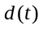, and 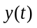the measured output available for feedback purposes. In addition,
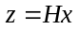 | (2)

is a tracking performance output, which must track the given reference input 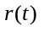. The performance output 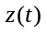is not generally equal to.
The dynamic compensator has the form
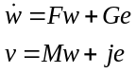 | (3)

wth state 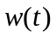, output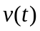and the input equal to the tracking error.
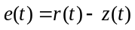 | (4)

,,, and are known matrices chosen to include the desired structure in the compensator.
The allowed form for the plant control input is
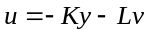 | (5)

Where the constant gain matrices and are to be chosen in the controls design step to result in satisfactory tracking of . This formulation allows for both feedback and feed forward compensator dynamics. These dynamics and output equations may be written in augmented form as
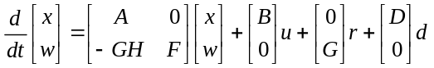 | (6)

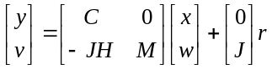 | (7)

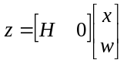 | (8)

and the control output may be expressed
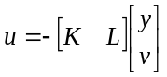 | (9)

Note that in terms of the augmented plant/compensator state description, the admissible controls are represented as a static output feedback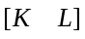. In the augmented description, all the matrices are known except the gains, and, which need to be selected to yield acceptable closed loop performance.

2.1 Disturbance rejection formulation of the tracker
By defining the state, the output and the matrix variable to stream line the notations we see that the augmented dynamics that contain the aircraft, compensator and the disturbance are of the form described by Equation 1.
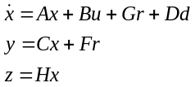 | (10)

The admissible controls are proportional output feedback of the form
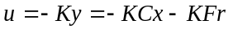. | (11)

Using these equations the closed-loop system is found to be of the form as in Equation 3, and illustrated in Figure (2).
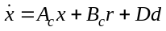, | (12)

with 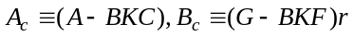.
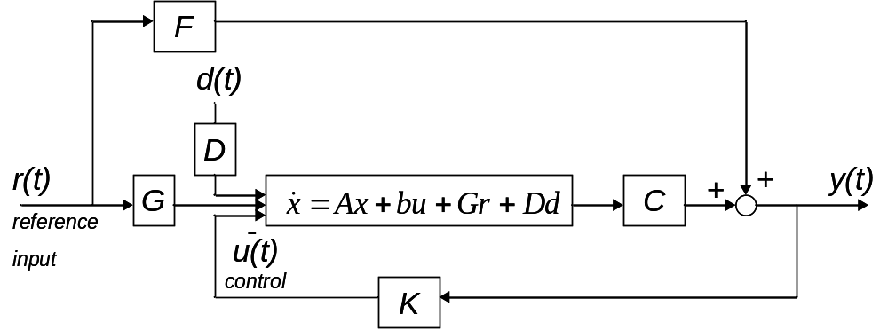

Figure 2 Plant/feedback structure with disturbance
It is well known that if the compensator is required to have a specific structure, the selection of control gains is an output feedback problem. Even if state-variable feedback might be able to guarantee stability, the resulting compensator has no structure and is unsuitable. Another important issue is that disturbances can affect the system performance even if stability is guaranteed. Therefore one is motivated to consider H-Infinity OPFB design.
Design of this tracking system can be converted to a regulator design problem (Stevens and Lewis, 2003). Having designed a suitable regulator using H-Infinity technique, the structure in Figure (1), which includes a unity gain outer tracking loop, then guarantees good tracking performance. The next section presents necessary and sufficient conditions for output feedback H-Infinity control.

3. Necessary and Sufficient Conditions for H-infinity static output-feedback

This section presents necessary and sufficient conditions for output feedback stabilizability with prescribed attenuation (Gadewadikar, Lewis and Abu-Khalaf, 2005). Consider the linear time-invariant system of Figure 3 with control input u(t),output y(t), and disturbance d(t) given by
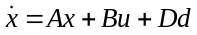, 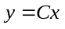, | (13)

and a performance output ζ(t) that satisfies

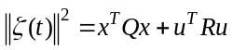, , | (14)

for some symmetric matrices 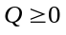 and 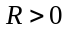. It is assumed that C has full row rank, a standard assumption to avoid redundant measurements.

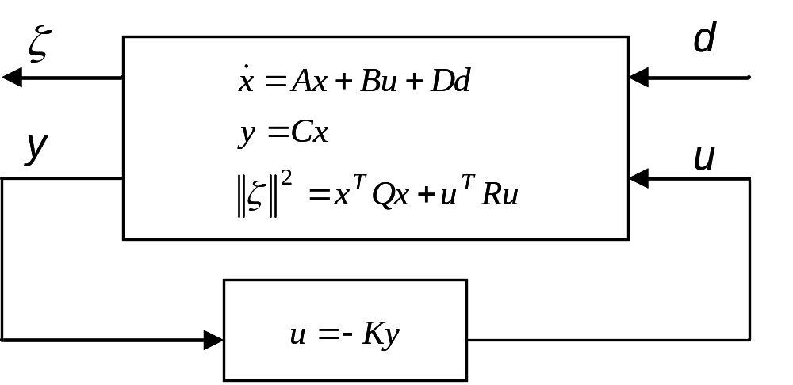

Figure 3 System Description

Bounded L₂ Gain Design Problem. Defining a constant output-feedback control as
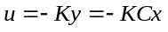, | (15)

it is desired to find a constant output-feedback gain K such that the system is stable and the L₂ gain is bounded by a prescribed value.
The System L₂ gain is said to be bounded or attenuated by γ if
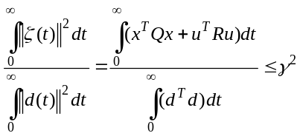. | (16)

Note that the definition of the performance output given by (14) is an instantaneous one. However, it is used in integral cost (16) for the formulation of the bounded L₂ gain.

Theorem: Necessary and Sufficient Conditions for H-Infinity static output-feedback.

Assume that and (A, 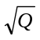) is detectable. Then system defined by Equation (13) is output-feedback stabilizable with L₂ gain bounded by , if and only if
- (A, B) is stabilizable and (A, C) is detectable.
- There exist matrices K* and L such that
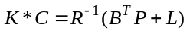, | (17)

where P>0, P^{T} =P, is a solution of
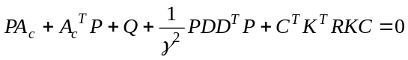. | (18)

Proof:
It can be shown that Equation (8) in (ii) is equivalent to
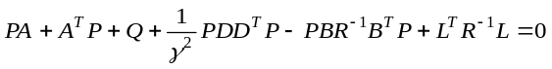. | (19)

The proof then follows from (Gadewadikar, Lewis, and Abu-Khalaf, 2005).
■
Note: By definition the pair (A, B) is said to be stabilizable if there exists a real matrix K such that is (asymptotically) stable. The pair (A, C) is said to be detectable if there exists a real matrix such that 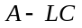 is stable. System (13) is said to be output feedback stabilizable if there exists a real matrix K such that 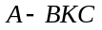is stable.
4. Computational Algorithm for output-feedback design
In this section we present a new algorithm to solve Equations (17) and (18). This is an OPFB H-Infinity design algorithm and is an extension of Klienman’s algorithm which was originally proposed for state-variable feedback control without disturbance (Klienman, 1968). At this point it is important to state that unlike the algorithms of (Moerder and Calise, 1985), (Jen Te-Yu 2004), it uses a Riccati equation solution, not a Lyapunov equation, at each step to solve for the H-Infinity design for a given admissible disturbance attenuation.
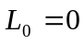, 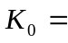Initial stabilizing gain.
- Solve for P
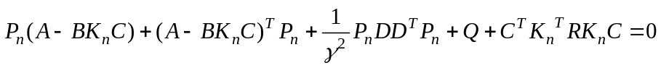. | (20)
- Update K
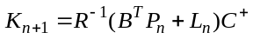. | (21)

Where 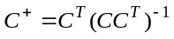 is defined as the unique Moore-Penrose inverse of C, since C is assumed to have a full row rank.
- Update L
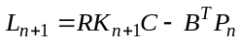. | (13)

- Check for convergence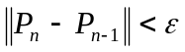, at convergence define K∞=K, go to 1 if not converged.
■
Lemma: If this algorithm converges, it provides the solution to Equations (17) and (18).
Proof: Clearly at convergence Equation (18) holds for P_{n}. Note that substitution of Equation (21) into Equation (22) yields.
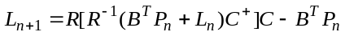
At convergence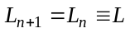, 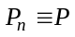 so that
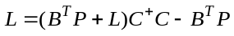, or
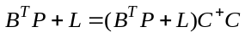. | (23)

This guarantees that there exists a solution K* to (17) given by 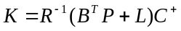.
■

5. F-16 Normal Acceleration Regulator Design
This section describes the design procedure of an H-infinity sub-optimal Linear Quadratic Tracker and compares the results with the optimal output feedback linear quadratic gain. We shall start with a brief description of the system. The normal acceleration control system taken from (Stevens and Lewis, 2003) is shown in the Figure 4, where r(t) is a reference step input and u(t) is the elevator actuator voltage. An integrator has been added in the feed-forward path to achieve zero steady state error. The performance output that should track the reference command r is normal acceleration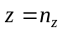, so that the tracking error is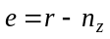.
The state vector comprises:
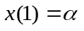: Angle of attack.
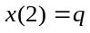: Pitch Rate.
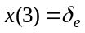: Elevator Actuator.
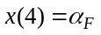: Filtered measurement of angle of attack.
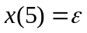: Integral Controller.
The measurement outputs are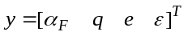.
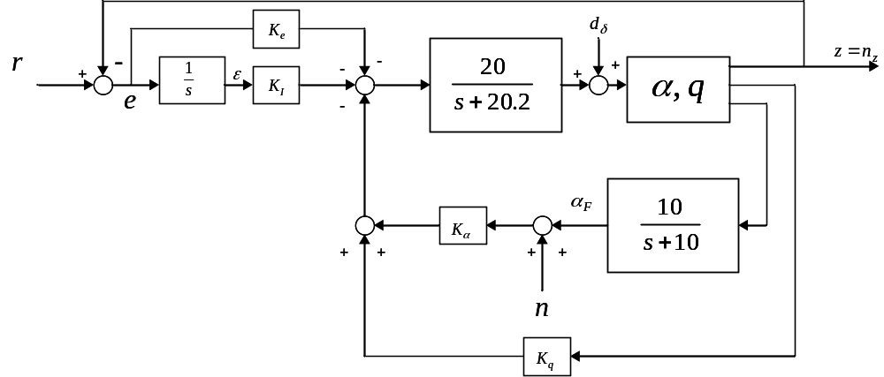

Figure 4 G Command System
We use the short period approximation to the F-16 dynamics linearized about the nominal flight condition described in (Stevens and Lewis, 2003), the dynamics are augmented to include the elevator actuator, angle-of-attack filter, and compensator dynamics. Disturbance 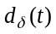 is affecting the elevator actuation and n(t) is affecting the filtered measurement, so that 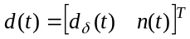. The result is the dynamics of the form given in equation (10) with
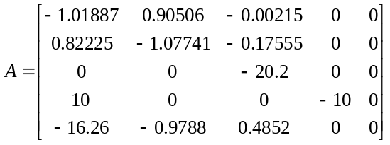

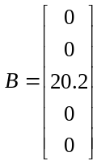,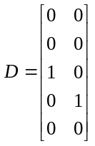,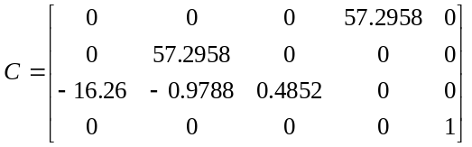, 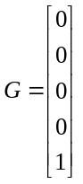, 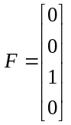,
.
The factor of 57.2958 is included to convert angles from radians to degrees.
The control input is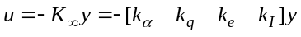. It is required to select the output-feedback feedback gains to yield stability with good closed-loop response and disturbance rejection. Note that 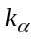 and 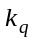 are feedback gains, while 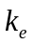and 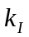are feed-forward gains. This approach allows the adjustment of both for the best bounded L₂ gain performance. The algorithm presented in Section 4 was used to design an H-Infinity tracker for a prescribed value of γ.
For the computation of the H-Infinity output feedback gain K∞ it is necessary to select design matrices Q and R to begin the design process. The choice of Q can be easily confronted more easily by considering the tracking performance objective. In this case tracking performance output is. Performance output 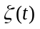then can be written as
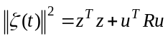

This is equivalent to effectively having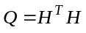; in this selection, one can see that the integral state is unobservable, since the integral pole is at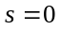, (A, H) is undetectable (unstable unobservable pole). To address this, we have included weighting on integral state 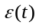to achieve detectability. Using the algorithm described in section 4 for the given γ, Q, and R the control gain K∞ is easily found using MATLAB in a few seconds. If this gain is not suitable in terms of time responses and closed-loop poles, the elements of Q and R can be changed and the design repeated. After repeating the design several times we selected the design matrices as
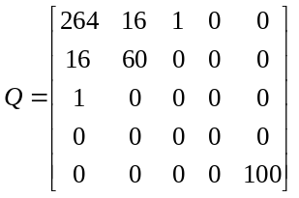, 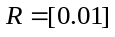

which yields the H-Infinity output feedback matrix
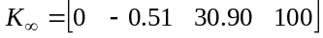, | (24)

and resulting closed loop poles
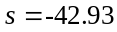, 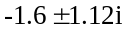,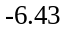, 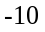.
The decreased control weighting has the effect of allowing larger control effort and so speeding up the response. The increased weighting on the integrator output has the effect of forcing normal acceleration to its final value of more quickly; increased weighting on pitch rate has the effect of providing increased damping.
The optimal output feedback gain K₂ for the same Q and R is given in (Stevens and Lewis, 2003). It is
. | (25)

We plotted the response with our H-Infinity output gain matrix given in equation (24) and the optimal output-feedback gain matrix given in equation (25), time response for a step command is shown in Figure 5. A step disturbances d(t) is introduced in simulations to verify disturbance rejection properties of the design. The resulting time responses are shown in Figures 6 and 7, it can be seen that the structure of the H-Infinity static OPFB controller with the prescribed loops guarantees good tracking when disturbance is introduced. In Figure 6 one sees the effect of unit step disturbance on the transient response on the optimal output-feedback controller performance; in Figure 7 the increased disturbances of magnitude 10 times higher than unit step will make the response of the optimal output- feedback worse. .
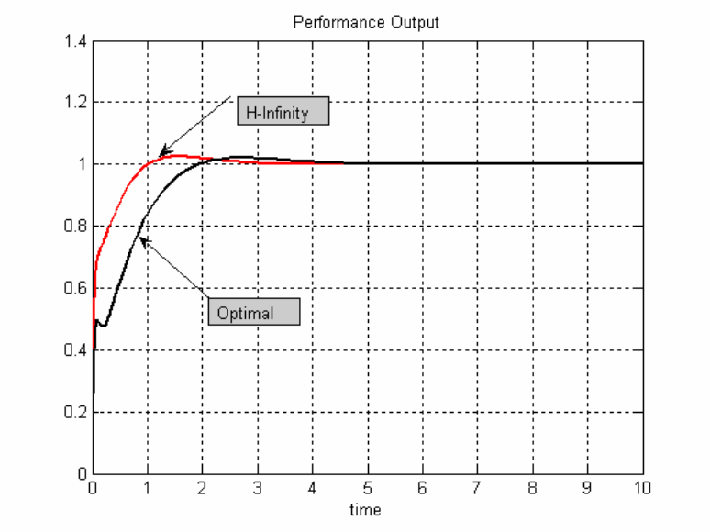
Figure 5: Response without disturbance

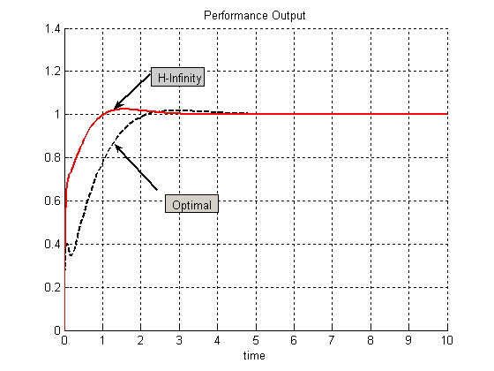
Figure 6: Response with a unit step disturbance

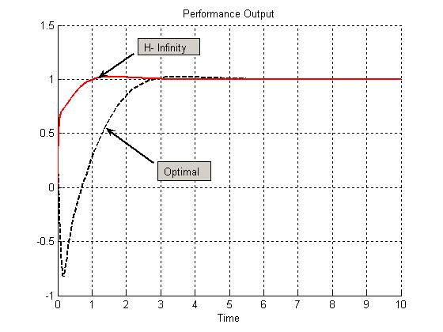
Figure 7: Response with increased disturbance

6. Conclusion
In this paper, necessary and sufficient conditions for H-Infinity output-feedback have been presented. Tracking system redesign procedure is elaborated. A new iterative algorithm is proposed to compute stabilizing gains. An aircraft design example is used to illustrate that the H-Infinity design improves the time response of the system. Comparison with Optimal output-feedback controller is done. Simulation results show that H-Infinity OPFB gives superior results when disturbance is present.

7. Acknowledgement
This research was supported by NSF grants ECS-0140490, NSF ECS-0501451 & ARO grants DAAD 19-02-1-0366, and W91NF-050-1-0314.

References

Cao, Y., Lam, J., and Sun, Y. 1998: Static Output Feedback Stabilization: An ILMI approach. IFAC Journal, AUTOMATICA, Vol. 34, No. 12, pp. 1641- 1645.

Colaneri, P., Geromel, J. C., and Locatelli, A. 1997: Control theory and design, an RH2 and RH∞ viewpoint, Academic Press Interscience, San Diego.

Davidson, E. J. and Ferguson, I. J. , 1981: The design of Controllers for the multivariable Robust servo mechanism Problems Using Parameter Optimization methods. IEEE Transactions on Automatic Control, Vol. AC-26, No 1, Feb 1981, pp. 93-110.

Doyle, J. H, Glover, K., Khargonekar, P., and Francis, B. 1989: State state solutions to standard and Control Problems. IEEE Transactions on Automatic Control, Vol. 34, No. 8, pp. 831-847.

Gadewadikar, J., Lewis F., Abu-Khalaf M. To be Published : Necessary and Sufficient Conditions for H-Infinity Static Output-Feedback Control. AIAA, Journal of Guidance Dynamics and Control.

Gahinet, P. , Nemirovski, A., Laub, A., and Chilali, M. 1995 : LMI Control Tool box, MATLAB., Mathworks, Inc., Natick, MA, 1995.

Ghaoui E., L., Oustry, F., AitRami, M., 1997: A cone complementarity linearization algorithm for static output-feedback and related problems. IEEE Transactions on Automatic Control, Vol. 42, No. 8, 1997, pp. 1171-1176.

Holl, C., and Scherer, C. 2004: computing Optimal Fixed Order H∞-synthesis Values by matrix Sum of Squares Relaxation. 43rd IEEE Conference on Decision and Control, Atlantis, Paradise Island, Bahmas, 2004, pp. 3147-3153.

Klienman, D. L., 1968: On an Iterative Technique for Riccati Equations Computations. IEEE Transactions on Automatic Control, Vol. 30, No. 1, 1968, pp. 114-115.

Knobloch, H. W., Isidori, A., and Flockerzi, D. 1993: Topics in control theory, Birkhauser, Berlin, Germany, 1993, pp. 43-49, 58-67, 99-111.

Levine W.S, and Athans M. 1970: On the determination of the optimal constant output feedback gains for linear multivariable systems. IEEE Trans. Automatic Control. Vol 15, pp 44-48.

Lewis, F. L. and Syrmos V. L., 1995: Optimal Control, 2nd ed , John Wiely and Sons, New York, pp. 359-375.

Moerder, D. D., and Calise, A. J., 1985 : Convergence of a Numerical Algorithm for calculating Optimal output feedback gains. IEEE Transactions on Automatic Control, Vol. 30, No. 9, pp. 900, 903.

Stevens B. L., Lewis F. L., Al-Sunni F., 1992: Aircraft flight controls design using output feedback., Journal of Guidance, Control, and Dynamics. Vol. 15, no. 1, pp. 238-246.

Stevens, B. L., and Lewis, F. L., 2003: Aircraft control and simulation, 2nd Ed, Wiley Interscience, New York, pp 403-419.

Syrmos, V. L., Abdallah, C.; Dorato, P., 1994: Static output feedback: a survey. Proceedings of 33rd IEEE Conference on Decision and Control, Orlando, FL, 1994, pp. 837-842

Zames, G. 1981: Feedback and optimal sensitivity: Model reference transformations, multiplicative seminorms, and approximate inverses. IEEE Transactions on Automatic Control, Vol. 26, No. 2, , pp. 301-320.

Yu, Jen-te, 2004 : A Convergent Algorithm for Computing Stabilizing Static Output Feedback Gain. IEEE Transactions on Automatic Control, Vol. 49, No. 12, December 2004

