Parameterization of All Stabilizing H∞ Static State-Feedback Gains: Application to Output-Feedback Design
J. Gadewadikar*a, Frank. L. Lewisb, L. Xiec, V. Kucerad, M. Abu-Khalafe

Abstract
This paper presents a simplified parameterization of all H∞ static state feedback controllers in terms of a single algebraic Riccati equation and a free parameter matrix. As a special case, necessary and sufficient conditions for the existence of an static output feedback gain are given. An efficient computational algorithm is given and its correctness proven. No initial stabilizing output feedback gain is needed. The technique is used to design an H∞ lateral-directional command augmentation system for the F-16 aircraft.

Key words: Controller parameterization, static output feedback, H∞ control.

- Introduction
The parameterization of all stabilizing controllers and the static output-feedback control problems are two of the most researched and written about issues in modern control. Static output feedback is indeed a special case of the former problem where the controller gain is restricted to lie in some subspace. The computation of optimal 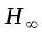 controllers of prescribed order and of static output feedback controllers are non-convex problems, and so are difficult to confront. Main objective of this work is to present a simpler parameterization to achieve disturbance attenuation with a static state feedback compensator; the approach is bringing control, static compensation, and parameterization together. First, an introduction of the relevant work is given below.
  - Parameterization of dynamic compensators
The parameterization of all stabilizing polynomial controllers was first given by Youla et al. (1976) and Kucera (1975, 1979) in terms of solutions to a Diophantine equation. The approach (Doyle, Glover, Khargonekar, and Francis 1989) has shown its effectiveness in the design of controllers for modern systems. A parameterization of dynamic compensators for the state feedback and full information cases was given by Zhou (1992) in terms of the Hamiltonian matrix and the Youla-Kucera parameterization. Parameterization of dynamic compensators was given by Iwasaki and Skelton (1995), and Mita et al. (1998). Henrion, Kucera, and Molina-Cristobal (2005) use the Youla-Kucera parameterization to provide a method for designing low order compensators by simultaneous optimization over the numerator and denominator of the compensator. Application is made to control.
The book by Colaneri, Geromel, and Locatelli (1997) provides a unifying point of view for optimal H₂ and control for linear systems. Parameterization of full information controllers is given, both for static state feedback and dynamic feedback. Parameterization of dynamic output feedback controllers is given in terms of solutions to two algebraic Riccati equations. LMI solutions are also given. A summary of design is given by Knobloch, Isidori, and Flockerzi (1993), which considers disturbance attenuation, full information regulators, and nonlinear techniques including observers.
  - Static Output-Feedback
A survey of static output feedback control is given by Syrmos et al. (1997). Conditions often involve two Riccati equations coupled by a spectral radius condition (Lewis and Syrmos 1995). Moerder and Calise (1985) presented an algorithm for computing the optimal H₂ static output feedback gain that is in standard use, along with a convergence proof. This algorithm is extended and used for aircraft control design in (Stevens and Lewis 2003). An initial stabilizing output-feedback gain is needed, which is difficult to determine for practical systems. Recent results address these issues. Jen-Te Yu (2004) provides a solution for the optimal static output feedback problem in terms of two AREs plus a projective coupling condition, but the AREs are standard ones involving state feedback, not output feedback. An algorithm is presented that requires an initial stabilizing state feedback gain, which is easy to find using standard LQR methods.
Covariance assignment techniques (Hotz and Skelton 1987, Skelton and Iwasaki 1993), involve coupled Lyapunov equations on subspaces. A parameterization of all static output feedback gains is given by Yasuda et al. (1993) in terms of such equations. LMI approaches have been presented by Iwasaki and Skelton (1995), where a parameterization was also presented. In (Colaneri, Geromel, and Locatelli 1997) and (Geromel, de Souza, and Skelton 1998), a parameterization of static output feedback gains is given in terms of the blocks of a symmetric matrix derived from coupled matrix inequalities. Also provided is a condition in terms of a matrix and its inverse. A numerical procedure is given to determine these quantities. LMI conditions for optimal and static output feedback are given by Shaked (2003). A solution to the static output feedback problem is given by Gu and Misra (1994) for a restricted class of systems in terms of a single ARE and a related negative definiteness condition. Synthesis of fixed-structure controllers has been given. El Ghaoui and Balakrishnan (1994) propose an iterative algorithm for designing LTI controllers with prespecified structure based on LMI’s. Solution via a bi linear matrix inequality formulation is given (Safonov, 1994; Mattei, 2000). Sufficient LMI conditions for OPFB control problem are presented in (Crusius et. al., 1999).
Trofino-Neto and Kucera (1993) solve the static output feedback problem using inverse optimal control in terms of a single ARE projected onto nullspace perpendicular of C and a free parameter matrix. Astolfi and Colaneri (1993, 2000, 2000b, 2001, 2002, 2005) over the years have contributed significantly on static output-feedback stabilization problems.
  - Motivation
Solutions to the parameterization of all stabilizing controllers and the output feedback problems are generally complex, depending for instance on coupled Riccati equations, LMIs, or on a matrix and its inverse belonging to some sets.
Geromel and Peres (1985) give a sufficient condition for a stabilizing static output feedback in terms of a single ARE with a free parameter matrix, plus a condition on the form of the gain matrix. A computational algorithm is proposed. Kucera and de Souza (1995) provide necessary and sufficient conditions for stabilizing static output feedback control using these constructions. Gadewadikar et al. (2005) extend these conditions to obtain necessary and sufficient conditions for the existence of an static output feedback control. Geromel et al. (1989) provide similar results for the discrete-time case for decentralized feedback and output feedback. De Souza and Xie (1992) provide for the discrete-time case a parameterization of all stabilizing controllers in terms of similar constructions, and use that result to solve the static output feedback problem for discrete systems.
To summarize; a lot of work has been pursued, however several problems are still open, most of the approaches though theoretically appealing, are hard to implement, are difficult to solve for higher-order systems, and can impose numerical problems. In this paper we present a parameterization of all stabilizing controllers for continuous-time systems in terms of a single ARE and a free parameter matrix. The form of the result is simple and can be used to select the parameter matrix to satisfy additional design criteria. The result is used to develop necessary and sufficient conditions for existence of a solution to the static output feedback problem for continuous-time systems. An algorithm is provided that does not require an initial stabilizing output feedback gain, but only an initial stabilizing state feedback gain, which is easy to find. The correctness of the algorithm is proven, namely that if it converges, it yields the correct solution. The results are used to simply design an lateral-directional command augmentation system for the F-16 aircraft given in (Stevens and Lewis 2003).
- Parameterization of All Stabilizing Static State Feedback Gains
  - System Description and Definitions
Consider the Linear Time-Invariant (LTI) system in Fig. 1
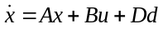, 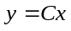 (1)
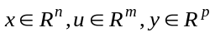
and a performance output 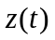 that satisfies
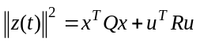, (2)
with 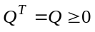, 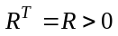. It is assumed that C has full row rank, a standard assumption to avoid redundant measurements.
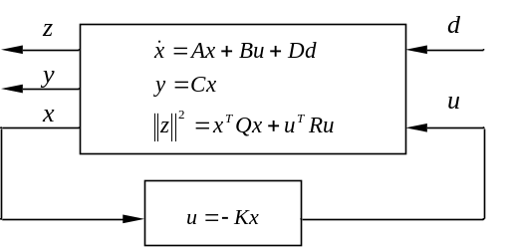
Fig. 1. System Description

The System 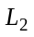 gain is said to be bounded or attenuated by if
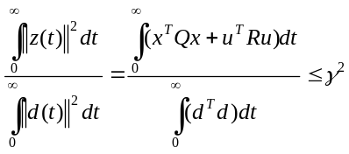 (3)
for any non-zero energy-bounded disturbance input . Call 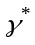 the minimum gain for which this occurs. For linear systems, there are explicit formulae to compute, see, e.g., Chen (2000). Throughout this paper we shall assume that is fixed and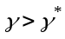.
  - Bounded Gain Design Problem
Defining a constant state-feedback control as
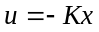, (4)
it is desired to find the state-variable feedback (SVFB) gain such that the closed-loop system 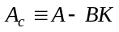 is asymptotically stable and the gain is bounded by a prescribed value.
The following main theorem shows necessary and sufficient conditions for the parameterization of all stabilizing 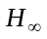 static state-feedback gains. It provides a simpler parameterization than most other results in the literature.
Theorem 1 – Parameterization of all H∞ SVFB gains
Assume that (,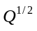) is detectable. Then K is a state feedback that stabilizes system (1) and guarantees gain bounded by, if and only if there exists a parameter matrix L such that
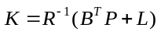, (5)
where 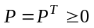, is a solution to
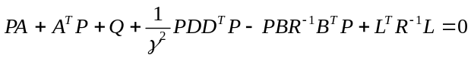 (6)
Proof:
Necessity: Suppose that there exists a state-feedback gain K that stabilizes the closed loop system 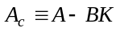 and satisfies gain bounded by. Consider the equation
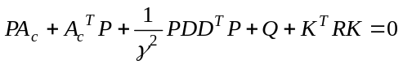 (7)
Considering the definition (2), from Knobloch et al. (1993), Theorem 2.3.1, closed-loop stability and gain boundedness implies that Eq. (7) has a unique symmetric solution such that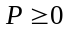. Rearranging Eq. (7) and completing the square will yield
(8)
Substituting the gain defined by (5) in (8) yields (6).
Sufficiency: Define 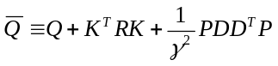 and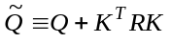. Suppose that (5) and (6) hold, then (7) follows, so that
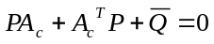. (9)
We claim that detectability of (,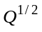) implies detectability of 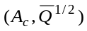. For, note that detectability of (,) implies that 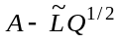 is stable for some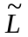. One can write
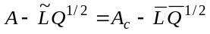 (10)
for 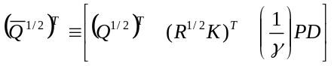 and 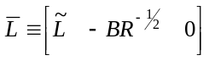. It follows that if pair 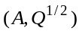 is detectable then pair 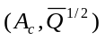 is detectable as well. Moreover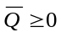, and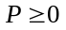. Therefore, using the Lyapunov stability criteria (Wonham, 1985), Lemma 12.2, Equation (9) implies closed-loop stability. Finally for 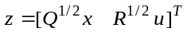 one has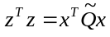, and
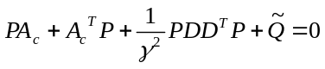, (11)
and system gain bounded-ness then follows from Van der Schaft (1992), Theorem 2.
■
A special case of this result shows when there exists a static output feedback (OPFB) gain F that stabilizes the system (1) with bounded gain. OPFB requires a restricted form of the gain matrix K that has C as a right divisor. Define the control input for OPFB as
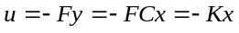
which yields the closed-loop system 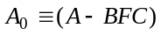 Equations for OPFB design are generally complicated, consisting of three coupled matrix equations, as given in Lewis and Syrmos (1995), Moerder and Calise (1985), and Jen Te Yu (2004).
The next result provides simplified equations for OPFB design. The Corollary holds for a prescribed matrix Q and follows directly from Theorem 1.
Corollary 1- Existence of OPFB for a given Q
Consider a specified 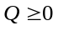 such that (,) is detectable, and a specified value of . Then there exists an OPFB gain F such that 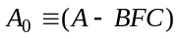 is asymptotically stable with bounded gain if and only if there exists a parameter matrix L such that
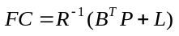, (12)
where , is a solution to
(13)
■
The next result gives necessary and sufficient conditions for the existence of a stabilizing OPFB with bounded gain. It follows from Corollary 1 by setting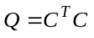. It is a refinement of the result in Kucera and de Souza (1995), and extends that result to solve the OPFB problem.
Corollary 2- Existence of H∞ OPFB
For a given, there exists an OPFB gain such that 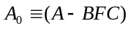is asymptotically stable with gain bounded by if and only if:
- 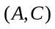is detectable
and there exist matrices L and 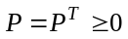such that:
- .
- 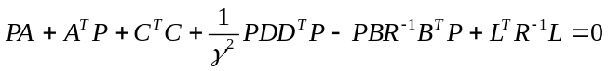 (14)
Proof:
Necessity: To prove necessity, set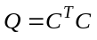, 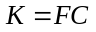 and proceed with the necessity proof of Theorem 1. Note further that 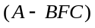 stability implies 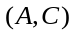 detectability.
Sufficiency: Suppose that (i), (ii) and (iii) hold, then the sufficiency proof of Theorem 1 holds with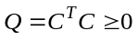. ■
Remarks. Note that under the special form , the performance output is given by
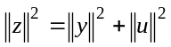,
Note that a stabilizability condition on 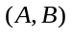 is hidden in the assumption of existence of a solution 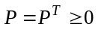 to (14).
- Solution Algorithm for Output Feedback
Most existing iterative algorithms for static OPFB design require the determination of an initial stabilizing OPFB gain, which can be very difficult for practical systems, and the solution of three coupled design equations- two Riccati equations and a spectral radius condition. Here is presented an algorithm to solve the two coupled design equations in Corollaries 1 and 2. The algorithm starts with a stabilizing SVFB gain, which can easily be found using standard computational tools (e.g. LQR). It is shown that the algorithm, if it converges, solves the output feedback problem.
Since C has full row rank, the right inverse is defined as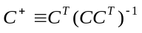, which is best computed using the SVD
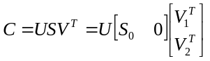. (15)
Then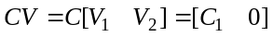, so that 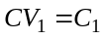, and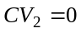. Note that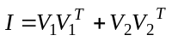. Therefore,
- 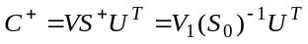.
- 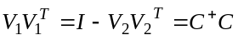 is the projection onto nullspace perpendicular of .
- 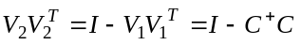 is the projection onto the nullspace of .
The equation 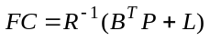 has an exact solution if and only if
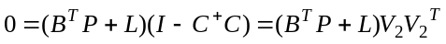.
Then the solution is given by
.
The following algorithm is based on Yu (2004), where, however, three coupled equations must be solved. It solves for a state feedback at each iteration, and then projects that SVFB onto nullspace perpendicular of C.
OPFB Design Algorithm
1. Initialize: Fix 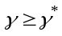. Set 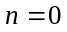, 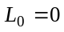. Solve a standard (e.g. LQR) Riccati equation for given Q and R and obtain a stabilizing SVFB gain as initial gain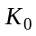. Define closed-loop matrix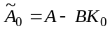.
2. n-th iteration: Solve ARE for P
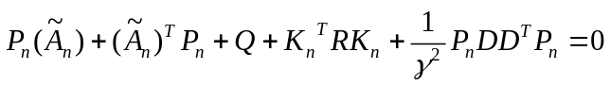, (16)
update K, project onto nullspace perpendicular of C
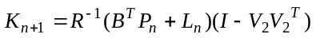, (17)
update L
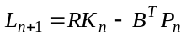, (18)
update closed-loop system matrix
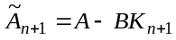, (19)
3. Check convergence. If converged, go to step 4 otherwise set 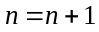 go to step 2.
4. End. Set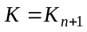 and compute OPFB gain 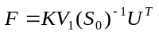.
The convergence can be checked using the norm of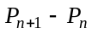 e.g. 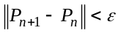 , hereis a small number and operator 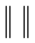denotes the matrix norm.
The next result shows the correctness of the algorithm, namely, that if it converges, it provides the H∞ OPFB gain.
Lemma 1: If this algorithm converges, it provides the H∞ OPFB gain.
Proof: Clearly, at convergence (7) holds for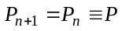. Substitution of Eq. (17) into Eq. (18) yields.
At convergence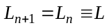, so that 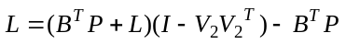, therefore
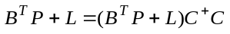 (20)
This guarantees that there exists a solution F to (12) given by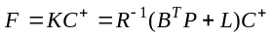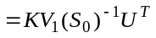. ■
Remark: Note that the proof guarantees that, if the algorithm converges, then there exists a solution F to (12).
- H∞ Output-Feedback Design for F-16 Regulator
In this example we demonstrate the effectiveness of the proposed static OPFB design technique on a realistic design example. It is desired to design a lateral-directional (e.g., roll damper/yaw damper) command augmentation system (CAS) for the F-16 dynamics from Stevens and Lewis (2003) linearized at the nominal flight condition in Table 3.6-3 (Stevens and Lewis, 2003) (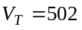ft/s, 300psf dynamic pressure, cg at 0.35). This CAS shown in Fig. 2 has two input channels, and includes actuators and a washout filter. 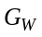is the washout circuit, the transfer function 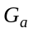represents an equivalent transfer function for differential actuation of the left and right ailerons, and 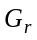is the rudder actuator. The design requires the selection of 8 control gains. The structured nature of the CAS means that OPFB, not SVFB, must be used.
The lateral states are sideslip, bank angle, roll p, and yaw rate r. Additional states 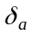 and 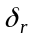 are introduced by the aileron and rudder actuators
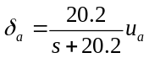, 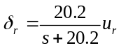.
A washout filter
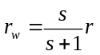
is used, with r the yaw rate and the washed out yaw rate. The washout filter state is denoted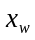. The entire state vector is
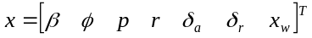.

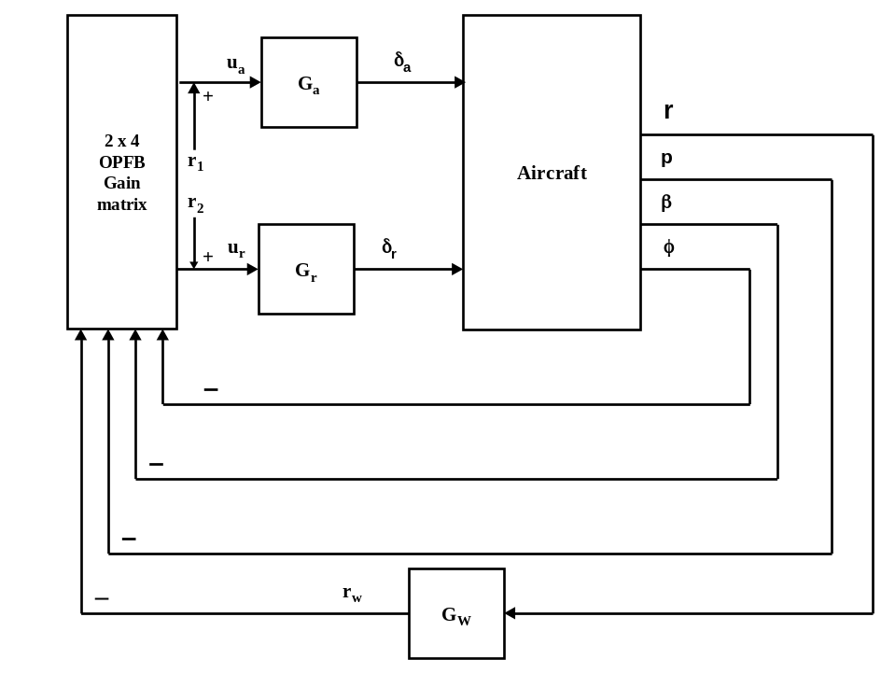
Fig. 2: Lateral/directional augmentation system
The control inputs are the rudder and aileron servo inputs so that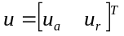. The disturbance is given by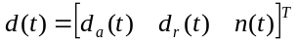, where 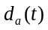 affects the aileron actuation, 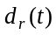 the rudder actuation, and 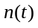 the washout filter state. Disturbances are applied to the control inputs, e.g. wind gusts, and to the measurements, i.e. measurement noise.
The full state variable model of the aircraft plus actuators, washout filter, disturbance, and control dynamics is of the form given by Eq. (1), with
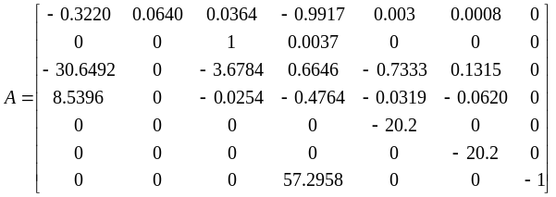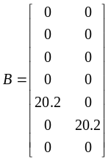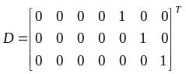
The output is
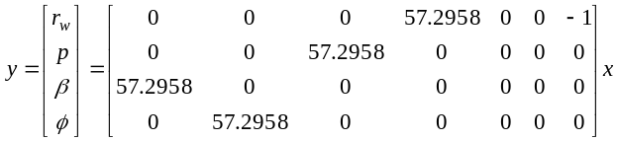
The factor of 57.2958 is added to convert angles from radians to degrees. The feedback control is output feedback of the form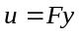, so that the F is a matrix. That is, eight feedback gains must be selected.
In this example are observable. For the computation of the output feedback gain F it is necessary to select Q, R, and. The proposed algorithm makes it very easy and fast to perform the design for different values of Q, R, . We selected and. If the resulting gain F is not suitable in terms of time responses and closed-loop poles, the elements of Q and R can be changed and the design repeated. These values were found suitable in this example.
The gain parameter defines the desired bound. For the initial design, a fairly large is selected. If the algorithm converges, the parameter   may be reduced. If is taken too small the algorithm will not converge since the ARE has no positive semidefinite solution. After some design repetitions, which were performed very quickly using the algorithm, we found the smallest value of the gain to be 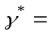1.499. To compare this with popular design methods, Chen (2000), smallest value of gain both with State-feedback and Dynamic OPFB compensator is 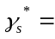0.996. H∞ static output feedback methods have bigger 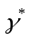 than state feedback methods because the static output feedback is a subset of state feedback. The results for the gain are
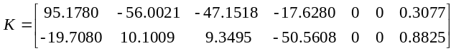
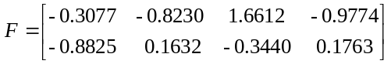.
The resulting closed-loop poles are at
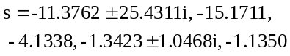.
Convergence properties can be observed with Figs. 3- 6. Note that the norm in Fig. 6 was used in the stopping criterion for the algorithm
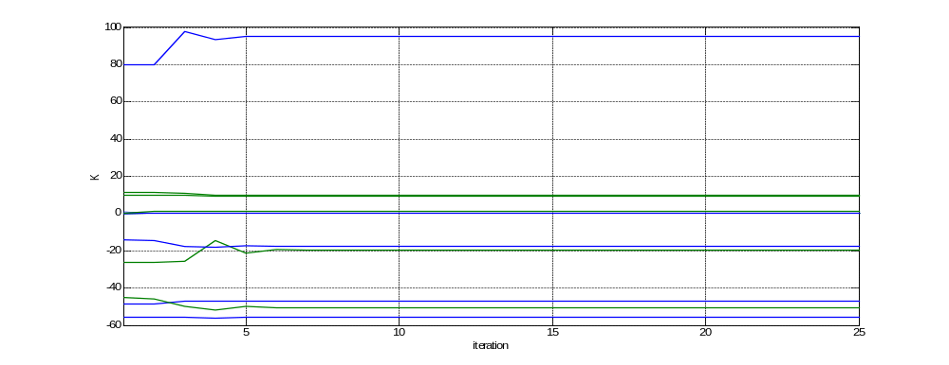
Fig. 3: Trajectory of the gain K
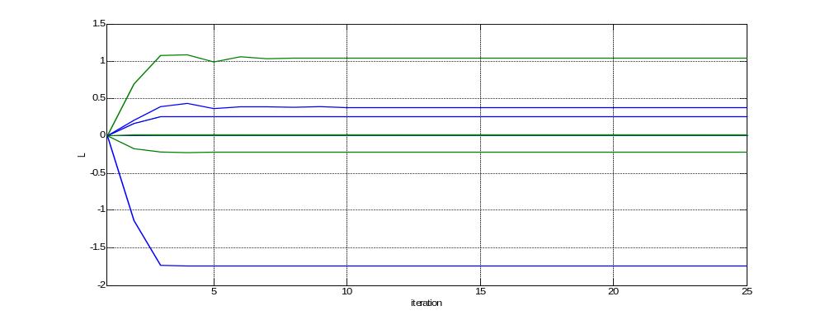
Fig. 4: Trajectory of the parameter matrix L
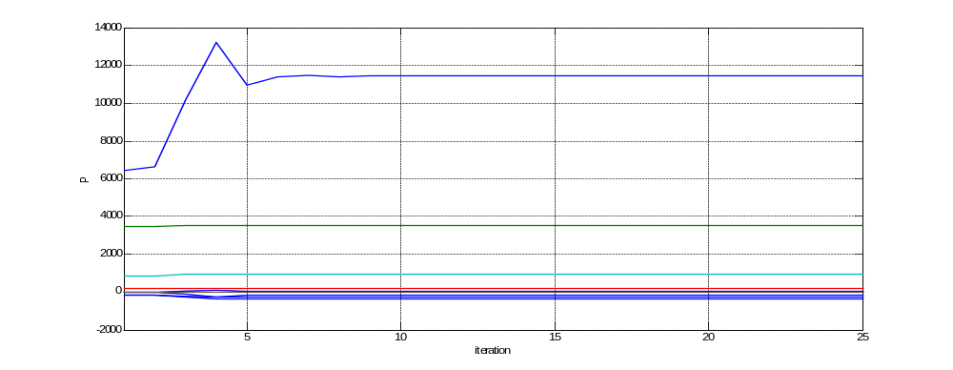
Fig. 5: Trajectory of Algebraic Riccati Equation solution P
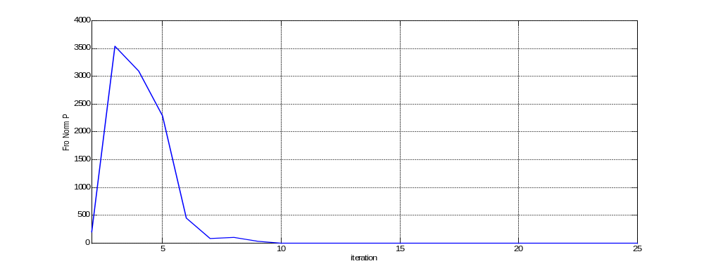
Fig. 6: Trajectory of Frobenius norm 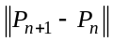
The resulting gains are applied to the system, and step disturbances d(t) are introduced in simulations to verify disturbance rejection properties of the design. The resulting time responses shown in Figs. 7 and 8 are very good. The design procedure based on solving two coupled equations is significantly easier than methods based on solving three coupled equations, e.g. as described in Lewis and Syrmos (1995) and Moerder and Calise (1985). Moreover, the static OPFB controller generally outperforms the H₂ optimal OPFB controller when disturbances are introduced.

Fig. 7: Closed loop response dutch roll states 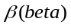and r.
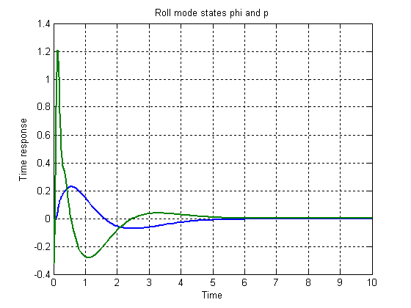
Fig. 8: roll mode states 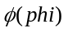and p.
- Conclusion
In this paper a characterization of all static state feedback controllers for continuous time systems has been given. A special case of the result gives necessary and sufficient conditions for existence of stabilizing OPFB gains. A computational algorithm to solve for the output-feedback gains was developed. The algorithm requires no initial stabilizing OPFB gain. A lateral regulator for the F-16 aircraft was designed using this algorithm.
Acknowledgements
The authors would like to acknowledge Carlos de Souza, for his enthusiasm and ongoing insight into the problems of output feedback and controller parameterization.
This research was supported by NSF grant ECS-0501451 and ARO grant W91NF-05-1-0314, and the Ministry of Education of the Czech Republic project 1M0567.
References
A. Astolfi and P. Colaneri (2000). Static output feedback stabilization of linear and nonlinear systems. Proc. IEEE Conf. Decision and Control, Sydney, 2920-2925.
A. Astolfi, and P. Colaneri (2000b). Static output feedback stabilization: from linear to nonlinear and back. In Nonlinear Control in the Year 2000, A. Isidori, F. Lamnabhi-Lagarrigue and W. Respondek Ed., Springer Verlag.
A. Astolfi and P. Colaneri (2001). An algebraic characterization of the static output feedback stabilization problem. Proc. American Control Conf., Arlington VA, 1408-1412.
A. Astolfi and P. Colaneri (2005). Hankel/Toeplitz matrices and the static output feedback stabilization problem. Math. Control Signals Systems (2005) 17: 231–268.
B. M. Chen (2000). Robust and Control, Springer, Berlin.
A. R. Cesar, and A. Trofino(1999) Sufficient LMI Conditions for Output Feedback Control Problems. IEEE Transactions on Automatic Control, 44(5), 1053-1057.
P. Colaneri, J.C. Geromel, and A. Locatelli (1997). Control Theory and design, an RH₂ and R viewpoint, Academic Press Interscience, San Diego.
J. H. Doyle, K. Glover, P. Khargonekar, and B. Francis (1989). State solutions to standard H₂ and H∞ Control Problems. IEEE Transactions on Automatic Control, 34(8), 831-847.
C.E. de Souza and L. Xie, (1992). On the Discrete-time Bounded Real Lemma with application in the characterization of static state feedback H∞ controllers. Systems & Control Letters,18(1), 61-71
L. El Ghaoui, and V. Balakrishnan (1994). Synthesis of fixed-structure controllers via numerical optimization Proc. IEEE Conf. Decision and Control, FL, 2678-2683.
J. Gadewadikar, F. L. Lewis, and M. Abu-Khalaf (to appear). Necessary and Sufficient Conditions for H∞ Static Output-Feedback Control. Journal of Guidance Dynamics and Control.
J. C. Geromel, and P.L.D. Peres (1985). Decentralised load frequency control. IEE Proceedings, 132(5), 225-230.
J. C. Geromel, C.C. de Souza and R. E. Skelton (1998). Static output feedback controllers: stability and convexity. IEEE Transactions on Automatic Control, 43(1), 120-125.
J.C. Geromel, A. Yamakami, and V.A. Armentano (1989). Structural constrained controllers for discrete-time linear systems. J. Optimization Theory and Applications, 61(1), 73-94.
G. Gu and P. Misra (1994). Disturbance attenuation and H(infinity) optimization with linear output feedback control, J. Guidance, Control, and Dynamics, 17(1), 145-152.
D. Henrion, V. Kucera, A. Molina-Cristobal. Optimizing simultaneously over the numerator and denominator polynomials in the Youla-Kucera Parametrization. IEEE Transactions on Automatic Control 50 (2005), 9, 1369-1374.
A. Hotz and R. Skelton (1987). Covariance control theory, Int. J. Control, 45, 13-32.
T. Iwasaki, and R.E. Skelton (1995). All fixed order H∞ controllers: observer based structure and covariance bounds. IEEE Transactions on Automatic Control, 40(3), 512-516.
H. W. Knobloch, A. Isidori, and D. Flockerzi (1993). Topics in Control Theory, Birkhauser, Berlin, Germany.
V. Kucera, Stability of discrete linear feedback systems. Preprints 6th IFAC Congress, vol .1, paper 44.1, Boston 1975.
V. Kucera, Discrete Linear Control: The Polynomial Equation Approach. Wiley, Chichester, 1979.
V. Kucera, and C.E. de Souza (1995). A necessary and sufficient condition for output feedback stabilizability. Automatica, 31( 9), 1357-1359.
F. L. Lewis, V. L. Syrmos (1995). Optimal Control, 2nd edition, Wiley-Interscience.New York.
M. Mattei (2000). Sufficient conditions for the synthesis of H∞ fixed-order controllers. International Journal of Robust and Nonlinear Control, 10, 1237-1248.
T. Mita, J. B. Matson, and B. D. O. Anderson (1998). A complete and simple parametrization of controllers for a non standsrd H∞ control problem. Automatica, 34(3), 369-374.
D. D Moerder, and A. J. Calise (1985). Convergence of a Numerical Algorithm for calculating optimal output feedback gains. IEEE Transactions on Automatic Control, 30(9), 900-903.
M.G. Safonov, K.C. Goh, and J. H. Ly (1994). Control Synthesis via Bilinear Matrix Inequalities Proc. ACC, MD, 45-49.
U. Shaked (2003). An LPD approach to robust H₂ and static output-feedback design. IEEE Trans. Automatic Control, 48(5), 866-872.
R.E. Skelton and T. Iwasaki, Lyapunov and covariance controllers. Int. J. Control, 57, 519-536.
B. L. Stevens, and F. L. Lewis (2003) Aircraft Control and Simulation, 2nd ed, Wiley Interscience, New York.
A. A. Stoorvogel, and A. Weeren (1994) The discrete time Riccati equation related to the H∞ control problem. IEEE Transactions on Automatic Control, 39(3), 686-691.
V. L. Syrmos, C.T. Abdallah, P. Dorato, and K. Grigoriadis (1997). Static output feedback- a survey. Automatica, 33(2),125-137.
A. Trofino-Neto, and V. Kucera (1993). Stabilization via static output feedback. IEEE Transactions on Automatic Control, 38(5), 764-765.
A. J. Van der schaft (1992) L₂ gain Analysis of Nonlinear Systems and Nonlinear State Feedback H∞ Control. IEEE Transactions on Automatic Control, 37(6), 770-784.
W. M. Wonham (1985) Linear Multivariable Control Springer Verlag , Berlin, Germany, 1985.
K. Yasuda, R. Skelton, and K. Grigoriadis (1993). Covariance controllers: a new parameterization of the class of all stabilizing controlers. Automatica, 29, 785-788.
D.C. Youla, Jabr H.A., and Bongiorno J.J.: Modern Wiener-Hopf design of optimal controllers, Part II: The multivariable case. IEEE Trans. Auto. Control, vol. AC-21, pp. 319-338, June 1976.
J.-T. Yu (2004). A convergent algorithm for Computing Stabilizing Static Output-Feedback Gains. IEEE Transactions on Automatic Control, 49(12), 2271-2275.
C. Yung, and C. Yang (1999). H∞ Control for linear time-varying systems: Controller Parameterization. IEEE Transactions on Automatic Control, 44(11),2058-2062.
M. Zeren, and H. Ozbay (2000). On the strong stabilization and stable H∞ controller design problems for MIMO systems. Automatica, Vol. 36(x),1675-1684.
K. Zhou (1992). On the parameterization of controllers. IEEE Trans. Automatic Control, 37(9), 1442-1445.

* Corresponding Author. Phone +1 817 272 5967 Fax +1 817 272 5989
a Automation and Robotics Research Institute , University of Texas at Arlington, jyotir@arri.uta.edu
b Automation and Robotics Research Institute, University of Texas at Arlington, lewis@uta.edu c School of Electrical and Electrical Engineering, Nanyang Technological University, ELHXIE@ntu.edu.sg d Head, Center for Applied Cybernetics, and Professor, Control Engineering at Czech Technical University, Prague, kucera@fel.cvut.cz e Automation and Robotics Research Institute, University of Texas at Arlington, abukhalaf@arri.uta.edu

