Republic of the Philippines
HIRAYA KIDS LEARNING CENTER
Montalban, Rizal
AN INTEGRATED MULTI-PLATFORM INFORMATION SYSTEM
FOR ENROLLMENT OPERATIONS, TEACHER–PARENT COORDINATION,
AND STUDENT MONITORING
A Capstone Project Manuscript
Aligned to the implemented HIRAYA React / Electron / Expo / ASP.NET system
Revised from the incomplete draft to match the working local prototype
(Researchers: retain your official names, program, and institution cover page.)

ABSTRACT
Hiraya Kids Learning Center currently depends on fragmented tools—paper or spreadsheet enrollment, Messenger or verbal updates, and separate records for attendance, payments, and progress. This capstone presents HIRAYA, an integrated information system with three clients and one hub: a Next.js public website with Super Administrator pages, an Electron desktop control system for Super Administrator work, and an Expo Go mobile app for teachers and parents. All clients use the same ASP.NET Core API (Hiraya.Api) and the same MySQL database (hiraya_learning_center). Children do not receive login accounts; a parent account represents each learner. Super Administrator functions include student, parent, and teacher management, enrollment review, class and schedule assignment, session packages, attendance (including “here today” confirmation), progress notes, payments ledger, announcements, tasks, in-app messages, website content, and Certificate of Employment PDF download for teachers. The study uses a quantitative descriptive-developmental design and ISO/IEC 25010 for later user evaluation. A live local test of the API confirmed a healthy hub, Super Administrator authentication, and populated school records. Remaining work includes ISO evaluation data collection, fuller parent–student linking, learning-module content, and production hosting.
Keywords: early childhood information system, enrollment, teacher–parent coordination, student monitoring, multi-platform, ASP.NET Core, React, Electron, Expo

CHAPTER 1: INTRODUCTION

1.1 Background of the Study
The integration of digital technologies in education has transformed how schools manage communication, student monitoring, and administrative processes. In early childhood settings, academic work is inseparable from socio-emotional growth, so coordination between teachers and parents is essential. Globally, schools adopt digital platforms to strengthen school–family partnership, automate administrative pipelines, and improve monitoring. Epstein (2022) emphasized that strong school–family collaboration contributes to better student behavior and academic success, while Thompson et al. (2023) found that multi-platform communication systems enhance parental engagement. UNESCO (2023) highlighted that digital tools in early childhood education support developmental monitoring and timely intervention.
In local educational contexts, digital communication is encouraged, yet many centers still use disconnected tools. Dela Cruz and Santos (2022) noted that parent involvement can improve even while systems remain siloed. Garcia et al. (2024) observed that behavioral monitoring in early childhood institutions is often manual. Reyes (2023) pointed out that Facebook Messenger and SMS are not designed for systematic school documentation. Enrollment, attendance, tuition notes, and class schedules frequently live in paper, chat threads, or spreadsheets that do not share one student identity.
At Hiraya Kids Learning Center in Montalban, Rizal, Super Administrator work, teacher classroom work, and parent follow-up must stay consistent. Before this project, updates were often verbal, written in notebooks, or sent through third-party chat, while registration remained largely manual. Staff time was spent re-encoding the same child in several places. The implemented HIRAYA system answers this by giving the Super Administrator a website admin desk and a Windows desktop app, giving teachers and parents a mobile app, and storing one school record in MySQL through Hiraya.Api.

1.2 Statement of the Problem
Effective coordination between teachers and parents is essential in early childhood education. At Hiraya Kids Learning Center, enrollment, home–school communication, attendance, session balances, and progress notes were previously split across informal channels. That produced delayed feedback, inconsistent documentation, and weak traceability of who was at the center on a given day.
This study therefore developed and aligned a working multi-platform system—not a .NET MAUI single-codebase app, and not a Flutter/Laravel stack. The implemented artifact is a React website, an Electron desktop app, and an Expo mobile app over one ASP.NET Core API.
Specifically, this study seeks to answer the following questions:
What is the operational usefulness of the system for enrollment operations in terms of online application, Super Administrator review (approve, reject, or cancel), and payment ledger recording?
What is the effectiveness of the website, desktop, and mobile clients in improving teacher–parent coordination in terms of in-app messages, announcements, schedules, and shared student records?
What is the effectiveness of the system in student monitoring in terms of attendance confirmation, remaining session packages, and progress notes visible to linked parents?
To what extent does one API and one MySQL database improve centralized data management across website, desktop, and mobile?
What is the software quality of the system, to be evaluated later with ISO/IEC 25010, in terms of functional suitability, usability, performance efficiency, reliability, security, and portability?

1.3 Objectives

1.3.1 General Objective
The general objective of this study is to design, develop, and evaluate an integrated multi-platform information system for enrollment operations, teacher–parent coordination, and student monitoring at Hiraya Kids Learning Center.

1.3.2 Specific Objectives
To develop a public website (Next.js) for center information, programs, contact, and public enrollment, plus a Super Administrator area (/admin) for school operations.
To develop a Windows desktop application (Electron + React) as the Super Administrator control system for students, parents, teachers, classes, schedules, attendance, sessions, tasks, announcements, messages, website content, settings, and Certificate of Employment PDF download.
To develop a mobile application (Expo / React Native) used only by teachers and parents. Super Administrators do not use the mobile app for center control. Children have no accounts.
To implement one Hiraya.Api backend with MySQL so website, desktop, and mobile share authentication (HMAC session header X-Hiraya-Session) and the same school store.
To evaluate software quality using ISO/IEC 25010 after supervised walkthroughs with Hiraya stakeholders and IT experts.

1.4 Conceptual Framework
The study uses the Input–Process–Output (IPO) model. Inputs are Hiraya operational rules, Super Administrator / teacher / parent roles, existing student and program records, and the technical stack (TypeScript/React clients, ASP.NET Core, MySQL). The process is iterative development: modeling, interface design, sprint implementation, and local verification against Hiraya.Api. The output is the HIRAYA prototype described in Chapter 4. Feedback is the planned ISO/IEC 25010 evaluation, which may return requirements to later sprints.
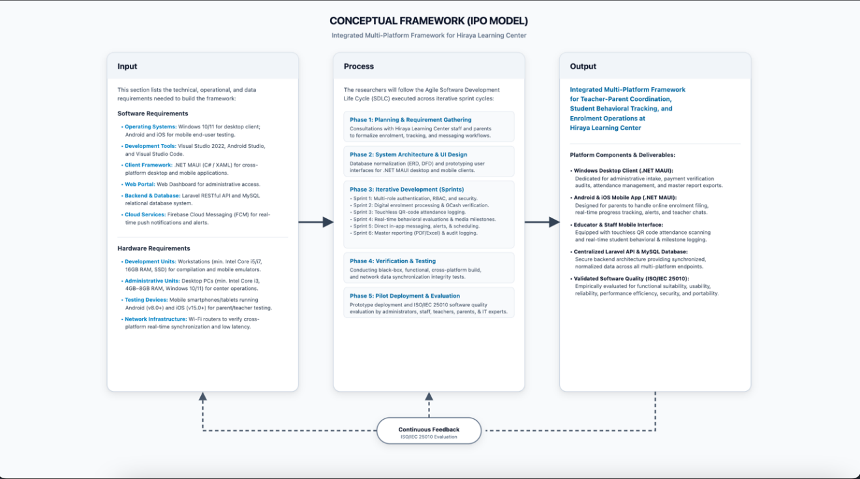Figure 1. Conceptual framework (IPO) used in this study. Technical inputs are the implemented React/Electron/Expo clients and Hiraya.Api, not .NET MAUI.
Input depends on center policy: Super Administrator only on website admin and desktop; teachers and parents on mobile; each student must be linked to a parent. Process work included authentication, enrollment applications, student and teacher records, session packages, attendance confirmation, messaging, and document generation. Output is a locally runnable system. Evaluation results are not yet the main body of this manuscript because ISO scoring is scheduled after the walkthrough; Chapter 5 reports the current technical status instead of invented survey means.

1.5 Operational Framework
Development followed Agile sprints mapped to the actual modules now present in the repository:
Sprint 1: Authentication, Super Administrator gate, teacher and parent roles, session tokens.
Sprint 2: Public enrollment, Super Administrator approval workflow, student–parent linking.
Sprint 3: Programs, classes, schedules, tasks assigned to teachers.
Sprint 4: Attendance records, “here today” confirmation, session package remaining = total − used.
Sprint 5: In-app messages, announcements, progress notes, payments ledger.
Sprint 6: Website CMS, Super Administrator profile, Certificate of Employment PDF download, local hub verification.
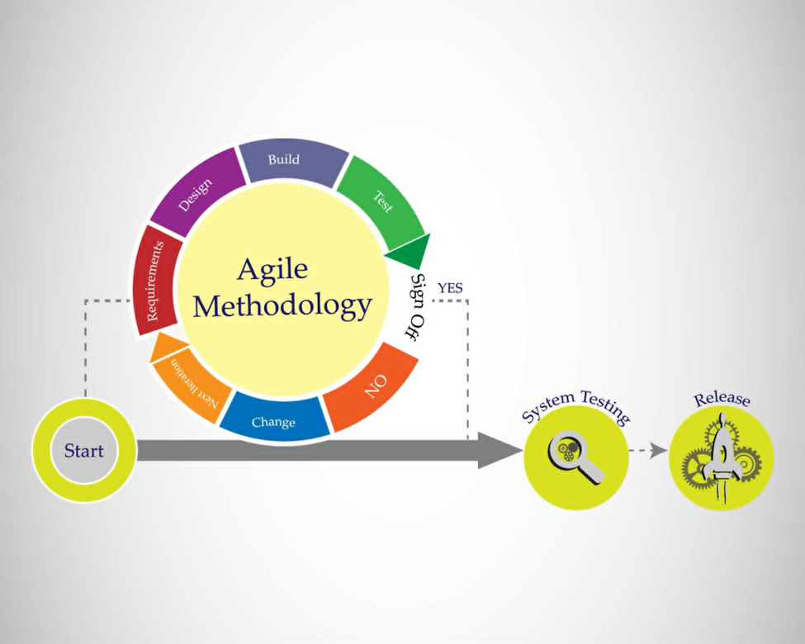Figure 2. Operational (Agile) framework. Testing in this project is primarily local hub verification rather than a completed automated test suite.

1.6 Scope and Limitations

Scope
Locale and institution: Hiraya Kids Learning Center, Montalban, Rizal.
Clients: public website and Super Administrator website pages; Windows Electron desktop; Expo Go mobile for teachers and parents.
Enrollment: public application form; Super Administrator approve, reject, or cancel; student record creation with required parent link.
People records: students, parents, teachers (employees). Certificate of Employment PDF for teachers.
Operations: classes, schedules, session packages, attendance, progress notes, payments ledger, announcements, tasks, in-app messages, website content, settings.
Evaluation plan: ISO/IEC 25010 questionnaire after prototype walkthroughs.

Limitations
Findings are specific to this learning center and may not generalize to DepEd K–12 SIS mandates.
Payments record method, amount, and status. The system does not settle GCash or bank merchant APIs automatically.
QR fields exist on student records and attendance models, but the live Super Administrator workflow confirms presence from Student management and Attendance pages rather than a finished phone camera scanner product.
There is no OTP login. Access uses username or email, password, and an HMAC session header.
The mobile app is Expo Go (Android/iOS clients via Expo). A public Play Store / App Store listing is not part of the current local prototype.
Desktop is for Super Administrator operations while connected to Hiraya.Api. It is not marketed as a fully offline encoding workstation.
Automated unit and end-to-end test projects are not yet in the repository.
Production cloud hosting (Vercel + hosted API) is documented but intentionally held until the owner authorizes deployment.
Progress notes are teacher or administrator entries. The system does not diagnose behavior with computer vision or psychological instruments.

1.7 Significance of the Study
Hiraya Kids Learning Center (Super Administrator): Gains one control system on desktop and website admin for enrollment, people, classes, attendance, sessions, and communications, instead of disconnected chats and sheets.
Teachers: Use the mobile app for assigned schedules, tasks, modules, students, and messages without using the Super Administrator desktop as their daily tool.
Parents: Use the mobile app for the child: schedule, attendance history, remaining sessions, payments they are allowed to see, announcements, and messages. They do not receive a child login.
Learners: Benefit indirectly when attendance, session use, and notes are recorded in one place so home and school see the same facts.
Future researchers: May reuse the pattern of three clients and one ASP.NET Core + MySQL hub for small Philippine learning centers.

1.8 General Features of the Implemented System
Public website: home, about, programs, contact, and enrollment call-to-action, with content that can be edited in website CMS.
Super Administrator website (/admin) and Electron desktop: student, parent, and teacher management; enrollment recording; programs and classes; schedules; tasks; announcements; session packages; attendance and “here today”; progress; payments; messages; reports; settings.
Mobile (teachers and parents only): home, schedule, progress or modules, alerts, profile, messages, and related child records.
One hub: GET/PUT /api/store plus dedicated routes for login, enrollment actions, staff, parents, modules, messages, and website CMS.
Session packages: remaining sessions never go below zero; present/late attendance can consume a session.
Certificate of Employment: generated from teacher records and downloaded as PDF (not a print-dialog workflow).
In-app messages: private threads stored in the shared database; they are an inbox, not a pop-up replacement for all alerts.

1.9 Definition of Terms
Approval workflow. Super Administrator review of a public enrollment application resulting in approve, reject, or cancel.
Attendance confirmation. Recording that a learner was at the center on a date (status present, late, absent, or excused), including the Student management “here today” action.
Centralization. One MySQL database and one Hiraya.Api process serving website, desktop, and mobile.
Certificate of Employment (COE). A downloadable PDF stating that a teacher or employee serves at Hiraya Kids Learning Center.
Enrollment operations. Application, review, student record, parent link, and class placement.
HMAC session. The API issues a signed ticket sent as header X-Hiraya-Session. This is not JWT and not OTP.
Interoperability. In this project, React (Next.js), Electron, and Expo clients exchanging JSON with ASP.NET Core over HTTP.
Multi-platform framework. Three purpose-built clients, not a single .NET MAUI binary for every device.
Parent account. The only family login. It represents one or more children.
Session package. Prepaid visit credits (total, used, remaining) per child.
Super Administrator. The center director role. Only this role uses website /admin and HIRAYA Desktop.
Usability. Ease of completing tasks, later scored with ISO/IEC 25010.

CHAPTER 2: REVIEW OF RELATED LITERATURE
This chapter retains the related literature assembled in the incomplete manuscript. Citations support teacher–parent coordination, digital enrollment, and student monitoring. The synthesis and research gap are revised so they do not claim .NET MAUI, Flutter, or Laravel as the project technology.

2.1 Teacher–Parent Collaboration and Digital Communication
Parent–teacher collaboration improves children’s academic performance, behavior, and well-being in early childhood education, yet many schools struggle to keep communication structured (Velasco et al., 2024). Digital channels used during COVID-19, including ClassDojo, helped maintain engagement (Chen & Rivera-Vernazza, 2022). Mobile instant messaging can increase involvement despite time constraints (Ziden et al., 2020), but chat apps rarely produce an official school record (Reyes, 2023). Trust-based school–home communication increases engagement (Houri et al., 2019). In the Philippines, weak communication tools during distance learning created gaps in monitoring (Lesmis, 2026; Tocalo, 2022). Structured parent–teacher partnership models clarify roles (Espejo et al., 2025). These findings support a dedicated in-app message and announcement module rather than relying on the teacher’s personal Messenger account.

2.2 Student Monitoring, Attendance, and Development
Early childhood monitoring systems help assess cognitive and behavioral development (Rathnayaka et al., 2023). Web-based student monitoring systems centralize academic records, attendance, and behavior (Wagh, 2026). Garcia et al. (2024) reported that behavioral monitoring in Philippine early childhood settings is still often manual. International work on classroom video analytics and attention detection (Su et al., 2021; Trabelsi et al., 2023; Lohar, 2025) shows what automated sensing can do; those methods are outside the ethical and technical scope of a small learning-center information system. HIRAYA therefore records teacher or Super Administrator observations and attendance statuses, not camera-based diagnosis.

2.3 Enrollment Systems and Small-Center Administration
Digitizing registration can cut processing time and transcription errors (Adhikari & Shrestha, 2023). Parents prefer mobile-first application pipelines (Baker, 2024). Platforms that combine admissions, tuition tracking, and communication retain parents better than disconnected tools (Kumar & Patel, 2024). In Philippine private academies, web-based enrollment reduced disorganization during peak admission (Mendoza & Bautista, 2023). Mayo et al. (2022) documented web-based enrollment for public junior high schools in Cavite. Santos and Ramos (2024) noted that small schools rarely have merchant APIs; a reference-and-receipt ledger is a practical billing design. HIRAYA follows that pattern: a payments ledger, not automatic GCash settlement.

2.4 Multi-Platform Architectures
Thompson et al. (2023) associated multi-platform access with stronger parent engagement. Enterprise suites are often too costly for community preschools (research gap). The incomplete draft proposed .NET MAUI as one shared native codebase. The implemented HIRAYA project instead separates UX by actor: a marketing and admin website, a wide Super Administrator desktop, and a phone app for teachers and parents, all talking to one API. That is a deliberate product split, not a failure to use MAUI. It matches how the center actually works: the director sits at a desk; teachers and parents use phones.

2.5 Synthesis
Foreign and local literature agree that enrollment, communication, attendance, and monitoring should share one student identity. Chat and spreadsheets create silos. Philippine small centers need lightweight systems, realistic payment recording, and device mix that includes modest Android phones and a Windows office PC. HIRAYA applies those lessons with three clients and one MySQL-backed API.

2.6 Research Gap
Siloed products: ClassDojo-type apps emphasize classroom points; traditional SIS apps emphasize billing. Few localized systems join enrollment, session packages, attendance confirmation, progress notes, and messaging for a play-and-preschool center.
Fit for community learning centers: Enterprise K–12 platforms are oversized for Hiraya Kids Learning Center.
Actor-based clients: Literature often assumes one app for everyone. This study implements role-separated clients (Super Administrator desk versus teacher/parent mobile) on a shared hub.
Lifecycle continuity: Applicant to enrolled child to daily presence and remaining sessions should remain one record. That linkage is the core of the HIRAYA store model.

CHAPTER 3: METHODOLOGY

3.1 Research Design
The study uses a quantitative descriptive-developmental design. The developmental phase produced the HIRAYA software. The descriptive phase will administer ISO/IEC 25010 questionnaires after walkthroughs. This manuscript already describes the implemented system so the evaluation instrument will rate the real prototype rather than a MAUI design that was not delivered.

3.2 System / Project Overview
HIRAYA is organized as one hub and three clients.
Layer
Technology
Who uses it
Public website
Next.js (apps/web)
Visitors and applicants
Website admin
Next.js /admin
Super Administrator
Desktop
Electron + Vite + React (apps/desktop)
Super Administrator
Mobile
Expo / React Native (apps/mobile)
Teachers and parents
API
ASP.NET Core Hiraya.Api
All clients
Database
MySQL hiraya_learning_center
API only
Auth
POST /api/auth/login + X-Hiraya-Session
All signed-in users
Most operational records travel as one HirayaDatabase document (GET and PUT /api/store). Dedicated routes exist for login, enrollment application actions, staff (teachers), parents, learning modules, messages, profile photos, and website CMS.

Implemented modules (aligned to code, not to unimplemented extras)
Authentication and roles. Super Administrator, teacher, parent. Extra admin/staff/student product logins are not used.
Child and enrollment management. Public form, application queue, parent required on each student.
Attendance. Date and status records; Super Administrator can mark a child here today from Student management.
Session packages. Total, used, remaining; present/late can consume one session.
Payments ledger. Amount, method, status. No automatic merchant capture.
Progress notes. Published notes for linked children.
Communication. In-app threads and announcements. Alerts are generated when schedules, tasks, or news are assigned.
Schedules and tasks. Super Administrator assigns; teachers see them on mobile.
Teacher employment documents. COE PDF download from teacher management.
Website CMS and Super Administrator profile/settings.

3.3 Respondents
Internal respondents: Super Administrator (center director), teachers, and parents of currently enrolled or applying children. External respondents: IT experts with at least a bachelor’s degree in an IT-related field and two years of experience, for ISO/IEC 25010 technical review.
Staff as a separate login role is not part of the product rule set; clerical Super Administrator tasks are evaluated under the director account and teacher accounts as applicable.

3.4 Sampling Technique
Total population sampling will be used for the small set of Super Administrator and teachers at the center. Purposive sampling will be used for parents (must have a linked child and a smartphone that can run Expo Go on the center Wi-Fi) and for IT experts.

3.5 Instruments and Methods
The primary instrument is a 5-point Likert questionnaire mapped to ISO/IEC 25010: functional suitability, usability, reliability, performance efficiency, security, and portability. Interviews will capture workflow pain before and after the walkthrough. Observation will note whether Super Administrator, teacher, and parent tasks complete on the actual apps.
Functional suitability items must name real tasks: approve enrollment, mark here today, download COE, send an in-app message, view remaining sessions. Do not rate OTP, GCash auto-debit, or QR camera scan unless those screens are added later.

3.6 Hardware Requirements
Development PC: 64-bit Windows 10/11, 16 GB RAM recommended, SSD, for Node.js 22, .NET SDK, and Android tooling.
Office PC: Windows 10/11 for HIRAYA Desktop and website admin.
Phones: Android or iOS devices on the same Wi-Fi as the API, running Expo Go.
Server PC or the same office PC: XAMPP MySQL and Hiraya.Api listening on port 5188, including LAN (0.0.0.0) so phones can connect.

3.7 Software Requirements
Node.js 22+ and pnpm 9 for website, desktop, and mobile workspaces.
.NET 8/9/10 SDK for Hiraya.Api.
MySQL 8 (XAMPP) database hiraya_learning_center.
Next.js 15, React 19, Electron 34, Expo SDK used by the mobile app, TypeScript.
Visual Studio Code or Cursor for TypeScript; Visual Studio or dotnet CLI for the API.
Git for version control.
The incomplete draft listed .NET MAUI, XAML, Visual Studio MAUI workloads, Firebase Cloud Messaging, and OTP. Those are not the implemented toolchain.

CHAPTER 4: SYSTEM DESIGN AND IMPLEMENTATION

4.1 Architecture
Clients never open MySQL directly. The website browser calls same-origin /api/*; Next.js proxies to Hiraya.Api. Desktop and mobile call Hiraya.Api using the shared TypeScript client (@hiraya/api). Shared packages hold types, validation, RBAC helpers, and UI primitives for web/desktop.
Logical flow: Public visitor submits enrollment → row stored as an application → Super Administrator reviews on desktop or /admin → approved applications become student records linked to a parent → teachers receive schedules and tasks → Super Administrator records presence → linked parents see attendance, sessions, and notes on mobile → messages stay in the shared inbox.

4.2 Role Design
Role
Website
Desktop
Mobile
Super Administrator
Public site + /admin
Full control system
Blocked (use desk apps)
Teacher
Not the admin desk
Not the product desk
Assigned work, students, messages
Parent
Public enroll / info
No
Child records and messages
Child / student
No login
No login
No login

4.3 Major Screens and Behaviors
Student management lists learners, parent, program, class, teacher, remaining sessions, and a Today column. Mark here today writes an attendance row for the local date and can consume a session package when status is present or late. Duplicate same-day present marks are rejected.
Teacher management stores employee code, position, specialty, and hire date. Certificate of Employment opens a letter matching the center’s COE style (addressee, position, start date, optional salary, duties, signatories). Download PDF saves Certificate-of-Employment.Name.pdf. It does not open the Windows print dialog as the primary action.
Enrollment recording shows public applications. Payments, progress, announcements, tasks, modules, and sessions have Super Administrator pages on both website and desktop. Mobile attendance for parents is a history of center-recorded days, consistent with “daily check-in from the center will appear here.”

4.4 Security Implementation
Passwords are stored as hashes. Development seed accounts exist only to start an empty database. The API uses HMAC session tickets. Super Administrator pages check role is super_admin. Mobile login rejects Super Administrator with an explicit message that the director must use desktop or website. HTTPS and a unique HIRAYA_SESSION_SECRET are required before any public internet deployment.

4.5 What Was Explicitly Not Implemented (honesty for the panel)
OTP / SMS login.
Automatic GCash or Maya merchant settlement.
Parent–teacher conference appointment booking as a separate calendar product.
Computer-vision behavior tracking.
Excel export suite and immutable forensic audit UI as a finished module (audit rows exist in the store; a dedicated auditor console is limited).
One MAUI codebase for web, desktop, and mobile.

CHAPTER 5: RESULTS AND PRESENT STATUS
ISO/IEC 25010 mean scores are not invented in this revision. They should be inserted after the evaluation day. This chapter reports the technical verification performed on the local hub so the manuscript matches the running project.

5.1 Local Hub Test (16 September 2026)
Check
Result
GET /api/health
status ok; database hiraya_learning_center; clients website, desktop, mobile
GET /api/hub
Documents session header X-Hiraya-Session and main endpoints
POST /api/auth/login (valid Super Administrator)
Success; role super_admin
POST /api/auth/login (wrong password)
HTTP 401
GET /api/store (authenticated)
Loaded live records
Website / and /programs (after starting Next.js)
HTTP 200, HIRAYA branding present
Website /admin
HTTP 200, staff sign-in UI present
Automated test suite
None in the repository

5.2 Live Record Counts at Test Time
Entity
Count
Interpretation
Users
16
Includes Super Administrator, teachers, parents
Teachers
11
Teacher management is populated
Students
46
Roster exists
Parent accounts
2
Too few versus 46 students; linking must be completed for the parent-app story
Parent–student links
2
Same gap
Programs / classes
8 / 6
Program catalog is usable
Class enrollments
4
Thin versus student headcount
Schedules
52
Calendar/schedule module is in active use
Session packages
3
Feature exists; not all children have packages
Attendance rows
1
Module exists; daily use is still starting
Payments
1
Ledger exists; not yet a full collections history
Learning modules
0
UI exists; content not yet uploaded
Announcements (news)
4
Broadcast module in use
Staff tasks
2
Task assignment exists
These counts show a working information system with incomplete operational data. That is expected in a center still migrating off paper and chat. It is not evidence that modules are missing from the software.

5.3 Estimated Completeness
Against the scope in Chapter 1, the researchers estimate about 72 percent overall for a local thesis prototype: architecture and Super Administrator clients are strong; mobile is usable for teachers and parents; evaluation data, automated tests, production hosting, and some data quality (parent links, modules, daily attendance) remain open. Production internet launch is a separate, lower percentage until secrets, HTTPS, and hosting are approved.

5.4 Planned ISO/IEC 25010 Presentation
After walkthroughs, insert frequency tables and means per characteristic (functional suitability, usability, reliability, performance efficiency, security, portability) for Super Administrator, teachers, parents, and IT experts. Use the 5-point Likert interpretation your college requires. Do not paste placeholder means.

CHAPTER 6: SUMMARY, CONCLUSIONS, AND RECOMMENDATIONS

6.1 Summary
The incomplete manuscript described a MAUI/Flutter-style product with OTP, QR scanning as the headline attendance method, GCash verification portal, and appointment booking. The working HIRAYA project is a React website, Electron desktop, and Expo mobile app on Hiraya.Api and MySQL. This revision rewrites objectives, scope, methodology, and implementation so the paper can be defended against the software on the researchers’ computers.

6.2 Conclusions
A single API and database can serve website, desktop, and mobile if each client is built for a real actor (director, teacher, parent) instead of one identical UI on every device.
Enrollment, people records, schedules, sessions, attendance confirmation, messaging, and COE generation are present in the prototype and were reachable through the local hub test.
Software quality (ISO/IEC 25010) is not yet empirically concluded until respondents finish the instrument.
Data quality (parent links, daily attendance, modules, payments history) is now the main operational risk, not the absence of a client app.

6.3 Recommendations
Complete parent accounts for every active student before the defense demo.
Run the ISO/IEC 25010 walkthrough and insert Chapter 5 statistics.
Add a small automated test set for login, enrollment approve, and attendance duplicate-date rules.
If the panel expects QR check-in, expose AttendanceService scan as a dedicated, supervised feature rather than claiming it is already the daily UI.
Keep production deploy on hold until session secrets, HTTPS, and password changes are done.
Replace remaining workbook aliases (uniforms, compliance, payroll) with honest labels or implement those modules explicitly.

REFERENCES
Adhikari, R., & Shrestha, S. (2023). Digitizing primary registration workflows in school information systems. (As cited in the original manuscript compilation.)
Anub, C. D. (2023). Teacher-parent communications to foster learners’ performance in English. Middle Eastern Journal of Research in Education and Social Sciences, 4(2), 55–68. https://doi.org/10.47631/mejress.v4i2.621
Baker, L. (2024). Parent preference for mobile-first school application pipelines. (As cited in the original manuscript compilation.)
Beeri, I., & Horowitz, D. (2020). Reducing students’ ‘absent presenteeism’ and mobile misbehaviour in class: An empirical study of teacher perspectives and practices. Technology, Pedagogy and Education, 29(3), 327–344. https://doi.org/10.1080/1475939X.2020.1731580
Chen, J. J., & Rivera-Vernazza, D. E. (2022). Communicating digitally: Building preschool teacher-parent partnerships via digital technologies during COVID-19. Early Childhood Education Journal, 51(5), 903–915. https://doi.org/10.1007/s10643-022-01366-7
Danacı, M. Ö. (2026). Prevalence and determinants of parent–school communication applications in early childhood education institutions. Technology, Knowledge and Learning, 31(1), 112–129.
Dela Cruz, M., & Santos, R. (2022). Digital communication in Philippine schools: Challenges and opportunities. Philippine E-Journals, 18(2), 45–59.
Destriana, R., Aksani, M. L., Yudi Priyanggodo, D., & Farzani, R. (2025). Design of a digital platform for PAUD child development monitoring using the Dynamic Systems Development Method and machine learning. Jurnal Teknik Informatika (JUTIF), 6(5), 3587–3601.
Discutido, R. B. (2026). Teacher-parent partnership in public elementary schools. International Journal of Sustainability and Advanced Integrated Research, 4(1), 112–124.
Ebron, G. (2026). The teacher-parent collaboration on the success of individualized education plans for students with special needs: Teachers’ perspective. JPAIR Multidisciplinary Research, 58(1), 77–94.
Epstein, J. L. (2022). School, family, and community partnerships: Preparing educators and improving schools (3rd ed.). Routledge. https://doi.org/10.4324/9780429494673
Espejo, C. T., Canoy, D. A., Escobia, I. L., & Montebon, D. R. T. (2022). Parents’ perceptions in an institutional flexible learning program. The Normal Lights, 16(2), 37–52.
Espejo, C. T., Canoy, D. A., Montebon, D. R. T., & Escobia, I. L. (2025). Toward the development of a parent-teacher partnership model for flexible learning. Dalat University Journal of Science, 15(1), 104–120.
Estu, G., Saputra, A., & Hidayat. (2025). Academic system for teacher–parent monitoring of student learning progress. Journal of Scientific Research, Education, and Technology (JSRET), 4(4), 935–948.
Garcia, P., Ramos, K., & Navarro, L. (2024). Behavioral monitoring systems in early education: A Philippine perspective. Education and Information Technologies, 29(4), 1234–1249.
Houri, A. K., Thayer, A. J., & Cook, C. R. (2019). Targeting parent trust to enhance engagement in a school–home communication system. School Psychology, 34(4), 421–432. https://doi.org/10.1037/spq0000318
Kumar, A., & Patel, R. (2024). Multi-tier school management architectures combining admissions, tuition, and communication. (As cited in the original manuscript compilation.)
Latagan-Doplayna, F. (2025). Exploring the nexus between teacher communication styles and parental attitudes towards school involvement. Nexus International Journal of Science and Education, 3(2), 392–408.
Lesmis, A. J. L. (2026). Exploring parent–teacher partnerships during the pandemic: A case study in Davao City, Philippines. Asian Journal of Education and Social Studies, 45(2), 65–79.
Leyte, A. K. D. (2025). Private teachers’ experiences with parents of students failing assessments in Tacloban City. Educative: Jurnal Ilmiah Pendidikan, 7(1), 1487–1498.
Lumbo, R. A. (2026). Parent–teacher communication in inclusive education. Divine Word International Journal of Management and Humanities, 5(1), 2888–2903.
Mayo, R. F., Villanueva, A. T., Ortiz, K. A. B., Reyes, A. C. M., Payad, J. J. S., Rodriguez, R. L., & Serrano, E. A. (2022). Web-based enrollment system for public junior high school in the Philippines: A case study in the province of Cavite public schools. 2022 2nd International Conference in Information and Computing Research (iCORE), 134–138. https://doi.org/10.1109/icore58172.2022.00044
Mendoza, J., & Bautista, K. (2023). Web-based enrolment systems in local Philippine private academies. (As cited in the original manuscript compilation.)
Reyes, L. (2023). Parent-teacher communication tools in the Philippines: An exploratory study.
Santos, M., & Ramos, D. (2024). Operational integration of Philippine fintech channels in educational billing. (As cited in the original manuscript compilation.)
Thompson, B., Ramirez, E., & Williams, H. (2023). Digital communication tools in education: Assessing parent engagement and multi-platform accessibility. Computers & Education, 194, Article 104689. https://doi.org/10.1016/j.compedu.2023.104689
Tocalo, A. W. I. (2022). Listening to Filipino parents’ voices during distance learning amidst COVID-19. Education 3–13, 52(3), 389–401. https://doi.org/10.1080/03004279.2022.2100439
UNESCO. (2023). Technology in early childhood education: Harnessing digital tools for holistic development. United Nations Educational, Scientific and Cultural Organization.
Velasco, M. N., Santos, E. J., & Ramos, D. M. (2024). Enhancing parent-teacher collaboration in early childhood education through a web-based app. 2024 7th International Conference on Informatics and Computational Sciences (ICICoS), 131–136. https://doi.org/10.1109/ICICoS62600.2024.10636878
Wagh, A. A. (2026). Student monitoring system: Centralizing academic records, attendance, and behavioral evaluation. International Journal for Research in Applied Science and Engineering Technology (IJRASET), 14(2), 787–795.
Ziden, A. A., Abdul Rahman, M. F., & Ching, T. W. (2020). Exploring the use of mobile instant messaging for parent-teacher communication. International Journal of Interactive Mobile Technologies (iJIM), 14(4), 143–158. https://doi.org/10.3991/ijim.v14i04.12403
Additional works cited in the incomplete draft (Beeri & Horowitz, 2020; Danacı, 2026; Destriana et al., 2025; Discutido, 2026; Ebron, 2026; Estu et al., 2025; Idris et al., 2026; Lohar, 2025; Lumbo, 2026; Onwuzurike, 2023; Paschal & Mrutu, 2025; Rathnayaka et al., 2023; Rosyid & Ismawati, 2025; Sahin et al., 2018; Sari et al., 2025; Simanjuntak et al., 2026; Su et al., 2021; Trabelsi et al., 2023; Zhao, 2025) remain available in that file’s reference list and may be restored in hanging-indent APA format in Word.

APPENDICES (to complete in Word)
Appendix A. College cover page, approval sheet, and original researcher names.
Appendix B. ISO/IEC 25010 questionnaire (items rewritten to HIRAYA tasks).
Appendix C. Sample screenshots: website home, /admin students with Here today, desktop teacher COE, mobile parent home.
Appendix D. Informed consent and center permission letter.
Appendix E. Hub endpoints from GET /api/hub.

