**3.1 Creating table and inserting data**:

create table 42_District_wise_crimes_committed_against_women_2001_2012 (

STATEOrUT char(50),

DISTRICT char(50),

YEARS numeric(4),

Rape numeric(20),

KidnappinAndAbduction numeric(20),

DowryDeaths numeric(20),

AssaultOnwomenWithintentTooutrageHerModesty numeric(20),

InsultTomodestyOfWomen numeric(20),

CrueltyByHusbandOrhisRelatives numeric(20),

ImportationOfGirls numeric(20)

);

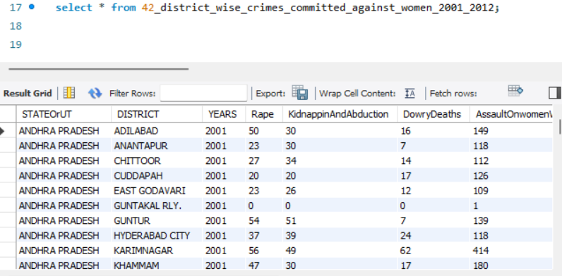

**3.2** **Write SQL query to find the highest number of rapes & Kidnappings that happened in which state, District, and year.**

(SELECT STATEOrUT AS STATE,DISTRICT,YEARS,Rape, KidnappinAndAbduction

FROM 42_district_wise_crimes_committed_against_women_2001_2012

order by Rape desc limit 1)

union

(SELECT STATEOrUT AS STATE,DISTRICT,YEARS,Rape, KidnappinAndAbduction

FROM 42_district_wise_crimes_committed_against_women_2001_2012

order by KidnappinAndAbduction desc limit 1);

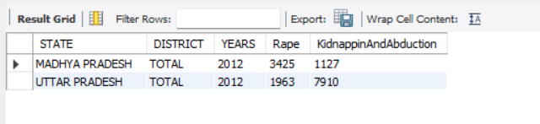

**3.3** **Write SQL query to find All the lowest number of rapes & Kidnappings that happened in which state, District, and year.**

(SELECT STATEOrUT AS STATE,DISTRICT,YEARS,Rape, KidnappinAndAbduction

FROM 42_district_wise_crimes_committed_against_women_2001_2012

order by Rape desc limit 1)

union

(SELECT STATEOrUT AS STATE,DISTRICT,YEARS,Rape, KidnappinAndAbduction

FROM 42_district_wise_crimes_committed_against_women_2001_2012

order by KidnappinAndAbduction desc limit 1);

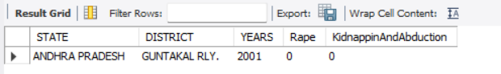

**3.4 Insert records from 02_District_wise_crimes_committed_against_ST_2001_2012.csv into a new table**

create table 02_01_District_wise_crimes_committed_against_SC_2001_2012 (

STATEOrUT char(50),

DISTRICT char(50),

YEARS numeric(4),

Murder numeric(20),

Rape numeric(20),

KidnappinAndAbduction numeric(20),

Dacoity numeric(20),

Robbery numeric(20),

Arson numeric(20),

Hurt numeric(20),

PreventionOfAtrocitiesPOAact numeric(20),

ProtectionOfCivilRightaPCRact numeric(20),

OtherCrimesAgainstSCs numeric(20)

);

**3.5** **Write SQL query to find the highest number of dacoity/robbery in which district.**

select robbery+dacoity as tot, district from 02_01_District_wise_crimes_committed_against_SC_2001_2012 where district <> 'TOTAL' order by tot desc limit 1;

Answer is : tot = 21, district = DAHOD

**3.6** **Write SQL query to find in which districts(All) the lowest number of murders happened.**

select district,murder from 02_01_District_wise_crimes_committed_against_SC_2001_2012 where murder=(select min(murder) from 02_01_District_wise_crimes_committed_against_SC_2001_2012);

Answer: we got 5966 rows with value as zero

**3.7** **Write SQL query to find the number of murders in ascending order in district and year wise.**

select district, years, murder from 02_01_District_wise_crimes_committed_against_SC_2001_2012 order by murder, years asc;

**3.8.1** **Insert records of STATE/UT, DISTRICT, YEAR, MURDER, ATTEMPT TO MURDER, and RAPE columns only from 01_District_wise_crimes_committed_IPC_2001_2012.csv into a new table.**

create table crimes_district_wise (

StateOrUt char(20),

district char(20),

years numeric(4),

murder numeric(20),

AttemptToMurder numeric(20),

rape numeric(20)

);

**3.8.2** **Write SQL query to find which District in each state/UT has the highest number of murders year wise. Your output should show STATE/UT, YEAR, DISTRICT, and MURDERS.**

select stateorut, district, murder, years from (select stateorut, district, murder, years,

row_number() over

(partition by stateorut,years order by murder desc) rownum

from crimes_district_wise where district<>'TOTAL') tab

where tab.rownum=1;