# S.I.E.S College of Arts, Science and Commerce Sion(W), Mumbai – 400 022.

**CERTIFICATE**

This is to certify that Master **Lingraj Ramu Namal**

Roll No. **SCS2223054** Has successfully completed the necessary course of experiments in the subject of **DATABASE MANAGEMENT SYSTEMS** during the academic year **2022 – 2023** complying with the requirements of **University of Mumbai**, for the course of **F.Y.BSc. Computer Science [Semester-1]**

Prof. In-Charge

# Dr. Abuzar Ansari

**(DATABASE MANAGEMENT SYSTEMS)**

Examination Date: Examiner’s Signature & Date:

Head of the Department



# Prof. Manoj Singh

College Seal And Date

DBMS Practical Journal

# Practical 1 )c’

Aim :- Creating and working with Insert/Update/Delete Trigger using Before/After clause. Question :- Create table emp (eno, ename, hrs, pno, super_no) & project (pname, pno, thrs, head_no) where thrs is the total hours and is the derived attribute. Its value is the sum of all employees working on that project. eno and pno are primary keys, head_no is foreign key to emp relation. Insert 10 tuples and write triggers to do the following :

* Creating a trigger to insert new employee tuple and display the new total hours from project table.
* Creating a trigger to change the hrs of existing employee and display the new total hours from project table.
* Creating a trigger to change the project of an employee and display the new total hours from project table.
* Creating a trigger to delete the project of an employee

# Code:

CREATE TABLE project (pno NUMBER(3) PRIMARY KEY, pname VARCHAR(20), thrs NUMBER(4), super_no NUMBER(2));

CREATE TABLE emp (eno NUMBER(3) PRIMARY KEY, ename VARCHAR(25), hrs

NUMBER(2), pno NUMBER(2) REFERENCES project(pno), super_no NUMBER(2));

/* A. INSERT TRIGGER */

CREATE OR REPLACE TRIGGER THRS AFTER INSERT ON emp

FOR EACH ROW WHEN(NEW.pno IS NOT NULL) BEGIN

UPDATE project SET thrs = thrs + :NEW.hrs WHERE pno = :NEW.pno; END;

/

/* B. Update Trigger */

CREATE OR REPLACE TRIGGER emp_update_trigger AFTER UPDATE ON emp

FOR EACH ROW WHEN(NEW.pno IS NOT NULL) BEGIN

UPDATE project SET thrs = thrs - :OLD.hrs + :NEW.hrs WHERE pno = :NEW.pno; END;

/

/* C. Delete Trigger */

CREATE OR REPLACE TRIGGER emp_delete_trigger BEFORE DELETE ON emp

FOR EACH ROW WHEN(OLD.pno is NOT NULL) BEGIN

UPDATE project SET thrs = thrs - :OLD.hrs WHERE pno = :OLD.pno; END;

/

/* Main */

INSERT INTO project VALUES(1, 'College Website', 0, 1); INSERT INTO project VALUES(2, 'Anime Website', 0, 1); INSERT INTO project VALUES(3, 'Dragon Website', 0, 1);

INSERT INTO emp VALUES(1, 'Harsh', 6, 1, 1);

INSERT INTO emp VALUES(2, 'Varun', 5, 2, 7);

INSERT INTO emp VALUES(3, 'Aneesh', 8, 3, 2);

select * from project;

UPDATE emp SET hrs = 7 WHERE eno = 1; SELECT * from project;

DELETE FROM emp WHERE eno = 3;

SELECT * FROM project;

**Now Lets put Inputs and check their Outputs:**

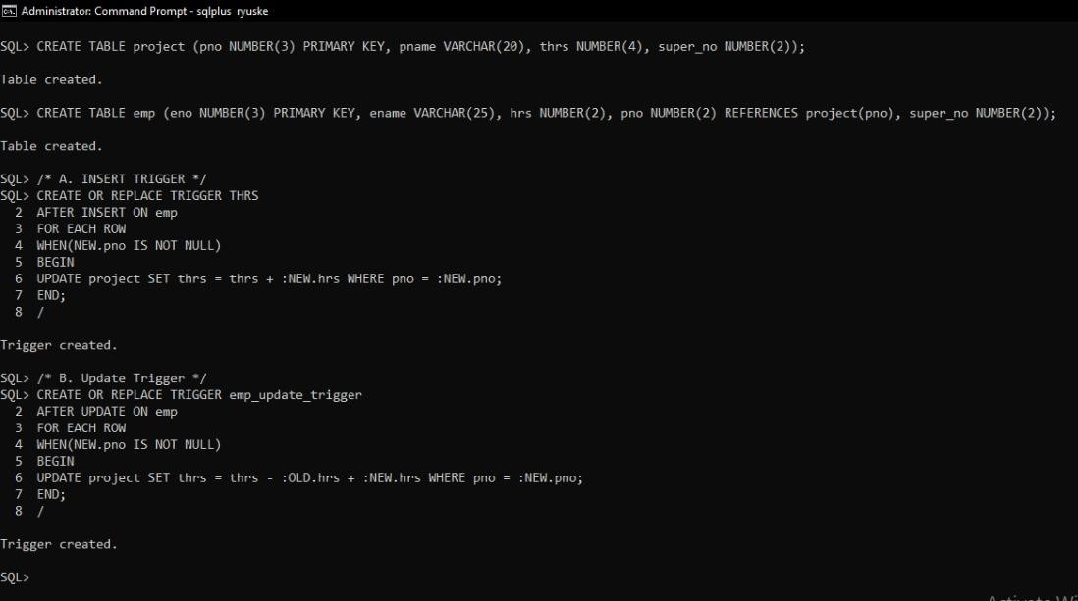

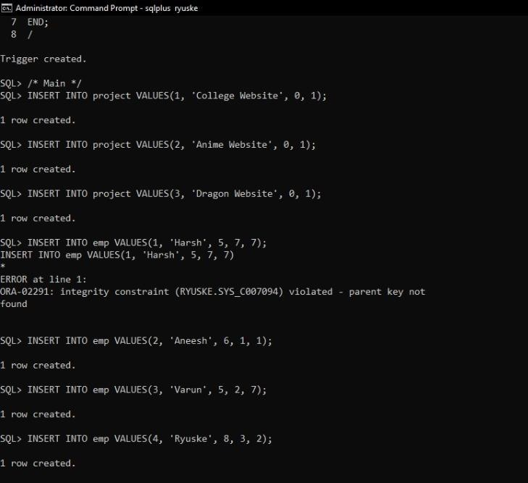

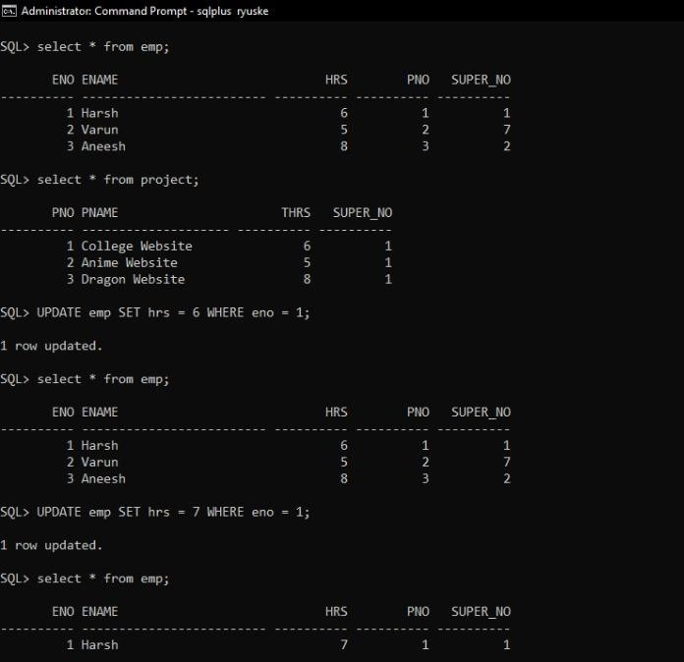

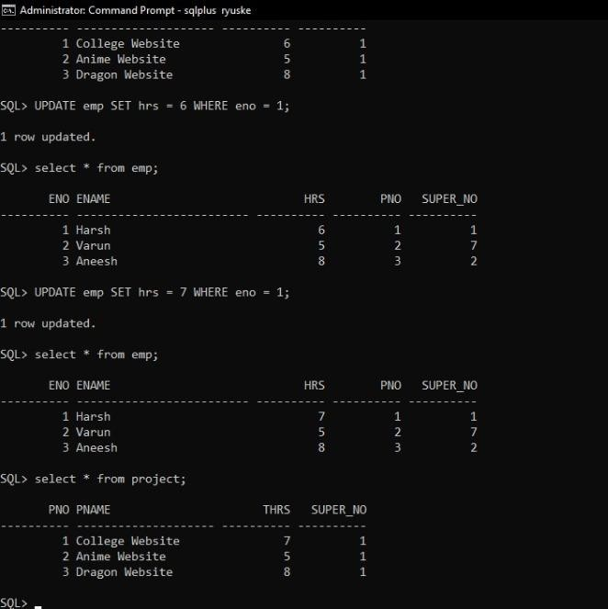

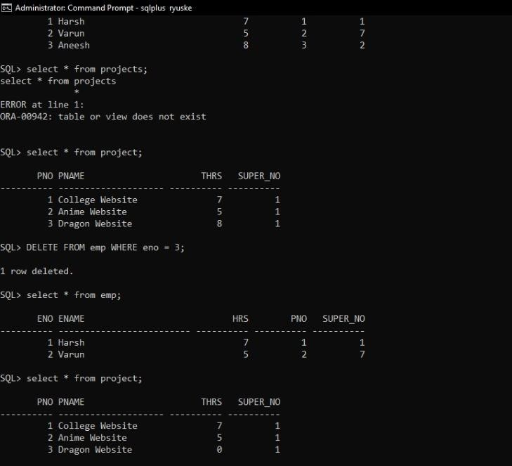

# Practical 2

) c’ Aim :- Writing PL/SQL Blocks with basic programming constructs by including following : Sequential Statements unconstrained loop. Question :- Write a PL/SQL block to insert 100 values in the table using loop [exit when] also auto increment the supplier id with the help of sequence. Table : Supplier {supid number(5) , suppname varchar2 (15)}

# Input:

CREATE SEQUENCE SUPPID MINVALUE 1

MAXVALUE 9999

START WITH 10

INCREMENT BY 5

CACHE 20;

CREATE TABLE SUPPLIER (SUPPID number(5), SUPPNAME varchar2(15)); DECLARE

V_COUNTER NUMBER(5):=0; V_SUPPID SUPPLIER.SUPPID%TYPE;

V_SUPPNAME SUPPLIER.SUPPNAME%TYPE:='HARSH'; BEGIN

LOOP

INSERT INTO SUPPLIER (SUPPNAME,SUPPID) VALUES (V_SUPPNAME,SUPPID.NEXTVAL); V_COUNTER:=V_COUNTER+1;

DBMS_OUTPUT.PUT_LINE(TO_CHAR(V_COUNTER)||' YOUR RECORDS ARE ADDED');

EXIT WHEN V_COUNTER=100; END LOOP;

END;

/

# Applying the input and output:

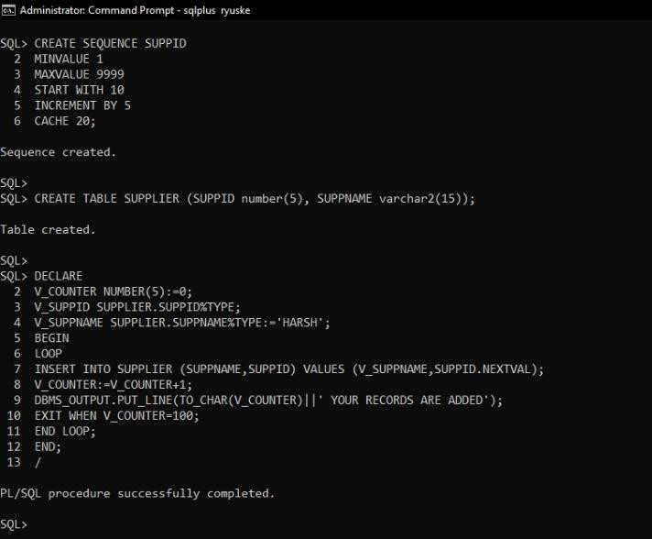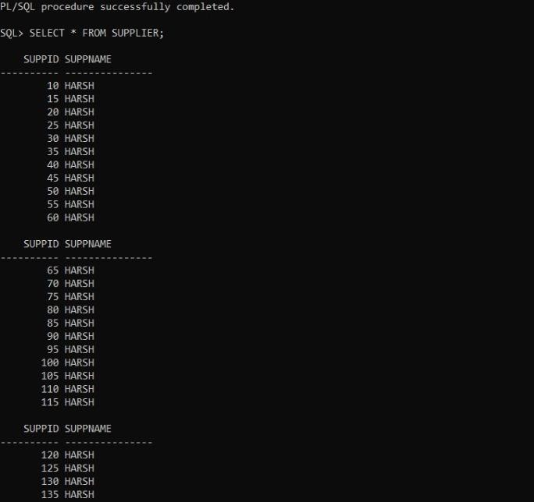

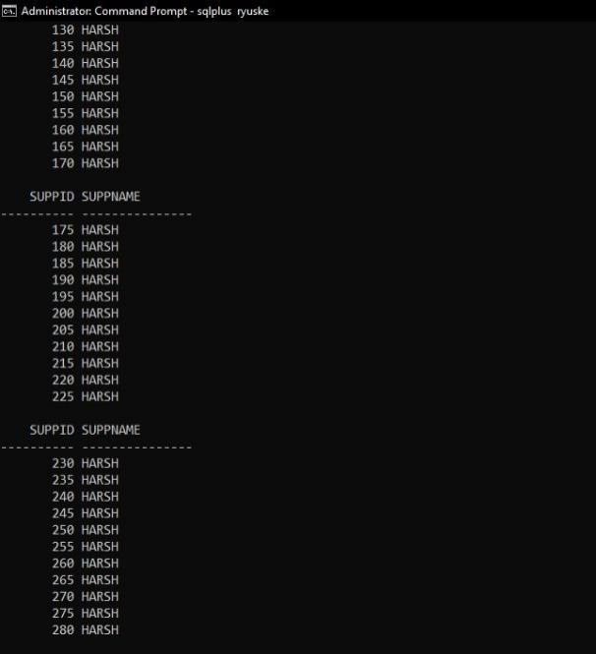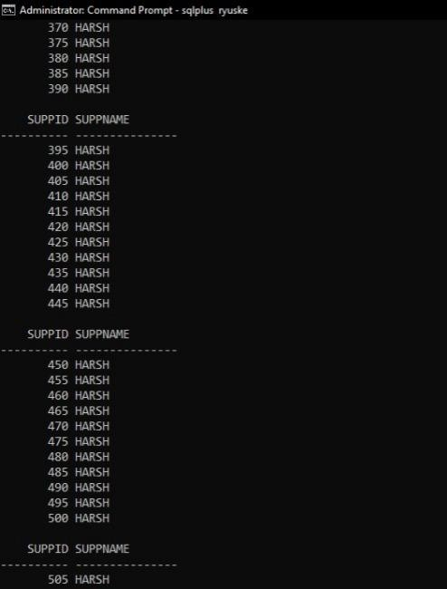

**Practical 3**

)c’ Aim :- Creating simple Sequences with clauses like START WITH, INCREMENT BY, MAXVALUE, MINVALUE, CYCLE | NOCYCLE, CACHE | NOCACHE, ORDER |

NOORECER. Creating and using Sequences for tables.

Question : - Write PL/SQL block to insert 10 records in Employee table , empno should be auto incremented , should begin with 10, the employee number should recycle after reaching to empno 50. Empno should increment by 10. [use sequence for empno ]

CREATE TABLE emp(eno NUMBER(5), ename VARCHAR(15));

CREATE SEQUENCE practical3_sequence START WITH 10 CYCLE MINVALUE 10 MAXVALUE 50 INCREMENT BY 10 CACHE 2;

BEGIN

FOR i IN 1..10 LOOP

INSERT INTO emp VALUES(practical3_sequence.NEXTVAL, 'HARSH'); END LOOP;

END;

/

SELECT * FROM emp;

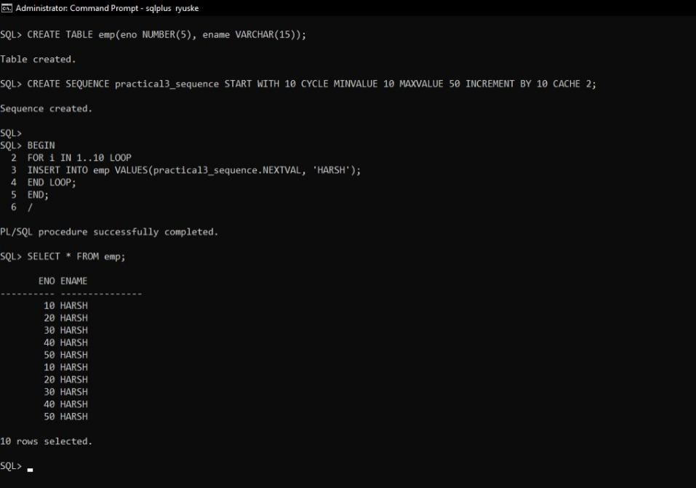

# Practical 04:

Aim: Writing PL/SQL Blocks with basic programming constructs by including following: If...then...Else, IF...ELSIF...ELSE... END IF Case statement

Question:-. Write a PL/SQL block to increase the salary of the employee by 15% whose date of joining is 12 December 2000 otherwise increase salary by 5%. Table : Employee { empno number(10), ename varchar2(10), salary number(10)} PL/SQL:- About ‘If...then...Else, IF...ELSIF...ELSE... END IF”

DROP TABLE emp;

CREATE TABLE emp (eno NUMBER(3) PRIMARY KEY, ename VARCHAR2(25), salary

NUMBER(6), join_date DATE);

INSERT INTO emp VALUES(1, 'Harsh', 15000,TO_DATE('20030412','YYYYMMDD')); INSERT INTO emp VALUES(2, 'Ryuske' , 15000, TO_DATE('20001212','YYYYMMDD'));

INSERT INTO emp VALUES(3, 'Zangetu' , 20000, TO_DATE('20020805','YYYYMMDD'));

INSERT INTO emp VALUES(4, 'Luffy' , 10000, TO_DATE('20020806','YYYYMMDD'));

DECLARE CURSOR emp_cursor IS SELECT eno, salary, join_date FROM emp; v_eno emp.eno%TYPE; v_salary emp.salary%TYPE;

v_join_date emp.join_date%TYPE; BEGIN

OPEN emp_cursor;

LOOP

FETCH emp_cursor INTO v_eno, v_salary, v_join_date; IF emp_cursor%NOTFOUND THEN

EXIT;

ELSIF v_join_date = TO_DATE('20001212','YYYYMMDD') THEN

UPDATE emp SET salary = v_salary*1.15 WHERE eno = v_eno; ELSE

UPDATE emp SET salary = v_salary*1.05 WHERE eno = v_eno; END IF;

END LOOP;

CLOSE emp_cursor;

END;

/

# Let’s implement the code:

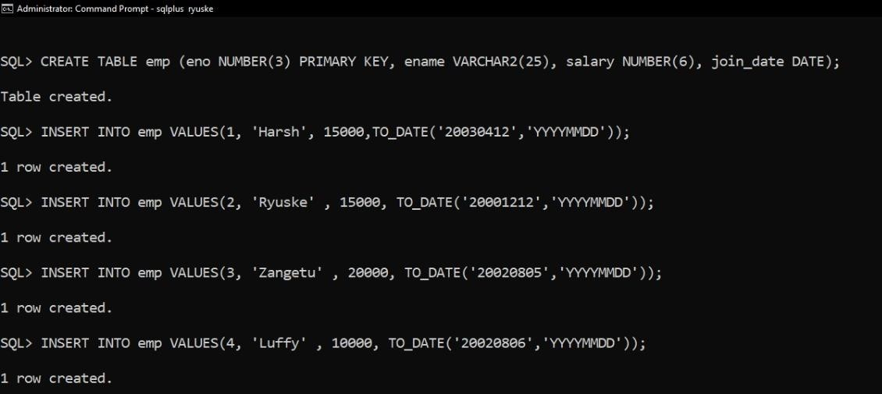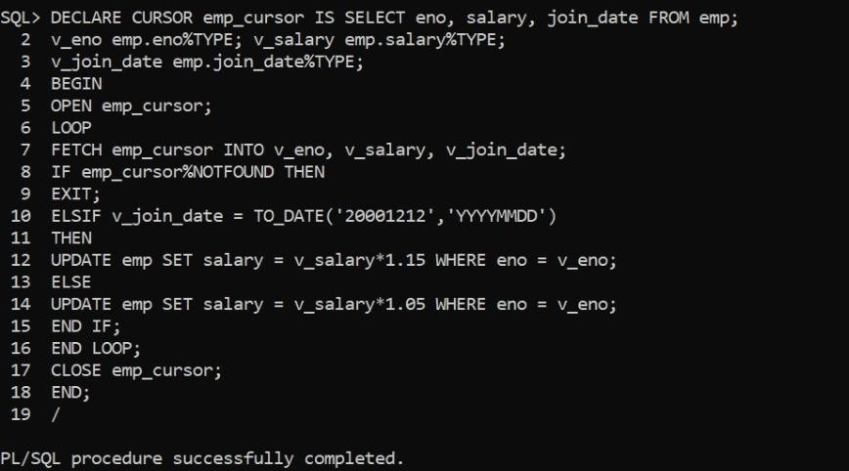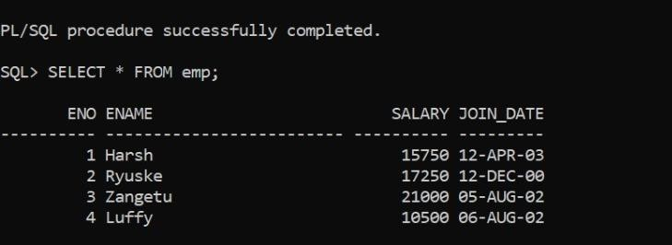

**Practical 05**

# Aim:

Create a table lecturer with one of the attribute as major subject. Write a PL/SQL block with CASE WHEN statement with variable which print the course name depending upon the major

subject for the specified lecturer id.

Table : Lecturer { lid NUMBER(4), lname varchar2(14), majorsubject varchar2(10), coursename varchar2(15)}

# Code:

SET SERVEROUTPUT ON

CREATE TABLE lecturer (lid NUMBER(4) PRIMARY KEY, lname VARCHAR2(14),

majorsubject VARCHAR2(10));

INSERT INTO lecturer VALUES(1, 'HARSH', 'CS'); INSERT INTO lecturer VALUES(2, 'ANEESH', 'A.I'); INSERT INTO lecturer VALUES(3, 'RYUSKE', 'BMM'); INSERT INTO lecturer VALUES(4, 'ZANGETSU', 'CB');

DECLARE

v_lid lecturer.lid%TYPE := &v_lid; v_lname lecturer.lname%TYPE;

v_majorsubject lecturer.majorsubject%TYPE; BEGIN

SELECT lname, majorsubject INTO v_lname, v_majorsubject FROM lecturer WHERE lid = v_lid;

CASE v_majorsubject

WHEN 'CS' THEN DBMS_OUTPUT.PUT_LINE(v_lname || ' : Computer Science'); WHEN 'A.I' THEN DBMS_OUTPUT.PUT_LINE(v_lname || ' : Artificial Intelligence'); WHEN 'BMM' THEN DBMS_OUTPUT.PUT_LINE(v_lname || ' : Mass Media'); WHEN 'CB' THEN DBMS_OUTPUT.PUT_LINE(v_lname || ' : Cyber Security');

END CASE;

END;

/

**Let’s implement and check the output:**

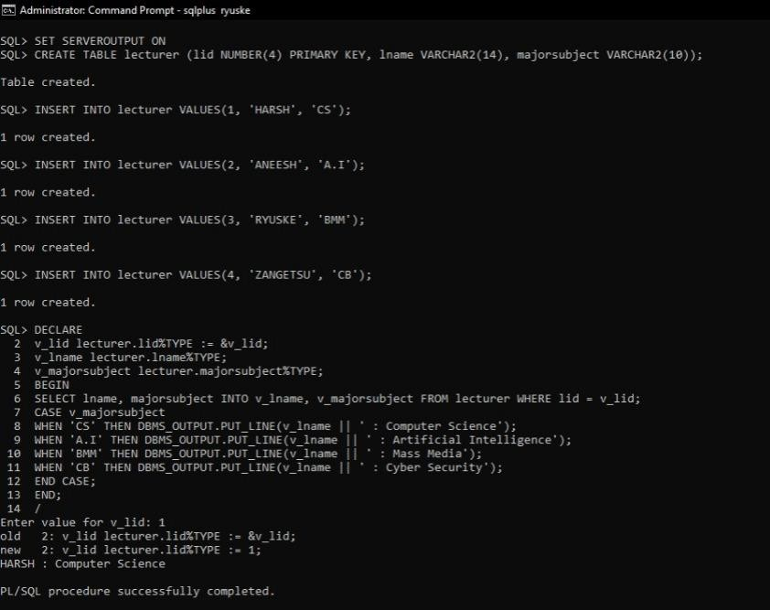

# Practical 6:

Aim :- Writing PL/SQL Blocks with basic programming constructs for

following Iterative Structure : While-loop Statements For-loop Statements. Question : - Write a PL/SQL block to print department wise total number of employees along the total salary paid to that department. [ USE : 1) While loop 2)For loop ]

Table(s) : Employee { empno number(4) primary key, ename varchar2(10), salary number(10), deptno number(4) reference key} Department { deptno number(4) primary key , dname varchar2(4) }

Code:

SET SERVEROUTPUT ON

CREATE TABLE department(deptno NUMBER(4) PRIMARY KEY, dname VARCHAR2(40));

INSERT INTO department VALUES(1, 'Computer Science'); INSERT INTO department VALUES(2, 'Artificial Intelligence'); INSERT INTO department VALUES(3, 'Data Science');

CREATE TABLE employee (empno NUMBER(4) PRIMARY KEY, ename VARCHAR2(10), salary NUMBER(10), deptno NUMBER(4) REFERENCES

department(deptno));

INSERT INTO employee VALUES(1, 'Harsh', 17000, 2); INSERT INTO employee VALUES(2, 'Aneesh' , 15000, 1); INSERT INTO employee VALUES(3, 'Vinit' , 70000, 3); INSERT INTO employee VALUES(4, 'Varun' , 50000, 2); INSERT INTO employee VALUES(5, 'Adarsh' , 60000, 2); INSERT INTO employee VALUES(6, 'Kartik' , 18000, 3); INSERT INTO employee VALUES(7, 'Shariq', 90000, 1); INSERT INTO employee VALUES(8, 'Vedant' , 20000, 3); INSERT INTO employee VALUES(9, 'Yash' , 14000, 1); INSERT INTO employee VALUES(10, 'Om' , 21000, 1); INSERT INTO employee VALUES(11, 'Surya' , 13000, 2); INSERT INTO employee VALUES(12, 'Kabilan' , 17000, 3); INSERT INTO employee VALUES(13, 'Ivin' , 37000, 2); INSERT INTO employee VALUES(14, 'Ryuske' , 89000, 1); INSERT INTO employee VALUES(15, 'Luffy' , 89000, 3); INSERT INTO employee VALUES(16, 'Senku' , 56000, 2);

DECLARE

CURSOR department_cursor IS SELECT deptno, dname FROM department; v_deptno department.deptno%TYPE;

v_dname department.dname%TYPE; v_salary_sum NUMBER(10); v_employee_count NUMBER(3); BEGIN

OPEN department_cursor;

FETCH department_cursor INTO v_deptno, v_dname;

WHILE department_cursor%FOUND LOOP

SELECT COUNT(empno), SUM(salary) INTO v_employee_count, v_salary_sum FROM employee

WHERE deptno = v_deptno;

DBMS_OUTPUT.PUT_LINE(v_deptno || ' ' || v_dname || ' Total Salary: ' || v_salary_sum || ' Employee Count:' || v_employee_count);

FETCH department_cursor INTO v_deptno, v_dname; END LOOP;

CLOSE department_cursor; END;

/

DECLARE

CURSOR department_cursor IS SELECT * FROM department; v_salary_sum NUMBER(10);

v_employee_count NUMBER(3); v_department_row department%ROWTYPE; BEGIN

FOR v_department_row IN department_cursor LOOP

SELECT COUNT(empno), SUM(salary) INTO v_employee_count, v_salary_sum FROM employee WHERE deptno = v_department_row.deptno; DBMS_OUTPUT.PUT_LINE(v_department_row.deptno || ' ' || v_department_row.dname || ' Total Salary: ' || v_salary_sum || ' Employee Count:' || v_employee_count);

END LOOP;

END;

/

# Let’s implement the code and check the output:

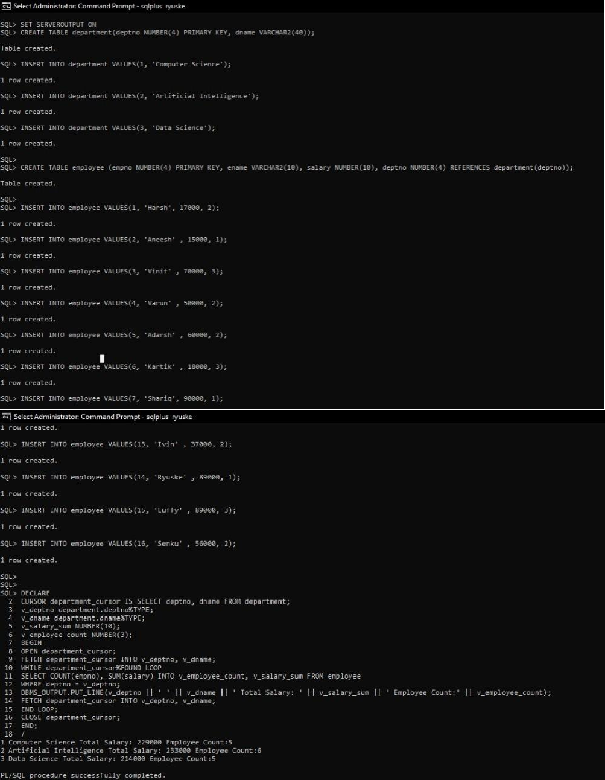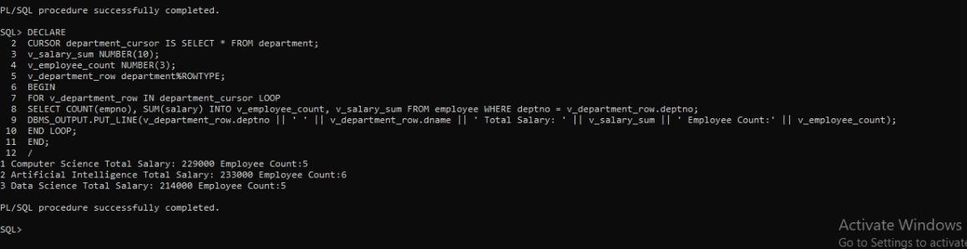

**Practical 7**

) c’ Aim :- Writing PL/SQL Blocks with basic programming constructs by including a GoTO to jump out of a loop and NULL as a statement inside IF Question : - Write a PL/SQL block to print employees name and number excluding empno 10 and 15 along their department name. [USE : Goto statement] Table employee { empno number(5) primary key , ename varchar2(15), deptno number(4) reference key } Department {deptno number(4) primary key

, dname varchar2(4)}

SET SERVEROUTPUT ON

CREATE TABLE department(deptno NUMBER(4) PRIMARY KEY, dname VARCHAR2(40)); INSERT INTO department VALUES(1, 'Computer Science');

INSERT INTO department VALUES(2, 'Artificial Intelligence'); INSERT INTO department VALUES(3, 'Data Science');

CREATE TABLE employee (empno NUMBER(4) PRIMARY KEY, ename VARCHAR2(10), salary NUMBER (10), deptno NUMBER(4) REFERENCES department (deptno));

INSERT INTO employee VALUES(1, 'Harsh', 15000, 2); INSERT INTO employee VALUES(2, 'Vinit' , 15000, 3); INSERT INTO employee VALUES(3, 'Aneesh' , 20000, 2);

INSERT INTO employee VALUES(4, 'Snowsan' , 10000, 2); INSERT INTO employee VALUES(5, 'Nayan' , 10000, 2);

INSERT INTO employee VALUES(6, 'Saishyam' , 16000, 3); INSERT INTO employee VALUES(7, 'Pranav', 20000, 1); INSERT INTO employee VALUES(8, 'Varun' , 30000, 3); INSERT INTO employee VALUES(9, 'Yash' , 11000, 1); INSERT INTO employee VALUES(10, 'Umesh' , 21000, 1); INSERT INTO employee VALUES(11, 'Tarun' , 15000, 2);

INSERT INTO employee VALUES(12, 'Gayathri' , 15000, 3); INSERT INTO employee VALUES(13, 'Aryan' , 37000, 2);

INSERT INTO employee VALUES(14, 'Siddhant' , 89000, 1); INSERT INTO employee VALUES(15, 'Ryuske' , 89000, 3);

INSERT INTO employee VALUES(16, 'Zangetsu' , 56000, 2);

SET SERVEROUTPUT ON DECLARE

CURSOR employee_cursor IS SELECT * from employee; v_employee_row employee%ROWTYPE;

v_dname department.dname%TYPE; BEGIN

FOR v_employee_row IN employee_cursor LOOP

IF v_employee_row.empno = 10 OR v_employee_row.empno = 15 THEN GOTO skip;

END IF;

SELECT dname INTO v_dname FROM department WHERE deptno = v_employee_row.deptno; DBMS_OUTPUT.PUT_LINE(v_employee_row.empno || ' ' || v_employee_row.ename || ' ' ||v_dname);

<<skip>> NULL; END LOOP; END;

/

**Let’s Implement the code:**

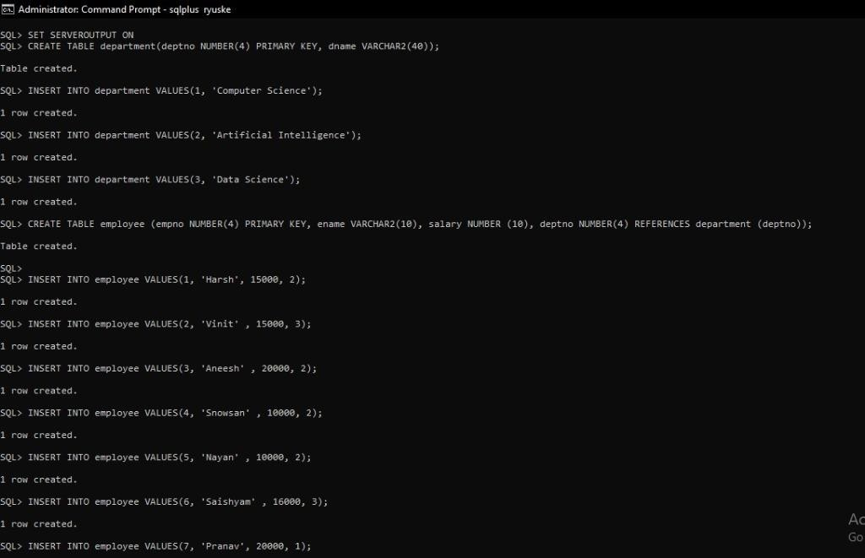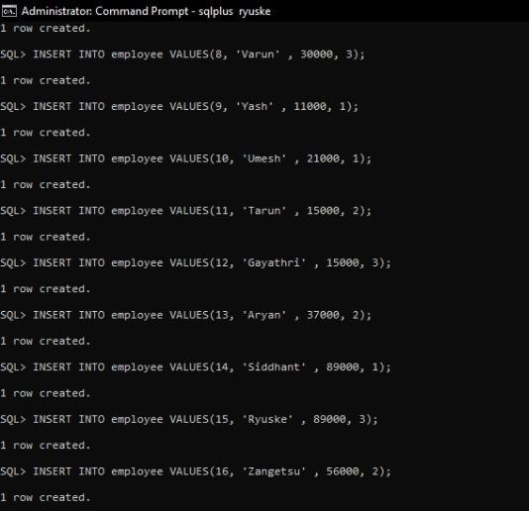

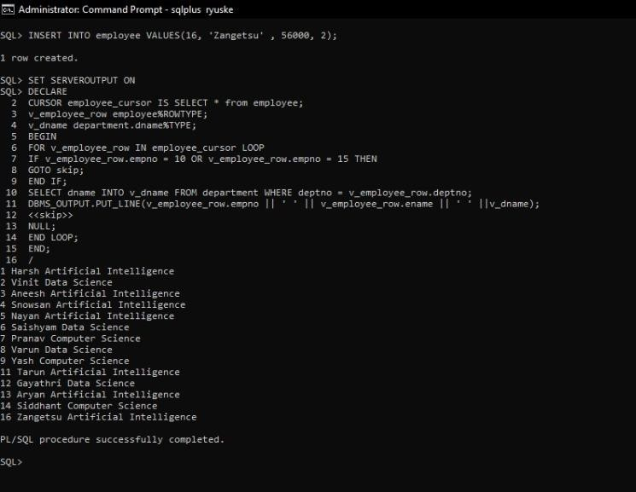

# Practical 8:

)’c **Aim :**- Writing Procedures in PL/SQL Block a. Create an empty procedure, replace a procedure and call procedure b. Create a stored procedure and call it c. Define procedure to insert data Question

: - The HRD manager has decided to rise the salary of employee by 0.15. write PL/SQL block to accept the employee number and update the salary of that employee through procedure. Display appropriate message based on the existence of the record in employee table. Table : employee { empno number(5) primary key , ename varchar2(15) }

Question: Write PL/SQL procedure to accept the employee number and display employees name along salary and his department name. Table employee { empno number(5) primary key , ename varchar2(15), deptno number(4) reference key } Department { deptno number

(4) primary key , dname varchar2(4) }

# Code:

CREATE TABLE department(deptno NUMBER(4) PRIMARY KEY, dname VARCHAR2(40)); INSERT INTO department VALUES(1, 'Computer Science');

INSERT INTO department VALUES(2, 'Artificial Intelligence'); INSERT INTO department VALUES(3, 'Data Science');

CREATE TABLE employee (empno NUMBER(4) PRIMARY KEY, ename VARCHAR2(10), salary NUMBER (10), deptno NUMBER(4) REFERENCES department(deptno));

INSERT INTO employee VALUES(1, 'Harsh', 15000, 2); INSERT INTO employee VALUES(2, 'Varun' , 15000, 1); INSERT INTO employee VALUES(3, 'Vinit' , 20000, 3); INSERT INTO employee VALUES(4, 'Luffy' , 10000, 2);

INSERT INTO employee VALUES(5, 'Zangetsu' , 10000, 2); INSERT INTO employee VALUES(6, 'Starfus' , 16000, 3); INSERT INTO employee VALUES(7, 'Vegil', 20000, 1);

INSERT INTO employee VALUES(8, 'Manoj sir' , 30000, 3); INSERT INTO employee VALUES(9, 'Dragon' , 11000, 1); INSERT INTO employee VALUES(10, 'Naruto' , 21000, 1); INSERT INTO employee VALUES(11, 'Katze' , 15000, 2);

INSERT INTO employee VALUES(12, 'Gayathri' , 15000, 3); INSERT INTO employee VALUES(13, 'Kamal' , 37000, 2); INSERT INTO employee VALUES(14, 'Harish' , 89000, 1); INSERT INTO employee VALUES(15, 'Hitesh' , 89000, 3); INSERT INTO employee VALUES(16, 'Ajit' , 56000, 2);

SET SERVEROUTPUT ON

CREATE OR REPLACE PROCEDURE increase_salary (p_empno employee.empno%TYPE) IS v_salary employee.salary%TYPE;

v_ename employee.ename%TYPE; BEGIN

SELECT ename, salary INTO v_ename, v_salary FROM employee WHERE empno = p_empno; UPDATE employee SET salary = v_salary*1.15 WHERE empno = p_empno; DBMS_OUTPUT.PUT_LINE('Incremented Salary for ' || v_ename || ' from ' || v_salary || ' to ' || v_salary * 1.15);

EXCEPTION

WHEN NO_DATA_FOUND THEN

DBMS_OUTPUT.PUT_LINE('Record Not Found'); END;

/

DECLARE

v_empno employee.empno%TYPE := &v_empno; BEGIN

increase_salary(v_empno); END;

/

CREATE OR REPLACE PROCEDURE display_employee (p_empno employee.empno%TYPE) IS v_ename employee.ename%TYPE;

v_salary employee.salary%TYPE; v_deptno employee.deptno%TYPE; v_dname department.dname%TYPE; BEGIN

SELECT ename, salary, deptno INTO v_ename, v_salary, v_deptno FROM employee WHERE empno

= p_empno;

SELECT dname INTO v_dname FROM department WHERE deptno = v_deptno; DBMS_OUTPUT.PUT_LINE(v_ename || ' ' || v_salary || ' ' || v_dname); EXCEPTION

WHEN NO_DATA_FOUND THEN

DBMS_OUTPUT.PUT_LINE('Record Not Found'); END;

/

DECLARE

v_empno employee.empno%TYPE := &v_empno; BEGIN

display_employee(v_empno); END;

/

**Let’s check the output:**

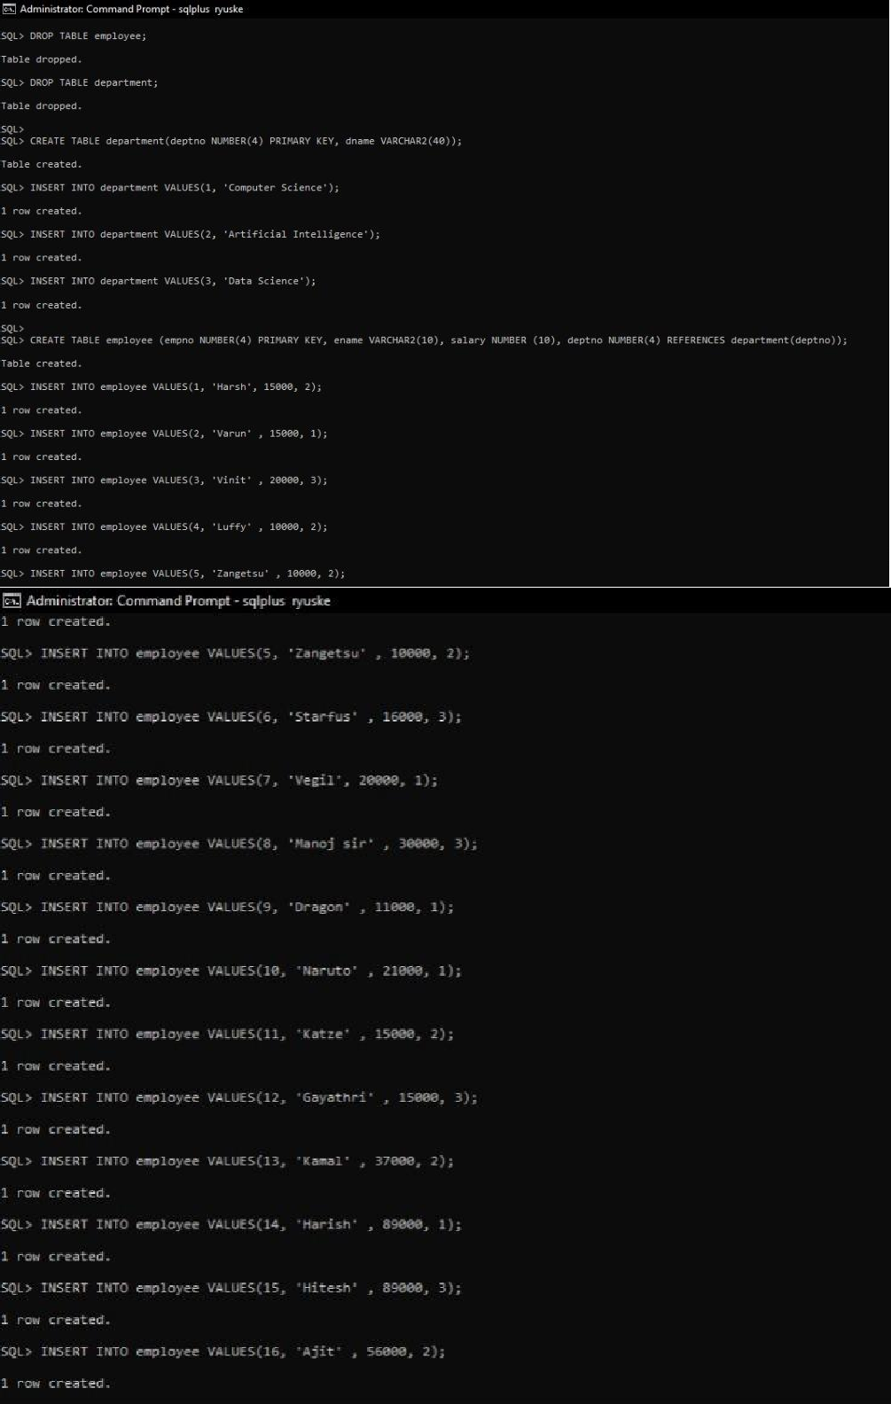

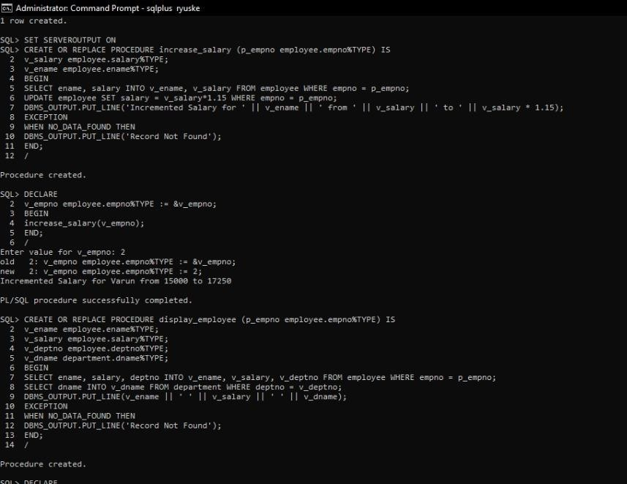

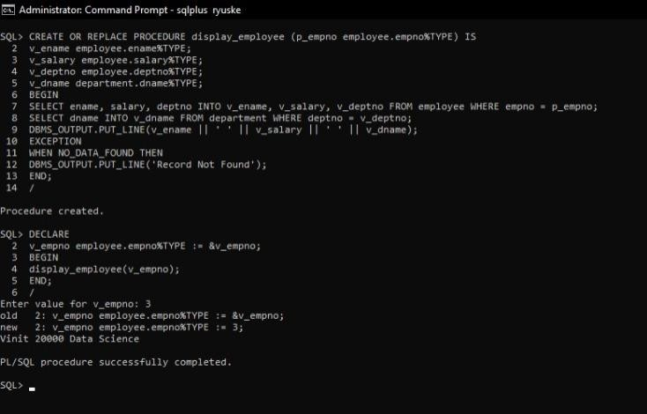

# Practical 9

)’c Aim :- Writing Functions in PL/SQL Block. Question : -Write PL/SQL function to accept department id and display total number of employees working in that department along the maximum salary of that department. Table employee { empno number(5) primary key , ename varchar2(15), deptno number(4) reference key } Department { deptno number

(4) primary key , dname varchar2(4) } Writing a recursive Functions in PL/SQL Block Question : Write PL/SQL recursive function to list top ten employees name along their salary. Table employee { empno number(5) primary key , ename varchar2(15) }

# Code:

SET SERVEROUTPUT ON

CREATE TABLE department(deptno NUMBER(4) PRIMARY KEY, dname VARCHAR2(40));

INSERT INTO department VALUES(1, 'Computer Science'); INSERT INTO department VALUES(2, 'Artificial Intelligence'); INSERT INTO department VALUES(3, 'Data Science');

CREATE TABLE employee (empno NUMBER(4) PRIMARY KEY, ename VARCHAR2(10), salary NUMBER (10), deptno NUMBER(4) REFERENCES

department(deptno));

INSERT INTO employee VALUES(1, 'Harsh', 15000, 2); INSERT INTO employee VALUES(2, 'Vinit' , 15000, 3); INSERT INTO employee VALUES(3, 'Aneesh' , 20000, 2); INSERT INTO employee VALUES(4, 'Varun' , 10000, 2); INSERT INTO employee VALUES(5, 'Ramesh' , 10000, 2); INSERT INTO employee VALUES(6, 'Naagin' , 16000, 3);

INSERT INTO employee VALUES(7, 'Abuzar sir', 20000, 1); INSERT INTO employee VALUES(8, 'Ryuske' , 30000, 3);

INSERT INTO employee VALUES(9, 'Zangetsu' , 11000, 1); INSERT INTO employee VALUES(10, 'Vikram' , 21000, 1); INSERT INTO employee VALUES(11, 'KGF' , 15000, 2);

INSERT INTO employee VALUES(12, 'Gayathri' , 15000, 3); INSERT INTO employee VALUES(13, 'Kamal' , 37000, 2); INSERT INTO employee VALUES(14, 'Nitish' , 89000, 1); INSERT INTO employee VALUES(15, 'Hitesh' , 89000, 3); INSERT INTO employee VALUES(16, 'Ajit' , 56000, 2);

SET SERVEROUTPUT ON

CREATE OR REPLACE FUNCTION practical9a_function(p_deptno department.deptno%TYPE)

RETURN VARCHAR2 IS

v_employee_count NUMBER(2); v_max_salary employee.salary%TYPE; BEGIN

SELECT COUNT(empno), MAX(salary) INTO v_employee_count, v_max_salary FROM employee

WHERE deptno = p_deptno;

IF v_employee_count = 0 THEN RETURN 'No Records';

ELSE

RETURN 'Employee Count: ' || v_employee_count || ' Max Salary: ' || v_max_salary; END IF;

END;

/

DECLARE

v_deptno department.deptno%TYPE := &v_deptno; BEGIN

DBMS_OUTPUT.PUT_LINE(practical9a_function(v_deptno)); END;

/

CREATE OR REPLACE FUNCTION practical9b_function(counter NUMBER) RETURN VARCHAR2

IS

v_ename employee.ename%TYPE; v_salary employee.salary%TYPE; BEGIN

IF counter = 11 THEN RETURN 'Completed'; END IF;

SELECT ename, salary INTO v_ename, v_salary FROM employee WHERE empno = counter;

DBMS_OUTPUT.PUT_LINE(v_ename || ' ' || v_salary); RETURN practical9b_function(counter + 1);

END;

/ BEGIN

DBMS_OUTPUT.PUT_LINE(practical9b_function(3)); END;

/

# Let’s check output with our codes:

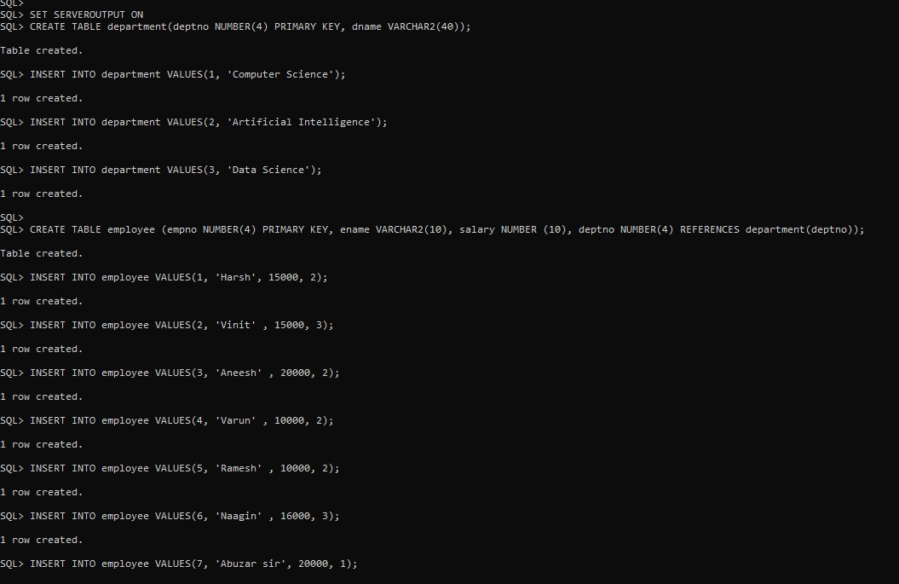

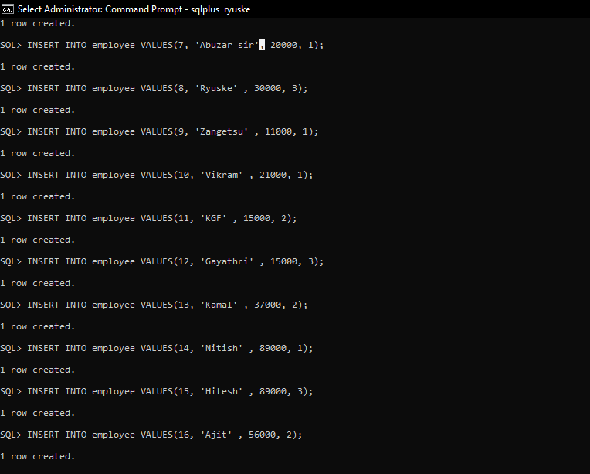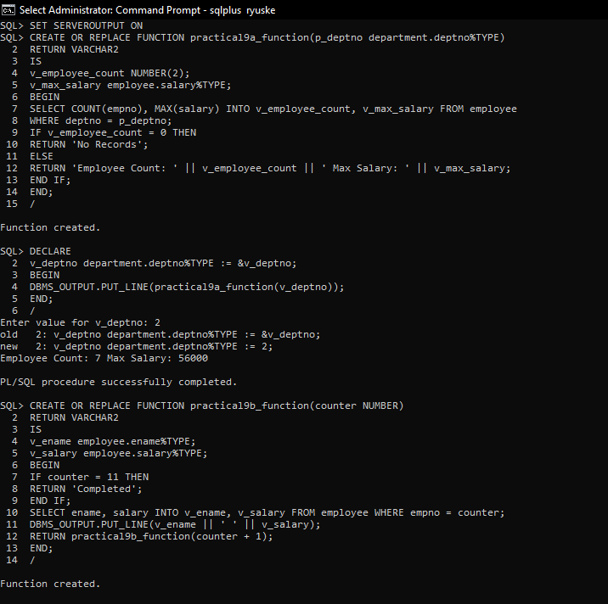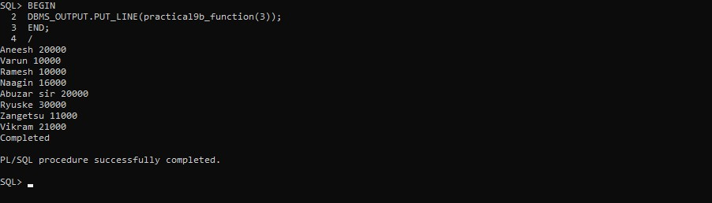

**Practical** º⬛ c’ ) Aim :- Write a PL/SQL block to auto insert 10 records in an employee table. Keep updating salary of Blake and Clark by Rs.2000 and Rs.1500 respectively. As long as total salary does not exceed to 20000. As soon as total salary reaches to more than 20000 then undo the Last salary updates of Blake and Clark

**Code:**

CREATE TABLE EMP4 (EMPNO NUMBER(5) PRIMARY KEY , ENAME VARCHAR2(15), SALARY NUMBER(10));

INSERT INTO EMP4 VALUES(001,’Blake’,900); INSERT INTO EMP4 VALUES(002,’Clark’,1000); INSERT INTO EMP4 VALUES(003,’Aneesh’,200); INSERT INTO EMP4 VALUES(004,’Harsh’,250); INSERT INTO EMP4 VALUES(005,’Varun’,350); INSERT INTO EMP4 VALUES(006,’Tarun’,300); INSERT INTO EMP4 VALUES(007,’Ankita’,500); INSERT INTO EMP4 VALUES(008,’Shri Hari’,550); INSERT INTO EMP4 VALUES(009,’Kartik’,600); INSERT INTO EMP4 VALUES(010,’Ryuske’,650);

DECLARE

TOTAL_SAL NUMBER(9); BEGIN

INSERT INTO EMP4 VALUES(011,'DAVID',1000); SAVEPOINT NO_UPDATE;

UPDATE EMP4 SET SALARY = SALARY+2000 WHERE ENAME = 'BLAKE'; UPDATE EMP4 SET SALARY = SALARY + 1500 WHERE ENAME = 'CLARK'; SELECT SUM(SALARY) INTO TOTAL_SAL FROM EMP4;

IF TOTAL_SAL>2000 THEN

ROLLBACK TO SAVEPOINT NO_UPDATE; END IF;

COMMIT;

END;

/

**Let’s check the code:**

