**Title**

Wenyuan Sun, Bowen Li,

Team name: MISEU

**Abstract -**

***Index Terms* – computed tomography, abdominal organs, image segmentation, deep learning, nnU-net, FLARE21**

1. **Introduction**

Deep learning – based image segmentation methods have been implemented to achieve high classification accuracy, and have been proved to be a great modality in many clinical scenarios. However, just as the problem - raised by FLARE21 - describes, there is currently a lack of segmentation method that can perform a multi-object detection trained on a diverse dataset, whereas have a high accuracy and efficiency. As a result, most of the neural network methods can only be used in a specific clinical practice, which without doubt create a lot of barriers on its usage.

In late 2020, a U-Net based deep learning framework called nnU-Net [1] was proposed to achieve automated configuration for any datasets. Meanwhile, it is fast and data efficient, which makes it a suitable solution for the problem above. Thus, for FLARE21 challenge, we seek to apply nnU-Net to the given abdomen CT image datasets, trying to achieve a superior segmentation performance.

1. **Method**

Figure 1 illustrates a basic U-Net architecture [2], on which nnU-Net is built. Figure 2 shows how nnU-Net automatically configures for the given input dataset [1]. It builds dependencies between “dataset fingerprint” (i.e., key properties of the dataset) and “pipeline fingerprint” (i.e., key parameters of the method), which gives it ability to generate a suitable solution for the given input data.

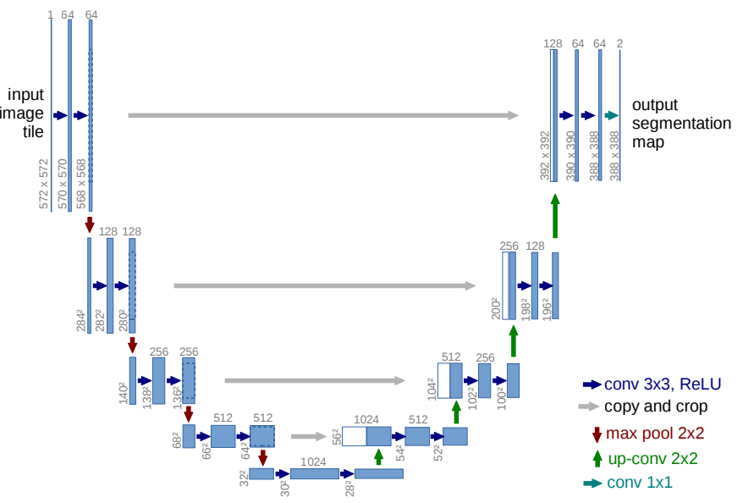

Figure 1. Basic U-Net architecture [2]

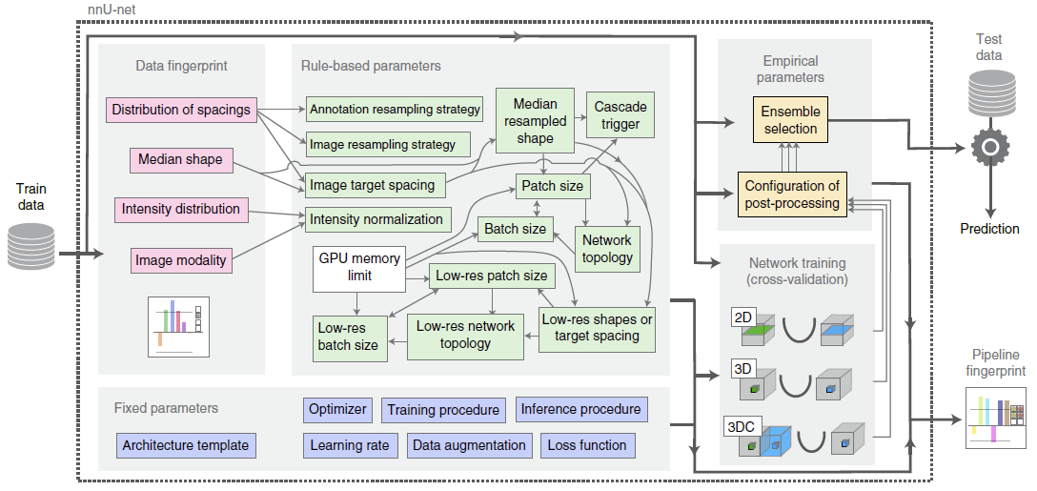

Figure 2. Schematic diagram for the nnU-Net automated method configuration [1]

In this work, we apply the FLARE21 baseline method and use 3d_fullres configuration. All the hyper-parameters are set as the defaulted ones. In all, there are 30,787,584 trainable parameters among 115 layers. The total FLOPs is 590861472000.

1. **Dataset and Evaluation Metrics**
   1. **Dataset**

The dataset used of FLARE2021 is adapted from MSD [3] (Liver [4], Spleen, Pancreas), NIH Pancreas [5-7], KiTS [8,9], and Nanjing University under the license permission. For more detail information of the dataset, please refer to the challenge website and [10].

The total number of cases is 511. An approximate 70%/10%/20% train/validation/testing split is employed resulting in 361 training cases, 50 validation cases, and 100 testing cases. The detail information is presented in Table 1.

Table 1. Data splits of FLARE2021. [3-10]

|  |  |  |  |
| --- | --- | --- | --- |
| Data split | Center | Phase | # Num. |
| Training (361 cases) | The National Institutes of Health Clinical Center | portal venous phase | 80 |
| Memorial Sloan Kettering Cancer Center | portal venous phase | 281 |
| Validation (50 cases) | Memorial Sloan Kettering Cancer Center | portal venous phase | 5 |
| University of Minnesota | late arterial phase | 25 |
| 7 Medical Centers | various phases | 20 |
| Testing (100 cases) | Memorial Sloan Kettering Cancer Center | portal venous phase | 5 |
| University of Minnesota | late arterial phase | 25 |
| 7 Medical Centers | various phases | 20 |
| Nanjing University | various phases | 50 |

* 1. **Evaluation Metrics**
* Dice Similarity Coefficient (DSC)
* Normalized Surface Distance (NSD)
* Running time
* Maximum used GPU memory (when the inference isstable)

1. **Environments and requirements**

The environments and requirements of the baseline method being used is shown in Table 2.

Table 2. Environments and requirements

|  |  |
| --- | --- |
| Ubuntu version |  |
| CPU |  |
| RAM |  |
| GPU |  |
| CUDA version |  |
| Programming language |  |
| Deep learning framework |  |
| Specification of dependencies | nnU-Net |

1. **Results**
2. **Discussion and Conclusion**

**Acknowledgement**

The authors of this paper declare that the segmentation method they implemented for participation in the FLARE challenge has not used any pre-trained models nor additional datasets other than those provided by the organizers.

**References**

[1] F. Isensee, P. F. Jaeger, S. A. Kohl, J. Petersen, and K. H. Maier-Hein, “nnU-Net: a self-configuring method for deep learning-based biomedical image segmentation,” *Nature Methods*, vol. 18, no. 2, pp. 203–211, 2021.

[2] O. Ronneberger, P. Fischer, and T. Brox, “U-net: Convolutional networks for biomedical image segmentation,” in *International Conference on Medical image computing and computer-assisted intervention*. Springer, 2015, pp. 234–241.

[3] A. L. Simpson, M. Antonelli, S. Bakas, M. Bilello, K. Farahani, B. Van Ginneken, A. Kopp-Schneider, B. A. Landman, G. Litjens, B. Menze *et al*., “A large annotated medical image dataset for the development and evaluation of segmentation algorithms,” *arXiv preprint arXiv:1902.09063*, 2019.

[4] P. Bilic, P. F. Christ, E. Vorontsov, G. Chlebus, H. Chen, Q. Dou, C.-W. Fu, X. Han, P.-A. Heng, J. Hesser *et al*., “The liver tumor segmentation benchmark (lits),” a*rXiv preprint arXiv:1901.04056*, 2019.

[5] H. Roth, A. Farag, E. Turkbey, L. Lu, J. Liu, and R. Summers, “Data from pancreas-ct. the cancer imaging archive (2016).”

[6] H. R. Roth, L. Lu, A. Farag, H.-C. Shin, J. Liu, E. B. Turkbey, and R. M. Summers, “Deeporgan: Multi-level deep convolutional networks for automated pancreas segmentation,” in *International conference on medical image computing and computer-assisted intervention*. Springer, 2015, pp. 556–564.

[7] K. Clark, B. Vendt, K. Smith, J. Freymann, J. Kirby, P. Koppel, S. Moore, S. Phillips, D. Maffitt, M. Pringle *et al*., “The cancer imaging archive (tcia): maintaining and operating a public information repository,” *Journal of digital imaging*, vol. 26, no. 6, pp. 1045–1057, 2013.

[8] N. Heller, F. Isensee, K. H. Maier-Hein, X. Hou, C. Xie, F. Li, Y. Nan, G. Mu, Z. Lin, M. Han *et al*., “The state of the art in kidney and kidney tumor segmentation in contrast-enhanced ct imaging: Results of the kits19 challenge,” *Medical Image Analysis*, vol. 67, p. 101821, 2021.

[9] N. Heller, S. McSweeney, M. T. Peterson, S. Peterson, J. Rickman, B. Stai, R. Tejpaul, M. Oestreich, P. Blake, J. Rosenberg *et al*., “An international challenge to use artificial intelligence to define the state-of-the-art in kidney and kidney tumor segmentation in ct imaging.” *American Society of Clinical Oncology*, vol. 38, no. 6, pp. 626–626, 2020.

[10] J. Ma, Y. Zhang, S. Gu, Y. Zhang, C. Zhu, Q. Wang, X. Liu, X. An, C. Ge, S. Cao *et al*., “Abdomenct-1k: Is abdominal organ segmentation a solved problem?” *arXiv preprint arXiv:2010.14808*, 2020.