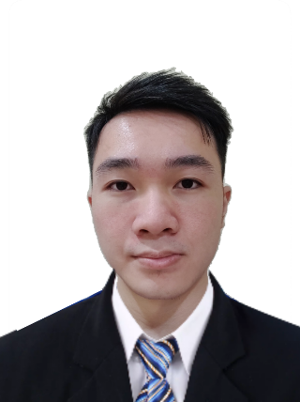**Lee Cheng Zhan**

Software Developer

 [leechengzhan7@gmail.com](mailto:leechengzhan7@gmail.com) +6018-3221917

linkedin

[LeeChengZhan2](https://github.com/LeeChengZhan2) [ChengZhan Lee](https://www.linkedin.com/in/chengzhan-lee-a87959220/)



<https://sites.google.com/view/leechengzhans-portfolio/home>

I am Lee Cheng Zhan, 23 years old, a **Malaysian** citizen. Graduate in a mathematics major course and have **over 1 Year** of experience as a software developer in the financial industry. An Inquisitive, energetic person with a strong foundation in math and logic. I am looking for a role that is related to computer science where I can grow and learn.

**EXPERIENCES**

2013-2020

**24 Festival Drummers** *JB Drum*

• Performed as a drummer in the 24 Festival drum, showcasing percussion skills and delivered over 70 high-energy performances in Malaysia, Singapore and China.

• Proven ability to communicate complex drumming techniques and concepts in a clear and concise manner, as demonstrated in drumming workshops and teaching sessions.

2018-2021

**Part Time Promoter & Salesman**  *Synmax Event & Jasler Enterprise Sdn.Bhd*

• Promote and sell products at outlets. Proven ability to adapt communication style and tone to suit different personalities and situations, resulting in improved engagement and rapport.

Jan 2022-Present

**Full Stack Developer**  *AceAtt Sdn.Bhd*

• Tasked to prepared report module for Bank Negara Malaysia using Java-based technologies.

• Store required data and search by using RESTful API provided by ElasticSearch and interact with Jasper reports to generate the final report output.

**Skill:** Java, Liferay, JSP, JavaScript, Ajax, jQuery, Bootstrap, Jaspersoft, ELK, MySQL

**Software Developer**

• Developed and maintained Java-based web applications for Alliance Bank.

• Collaborate with cross-functional teams to ensure timely and high-quality project delivery.

• Work closely with the client to understand their needs and provide regular updates on the project.

• Deploy Code to UAT and production stage.

• Provide support by troubleshooting and resolving production issues reported by client.

**Skill:** Java, Vert.x, Hibernate, Docker, Linux, Putty, Db2, Insomnia, OpenShift, Git, Maven

**Education**

**Tun Abdul Rahman University College**

Bachelor of Science in Mathematics with Computing CGPA *3.63*

**Skill Languages**

* Spring Boot
* JPA
* Kafka
* C++
* VB.NET
* Python
* R
* Mathematics

• Mandarin

• English

• Malay