작성자: 이대형(팀장), 오상복, 박민수
생성일자: 2015-04-13
최종 갱신: 2015-04-13
버전: 1

5.2 Class Diagram
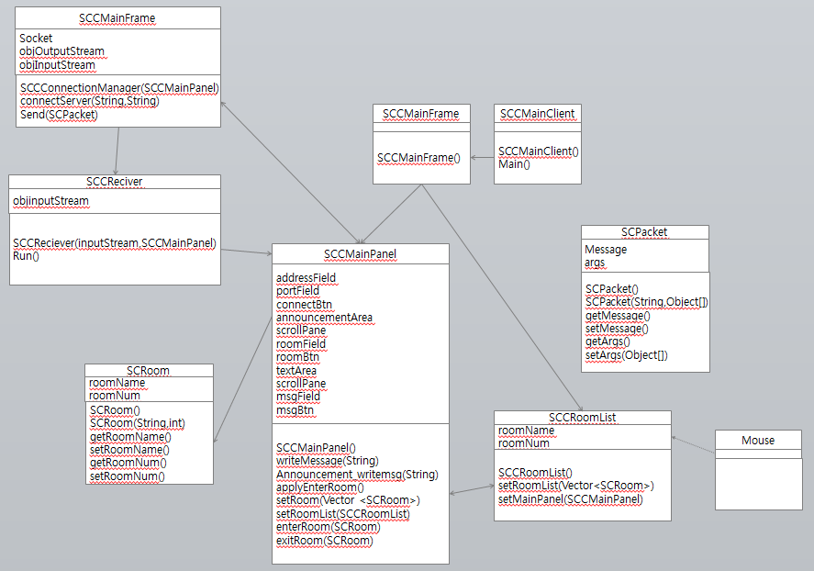
Figure 1. Client Class Diagram for chatting System
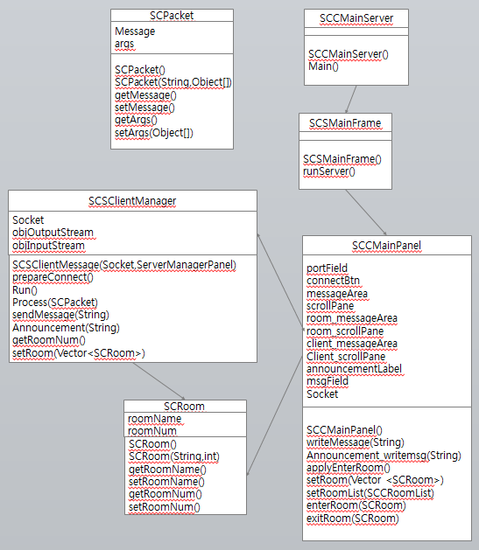
Figure 2. Server Class Diagram for chatting System

